

Artificial Intelligence

Project Report

DT228/DT282

Computer Science

**Arshad shah**

School of Computer Science

Technological University Dublin

**12/12/2019**

Declaration

I hereby declare that the work described in this dissertation is, except where otherwise stated, entirely my own work and has not been submitted as an exercise for a degree at this or any other university.

Signed:

___________________

Arshad shah

12/12/2019

Table of Contents

*1.* Problem Description 4

*2.* Research 4

*3.* Technology Selection and Site Architecture 5

*4.* Low Fidelity Prototype 8

*5.* Development Plan 8

*6.* Testing Plan 9

*7.* Site Evaluation 10

*8.* Deployment 10

Appendices 10

# Problem Description

The Website is aimed at audience of all ages as it is a generic and rather important topic that does not contain restricted or bad language that is inappropriate for some users such as children.

The Problem that the website tries to solve is the awareness to the concept of Artificial Intelligence. Nowadays it is an exciting topic for a humans to have human made creatures with conscience like us.

But that can back fire because there is no regulatory body whatsoever to look after the creation of that conscience. And due to that we may inevitably create something that we are not able to control.

It’s the same with guns or drugs. the guns and drugs are not widespread because it is not considered good and thus controlled.

But if we do not act accordingly guns will be the least of our worries. Because guns can cause a limited amount of damage but A I will damage the whole biosphere of our earth. In games we have a reset button or a redo but, we will get to the point of biosphere wide extinction.

# Research

I conducted my research using books and websites and I have included in every webpage a reference to any content taken from someplace else which acts as a click button to access that content from where it is taken from that also includes videos taken from YouTube as well.

As for the layout I looked at examples for menu given in W3schools website and further improved that design example given for use, where a hamburger sign is used to mark the menu and hide or show it based on the screen width.

Therefore making it better suited for small as well as big screens.

For the favicons I looked at forums from stack overflow to determine how to effectively use it. Then I made a logo online and downloaded free zip file with multiple layouts of the logo.

I searched code pen to learn hamburger icon and how to affectively use that in the menu design.

For the general layout I checked websites for ideas such as <https://colibriwp.com/blog/website-layout-design-ideas/>

Where it shows ten good and professional website layouts.

I took parts that I considered to be simple and clean to make and created my site based on those parts.

I also took parts from <https://www.crazyegg.com/blog/best-website-layouts/>

Where it shows how to make good content on sites.

Last I looked at web flow at <https://webflow.com/blog/unique-website-layouts>

Where I found the best simple and neat sites from which I learned as well.

My website is based on parts from all three of the sites upon which I build it up to my satisfaction.

# Technology Selection and Site Architecture

I used HTML5 and CSS3 as well as JavaScript to structure and design my website.

As it is an article style website, I used the idea of content in a book there are individual topics from” What is AI” to “Development in AI” that focus on that topic as a chapter in a book does.

By using the click to get idea I reduced the work load by big margin as I did not have to refer page to give out references.

I have used the hamburger menu design to reduce menu covering the content.

As the hamburger sign covers all the links except the homepage link.

The website can be seen on any device from phone to a full HD laptop.

The website has CSS in key places that targets requirements from browsers like safari and making them work in those browsers.

Other than the menu I used a wrapper and media queries to create a good responsive website that works with my content. As I have a variety of content on the site so making it to work together takes time and patience

Following are the sketches for the website.

Home page:

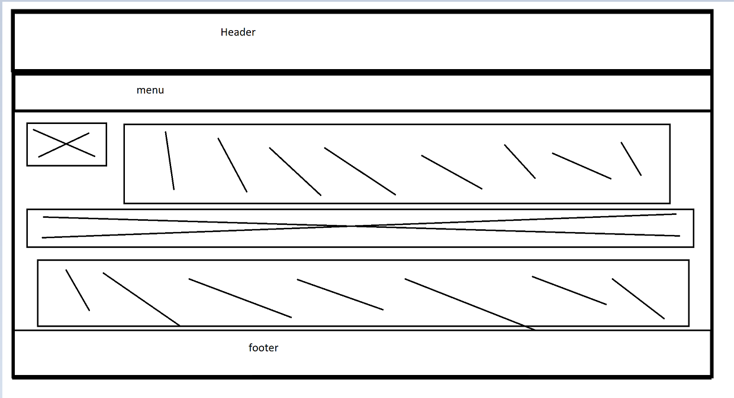

Benefits

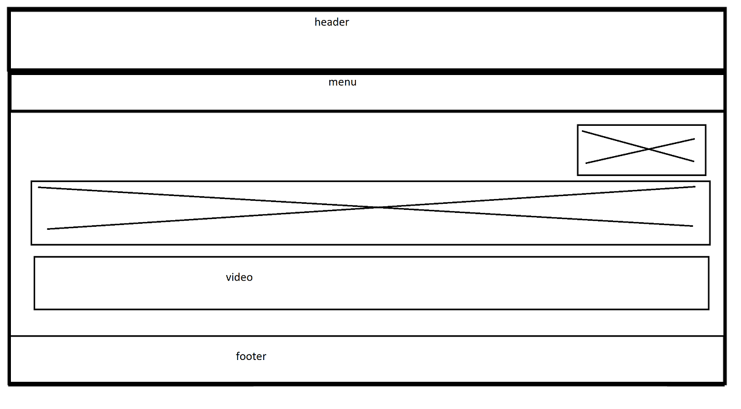

Dangers



Development

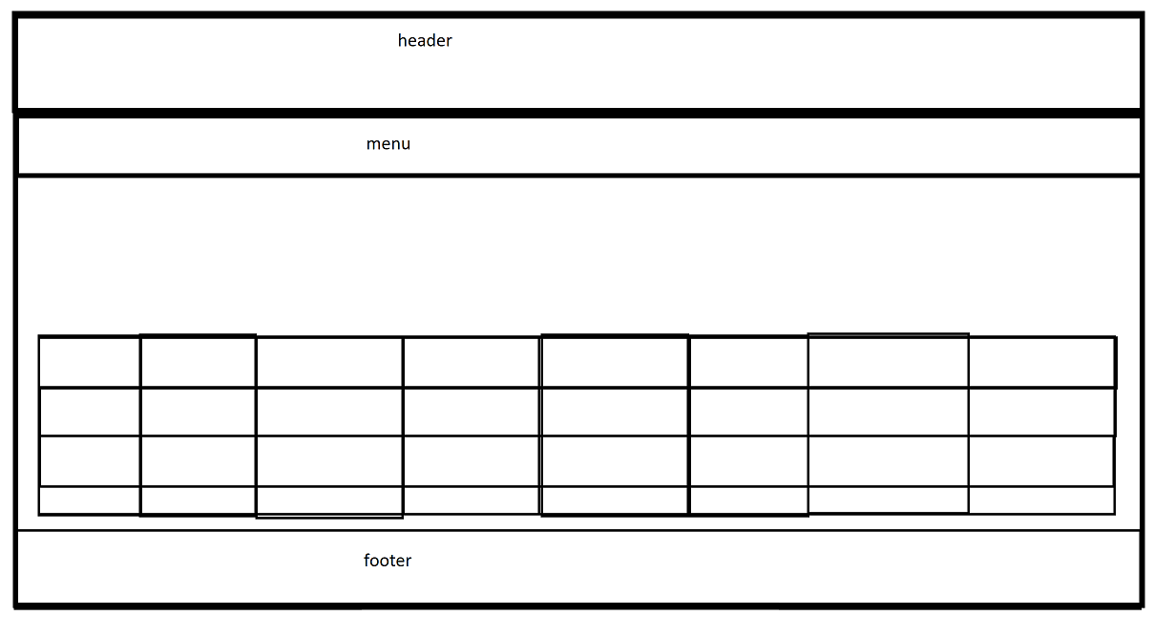

Contact

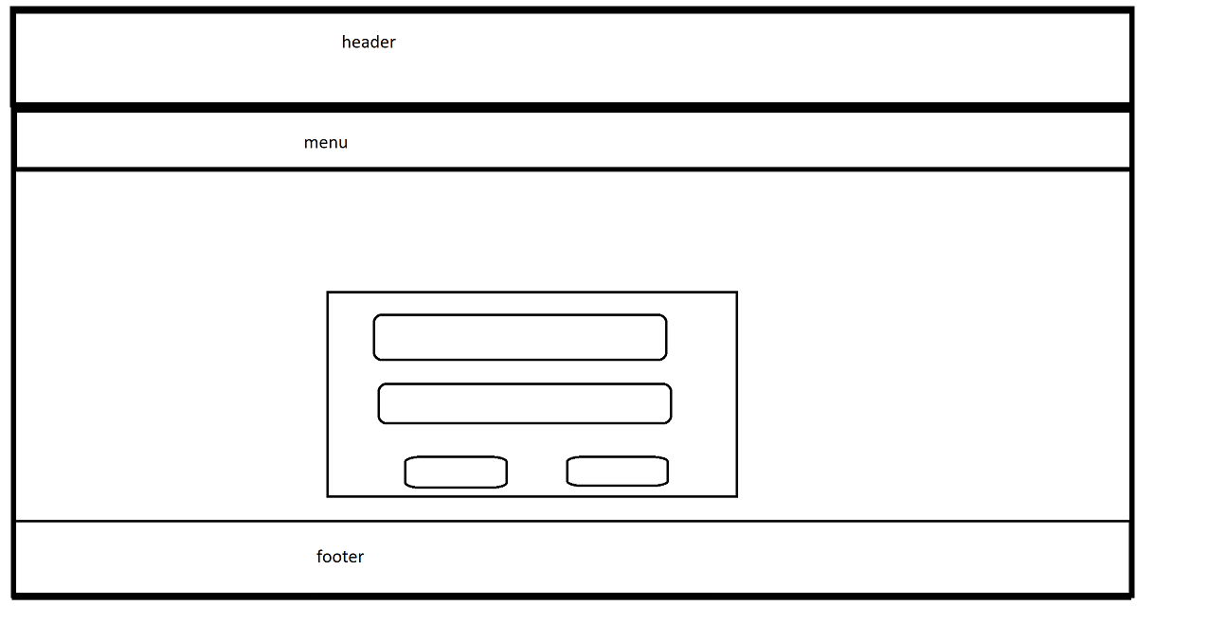

# Low Fidelity Prototype

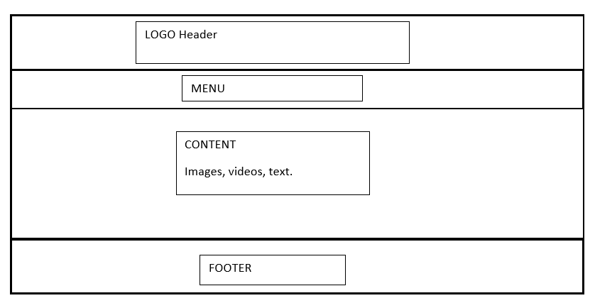

This Lo-Fi prototype very clearly demonstrates the simplicity of the site.

The whole site is designed around the concept of header menu content footer design.

Its main advantages are that it is simple, and easy to navigate.

Therefore the prototype describes in detail the design of the website to a non tech savvy costumer or stakeholder as the website uses the same layout for the whole webpage and the webpage can be upgraded and updated easily or even altered due to its easy layout.

As the CSS is divided into key parts such as media styling certain style can be found easily.

# Development Plan

My development plan started with sketches and then the website, I started with general and simple idea and went on to build on that.

I based my content on talks, articles and quotes.

Due to the nature of the topic as it needs to be supported by Cold hard Facts.

The whole site designed through both internal and external CSS sheets due to different fonts and icons being used.

The main pure CSS that I wrote takes care of the main things like images, text, the body design, the iframes, the content boxes.

There are three JavaScript scripts that take care of individual pieces of the website.

The menu_design.js file as the name suggests takes care of the responsive self-collapsing hamburger menu where the JavaScript changes the class topnav with responsive to collapse the menu and hide it.

The form_validator.js takes care of the validation of form entry, it works by checking the input with a REGEX key to validate it if it is wrong it gives a message in red beneath the text area and will not allow a submission of the form until it is completed correctly.

There is also another function that is added in this script where a function is added so that if the text in the text area fills the current viewable area it increases in size on the entry of more text. To avoid overlap of text underneath the text area.

The back_to_top.js takes care of the back to top button where it creates a small button which only appears after scrolling a certain amount and hides when scrolled below that amount.

When clicked it resets the scroll value of the page and goes to the top.

All the above have pure CSS written by the Author which contains everything from styles to the general layout of the website.

The CSS is reused for header, menu, footer and main layout of the page. The content section is given further CSS styling to make it a varied website.

The CSS for the font and icons is taken from other sources for example font awesome.

And the bootstrap CSS.

To make certain features of some JavaScript work I imported a jQuery file.

# Testing Plan

My testing Plan included using multiple browsers and different screen media to see if it worked correctly on small screen devices and after a long browsing media queries and wrapper design, I achieved the responsive deign that I wanted.

The method I used was as follows:

Test:

Where I would upload my site to W3C markup validator and check for bugs, I will then correct those bugs and reupload the file which was

Recheck :

Where I would check the markup after correction in a browser to see that it met my design parameter and then I would reupload it to markup validator and look for problems.

And test.

And repeat the first step.

Until I made it as near to the idea I started with as possible.

I used w3c validation to check the mark-up and found a lot of bugs, therefore it was very beneficial to do. As the code was working but it has problems in small things like spaces and parts of tags missing.

The testing phase was the beneficial of the lot as even after the development of the website in testing I found mistakes in small things such as padding and margin values causing misalignment in the website. Therefore, it saved me from bad design on deployment of the website and working with the deployed website. I did however hit a wall where the site contact form is not loading correctly due to problem with the hosting, I assume at this stage but Iam unable to find the error. As the code works perfectly on local computer.

And I believe it can be due to bandwidth restriction or disk space as it is a free hosting service, so it is possible, but I am still looking into that to correct it.

The website was tested on three main web browsers namely the chrome, opera, Mozilla. Browsers for compatibility and no issues were found in layout or any other aspect of the website.

Following are the three sizes showing responsive design implementation from mobile to tablet to laptop screen.

Mobile:

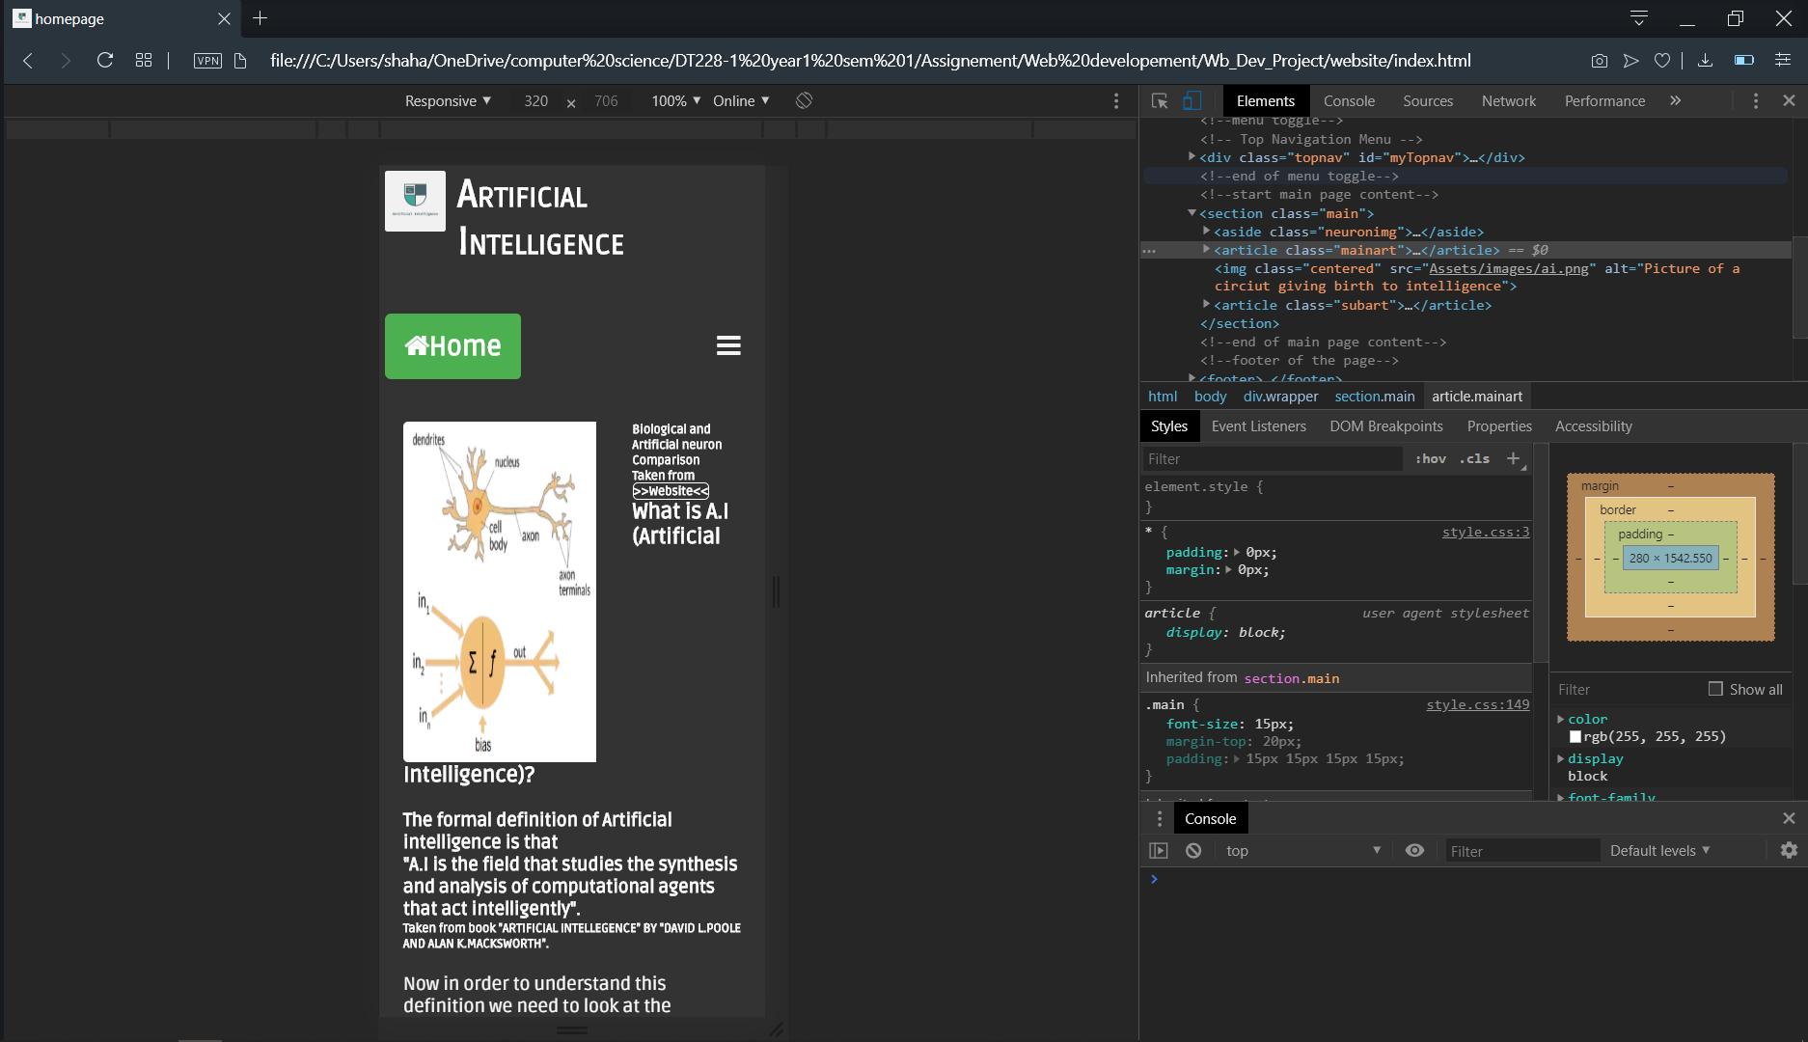  
tablet:

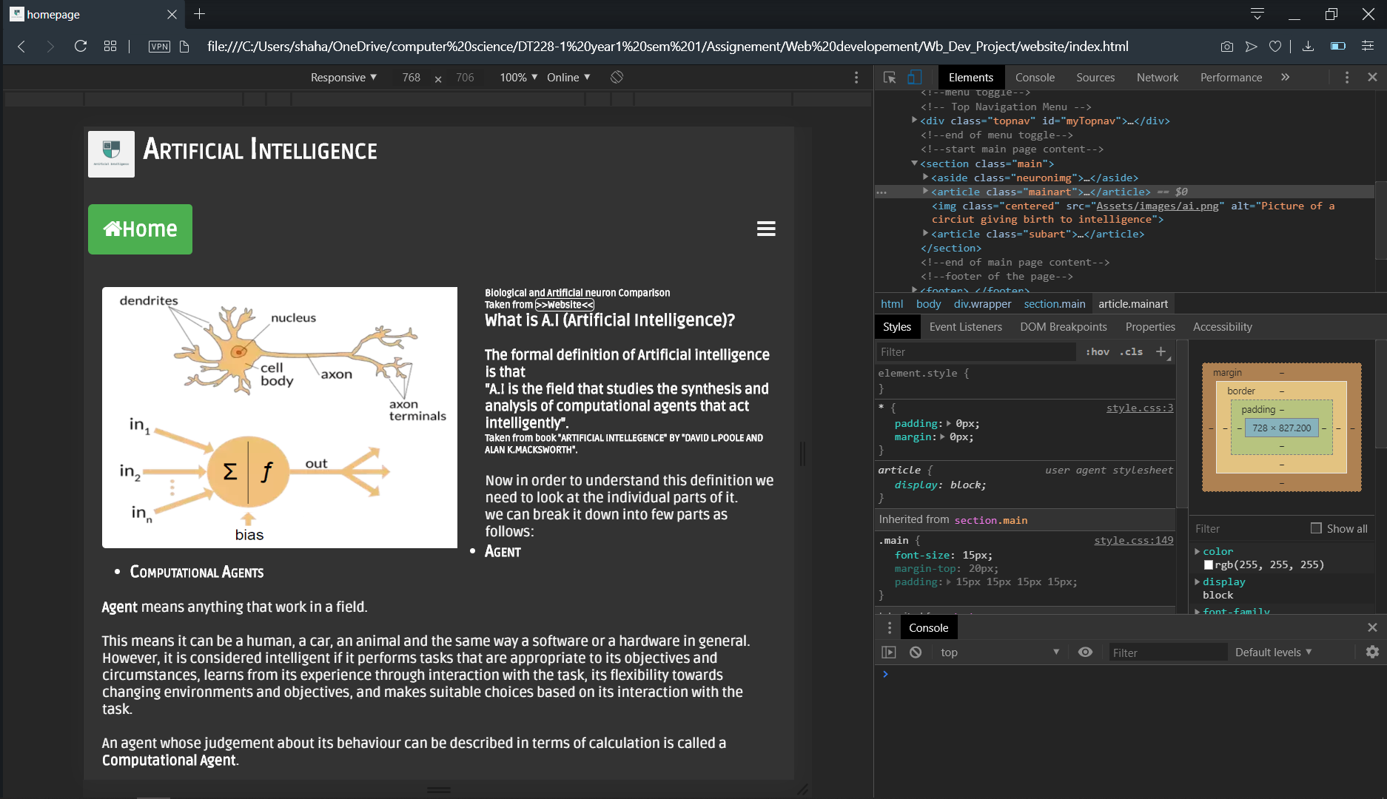

Laptop:

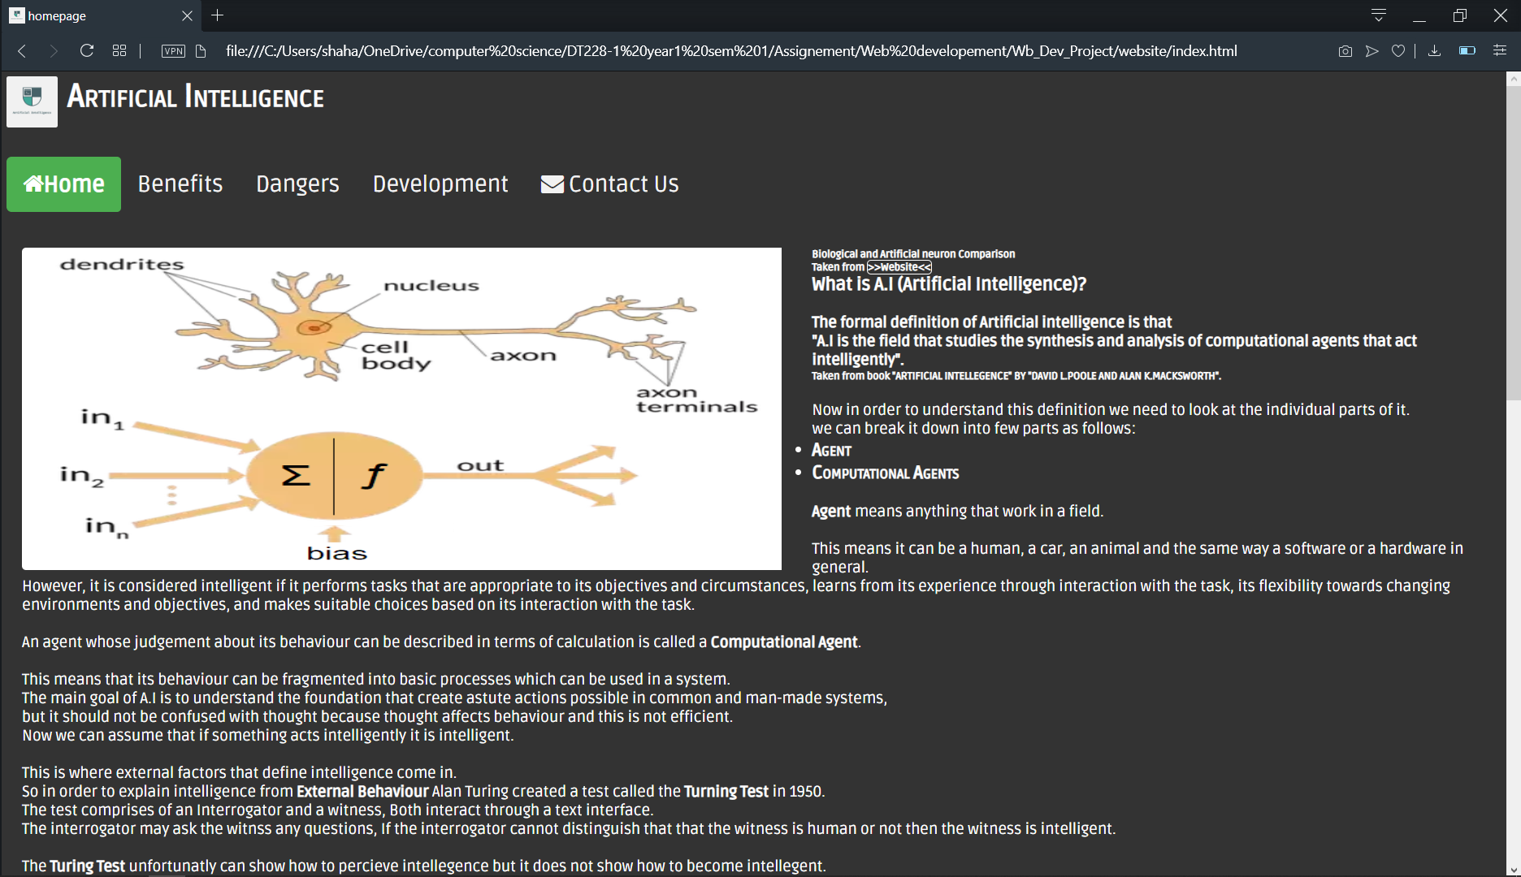

# Site Evaluation

I evaluated my site using w3c validation and general corrections in the code and adding the comments.

As well as checking the website on multiple browsers for compatibility of the website design parameters with that browser

# Deployment

I deployed my site on infinity free. The website can be accessed through theai.epizy.com

The techniques that I used for SEO is that I used both keyword and description metatags.

To improve its chance of being picked up by the search engine.

The deployment creates issues with the form of the website as for some reason it causes it to deactivate the CSS used for the form.

# Appendices

Weekly Logs

Week 8/ project week 1

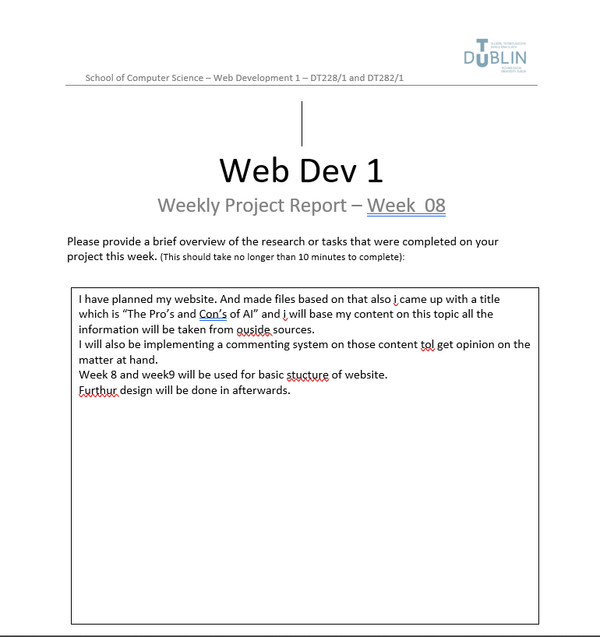

Week9/project week 2

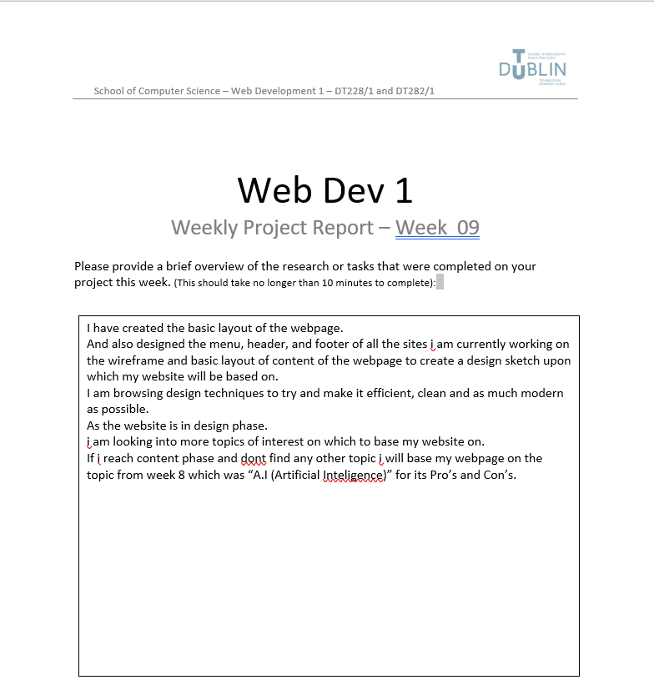

Week10/project week 3

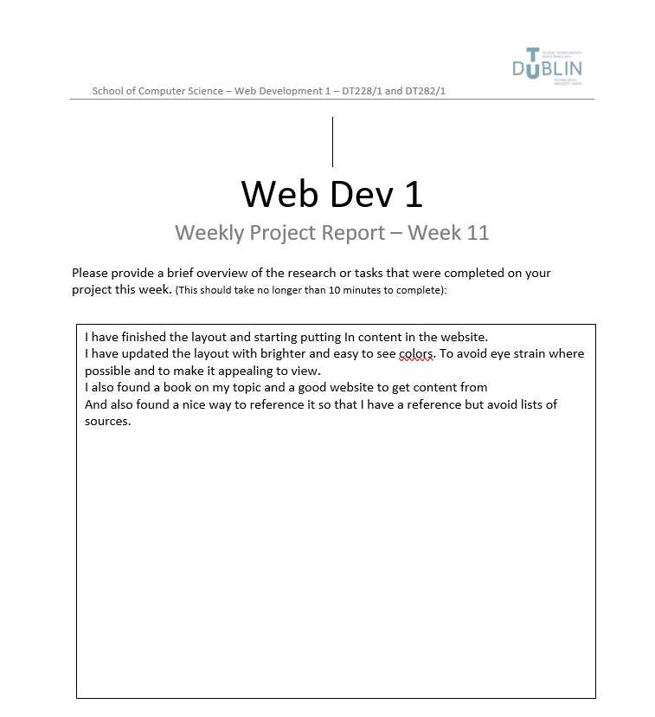

Week11/project week 4

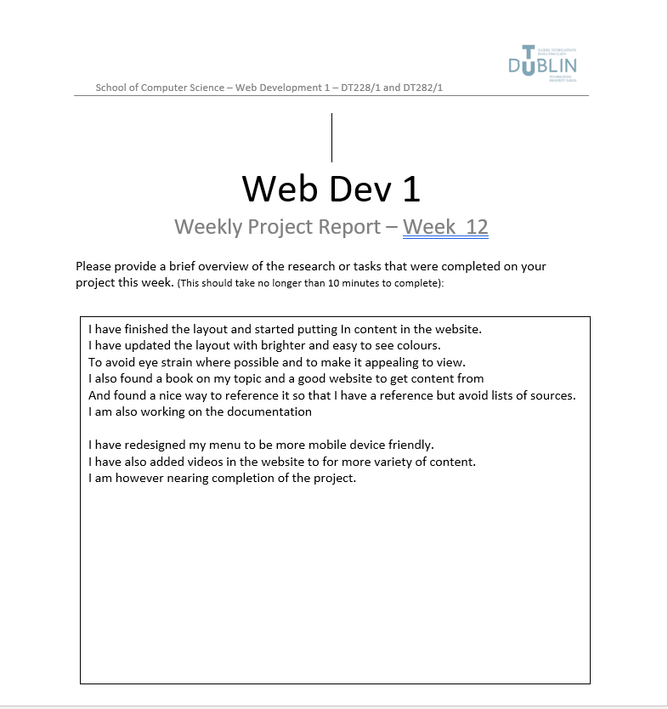

Week12/project week 5

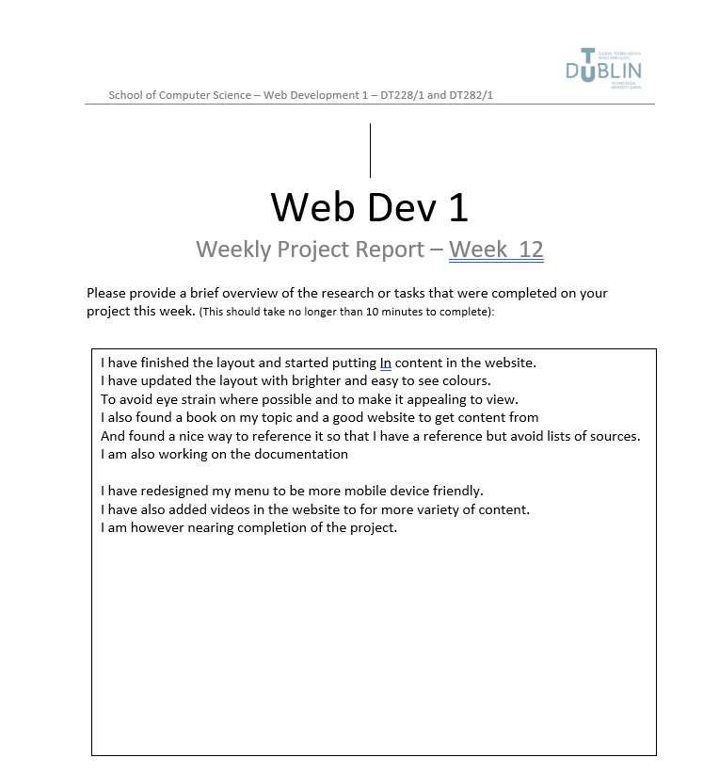

For main files please look into the documentation folder with the website.