Assignment 10.2

Creating Dataset

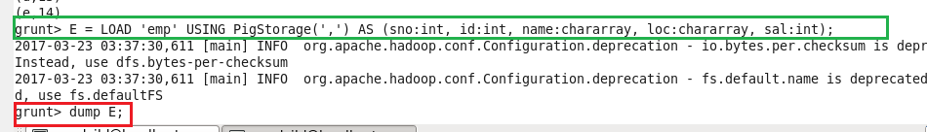

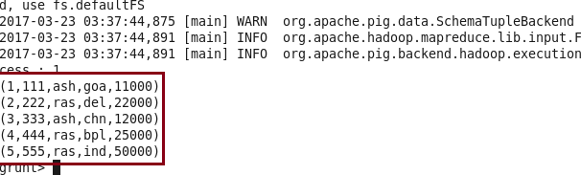

1. CONCAT : CONCAT function is used to concatenate two elements.

Command

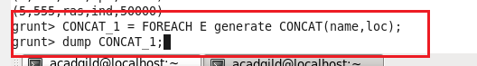

**Output**

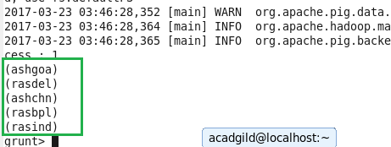

1. TOKENIZE : Splits a string and outputs a bag of words.

Command :

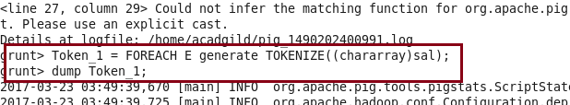

**OUTPUT**

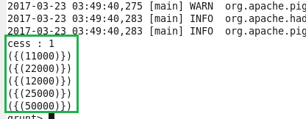

1. Sum **:** SUM function is used to compute the sum of a set of numeric values in a single-column bag.

**Commands :**

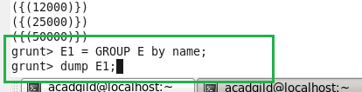

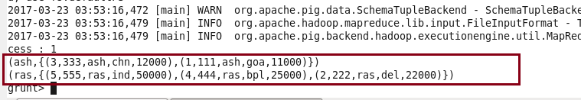

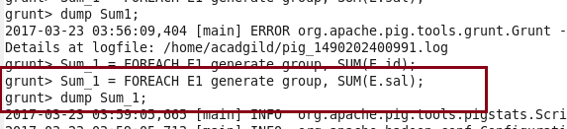

**OUTPUT**

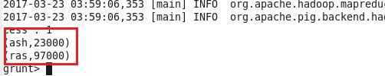

1. **MIN :** Weuse the MIN function to compute the minimum of a set of numeric values or chararrays in a single-column bag.

**Commands**





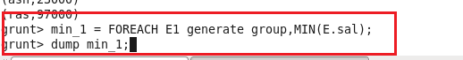

**Output**

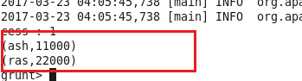

1. **MAX :** Use the MAX function to compute the maximum of the numeric values or chararrays in a single-column bag.

**Command :**

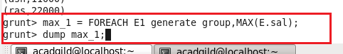

**Output**

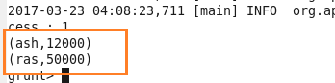

1. **LIMIT :** We use the LIMIT operator to limit the number of output tuples.

**Command :**

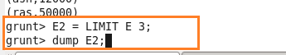

**Output**

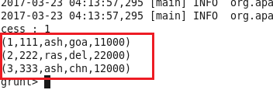

1. **STORE :** Stores or saves results to the file system.

**Command:**



Output :

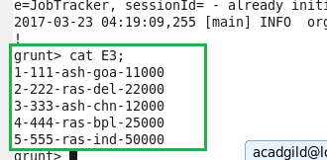

1. **Distinct :** Removes duplicate tuples in a relation.

**Command:**

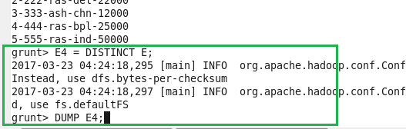

**Output :**

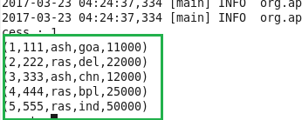

1. **Flatten :** Flatten un-nests tuples as well as bags.

**Command :**

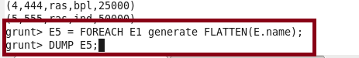

**Output**

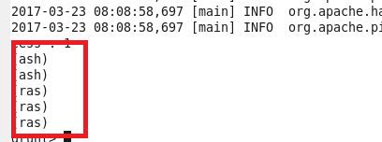

**10.IsEmpty :** Checks if a bag or map is empty.