16.3 Problem Statement

Execute Session 16 - Assignment 1 (Machine and Sensor data analysis) using Reduce side join and compare which join is faster in normal conditions.

Driver class

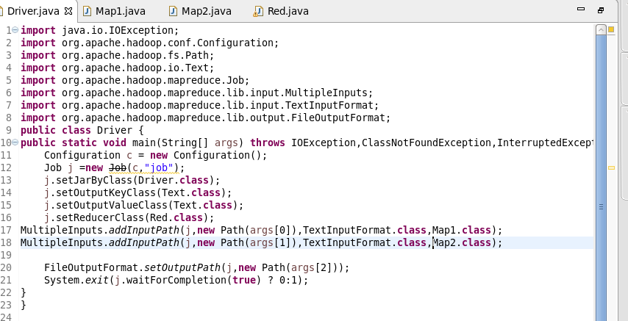

Mapper1 Class

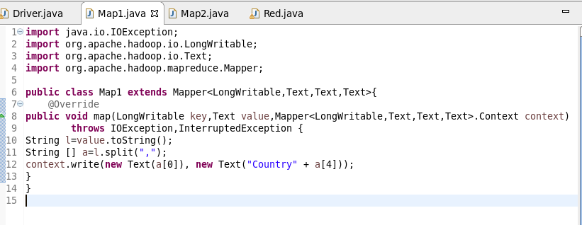

Mapper2 Class

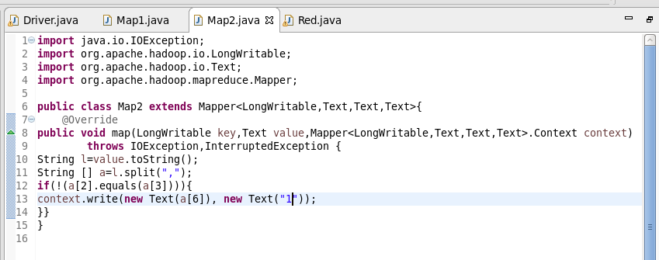

Reducer Class

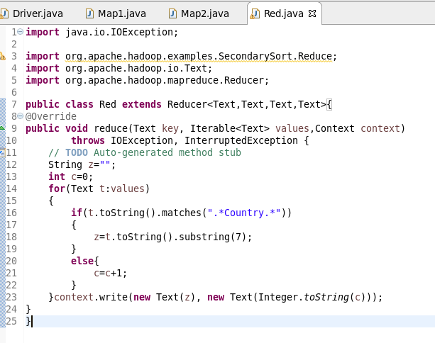

Running Jars

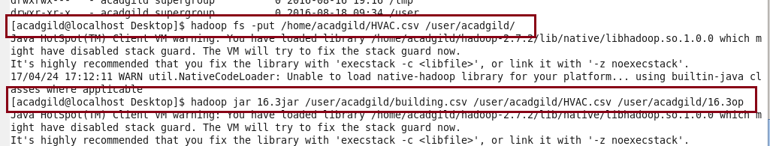

OUTPUT

