Ques6.1 - . Problem Statement

We have a dataset of travel data analysis

https://github.com/prateekATacadgild/DatasetsForCognizant/blob/master/TravelData.txt Problem

statement 1: Find out how many people has chosen their destination as MIA and MCO Problem

statement 2: Find out the number of people undertaken the trips from the places MIA and HOU Problem

statement 3: Find out how many people has chosen airline mode of travel for the places LAS and LAX

Driver Class

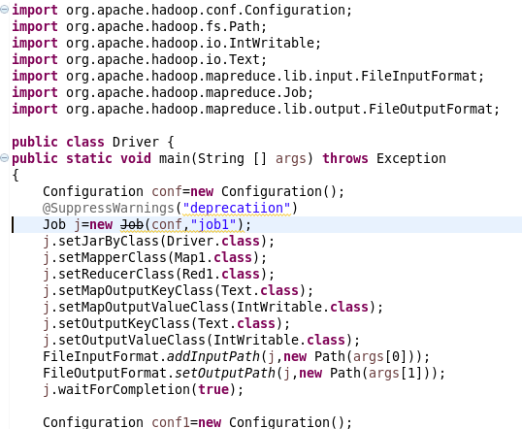

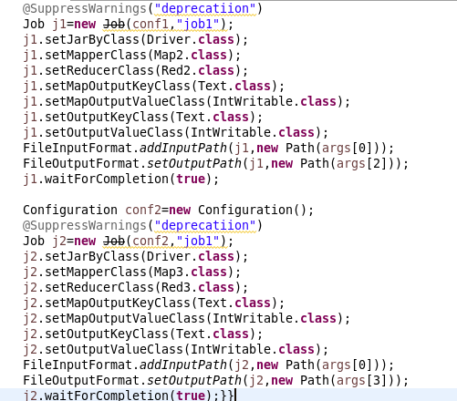

Mapper 1

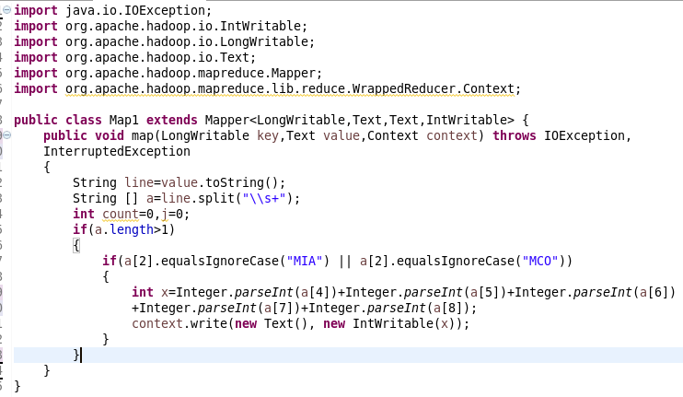

Reducer 1

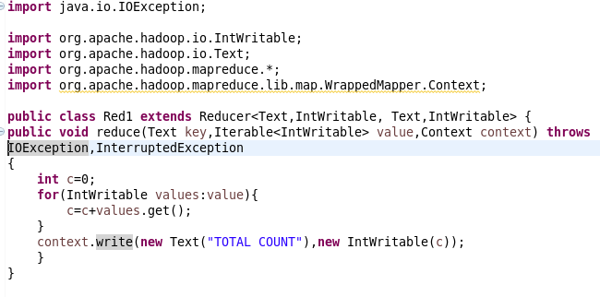

Mapper 2

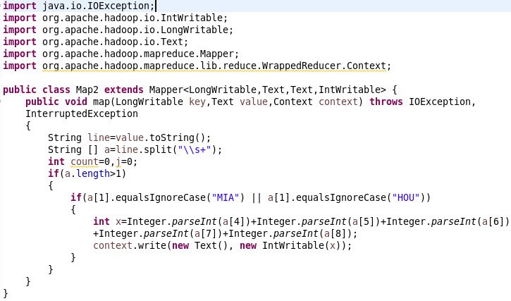

Reducer 2

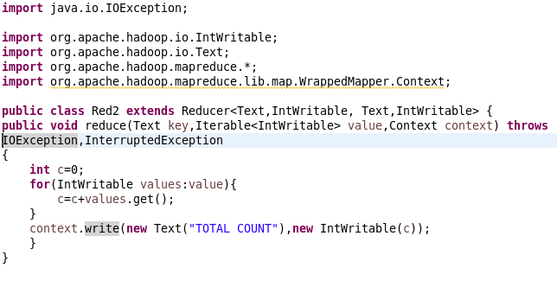

Mapper 3

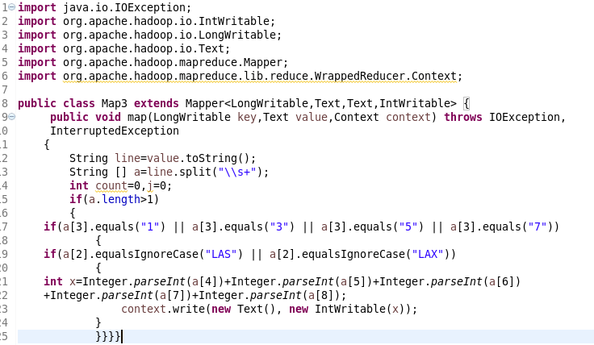

Reducer 3

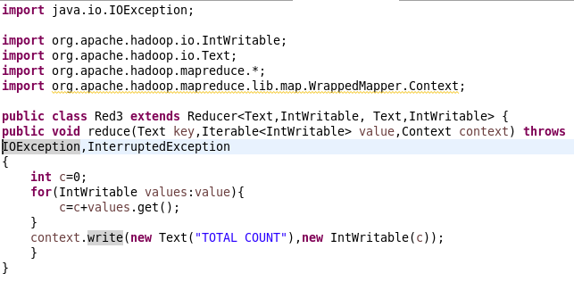

Output 1



Output 2

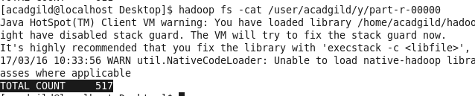

Output 3

