**Get-Viewed**

**A**

**Project Report**

**Submitted by**

***VIVEK DHOLAKIYA & ARSHIT VORA***

**FOR FULFILLMENT OF FIFTH SEMESTER IN**

**BACHELOR OF COMPUTER APPLICATION**



H. &H.B.KOTAK INSTITUTE OF

SCIENCE.

Our Profile



Name: Dholakiya Vivek

Stream: BCA 5

Mobile: 9409854626

Email: vivekd.personL@gmail.com

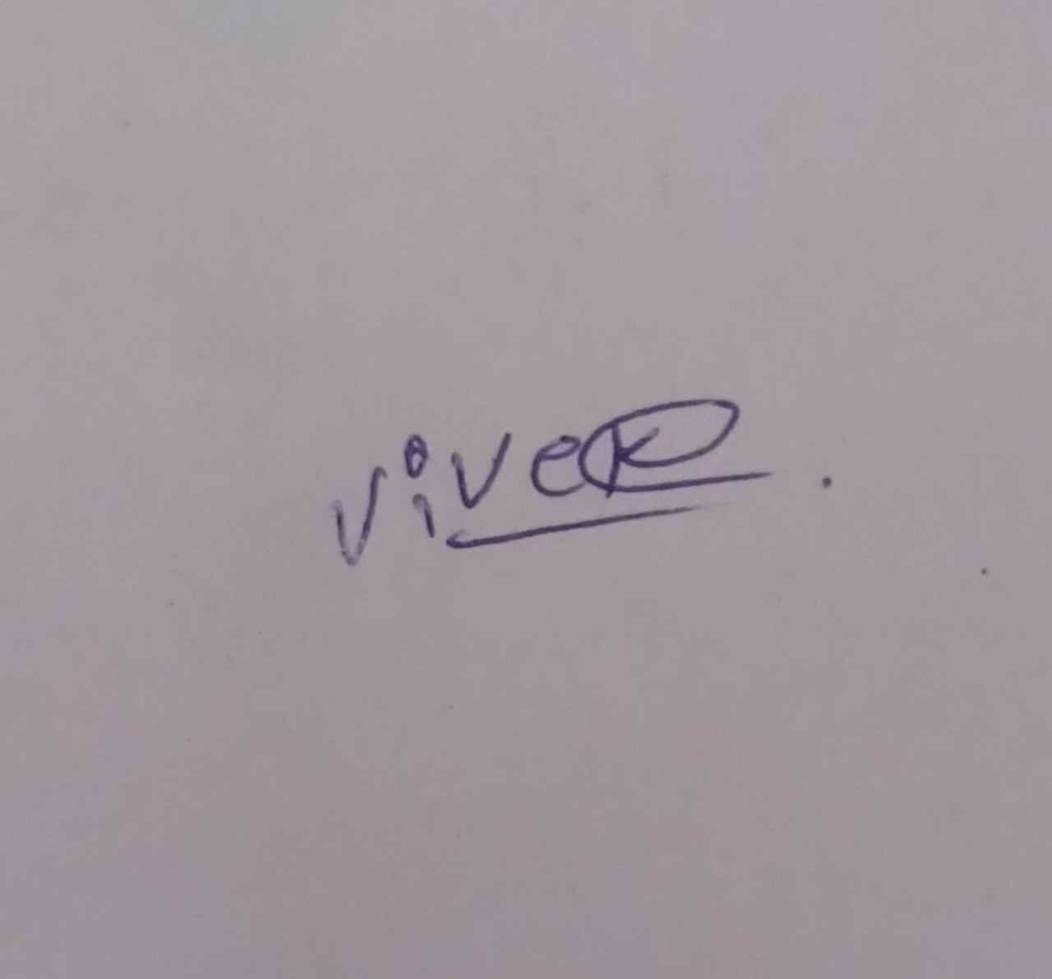



Name: Vora Arshit

Stream: BCA 5

Mobile: 9743502767

Email: arsh2002vora@gmail.com

Preface

Theory of any subject is important but without its practice it useless particularly for the computer student. A computer student cannot become perfect man of technologist without practical understanding of branch.

We can also say, “Experience is the best teacher” so our project is one Kind of Experience, the part of our life. Through the project we have learnt Good, Real, and Practical application.

The project training in the B.C.A of the course gives us the exposure to real world. The aim of the project training, by understanding a project, is to have practical experience of the real world. It also clears the picture of practical field to prompt the student to develop their qualities talents, etc. So that we can expand our view about the implication of the theoretical Knowledge in the practical field, we had the opportunity for the same at various field.

Acknowledgement

The present of this report gives us the feeling of the final frontier toward achieving the BCA Degree. the activity of going through industrials orientation has bridged the gap between the academics and practical real-life work for us.

It has prepared us to apply ourselves to become good IT professional. Naturally, it requires lot of people support to complete this project. We take this opportunity to acknowledge their support to us.

In the acknowledge, hear first of all we would like to thanks our College h.&h.b.kotak institute of science that they gave such Good opportunity for develop a project which would evaluate. We Thanks to our friends to give support for a development of this project.

We would also like to thanks all those people who made this project directly or indirectly possible.

*Thank You*

Vivek H. Dholakiya

Arshit N. Vora

Used Of Software

|  |  |  |
| --- | --- | --- |
| No. | Software Used | Remarks |
| 1 | PHP | Used for creating front end programming. |
| 2 | MY SQL | Used the Back End for the system. It holds the entire database. |
| 3 | Notepad++ | It is the technology Used as the Programming Language. |
| 4 | Any O.S. | Used on the client side. |
| 5 | Ms Word, Notepad | Used as documentation tools. |
| 6 | Web Browser | Communication between client & server. |

Index

|  |  |  |  |  |
| --- | --- | --- | --- | --- |
| **No.** | **Title** | | **Page No.** | |
|  | | Introduction of Project | | 06 | |
|  | | Project Profile | | 07 | |
|  | | Data Dictionary | | 08 | |
|  | | Data Flow Diagram | | 10 | |
|  | | Use Case Diagram | | 12 | |
|  | | ER Diagram | | 13 | |
|  | | Activity Diagram | | 14 | |
|  | | System Design | | 15 | |
|  | | Testing | | 20 | |
|  | | Conclusion | | 21 | |
|  | | Bibliography | | 22 | |

Introduction of Project

We created project named “Get-Viewed”, hear we provide a complete traffic solution for YouTube videos.

Our main goal is to promote new youtubers for achieving views.

By digitalizing the process of marketing YouTube channels and videos.

Here is how it works,

* To use our service, firstly users have to sign up on our website.
* After signing it up the user will get 100 GVC (Get-Viewed Credit) for free.
* On the dashboard user will find globally uploaded YouTube videos link by users.
* By clicking on the link globally uploaded the user will be redirected on that particular video.
* After viewing the user will get 1 GVC and the owner of that link will lose 2 GVC. (for making it commercial purpose the other 1 GVC will be the charge of this service)
* After getting * all the GVC, the user will not be able to upload any YouTube videos links. Then the user will have to buy some GVC from the website to proceed further or the user will have to view some videos to earn more GVC.
* There is also a user panel where the user will have full control on YouTube videos link and the available GVC in their account.

Project-Profile

Project Name : Get-Viewed

Programming Language : PHP

Database : MySQL

Documentation Tool : Microsoft Word 2010

Platform : Desktop

Web Browser : Any browser

Source Code / VCS : GitHub

Project Duration : 2 Month

Prepared By : Dholakiya Vivek & Vora Arshit

Submitted To : H. & H.B. Kotak Institute Of Science.

Data-Dictionary

* Table Name: users
* Table Description: We store user credential In this table login and

signup.

|  |  |  |  |
| --- | --- | --- | --- |
| Name | Type | Constraints | Description |
| u_id | INT(10) | Primary Key |  |
| user_name | VARCHAR(30) | NOT NULL | Username of user |
| email | VARCHAR(255) | NOT NULL | Email of user |
| password | VARCHAR(255) | NOT NULL | Password of user |
| GVC | INT(255) | NULL | Credit of user |

* Table Name: users_data
* Table Description: We store user data about link and video of

YouTube.

|  |  |  |  |
| --- | --- | --- | --- |
| Name | Type | Constraints | Description |
| link_id | INT(10) | Primary Key |  |
| u_id | INT(10) | Foreign Key |  |
| link_url | VARCHAR(255) | NOT NULL | Link of user |

* Table Name: viewed
* Table Description: When the user watches the video or link ,

we record this table.

|  |  |  |  |
| --- | --- | --- | --- |
| Name | Type | Constraints | Description |
| link_id | INT(10) | Foreign Key |  |
| u_id | INT(10) | Foreign Key |  |

Data Flow Diagram

* 0 Level DFD

**User**

**User**

**User**

**User**

* 1 LevelDiagram

**User**

**User data**

**Data**

**View data**

**GVC**

Use case Diagram

**User**

Entity-Relationship (ER) Diagram

**users**

**user_data**

**viewed**

Activity Diagram

**e**

Login

Enter name, email, password

**In case of invalid data**

Verify name, email, password

**Check**

Valid data

***User dashboard***

Home

Manage link

Manage profile

Home

System analysis

* View: Home screen
* Desc: when we start the Web-site at first time then one user-interface

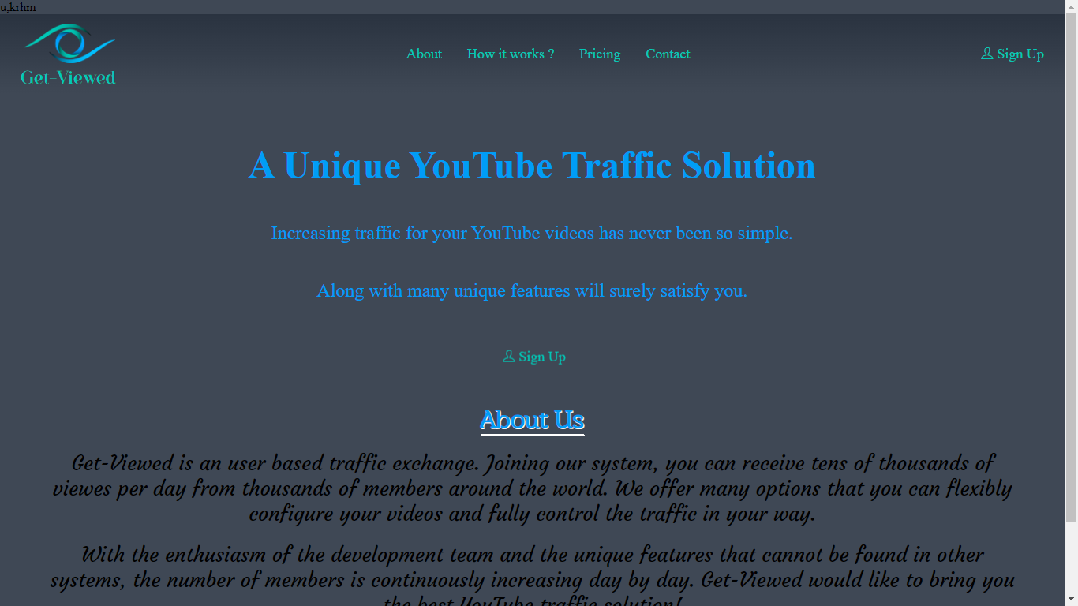

* View: Sign-up screen
* Desc: Here users can create their personal account for free with quick and easy steps.

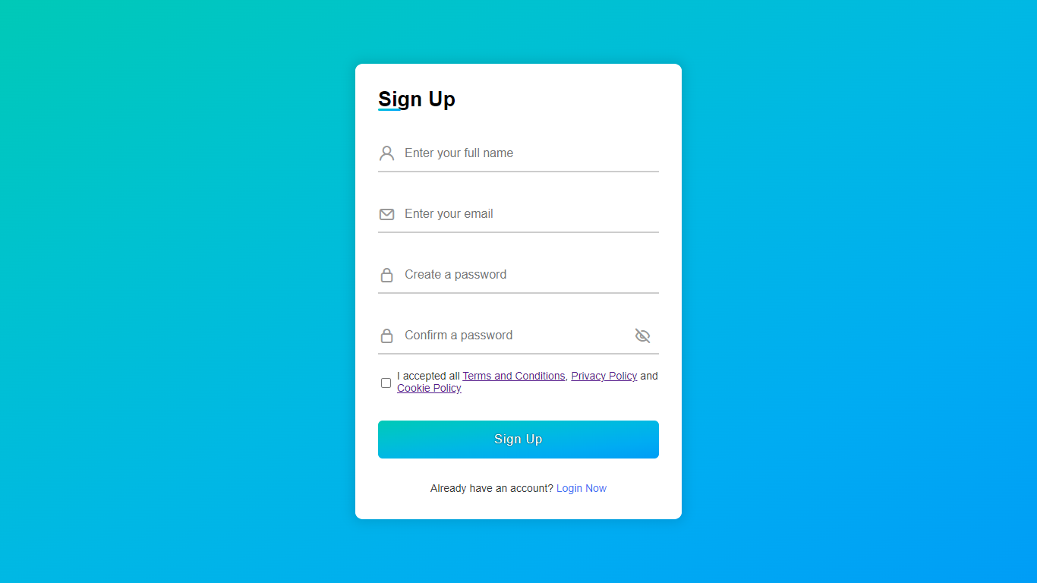

* View: Login screen
* Desc: Here users can Login into their personal account to go through.

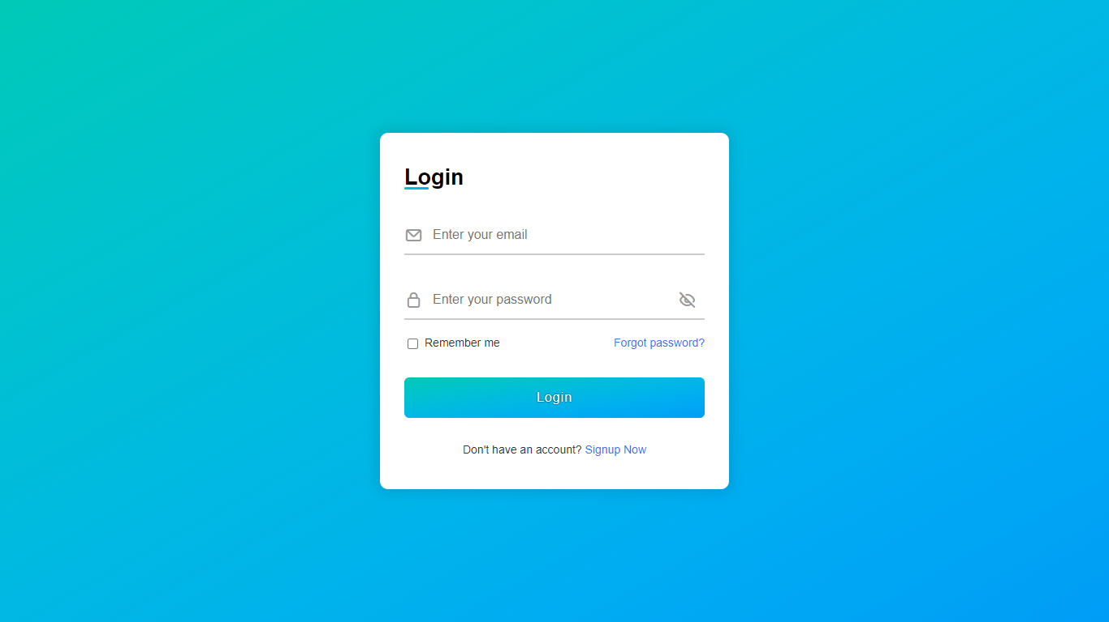

* View: Dashboard
* Desc: Here the data of the logged in user will be shown i.e. uploaded links, balance GVC etc.

Testing

**Manual**

We use **Black Box** testing technique to test this website

We tested several times and we sorted out some issue which is we identified.

In addition, we launched Beta version for our College colleague to test and give the feedback or Suggestion to us.

We Also Perform **White Box** Testing by Our Selves and Our Colleagues Who have Experience of Web Developing.

Conclusion

The project report entitled "Get-Viewed" has come to its conclusion

The new system has been developed with so much care that it is free of errors and at the same time, efficient and less time consuming

System is robust. In addition, provision is provided for future developments in the system

It was a wonderful learning experience for us while working on this project. This project took us through the various phases of project development and gave us a real insight into the world of software engineering. The joy of working and the thrill involved while tackling the various problems and challenges gave me a feel of developer’s industry.

It was due to this project we came to know how professional software is designed.

In this project we learned a lot we thankful to our college and Saurashtra University.

Bibliography

Here are the following names of website referred during the different system development life cycle. We referred this book and website at the time during difficulties and doubts. Really those websites are surely our best friends at the time of problems, they help a lot.

* Websites References:
  + [www.stackoverflow.com](http://www.stackoverflow.com)
  + [www.youtube.com](http://www.youtube.com)

**