Week-3 Hands On
Spring Core and Maven

Exercise 1: Configuring a Basic Spring Application

<project xmlns="http://maven.apache.org/POM/4.0.0" xmlns:xsi="http://www.w3.org/2001/XMLSchema-instance" xsi:schemaLocation="http://maven.apache.org/POM/4.0.0 https://maven.apache.org/xsd/maven-4.0.0.xsd">
<modelVersion>4.0.0</modelVersion>
<groupId>com.library</groupId>
<artifactId>LibraryManagement</artifactId>
<version>0.0.1-SNAPSHOT</version>
<dependencies>
<dependency>
<groupId>org.springframework</groupId>
<artifactId>spring-context</artifactId>
<version>5.3.34</version>
</dependency>
</dependencies>
</project>

package com.library.repository;

import java.util.Arrays;
import java.util.List;

public class BookRepository {
public List<String> getAllBooks() {
return Arrays.asList("RD Sharma", "RS Agarwal", "MBD Guide");
}
}

package com.library.service;

import com.library.repository.BookRepository;
import java.util.List;

public class BookService {
private BookRepository bookRepository;

public void setBookRepository(BookRepository bookRepository) {
this.bookRepository = bookRepository;
}

public void displayBooks() {
List<String> books = bookRepository.getAllBooks();
System.out.println("Available Books:");
books.forEach(System.out::println);
}
}

<?xml version="1.0" encoding="UTF-8"?>
<beans xmlns="http://www.springframework.org/schema/beans"
xmlns:xsi="http://www.w3.org/2001/XMLSchema-instance"
xsi:schemaLocation="
http://www.springframework.org/schema/beans
https://www.springframework.org/schema/beans/spring-beans.xsd">

<bean id="bookRepository" class="com.library.repository.BookRepository"/>

<bean id="bookService" class="com.library.service.BookService">
<property name="bookRepository" ref="bookRepository"/>
</bean>

</beans>

package com.library;
import com.library.service.BookService;
import org.springframework.context.ApplicationContext;
import org.springframework.context.support.ClassPathXmlApplicationContext;

public class LibraryApp {
public static void main(String[] args) {
ApplicationContext context = new ClassPathXmlApplicationContext("applicationContext.xml");

BookService bookService = context.getBean(BookService.class);
bookService.displayBooks(); // AOP will wrap this
}
}

OUTPUT:
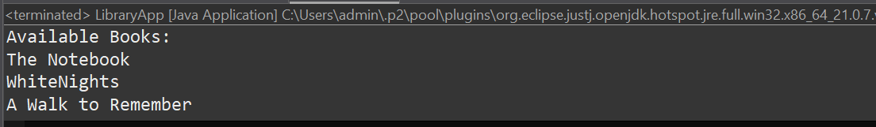

Exercise 2: Implementing Dependency Injection

<?xml version="1.0" encoding="UTF-8"?>
<beans xmlns="http://www.springframework.org/schema/beans"
xmlns:xsi="http://www.w3.org/2001/XMLSchema-instance"
xsi:schemaLocation="http://www.springframework.org/schema/beans
http://www.springframework.org/schema/beans/spring-beans.xsd">

<!-- Define BookRepository bean -->
<bean id="bookRepository" class="com.library.repository.BookRepository" />

<!-- Define BookService bean with DI -->
<bean id="bookService" class="com.library.service.BookService">
<property name="bookRepository" ref="bookRepository" />
</bean>

</beans>

package com.library.service;

import com.library.repository.BookRepository;
import java.util.List;

public class BookService {
private BookRepository bookRepository;

public void setBookRepository(BookRepository bookRepository) {
this.bookRepository = bookRepository;
}

public void displayBooks() {
List<String> books = bookRepository.getAllBooks();
System.out.println("Available Books:");
books.forEach(System.out::println);
}
}

package com.library.repository;

import java.util.Arrays;
import java.util.List;

public class BookRepository {
public List<String> getAllBooks() {
return Arrays.asList("RD Sharma", "RS Agarwal", "MBD Guide");
}
}

package com.library;

import com.library.service.BookService;
import org.springframework.context.ApplicationContext;
import org.springframework.context.support.ClassPathXmlApplicationContext;

public class LibraryApp {
public static void main(String[] args) {
ApplicationContext context = new ClassPathXmlApplicationContext("applicationContext.xml");

BookService service = context.getBean("bookService", BookService.class);

service.displayBooks();
}
}

OUTPUT:
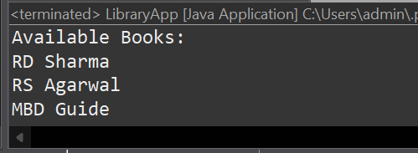

Exercise 4: Creating and Configuring a Maven Project

//Include dependencies for Spring Context, Spring AOP, and Spring WebMVC.

<dependencies>
<dependency>
<groupId>org.springframework</groupId>
<artifactId>spring-context</artifactId>
<version>5.3.34</version>
</dependency>

<dependency>
<groupId>org.springframework</groupId>
<artifactId>spring-aop</artifactId>
<version>5.3.34</version>
</dependency>

<dependency>
<groupId>org.aspectj</groupId>
<artifactId>aspectjweaver</artifactId>
<version>1.9.21</version>
</dependency>
</dependencies>

//Configure the Maven Compiler Plugin for Java version 1.8 in the pom.xml file.

<build>
<plugins>
<plugin>
<groupId>org.apache.maven.plugins</groupId>
<artifactId>maven-compiler-plugin</artifactId>
<version>3.11.0</version>
<configuration>
<source>1.8</source>
<target>1.8</target>
</configuration>
</plugin>
</plugins>
</build>

Exercise 5: Configuring the Spring IoC Container

package com.library.service;

import com.library.repository.BookRepository;

public class BookService {
private BookRepository bookRepository;

public void setBookRepository(BookRepository bookRepository) {
this.bookRepository = bookRepository;
}

public void displayBooks() {
for (String book : bookRepository.getAllBooks()) {
System.out.println(book);
}
}
}

//Defining beans for BookService and BookReository
<beans xmlns="http://www.springframework.org/schema/beans"
xmlns:xsi="http://www.w3.org/2001/XMLSchema-instance"
xsi:schemaLocation="
http://www.springframework.org/schema/beans
https://www.springframework.org/schema/beans/spring-beans.xsd">

<bean id="bookRepository" class="com.library.repository.BookRepository"/>

<bean id="bookService" class="com.library.service.BookService">
<property name="bookRepository" ref="bookRepository"/>
</bean>

</beans>

package com.library;

import com.library.service.BookService;
import org.springframework.context.ApplicationContext;
import org.springframework.context.support.ClassPathXmlApplicationContext;

public class LibraryApp {
public static void main(String[] args) {
ApplicationContext context = new ClassPathXmlApplicationContext("applicationContext.xml");

BookService service = context.getBean("bookService", BookService.class);
service.displayBooks();
}
}

OUTPUT:
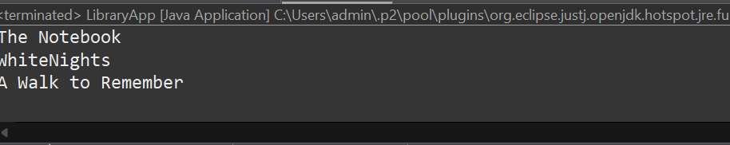

Exercise 7: Implementing Constructor and Setter Injection

<?xml version="1.0" encoding="UTF-8"?>
<beans xmlns="http://www.springframework.org/schema/beans"
xmlns:xsi="http://www.w3.org/2001/XMLSchema-instance"
xmlns:context="http://www.springframework.org/schema/context"
xsi:schemaLocation="
http://www.springframework.org/schema/beans http://www.springframework.org/schema/beans/spring-beans.xsd
http://www.springframework.org/schema/context http://www.springframework.org/schema/context/spring-context.xsd">

<context:component-scan base-package="com.library" />

<bean id="bookRepository" class="com.library.repository.BookRepository" />

<bean id="bookService" class="com.library.service.BookService">
<constructor-arg value="LibraryService" />
<property name="bookRepository" ref="bookRepository" />
</bean>

</beans>

package com.library.service;

import com.library.repository.BookRepository;

public class BookService {

private String serviceName;
private BookRepository bookRepository;

public BookService(String serviceName) {
this.serviceName = serviceName;
System.out.println("BookService created with service name: " + serviceName);
}

public void setBookRepository(BookRepository bookRepository) {
this.bookRepository = bookRepository;
}

public void displayBooks() {
System.out.println("Service: " + serviceName);
bookRepository.getAllBooks().forEach(System.out::println);
}
}

package com.library.repository;

import org.springframework.stereotype.Repository;
import java.util.List;
import java.util.Arrays;

@Repository
public class BookRepository {

public List<String> getAllBooks() {
return Arrays.asList("RD Sharma", "A Walk To Remember");
}
}

package com.library;

import com.library.service.BookService;
import org.springframework.context.ApplicationContext;
import org.springframework.context.support.ClassPathXmlApplicationContext;

public class LibraryApp {
public static void main(String[] args) {
ApplicationContext context = new ClassPathXmlApplicationContext("applicationContext.xml");

BookService bookService = context.getBean(BookService.class);
bookService.displayBooks();
}
}

OUTPUT:
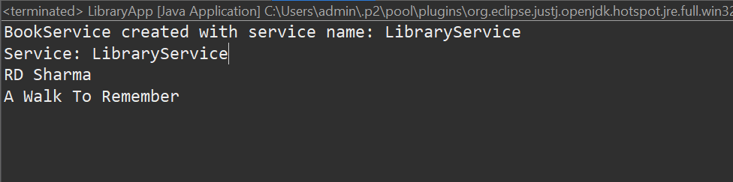

9.Creating a Spring Boot Application
XML Files:
<dependencies>
<dependency>
<groupId>org.springframework.boot</groupId>
<artifactId>spring-boot-starter-web</artifactId>
</dependency>
<dependency>
<groupId>org.springframework.boot</groupId>
<artifactId>spring-boot-starter-data-jpa</artifactId>
</dependency>
<dependency>
<groupId>com.h2database</groupId>
<artifactId>h2</artifactId>
<scope>runtime</scope>
</dependency>
</dependencies>

package com.library.repository;
import com.library.entity.Book;
import org.springframework.data.jpa.repository.JpaRepository;
public interface BookRepository extends JpaRepository<Book, Long> {
}

package com.library.controller;
import com.library.entity.Book;
import com.library.repository.BookRepository;
import org.springframework.beans.factory.annotation.Autowired;
import org.springframework.web.bind.annotation.*;
import java.util.List;
@RestController
@RequestMapping("/books")
public class BookController {
@Autowired
private BookRepository bookRepository;
@GetMapping
public List<Book> getAllBooks() {
return bookRepository.findAll();
}
@GetMapping("/{id}")
public Book getBookById(@PathVariable Long id) {
return bookRepository.findById(id).orElse(null);
}
@PostMapping
public Book createBook(@RequestBody Book book) {
return bookRepository.save(book);
}
@PutMapping("/{id}")
public Book updateBook(@PathVariable Long id, @RequestBody Book bookDetails) {
Book book = bookRepository.findById(id).orElse(null);
if (book != null) {
book.setTitle(bookDetails.getTitle());
book.setAuthor(bookDetails.getAuthor());
return bookRepository.save(book);
}
return null;
}
@DeleteMapping("/{id}")
public String deleteBook(@PathVariable Long id) {
bookRepository.deleteById(id);
return "Book deleted with id: " + id;
}
}

package com.library;
import org.springframework.boot.SpringApplication;
import org.springframework.boot.autoconfigure.SpringBootApplication;
@SpringBootApplication
public class LibraryManagementApplication {
public static void main(String[] args) {
SpringApplication.run(LibraryManagementApplication.class, args);
}
}

package com.library.entity;
import jakarta.persistence.Entity;
import jakarta.persistence.GeneratedValue;
import jakarta.persistence.GenerationType;
import jakarta.persistence.Id;
@Entity
public class Book {
@Id
@GeneratedValue(strategy = GenerationType.IDENTITY)
private Long id;
private String title;
private String author;
public Book() {}
public Book(String title, String author) {
this.title = title;
this. author = author;
}
public Long getId() { return id; }
public void setId(Long id) { this.id = id; }

public String getTitle() { return title; }
public void setTitle(String title) { this.title = title; }

public String getAuthor() { return author; }
public void setAuthor(String author) { this.author = author; }
}

spring-data-jpa-handson

Spring Data JPA - Quick Example
spring.application.name=orm-learn
# DATABASE
spring.datasource.url=jdbc:h2:mem:testdb
spring.datasource.driver-class-name=org.h2.Driver
spring.datasource.username=sa
spring.datasource.password=

# HIBERNATE
spring.jpa.hibernate.ddl-auto=update
spring.jpa.defer-datasource-initialization=true

# LOGGING & DEBUGGING
spring.jpa.show-sql=true
spring.jpa.properties.hibernate.format_sql=true
logging.level.org.hibernate.SQL=debug
logging.level.org.hibernate.type.descriptor.sql.BasicBinder=trace

# H2 CONSOLE
spring.h2.console.enabled=true
spring.h2.console.path=/h2-console

package com.cognizant.orm_learn;

import org.springframework.data.jpa.repository.JpaRepository;
import org.springframework.stereotype.Repository;
import com.cognizant.orm_learn.Country;

@Repository
public interface CountryRepository extends JpaRepository<Country, String> {
}

package com.cognizant.orm_learn;

import com.cognizant.orm_learn.Country;
import com.cognizant.orm_learn.CountryRepository;
import org.springframework.beans.factory.annotation.Autowired;
import org.springframework.stereotype.Service;
import jakarta.transaction.Transactional;
import java.util.List;

@Service
public class CountryService {

@Autowired
private CountryRepository countryRepository;

@Transactional
public List<Country> getAllCountries() {
return countryRepository.findAll();
}
}

package com.cognizant.orm_learn;

import com.cognizant.orm_learn.Country;
import com.cognizant.orm_learn.CountryService;

import org.slf4j.Logger;
import org.slf4j.LoggerFactory;

import org.springframework.boot.SpringApplication;
import org.springframework.boot.autoconfigure.SpringBootApplication;
import org.springframework.context.ApplicationContext;

import java.util.List;

@SpringBootApplication
public class OrmLearnApplication {

private static CountryService service;

private static final Logger log = LoggerFactory.getLogger(OrmLearnApplication.class);

public static void main(String[] args) {
ApplicationContext context = SpringApplication.run(OrmLearnApplication.class, args);
log.info("Application started successfully.");

service = context.getBean(CountryService.class);

showCountries(); // Just a test to fetch all data
}

private static void showCountries() {
log.info("Fetching countries...");

List<Country> countryList = service.getAllCountries();

for (Country c : countryList) {
System.out.println(c); // just printing for now

}

log.info("Done fetching countries.");
}
}

insert into country (co_code, co_name) values ('IN', 'India');
insert into country (co_code, co_name) values ('US', 'United States');

OUTPUT:
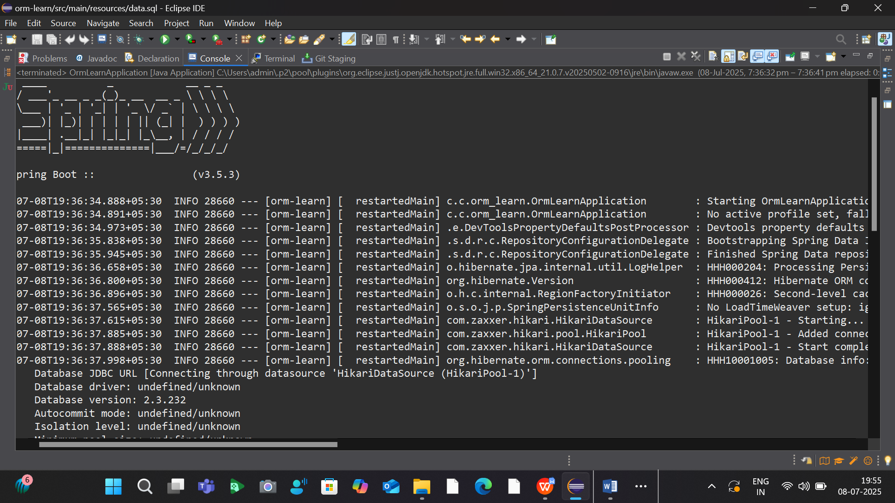
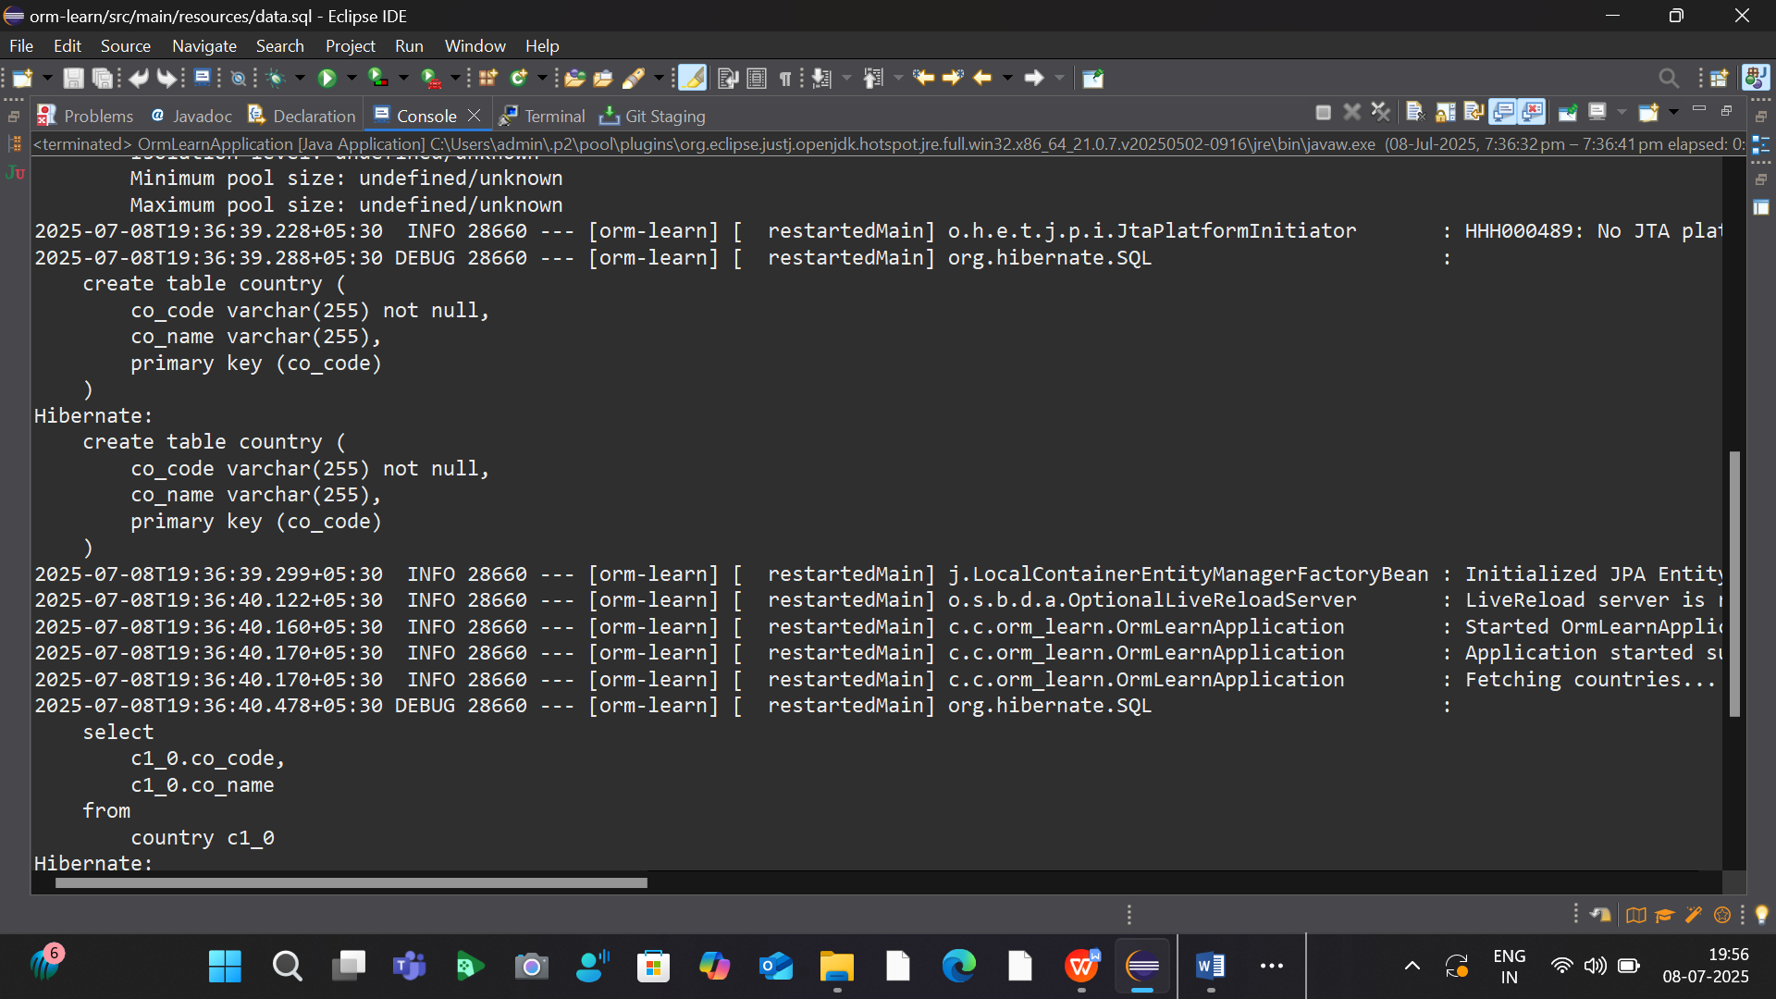
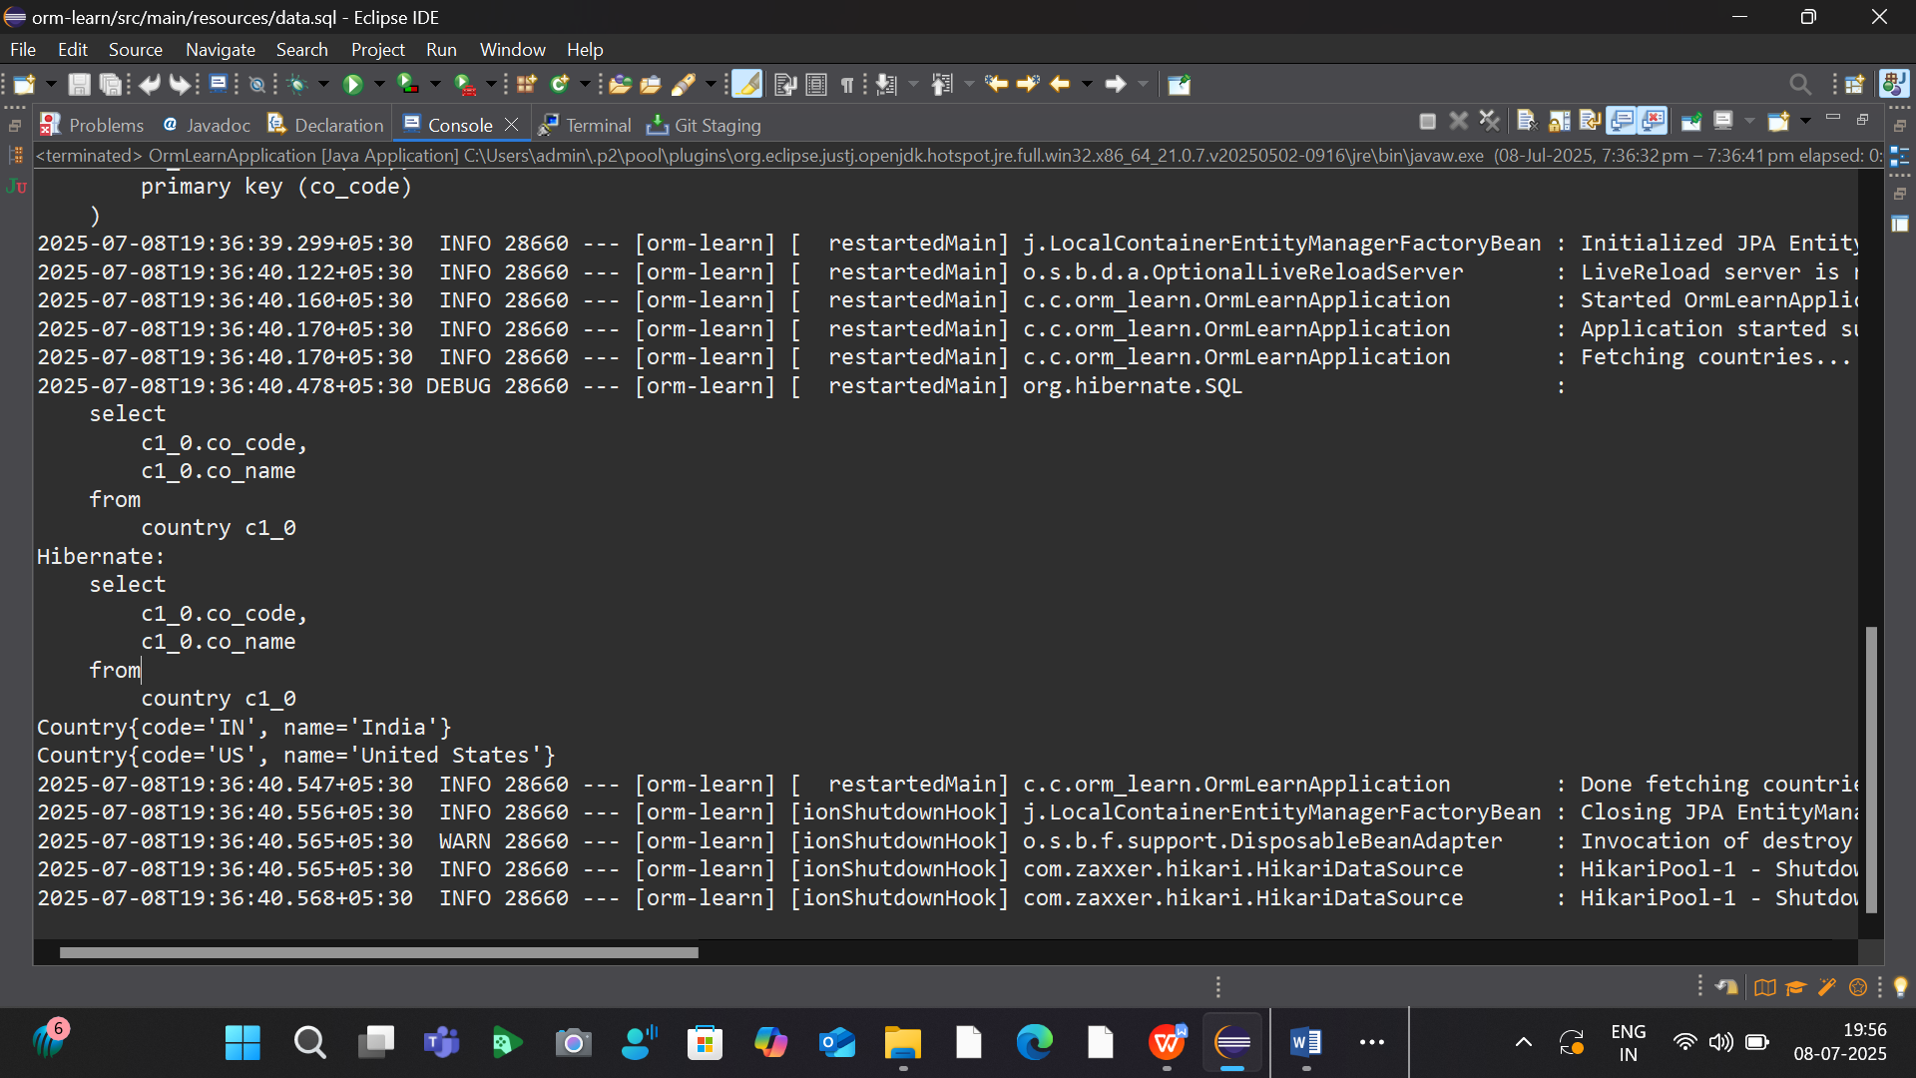

Difference between JPA, Hibernate and Spring Data JPA

package com.cognizant.orm_learn;

import jakarta.persistence.*;

@Entity
@Table(name = "employee")
public class Employee {

@Id
@GeneratedValue(strategy = GenerationType.IDENTITY)
private int id;

@Column(name = "name")
private String name;

@Column(name = "salary")
private double salary;

// Constructors
public Employee() {
}

public Employee(String name, double salary) {
this.name = name;
this.salary = salary;
}

// Getters & Setters
public int getId() {
return id;
}

public String getName() {
return name;
}

public void setName(String name) {
this.name = name;
}

public double getSalary() {
return salary;
}

public void setSalary(double salary) {
this.salary = salary;
}
}

package com.cognizant.orm_learn;
import com.cognizant.orm_learn.Employee;
import org.springframework.data.jpa.repository.JpaRepository;
import org.springframework.stereotype.Repository;

@Repository
public interface EmployeeRepository extends JpaRepository<Employee, Integer> {
}

package com.cognizant.orm_learn;
import com.cognizant.orm_learn.Employee;
import com.cognizant.orm_learn.EmployeeRepository;
import org.springframework.beans.factory.annotation.Autowired;
import org.springframework.boot.CommandLineRunner;
import org.springframework.boot.SpringApplication;
import org.springframework.boot.autoconfigure.SpringBootApplication;

@SpringBootApplication
public class OrmLearnApplication implements CommandLineRunner {

@Autowired
private EmployeeRepository employeeRepository;

public static void main(String[] args) {
SpringApplication.run(OrmLearnApplication.class, args);
}

@Override
public void run(String... args) throws Exception {
Employee emp1 = new Employee("Alice", 65000);
Employee emp2 = new Employee("Bob", 72000);

employeeRepository.save(emp1);
employeeRepository.save(emp2);

System.out.println("All Employees:");
employeeRepository.findAll().forEach(e ->
System.out.println(e.getId() + " | " + e.getName() + " | " + e.getSalary()));
}
}

OUTPUT:
. ____ _ __ _ _
/\\ / ___'_ __ _ _(_)_ __ __ _ \ \ \ \
( ( )\___ | '_ | '_| | '_ \/ _` | \ \ \ \
\\/ ___)| |_)| | | | | || (_| | ) ) ) )
' |____| .__|_| |_|_| |_\__, | / / / /
=========|_|==============|___/=/_/_/_/

:: Spring Boot :: (v3.5.3)

2025-07-10T07:57:13.205+05:30 INFO 31556 --- [orm-learn] [ restartedMain] c.c.orm_learn.OrmLearnApplication : Starting OrmLearnApplication using Java 21.0.7 with PID 31556 (C:\Users\admin\Downloads\orm-learn\orm-learn\target\classes started by admin in C:\Users\admin\Downloads\orm-learn\orm-learn)
2025-07-10T07:57:13.207+05:30 INFO 31556 --- [orm-learn] [ restartedMain] c.c.orm_learn.OrmLearnApplication : No active profile set, falling back to 1 default profile: "default"
2025-07-10T07:57:13.287+05:30 INFO 31556 --- [orm-learn] [ restartedMain] .e.DevToolsPropertyDefaultsPostProcessor : Devtools property defaults active! Set 'spring.devtools.add-properties' to 'false' to disable
2025-07-10T07:57:14.217+05:30 INFO 31556 --- [orm-learn] [ restartedMain] .s.d.r.c.RepositoryConfigurationDelegate : Bootstrapping Spring Data JPA repositories in DEFAULT mode.
2025-07-10T07:57:14.327+05:30 INFO 31556 --- [orm-learn] [ restartedMain] .s.d.r.c.RepositoryConfigurationDelegate : Finished Spring Data repository scanning in 93 ms. Found 2 JPA repository interfaces.
2025-07-10T07:57:14.998+05:30 INFO 31556 --- [orm-learn] [ restartedMain] o.hibernate.jpa.internal.util.LogHelper : HHH000204: Processing PersistenceUnitInfo [name: default]
2025-07-10T07:57:15.105+05:30 INFO 31556 --- [orm-learn] [ restartedMain] org.hibernate.Version : HHH000412: Hibernate ORM core version 6.6.18.Final
2025-07-10T07:57:15.172+05:30 INFO 31556 --- [orm-learn] [ restartedMain] o.h.c.internal.RegionFactoryInitiator : HHH000026: Second-level cache disabled
2025-07-10T07:57:15.746+05:30 INFO 31556 --- [orm-learn] [ restartedMain] o.s.o.j.p.SpringPersistenceUnitInfo : No LoadTimeWeaver setup: ignoring JPA class transformer
2025-07-10T07:57:15.784+05:30 INFO 31556 --- [orm-learn] [ restartedMain] com.zaxxer.hikari.HikariDataSource : HikariPool-1 - Starting...
2025-07-10T07:57:16.030+05:30 INFO 31556 --- [orm-learn] [ restartedMain] com.zaxxer.hikari.pool.HikariPool : HikariPool-1 - Added connection conn0: url=jdbc:h2:mem:testdb user=SA
2025-07-10T07:57:16.032+05:30 INFO 31556 --- [orm-learn] [ restartedMain] com.zaxxer.hikari.HikariDataSource : HikariPool-1 - Start completed.
2025-07-10T07:57:16.127+05:30 INFO 31556 --- [orm-learn] [ restartedMain] org.hibernate.orm.connections.pooling : HHH10001005: Database info:
Database JDBC URL [Connecting through datasource 'HikariDataSource (HikariPool-1)']
Database driver: undefined/unknown
Database version: 2.3.232
Autocommit mode: undefined/unknown
Isolation level: undefined/unknown
Minimum pool size: undefined/unknown
Maximum pool size: undefined/unknown
2025-07-10T07:57:17.380+05:30 INFO 31556 --- [orm-learn] [ restartedMain] o.h.e.t.j.p.i.JtaPlatformInitiator : HHH000489: No JTA platform available (set 'hibernate.transaction.jta.platform' to enable JTA platform integration)
2025-07-10T07:57:17.383+05:30 INFO 31556 --- [orm-learn] [ restartedMain] j.LocalContainerEntityManagerFactoryBean : Initialized JPA EntityManagerFactory for persistence unit 'default'
2025-07-10T07:57:18.370+05:30 INFO 31556 --- [orm-learn] [ restartedMain] o.s.b.d.a.OptionalLiveReloadServer : LiveReload server is running on port 35729
2025-07-10T07:57:18.403+05:30 INFO 31556 --- [orm-learn] [ restartedMain] c.c.orm_learn.OrmLearnApplication : Started OrmLearnApplication in 5.886 seconds (process running for 6.593)
2025-07-10T07:57:18.492+05:30 DEBUG 31556 --- [orm-learn] [ restartedMain] org.hibernate.SQL :
insert
into
employee
(name, salary, id)
values
(?, ?, default)
Hibernate:
insert
into
employee
(name, salary, id)
values
(?, ?, default)
2025-07-10T07:57:18.643+05:30 DEBUG 31556 --- [orm-learn] [ restartedMain] org.hibernate.SQL :
insert
into
employee
(name, salary, id)
values
(?, ?, default)
Hibernate:
insert
into
employee
(name, salary, id)
values
(?, ?, default)
All Employees:
2025-07-10T07:57:18.822+05:30 DEBUG 31556 --- [orm-learn] [ restartedMain] org.hibernate.SQL :
select
e1_0.id,
e1_0.name,
e1_0.salary
from
employee e1_0
Hibernate:
select
e1_0.id,
e1_0.name,
e1_0.salary
from
employee e1_0
1 | Alice | 65000.0
2 | Bob | 72000.0
101 | Alice | 65000.0
102 | Bob | 72000.0
2025-07-10T07:57:18.864+05:30 INFO 31556 --- [orm-learn] [ionShutdownHook] j.LocalContainerEntityManagerFactoryBean : Closing JPA EntityManagerFactory for persistence unit 'default'
2025-07-10T07:57:18.873+05:30 WARN 31556 --- [orm-learn] [ionShutdownHook] o.s.b.f.support.DisposableBeanAdapter : Invocation of destroy method failed on bean with name 'inMemoryDatabaseShutdownExecutor': org.h2.jdbc.JdbcSQLNonTransientConnectionException: Database is already closed (to disable automatic closing at VM shutdown, add ";DB_CLOSE_ON_EXIT=FALSE" to the db URL) [90121-232]
2025-07-10T07:57:18.874+05:30 INFO 31556 --- [orm-learn] [ionShutdownHook] com.zaxxer.hikari.HikariDataSource : HikariPool-1 - Shutdown initiated...
2025-07-10T07:57:18.877+05:30 INFO 31556 --- [orm-learn] [ionShutdownHook] com.zaxxer.hikari.HikariDataSource : HikariPool-1 - Shutdown completed.

JPA (Java Persistence API) | Hibernate | Spring Data JPA
A specification (standard) to define how to manage relational data in Java. | A framework/tool that implements the JPA specification. | A Spring-based abstraction that sits on top of JPA (and Hibernate).
JPA is just a set of guidelines and interfaces. | Hibernate is a real tool that does the job. | It delegates to Hibernate (or another JPA provider) internally.
Java EE (Jakarta EE) / Oracle | Red Hat (Hibernate ORM Project) | Spring Framework (Pivotal / VMware)
A lot — need to write EntityManager, handle transactions manually. | Less than JDBC, but still need Session, Transaction mgmt. | Very little — uses JpaRepository, @Transactional, etc.
Low-level configuration using EntityManager | Similar, but uses Session API | High-level: just create interface, Spring does the rest!
Manual or via container | Manual using Transaction object | Handled automatically with @Transactional
javax.persistence | org.hibernate | org.springframework.data.jpa
em.persist(obj) with EntityManager | session.save(obj) with transaction mgmt | employeeRepository.save(obj) automatically handled

Implement services for managing country

​​​​
spring.application.name=orm-learn
# DATABASE
spring.datasource.url=jdbc:h2:mem:testdb
spring.datasource.driver-class-name=org.h2.Driver
spring.datasource.username=sa
spring.datasource.password=

#HIBERNATE
spring.jpa.defer-datasource-initialization=true

# LOGGING & DEBUGGING
spring.jpa.show-sql=true
spring.jpa.properties.hibernate.format_sql=true
logging.level.org.hibernate.SQL=debug
logging.level.org.hibernate.type.descriptor.sql.BasicBinder=trace

# H2 CONSOLE
spring.h2.console.enabled=true
spring.h2.console.path=/h2-console
spring.datasource.initialization-mode=always
# \u2705 Enable schema initialization
spring.sql.init.mode=always

# \u2705 Optional for development \u2014 lets Hibernate create the schema
spring.jpa.hibernate.ddl-auto=none

package com.cognizant.orm_learn;

import jakarta.persistence.Column;
import jakarta.persistence.Entity;
import jakarta.persistence.Id;
import jakarta.persistence.Table;

@Entity
@Table(name = "country")
public class Country {
@Id
@Column(name = "co_code")
private String code;

@Column(name = "co_name")
private String name;

public String getCode() {
return code;
}

public void setCode(String code) {
this.code = code;
}

public String getName() {
return name;
}

public void setName(String name) {
this.name = name;
}

}

package com.cognizant.orm_learn;

import com.cognizant.orm_learn.Country;
import com.cognizant.orm_learn.CountryRepository;
import org.springframework.beans.factory.annotation.Autowired;
import org.springframework.stereotype.Service;
import java.util.List;

@Service
public class CountryService {

@Autowired
private CountryRepository countryRepository;

public Country findCountryByCode(String code) {
return countryRepository.findById(code).orElse(null);
}

public void addCountry(Country country) {
countryRepository.save(country);
}

public void updateCountry(String code, String newName) {
Country country = countryRepository.findById(code).orElse(null);
if (country != null) {
country.setName(newName);
countryRepository.save(country);
}
}

public void deleteCountry(String code) {
countryRepository.deleteById(code);
}
public List<Country> findCountriesByPartialName(String partial) {
return countryRepository.findByNameContaining(partial);
}
}

package com.cognizant.orm_learn;

import com.cognizant.orm_learn.Country;
import org.springframework.data.jpa.repository.JpaRepository;
import java.util.List;

public interface CountryRepository extends JpaRepository<Country, String> {
List<Country> findByNameContaining(String partialName);
}

package com.cognizant.orm_learn;

import com.cognizant.orm_learn.Country;
import com.cognizant.orm_learn.CountryService;

import org.springframework.beans.factory.annotation.Autowired;
import org.springframework.boot.CommandLineRunner;
import org.springframework.boot.SpringApplication;
import org.springframework.boot.autoconfigure.SpringBootApplication;

@SpringBootApplication
public class OrmLearnApplication implements CommandLineRunner {

@Autowired
private CountryService countryService;

public static void main(String[] args) {
SpringApplication.run(OrmLearnApplication.class, args);
}

@Override
public void run(String... args) {
System.out.println("Fetching country by code: IN");
Country india = countryService.findCountryByCode("IN");
System.out.println(india.getName());

System.out.println("Adding new country...");
Country test = new Country();
test.setCode("XX");
test.setName("Testland");
countryService.addCountry(test);

System.out.println("Updating country XX...");
countryService.updateCountry("XX", "Test Republic");

System.out.println("Searching partial 'Re'...");
countryService.findCountriesByPartialName("Re").forEach(c -> System.out.println(c.getName()));

System.out.println("Deleting country XX...");
countryService.deleteCountry("XX");
}
}

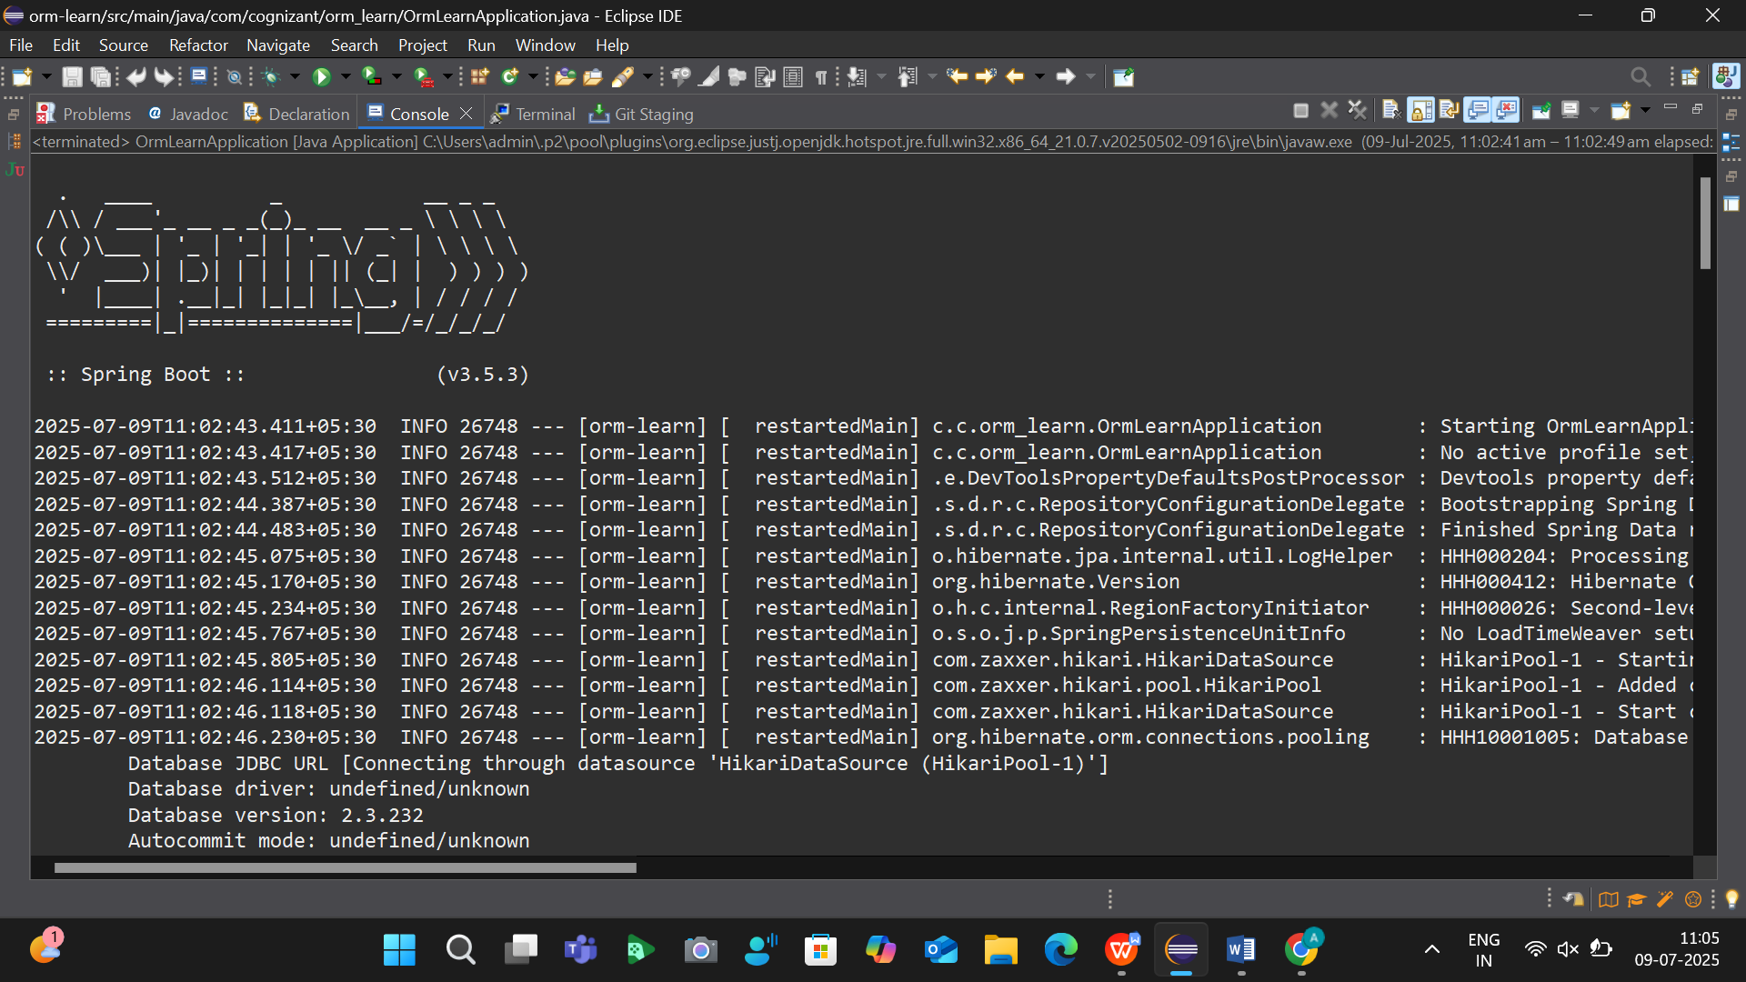
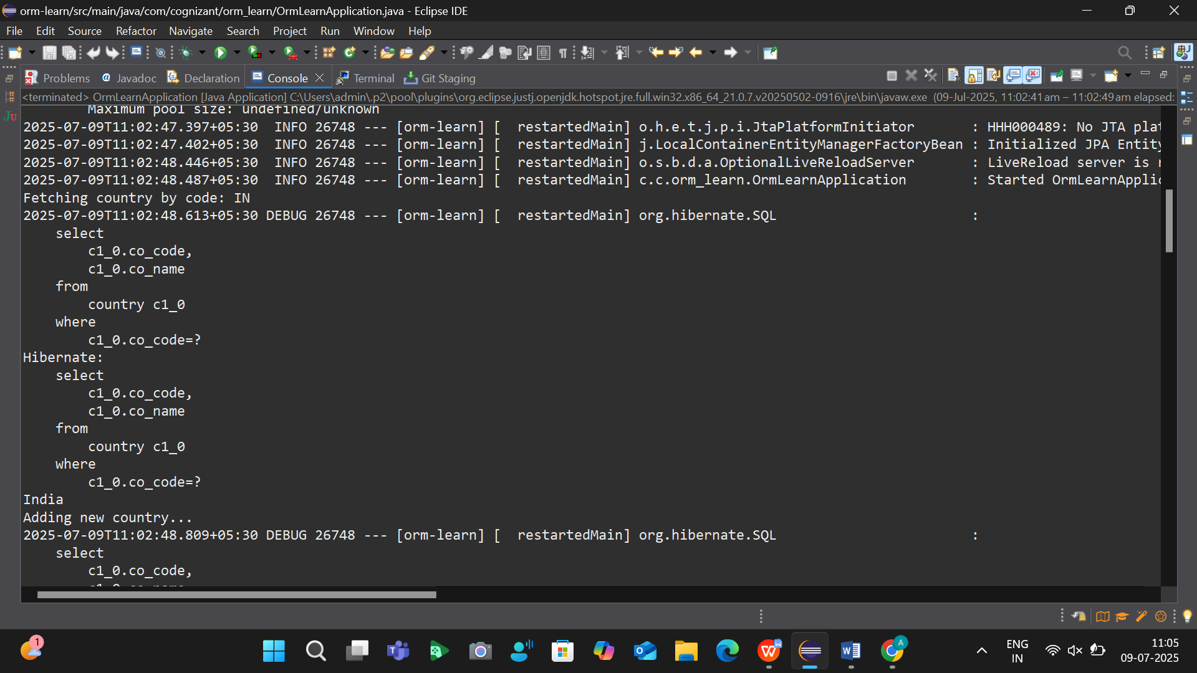
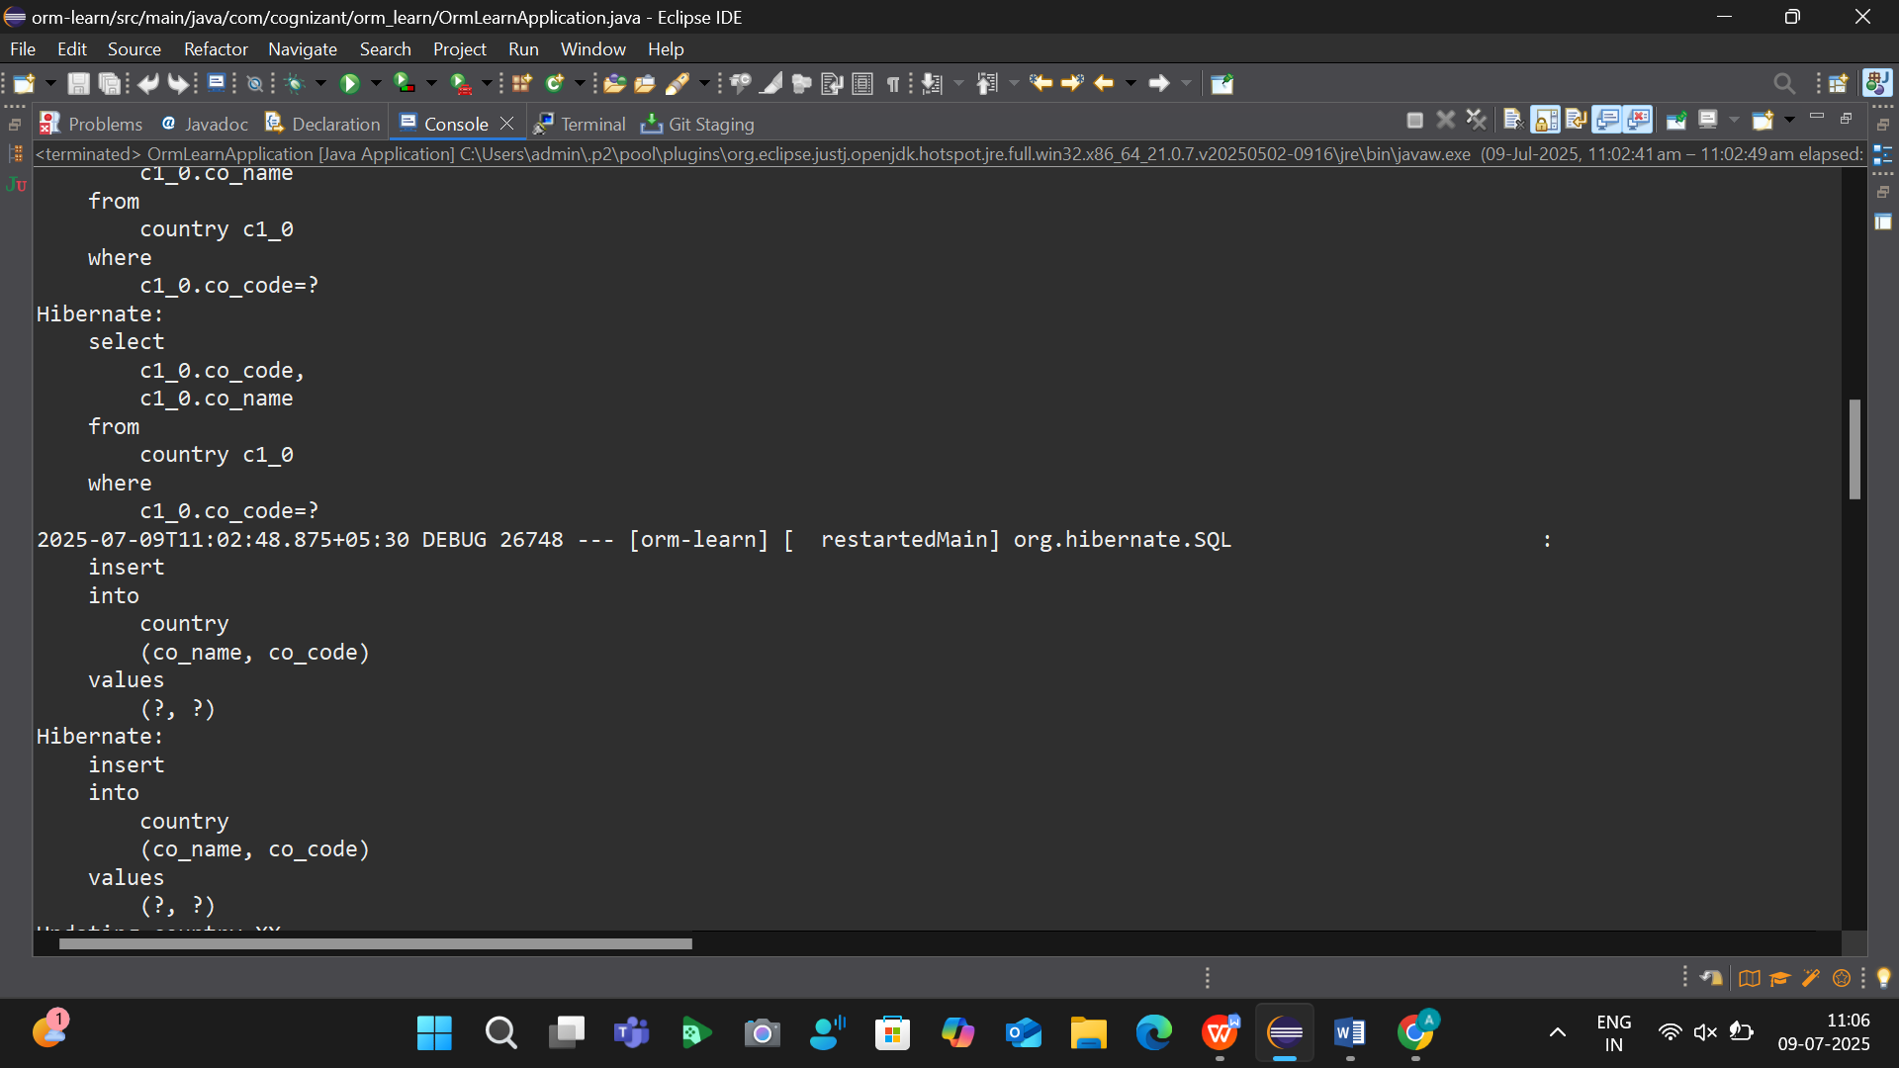
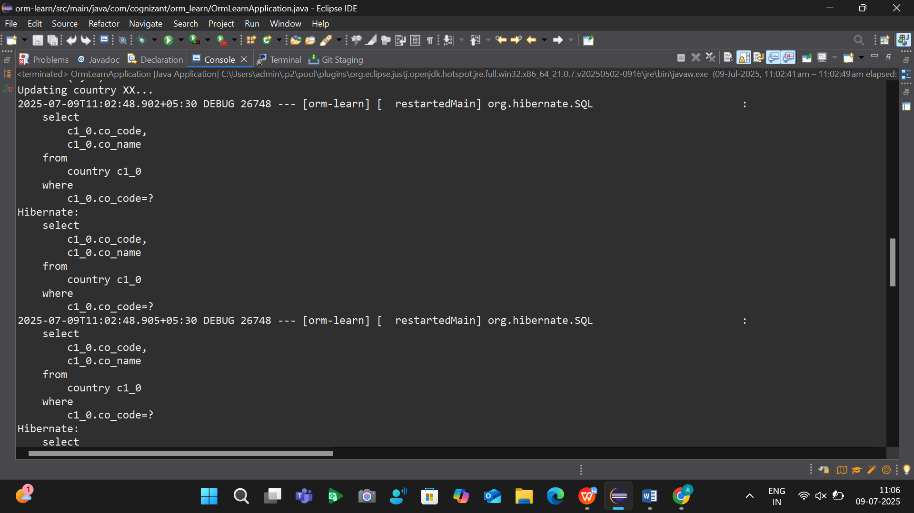
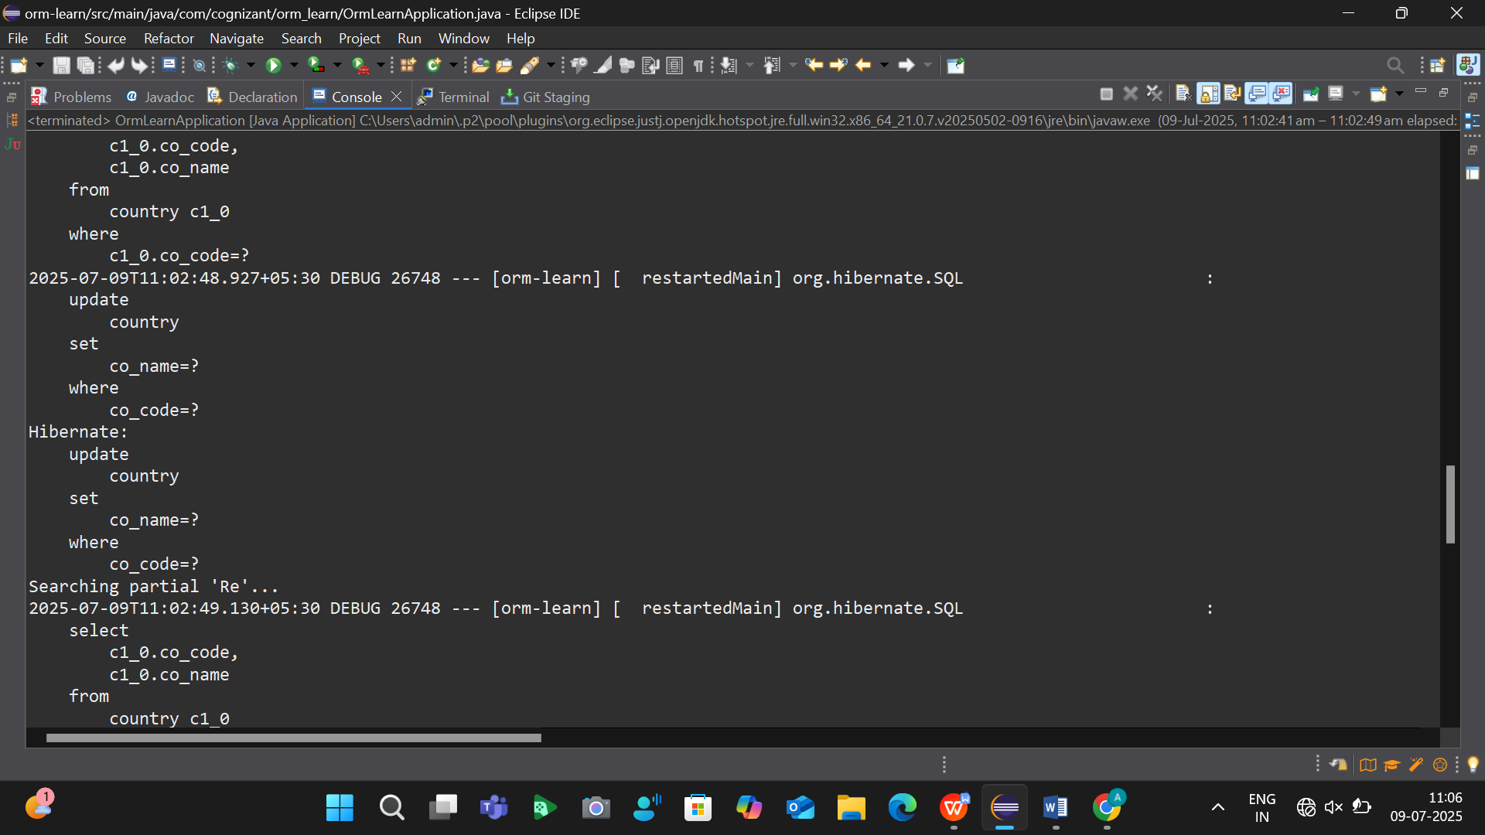
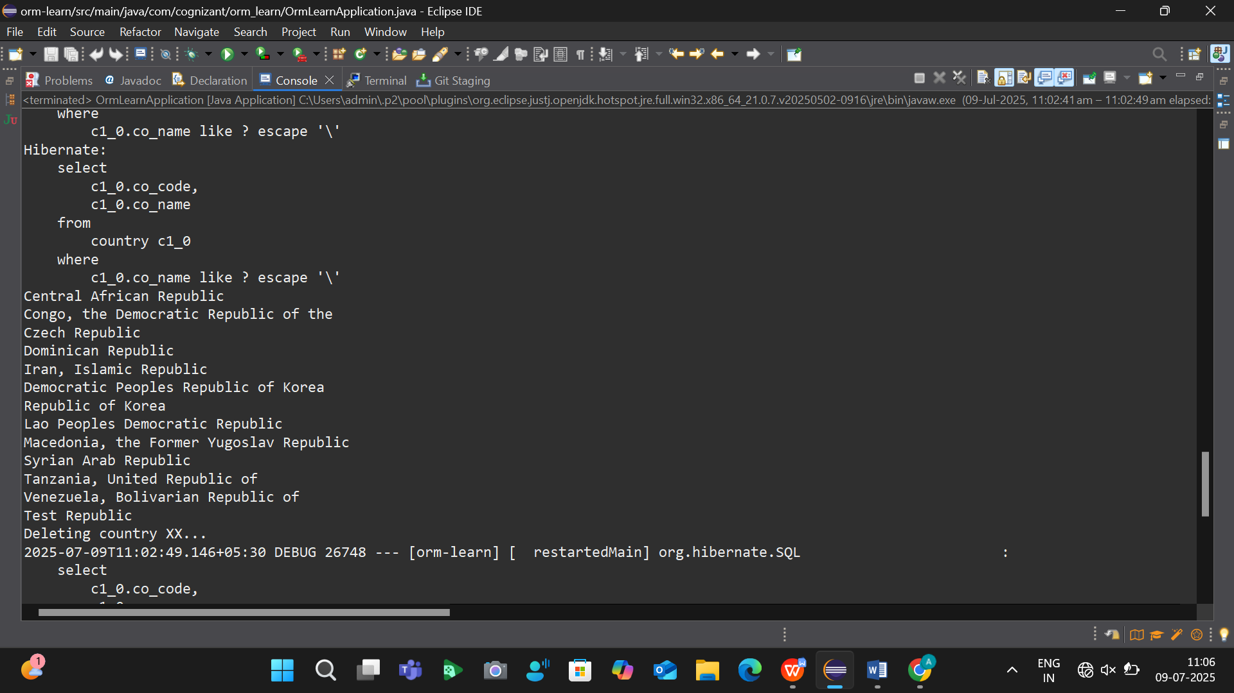
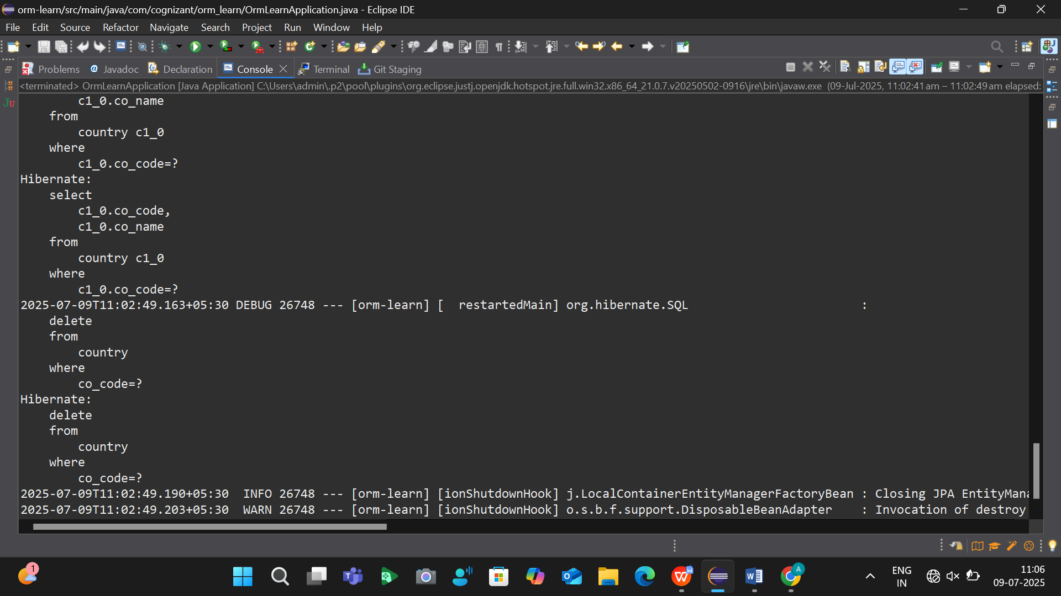

Find a country based on country code

package com.cognizant.orm_learn;

import jakarta.persistence.Entity;
import jakarta.persistence.Id;
import jakarta.persistence.Table;

@Entity
@Table(name = "country")
public class Country {

@Id
private String coCode;

private String coName;

public String getCoCode() {
return coCode;
}

public void setCoCode(String coCode) {
this.coCode = coCode;
}

public String getCoName() {
return coName;
}

public void setCoName(String coName) {
this.coName = coName;
}

@Override
public String toString() {
return "Country{" +
"code='" + coCode + '\'' +
", name='" + coName + '\'' +
'}';
}
}

package com.cognizant.orm_learn;

import com.cognizant.orm_learn.Country;
import org.springframework.data.jpa.repository.JpaRepository;
import java.util.List;

public interface CountryRepository extends JpaRepository<Country, String> {
List<Country> findByCoNameContaining(String coName);
}

package com.cognizant.orm_learn;

import com.cognizant.orm_learn.Country;
import com.cognizant.orm_learn.CountryRepository;
import com.cognizant.orm_learn.CountryNotFoundException;
import jakarta.transaction.Transactional;
import org.springframework.beans.factory.annotation.Autowired;
import org.springframework.stereotype.Service;

import java.util.Optional;

@Service
public class CountryService {

@Autowired
private CountryRepository countryRepository;

@Transactional
public Country findCountryByCode(String countryCode) throws CountryNotFoundException {
Optional<Country> result = countryRepository.findById(countryCode);
if (!result.isPresent()) {
throw new CountryNotFoundException("Country not found for code: " + countryCode);
}
return result.get();
}
}

package com.cognizant.orm_learn;

import com.cognizant.orm_learn.Country;
import com.cognizant.orm_learn.CountryService;
import com.cognizant.orm_learn.CountryNotFoundException;

import org.slf4j.Logger;
import org.slf4j.LoggerFactory;
import org.springframework.boot.SpringApplication;
import org.springframework.boot.autoconfigure.SpringBootApplication;
import org.springframework.context.ApplicationContext;

@SpringBootApplication
public class OrmLearnApplication {

private static final Logger LOGGER = LoggerFactory.getLogger(OrmLearnApplication.class);

private static CountryService countryService;

public static void main(String[] args) {
ApplicationContext context = SpringApplication.run(OrmLearnApplication.class, args);
countryService = context.getBean(CountryService.class);

getAllCountriesTest();
}

private static void getAllCountriesTest() {
LOGGER.info("Start");

try {
Country country = countryService.findCountryByCode("IN");
LOGGER.debug("Country: {}", country);
} catch (CountryNotFoundException e) {
LOGGER.error("Exception: {}", e.getMessage());
}

LOGGER.info("End");
}
}

OUTPUT:

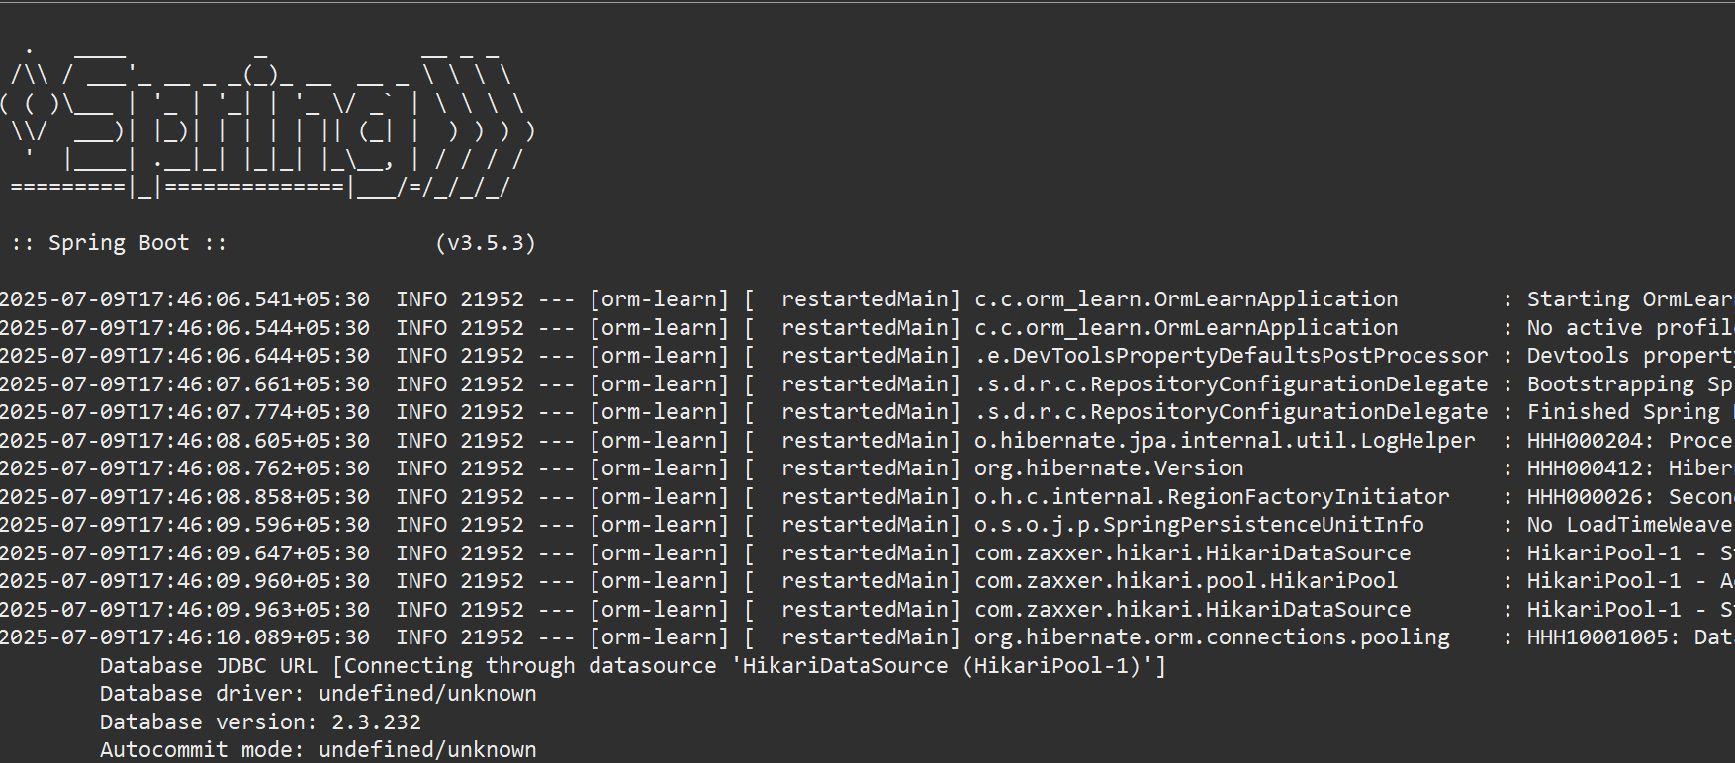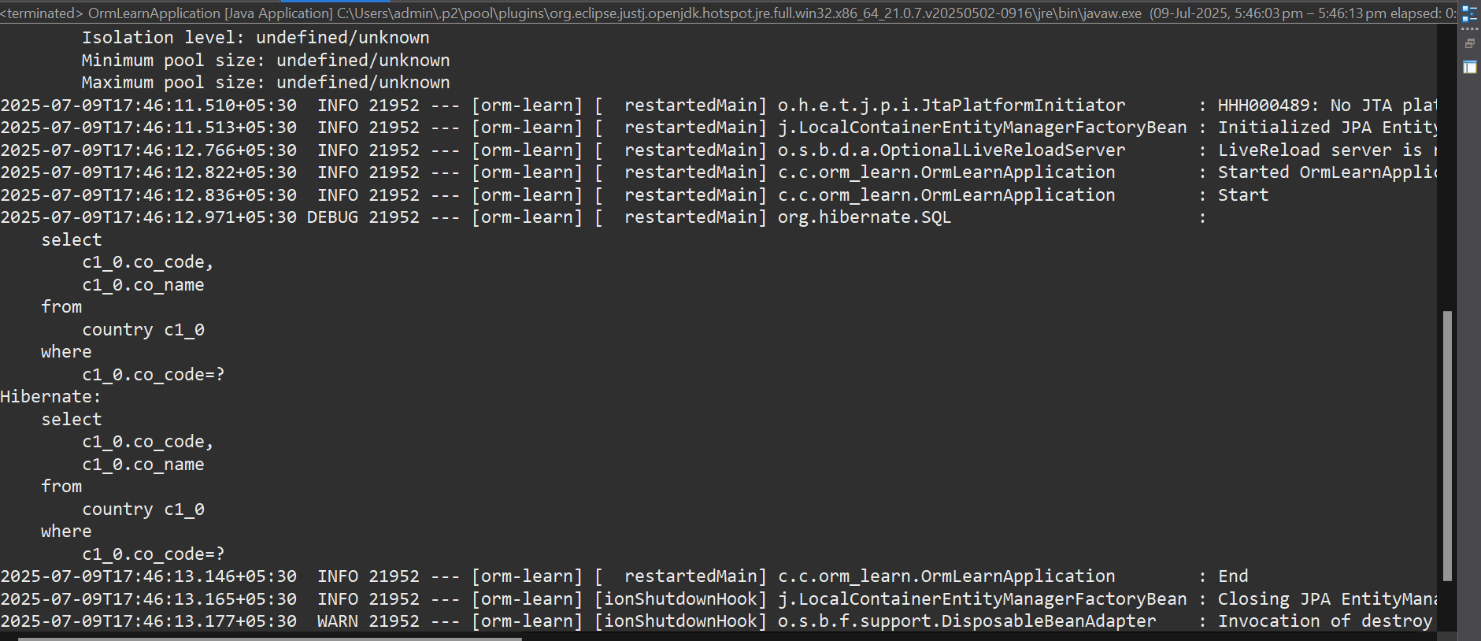

Add a new country

package com.cognizant.orm_learn;

import com.cognizant.orm_learn.Country;
import com.cognizant.orm_learn.CountryRepository;
import com.cognizant.orm_learn.CountryNotFoundException;
import jakarta.transaction.Transactional;
import org.springframework.beans.factory.annotation.Autowired;
import org.springframework.stereotype.Service;

import java.util.Optional;

@Service
public class CountryService {

@Autowired
private CountryRepository countryRepository;

@Transactional
public Country findCountryByCode(String countryCode) throws CountryNotFoundException {
Optional<Country> result = countryRepository.findById(countryCode);
if (!result.isPresent()) {
throw new CountryNotFoundException("Country not found for code: " + countryCode);
}
return result.get();
}

@Transactional
public void addCountry(Country country) {
countryRepository.save(country);
}
}

package com.cognizant.orm_learn;

import com.cognizant.orm_learn.Country;
import com.cognizant.orm_learn.CountryService;
import com.cognizant.orm_learn.CountryNotFoundException;

import org.slf4j.Logger;
import org.slf4j.LoggerFactory;
import org.springframework.boot.SpringApplication;
import org.springframework.boot.autoconfigure.SpringBootApplication;
import org.springframework.context.ApplicationContext;

@SpringBootApplication
public class OrmLearnApplication {

private static final Logger LOGGER = LoggerFactory.getLogger(OrmLearnApplication.class);
private static CountryService countryService;

public static void main(String[] args) {
ApplicationContext context = SpringApplication.run(OrmLearnApplication.class, args);
countryService = context.getBean(CountryService.class);

getAllCountriesTest(); // Test fetching by code
testAddCountry(); // Test adding new country
}

private static void getAllCountriesTest() {
LOGGER.info("Start");
try {
Country country = countryService.findCountryByCode("IN");
LOGGER.debug("Country: {}", country);
} catch (CountryNotFoundException e) {
LOGGER.error("Country not found!", e);
}
LOGGER.info("End");
}

private static void testAddCountry() {
LOGGER.info("Start - Add Country");

Country newCountry = new Country();
newCountry.setCoCode("NP");
newCountry.setCoName("Nepal");

countryService.addCountry(newCountry);

try {
Country country = countryService.findCountryByCode("NP");
LOGGER.debug("Added Country: {}", country);
} catch (CountryNotFoundException e) {
LOGGER.error("Country not found after adding!", e);
}

LOGGER.info("Add Country");
}
}

OUTPUT:

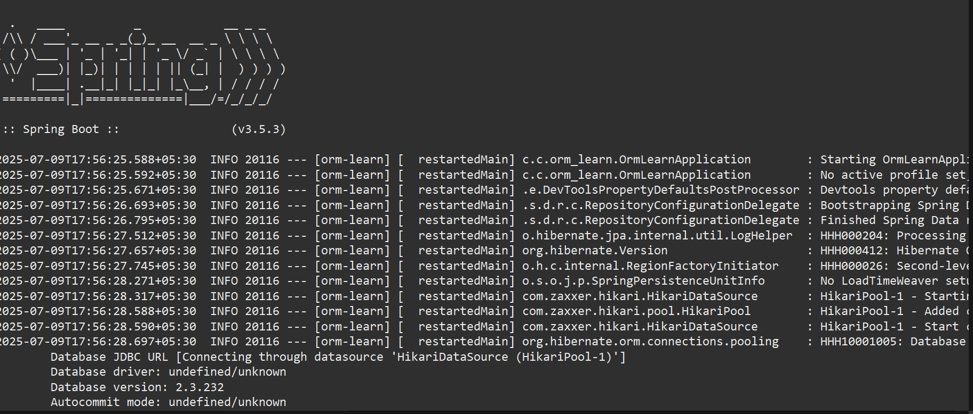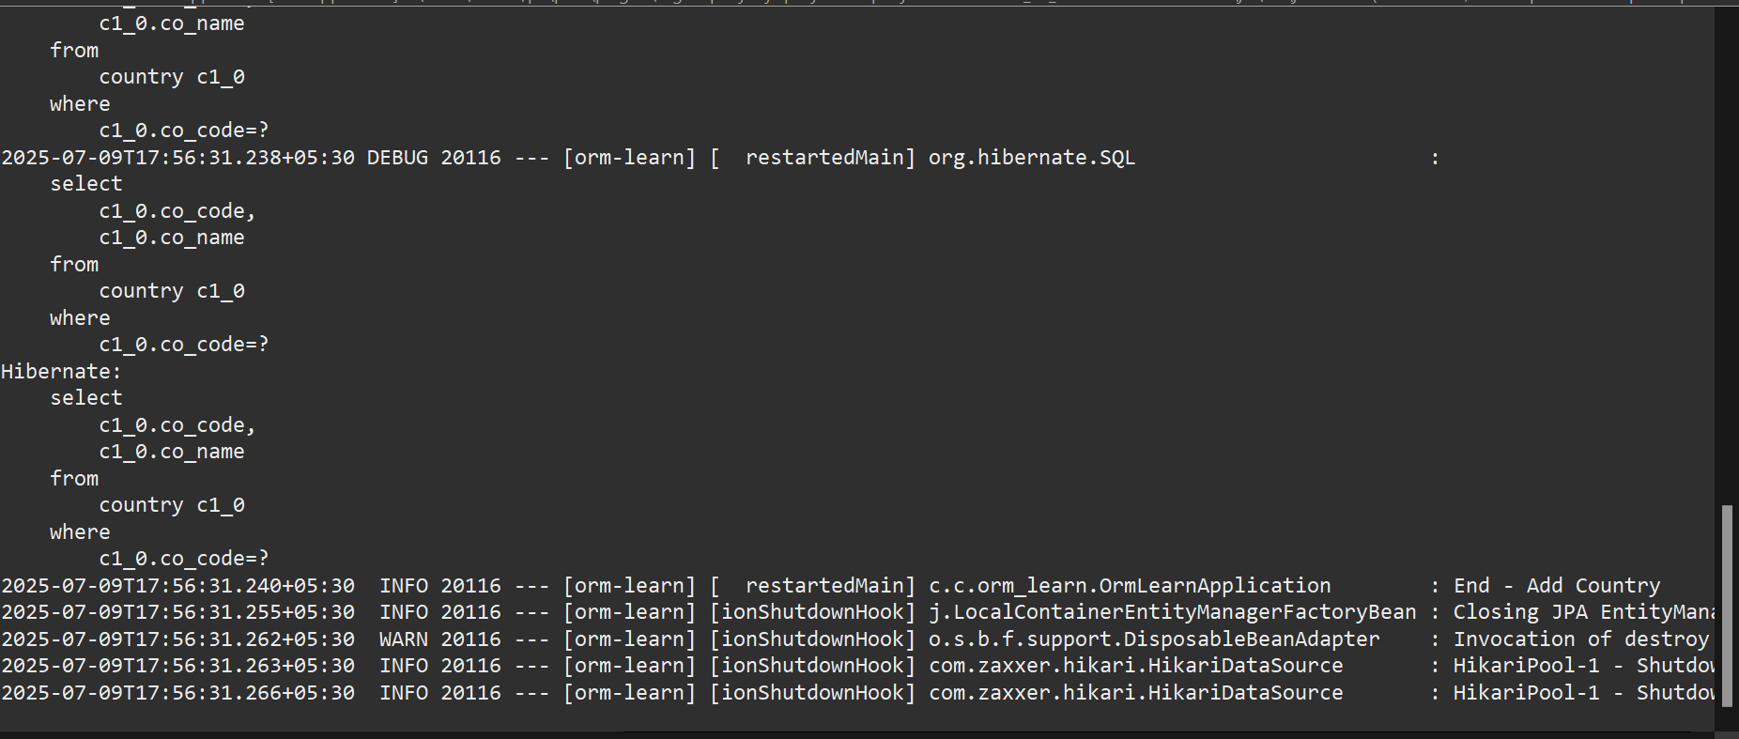

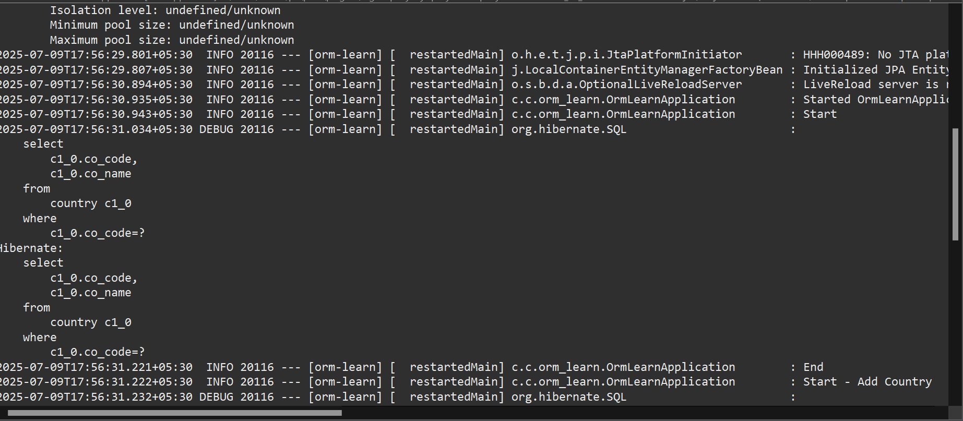

Demonstrate implementation of Query method features of Spring data JPA

Write queries on country table using Query Methods

package com.cognizant.orm_learn;
import jakarta.persistence.Entity;
import jakarta.persistence.Id;
import jakarta.persistence.Table;
import jakarta.persistence.Column;

@Entity
@Table(name = "country")
public class Country {

@Id
@Column(name = "co_code")
private String code;

@Column(name = "co_name")
private String name;

public String getCode() {
return code;
}

public void setCode(String code) {
this.code = code;
}

public String getName() {
return name;
}

public void setName(String name) {
this.name = name;
}
}

package com.cognizant.orm_learn;

import java.util.List;
import org.springframework.data.jpa.repository.JpaRepository;
import org.springframework.stereotype.Repository;
import com.cognizant.orm_learn.Country;

@Repository
public interface CountryRepository extends JpaRepository<Country, String> {
List<Country> findByNameContaining(String keyword); // works if field is 'name'
List<Country> findByNameContainingOrderByNameAsc(String keyword);
List<Country> findByNameStartingWith(String prefix);
}

package com.cognizant.orm_learn;

import com.cognizant.orm_learn.Country;
import com.cognizant.orm_learn.CountryRepository;
import com.cognizant.orm_learn.CountryNotFoundException;
import jakarta.transaction.Transactional;
import org.springframework.beans.factory.annotation.Autowired;
import org.springframework.stereotype.Service;

import java.util.Optional;

@Service
public class CountryService {

@Autowired
private CountryRepository countryRepository;

@Transactional
public Country findCountryByCode(String countryCode) throws CountryNotFoundException {
Optional<Country> result = countryRepository.findById(countryCode);
if (!result.isPresent()) {
throw new CountryNotFoundException("Country not found for code: " + countryCode);
}
return result.get();
}

@Transactional
public void addCountry(Country country) {
countryRepository.save(country);
}
}

package com.cognizant.orm_learn;

import com.cognizant.orm_learn.Country;
import com.cognizant.orm_learn.CountryService;
import com.cognizant.orm_learn.CountryNotFoundException;

import java.util.List;

import org.springframework.beans.factory.annotation.Autowired;
import org.springframework.boot.CommandLineRunner;
import org.springframework.boot.SpringApplication;
import org.springframework.boot.autoconfigure.SpringBootApplication;

@SpringBootApplication
public class OrmLearnApplication implements CommandLineRunner {

@Autowired
private CountryRepository countryRepository;

public static void main(String[] args) {
SpringApplication.run(OrmLearnApplication.class, args);
}

@Override
public void run(String... args) throws Exception {

// Task 1: Search countries by keyword in name
System.out.println("\n[1] Countries containing 'ou':");
List<Country> countriesWithOu = countryRepository.findByNameContaining("ou");
countriesWithOu.forEach(c -> System.out.println(c.getCode() + " - " + c.getName()));

// Task 2: Search and sort countries by keyword in name
System.out.println("\n[2] Countries containing 'ou' (sorted ascending):");
List<Country> countriesSorted = countryRepository.findByNameContainingOrderByNameAsc("ou");
countriesSorted.forEach(c -> System.out.println(c.getCode() + " - " + c.getName()));

// Task 3: Countries starting with 'Z'
System.out.println("\n[3] Countries starting with 'Z':");
List<Country> countriesStartingWithZ = countryRepository.findByNameStartingWith("Z");
countriesStartingWithZ.forEach(c -> System.out.println(c.getCode() + " - " + c.getName()));
}
}

OUTPUT:
. ____ _ __ _ _
/\\ / ___'_ __ _ _(_)_ __ __ _ \ \ \ \
( ( )\___ | '_ | '_| | '_ \/ _` | \ \ \ \
\\/ ___)| |_)| | | | | || (_| | ) ) ) )
' |____| .__|_| |_|_| |_\__, | / / / /
=========|_|==============|___/=/_/_/_/

:: Spring Boot :: (v3.5.3)

2025-07-09T19:32:30.863+05:30 INFO 32660 --- [orm-learn] [ restartedMain] c.c.orm_learn.OrmLearnApplication : Starting OrmLearnApplication using Java 21.0.7 with PID 32660 (C:\Users\admin\Downloads\orm-learn\orm-learn\target\classes started by admin in C:\Users\admin\Downloads\orm-learn\orm-learn)
2025-07-09T19:32:30.866+05:30 INFO 32660 --- [orm-learn] [ restartedMain] c.c.orm_learn.OrmLearnApplication : No active profile set, falling back to 1 default profile: "default"
2025-07-09T19:32:30.945+05:30 INFO 32660 --- [orm-learn] [ restartedMain] .e.DevToolsPropertyDefaultsPostProcessor : Devtools property defaults active! Set 'spring.devtools.add-properties' to 'false' to disable
2025-07-09T19:32:31.909+05:30 INFO 32660 --- [orm-learn] [ restartedMain] .s.d.r.c.RepositoryConfigurationDelegate : Bootstrapping Spring Data JPA repositories in DEFAULT mode.
2025-07-09T19:32:32.015+05:30 INFO 32660 --- [orm-learn] [ restartedMain] .s.d.r.c.RepositoryConfigurationDelegate : Finished Spring Data repository scanning in 87 ms. Found 1 JPA repository interface.
2025-07-09T19:32:32.755+05:30 INFO 32660 --- [orm-learn] [ restartedMain] o.hibernate.jpa.internal.util.LogHelper : HHH000204: Processing PersistenceUnitInfo [name: default]
2025-07-09T19:32:32.887+05:30 INFO 32660 --- [orm-learn] [ restartedMain] org.hibernate.Version : HHH000412: Hibernate ORM core version 6.6.18.Final
2025-07-09T19:32:32.961+05:30 INFO 32660 --- [orm-learn] [ restartedMain] o.h.c.internal.RegionFactoryInitiator : HHH000026: Second-level cache disabled
2025-07-09T19:32:33.513+05:30 INFO 32660 --- [orm-learn] [ restartedMain] o.s.o.j.p.SpringPersistenceUnitInfo : No LoadTimeWeaver setup: ignoring JPA class transformer
2025-07-09T19:32:33.551+05:30 INFO 32660 --- [orm-learn] [ restartedMain] com.zaxxer.hikari.HikariDataSource : HikariPool-1 - Starting...
2025-07-09T19:32:33.808+05:30 INFO 32660 --- [orm-learn] [ restartedMain] com.zaxxer.hikari.pool.HikariPool : HikariPool-1 - Added connection conn0: url=jdbc:h2:mem:testdb user=SA
2025-07-09T19:32:33.811+05:30 INFO 32660 --- [orm-learn] [ restartedMain] com.zaxxer.hikari.HikariDataSource : HikariPool-1 - Start completed.
2025-07-09T19:32:33.919+05:30 INFO 32660 --- [orm-learn] [ restartedMain] org.hibernate.orm.connections.pooling : HHH10001005: Database info:
Database JDBC URL [Connecting through datasource 'HikariDataSource (HikariPool-1)']
Database driver: undefined/unknown
Database version: 2.3.232
Autocommit mode: undefined/unknown
Isolation level: undefined/unknown
Minimum pool size: undefined/unknown
Maximum pool size: undefined/unknown
2025-07-09T19:32:35.250+05:30 INFO 32660 --- [orm-learn] [ restartedMain] o.h.e.t.j.p.i.JtaPlatformInitiator : HHH000489: No JTA platform available (set 'hibernate.transaction.jta.platform' to enable JTA platform integration)
2025-07-09T19:32:35.254+05:30 INFO 32660 --- [orm-learn] [ restartedMain] j.LocalContainerEntityManagerFactoryBean : Initialized JPA EntityManagerFactory for persistence unit 'default'
2025-07-09T19:32:36.448+05:30 INFO 32660 --- [orm-learn] [ restartedMain] o.s.b.d.a.OptionalLiveReloadServer : LiveReload server is running on port 35729
2025-07-09T19:32:36.486+05:30 INFO 32660 --- [orm-learn] [ restartedMain] c.c.orm_learn.OrmLearnApplication : Started OrmLearnApplication in 6.304 seconds (process running for 7.058)

[1] Countries containing 'ou':
2025-07-09T19:32:36.793+05:30 DEBUG 32660 --- [orm-learn] [ restartedMain] org.hibernate.SQL :
select
c1_0.co_code,
c1_0.co_name
from
country c1_0
where
c1_0.co_name like ? escape '\'
Hibernate:
select
c1_0.co_code,
c1_0.co_name
from
country c1_0
where
c1_0.co_name like ? escape '\'
BV - Bouvet Island
DJ - Djibouti
TF - French Southern Territories
GP - Guadeloupe
LU - Luxembourg
ZA - South Africa
GS - South Georgia and the South Sandwich Islands
SS - South Sudan

[2] Countries containing 'ou' (sorted ascending):
2025-07-09T19:32:36.884+05:30 DEBUG 32660 --- [orm-learn] [ restartedMain] org.hibernate.SQL :
select
c1_0.co_code,
c1_0.co_name
from
country c1_0
where
c1_0.co_name like ? escape '\'
order by
c1_0.co_name
Hibernate:
select
c1_0.co_code,
c1_0.co_name
from
country c1_0
where
c1_0.co_name like ? escape '\'
order by
c1_0.co_name
BV - Bouvet Island
DJ - Djibouti
TF - French Southern Territories
GP - Guadeloupe
LU - Luxembourg
ZA - South Africa
GS - South Georgia and the South Sandwich Islands
SS - South Sudan

[3] Countries starting with 'Z':
2025-07-09T19:32:36.891+05:30 DEBUG 32660 --- [orm-learn] [ restartedMain] org.hibernate.SQL :
select
c1_0.co_code,
c1_0.co_name
from
country c1_0
where
c1_0.co_name like ? escape '\'
Hibernate:
select
c1_0.co_code,
c1_0.co_name
from
country c1_0
where
c1_0.co_name like ? escape '\'
ZM - Zambia
ZW - Zimbabwe
2025-07-09T19:32:36.909+05:30 INFO 32660 --- [orm-learn] [ionShutdownHook] j.LocalContainerEntityManagerFactoryBean : Closing JPA EntityManagerFactory for persistence unit 'default'
2025-07-09T19:32:36.916+05:30 WARN 32660 --- [orm-learn] [ionShutdownHook] o.s.b.f.support.DisposableBeanAdapter : Invocation of destroy method failed on bean with name 'inMemoryDatabaseShutdownExecutor': org.h2.jdbc.JdbcSQLNonTransientConnectionException: Database is already closed (to disable automatic closing at VM shutdown, add ";DB_CLOSE_ON_EXIT=FALSE" to the db URL) [90121-232]
2025-07-09T19:32:36.917+05:30 INFO 32660 --- [orm-learn] [ionShutdownHook] com.zaxxer.hikari.HikariDataSource : HikariPool-1 - Shutdown initiated...
2025-07-09T19:32:36.919+05:30 INFO 32660 --- [orm-learn] [ionShutdownHook] com.zaxxer.hikari.HikariDataSource : HikariPool-1 - Shutdown completed.

Write queries on stock table using Query Methods

CREATE TABLE IF NOT EXISTS `stock` (
`st_id` INT NOT NULL AUTO_INCREMENT,
`st_code` varchar(10),
`st_date` date,
`st_open` numeric(10,2),
`st_close` numeric(10,2),
`st_volume` numeric,
PRIMARY KEY (`st_id`)
);

INSERT INTO stock (st_code, st_date, st_open, st_close, st_volume) VALUES
('FB', '2019-09-03', 184.00, 182.39, 9779400),
('FB', '2019-09-04', 184.65, 187.14, 11308000),
('GOOGL', '2019-04-22', 1236.67, 1253.76, 954200),
('GOOGL', '2019-04-23', 1256.64, 1270.59, 1593400),
('NFLX', '2018-12-21', 263.83, 246.39, 21397600),
('NFLX', '2018-12-24', 242.00, 233.88, 9547600),
('NFLX', '2018-12-26', 233.92, 253.67, 14402700),
('FB', '2019-01-31', 165.60, 166.69, 77233600);

package com.cognizant.orm_learn;

import jakarta.persistence.*;
import java.time.LocalDate;

@Entity
@Table(name = "stock")
public class Stock {
@Id
@GeneratedValue(strategy = GenerationType.IDENTITY)
private int stId;

private String stCode;
private LocalDate stDate;
private Double stOpen;
private Double stClose;
private Long stVolume;

// Getters and Setters
public int getStId() { return stId; }
public void setStId(int stId) { this.stId = stId; }

public String getStCode() { return stCode; }
public void setStCode(String stCode) { this.stCode = stCode; }

public LocalDate getStDate() { return stDate; }
public void setStDate(LocalDate stDate) { this.stDate = stDate; }

public Double getStOpen() { return stOpen; }
public void setStOpen(Double stOpen) { this.stOpen = stOpen; }

public Double getStClose() { return stClose; }
public void setStClose(Double stClose) { this.stClose = stClose; }
}

package com.cognizant.orm_learn;

import com.cognizant.orm_learn.Stock;
import org.springframework.data.jpa.repository.JpaRepository;
import org.springframework.data.jpa.repository.Query;

import java.time.LocalDate;
import java.util.List;

public interface StockRepository extends JpaRepository<Stock, Integer> {

List<Stock> findByStCodeAndStDateBetween(String stCode, LocalDate startDate, LocalDate endDate);

List<Stock> findByStCodeAndStCloseGreaterThan(String stCode, double closePrice);

List<Stock> findTop3ByOrderByStVolumeDesc();

List<Stock> findTop3ByStCodeOrderByStCloseAsc(String stCode);
}

package com.cognizant.orm_learn;

import com.cognizant.orm_learn.Stock;
import com.cognizant.orm_learn.StockRepository;
import org.slf4j.Logger;
import org.slf4j.LoggerFactory;
import org.springframework.boot.SpringApplication;
import org.springframework.boot.autoconfigure.SpringBootApplication;
import org.springframework.context.ApplicationContext;

import java.time.LocalDate;
import java.util.List;

@SpringBootApplication
public class OrmLearnApplication {
private static final Logger LOGGER = LoggerFactory.getLogger(OrmLearnApplication.class);
private static StockRepository stockRepository;

public static void main(String[] args) {
ApplicationContext context = SpringApplication.run(OrmLearnApplication.class, args);
stockRepository = context.getBean(StockRepository.class);

testFacebookSeptember2019();
testGooglePriceGreaterThan1250();
testTop3Volume();
testNetflixLowest3();
}

private static void testFacebookSeptember2019() {
LOGGER.info("Fetching Facebook stocks in Sep 2019");
LocalDate start = LocalDate.of(2019, 9, 1);
LocalDate end = LocalDate.of(2019, 9, 30);
List<Stock> stocks = stockRepository.findByStCodeAndStDateBetween("FB", start, end);
stocks.forEach(stock -> LOGGER.debug(stock.toString()));
}

private static void testGooglePriceGreaterThan1250() {
LOGGER.info("Fetching Google stocks > 1250");
List<Stock> stocks = stockRepository.findByStCodeAndStCloseGreaterThan("GOOGL", 1250);
stocks.forEach(stock -> LOGGER.debug(stock.toString()));
}

private static void testTop3Volume() {
LOGGER.info("Fetching top 3 stocks by volume");
List<Stock> stocks = stockRepository.findTop3ByOrderByStVolumeDesc();
stocks.forEach(stock -> LOGGER.debug(stock.toString()));
}

private static void testNetflixLowest3() {
LOGGER.info("Fetching 3 lowest Netflix stocks");
List<Stock> stocks = stockRepository.findTop3ByStCodeOrderByStCloseAsc("NFLX");
stocks.forEach(stock -> LOGGER.debug(stock.toString()));
}
}

OUTPUT:
. ____ _ __ _ _
/\\ / ___'_ __ _ _(_)_ __ __ _ \ \ \ \
( ( )\___ | '_ | '_| | '_ \/ _` | \ \ \ \
\\/ ___)| |_)| | | | | || (_| | ) ) ) )
' |____| .__|_| |_|_| |_\__, | / / / /
=========|_|==============|___/=/_/_/_/

:: Spring Boot :: (v3.5.3)

2025-07-10T18:39:37.990+05:30 INFO 25184 --- [ restartedMain] c.c.orm_learn.OrmLearnApplication : Starting OrmLearnApplication using Java 21.0.7 with PID 25184 (C:\Users\admin\Downloads\orm-learn\orm-learn\target\classes started by admin in C:\Users\admin\Downloads\orm-learn\orm-learn)
2025-07-10T18:39:37.993+05:30 INFO 25184 --- [ restartedMain] c.c.orm_learn.OrmLearnApplication : No active profile set, falling back to 1 default profile: "default"
2025-07-10T18:39:38.067+05:30 INFO 25184 --- [ restartedMain] .e.DevToolsPropertyDefaultsPostProcessor : Devtools property defaults active! Set 'spring.devtools.add-properties' to 'false' to disable
2025-07-10T18:39:38.971+05:30 INFO 25184 --- [ restartedMain] .s.d.r.c.RepositoryConfigurationDelegate : Bootstrapping Spring Data JPA repositories in DEFAULT mode.
2025-07-10T18:39:39.087+05:30 INFO 25184 --- [ restartedMain] .s.d.r.c.RepositoryConfigurationDelegate : Finished Spring Data repository scanning in 103 ms. Found 4 JPA repository interfaces.
2025-07-10T18:39:39.611+05:30 INFO 25184 --- [ restartedMain] com.zaxxer.hikari.HikariDataSource : HikariPool-1 - Starting...
2025-07-10T18:39:39.944+05:30 INFO 25184 --- [ restartedMain] com.zaxxer.hikari.pool.HikariPool : HikariPool-1 - Added connection conn0: url=jdbc:h2:mem:testdb user=SA
2025-07-10T18:39:39.948+05:30 INFO 25184 --- [ restartedMain] com.zaxxer.hikari.HikariDataSource : HikariPool-1 - Start completed.
2025-07-10T18:39:40.205+05:30 INFO 25184 --- [ restartedMain] o.hibernate.jpa.internal.util.LogHelper : HHH000204: Processing PersistenceUnitInfo [name: default]
2025-07-10T18:39:40.321+05:30 INFO 25184 --- [ restartedMain] org.hibernate.Version : HHH000412: Hibernate ORM core version 6.6.18.Final
2025-07-10T18:39:40.378+05:30 INFO 25184 --- [ restartedMain] o.h.c.internal.RegionFactoryInitiator : HHH000026: Second-level cache disabled
2025-07-10T18:39:40.889+05:30 INFO 25184 --- [ restartedMain] o.s.o.j.p.SpringPersistenceUnitInfo : No LoadTimeWeaver setup: ignoring JPA class transformer
2025-07-10T18:39:41.026+05:30 INFO 25184 --- [ restartedMain] org.hibernate.orm.connections.pooling : HHH10001005: Database info:
Database JDBC URL [Connecting through datasource 'HikariDataSource (HikariPool-1)']
Database driver: undefined/unknown
Database version: 2.3.232
Autocommit mode: undefined/unknown
Isolation level: undefined/unknown
Minimum pool size: undefined/unknown
Maximum pool size: undefined/unknown
2025-07-10T18:39:42.472+05:30 INFO 25184 --- [ restartedMain] o.h.e.t.j.p.i.JtaPlatformInitiator : HHH000489: No JTA platform available (set 'hibernate.transaction.jta.platform' to enable JTA platform integration)
Hibernate: create table country (co_code varchar(255) not null, co_name varchar(255), primary key (co_code))
Hibernate: create table department (id integer generated by default as identity, name varchar(255), primary key (id))
Hibernate: create table employee (id integer generated by default as identity, date_of_birth timestamp(6), name varchar(255), permanent boolean, salary float(53), department_id integer, primary key (id))
Hibernate: alter table if exists stock alter column st_close set data type float(53)
Hibernate: alter table if exists stock alter column st_code set data type varchar(255)
Hibernate: alter table if exists stock alter column st_open set data type float(53)
Hibernate: alter table if exists stock alter column st_volume set data type bigint
Hibernate: alter table if exists employee add constraint FKbejtwvg9bxus2mffsm3swj3u9 foreign key (department_id) references department
2025-07-10T18:39:42.586+05:30 INFO 25184 --- [ restartedMain] j.LocalContainerEntityManagerFactoryBean : Initialized JPA EntityManagerFactory for persistence unit 'default'
2025-07-10T18:39:43.773+05:30 INFO 25184 --- [ restartedMain] o.s.b.d.a.OptionalLiveReloadServer : LiveReload server is running on port 35729
2025-07-10T18:39:43.826+05:30 INFO 25184 --- [ restartedMain] c.c.orm_learn.OrmLearnApplication : Started OrmLearnApplication in 6.458 seconds (process running for 7.215)
2025-07-10T18:39:43.836+05:30 INFO 25184 --- [ restartedMain] c.c.orm_learn.OrmLearnApplication : Fetching Facebook stocks in Sep 2019
Hibernate: select s1_0.st_id,s1_0.st_close,s1_0.st_code,s1_0.st_date,s1_0.st_open,s1_0.st_volume from stock s1_0 where s1_0.st_code=? and s1_0.st_date between ? and ?
2025-07-10T18:39:44.147+05:30 INFO 25184 --- [ restartedMain] c.c.orm_learn.OrmLearnApplication : Fetching Google stocks > 1250
Hibernate: select s1_0.st_id,s1_0.st_close,s1_0.st_code,s1_0.st_date,s1_0.st_open,s1_0.st_volume from stock s1_0 where s1_0.st_code=? and s1_0.st_close>?
2025-07-10T18:39:44.153+05:30 INFO 25184 --- [ restartedMain] c.c.orm_learn.OrmLearnApplication : Fetching top 3 stocks by volume
Hibernate: select s1_0.st_id,s1_0.st_close,s1_0.st_code,s1_0.st_date,s1_0.st_open,s1_0.st_volume from stock s1_0 order by s1_0.st_volume desc fetch first ? rows only
2025-07-10T18:39:44.164+05:30 INFO 25184 --- [ restartedMain] c.c.orm_learn.OrmLearnApplication : Fetching 3 lowest Netflix stocks
Hibernate: select s1_0.st_id,s1_0.st_close,s1_0.st_code,s1_0.st_date,s1_0.st_open,s1_0.st_volume from stock s1_0 where s1_0.st_code=? order by s1_0.st_close fetch first ? rows only
2025-07-10T18:39:44.179+05:30 INFO 25184 --- [ionShutdownHook] j.LocalContainerEntityManagerFactoryBean : Closing JPA EntityManagerFactory for persistence unit 'default'
2025-07-10T18:39:44.188+05:30 WARN 25184 --- [ionShutdownHook] o.s.b.f.support.DisposableBeanAdapter : Invocation of destroy method failed on bean with name 'inMemoryDatabaseShutdownExecutor': org.h2.jdbc.JdbcSQLNonTransientConnectionException: Database is already closed (to disable automatic closing at VM shutdown, add ";DB_CLOSE_ON_EXIT=FALSE" to the db URL) [90121-232]
2025-07-10T18:39:44.189+05:30 INFO 25184 --- [ionShutdownHook] com.zaxxer.hikari.HikariDataSource : HikariPool-1 - Shutdown initiated...
2025-07-10T18:39:44.193+05:30 INFO 25184 --- [ionShutdownHook] com.zaxxer.hikari.HikariDataSource : HikariPool-1 - Shutdown completed.

Create payroll tables and bean mapping
spring.datasource.url=jdbc:h2:mem:testdb
spring.datasource.driverClassName=org.h2.Driver
spring.datasource.username=sa
spring.datasource.password=

spring.jpa.hibernate.ddl-auto=update
spring.jpa.show-sql=true

spring.h2.console.enabled=true
spring.h2.console.path=/h2-console

package com.cognizant.orm_learn;

import jakarta.persistence.*;
import java.util.Date;
import java.util.List;

@Entity
@Table(name = "employee")
public class Employee {
@Id
@GeneratedValue(strategy = GenerationType.IDENTITY)
private int id;

@Column(name = "name")
private String name;

@Column(name = "salary")
private double salary;

@Column(name = "permanent")
private boolean permanent;

@Column(name = "date_of_birth")
private Date dateOfBirth;

@ManyToOne
@JoinColumn(name = "department_id")
private Department department;

@ManyToMany(fetch = FetchType.EAGER)
@JoinTable(name = "employee_skill",
joinColumns = @JoinColumn(name = "employee_id"),
inverseJoinColumns = @JoinColumn(name = "skill_id"))
private List<Skill> skills;

@Override
public String toString() {
return "Employee [id=" + id + ", name=" + name + ", salary=" + salary + ", permanent=" + permanent
+ ", dateOfBirth=" + dateOfBirth + ", department=" + department + "]";
}

public int getId() {
return id;
}

public void setId(int id) {
this.id = id;
}

public String getName() {
return name;
}

public void setName(String name) {
this.name = name;
}

public double getSalary() {
return salary;
}

public void setSalary(double salary) {
this.salary = salary;
}

public boolean isPermanent() {
return permanent;
}

public void setPermanent(boolean permanent) {
this.permanent = permanent;
}

public Date getDateOfBirth() {
return dateOfBirth;
}

public void setDateOfBirth(Date dateOfBirth) {
this.dateOfBirth = dateOfBirth;
}

public Department getDepartment() {
return department;
}

public void setDepartment(Department department) {
this.department = department;
}

public List<Skill> getSkills() {
return skills;
}

public void setSkills(List<Skill> skills) {
this.skills = skills;
}

// Getters, Setters, toString
}

package com.cognizant.orm_learn;

import jakarta.persistence.*;
import java.util.List;

@Entity
@Table(name = "department")
public class Department {
@Id
@GeneratedValue(strategy = GenerationType.IDENTITY)
private int id;

@Column(name = "name")
private String name;

@OneToMany(mappedBy = "department")
private List<Employee> employees;

@Override
public String toString() {
return "Department [id=" + id + ", name=" + name + ", employees=" + employees + "]";
}

public int getId() {
return id;
}

public void setId(int id) {
this.id = id;
}

public String getName() {
return name;
}

public void setName(String name) {
this.name = name;
}

public List<Employee> getEmployees() {
return employees;
}

public void setEmployees(List<Employee> employees) {
this.employees = employees;
}

}

package com.cognizant.orm_learn;

import jakarta.persistence.*;
import java.util.List;

@Entity
@Table(name = "skill")
public class Skill {
@Id
@GeneratedValue(strategy = GenerationType.IDENTITY)
private int id;

@Column(name = "name")
private String name;

@ManyToMany(mappedBy = "skills")
private List<Employee> employees;

public int getId() {
return id;
}

public void setId(int id) {
this.id = id;
}

public String getName() {
return name;
}

public void setName(String name) {
this.name = name;
}

public List<Employee> getEmployees() {
return employees;
}

public void setEmployees(List<Employee> employees) {
this.employees = employees;
}

@Override
public String toString() {
return "Skill [id=" + id + ", name=" + name + ", employees=" + employees + "]";
}

// Getters, Setters, toString

}

package com.cognizant.orm_learn;

import org.springframework.data.jpa.repository.JpaRepository;
import com.cognizant.orm_learn.Department;

public interface DepartmentRepository extends JpaRepository<Department, Integer> {}

package com.cognizant.orm_learn;

import org.springframework.data.jpa.repository.JpaRepository;
import com.cognizant.orm_learn.Skill;

public interface SkillRepository extends JpaRepository<Skill, Integer> {}

package com.cognizant.orm_learn;

import org.springframework.data.jpa.repository.JpaRepository;
import com.cognizant.orm_learn.Employee;

public interface EmployeeRepository extends JpaRepository<Employee, Integer> {}

package com.cognizant.orm_learn;

import com.cognizant.orm_learn.Department;
import com.cognizant.orm_learn.Employee;
import com.cognizant.orm_learn.Skill;
import com.cognizant.orm_learn.EmployeeRepository;

import org.springframework.beans.factory.annotation.Autowired;
import org.springframework.boot.CommandLineRunner;
import org.springframework.boot.SpringApplication;
import org.springframework.boot.autoconfigure.SpringBootApplication;

import java.util.List;

@SpringBootApplication
public class OrmLearnApplication implements CommandLineRunner {

@Autowired
private EmployeeRepository employeeRepository;

public static void main(String[] args) {
SpringApplication.run(OrmLearnApplication.class, args);
}

@Override
public void run(String... args) throws Exception {
System.out.println("Getting employee details with department and skills...");

Employee employee = employeeRepository.findById(1).orElse(null);

if (employee != null) {
System.out.println("Name: " + employee.getName());
System.out.println("Salary: " + employee.getSalary());
System.out.println("Department: " + employee.getDepartment().getName());

List<Skill> skills = employee.getSkills();
System.out.println("Skills:");
for (Skill skill : skills) {
System.out.println(" - " + skill.getName());
}
} else {
System.out.println("Employee not found!");
}
}
}

OUTPUT:
. ____ _ __ _ _
/\\ / ___'_ __ _ _(_)_ __ __ _ \ \ \ \
( ( )\___ | '_ | '_| | '_ \/ _` | \ \ \ \
\\/ ___)| |_)| | | | | || (_| | ) ) ) )
' |____| .__|_| |_|_| |_\__, | / / / /
=========|_|==============|___/=/_/_/_/

:: Spring Boot :: (v3.5.3)

2025-07-10T08:32:48.799+05:30 INFO 33808 --- [ restartedMain] c.c.orm_learn.OrmLearnApplication : Starting OrmLearnApplication using Java 21.0.7 with PID 33808 (C:\Users\admin\Downloads\orm-learn\orm-learn\target\classes started by admin in C:\Users\admin\Downloads\orm-learn\orm-learn)
2025-07-10T08:32:48.801+05:30 INFO 33808 --- [ restartedMain] c.c.orm_learn.OrmLearnApplication : No active profile set, falling back to 1 default profile: "default"
2025-07-10T08:32:48.876+05:30 INFO 33808 --- [ restartedMain] .e.DevToolsPropertyDefaultsPostProcessor : Devtools property defaults active! Set 'spring.devtools.add-properties' to 'false' to disable
2025-07-10T08:32:49.735+05:30 INFO 33808 --- [ restartedMain] .s.d.r.c.RepositoryConfigurationDelegate : Bootstrapping Spring Data JPA repositories in DEFAULT mode.
2025-07-10T08:32:49.844+05:30 INFO 33808 --- [ restartedMain] .s.d.r.c.RepositoryConfigurationDelegate : Finished Spring Data repository scanning in 90 ms. Found 4 JPA repository interfaces.
2025-07-10T08:32:50.353+05:30 INFO 33808 --- [ restartedMain] com.zaxxer.hikari.HikariDataSource : HikariPool-1 - Starting...
2025-07-10T08:32:50.726+05:30 INFO 33808 --- [ restartedMain] com.zaxxer.hikari.pool.HikariPool : HikariPool-1 - Added connection conn0: url=jdbc:h2:mem:testdb user=SA
2025-07-10T08:32:50.730+05:30 INFO 33808 --- [ restartedMain] com.zaxxer.hikari.HikariDataSource : HikariPool-1 - Start completed.
2025-07-10T08:32:50.975+05:30 INFO 33808 --- [ restartedMain] o.hibernate.jpa.internal.util.LogHelper : HHH000204: Processing PersistenceUnitInfo [name: default]
2025-07-10T08:32:51.044+05:30 INFO 33808 --- [ restartedMain] org.hibernate.Version : HHH000412: Hibernate ORM core version 6.6.18.Final
2025-07-10T08:32:51.086+05:30 INFO 33808 --- [ restartedMain] o.h.c.internal.RegionFactoryInitiator : HHH000026: Second-level cache disabled
2025-07-10T08:32:51.465+05:30 INFO 33808 --- [ restartedMain] o.s.o.j.p.SpringPersistenceUnitInfo : No LoadTimeWeaver setup: ignoring JPA class transformer
2025-07-10T08:32:51.582+05:30 INFO 33808 --- [ restartedMain] org.hibernate.orm.connections.pooling : HHH10001005: Database info:
Database JDBC URL [Connecting through datasource 'HikariDataSource (HikariPool-1)']
Database driver: undefined/unknown
Database version: 2.3.232
Autocommit mode: undefined/unknown
Isolation level: undefined/unknown
Minimum pool size: undefined/unknown
Maximum pool size: undefined/unknown
2025-07-10T08:32:52.863+05:30 INFO 33808 --- [ restartedMain] o.h.e.t.j.p.i.JtaPlatformInitiator : HHH000489: No JTA platform available (set 'hibernate.transaction.jta.platform' to enable JTA platform integration)
Hibernate: create table country (co_code varchar(255) not null, co_name varchar(255), primary key (co_code))
Hibernate: alter table if exists employee alter column date_of_birth set data type timestamp(6)
2025-07-10T08:32:52.944+05:30 INFO 33808 --- [ restartedMain] j.LocalContainerEntityManagerFactoryBean : Initialized JPA EntityManagerFactory for persistence unit 'default'
2025-07-10T08:32:54.018+05:30 INFO 33808 --- [ restartedMain] o.s.b.d.a.OptionalLiveReloadServer : LiveReload server is running on port 35729
2025-07-10T08:32:54.051+05:30 INFO 33808 --- [ restartedMain] c.c.orm_learn.OrmLearnApplication : Started OrmLearnApplication in 5.91 seconds (process running for 6.738)
Getting employee details with department and skills...
Hibernate: select e1_0.id,e1_0.date_of_birth,d1_0.id,d1_0.name,e1_0.name,e1_0.permanent,e1_0.salary,s1_0.employee_id,s1_1.id,s1_1.name from employee e1_0 left join department d1_0 on d1_0.id=e1_0.department_id left join employee_skill s1_0 on e1_0.id=s1_0.employee_id left join skill s1_1 on s1_1.id=s1_0.skill_id where e1_0.id=?
Name: Ram
Salary: 50000.0
Department: Engineering
Skills:
- Java
- Python
2025-07-10T08:32:54.259+05:30 INFO 33808 --- [ionShutdownHook] j.LocalContainerEntityManagerFactoryBean : Closing JPA EntityManagerFactory for persistence unit 'default'
2025-07-10T08:32:54.268+05:30 WARN 33808 --- [ionShutdownHook] o.s.b.f.support.DisposableBeanAdapter : Invocation of destroy method failed on bean with name 'inMemoryDatabaseShutdownExecutor': org.h2.jdbc.JdbcSQLNonTransientConnectionException: Database is already closed (to disable automatic closing at VM shutdown, add ";DB_CLOSE_ON_EXIT=FALSE" to the db URL) [90121-232]
2025-07-10T08:32:54.269+05:30 INFO 33808 --- [ionShutdownHook] com.zaxxer.hikari.HikariDataSource : HikariPool-1 - Shutdown initiated...
2025-07-10T08:32:54.274+05:30 INFO 33808 --- [ionShutdownHook] com.zaxxer.hikari.HikariDataSource : HikariPool-1 - Shutdown completed.

Demonstrate implementation of O/R Mapping
package com.cognizant.orm_learn;

import org.hibernate.Session;
import org.hibernate.SessionFactory;
import org.hibernate.cfg.Configuration;
public class App {
public static void main(String[] args) {
SessionFactory factory = new Configuration().configure().buildSessionFactory();
Session session = factory.openSession();
session.beginTransaction();
Student student = new Student("John Doe", "Computer Science");
session.save(student);
session.getTransaction().commit();
session.close();
System.out.println("Student saved successfully!");
}
}

package com.cognizant.orm_learn;
public class Student {
private int id;
private String name;
private String department;
public Student() {}
public Student(String name, String department) {
this.name = name;
this.department = department;
}
public int getId() { return id; }
public void setId(int id) { this.id = id; }
public String getName() { return name; }
public void setName(String name) { this.name = name; }
public String getDepartment() { return department; }
public void setDepartment(String department) { this.department = department; }
}

<hibernate-configuration>
<session-factory>
<property name="hibernate.connection.driver_class">com.mysql.cj.jdbc.Driver</property>
<property name="hibernate.connection.url">jdbc:mysql://localhost:3306/testdb</property>
<property name="hibernate.connection.username">root</property>
<property name="hibernate.connection.password">password</property>
<property name="hibernate.dialect">org.hibernate.dialect.MySQLDialect</property>
<property name="show_sql">true</property>
<mapping resource="student.hbm.xml"/>
</session-factory>
</hibernate-configuration>

<hibernate-mapping>
<class name="com.orm.demo.Student" table="student">
<id name="id" column="id" type="int">
<generator class="increment"/>
</id>
<property name="name" column="name" type="string"/>
<property name="department" column="department" type="string"/>
</class>
</hibernate-mapping>

OUTPUT:
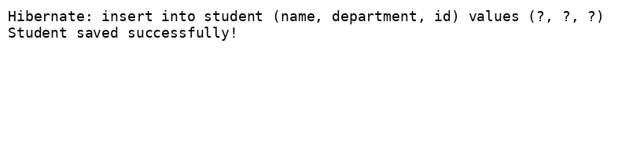

Demonstrate writing Hibernate Query Language and Native Query

DROP TABLE IF EXISTS employee_skill;
DROP TABLE IF EXISTS employee;
DROP TABLE IF EXISTS skill;
DROP TABLE IF EXISTS department;

CREATE TABLE department (
id INT PRIMARY KEY,
name VARCHAR(255)
);

CREATE TABLE skill (
id INT PRIMARY KEY,
name VARCHAR(255)
);

CREATE TABLE employee (
id INT PRIMARY KEY,
name VARCHAR(255),
salary DECIMAL(10, 2),
permanent BOOLEAN,
date_of_birth DATE,
department_id INT,
FOREIGN KEY (department_id) REFERENCES department(id)
);

CREATE TABLE employee_skill (
employee_id INT NOT NULL,
skill_id INT NOT NULL,
PRIMARY KEY (employee_id, skill_id),
CONSTRAINT fk_emp FOREIGN KEY (employee_id) REFERENCES employee(id),
CONSTRAINT fk_skill FOREIGN KEY (skill_id) REFERENCES skill(id)
);

INSERT INTO department (id, name) VALUES (1, 'Technology'), (2, 'HR');

INSERT INTO skill (id, name) VALUES (1, 'Java'), (2, 'SQL'), (3, 'Spring Boot');

INSERT INTO employee (id, name, salary, permanent, date_of_birth, department_id)
VALUES (1, 'Alice', 60000, true, '1995-02-15', 1),
(2, 'Bob', 50000, false, '1996-07-23', 1),
(3, 'Carol', 70000, true, '1990-03-10', 2);

INSERT INTO employee_skill (employee_id, skill_id) VALUES
(1, 1), (1, 2), (2, 2), (3, 1), (3, 3);

package com.cognizant.orm_learn;

import jakarta.persistence.*;
import java.util.Date;
import java.util.List;

@Entity
@Table(name = "employee")
public class Employee {
@Id @GeneratedValue(strategy = GenerationType.IDENTITY)
private Integer id;
private String name;
private double salary;
private boolean permanent;
@Temporal(TemporalType.DATE)
private Date dateOfBirth;

@ManyToOne(fetch = FetchType.LAZY)
@JoinColumn(name = "department_id")
private Department department;

@ManyToMany(fetch = FetchType.LAZY)
@JoinTable(name = "employee_skill",
joinColumns = @JoinColumn(name = "employee_id"),
inverseJoinColumns = @JoinColumn(name = "skill_id"))
private List<Skill> skillList;

public Integer getId() {
return id;
}

public void setId(Integer id) {
this.id = id;
}

public String getName() {
return name;
}

public void setName(String name) {
this.name = name;
}

public double getSalary() {
return salary;
}

public void setSalary(double salary) {
this.salary = salary;
}

public boolean isPermanent() {
return permanent;
}

public void setPermanent(boolean permanent) {
this.permanent = permanent;
}

public Date getDateOfBirth() {
return dateOfBirth;
}

public void setDateOfBirth(Date dateOfBirth) {
this.dateOfBirth = dateOfBirth;
}

public Department getDepartment() {
return department;
}

public void setDepartment(Department department) {
this.department = department;
}

public List<Skill> getSkillList() {
return skillList;
}

public void setSkillList(List<Skill> skillList) {
this.skillList = skillList;
}

@Override
public String toString() {
return "Employee [id=" + id + ", name=" + name + ", salary=" + salary + ", permanent=" + permanent
+ ", dateOfBirth=" + dateOfBirth + ", department=" + department + ", skillList=" + skillList + "]";
}

}

package com.cognizant.orm_learn;
import jakarta.persistence.*;

@Entity @Table(name = "skill")
public class Skill {
@Id @GeneratedValue(strategy = GenerationType.IDENTITY)
private Integer id;
private String name;
public Integer getId() {
return id;
}
public void setId(Integer id) {
this.id = id;
}
public String getName() {
return name;
}
public void setName(String name) {
this.name = name;
}
@Override
public String toString() {
return "Skill [id=" + id + ", name=" + name + "]";
}

}

package com.cognizant.orm_learn;

import jakarta.persistence.*;

@Entity @Table(name = "department")
public class Department {
@Id @GeneratedValue(strategy = GenerationType.IDENTITY)
private Integer id;
private String name;
public Integer getId() {
return id;
}
public void setId(Integer id) {
this.id = id;
}
public String getName() {
return name;
}
public void setName(String name) {
this.name = name;
}
@Override
public String toString() {
return "Department [id=" + id + ", name=" + name + "]";
}

}

package com.cognizant.orm_learn;

import com.cognizant.orm_learn.Department;
import org.springframework.data.jpa.repository.JpaRepository;

public interface DepartmentRepository extends JpaRepository<Department, Integer> { }

package com.cognizant.orm_learn;

import org.springframework.data.jpa.repository.JpaRepository;

public interface SkillRepository extends JpaRepository<Skill, Integer> { }

package com.cognizant.orm_learn;

import com.cognizant.orm_learn.Employee;
import org.springframework.data.jpa.repository.JpaRepository;
import org.springframework.data.jpa.repository.Query;
import java.util.List;

public interface EmployeeRepository extends JpaRepository<Employee, Integer> {
// HQL / JPQL
@Query("SELECT e FROM Employee e WHERE e.permanent = true")
List<Employee> findPermanent();

// HQL with JOIN FETCH to avoid N+1
@Query("SELECT DISTINCT e FROM Employee e " +
"JOIN FETCH e.department JOIN FETCH e.skillList " +
"WHERE e.permanent = true")
List<Employee> findPermanentWithDetails();

// HQL aggregate example: average salary per department
@Query("SELECT e.department.name, AVG(e.salary) FROM Employee e GROUP BY e.department.name")
List<Object[]> avgSalaryByDepartment();

// Native query: return all permanent employees
@Query(value = "SELECT * FROM employee WHERE permanent = true", nativeQuery = true)
List<Employee> findPermanentNative();
}

package com.cognizant.orm_learn;

import com.cognizant.orm_learn.Employee;
import com.cognizant.orm_learn.EmployeeRepository;
import org.springframework.stereotype.Service;
import jakarta.transaction.Transactional;
import java.util.List;

@Service
public class EmployeeService {
private final EmployeeRepository repo;
public EmployeeService(EmployeeRepository repo) { this.repo = repo; }

@Transactional public List<Employee> getPermanent() {
return repo.findPermanent();
}

@Transactional public List<Employee> getPermanentWithDetails() {
return repo.findPermanentWithDetails();
}

@Transactional public List<Object[]> getAvgSalaryByDept() {
return repo.avgSalaryByDepartment();
}

@Transactional public List<Employee> getPermanentNative() {
return repo.findPermanentNative();
}
}

package com.cognizant.orm_learn;

import com.cognizant.orm_learn.Department;
import com.cognizant.orm_learn.DepartmentRepository;
import jakarta.transaction.Transactional;
import org.slf4j.Logger;
import org.slf4j.LoggerFactory;
import org.springframework.stereotype.Service;
import org.springframework.beans.factory.annotation.Autowired;

@Service
public class DepartmentService {
private static final Logger LOGGER = LoggerFactory.getLogger(DepartmentService.class);

@Autowired
private DepartmentRepository departmentRepository;

@Transactional
public Department get(int id) {
LOGGER.info("Start");
return departmentRepository.findById(id).get();
}

@Transactional
public void save(Department department) {
LOGGER.info("Start");
departmentRepository.save(department);
LOGGER.info("End");
}
}

package com.cognizant.orm_learn;

import com.cognizant.orm_learn.Employee;
import com.cognizant.orm_learn.EmployeeService;
import org.slf4j.*;
import org.springframework.boot.*;
import org.springframework.boot.autoconfigure.SpringBootApplication;
import org.springframework.context.ApplicationContext;
import java.util.List;

@SpringBootApplication
public class OrmLearnApplication implements CommandLineRunner {
private static final Logger LOGGER = LoggerFactory.getLogger(OrmLearnApplication.class);
private final EmployeeService employeeService;

public OrmLearnApplication(EmployeeService employeeService) {
this.employeeService = employeeService;
}

public static void main(String[] args) {
SpringApplication.run(OrmLearnApplication.class, args);
}

@Override
public void run(String... args) {
LOGGER.info("=== HQL without fetch ===");
employeeService.getPermanent().forEach(e -> LOGGER.debug("Emp: {}", e));

LOGGER.info("=== HQL with JOIN FETCH ===");
employeeService.getPermanentWithDetails()
.forEach(e -> LOGGER.debug("Emp: {} Dept: {} Skills: {}", e.getName(), e.getDepartment(), e.getSkillList()));

LOGGER.info("=== HQL Aggregate (Avg salary per dept) ===");
employeeService.getAvgSalaryByDept()
.forEach(row -> LOGGER.debug("Dept: {} Avg Salary: {}", row[0], row[1]));

LOGGER.info("=== Native SQL Query ===");
employeeService.getPermanentNative().forEach(e -> LOGGER.debug("Emp (Native): {}", e));
}
}

OUTPUT:
. ____ _ __ _ _
/\\ / ___'_ __ _ _(_)_ __ __ _ \ \ \ \
( ( )\___ | '_ | '_| | '_ \/ _` | \ \ \ \
\\/ ___)| |_)| | | | | || (_| | ) ) ) )
' |____| .__|_| |_|_| |_\__, | / / / /
=========|_|==============|___/=/_/_/_/

:: Spring Boot :: (v3.5.3)

2025-07-10T19:54:26.803+05:30 INFO 23448 --- [ restartedMain] c.c.orm_learn.OrmLearnApplication : Starting OrmLearnApplication using Java 21.0.7 with PID 23448 (C:\Users\admin\Downloads\orm-learn\orm-learn\target\classes started by admin in C:\Users\admin\Downloads\orm-learn\orm-learn)
2025-07-10T19:54:26.806+05:30 INFO 23448 --- [ restartedMain] c.c.orm_learn.OrmLearnApplication : No active profile set, falling back to 1 default profile: "default"
2025-07-10T19:54:26.886+05:30 INFO 23448 --- [ restartedMain] .e.DevToolsPropertyDefaultsPostProcessor : Devtools property defaults active! Set 'spring.devtools.add-properties' to 'false' to disable
2025-07-10T19:54:27.877+05:30 INFO 23448 --- [ restartedMain] .s.d.r.c.RepositoryConfigurationDelegate : Bootstrapping Spring Data JPA repositories in DEFAULT mode.
2025-07-10T19:54:27.986+05:30 INFO 23448 --- [ restartedMain] .s.d.r.c.RepositoryConfigurationDelegate : Finished Spring Data repository scanning in 90 ms. Found 5 JPA repository interfaces.
2025-07-10T19:54:28.570+05:30 INFO 23448 --- [ restartedMain] com.zaxxer.hikari.HikariDataSource : HikariPool-1 - Starting...
2025-07-10T19:54:28.960+05:30 INFO 23448 --- [ restartedMain] com.zaxxer.hikari.pool.HikariPool : HikariPool-1 - Added connection conn0: url=jdbc:h2:mem:testdb user=SA
2025-07-10T19:54:28.963+05:30 INFO 23448 --- [ restartedMain] com.zaxxer.hikari.HikariDataSource : HikariPool-1 - Start completed.
2025-07-10T19:54:29.267+05:30 INFO 23448 --- [ restartedMain] o.hibernate.jpa.internal.util.LogHelper : HHH000204: Processing PersistenceUnitInfo [name: default]
2025-07-10T19:54:29.355+05:30 INFO 23448 --- [ restartedMain] org.hibernate.Version : HHH000412: Hibernate ORM core version 6.6.18.Final
2025-07-10T19:54:29.417+05:30 INFO 23448 --- [ restartedMain] o.h.c.internal.RegionFactoryInitiator : HHH000026: Second-level cache disabled
2025-07-10T19:54:29.928+05:30 INFO 23448 --- [ restartedMain] o.s.o.j.p.SpringPersistenceUnitInfo : No LoadTimeWeaver setup: ignoring JPA class transformer
2025-07-10T19:54:30.078+05:30 INFO 23448 --- [ restartedMain] org.hibernate.orm.connections.pooling : HHH10001005: Database info:
Database JDBC URL [Connecting through datasource 'HikariDataSource (HikariPool-1)']
Database driver: undefined/unknown
Database version: 2.3.232
Autocommit mode: undefined/unknown
Isolation level: undefined/unknown
Minimum pool size: undefined/unknown
Maximum pool size: undefined/unknown
2025-07-10T19:54:31.892+05:30 INFO 23448 --- [ restartedMain] o.h.e.t.j.p.i.JtaPlatformInitiator : HHH000489: No JTA platform available (set 'hibernate.transaction.jta.platform' to enable JTA platform integration)
Hibernate: create table country (co_code varchar(255) not null, co_name varchar(255), primary key (co_code))
Hibernate: alter table if exists employee alter column salary set data type float(53)
Hibernate: create table stock (st_id integer generated by default as identity, st_close float(53), st_code varchar(255), st_date date, st_open float(53), st_volume bigint, primary key (st_id))
2025-07-10T19:54:32.008+05:30 INFO 23448 --- [ restartedMain] j.LocalContainerEntityManagerFactoryBean : Initialized JPA EntityManagerFactory for persistence unit 'default'
2025-07-10T19:54:32.670+05:30 INFO 23448 --- [ restartedMain] o.s.d.j.r.query.QueryEnhancerFactory : Hibernate is in classpath; If applicable, HQL parser will be used.
2025-07-10T19:54:34.262+05:30 INFO 23448 --- [ restartedMain] o.s.b.d.a.OptionalLiveReloadServer : LiveReload server is running on port 35729
2025-07-10T19:54:34.290+05:30 INFO 23448 --- [ restartedMain] c.c.orm_learn.OrmLearnApplication : Started OrmLearnApplication in 8.133 seconds (process running for 8.866)
2025-07-10T19:54:34.302+05:30 INFO 23448 --- [ restartedMain] c.c.orm_learn.OrmLearnApplication : === HQL without fetch ===
Hibernate: select e1_0.id,e1_0.date_of_birth,e1_0.department_id,e1_0.name,e1_0.permanent,e1_0.salary from employee e1_0 where e1_0.permanent=true
2025-07-10T19:54:34.566+05:30 INFO 23448 --- [ restartedMain] c.c.orm_learn.OrmLearnApplication : === HQL with JOIN FETCH ===
Hibernate: select distinct e1_0.id,e1_0.date_of_birth,d1_0.id,d1_0.name,e1_0.name,e1_0.permanent,e1_0.salary,sl1_0.employee_id,sl1_1.id,sl1_1.name from employee e1_0 join department d1_0 on d1_0.id=e1_0.department_id join employee_skill sl1_0 on e1_0.id=sl1_0.employee_id join skill sl1_1 on sl1_1.id=sl1_0.skill_id where e1_0.permanent=true
2025-07-10T19:54:34.605+05:30 INFO 23448 --- [ restartedMain] c.c.orm_learn.OrmLearnApplication : === HQL Aggregate (Avg salary per dept) ===
Hibernate: select d1_0.name,avg(e1_0.salary) from employee e1_0 join department d1_0 on d1_0.id=e1_0.department_id group by d1_0.name
2025-07-10T19:54:34.629+05:30 INFO 23448 --- [ restartedMain] c.c.orm_learn.OrmLearnApplication : === Native SQL Query ===
Hibernate: SELECT * FROM employee WHERE permanent = true
2025-07-10T19:54:34.688+05:30 INFO 23448 --- [ionShutdownHook] j.LocalContainerEntityManagerFactoryBean : Closing JPA EntityManagerFactory for persistence unit 'default'
2025-07-10T19:54:34.695+05:30 WARN 23448 --- [ionShutdownHook] o.s.b.f.support.DisposableBeanAdapter : Invocation of destroy method failed on bean with name 'inMemoryDatabaseShutdownExecutor': org.h2.jdbc.JdbcSQLNonTransientConnectionException: Database is already closed (to disable automatic closing at VM shutdown, add ";DB_CLOSE_ON_EXIT=FALSE" to the db URL) [90121-232]
2025-07-10T19:54:34.696+05:30 INFO 23448 --- [ionShutdownHook] com.zaxxer.hikari.HikariDataSource : HikariPool-1 - Shutdown initiated...
2025-07-10T19:54:34.699+05:30 INFO 23448 --- [ionShutdownHook] com.zaxxer.hikari.HikariDataSource : HikariPool-1 - Shutdown completed.

