COMMUNITY ENGAGEMENT PROJECT REPORT
Theme: Environmental Sustainability & Energy Awareness
Energy Consumption Pattern Analysis Using Primary Survey Data
at Sanjay Gandhi National Park, Borivali East, Mumbai

Submitted By
Ms. Arshiya Chaudhary
Roll No.: 202405008
Programme: Third Year Bachelor of Science (Data Science)

Under the Guidance of
Ms. Gayatri Bhaktiani

THAKUR SHYAMNARAYAN DEGREE COLLEGE (TSDC)
University of Mumbai
Academic Year: 2026–2027
Month of Submission: September 2026

CERTIFICATE
I hereby certify that Ms. Arshiya Chaudhary, student of Thakur Shyamnarayan Degree College, studying in the Third Year Bachelor of Science (Data Science) program, has successfully completed the Community Engagement Project titled “Energy Consumption Pattern Analysis Using Primary Survey Data” under the theme “Environmental Sustainability & Energy Awareness” for the academic year 2026–2027.
The project is based on primary survey data collected through a structured Google Form from household respondents associated with the survey activity at Sanjay Gandhi National Park (SGNP), Borivali East, Mumbai. To the best of my knowledge, the work carried out by the student and the information presented in the report are based on the collected survey responses and the analysis undertaken for the project.

Internal Guide | Head of the Department | Principal
Ms. Gayatri Bhaktiani

GUIDE INTERACTION DIARY FORM
I, the undersigned Ms. Arshiya Chaudhary, Roll No.: 202405008, currently enrolled in the Third Year of the Data Science Full-time Program at Thakur Shyamnarayan Degree College, am undertaking my Community Engagement Project titled “Energy Consumption Pattern Analysis Using Primary Survey Data” under the guidance of Ms. Gayatri Bhaktiani. I confirm that I have met my internal guide for project guidance and discussion.
Sr. No. | Date | Signature of the Internal Guide
1 | ________________ | ________________
2 | ________________ | ________________
3 | ________________ | ________________
4 | ________________ | ________________
5 | ________________ | ________________
6 | ________________ | ________________
Signature of the Candidate: ____________________ Signature of Internal Guide: ____________________

DECLARATION
I, Ms. Arshiya Chaudhary, student of Thakur Shyamnarayan Degree College, studying in the Third Year Bachelor of Science (Data Science) program, hereby declare that I have completed the Community Engagement Project titled “Energy Consumption Pattern Analysis Using Primary Survey Data” under the theme “Environmental Sustainability & Energy Awareness.”
The report is based on primary data collected through a structured Google Form and the analysis carried out on the collected responses. The data and information included in the project are presented for academic purposes and are based on the survey conducted for this Community Engagement Project.
Due credit is extended to secondary sources, classroom material, and other supporting references by acknowledging them in the References section.
Signature of the Student with date: ____________________
Name of Student: Arshiya Chaudhary

ACKNOWLEDGMENT
To list everyone who has helped me is difficult because their support and guidance contributed significantly to the completion of this project.
I would like to acknowledge the University of Mumbai for giving me the opportunity to undertake this project as part of the Community Engagement Project.
I would like to thank our Principal, Dr. G.D. GIRI, for providing the necessary facilities and support required for the completion of this project.
I sincerely thank Ms. Gayatri Bhaktiani, my Project Guide, for her valuable guidance, encouragement, suggestions, and continuous support throughout the project.
I would also like to thank my college library and faculty members for providing access to learning resources related to Data Science, survey methodology, environmental awareness, and data analysis.
I am grateful to all the survey respondents and community members who participated in the primary survey and shared information about their household electricity consumption patterns.
Lastly, I would like to thank my parents, group members, classmates, and peers for their constant support and encouragement during the completion of this Community Engagement Project.

ABSTRACT
This Community Engagement Project (CEP) is undertaken as part of the Third Year Bachelor of Science (Data Science) programme at Thakur Shyamnarayan Degree College (TSDC), University of Mumbai, for the academic year 2026–2027. The project focuses on “Energy Consumption Pattern Analysis Using Primary Survey Data” and examines household electricity-use patterns through primary survey responses.
A structured questionnaire was prepared and responses were collected through Google Forms during the survey activity associated with Sanjay Gandhi National Park (SGNP), Borivali East, Mumbai. The final dataset supplied for analysis contains 172 household responses. The questionnaire covers type of house, household size, approximate monthly electricity bill, regularly used electrical appliances, daily appliance-use duration, factors influencing electricity consumption, season of highest consumption, peak evening usage, renewable-energy use, and willingness to change electricity-use habits.
The project applies Data Science techniques to clean, organize, summarize, and visualize the collected responses. Exploratory Data Analysis (EDA) is used to identify distributions and patterns in household energy consumption. Graphical representations are used to communicate the survey findings clearly.
The survey data shows that household electricity consumption is associated with everyday household characteristics such as household size, appliance usage, duration of use, cooling requirements, and seasonal conditions. The collected responses also provide information about renewable-energy adoption and willingness to modify electricity-use habits.

TABLE OF CONTENTS
Sr. No. | Content | Page No.
1 | Title | 9
2 | Introduction | 10
3 | Background of the Study | 11
4 | Literature Review | 12
5 | Methodology | 14
6 | Details of Visit | 16
7 | Activities Performed | 17
8 | Observations | 18
9 | Learning Outcomes | 20
10 | Conclusion and Recommendations | 21
11 | References | 23
12 | Appendices | 24
13 | Students Feedback on CEP | 27

LIST OF FIGURES AND TABLES
Figure No. | Title
1 | Type of House Distribution
2 | Household Size Distribution
3 | Monthly Electricity Bill Distribution
4 | Daily Appliance Usage Hours
5 | Season with Highest Electricity Consumption
6 | Peak Evening Appliance Usage
7 | Renewable Energy Use
8 | Willingness to Change Electricity Habits
9 | Frequently Used Electrical Appliances

Table No. | Title
1 | Questionnaire Used for Primary Data Collection
2 | Household Size × Monthly Electricity Bill Cross-tabulation
3 | Summary of Major Survey Findings

TITLE
Energy Consumption Pattern Analysis Using Primary Survey Data
Survey Area: Sanjay Gandhi National Park (SGNP), Borivali East, Mumbai
The project studies household electricity consumption patterns using primary survey data collected through a structured Google Form. The study combines community engagement, field-based survey activity, and Data Science techniques for data cleaning, exploratory analysis, visualization, and interpretation.

INTRODUCTION
Energy is an essential part of modern household life. Electricity is used for lighting, cooling, cooking, entertainment, communication, study, work, and other daily activities. The amount of electricity consumed by a household can vary according to the number of people living in the household, the appliances available, the duration for which appliances are used, seasonal weather conditions, and household habits.
The present Community Engagement Project focuses on “Energy Consumption Pattern Analysis Using Primary Survey Data.” Instead of using only a secondary dataset, the project uses information collected directly from household respondents through a structured questionnaire. This makes the study relevant to the Data Science component of the CEP because real-world responses must be organized, cleaned, summarized, and interpreted before useful patterns can be identified.
The survey was conducted in connection with the CEP activity at Sanjay Gandhi National Park, Borivali East, Mumbai. The collected responses provide household-level information about electricity bills, appliance usage, usage duration, seasonal consumption, peak-hour usage, renewable-energy adoption, and willingness to change electricity-use habits.
The project uses descriptive analysis and graphical representation to understand the collected data. The purpose is not to estimate the electricity consumption of all households in Mumbai, but to describe the patterns observed within the surveyed responses.
The study therefore connects community engagement with practical Data Science skills such as questionnaire design, primary data collection, data cleaning, frequency analysis, cross-tabulation, visualization, and interpretation.

BACKGROUND OF THE STUDY
Household electricity consumption is influenced by both household characteristics and patterns of appliance use. Larger households may have more simultaneous electricity needs, while households with more appliances or longer daily usage may have higher electricity requirements. Seasonal weather can also influence the use of fans, air conditioners, water heaters, and other appliances.
The questionnaire for this project was designed to capture these factors in a structured form. It includes questions about household type and size, approximate monthly electricity bill, regularly used appliances, daily usage hours, major factors influencing electricity consumption, season of highest consumption, peak evening appliance use, renewable-energy use, and willingness to change electricity-use habits.
The study area is associated with Sanjay Gandhi National Park (SGNP), Borivali East, Mumbai. The CEP field activity provides a practical community and environmental context for discussing responsible resource use. The survey component focuses specifically on household electricity consumption.
Because the project uses primary data, the findings depend on the responses received from the surveyed participants. The results should therefore be interpreted as patterns within the collected sample rather than as a complete representation of every household in Mumbai.

LITERATURE REVIEW
Household energy consumption is commonly studied through variables such as household size, appliance ownership, appliance-use duration, electricity tariffs or bills, seasonal conditions, and energy-saving behaviour. Survey-based approaches are useful for understanding how household practices contribute to electricity demand.
Appliance Usage and Energy Demand
Electrical appliances represent important components of household energy use. Fans, refrigerators, televisions, washing machines, computers, air conditioners, water heaters, and other appliances may have different usage frequencies and operating durations. A survey can therefore provide useful information about which appliances are commonly present and how long households report using appliances each day.
Seasonal and Peak-Time Consumption
Electricity use may vary across seasons because household cooling and heating requirements change with weather. Peak evening periods can also be important because several household activities may occur at the same time. The present questionnaire includes both seasonal consumption and peak-evening usage to examine these patterns within the collected sample.
Renewable Energy and Energy-Saving Behaviour
Household adoption of renewable sources such as solar energy can be examined alongside conventional electricity-use patterns. Willingness to modify electricity-use habits provides another behavioural dimension. These survey variables can be used to describe the current level of renewable-energy use and reported willingness to change habits.
Relevance to the Present Study
The literature-based concepts provide a background for selecting variables and interpreting survey responses. The actual findings in this project are derived from the primary dataset supplied for analysis. The observations reported in this document are therefore based on the collected responses rather than assumptions about households outside the surveyed group.

METHODOLOGY
The methodology describes the systematic process followed to collect, organize, analyze, and interpret information related to household electricity consumption.
Research Approach
A survey-based descriptive approach was used. Primary information was collected directly from household respondents through a structured Google Form. The collected responses were then organized into a tabular dataset for analysis.
Primary Data Collection
The supplied dataset contains 172 responses. The timestamps in the dataset range from 9 September 2026 to 21 September 2026. The survey was conducted in the context of the CEP activity associated with Sanjay Gandhi National Park, Borivali East, Mumbai.
Questionnaire Design
The questionnaire contains 10 questions covering household characteristics, electricity expenditure, appliance usage, daily usage duration, consumption drivers, seasonal consumption, peak evening use, renewable energy, and willingness to change electricity-use habits.
Q. No. | Question
1 | What type of house do you live in?
2 | How many people live in your household?
3 | What is your approximate monthly household electricity bill?
4 | Which electrical appliances are regularly used in your household?
5 | Approximately how many hours per day are electrical appliances used in your household?
6 | Which factor has the greatest influence on your household's electricity consumption?
7 | During which season does your household usually have the highest electricity consumption?
8 | How often are electrical appliances used during peak evening hours (6 PM–10 PM)?
9 | Does your household use any renewable energy source, such as solar energy?
10 | How willing would your household be to change its electricity-use habits to reduce energy consumption and monthly bills?
Data Cleaning and Preparation
- Imported the Google Form response file into a DataFrame.
- Removed the respondent Name field from the analysis dataset to keep the analysis focused on survey variables.
- Checked the dataset structure, response counts, missing values, and duplicate rows.
- Standardized categorical text values for consistent grouping.
- Split the multi-response appliance field into individual appliance categories for frequency analysis.
- Prepared frequency tables and visualizations for major survey variables.

DETAILS OF VISIT
As part of the Community Engagement Project, the field activity was associated with Sanjay Gandhi National Park (SGNP), Borivali East, Mumbai. The field-based component provided an opportunity to connect classroom learning with community interaction and environmental awareness.
Purpose of the Visit
The purpose of the CEP activity was to participate in community-oriented field work and collect primary information through a structured household survey. The activity also provided practical exposure to the surrounding environmental setting and encouraged discussion of responsible resource use.
Place of Visit
Item | Details
Place | Sanjay Gandhi National Park (SGNP), Borivali East, Mumbai
CEP Activity | Community engagement and primary household survey
Project Topic | Energy Consumption Pattern Analysis Using Primary Survey Data
Data Collection Instrument | Google Form / structured questionnaire
Dataset Size | 172 survey responses
The field activity and survey were complementary components of the project: the visit provided community and environmental context, while the survey generated the primary dataset used for Data Science analysis.

ACTIVITIES PERFORMED
The Community Engagement Project involved the following major activities:
- Selected the project topic related to household energy consumption patterns.
- Prepared a structured questionnaire with 10 questions.
- Converted the questionnaire into a Google Form for systematic response collection.
- Conducted the primary household survey in the context of the CEP activity at Sanjay Gandhi National Park, Borivali East, Mumbai.
- Collected and exported the responses into an Excel dataset.
- Performed data cleaning and checked missing values and duplicate records.
- Analyzed household characteristics, electricity bills, appliance usage, daily usage hours, seasonal patterns, peak evening use, renewable-energy use, and willingness to change habits.
- Created charts to communicate the distributions observed in the primary data.
- Prepared interpretations and recommendations based on the observed survey patterns.
The project therefore combined community engagement, primary data collection, and practical Data Science analysis.

OBSERVATIONS
The analysis was performed on 172 valid survey responses. The dataset contained no missing values and no duplicate rows after the analysis preparation. The following observations are directly based on the supplied responses.
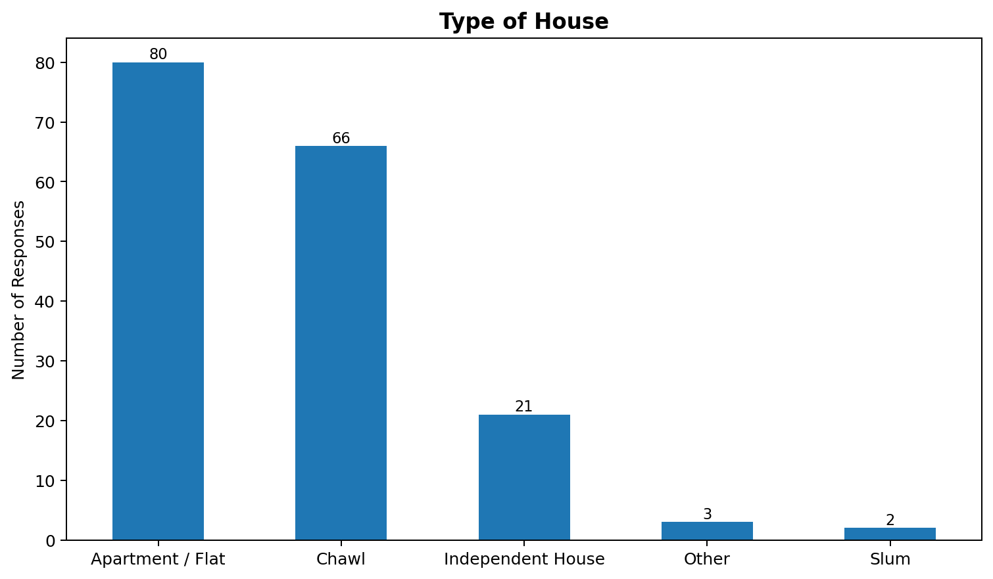
Figure 1: Type of House Distribution
Observation: Apartment / Flat was the most frequently reported house type, with 80 responses (46.5%). Chawl households accounted for 66 responses, while Independent House and Other/Slum categories had fewer responses.
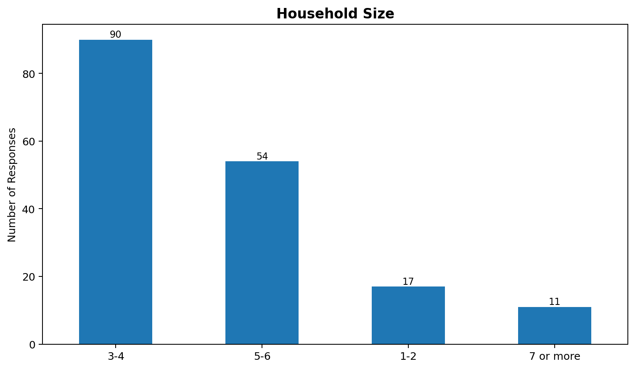
Figure 2: Household Size Distribution
Observation: The 3–4 person household category was the largest group, with 90 responses (52.3%). The 5–6 category followed with 54 responses. This provides a useful basis for examining household size against reported electricity bills.

OBSERVATIONS – ELECTRICITY BILL AND USAGE
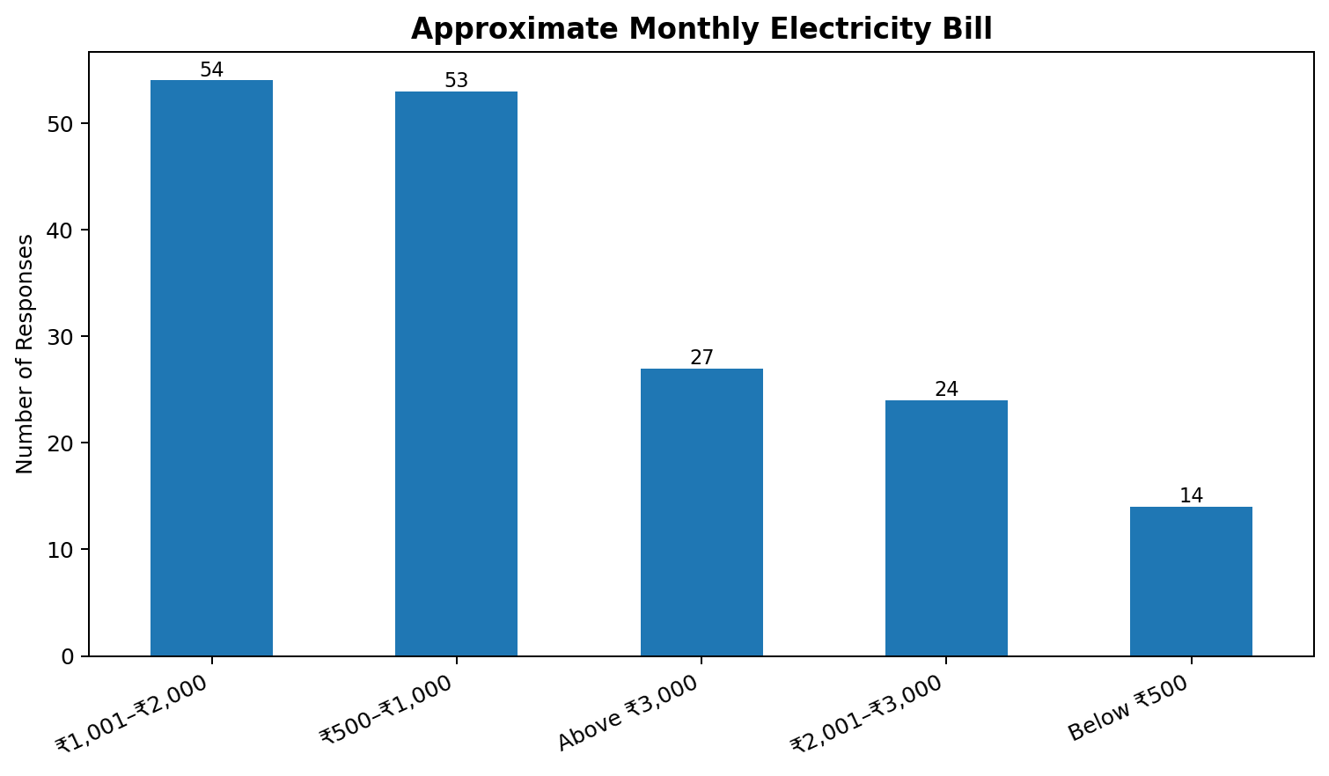
Figure 3: Approximate Monthly Electricity Bill
Observation: The most common reported bill category was ₹1,001–₹2,000, with 54 responses (31.4%). The next category was ₹500–₹1,000 with 53 responses. The dataset also contains households reporting bills above ₹3,000.
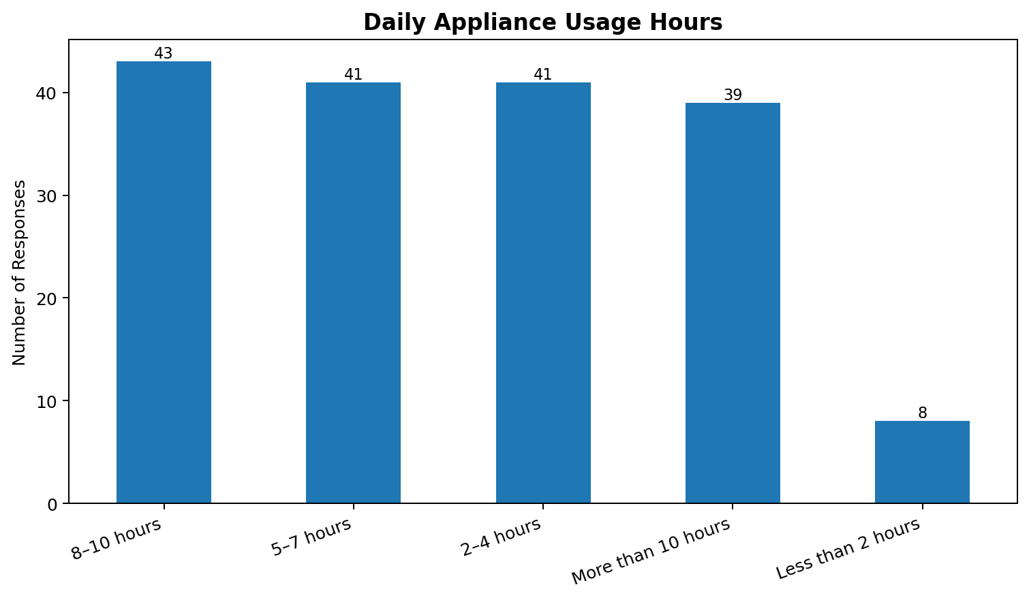
Figure 4: Daily Appliance Usage Hours
Observation: 8–10 hours was the most common daily appliance-use category, with 43 responses (25.0%). A substantial number of respondents also reported 5–7 hours, 2–4 hours, and more than 10 hours of daily use.

OBSERVATIONS – SEASONAL AND PEAK USAGE
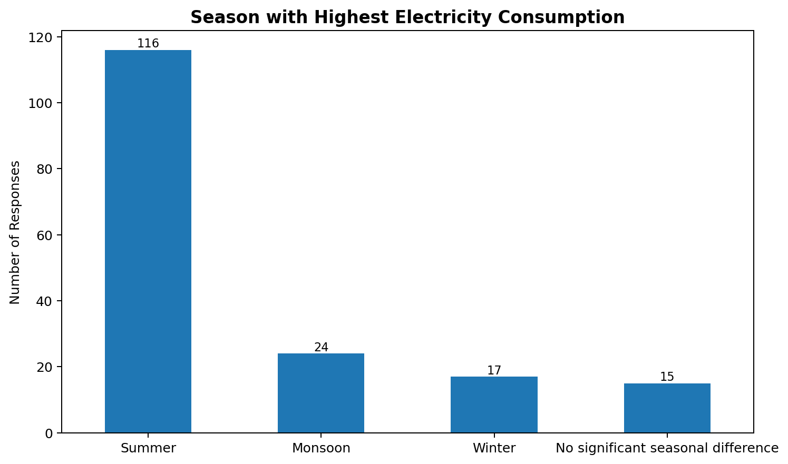
Figure 5: Season with Highest Electricity Consumption
Observation: Summer was the most frequently selected season, with 116 responses (67.4%). Monsoon and winter were reported less frequently, while some respondents indicated no significant seasonal difference.
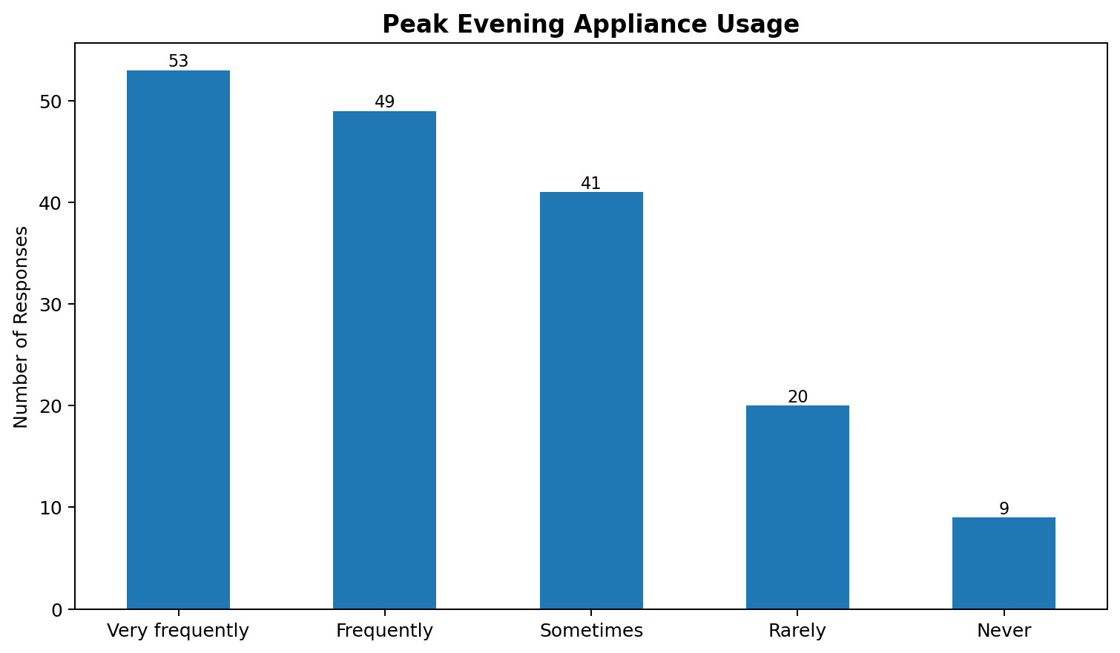
Figure 6: Peak Evening Appliance Usage
Observation: 53 respondents reported very frequent appliance use during 6 PM–10 PM, while 49 reported frequent use. Together, these responses indicate that evening appliance activity is common within the surveyed sample.

OBSERVATIONS – RENEWABLE ENERGY AND BEHAVIOUR
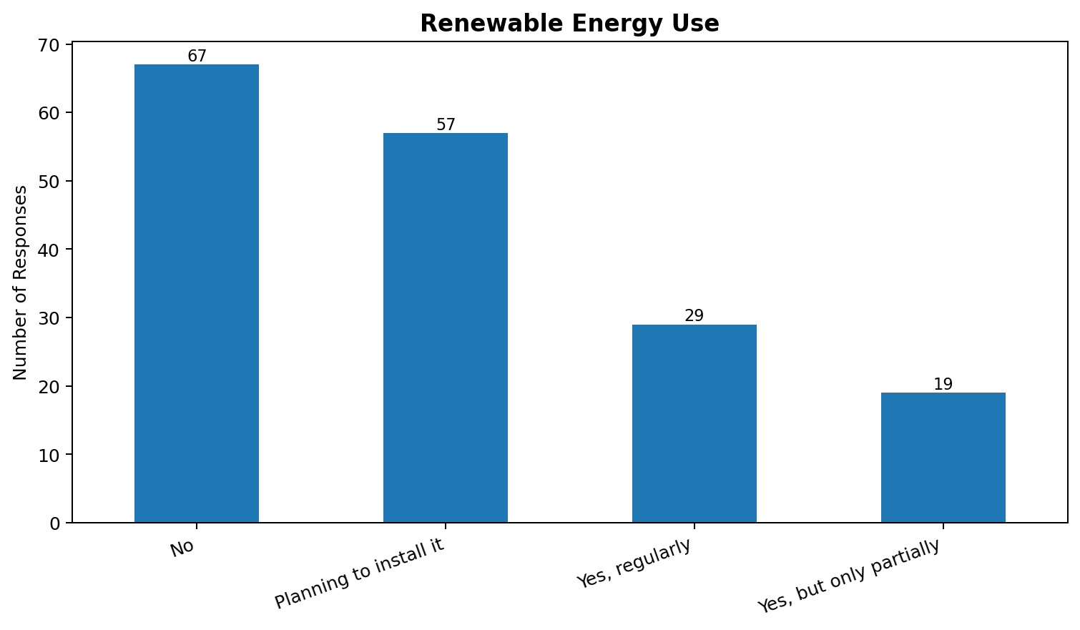
Figure 7: Renewable Energy Use
Observation: 67 respondents reported that their household does not currently use renewable energy, while 57 reported plans to install it. 29 respondents reported regular use and 19 reported partial use.
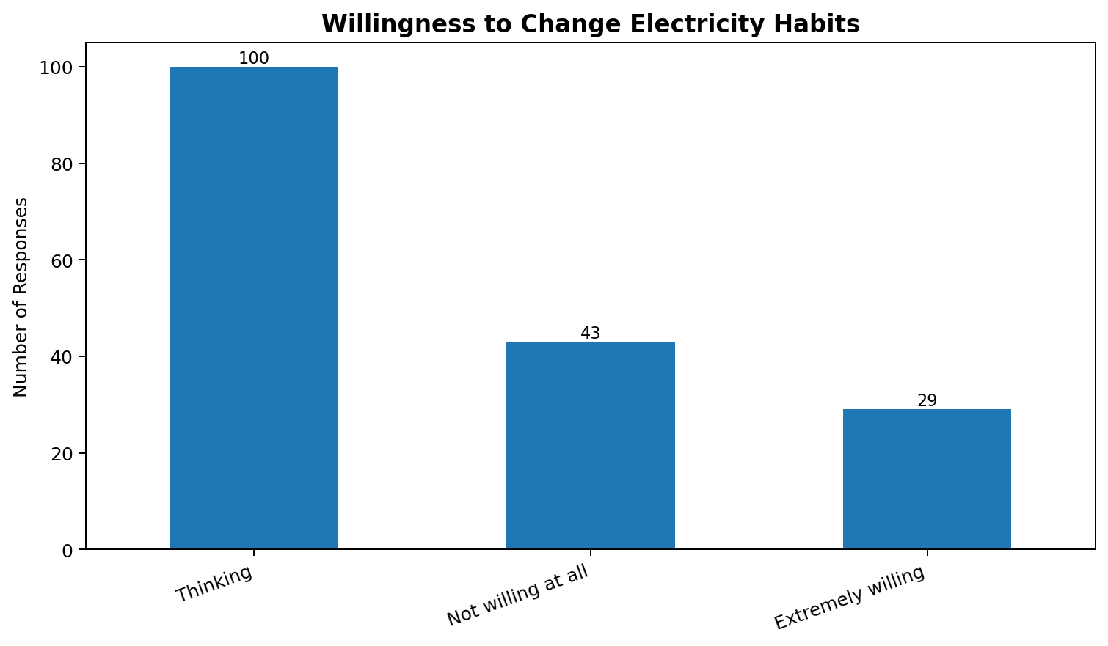
Figure 8: Willingness to Change Electricity Habits
Observation: The most frequent response was “Thinking,” with 100 responses (58.1%). 29 respondents were extremely willing, while 43 selected not willing at all. These categories describe the responses recorded in the supplied dataset.

OBSERVATIONS – APPLIANCE USAGE
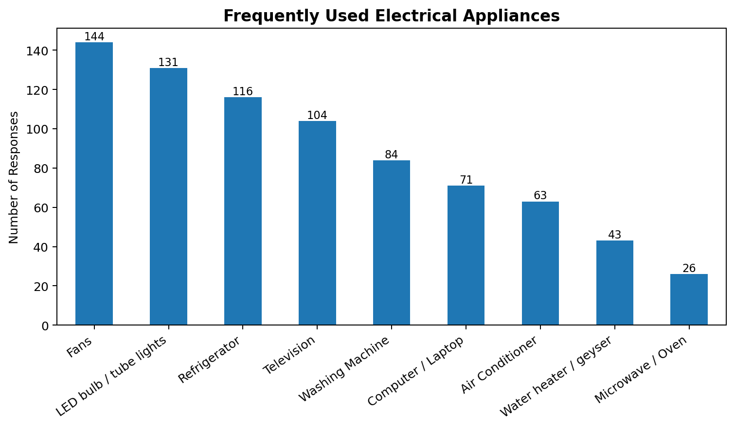
Figure 9: Frequently Used Electrical Appliances
Observation: Fans were the most frequently reported appliance, followed by LED bulbs/tube lights, refrigerators, televisions, and washing machines. The appliance counts were obtained by splitting the multi-select survey response into individual appliance categories.
Fans: 144 households (83.7%).
LED bulb / tube lights: 131 households (76.2%).
Refrigerator: 116 households (67.4%).
Television: 104 households (60.5%).
Washing Machine: 84 households (48.8%).

CROSS-TABULATION AND DATA INTERPRETATION
To examine relationships between survey variables, a cross-tabulation was prepared between household size and approximate monthly electricity bill. This does not establish causation, but it provides a descriptive view of how the two categorical variables are distributed together.
Household Size | Above ₹3,000 | Below ₹500 | ₹1,001–₹2,000 | ₹2,001–₹3,000 | ₹500–₹1,000
1-2 | 0 | 8 | 0 | 1 | 8
3-4 | 13 | 6 | 32 | 10 | 29
5-6 | 8 | 0 | 20 | 12 | 14
7 or more | 6 | 0 | 2 | 1 | 2
The cross-tabulation can be used to identify which bill categories occur most often within each household-size group. Similar cross-tabulations can be created for appliance-use hours versus bill category, season versus daily usage hours, and renewable-energy status versus willingness to change electricity habits.
Indicator | Observed result
Total survey responses | 172
Missing values | 0
Duplicate rows | 0
Most common house type | Apartment / Flat (80 responses)
Most common household size | 3-4 (90 responses)
Most common bill category | ₹1,001–₹2,000 (54 responses)
Most common daily usage category | 8–10 hours (43 responses)
Most common highest-consumption season | Summer (116 responses)
Most common peak usage response | Very frequently (53 responses)
Renewable-energy response with highest frequency | No (67 responses)
Most common willingness response | Thinking (100 responses)

LEARNING OUTCOMES
The Community Engagement Project provided practical learning beyond classroom-based theory. The project helped in understanding how a real-world community topic can be converted into a structured Data Science problem.
- Learned how to design a structured questionnaire for collecting primary data.
- Learned how to use Google Forms for digital survey data collection.
- Developed practical understanding of organizing survey responses in Excel.
- Learned how to inspect a dataset and identify missing values and duplicate records.
- Practiced categorical frequency analysis and percentage-based interpretation.
- Learned how to process multi-response questions such as appliance usage.
- Developed skills in creating bar charts and communicating survey findings.
- Understood how cross-tabulation can be used to compare two categorical variables.
- Learned that survey findings describe the collected sample and should not automatically be generalized to all households.
- Connected Data Science methods with a community and environmental topic.

CONCLUSION AND RECOMMENDATIONS
Conclusion
The Community Engagement Project examined household electricity consumption patterns using 172 primary survey responses collected through a structured Google Form. The study covered household characteristics, electricity bills, appliance usage, daily appliance-use duration, consumption factors, seasonal patterns, peak evening use, renewable-energy adoption, and willingness to change electricity-use habits.
The descriptive analysis shows clear variation across households. The largest household-size group was 3–4 people, the most common bill category was ₹1,001–₹2,000, and summer was the most frequently selected season for highest electricity consumption. Fans and LED lighting were the most frequently reported appliances. The dataset also records a mix of renewable-energy adoption levels and willingness to modify electricity-use habits.
These findings demonstrate how primary survey data can be transformed into meaningful information through data cleaning, frequency analysis, cross-tabulation, and visualization. The project also provided practical experience in community engagement and field-based primary data collection.
Recommendations
- Encourage households to monitor electricity use and identify appliances that operate for long durations.
- Promote efficient use of fans, lighting, cooling appliances, and other frequently used equipment.
- Encourage households to avoid unnecessary appliance use during peak evening periods where practical.
- Increase awareness about renewable-energy options such as rooftop solar where suitable.
- Encourage households to adopt energy-saving habits such as switching off unused appliances and using efficient lighting.
- Use household electricity bills as a simple monthly indicator for monitoring changes in consumption.
- Conduct awareness activities that explain how household size, appliance ownership, usage duration, and seasonal conditions can influence electricity demand.
- Future surveys can collect additional quantitative information such as monthly units consumed (kWh) and appliance-wise usage duration for deeper statistical analysis.

REFERENCES
1. Community Engagement Project (CEP) Questionnaire – Energy Consumption Pattern Analysis Using Primary Survey Data, prepared for primary household survey.
2. Primary Survey Responses collected through Google Forms and supplied as the project dataset.
3. Sanjay Gandhi National Park (SGNP), Borivali East, Mumbai – field activity and community engagement context.
4. Classroom notes and study material related to Data Science, Exploratory Data Analysis, environmental sustainability, and survey methodology.
5. Microsoft Excel / spreadsheet documentation used for organizing survey responses.
6. Python data-analysis libraries and classroom learning resources used for data cleaning and visualization.

APPENDICES
Appendix A – Questionnaire
The complete questionnaire used for collecting primary data through Google Forms is reproduced below.
Q. No. | Question
1 | What type of house do you live in?
2 | How many people live in your household?
3 | What is your approximate monthly household electricity bill?
4 | Which electrical appliances are regularly used in your household?
5 | Approximately how many hours per day are electrical appliances used in your household?
6 | Which factor has the greatest influence on your household's electricity consumption?
7 | During which season does your household usually have the highest electricity consumption?
8 | How often are electrical appliances used during peak evening hours (6 PM–10 PM)?
9 | Does your household use any renewable energy source, such as solar energy?
10 | How willing would your household be to change its electricity-use habits to reduce energy consumption and monthly bills?
Appendix B – Survey Documentation
Insert screenshots of the Google Form and Google Form response summary in this section.
[Insert Google Form screenshot here]
[Insert Google Form response summary screenshot here]
Appendix C – Survey Photographs
Insert photographs taken during the primary survey / CEP field activity at Sanjay Gandhi National Park here.
[Insert survey photograph here]
[Insert field-visit photograph here]
Appendix D – Data Analysis
The charts generated from the supplied primary dataset can be inserted as supporting evidence in the final printed report.
Figure 1: Type of House Distribution
Figure 2: Household Size Distribution
Figure 3: Approximate Monthly Electricity Bill
Figure 4: Daily Appliance Usage Hours
Figure 5: Season with Highest Electricity Consumption
Figure 6: Peak Evening Appliance Usage
Figure 7: Renewable Energy Use
Figure 8: Willingness to Change Electricity Habits
Figure 9: Frequently Used Electrical Appliances

STUDENTS FEEDBACK ON CEP
Field | Details
Student Name | Arshiya Chaudhary
Seat No. / Roll No. | 202405008
Department | Data Science
Name of the Mentor / Guide | Ms. Gayatri Bhaktiani
Title of Community Engagement Project | Energy Consumption Pattern Analysis Using Primary Survey Data
Theme | Environmental Sustainability & Energy Awareness
Survey / CEP Location | Sanjay Gandhi National Park, Borivali East, Mumbai
Dataset Size | 172 responses
Brief description of CEP carried out:
The Community Engagement Project focused on studying household electricity consumption patterns using primary survey data. A structured questionnaire was prepared and distributed through Google Forms to collect information about household size, electricity bills, appliance usage, daily usage duration, consumption factors, seasonal patterns, peak evening usage, renewable-energy use, and willingness to change electricity-use habits. A total of 172 responses were analyzed. The project also included community and environmental engagement associated with Sanjay Gandhi National Park, Borivali East.
Date / Period of CEP: September 2026
Student Signature: ____________________
Name: Arshiya Chaudhary
Date: ____________________

