Batch 06
Comparative Study of Recommendation Systems Using Machine Learning
Domain
- Machine Learning
- Recommendation Systems

Dataset
- MovieLens 100K / 1M (user-movie ratings, genres, timestamps)
https://grouplens.org/datasets/movielens/
- Amazon Reviews (real-world e-commerce reviews with product metadata)
https://www.kaggle.com/datasets/snap/amazon-fine-food-reviews
- Book-Crossing (book ratings with demographic info) https://www.kaggle.com/datasets/saurabhbagchi/book-crossing-dataset

Abstract
Recommendation systems have become an essential component of modern digital platforms by helping users discover relevant products, movies, books, and other items based on their preferences and historical interactions. Different recommendation techniques exhibit varying levels of performance depending on the characteristics of the dataset and the recommendation domain. This project presents a comparative study of multiple recommendation system approaches using benchmark datasets, including MovieLens 100K/1M, Amazon Product Reviews, and the Book-Crossing Dataset. The study evaluates the effectiveness of Popularity-Based Recommendation, Content-Based Filtering, Collaborative Filtering (User-Based and Item-Based), Matrix Factorization, and Machine Learning-based recommendation models.
The project begins with data collection, followed by data preprocessing, which includes handling missing values, removing duplicates, encoding categorical variables, and normalizing the data. Exploratory Data Analysis (EDA) is then performed to understand user behaviour, item popularity, rating distributions, and feature relationships. Subsequently, different recommendation algorithms are implemented and evaluated using appropriate performance metrics such as RMSE, MAE, Precision, Recall, F1-Score, and NDCG. The performance of each recommendation model is compared to identify its strengths, limitations, and suitability for different application domains.
The findings of this study provide valuable insights into selecting the most effective recommendation technique based on dataset characteristics, computational complexity, and recommendation accuracy. The project also demonstrates how machine learning techniques can enhance personalized recommendations, thereby improving user satisfaction and decision-making across various online platforms such as e-commerce, streaming services, and digital libraries.

Data Analytics (EDA)
Raw Dataset
↓
Dataset Overview
↓
Data Quality Assessment
↓
Descriptive Statistics
↓
Missing Values
↓
Duplicate Records
↓
Outlier Detection
↓
Univariate Analysis
↓
Bivariate Analysis
↓
Correlation Analysis
↓
Feature Engineering
↓
Feature Selection

Data Preprocessing
- Handle missing values
- Remove duplicates
- Encode User IDs
- Encode Item IDs
- Normalize ratings
- Feature scaling

Recommendation Algorithms
Compare different recommendation techniques.

Model 1: Popularity-Based Recommendation
- Recommend highest-rated items
- Simple baseline

Model 2: Content-Based Filtering
Uses:
- Genres
- Categories
- Description
- Keywords
Algorithms:
- Cosine Similarity

Model 3: Collaborative Filtering
User-Based Collaborative Filtering
Item-Based Collaborative Filtering
Algorithms:
- KNN
- Cosine Similarity
- Pearson Correlation

Model 4: Matrix Factorization
Algorithms:
- Singular Value Decomposition (SVD)
- Non-negative Matrix Factorization (NMF)

Model 5: Machine Learning Model
Use supervised learning to predict ratings.
Examples:
- Decision Tree
- Random Forest
- XGBoost
- Logistic Regression
- LightGBM

Evaluation Metrics
Recommendation systems are commonly evaluated using:
Rating Prediction
- RMSE
- MAE
Recommendation Quality
- Precision
- Recall
- F1-Score
- MAP (Mean Average Precision)
- Hit Ratio
Comparative Analysis
• Accuracy
• RMSE
• MAE
• Precision
• Recall
• F1-Score
• NDCG
Research Pipeline
Benchmark Dataset
↓
Data Cleaning
↓
EDA
↓
Feature Engineering
↓
Feature Selection
↓
Train-Test Split
↓
Recommendation Models
↓
Performance Evaluation
↓
Visualization
↓
Comparative Analysis
↓
Research Conclusions
Architecture Diagram
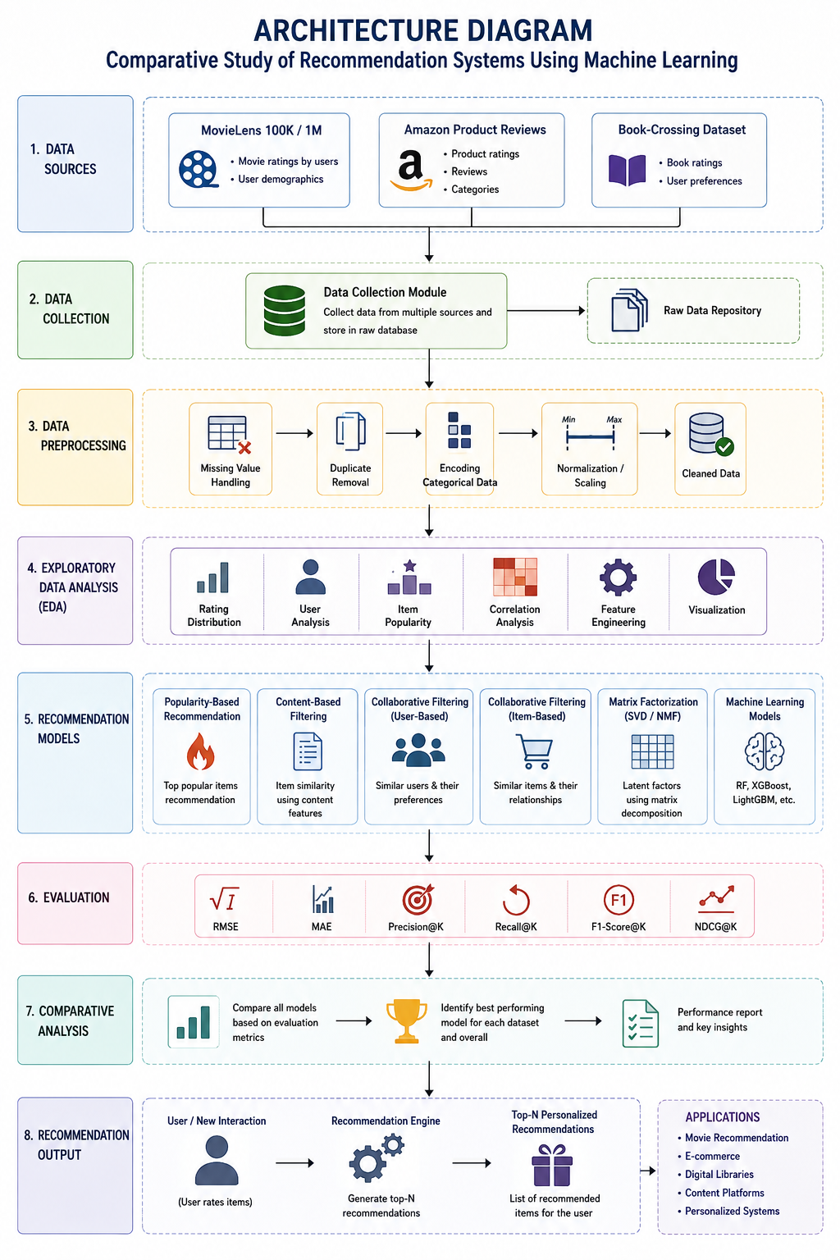

Expected Outcome
- Compare traditional recommendation methods with machine learning approaches.
- Identify the best-performing algorithm based on recommendation quality and prediction accuracy.
- Analyze trade-offs between accuracy, computational complexity, and scalability.
- Provide insights into which recommendation technique is most suitable for real-world applications such as movie, e-commerce, or book recommendation systems.

