HTML5_Day<1>_Hands_On_<Arshiya Anjum>

Problem 1
Assessment Goal: Check if learners understand basic HTML structure and content creation.
Hands-on Tasks:
1. Create a basic HTML page with proper structure (DOCTYPE, head, body)
2. Add a heading and a paragraph introducing yourself
3. Create an unordered list showing your hobbies
4. Create an ordered list showing daily routine steps
5. Create a simple table showing:
o Student Name
o Subject
o Marks
Expected Outcome:
A static HTML page that displays structured content correctly in the browser.

CODE:

<!DOCTYPE html>
<html lang="en">
<head>
<meta charset="UTF-8">
<meta name="viewport" content="width=device-width, initial-scale=1.0">
<title>Document</title>
</head>
<body>

<h1>Welcome To Profile Page</h1>
<p>Hello, my name is Arshiya. I am learning full stack development </p>

<!-- Unordered list -->
<h2>My Hobbies</h2>
<ul>
<li>Reading</li>
<li>Listening to music</li>
<li>Watching movies</li>
<li>Learning coding</li>
</ul>

<!-- Ordered list -->
<h2>My Daily Routine</h2>
<ol>
<li>Wake up</li>
<li>Get ready</li>
<li>Attend classes</li>
<li>Practice coding</li>

</ol>

<!-- Table -->
<h2>Student Marks</h2>
<table border="1">
<tr>
<th>Student Name</th>
<th>Subject</th>
<th>Marks</th>
</tr>
<tr>
<td>Arshiya</td>
<td>Math</td>
<td>85</td>
</tr>
<tr>
<td>Arshiya</td>
<td>Science</td>
<td>90</td>
</tr>
</table>

</body>

</html>

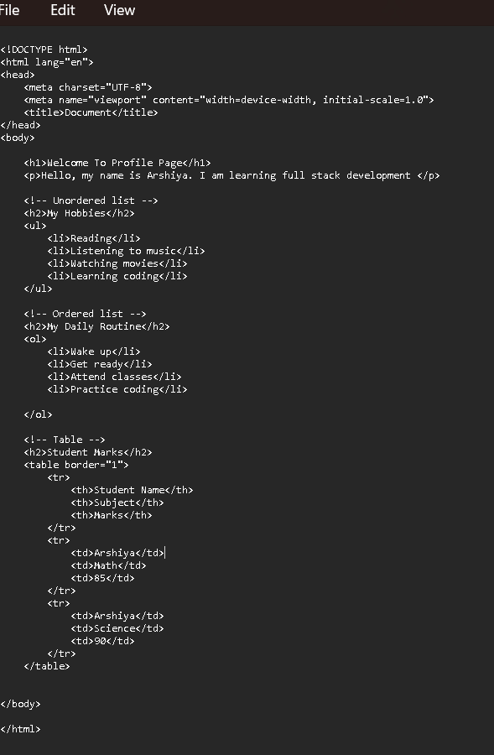

Output:

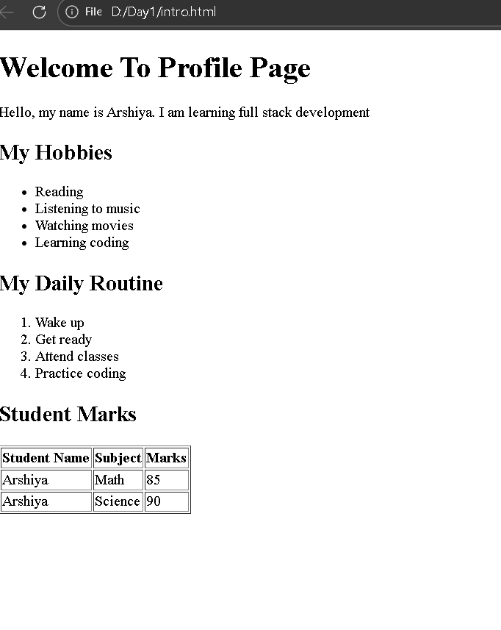

Code Explanation:

This HTML document begins with the <!DOCTYPE html> declaration, which tells the browser to use HTML5. The <html> tag is the root element that contains the entire webpage, and the lang="en" attribute specifies that the page is in English. Inside the <head> section, the <meta charset="UTF-8"> tag allows the use of all characters and symbols, while the viewport meta tag makes the page responsive on mobile devices. The <title> tag sets the text shown on the browser tab.
The <body> section contains all the visible content of the page. It starts with an <h1> heading that displays the main title, followed by a paragraph introducing the user. An <h2> heading introduces the hobbies section, which uses an unordered list (<ul>) with list items (<li>) to display hobbies. Another <h2> heading introduces the daily routine, shown using an ordered list (<ol>) to present steps in sequence. The student marks section uses a table created with the <table> tag, where <tr> defines rows, <th> defines header cells, and <td> defines data cells. Finally, the </body> and </html> tags close the webpage structure, completing the HTML document.

Problem 2: Restaurant Menu Webpage (Level-1)
Scenario
A small restaurant wants a basic menu webpage to display their offerings online before moving to a full website.

Requirements
Create an HTML page that displays:
Restaurant Name (Heading)
About the Restaurant (Paragraph)
Menu Categories (Unordered List)
Price List (Table)

Table Structure
Item Name
Category
Price (₹)
Paneer Butter Masala
Main Course
220
Veg Biryani
Main Course
180
Masala Dosa
Breakfast
90
Cold Coffee
Beverages
120

️ Technical Constraints
Use proper HTML boilerplate
Use at least 5 HTML elements
Use HTML attributes such as border, title, align
Use:
<table>, <tr>, <th>, <td>
<ul> and <li>
Learning Outcome
You should be able to:
Build a complete HTML page structure
Use tables for structured data
Use lists for grouped information

CODE:

<!DOCTYPE html>
<html lang="en">
<head>
<meta charset="UTF-8">
<title title="Restaurant Menu Page">Paradise Restaurant</title>
</head>
<body>

<h1>Paradise Restaurant</h1>

<!-- About Section -->
<p title="About the Restaurant">
Welcome to Paradise Restaurant! We serve delicious and freshly prepared vegetarian meals
with authentic flavors and affordable prices.
</p>

<!-- Menu Categories -->
<h2>Menu Categories</h2>
<ul title="Menu List">
<li>Breakfast</li>
<li>Main Course</li>
<li>Beverages</li>
</ul>

<!-- Price Table -->
<h2>Price List</h2>
<table border="1" title="Menu Price Table">
<tr>
<th>Item Name</th>
<th>Category</th>
<th>Price (₹)</th>
</tr>
<tr>
<td>Paneer Butter Masala</td>
<td>Main Course</td>
<td>220</td>
</tr>
<tr>
<td>Veg Biryani</td>
<td>Main Course</td>
<td>180</td>
</tr>
<tr>
<td>Masala Dosa</td>
<td>Breakfast</td>
<td>100</td>
</tr>
<tr>
<td>Cold Coffee</td>
<td>Beverages</td>
<td>80</td>
</tr>

</table>
</body>
</html>

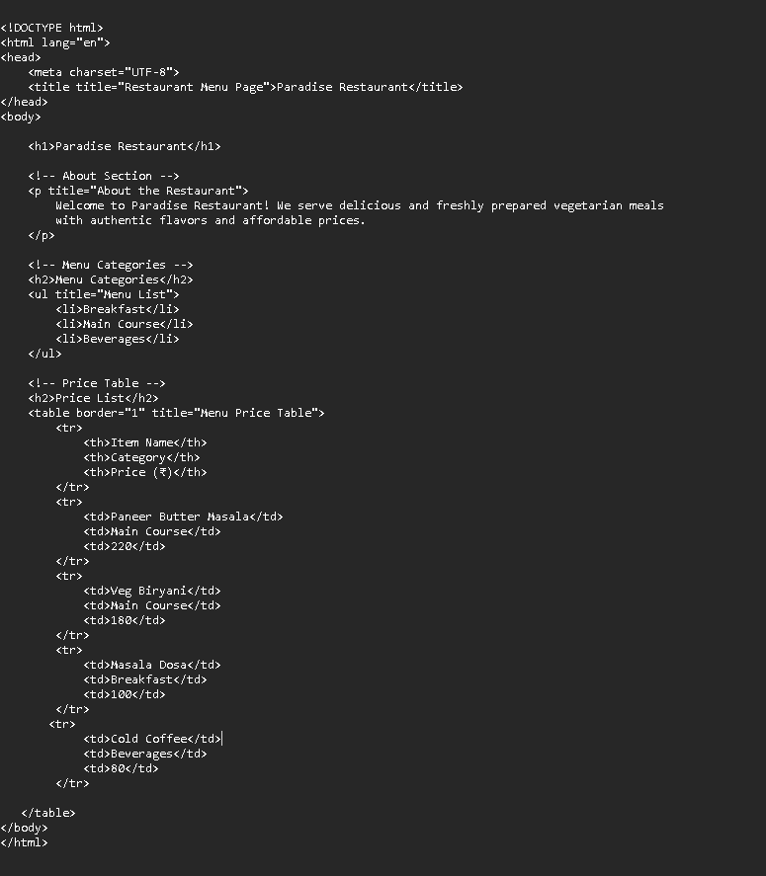

OUTPUT:

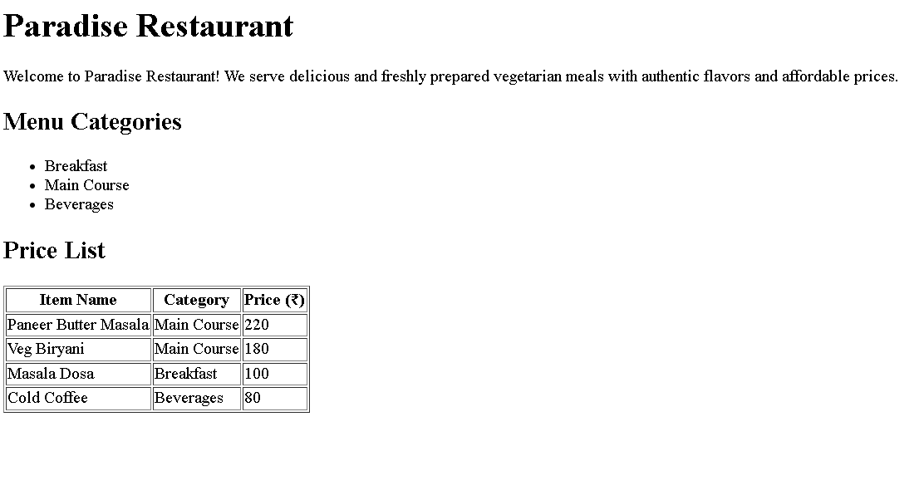

Code Explanation:

This HTML code creates a simple restaurant menu webpage. It begins with the <!DOCTYPE html> declaration, which tells the browser to use HTML5. The <html> tag is the root element of the page, and the lang="en" attribute specifies that the content is in English. Inside the <head> section, the <meta charset="UTF-8"> tag allows special characters like the rupee symbol, and the <title> tag sets the text that appears on the browser tab. The <title> tag should not contain a title attribute; it should only include the page title.
The <body> section contains the visible content of the page. It starts with an <h1> heading showing the restaurant name. Below that, a paragraph describes the restaurant, and its title attribute shows a tooltip when hovered. The menu categories are displayed using an <h2> subheading and an unordered list (<ul>) with list items (<li>). The price list is shown using a table created with the <table> tag, where <tr> defines rows and <th> defines header cells. This structure organizes the menu items clearly, making the webpage easy to read and understand.

Problem 3: Personal Grocery Checklist (Level-1)

Scenario
You are building a simple webpage for personal use to plan your weekly grocery shopping. The page should clearly show priority items and optional items, so it’s easy to decide what to buy first.
Requirements
Create an HTML webpage that includes:
A page title:
Weekly Grocery Checklist
A main heading displaying the same title.
An Ordered List showing high-priority grocery items, such as:
Rice
Milk
Vegetables
Cooking Oil
An Unordered List showing optional or non-essential items, such as:
Snacks
Ice cream
Soft drinks

️ Technical Constraints
Use proper HTML boilerplate:
<!DOCTYPE html>
<html>, <head>, <body>
Use:
<ol> and <ul> correctly
<li> for each item
Add at least one HTML attribute (example: title)
Ensure proper indentation and readability

CODE:

<!DOCTYPE html>
<html lang="en">
<head>
<title>Weekly Grocery Checklist</title>
<meta charset="UTF-8">
</head>
<body>

<h1>Weekly Grocery Checklist</h1>

<h2>High-Priority Items</h2>
<ol>
<li>Rice</li>
<li>Milk</li>
<li>Vegetables</li>
<li>Cooking Oil</li>
</ol>

<h2>Optional Items</h2>
<ul>
<li>Snacks</li>
<li>Ice cream</li>
<li>Soft drinks</li>
</ul>

</body>
</html>

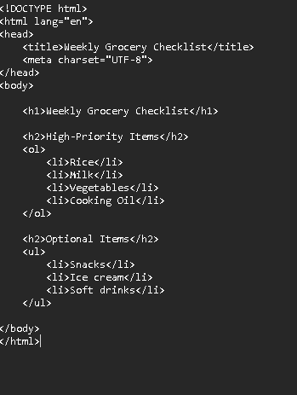

OUTPUT:

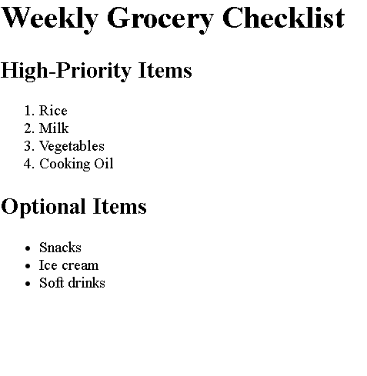

CODE EXPLANATION:

This HTML code creates a simple Weekly Grocery Checklist webpage. It starts with the <!DOCTYPE html> declaration, which tells the browser that the document uses HTML5 and ensures proper rendering. The <html> tag is the root element that contains the entire page, and the lang="en" attribute specifies that the content is in English. Inside the <head> section, the <title> tag sets the text shown on the browser tab, and the <meta charset="UTF-8"> tag allows the page to display all characters and symbols correctly.
The <body> section contains the visible content of the page. It begins with an <h1> heading that displays the main title, “Weekly Grocery Checklist.” The high-priority items are shown under an <h2> subheading using an ordered list (<ol>), which displays items in a numbered format. The optional items are displayed under another <h2> subheading using an unordered list (<ul>), which shows items with bullet points. Finally, the </body> and </html> tags close the webpage structure, completing the HTML document.

Problem 4: Employee Onboarding Page (Level-2)
Scenario
A company wants a basic onboarding page for new employees that HR can later style using CSS.

Requirements
Use Semantic HTML:
<header> → Company name & welcome message
<section> → Employee details
<article> → Company policies
<footer> → Contact information
Content Structure
Employee Information (Table)
Employee ID
Name
Department
Joining Date
Company Policies (Ordered List)
Working hours
Leave policy
Code of conduct
Facilities Provided (Unordered List)
Laptop
Internet access
Training materials

️ Technical Constraints
· Use semantic tags only (no <div> for layout)
· Add meaningful attributes (title, lang, etc.)
· Proper indentation & readability

CODE:

<!DOCTYPE html>
<html lang="en">
<head>
<meta charset="UTF-8">
<title title="Employee Onboarding Page">Employee Onboarding</title>
</head>
<body>

<header>
<h1>STAR Technologies</h1>
<p>Welcome to the company! We are excited to have you on board.</p>
</header>

<main>

<section>
<h2>Employee Information</h2>
<table border="1" title="Employee Details Table">
<tr>
<th>Employee ID</th>
<th>Name</th>
<th>Department</th>
<th>Joining Date</th>
</tr>
<tr>
<td>EMP001</td>
<td>Anjum</td>
<td>Software Development</td>
<td>16-Feb-2026</td>
</tr>
</table>
</section>

<article>
<h2>Company Policies</h2>
<ol>
<li title="Working Hours Policy">Working hours: 9:00 AM – 6:00 PM</li>
<li title="Leave Policy">Leave policy: 20 days annual leave</li>
<li title="Code of Conduct">Follow professional code of conduct</li>
</ol>

<h3>Facilities Provided</h3>
<ul>
<li>Laptop</li>
<li>Internet access</li>
<li>Training materials</li>
</ul>
</article>

</main>

<footer>
<p title="Contact Information">
Contact HR: hr@startech.com | +91-9876543210
</p>
</footer>

</body>
</html>

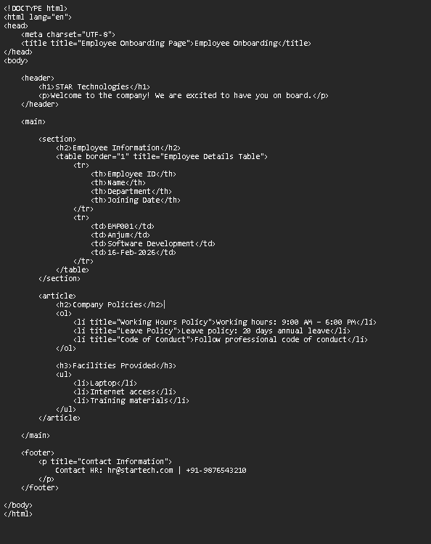

OUTPUT:

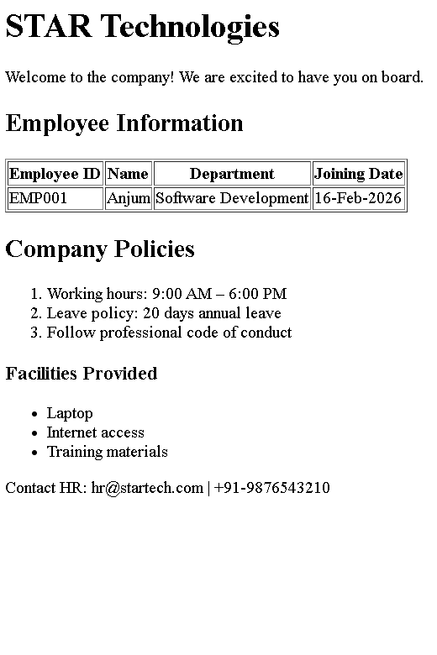

CODE EXPLANATION:

This HTML code creates a simple Employee Onboarding webpage using semantic HTML elements. The document begins with the <!DOCTYPE html> declaration, which tells the browser to use HTML5. Inside the <html> tag, the <head> section contains the character encoding and the page title, which appears on the browser tab. The <body> contains all the visible content. The <header> displays the company name and a welcome message for new employees. The <main> section organizes the main content into a <section> and an <article>. The section shows employee details in a table with columns for ID, name, department, and joining date. The article lists company policies using an ordered list and facilities using an unordered list. Finally, the <footer> provides HR contact information. Overall, the page uses semantic tags to structure the content clearly and make it easy to understand and maintain.

Problem 5: College Department Information Page (Level-2)
Scenario
A college wants to create a basic informational webpage for one of its departments (e.g., Computer Science, Information Technology).
The page will be used by students and parents to understand faculty details, subjects offered, and the weekly timetable before the site is enhanced with CSS and backend features.
Requirements
Create an HTML webpage that includes the following sections:
Header
Department Name
College Name
Section 1: Faculty Details
Display faculty information in a table with columns:
Faculty Name
Designation
Subject Handled
Section 2: Subjects Offered
Display the list of subjects using an unordered list
Section 3: Weekly Timetable
Display timetable details in a table with columns:
Day
Subject
Time Slot
Footer
College address
Contact information

️Technical Constraints
Use proper HTML document structure:
<!DOCTYPE html>
<html>, <head>, <body>
Use semantic HTML elements:
<header>, <section>, <footer>
Use:
<table>, <tr>, <th>, <td>
<ul> and <li>
Add meaningful HTML attributes such as lang or title
Avoid CSS and JavaScript (HTML only)

You will be able to:
Build real-world HTML pages with structured content
Understand how semantic HTML improves readability and maintenance
Organize information logically using tables and lists
Prepare HTML content that is ready for CSS styling and backend integration.

CODE:
<!DOCTYPE html>
<html lang="en">
<head>
<meta charset="UTF-8">
<title>Computer Science Department</title>
</head>
<body>

<!-- Header Section -->
<header>
<h1>Computer Science Department</h1>
<h2>JNTU Engineering College</h2>
</header>

<!-- Faculty Details Section -->
<section title="Faculty Details">
<h3>Faculty Details</h3>
<table border="1">
<tr>
<th>Faculty Name</th>
<th>Designation</th>
<th>Subject Handled</th>
</tr>
<tr>
<td>Dr. Ramesh Kumar</td>
<td>Professor</td>
<td>Data Structures</td>
</tr>
<tr>
<td>Ms. Anjali Sharma</td>
<td>Assistant Professor</td>
<td>Database Management</td>
</tr>
<tr>
<td>Mr. Suresh Reddy</td>
<td>Lecturer</td>
<td>Web Technologies</td>
</tr>
</table>
</section>

<!-- Subjects Offered Section -->
<section title="Subjects Offered">
<h3>Subjects Offered</h3>
<ul>
<li>Data Structures</li>
<li>Database Management Systems</li>
<li>Operating Systems</li>
<li>Web Technologies</li>
<li>Computer Networks</li>
</ul>
</section>

<!-- Weekly Timetable Section -->
<section title="Weekly Timetable">
<h3>Weekly Timetable</h3>
<table border="1">
<tr>
<th>Day</th>
<th>Subject</th>
<th>Time Slot</th>
</tr>
<tr>
<td>Monday</td>
<td>Data Structures</td>
<td>9:00 AM – 10:00 AM</td>
</tr>
<tr>
<td>Tuesday</td>
<td>Database Management</td>
<td>10:00 AM – 11:00 AM</td>
</tr>
<tr>
<td>Wednesday</td>
<td>Operating Systems</td>
<td>11:00 AM – 12:00 PM</td>
</tr>
<tr>
<td>Thursday</td>
<td>Web Technologies</td>
<td>1:00 PM – 2:00 PM</td>
</tr>
<tr>
<td>Friday</td>
<td>Computer Networks</td>
<td>2:00 PM – 3:00 PM</td>
</tr>
</table>
</section>

<!-- Footer Section -->
<footer>
<p>JNTU Engineering College, Main Road, Hyderabad, India</p>
<p>Contact: +91 98765 43210 | Email: info@jntuenggcollege.edu</p>
</footer>

</body>
</html>
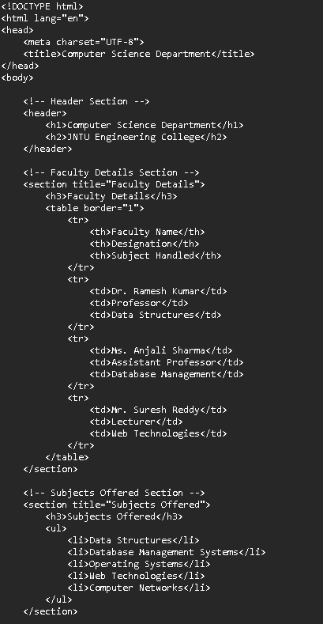

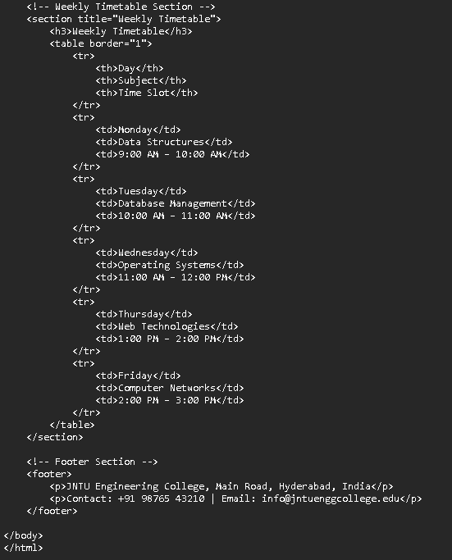

OUTPUT:

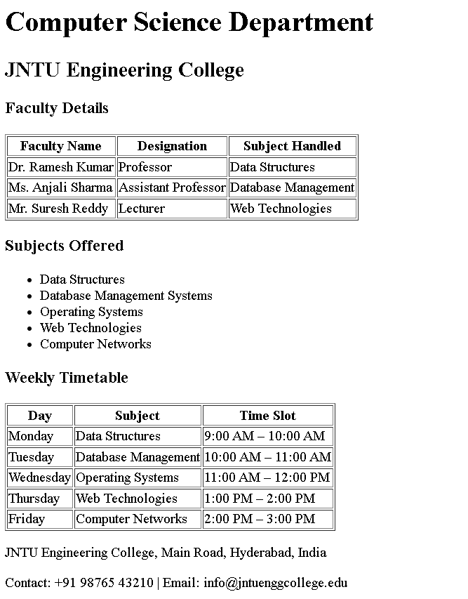

CODE EXPLANATION:

This HTML code creates a Computer Science Department information webpage using a clear and simple structure. The document starts with the <!DOCTYPE html> declaration, which tells the browser to use HTML5. Inside the <head> section, the character encoding is set and the page title is defined as “Computer Science Department,” which appears on the browser tab. The <body> contains all the visible content. The <header> section displays the department name and college name as headings. The first <section> shows faculty details in a table, including the faculty name, designation, and subject handled. The second section lists the subjects offered using an unordered list. The third section displays the weekly timetable in a table, showing the day, subject, and time slot. Finally, the <footer> provides the college address and contact information. Overall, the page uses semantic elements like header, section, and footer to organize the content in a clear and meaningful way.

