DAY-2 HTML5_Hands_On_ARSHIYA_ANJUM

Problem 1
Assessment Goal: Validate understanding of links and form elements.
Hands-on Tasks:
- Create two HTML pages and link them using navigation links
- Add a navigation bar with Home and Contact links
- Create a registration form with:
  - Name
  - Email
  - Password
  - Gender (radio buttons)
  - Course selection (dropdown)
- Use required and placeholder attributes
Expected Outcome:
A multi-page website with working navigation and a basic form.

CODE:
Index.html:
<!-- Arshiya_Anjum_HTML_Day2_Handson_problem_Statement1-->
<!DOCTYPE html>
<html lang="en">

<head>
<meta charset="UTF-8">
<title>Home</title>
</head>

<body>

<nav>
<a href="index.html">Home</a> |
<a href="contact.html">Contact</a>
</nav>

<h1>Welcome to Our Website</h1>

<h1>Register Here!</h1>

<form>

<label for="name">Name:</label><br>
<input type="text" id="name" name="name" placeholder="Enter your name" required><br><br>

<label for="email">Email:</label><br>
<input type="email" id="email" name="email" placeholder="Enter your email" required><br><br>

<label for="password">Password:</label><br>
<input type="password" id="password" name="password" placeholder="Enter password" required><br><br>

<label>Gender:</label><br>
<input type="radio" id="male" name="gender" value="Male" required>
<label for="male">Male</label>

<input type="radio" id="female" name="gender" value="Female">
<label for="female">Female</label><br><br>

<label for="course">Select Course:</label><br>
<input list="courses" id="course" name="course" placeholder="Choose or type course" required>

<datalist id="courses">
<option value="HTML">
<option value="CSS">
<option value="JavaScript">
<option value="Python">
</datalist>
<br><br>

<button type="submit">Register</button>
</form>

</body>

</html>

Contact.html:

<!DOCTYPE html>
<html lang="en">
<head>
<meta charset="UTF-8">
<title>Contact</title>
</head>
<body>

<nav>
<a href="index.html">Home</a> |
<a href="contact.html">Contact</a>
</nav>

<h1>Contact Us</h1>
<p>Email: Anjum@123.com</p>
<p>Phone: +91 98765 43210</p>

</body>
</html>

OUTPUT:

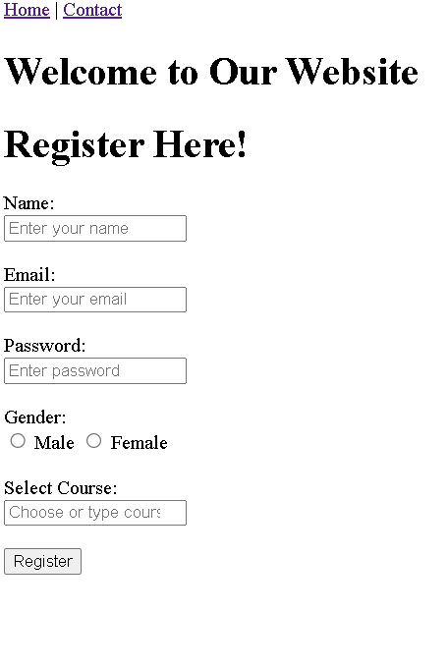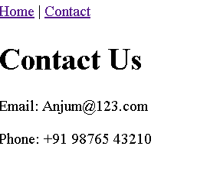

CODE EXPLANATION:

- The project contains two HTML pages: index.html (Home) and contact.html (Contact), connected using a navigation bar with links.
- The Home page includes a registration form with fields for name, email, password, gender (radio buttons), and course selection.
- The form uses required attributes to ensure mandatory input and placeholder text to guide the user.
- A datalist provides suggested course options while still allowing custom input.
- The Contact page displays basic contact details and shares the same navigation menu for easy page switching.

Problem 2: Simple Website Navigation System (Level-1)
Scenario
A small coaching institute wants a basic static website with multiple pages so students can easily navigate between sections like Home, Courses, and Contact.
📌 Requirements
- Create 3 HTML pages:
  - index.html (Home)
  - courses.html
  - contact.html
- Use:
  - <nav> element to create a navigation menu
  - <a> anchor tags for navigation
- Navigation menu should appear on all pages
- Use relative paths to link pages
- Include at least:
  - One internal anchor link (#section)
  - One external link (e.g., institute’s social media)

🛠️ Technical Constraints
- Only HTML5
- No CSS or JavaScript
- Navigation must be semantic (<nav>)
🎯 Learning Outcome
You should be able to:
- Use <nav> and <a> elements
- Understand relative paths
- Build a simple multi-page navigation structure
- Users should move seamlessly between pages
- Code should be readable and well-indented
- Navigation links should work correctly

CODE:
Index.html:
<!-- Arshiya_Anjum_HTML_Day2_Handson_problem_Statement2-->
<!DOCTYPE html>
<html lang="en">
<head>
<meta charset="UTF-8">
<title>CodeSpark Institute - Home</title>
</head>
<body>

<header>
<h1>CodeSpark Institute</h1>

<nav>
<a href="index.html">Home</a> |
<a href="courses.html">Courses</a> |
<a href="contact.html">Contact</a>
</nav>
</header>

<main>
<h2>Welcome to CodeSpark Institute</h2>
<img src="img.png"
alt="Sample Institute Image" width="400px" height="200px">

<p>
We help students achieve their academic goals through expert teaching
and personalized guidance.
</p>

<p>
<a href="#highlights">Jump to Institute Highlights</a>
</p>

<section id="highlights">
<h2>Institute Highlights</h2>
<ul>
<li>Experienced faculty</li>
<li>Small batch sizes</li>
<li>Weekly tests and feedback</li>
<li>Career guidance sessions</li>
</ul>
</section>

<h3>Follow us on social media</h3>
<p>
<a href="https://www.instagram.com" target="_blank">
Visit our Instagram page
</a>
</p>
</main>

<footer>
<p>&copy; 2026 CodeSpark Institute</p>
</footer>

</body>
</html>

courses.html:
<!DOCTYPE html>
<html lang="en">
<head>
<meta charset="UTF-8">
<title>Courses - CodeSpark Institute</title>
</head>
<body>

<header>
<h1>Our Courses</h1>
<nav>
<a href="index.html">Home</a> |
<a href="courses.html">Courses</a> |
<a href="contact.html">Contact</a>
</nav>
</header>

<main>
<h2>Popular Courses</h2>

<section>
<h3>Web Development</h3>
<p>Learn HTML, CSS, JavaScript, and modern web tools.</p>
</section>

<section>
<h3>Python Programming</h3>
<p>Start from basics and move to real-world projects.</p>
</section>

<section>
<h3>Data Structures</h3>
<p>Master problem-solving and algorithms.</p>
</section>

<p>
<a href="#schedule">Jump to Class Schedule</a>
</p>

<section id="schedule">
<h2>Class Schedule</h2>
<ul>
<li>Morning Batch: 8:00 AM - 10:00 AM</li>
<li>Afternoon Batch: 1:00 PM - 3:00 PM</li>
<li>Evening Batch: 6:00 PM - 8:00 PM</li>
</ul>
</section>
<p>
<a href="https://www.youtube.com" target="_blank">
Watch our free demo classes on YouTube
</a>
</p>
</main>

<footer>
<p>&copy; 2026 CodeSpark Institute</p>
</footer>

</body>
</html>

Contact.html:

<!DOCTYPE html>
<html lang="en">
<head>
<meta charset="UTF-8">
<title>Contact -CodeSpark Institute</title>
</head>
<body>

<header>
<h1>Contact Us</h1>

<nav>
<a href="index.html">Home</a> |
<a href="courses.html">Courses</a> |
<a href="contact.html">Contact</a>
</nav>
</header>

<main>
<h2>Get in Touch</h2>

<p><strong>Address:</strong> Subhashnagar Street, Chennai</p>
<p><strong>Phone:</strong> +91 98765 43210</p>
<p><strong>Email:</strong> info@brightfuture.com</p>

<p>
<a href="#map">Jump to Location Details</a>
</p>

<section id="map">
<h3>Location Details</h3>
<p>
Our institute is near the central bus stand,
opposite City Library.
</p>
</section>
<p>
<a href="https://maps.google.com" target="_blank">
Open location in Google Maps
</a>
</p>
</main>
<footer>
<p>&copy; 2026 CodeSpark Institute</p>
</footer>
</body>
</html>

OUTPUT: 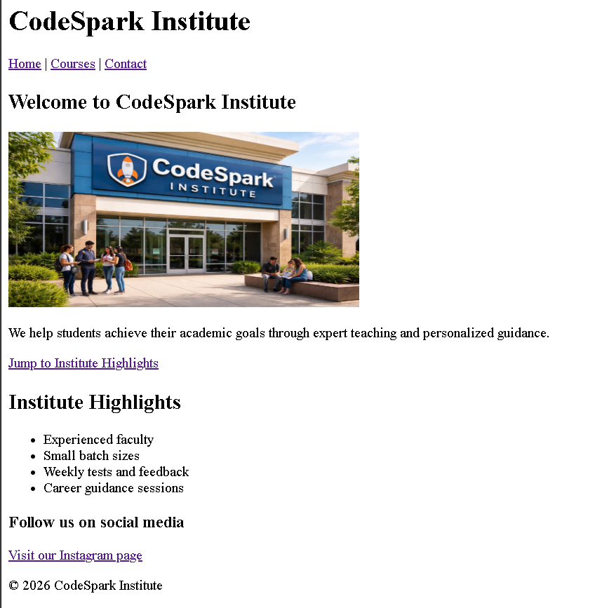

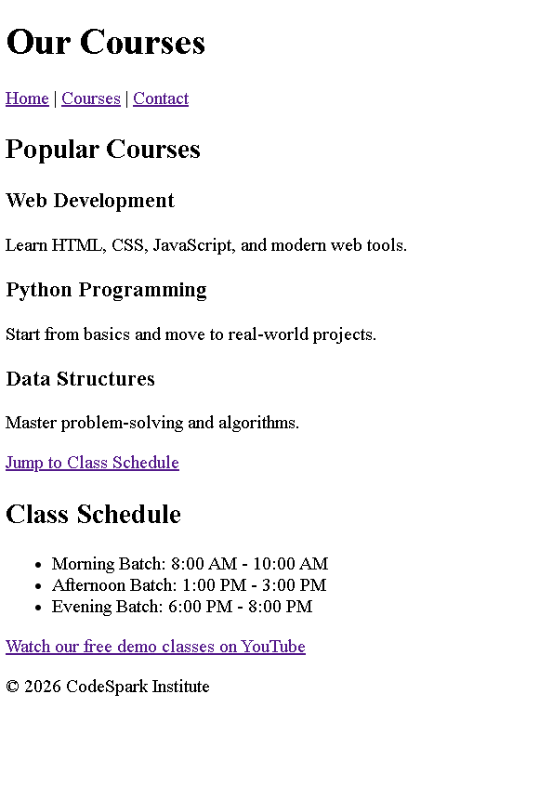

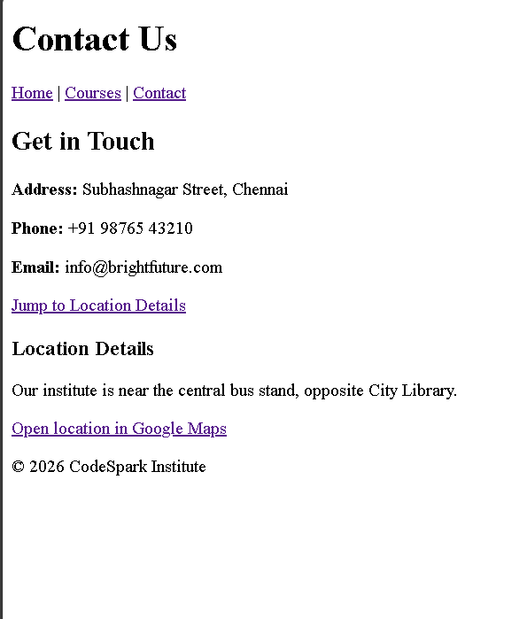

CODE EXPLANATION:
- The project contains three pages: index.html, courses.html, and contact.html.
- Each page uses a semantic <nav> element with anchor (<a>) tags for navigation.
- The same navigation menu appears on all pages, allowing smooth movement between sections.
- Relative paths are used to link the pages.
- An internal anchor link (#highlights, #schedule, #map) jumps to specific sections.
- External links open social media or other sites in a new tab using target="_blank".

Problem 3: Student Registration Form with Input Types (Level-1)
Scenario
An institute wants a basic student registration form with built-in validation to reduce incorrect submissions.
📌 Requirements
Create an HTML webpage that includes:
Create a form with following input types:
- text (Name)
- email
- tel
- number (Age)
- date
Use HTML5 built-in validation:
- required
- min, max
- pattern (for phone number)
Add submit button

🛠️ Technical Constraints
- HTML5 only
- No JavaScript validation
- Use proper <label> tags

🎯 Learning Outcome
You will be able to:
- Use advanced input types
- Apply built-in HTML5 validation
- Improve form usability without JavaScript
- Browser should show validation errors automatically
- Inputs should restrict invalid values
- Form should be user-friendly

CODE:
Index.html:

<!-- Arshiya_Anjum_HTML_Day2_Handson_problem_Statement3-->
<!DOCTYPE html>
<html lang="en">
<head>
<meta charset="UTF-8">
<title>Student Registration Form</title>
</head>
<body>

<h1>Student Registration</h1>

<form action="success.html">

<label for="name">Full Name:</label><br>
<input type="text" id="name" name="name" required>
<br><br>

<label for="email">Email Address:</label><br>
<input type="email" id="email" name="email" required>
<br><br>

<label for="phone">Phone Number:</label><br>
<input
type="tel"
id="phone"
name="phone"
pattern="[0-9]{10}"
placeholder="10 digit number"
required>
<br><br>

<label for="age">Age:</label><br>
<input
type="number"
id="age"
name="age"
min="16"
max="60"
required>
<br><br>

<label for="dob">Date of Birth:</label><br>
<input type="date" id="dob" name="dob" required>
<br><br>

<button type="submit">Register</button>

</form>

</body>
</html>

success.html:

<!DOCTYPE html>
<html lang="en">
<head>
<meta charset="UTF-8">
<title>Registration Successful</title>
</head>
<body>

<h1>Registration Successful!</h1>
<p>Your form has been submitted successfully.</p>

<a href="index.html">Go back to registration form</a>

</body>
</html>

OUTPUT:

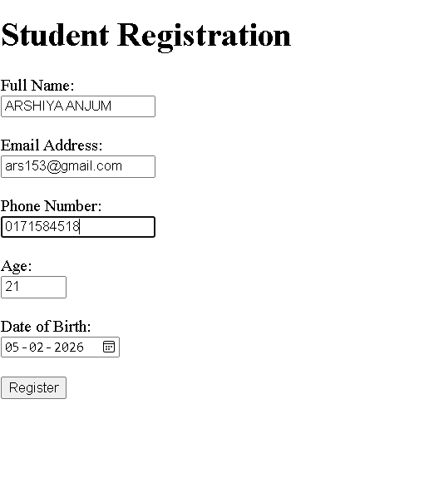
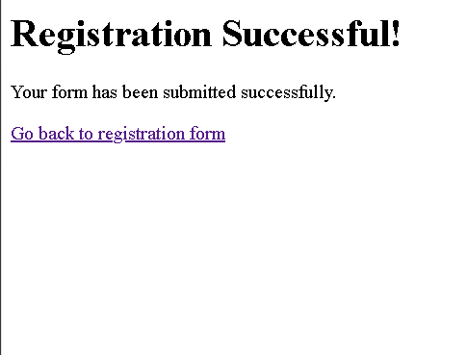

CODE EXPLANATION:

- This page contains a student registration form with various HTML5 input types.
- Inputs include text (name), email, telephone, number (age), and date.
- The form uses built-in validation:
- required ensures fields are not empty.
- min and max restrict the age range.
- pattern ensures a 10-digit phone number.
- When the form is submitted, the user is redirected to success.html.

Problem 4: Multi-Page Website with Breadcrumb Navigation (Level-2)
Scenario
A training portal website has multiple levels of pages and users often get confused about where they are. The company wants breadcrumbs for better navigation.
📌 Requirements
Pages:
- Home
- Courses
- Web Development
- HTML Course
Implement:
- <nav> for main menu
- Breadcrumb navigation using anchor tags
Example:
Home > Courses > Web Development > HTML
Use:
- Hierarchical linking
- Relative paths
Breadcrumb should update based on page hierarchy

🛠️ Technical Constraints
- HTML5 only
- No CSS frameworks
- Semantic elements preferred

🎯 Learning Outcome
Learners should be able to:
- Breadcrumbs must reflect correct page structure
- Navigation must work without broken links
- Clear hierarchy in folder structure
- Design hierarchical navigation
- Implement breadcrumbs
- Understand real-world website structure

CODE:
Index.html:
<!-- Arshiya_Anjum_HTML_Day2_Handson_problem_Statement4-->
<!DOCTYPE html>
<html lang="en">
<head>
<meta charset="UTF-8">
<title>Home</title>
</head>
<body>

<nav>
<a href="index.html">Home</a> |
<a href="courses.html">Courses</a>
</nav>

<h1>Welcome to Training Portal</h1>
<p>This is the home page.</p>

</body>
</html>

courses.html:
<!DOCTYPE html>
<html lang="en">
<head>
<meta charset="UTF-8">
<title>Courses</title>
</head>
<body>

<nav>
<a href="index.html">Home</a> |
<a href="courses.html">Courses</a>
</nav>

<!-- Breadcrumb -->
<p>
<a href="index.html">Home</a> >
Courses
</p>

<h1>Courses</h1>
<a href="web-development.html">Web Development</a>

</body>
</html>

web-development.html:
<!DOCTYPE html>
<html lang="en">
<head>
<meta charset="UTF-8">
<title>Web Development</title>
</head>
<body>

<nav>
<a href="index.html">Home</a> |
<a href="courses.html">Courses</a>
</nav>

<!-- Breadcrumb -->
<p>
<a href="index.html">Home</a> >
<a href="courses.html">Courses</a> >
Web Development
</p>

<h1>Web Development</h1>
<a href="html-course.html">HTML Course</a>

</body>
</html>

html-course.html:
<!DOCTYPE html>
<html lang="en">
<head>
<meta charset="UTF-8">
<title>HTML Course</title>
</head>
<body>
<nav>
<a href="index.html">Home</a> |
<a href="courses.html">Courses</a>
</nav>
<!-- Breadcrumb -->
<p>
<a href="index.html">Home</a> >
<a href="courses.html">Courses</a> >
<a href="web-development.html">Web Development</a> >
HTML Course
</p>
<h1>HTML Course</h1>
<p>Welcome to the HTML course.</p>
</body>
</html>

OUTPUT:

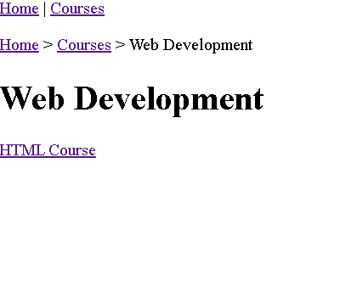
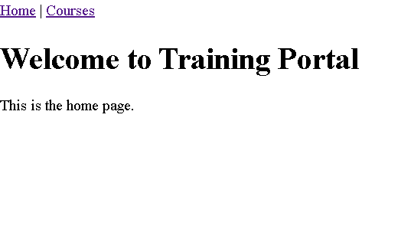
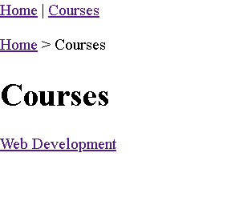
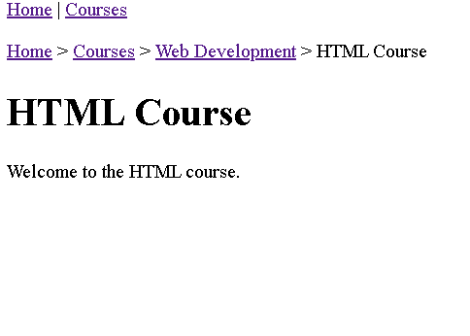

CODE EXPLANATION:

- The website contains a hierarchical structure of pages:
- Home → Courses → Web Development → HTML Course.
- Each page includes a main navigation menu using <nav>.
- A breadcrumb trail shows the user’s current location in the site structure.
- Breadcrumb links use relative paths to move back to parent pages.
- This improves navigation and helps users understand the page hierarchy.

Problem 5: Course Enrollment Form with Advanced HTML Elements
Scenario
An online learning platform wants to enhance user experience by showing course progress, skill levels, and suggested inputs while filling the form.
📌 Requirements
Create an enrollment form using:
- <datalist> for course suggestions
- <progress> to show enrollment completion
- <meter> to indicate skill level (Beginner–Advanced)
Include modern input types:
- email
- range
- number
Use built-in validation

🛠️ Technical Constraints
- HTML5 only
- No JavaScript or CSS
- Must use semantic elements

🎯 Learning Outcome
You will be able to:
- Use advanced HTML5 elements
- Enhance form UX without JavaScript
- Understand real-time data representation in HTML
Browser should display:
- Dropdown suggestions via <datalist>
- Progress bar updates (static value)
- Meter shows skill level visually
Clean and structured form layout

CODE:
index.html:

<!-- Arshiya_Anjum_HTML_Day2_Handson_problem_Statement5-->
<!DOCTYPE html>
<html lang="en">
<head>
<meta charset="UTF-8">
<title>Course Enrollment Form</title>
</head>
<body>

<header>
<h1>Online Course Enrollment</h1>
<p>Fill in your details to enroll in a course.</p>
</header>

<main>
<section>
<h2>Enrollment Progress</h2>
<!-- Static progress bar -->
<progress value="60" max="100">60%</progress>
<p>Form completion: 60%</p>
</section>

<section>
<h2>Enrollment Form</h2>

<form action="#" method="post">

<!-- Name -->
<p>
<label for="name">Full Name:</label><br>
<input type="text" id="name" name="name" required>
</p>

<!-- Email -->
<p>
<label for="email">Email Address:</label><br>
<input type="email" id="email" name="email" required>
</p>

<!-- Course with datalist -->
<p>
<label for="course">Select Course:</label><br>
<input list="courses" id="course" name="course" required>
<datalist id="courses">
<option value="HTML Basics">
<option value="CSS Fundamentals">
<option value="JavaScript Essentials">
<option value="Python for Beginners">
<option value="Full Stack Development">
</datalist>
</p>

<!-- Age -->
<p>
<label for="age">Age:</label><br>
<input type="number" id="age" name="age" min="15" max="60" required>
</p>

<!-- Skill level range -->
<p>
<label for="skill">Select Skill Level:</label><br>
<input type="range" id="skill" name="skill" min="0" max="10" value="5">
</p>

<!-- Meter to show skill level -->
<section>
<h3>Skill Level Indicator</h3>
<meter value="5" min="0" max="10" low="3" high="7" optimum="9">
Skill level
</meter>
<p>Beginner → Advanced</p>
</section>

<!-- Submit -->
<p>
<input type="submit" value="Enroll Now">
</p>

</form>
</section>
</main>

<footer>
<p>© 2026 Online Learning Platform</p>
</footer>

</body>
</html>

OUTPUT:
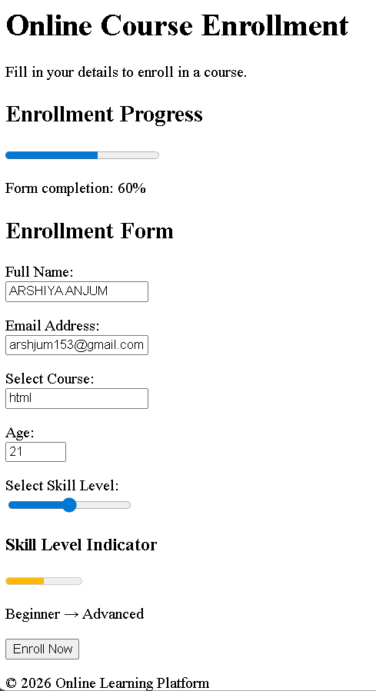

CODE EXPLANATION:

- This page contains a course enrollment form using advanced HTML5 elements.
- A <progress> element shows form completion percentage.
- A <datalist> provides course suggestions while still allowing custom input.
- A <range> input lets users select their skill level.
- A <meter> visually displays the skill level from beginner to advanced.
- Built-in validation ensures required fields are filled correctly.

