1.States of a Process In Linux
In Linux, the process goes through several states during its lifetime. The stages of a process in Linux are as follows:
1. Created: A process is created when a program is executed.
2. Ready: The process enters the "ready" state when it is waiting to be assigned to a processor by the Linux scheduler.
3. Running: The process enters the "running" state when it is assigned to a processor and is actively executing its instructions.
4. Waiting: The process enters the "waiting" state when it is waiting for some event to occur, such as input/output completion, a signal, or a timer.
5. Zombie: A process enters the "zombie" state when it has completed its execution but its parent process has not yet read its exit status.
6. Stopped: The process enters the "paused" when is has passed usually by a command user.
7. Terminated: The process enters the "terminated" state when it has completed its execution or has been terminated by a signal.
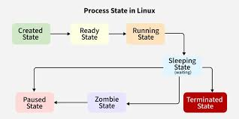

2. Five commonly used commands
Hostname – to check hostname
free -m – to check the memory
df -h – to check the dick space
uname -r – to check the kernel version
hostname -f – to check fqdn of the server
Here is the link of the articles for linux architecture and linux booting process
https://lnkd.in/g7c2DxuD
https://lnkd.in/g7c2DxuD

