Project Title
URL SAFETY CHECKER

Internship Organization:
SAM AI Technologies

Duration:
1 Months Internship

Year: 2026

Project Report Submitted By
Name: Arshi

URL SAFETY CHECKER
Project Analysis, Testing, Limitations & Improvement Roadmap
Project type: Beginner Cybersecurity / Web Security | Implementation: HTML, CSS, JavaScript
Prepared with the assistance of an AI tool. The project code and recommendations should be reviewed, tested, and understood by the student before submission.
Source reviewed: URL Safety Checker.html (uploaded project file). Analysis is based on the source code; browser execution and live URL-reputation checks were not performed as part of this review.

1. Executive Summary
This project is a browser-based URL Safety Checker implemented in HTML, CSS, and JavaScript. A user enters a URL and selects “Check URL”. The program validates the URL format, checks selected risk indicators, calculates a heuristic score, and labels the result LOW, MEDIUM, or HIGH.
The current version is a useful beginner-level cybersecurity demonstration. It does not query threat-intelligence databases, inspect the destination website, verify certificate trust, or prove that a URL is safe. “SAFE” in the current UI means only that the implemented rules did not produce a high score.

2. Project Definition
URL Safety Checker is a client-side, rule-based tool that evaluates a submitted HTTP/HTTPS URL against a small set of suspicious indicators and displays a risk score with the reasons that contributed to it.
Objective: help a user notice common URL warning signs before opening a link. Intended use: educational demonstration and preliminary triage—not a replacement for a browser security warning, antivirus, security gateway, or professional phishing analysis.

3. Technology Stack and Terminology
HTML (HyperText Markup Language): creates the page structure, URL input, button, and report area.
CSS (Cascading Style Sheets): controls the dark theme, layout, input, button, and risk-result colors.
JavaScript: performs URL parsing, applies the checks, calculates the score, and updates the page. Important correction: the supplied file uses JavaScript, not Java. Java and JavaScript are different programming languages.
Browser URL API: new URL(rawUrl) parses and normalizes a URL and allows the program to read protocol and hostname.

4. Current Features — Option-by-Option Definition
Option 1 — URL Input: a text field accepts the URL. The initial value is http://192.168.1.20/login/verify. A user can replace it with a test URL.
Option 2 — URL Format Validation: new URL(rawUrl) attempts to parse the value. The code accepts only http: and https:. Other protocols and invalid input display an invalid-format message.
Option 3 — HTTPS Check: if the protocol is not HTTPS, add 2 risk points. HTTPS encrypts transport when configured correctly, but HTTPS alone does not prove that a website is legitimate.
Option 4 — IP Address Check: a regular expression checks for a dotted-decimal IPv4-looking hostname. A match adds 2 points. The regular expression does not validate each octet to the 0–255 range and does not detect IPv6 addresses.
Option 5 — Suspicious Keyword Check: searches the full input, case-insensitively, for login, verify, password, account, secure, update, signin, payment, banking, and authenticate. The score is the number of matched keywords, capped at 3 points. These words can also appear in legitimate URLs, so this check can create false positives.
Option 6 — Subdomain Count: splits the hostname on dots and treats all parts beyond two as subdomains. If the count is at least 3, add 2 points. This is a simple approximation and does not understand public suffixes such as co.uk.
Option 7 — URL Length: if the raw URL is longer than 75 characters, add 1 point. Long URLs can be legitimate; short URLs can be malicious.
Option 8 — Suspicious TLD Check: adds 1 point if the hostname ends with one of .tk, .ml, .ga, .cf, .gq, .xyz, or .top. A top-level domain alone is not evidence of maliciousness; lists also become outdated.
Option 9 — Risk Classification: score 0–2 = LOW / SAFE; score 3–4 = MEDIUM / SUSPICIOUS; score 5 or above = HIGH / SUSPICIOUS.
Option 10 — Risk Factors Report: shows the entered URL, validity, HTTPS status, IP indicator, matched keywords, subdomain count, length, score, risk level, result, and reasons that added points.

5. Program Workflow
1. Read and trim the input. 2. Parse the URL using the browser URL API. 3. Reject invalid URLs or protocols other than HTTP/HTTPS. 4. Check HTTPS, IPv4-looking host, keywords, subdomains, URL length, and listed TLDs. 5. Add rule-based points. 6. Map the score to a risk level. 7. display the summary and risk reasons.
Current scoring rules: HTTP +2; IPv4-looking hostname +2; matched keywords + up to 3; 3 or more estimated subdomains +2; URL length over 75 characters +1; listed TLD +1.

6. Static Code Analysis — Findings
Finding A — No live reputation lookup: the program does not contact a threat-intelligence service or determine whether the URL is known to host phishing or malware.
Finding B — “SAFE” may overstate certainty: a low score only means few configured indicators matched. Change the wording to “LOW RISK INDICATORS DETECTED — NOT A GUARANTEE OF SAFETY.”
Finding C — Potential HTML injection in report rendering: raw user input is interpolated into outputDiv.innerHTML. Because the report is built as HTML, untrusted input should not be inserted this way. Prefer creating DOM elements and assigning user-controlled values with textContent. This is an important security improvement for a security-focused project.
Finding D — IP detection is incomplete: the regex checks the shape of IPv4 addresses but not numeric range; IPv6 is not covered.
Finding E — Heuristic limitations: keyword/TLD/length/subdomain rules can flag legitimate URLs and miss carefully crafted malicious URLs. The score thresholds have not been validated against a labeled dataset.
Finding F — No automated tests: the file contains no test suite, measured precision/recall, or documented benchmark.
Finding G — No accessibility and input-state enhancements: add clear error messages, keyboard-friendly behavior, accessible status announcements, and responsive-layout checks.
Finding H — No server-side component or persistent report: the supplied file runs in the browser only. It does not save reports or provide centralized monitoring.

7. Recommended Improvements — Prioritized Roadmap
Priority 1 — Fix output handling: never place raw input directly into innerHTML. Build report rows as DOM nodes and use textContent for user-controlled strings. Retest with harmless HTML-like strings to confirm they display as text.
Priority 2 — Improve wording: replace “SAFE” with “No configured warning indicators found” and show a disclaimer on every result.
Priority 3 — Strengthen parsing: trim input; explicitly require a hostname; handle IPv4 and IPv6 correctly; validate IPv4 octets; normalize internationalized domain names; and test user-info tricks such as trusted.example@evil.example.
Priority 4 — Explain scoring: display a short explanation for each indicator and make it clear that the score is a heuristic, not a probability.
Priority 5 — Add threat intelligence (optional next phase): use a reputable URL-reputation API through a small backend service. Keep API keys on the server, not in front-end JavaScript. Check provider terms, rate limits, privacy, and whether submitted URLs may be stored/shared. Do not automatically visit suspicious URLs.
Priority 6 — Add safe analysis signals: where feasible, include domain age/reputation, redirect-chain analysis, certificate details, and DNS signals via a controlled backend. These are enhancements, not proof of safety.
Priority 7 — Testing and evidence: create a test matrix, unit tests for each rule, and a small labeled dataset. Measure false positives, false negatives, precision, and recall before claiming detection accuracy.
Priority 8 — User experience: add Clear button, example URLs, loading/error states for API checks, accessible labels/status announcements, and mobile responsiveness.
Priority 9 — Privacy and documentation: do not store full URLs unnecessarily; query strings can contain tokens or personal data. Document what is processed, where it is sent, retention, limitations, and safe testing rules.

8. Test Plan and Expected Results
Test 1 — https://example.com : expected format valid, HTTPS YES, no listed indicator, score 0, LOW. Interpretation: no configured warning indicators; not proof of safety.
Test 2 — http://example.com : expected HTTP +2, score 2, LOW.
Test 3 — http://192.168.1.20/login/verify : expected HTTP +2, IP-looking host +2, keywords login and verify +2; total score 6, HIGH / SUSPICIOUS.
Test 4 — https://secure.login.example.xyz : expected keywords secure and login (+2), listed TLD .xyz (+1); score 3, MEDIUM / SUSPICIOUS. Subdomain count is 2, so the excessive-subdomain rule does not trigger.
Test 5 — example.com : expected invalid format because the code requires a parseable absolute URL and HTTP/HTTPS protocol.
Test 6 — https://a.b.c.d.example.com : expected excessive subdomains (4, +2); other checks may also contribute depending on the full URL and hostname.
Test 7 — URL longer than 75 characters on HTTPS and a normal hostname: expected +1 for length only, assuming no other indicators.
Test 8 — IPv6 URL such as https://[2001:db8::1]/ : URL parsing may succeed, but current IPv4 regex will not classify the hostname as an IP.
Test 9 — Input containing HTML-like characters in a URL: test safely in a local browser after fixing output rendering. Confirm it is displayed as text and no markup/event handler is executed.

9. How to Demonstrate the Project
1. Open URL Safety Checker.html in a modern browser. 2. Enter one test URL from the table. 3. Click Check URL. 4. Record the displayed risk score and reasons. 5. Repeat with at least three different test cases. 6. Capture screenshots of the initial page, a low-risk example, a medium/high-risk example, and invalid input. 7. Include the code file, screenshots, this report, and a short limitations section in the internship submission.
Use only URLs you own, documented training examples, or safe reserved/example domains. Do not open or scan suspicious live links just to demonstrate the project.

10. Recommended Project Structure for the Improved Version
URL-Safety-Checker/ | index.html (page structure) | style.css (styles) | app.js (validation and scoring) | tests/ (test cases) | screenshots/ (evidence) | docs/project-report.pdf | README.md (setup, features, limitations, test results, AI disclosure).
Splitting HTML, CSS, and JavaScript into separate files improves maintainability. A backend and reputation API should be added only as a clearly documented next phase.

11. Limitations and Ethical Use
The present tool is a lightweight educational heuristic, not a validated phishing detector. It does not fetch the target site, inspect page content, verify real-time reputation, or guarantee a safe/unsafe verdict. False positives and false negatives are expected.
Do not use it as the sole basis for security decisions. Do not submit private URLs, session tokens, or confidential links to third-party reputation services without authorization. Test only in a lawful, controlled environment.

12. Conclusion
The uploaded file is a functional starting point for a beginner cybersecurity project. Its strongest demonstration points are URL parsing, rule-based scoring, and explaining which indicators contributed to a result. Before presenting it as an improved project, prioritize safe output rendering, more accurate parsing, cautious result wording, repeatable tests, and documented limitations. Add external reputation checking only in a later phase and implement it with privacy and API-key protection.
Internship note: no selection can be guaranteed by a report. Be prepared to explain each rule, show the tests live, discuss false positives/negatives, and clearly state which improvements are implemented versus planned.

AI Assistance Disclosure
This report was prepared with the assistance of an AI tool for code review, explanation, test-case planning, and documentation drafting. The project source file was reviewed as provided. The student should personally verify the findings, run the test cases, add actual screenshots/results, and ensure that the final submission follows the internship provider’s AI-use policy. AI assistance should be disclosed honestly; do not claim unperformed tests or unimplemented features.

Appendix A — Scoring Summary
Indicator | Condition | Points
HTTP protocol | Protocol is http: | +2
IPv4-looking host | Regex matches dotted decimal | +2
Suspicious keywords | Number of matched terms, capped | +0 to +3
Excessive subdomains | Estimated count >= 3 | +2
URL length | More than 75 characters | +1
Listed TLD | Hostname ends with listed TLD | +1
Classification thresholds: 0–2 LOW; 3–4 MEDIUM; 5+ HIGH.

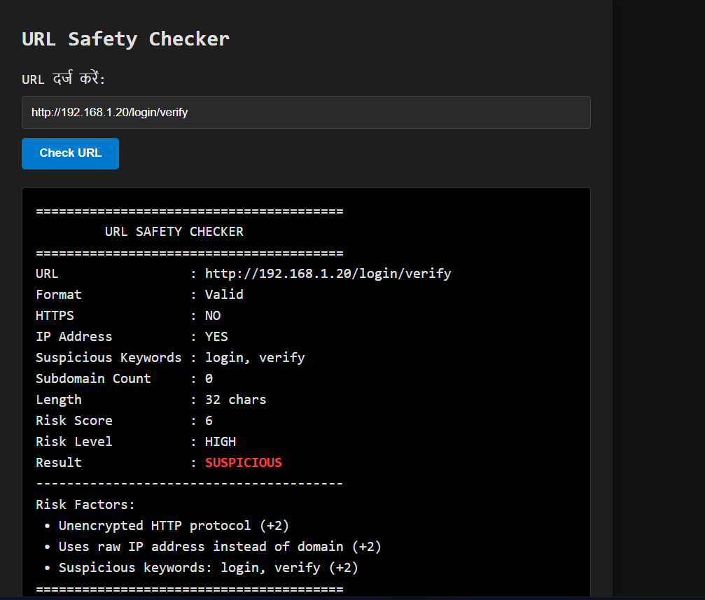

Definition :The URL Safety Checker is an automated heuristic security analysis interface designed to evaluate web addresses for potential phishing, credential harvesting, and social engineering threats. By parsing URL syntax, inspecting transport-layer encryption (HTTPS), detecting direct IP address hosting, and scanning lexical patterns for sensitive keywords, the system computes a quantitative risk score to categorize targets into standardized risk tiers (LOW, MEDIUM, HIGH) with a final deterministic verdict of SAFE or SUSPICIOUS."

About the Project: URL Safety Checker
The URL Safety Checker is a lightweight cybersecurity utility built to detect structural anomalies and deceptive indicators commonly found in malicious web links. Traditional web browsing often exposes users to zero-day phishing campaigns and spoofed portals before reputation blacklists can update their databases. This tool bridges that gap by running multi-vector heuristic analysis directly on the link parameters before user navigation occurs.

Key Capabilities & Architecture
- Syntax & Format Validation: Parses incoming URLs to verify standard RFC web compliance, ensuring proper schema isolation (http:// vs https://) and host boundary recognition.

- Protocol & Encryption Verification: Flags unencrypted HTTP connections (HTTPS: NO), warning users against entering credentials over insecure channels.

- Host Type & IP Detection: Identifies direct IPv4/IPv6 host addresses (IP Address: YES) used in place of fully qualified domain names (FQDN), a common tactic used to bypass domain reputation checks.

- Lexical Pattern Matching: Analyzes path and query strings to flag social engineering bait keywords such as login, verify, password, and account.

- Structural Metrics Calculation: Monitors nested subdomain depth and excessive URL length thresholds to catch obfuscated redirect chains.

- Weighted Risk Scoring Engine: Aggregates individual threat scores (e.g., HTTP penalty, IP penalty, keyword occurrences) into a comprehensive cumulative score, producing a transparent risk breakdown and final safety verdict.

