**ILLUSTRATIONS**

These are a few illustrations to have an idea about how the program’s flow works. There are several test cases possible depending on the user inputs.

**CASE 1:**

User Inputs:

* Preferred Vendors: **-1** (All vendors will be considered)
* Preferred lower and upper limit for 24-month monthly price at $0 down: **-1** (Consider entire range)
* Preferred lower and upper limit for Full Device price: **-1** (Consider entire range)
* Preferred Colors: -1 (Consider all colors)

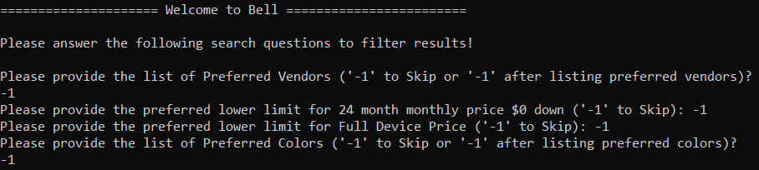

**OUTPUT RESULTS**

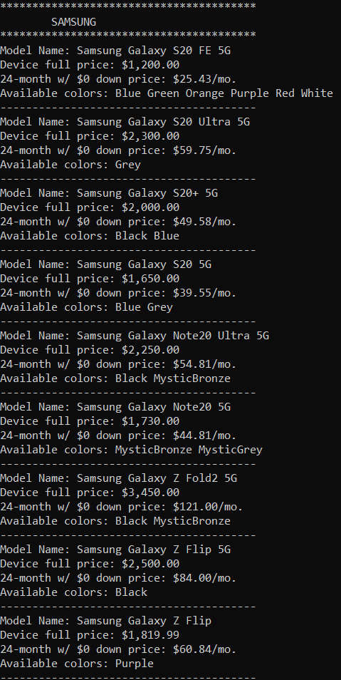 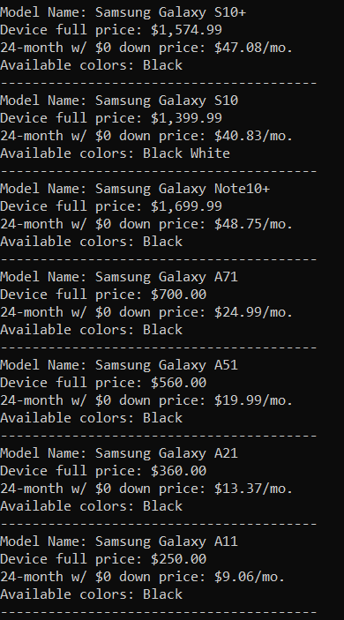

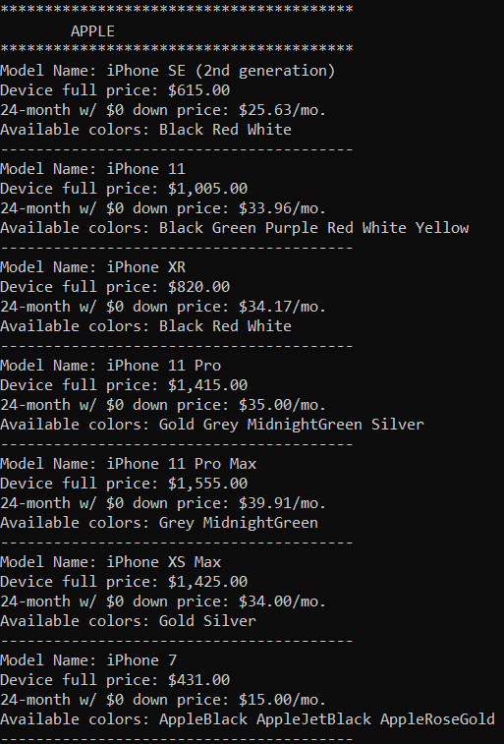 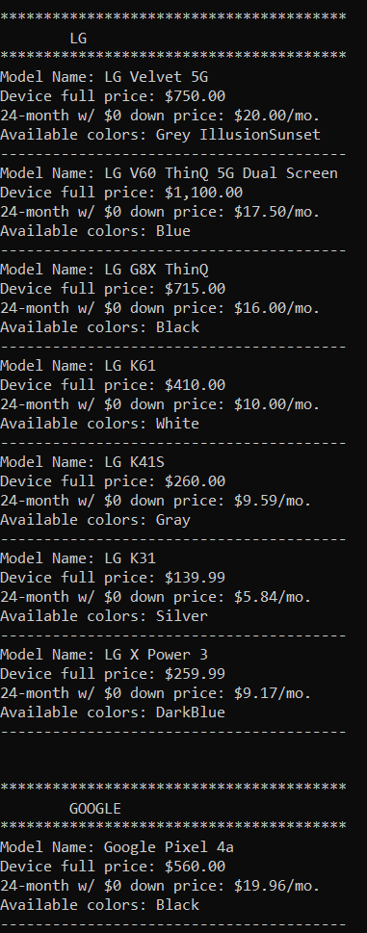

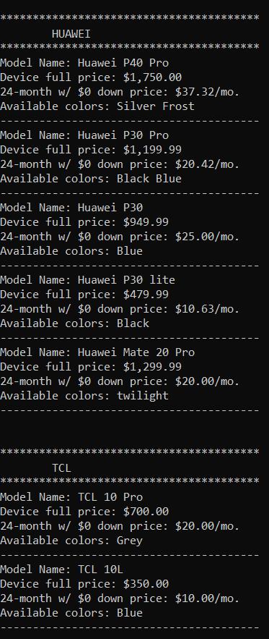 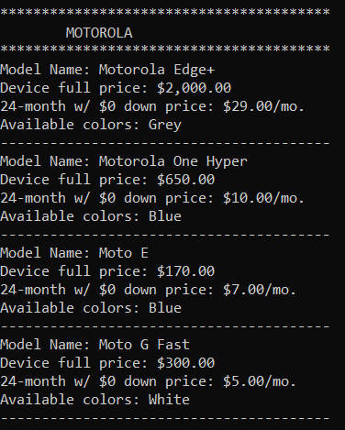

**CASE 2:**

User Inputs:

* Preferred Vendors: **Apple** and **Samsung**
* Preferred lower and upper limit for 24-month monthly price at $0 down: **25** to **50**
* Preferred lower and upper limit for Full Device price: **-1** (Consider entire range for Full Device Price)
* Preferred Colors: -1 (Consider all colors)

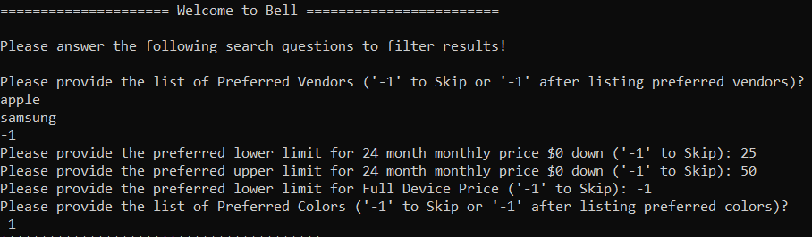

**OUTPUT RESULTS**

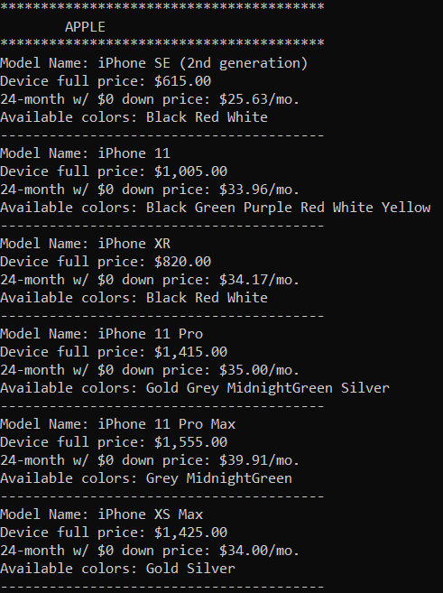 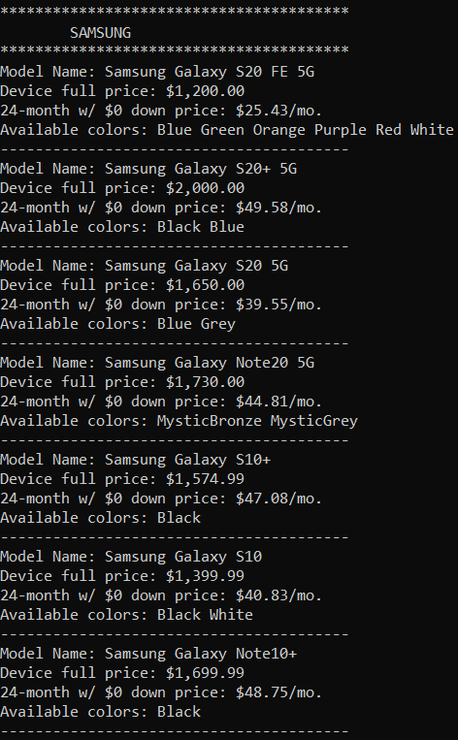

**CASE 3**

User Inputs:

* Preferred Vendors: **Apple** and **Samsung**
* Preferred lower and upper limit for 24-month monthly price at $0 down: **25** to **50**
* Preferred lower and upper limit for Full Device price: **300** to **2000**
* Preferred Colors: **Black**

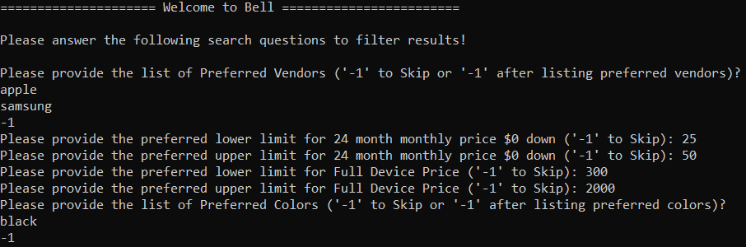

**OUTPUT RESULTS**

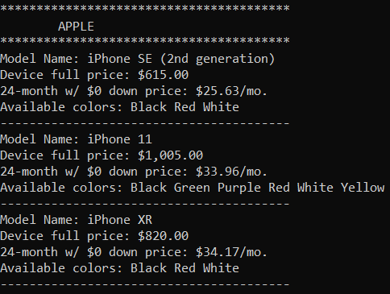 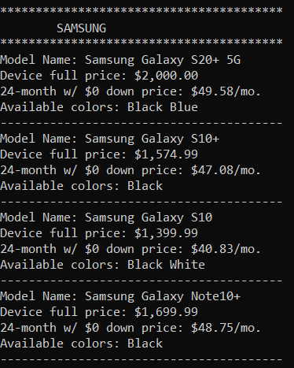

**CASE 4**

User Inputs:

* Preferred Vendors: **LG** and **TCL**
* Preferred lower and upper limit for 24-month monthly price at $0 down: **-1** (Consider entire range)
* Preferred lower and upper limit for Full Device price: **-1** (Consider entire range)
* Preferred Colors: **Grey**

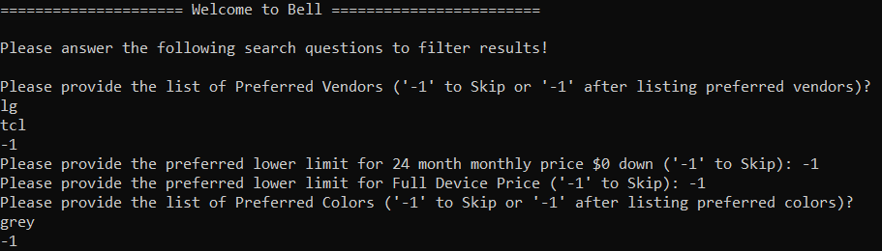

**OUTPUT RESULTS**

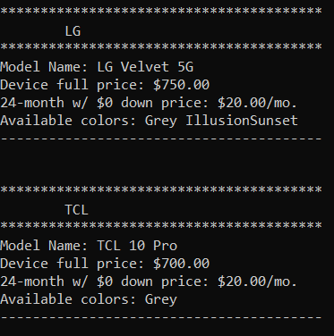

**CASE 5**

User Inputs:

* Preferred Vendors: **Apple** and **LG**
* Preferred lower and upper limit for 24-month monthly price at $0 down: **10** to **50**
* Preferred lower and upper limit for Full Device price: **-1**
* Preferred Colors: **Black** and **Grey**

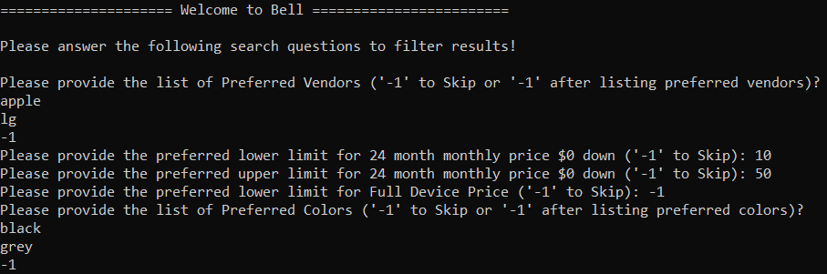

**OUTPUT RESULTS**

