**1. INTRODUCTION**

**1.1 College Management System** is a Web-Based ERP System. It's specially designed for online learning, and easily monitors the performance of the whole education system. It is helpful for a different kind of management of education like Admission management, Fees management, Attendance management, Library Management, student management, etc.

In effective **College Management System** should also be able to help schools better manage their finances by automating tasks such as invoicing parents for tuition payments or tracking expenses related to textbooks and supplies purchases. Additionally, these systems offer powerful tools that enable educators track progress on key metrics such as test scores or graduation rates which are essential indicators of success in any learning environment. By having access this type of data at their fingertips administrators will have a much clearer picture when making important decisions about curriculum design or budget allocation strategies moving forward.

Digital transformation is the new reality of this modern world. Besides industries such as manufacturing, corporates, banking, and commerce, education domain has new challenges and its of paramount importance to address the evolving needs of this domain. The college management system helps Educational Institutions especially colleges in various ways, such as storing data, maintain student profiles, analysing administrative and academic data, improving communication, and engaging students.

There are several college ERP software’s that’s available in the market to streamline administrative processes. The world is rapidly changing and technology has to meet the expectations of the new age learners. Students of this generation rely on technology to update themselves on a regular basis. Giving them a seamless experience of transitioning from the real to the digital world and vice versa is imperative. As a forward-thinking educational institution, need to think of the ways on how the colleges will look at ERP Software. Online college management system effortlessly ensures efficiency in the operations of large-scale Institutions.

### ****1.2 What is the College Management System?****

The College Management System is the ultimate solution to digitize and streamline the day-to-day operations of colleges and universities. From student enrolment system to admission management and [online classes](https://camudigitalcampus.com/camu-virtual-classroom) management to finance management and human resource management, as well as every other process of college operations. It also digitizes routine work of the campus such as [student attendance management system](https://camudigitalcampus.com/guide/online-attendance-management-software-guide), student record management system, student profile management system, student record keeping system, student mark management system, [student fee management](https://camudigitalcampus.com/guide/benefits-of-using-fee-management-software-in-schools), and other small and big operations.

The approach of college ERP software has several benefits. It has one username credentials for all the processes connected to that college. In addition, it analyses the captured data in different modules within the software. The college management system is a new version of the Management Information System, or MIS – a tool used to collect college operations data and analyse. Management uses this data to make informed decisions. The software contains the functionalities of the it as well as the management information system. It manages the complete student lifecycle, parent, as well as faculty in the college. It also manages the academic, administrative, and fee management and all other financial activities of a college.

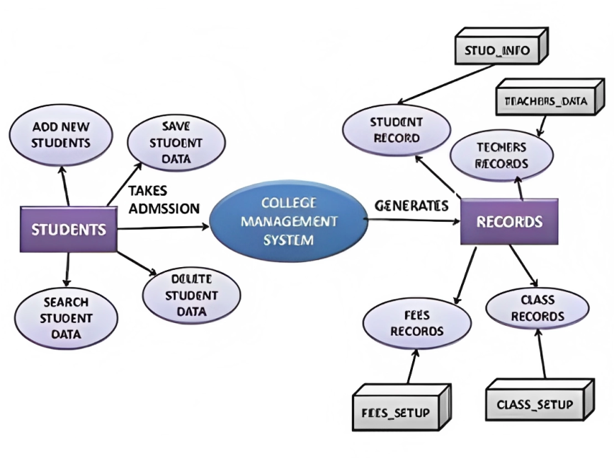

Fig. 1.1 Illustrates how College Management System works

**2. INTRODUCTION TO JAVA**

**2.1 Introduction**

Java is a popular, general-purpose programming language that was first released by Sun Microsystems (now owned by Oracle) in 1995. It is designed to be platform-independent, meaning that Java code can run on any device or operating system that has a Java Virtual Machine (JVM) installed. This makes Java a popular choice for developing cross-platform applications.

Java utilises a syntax resembling C++ and is an object-oriented programming language, which means it is built on the idea of objects, which are instances of classes. Java also features a sizable, well-documented class library that makes it simple for programmers to do typical tasks, such connecting to a database or making a user interface. One of Java's distinguishing characteristics is its "write once, run anywhere" (WORA) approach, which enables programmers to write a single version of code that may run on any platform that supports Java. This is accomplished by using the Java Virtual Machine (JVM), which serves as an interpreter for Java bytecode, the intermediate representation of Java source code.

Enterprise software, the creation of web and mobile applications, big data, and the Internet of Things are just a few of the numerous industries that employ Java (IoT). Apache Struts, Hibernate, and Spring are a few well-known Java frameworks and libraries. In conclusion, Java is a widely used object-oriented, cross-platform, general-purpose programming language. The JVM, a sizable class library, and the WORA principle.

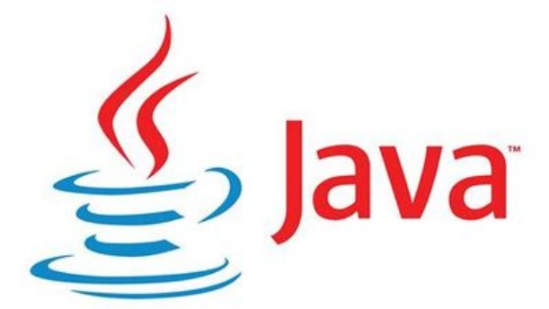

Fig. 2.1 Java logo

**2.2 Basic of JAVA**

* **2.2.1 Java Virtual Machine** (JVM) enables a computer to execute Java programmers. Since the JVM is platform neutral, the same Java code can be executed on any hardware or operating system that supports the JVM. Memory management, garbage collection, and security in Java programmers are all handled by the JVM.
* The Java virtual machine is an application that runs other applications. It's a straightforward concept that also serves as one of our best displays of coding mastery. The JVM challenged the status quo at the time and supports programming innovation even now.
* **2.2.2 Java Runtime Environment** (JRE) is a software bundle that offers the fundamental conditions for running Java programmers. It consists of the Java Virtual Machine (JVM), Java class libraries, and additional tools for running Java programmers. Because the JRE is platform-specific, different JRE versions must be installed on each platform (such as Windows, MacOS, and Linux) where Java applications will be used.
* Java programmers need the Java Runtime Environment (JRE) to function properly. Many of the most popular online and mobile applications today are written in the computer language Java. It serves as a translator and facilitator, giving all the tools necessary for Java applications to operate natively on any operating system after being written.

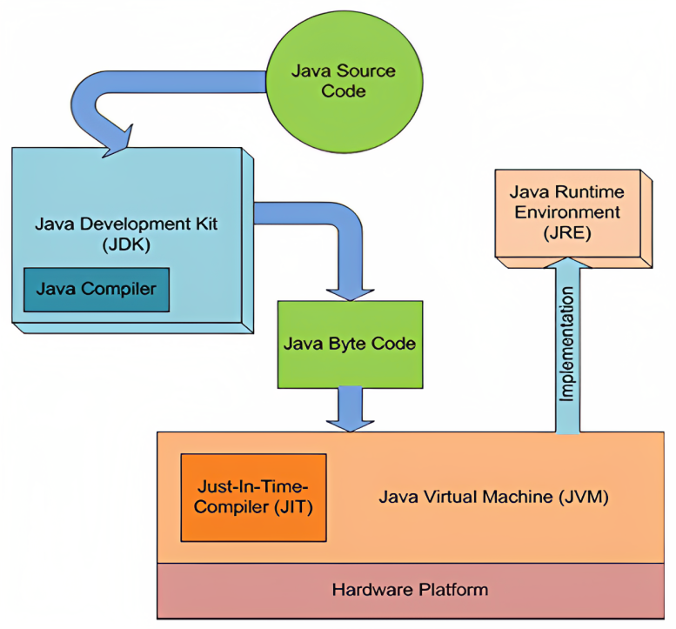

Fig. 2.2 Working structure of Java

**3. Object Oriented Programming**

* **3.1 Inheritance in Java** allows a subclass or child class to inherit the properties and methods of a superclass or parent class. This means that the child class can access the members of the parent class, including variables and methods, as if they were its own. This concept of inheritance allows for code reuse and a more organized class hierarchy. Java implements inheritance through the use of the "extends" keyword, which is used to indicate that a class is a subclass of another class.

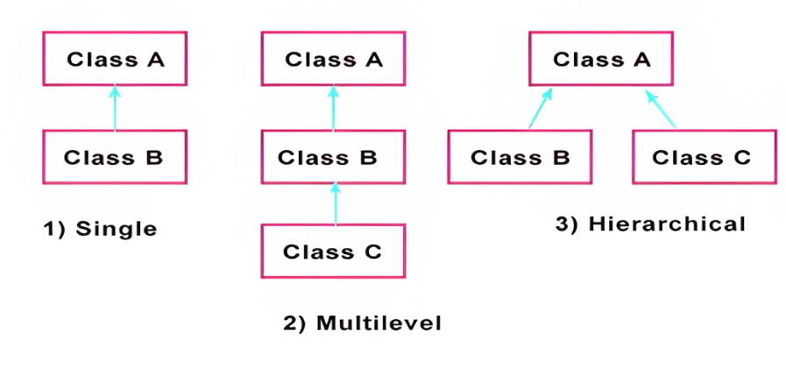

Fig. 3.1 Inheritance in Java

* **3.2** **Encapsulation in Java** is a way for shielding an object's implementation details from the outside world. It is accomplished by designating the class variables as private and offering public methods (getters and setters) to access and adjust their values. This gives flexibility in modifying the implementation without having an impact on the external code and helps prevent the data from being altered or accessed by unauthorized parties.

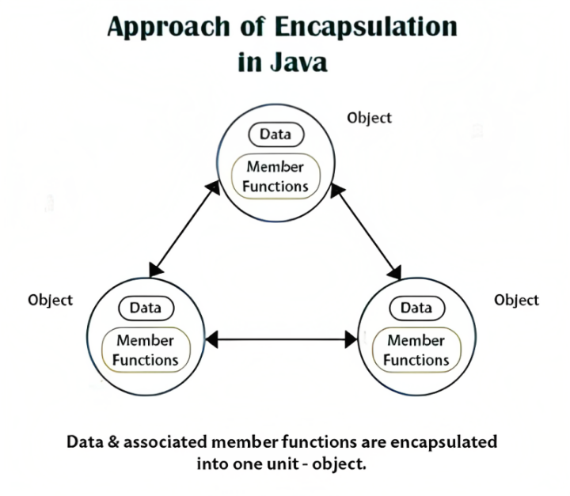

Fig. 3.2 Encapsulation in Java

* **3.3** **Polymorphism in Java** refers to a function's or method's capacity to work with different kinds of data. As a result, depending on the type of data being operated on, a single function can be utilized to carry out various tasks. This is accomplished through the usage of the idea of inheritance, where a parent class is used to specify a function's fundamental functionality and its child classes are then able to replace or expand that functionality. This enables more effective and adaptable code as well as the simple addition of new functionality to already existing classes.

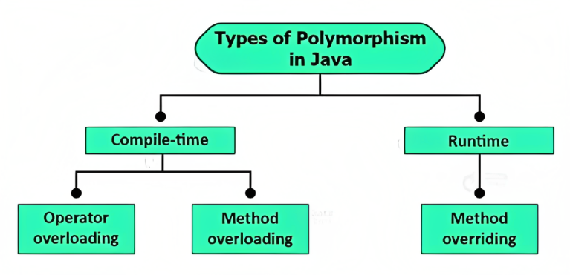

Fig. 3.3 Polymorphism in Java

* **3.4** **Abstraction in Java** allows users to see only the data they need without being shown the class's implementation details. It is accomplished through the use of abstract classes and interfaces and is one of the core ideas in object-oriented programming. A class that cannot be instantiated and serves as a model for other classes is known as an abstract class. A class can implement the abstract methods found in an interface. In order to make the code more reusable and maintainable, abstract classes and interfaces both enable the development of a universal interface that may be utilized by numerous classes.

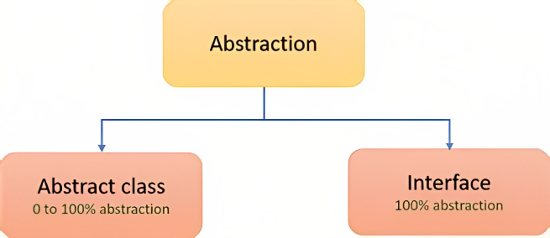

Fig. 3.4 Abstraction in Java

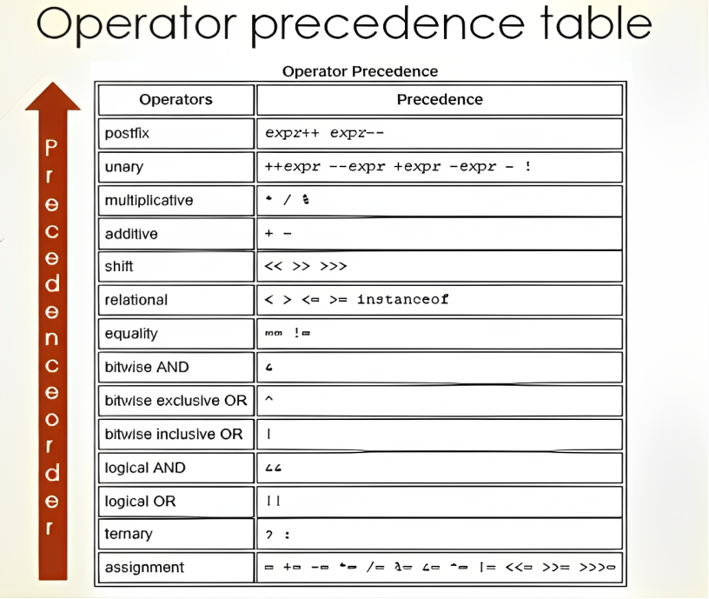

Table 3.1 Operators in Java

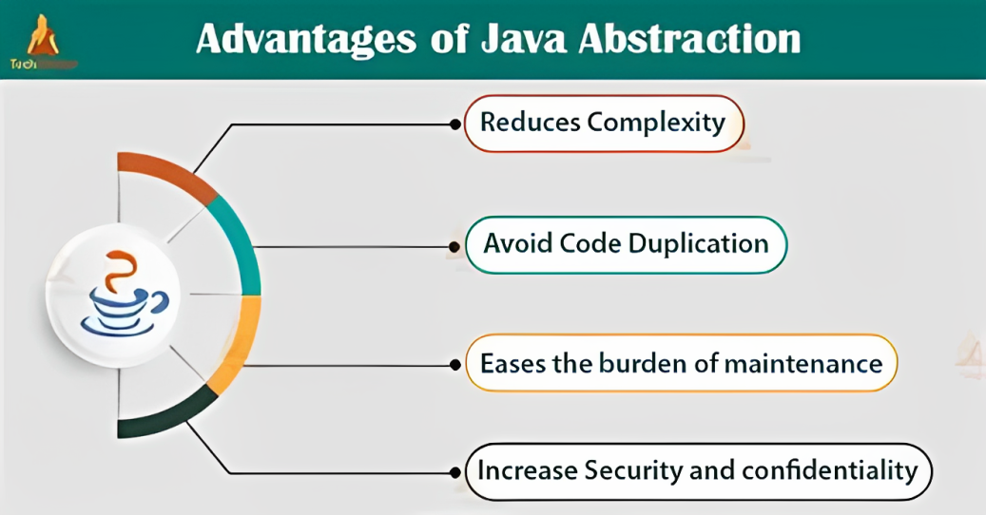

Fig. 3.5 Advantages of Java Abstraction

**4. Object Oriented Programming**

* **4.1 Method Overloading in Java** refers to a class's ability to have many methods with the same name but distinct argument lists. As a result, methods can be called with the same name and different arguments; the correct method will be called and run depending on the quantity and type of arguments. Compile-time polymorphism or static polymorphism are other names for method overloading.
* The ability to construct numerous methods with the same name in the same class, each of which performs a different function, is known as method overloading. The term "overloaded method" refers to a sort of methods that is formed when a class contains many methods with the same name. If it is possible that a programmer has to take only one name and the program itself decides which method to use for which type of value, then it will be easier for the programmer to get the same. There is no need to memorize the names of more than one method for type work. In Java, we can give the above three methods the same names.

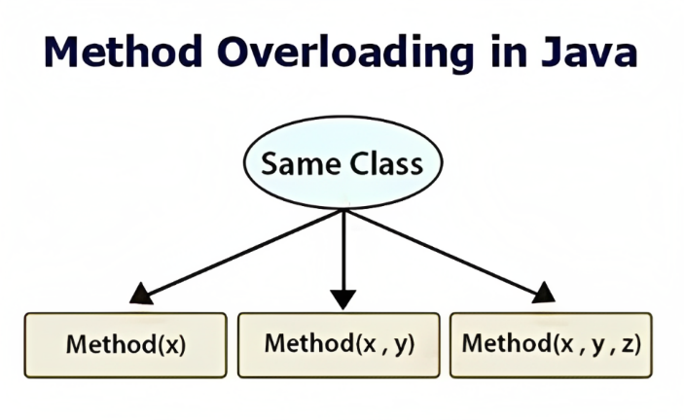

Fig. 4.1 Overloading in Java

* **4.2 Method Overriding in Java** describes a subclass's ability to provide a particular implementation of a method that is already supplied by its superclass. This enables a subclass to inherit and utilize the methods of its superclass while also customizing or extending those methods' functionality as necessary. Runtime polymorphism or dynamic polymorphism are other names for method overriding.
* One technique for Java to implement Run Time Polymorphism is by overriding methods. The object that is used to invoke a method will determine which version of it is executed. If a method is invoked by an object of a parent class, the method in the parent class will be utilised; however, if a method is invoked by an object of a subclass, the method in the child class will be used. To put it another way, the type of the object being referenced decides which override method will be called, not the type of the reference variable.

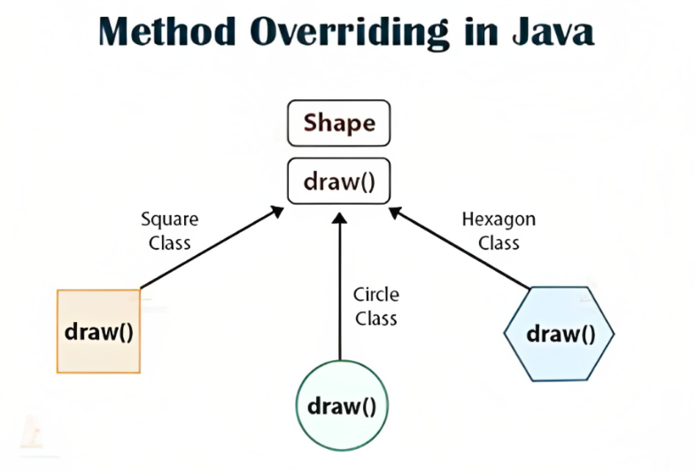

Fig. 4.2 Overriding in Java

**5. APPLIACTIONS OF JAVA**

* **5.1 Abstract Window Toolkit** acronym AWT is a toolkit of classes in Java that helps a programmer to develop Graphical User Interface applications. The AWT API in Java primarily consists of a comprehensive set of classes and methods that are required for creating and managing the GUI in a simplified manner. It was developed for providing a common set of tools for designing cross-platform GUIs which are user-friendly.
* Apart from being platform-dependent, there are several other features of AWT classes like it a set of native user interface components based upon an event-handling model that provides Graphics tools, such as *shape, color*, and *font* classes AWT also avails layout managers which helps in increasing the flexibility of the window layouts Data transfer classes are also a part of AWT native platform clipboard supports a wide range of libraries that are necessary for creating graphics for gaming, banking, educational purposes, etc.

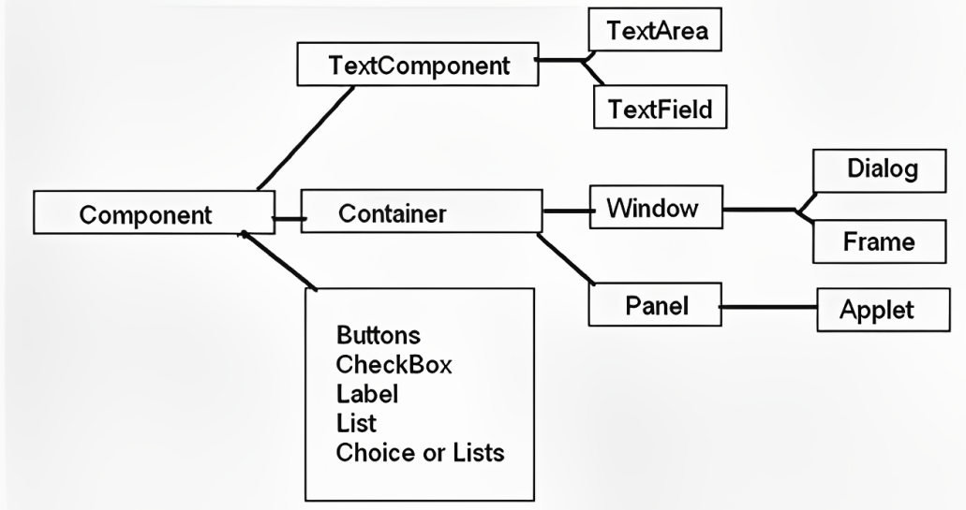

Fig 5.1 Components of Abstract Window Toolkit

* **5.2 File Handling** is typically done using the FileInputStream, FileOutputStream, and RandomAccessFile classes for reading and writing binary data, and the FileReader and FileWriter classes for reading and writing text data. Additionally, the java.io package provides additional classes for more advanced file handling, such as the Path and Files classes.
* File handling in Java implies reading from and writing data to a file. The File class from the **java.io package**, allows us to work with different formats of files. In order to use the File class, you need to create an object of the [class](https://www.edureka.co/blog/java-tutorial/#obj) and specify the filename or directory name.

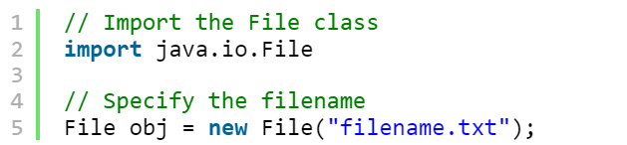

Fig. 5.2 Use of file handling

* **5.3 File Operations in Java**

Basically, you can perform four operations on a file. They are as follows:

* + [Create a File](https://www.edureka.co/blog/file-handling-in-java/#createfile)
  + [Get File Information](https://www.edureka.co/blog/file-handling-in-java/#getfile)
  + [Write To a File](https://www.edureka.co/blog/file-handling-in-java/#writefile)
  + [Read from a File](https://www.edureka.co/blog/file-handling-in-java/#readfile)

Now, let’s get into the details of each of these operations:

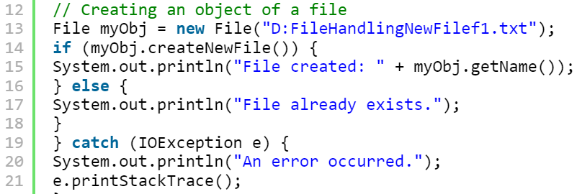**5.3.1 Create a File** is a case, to create a file you can use the createNewFile() method. This method returns **true** if the file was successfully created, and **false** if the file already exists. Let’s see an example of how to create a file in [Java](https://docs.oracle.com/javase/tutorial/).

* **5.3.2 Get file information** contains a lot of classes with predefined methods to read and access the attributes of a file. Firstly getFileAttributeView() method is used to get the files attributes and then readAttributes() method is used to get the attributes of the file. Then finally several methods of the class “BasicFileAttributes” are used to display various attributes of the file.
* **5.3.3. Write to a file** isinvocation of PrintWriter’s print() method would cause characters to be converted into bytes that would then be written immediately to the file, which can be very inefficient. So it is recommended to buffer the PrintWriter’s output to the file with BufferedWriter
* **5.3.4 Read from a file** reads a character-input stream. It buffers characters in a buffer with a default size of 8 KB to make the reading process more efficient. If you want to read a file line by line, using BufferedReader is a good choice.

**6. APPLICATION STRUCTURE**

* 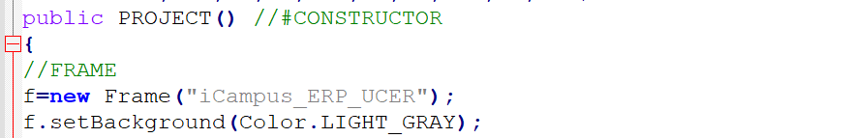**6.1 Frame**  is a subclass of Window and contains title, border, and menu bars. It comes with a resizing canvas and is the most widely used container for developing AWT applications. It is capable of holding various components such as buttons, text fields, scrollbars, etc.
* 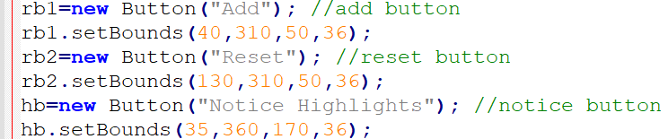**6.2 Button** class is used to create a labeled button. GUI component that triggers a certain programmed action upon clicking it. The Button class has two constructors :
* **6.3 Label** class provides a descriptive text string that is visible on GUI. An AWT Label object is a component for placing text in a container. Label class has three constructors which help in easy implementation on frames etc.

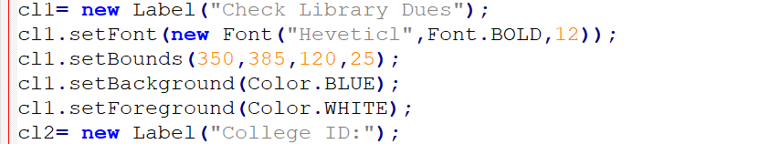

* 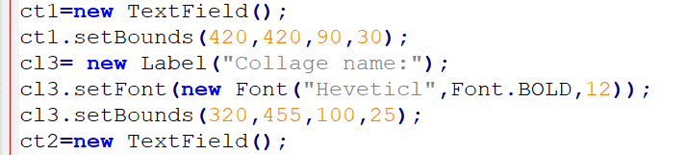**Text Field** class creates a single-line text box for users to enter texts. The Text Field class has three constructors which help in easy storage on data.

**7. CONCLUSION**

* Providing a centralized system for storing and managing student information, such as personal details, academic records, and enrollment status.
* Improving communication and collaboration between students, teachers, and administrative staff by providing tools for online communication, scheduling, and document sharing.
* Streamlining administrative tasks, such as class scheduling, grade tracking, and report generation.
* Enhancing student engagement and success by providing students with easy access to resources, such as course materials, grades, and academic advisors.
* Improving data analysis and decision-making by providing easy access to detailed student data.
* Enhancing the overall efficiency and effectiveness of the institution by providing real-time information and automating repetitive tasks.

**REFERENCES**

* <https://www.quora.com/What-is-college-management-system>
* <https://www.mygreatlearning.com/blog/method-overloading-in-java/>
* <https://www.geeksforgeeks.org/overriding-in-java/>
* <https://www.edureka.co/blog/file-handling-in-java/>
* <https://www.edureka.co/blog/file-handling-in-java/>
* <https://openai.com/blog/chatgpt/>