实验报告
课程 操作系统 实验名称

专业__软件工程__ 班级_软工一班__ 学号_116052017001__ 姓名 周靖赟
实验日期： 年 月 日
一、实验目的
用高级语言编写和调试一个进程调度程序，以加深对进程的概念及进程调度算法的理解。

二、实验内容
实现一个有 N个进程并发执行的进程调度程序。(规定道数，至少5道)。
说明：每个进程有一个进程控制块（ PCB）表示。进程控制块可以包含如下信息：进程名、优先数、需要运行时间、已用CPU时间、进程状态等等。
调度程序按
按优先数调度算法实现处理机调度的程序
按时间片轮转实现处理机调度的程序
进程的优先数及需要的运行时间可以事先人为地指定（也可以由随机数产生）。进程的到达时间为进程输入的时间。进程的运行时间以时间片为单位进行计算。

三、实验环境
Archlinux
vscode
四、实验步骤
1.界面
2.获取用户输入，加入进程列表
3.进程排序
4.运行
4.1 每运行一次都进行排序
4.2 跑完的进程优先级置0
4.3 当排序后第一个进程优先级为0时，判断进程全部执行完毕

五、实验结果与讨论
成功。
无法处理优先级0以下任务
六、总结
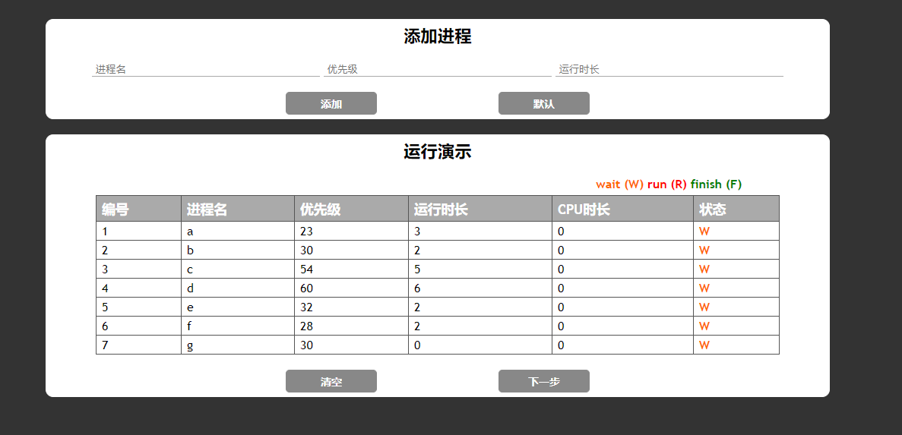

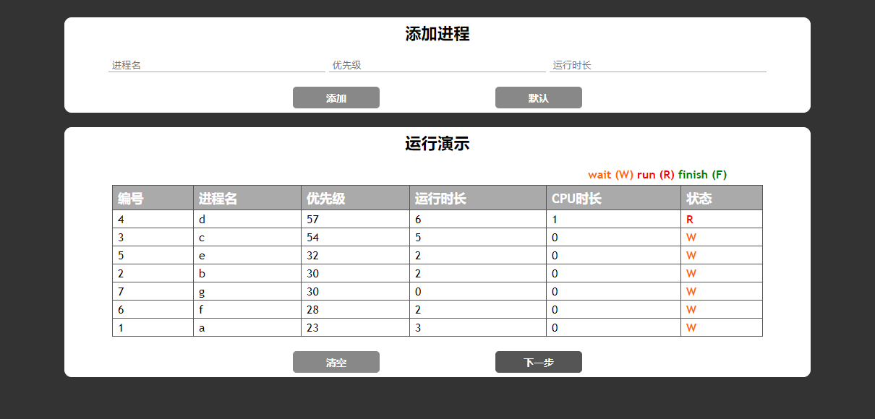

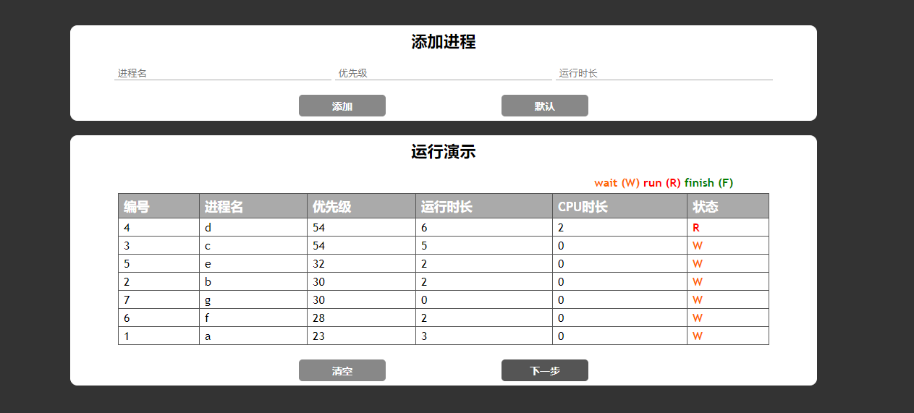
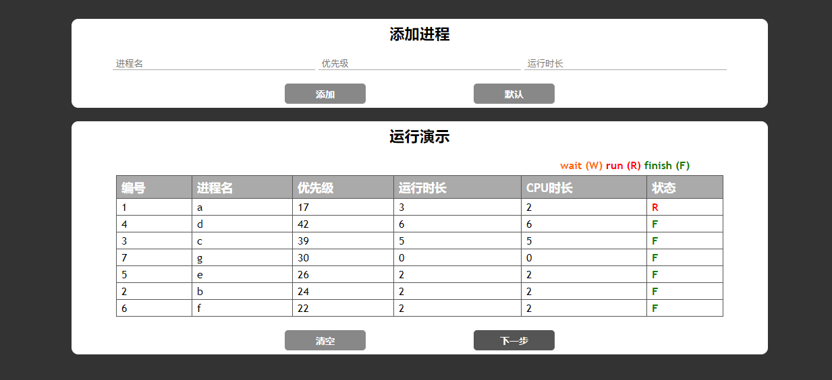
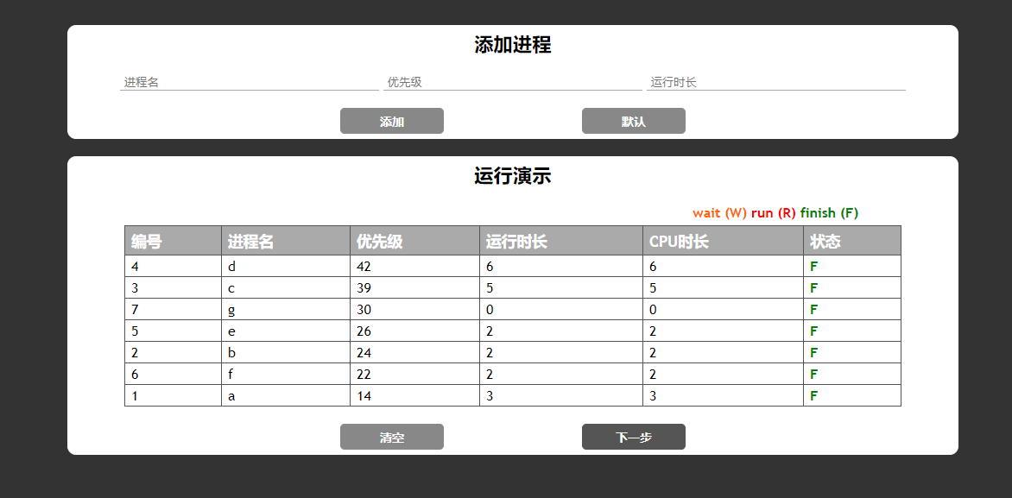
var isEmpty = (value) => {
if (value == null || value.trim() == "")
return true;
else
return false;
},
sortFun = (a, b) => {
var reply = b.priority - a.priority;

if (reply <= 0) {
if (b.finish) reply = -reply;
} else {
if (a.finish) reply = -reply;
}

return reply;
},
wait = (obj) => {
obj.state = 'W';
obj.type = 'wait';
},
run = (obj) => {
obj.state = 'R';
obj.type = 'run';
obj.cpu += 1;
obj.priority -= 3;
},
finish = (obj) => {
obj.state = 'F';
obj.type = 'finish';
obj.finish = true;
};

window.onload = (event) => {
var main = new Vue({
el: "#main",
data: {
form: {
name: null,
priority: null,
time: null
},
process_list: [],
finish_list: []
},
methods: {
add: () => {
var form = main.$data.form,
process_list = main.$data.process_list;
if (isEmpty(form.name)) {
alert("进程名为空");
} else if (isEmpty(form.priority)) {
alert("优先级为空");
} else if (isEmpty(form.time) || form.time < 0) {
alert("运行时长为空或筱小于零");
} else {
process_list.push({
id: process_list.length + 1,
name: form.name,
priority: form.priority,
time: form.time,
cpu: 0,
state: 'W',
type: 'wait',
finish: false
});

form.name = null;
form.priority = null;
form.time = null;
}
},
clear: () => {
main.$data.process_list = [];
main.$data.finish_list = [];
},
next: () => {
var list = main.$data.process_list;

//是否运行完成
if (list.length == 0) {
alert("全部运行完毕");
return;
}

if (list[0].state == 'R') wait(list[0]);

list.sort(sortFun);

//是否运行时间为零
if (list[0].time == 0) {
finish(list[0]);
var temp = list[0];
list.splice(0, 1);
main.$data.finish_list.push(temp);
}

run(list[0]);

if (list[0].cpu == list[0].time) {
finish(list[0]);
var temp = list[0];
list.splice(0, 1);
main.$data.finish_list.push(temp);
}
},
defaultValue: () => {
main.$data.process_list = [
{ id: 1, name: 'a', priority: 23, time: 3, cpu: 0, state: 'W', finish: false, type: 'wait' },
{ id: 2, name: 'b', priority: 30, time: 2, cpu: 0, state: 'W', finish: false, type: 'wait' },
{ id: 3, name: 'c', priority: 54, time: 5, cpu: 0, state: 'W', finish: false, type: 'wait' },
{ id: 4, name: 'd', priority: 60, time: 6, cpu: 0, state: 'W', finish: false, type: 'wait' },
{ id: 5, name: 'e', priority: 32, time: 2, cpu: 0, state: 'W', finish: false, type: 'wait' },
{ id: 6, name: 'f', priority: 28, time: 2, cpu: 0, state: 'W', finish: false, type: 'wait' },
{ id: 7, name: 'g', priority: 30, time: 0, cpu: 0, state: 'W', finish: false, type: 'wait' }
];

main.$data.finish_list = [];
}
}
});
}
html,
body,
div,
table,
tr,
td,
th {
margin: 0;
padding: 0;
}

body {
background-color: #333;
font-family: "Trebuchet MS", Arial, Helvetica, sans-serif;
}

input,
button {
outline: none;
}

.clearfix {
zoom: 1;
}

.clearfix:after {
content: "\20";
display: block;
height: 0;
clear: both;
}

#main {
width: 1000px;
margin: 50px auto 0 auto;
}

.add-table-box,
.show-table-box {
width: 100%;
padding: 5px 15px;
background-color: #fff;
border: 1px #fff solid;
border-radius: 10px;
}

.show-table-box {
margin-top: 20px;
}

.add-table-box .title,
.show-table-box .title {
text-align: center;
font-size: 1.4em;
font-weight: bolder;
margin: 0 auto 20px auto;
}

.add-table-box .form-contain {
width: 910px;
margin: 0 auto;
}

.add-table-box .form-contain input[type="text"],
.add-table-box .form-contain input[type="number"] {
width: 300px;
border-top: none;
border-left: none;
border-right: none;
border-bottom: 1px #aaa solid;
color: #888;
padding-left: 5px;
}

.add-table-box .form-contain input[type="text"]:focus,
.add-table-box .form-contain input[type="number"]:focus {
border-bottom: 1px #555 solid;
}

.add-table-box .form-contain .button-area,
.show-table-box .button-area {
width: 400px;
margin: 20px auto 0 auto;
overflow: hidden;
}

.add-table-box .form-contain .button-area button,
.show-table-box .button-area button {
width: 120px;
height: 30px;
background-color: #888;
border: 1px #888 solid;
border-radius: 5px;
color: #fff;
cursor: pointer;
font-weight: bold;
font-size: 14px;
}

.add-table-box .form-contain .button-area button:hover,
.show-table-box .button-area button:hover {
background-color: #555;
border: 1px #555 solid;
}

.add-table-box .form-contain .button-area button:active,
.show-table-box .button-area button:active {
background-color: #333;
border: 1px #333 solid;
}

.add-table-box .form-contain .button-area button:nth-child(1),
.show-table-box .button-area button:nth-child(1) {
float: left;
}

.add-table-box .form-contain .button-area button:nth-child(2),
.show-table-box .button-area button:nth-child(2) {
float: right;
}

.show-table-box .introduce-state-box {
width: 90%;
margin-top: 10px;
margin-bottom: 5px;
}

.show-table-box .introduce-state-box .state-box {
float: right;
}

.show-table-box .introduce-state-box .state-box div {
display: inline-block;
font-size: 16px;
font-weight: bold;
}

.show-table-box .introduce-state-box .state-box .wait {
color: #FF6600;
}

.show-table-box .introduce-state-box .state-box .run {
color: red;
}

.show-table-box .introduce-state-box .state-box .finish {
color: green;
}

.show-table-box .table-contain {
width: 900px;
margin: 0 auto;
}

.show-table-box .table-contain table {
width: 100%;
border-collapse: collapse;
}

.show-table-box .table-contain table th,
.show-table-box .table-contain table td {
border: 1px solid #555;
padding: 3px 7px 2px 7px;
}

.show-table-box .table-contain table th {
font-size: 1.1em;
text-align: left;
padding-top: 5px;
padding-bottom: 4px;
background-color: #aaa;
color: #ffffff;
}

.show-table-box .table-contain table td {
font-size: 1em;
}

.show-table-box .table-contain table tr.alt td {
color: #000000;
background-color: #EAF2D3;
}

.show-table-box .table-contain .wait {
font-size: 16px;
font-weight: bold;
color: #FF6600;
}

.show-table-box .table-contain .run {
font-size: 16px;
font-weight: bold;
color: red;
}

.show-table-box .table-contain .finish {
font-size: 16px;
font-weight: bold;
color: green;
}
<html>

<head>
<title>os lab 01</title>
<meta charset="utf-8">
<link rel="stylesheet" href="css/style.css">
<script src="js/vue.js"></script>
<script src="js/index.js"></script>
</head>

<body>
<div id="main">
<div class="add-table-box">
<div class="title">添加进程</div>
<div class="form-contain">
<input type="text" placeholder="进程名" v-model="form.name">
<input type="number" placeholder="优先级" v-model="form.priority">
<input type="number" placeholder="运行时长" v-model="form.time">
<div class="button-area clearfix">
<button @click="add">添加</button>
<button @click="defaultValue">默认</button>
</div>
</div>
</div>
<div class="show-table-box">
<div class="title">运行演示</div>
<div class="introduce-state-box clearfix">
<div class="state-box">
<div class="wait">wait (W)</div>
<div class="run">run (R)</div>
<div class="finish">finish (F)</div>
</div>
</div>
<div class="table-contain">
<table>
<tr>
<th>编号</th>
<th>进程名</th>
<th>优先级</th>
<th>运行时长</th>
<th>CPU时长</th>
<th>状态</th>
</tr>
<tr v-for="process in process_list">
<td>{{ process.id }}</td>
<td>{{ process.name }}</td>
<td>{{ process.priority }}</td>
<td>{{ process.time }}</td>
<td>{{ process.cpu }}</td>
<td :class="process.type">{{ process.state }}</td>
</tr>
<tr v-for="process in finish_list">
<td>{{ process.id }}</td>
<td>{{ process.name }}</td>
<td>{{ process.priority }}</td>
<td>{{ process.time }}</td>
<td>{{ process.cpu }}</td>
<td :class="process.type">{{ process.state }}</td>
</tr>
</table>
</div>
<div class="button-area clearfix">
<button @click="clear">清空</button>
<button @click="next">下一步</button>
</div>
</div>
</div>
</body>

</html>

