实验2 开闭原则与里氏代换原则综合训练
实验目的：加深对开闭原则与里氏代换原则的理解（如果你能用配置文件，建议用配置文件解决。）
实验环境：C#.Net/VC++.Net或MyEclipse(Java)等
实验内容：
1、问题(一)“长方形和正方形“。
试写一个求面积与周长的解决方案，要求画UML图并编程实现，并体现出开闭原则与里氏代换原则。
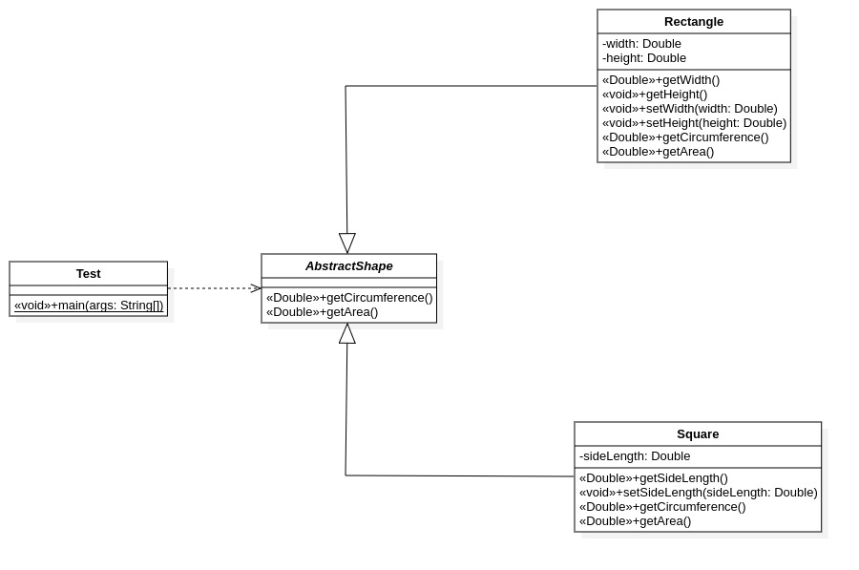
AbstractShape.java
package shape;
public abstract class AbstractShape {
public abstract double getCircumference();
public abstract double getArea();
}

Rectangle.java
package shape;
public class Rectangle extends AbstractShape{
private double width;
private double height;
public Rectangle(double width, double height) {
this.width = width;
this.height = height;
}
public Rectangle() {
this(0.00, 0.00);
}
public double getWidth() {
return width;
}
public void setWidth(double width) {
this.width = width;
}
public double getHeight() {
return height;
}
public void setHeight(double height) {
this.height = height;
}
@Override
public double getCircumference() {
return (width + height) * 2;
}
@Override
public double getArea() {
return width * height;
}
}

Square.java
package shape;
public class Square extends AbstractShape{
private double sideLength;
public Square(double sideLength) {
this.sideLength = sideLength;
}
public Square() {
this(0.00);
}
public double getSideLength() {
return sideLength;
}
public void setSideLength(double sideLength) {
this.sideLength = sideLength;
}
@Override
public double getCircumference() {
return sideLength * 4;
}
@Override
public double getArea() {
return sideLength * sideLength;
}
}

TestShape.java
import shape.AbstractShape;
import shape.Rectangle;
import shape.Square;
public class TestShape {
public static void main(String[] args) {
AbstractShape shape;
//正方形
shape = new Square(2);
System.out.println("Square: area-"+shape.getArea()+" circumference-"+shape.getCircumference());
//长方形
shape = new Rectangle(2, 3);
System.out.println("Rectangle: area-"+shape.getArea()+" circumference-"+shape.getCircumference());
}
}

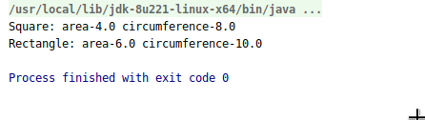

2、问题(二)“士兵用枪杀敌”UML图理解与编程实现
（１）CS游戏中的枪械类图
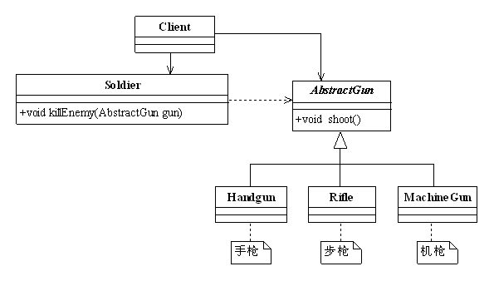
AbstractGun.java
package gun;
public abstract class AbstractGun {
public abstract void shoot();
}

HandGun.java
package gun;
public class HandGun extends AbstractGun {
@Override
public void shoot() {
System.out.println("handgun shoot.");
}
}

MachineGun.java
package gun;
public class MachineGun extends AbstractGun {
@Override
public void shoot() {
System.out.println("machine gun shoot.");
}
}

Rifle.java
package gun;
public class Rifle extends AbstractGun {
@Override
public void shoot() {
System.out.println("rifle shoot.");
}
}

Soldier.java
package role;
import gun.AbstractGun;
public class Soldier {
public void killEnemy(AbstractGun gun) {
gun.shoot();
}
}

Client.java
package test;
import gun.HandGun;
import gun.MachineGun;
import gun.Rifle;
import role.Soldier;
public class Client {
public static void main(String[] args) {
Soldier soldier = new Soldier();
soldier.killEnemy(new HandGun());
soldier.killEnemy(new MachineGun());
soldier.killEnemy(new Rifle());
soldier.killEnemy(new gun.ToyGun());
soldier.killEnemy(new gun.toy.ToyGun());
}
}

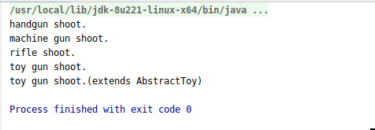

（２）如果我们有一个玩具手枪，该如何定义呢？先在上图增加一个类ToyGun，然后继承于AbstractGun类

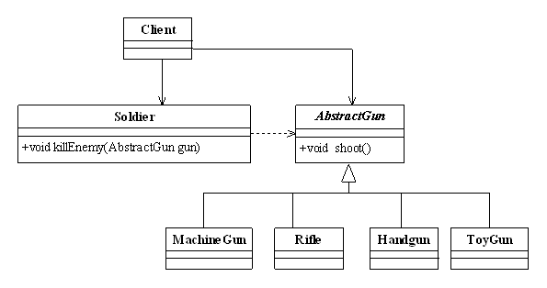
ToyGun.java
package gun;
public class ToyGun extends AbstractGun {
@Override
public void shoot() {
System.out.println("toy gun shoot.");
}
}

（３）具枪与真实枪分离的类图
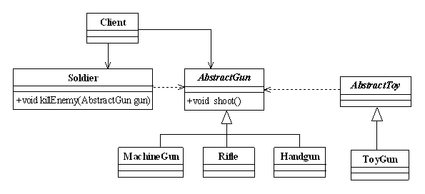
AbstractToy.java
package gun.toy;
import gun.AbstractGun;
public abstract class AbstractToy extends AbstractGun {
}

ToyGun.java
package gun.toy;
public class ToyGun extends AbstractToy {
@Override
public void shoot() {
System.out.println("toy gun shoot.(extends AbstractToy)");
}
}

