Tobacco mutational signature SBS4 and mutation placement in predicted disordered protein regions: a context-adjusted equivalence analysis in 373 lung tumours
Arsen Turagabulov
10th-grade student, School No. 125 "Kemel Urpaq", Taraz, Kazakhstan
Correspondence: [email to be inserted]
Abstract
Intrinsically disordered protein regions lack stable structure and are often functional, but whether tobacco smoke mutagenesis places its mutations preferentially in such regions is unknown. I analysed 373 lung tumours: 143 small-cell lung carcinomas (SCLC) and 230 lung adenocarcinomas (LUAD) from TCGA, including 32 never-smokers, which extends the smoking range from zero to heavy exposure. Mutations were mapped to UniProt residues and labelled as disordered when AlphaFold pLDDT < 50. For each tumour I computed the observed number of mutations in disordered regions (O) and the number expected (E) under the tumour's own 96-context mutation spectrum against a genome-wide coding-space background; association with the smoke signature SBS4 was tested by Poisson/negative-binomial regression with log(E) as offset, with equivalence bounds 0.833-1.2 per SD fixed before the runs, negative controls (SBS1 as predictor, silent mutations as outcome) and a parametric background-resampling test. No association was found: SCLC O/E = 1.008 per SD (95% CI 0.985-1.033); across the full smoking range in LUAD O/E = 0.9998 (0.975-1.025), with pack-years (0.9991) and the never-vs-current contrast (1.017) agreeing; raw correlations were also null. Effects of 1.2 per SD and larger are excluded; confidence intervals constrain effects to about +/-3% per SD on the measured-predictor scale. The strength of the tobacco mutational signature does not track mutation placement in predicted disordered protein regions.
Keywords: intrinsically disordered proteins; mutational signatures; SBS4; tobacco smoking; AlphaFold; lung cancer; observed/expected analysis

1. Introduction
A large fraction of the human proteome contains intrinsically disordered protein regions (IDRs): segments that lack a stable three-dimensional fold and often act as flexible interaction hubs (1). Because IDRs tolerate sequence change differently from folded domains, the question of where cancer mutations land relative to disorder has attracted interest: a pan-cancer analysis mapped the mutational landscape of disordered hotspots (2), and driver mutations were shown to be depleted from, but not absent of, disordered regions (3).
Tobacco smoke leaves a quantitative mutational footprint in the tumour genome: single-base substitution signature SBS4 (4, 5). Its strength can be estimated per tumour from the mutation spectrum itself, which gives a continuous exposure measure rather than a smoker/non-smoker label. Whether smoke-associated mutations are placed preferentially in predicted disordered regions is, to my knowledge, untested - and there is no direct mechanism linking a DNA damage process to a property of the translated protein.
Here I test the working hypothesis (H1) that, after adjusting for the tumour's own 96-context mutation spectrum, the share of mutations falling in predicted disordered regions increases with SBS4 strength; the null hypothesis (H0) is that no systematic shift remains after such adjustment. The study is framed as a coincidence analysis, not a causal claim. Two cohorts cover complementary ranges: 143 SCLC tumours (essentially all smokers) and 230 LUAD tumours spanning never-smokers to heavy smokers. Disordered positions are defined operationally as residues with AlphaFold pLDDT < 50 - a proxy for disorder rather than a strict biophysical IDR definition, a limitation kept explicit throughout.

2. Materials and Methods

2.1 Data and cohorts
SCLC: somatic coding single-nucleotide variants (SNVs) from George et al. 2015 (WGS; 107 tumours after deduplication), Rudin et al. 2012 (30 tumours; 12 cell lines excluded using sample annotations), and Peifer et al. 2012 (6 tumours after deduplication) - 143 primary tumours in total (6, 7). LUAD: TCGA Firehose Legacy somatic mutations and clinical data for 230 primary tumours, including 32 lifelong never-smokers, with pack-years available for 158 (8). Structural labels: AlphaFold Protein Structure Database per-residue pLDDT (9, 10). Annotations: GENCODE v19 CDS, UniProt/Swiss-Prot, hg19/GRCh37 (11, 12). Mutational signature definitions: COSMIC v3.3.1 (13).

2.2 Mutation processing and residue validation
Coding SNVs in primary tumours were retained; duplicate samples across studies (overlap coefficient >= 0.5) were removed keeping the higher-coverage sample. Each mutation was translated through its GENCODE transcript and the resulting amino acid compared with the UniProt sequence; only mutations whose residue matched were analysed, and discard fractions were recorded per cohort (SCLC 13-17%, LUAD 21%). Reference alleles were checked against hg19.

2.3 Disorder annotation
A residue was labelled disordered when AlphaFold pLDDT < 50. Mutations without pLDDT coverage were excluded from both observed and expected counts (coverage 92-96% of validated mutations). The threshold and all analysis rules were fixed before the runs (Supplementary: analysis plan).

2.4 Observed and expected counts
For each tumour, O is the number of validated mutations in disordered residues and E is the expected number under the tumour's own 96-context spectrum: the sum over its mutations of the background probability that a site of that substitution channel is disordered. The background was computed over the whole protein-coding space (all GENCODE CDS sites with pLDDT coverage); its per-channel coverage was verified channel-neutral (ratio 0.861 +/- 0.007 across 96 channels), and O and E always use the same mutation set.

2.5 Statistical model
Primary model: Poisson regression of O with log(E) offset, covariates SBS4 fraction (z-scored), tumour mutation burden, and - in the combined SCLC analysis - data source; the reported measure is the observed/expected ratio per 1 SD of SBS4. Overdispersion is handled by negative-binomial regression with t-based confidence intervals (NB2-t), with a pre-specified boundary rule: when the dispersion estimate is at zero, the Poisson-t limit is used. Calibration by simulation (500 runs per scenario, gamma, lognormal and NB1-type overdispersion) kept type-I error within 3.5-6.5% and coverage within 93-97%. Equivalence bounds (0.833, 1.2) per SD were fixed before the runs as the threshold of biological interest (the rationale was written down afterwards; the bound is not a detection limit - the realised design constrains effects to a few percent per SD). Because O is a bounded count (binomial-like, variance E(1-p)), the Poisson variance assumption is slightly conservative here, widening rather than narrowing intervals. Raw Pearson and Spearman correlations were computed as descriptive analyses without adjustment.

2.6 Controls and null test
Two negative controls used the identical code path: SBS1 (age-related signature) as predictor, and silent mutations as outcome. A failure of any control would mark the result as questionable. A parametric background-resampling test (10,000 runs; binomial draws from the background per context; minimal attainable p = 1e-4, reported as a bound) assessed the global O/E level.

2.7 Analysis transparency
Analysis rules, equivalence bounds and outcome interpretation were documented before the runs; the plan and a dated deviations log are available in the code repository. Deviations include: real coefficients seen during a rehearsal before the SCLC run (a flag was not passed to the model calls), and a change of the LUAD mutation source from PanCanAtlas to Firehose Legacy after the first attempt crashed (the PanCanAtlas profile contains no synonymous mutations, making the silent control impossible). Each analysis was executed exactly once to completion; results files are preserved unchanged. Global O/E showed a consistent depletion in disordered regions (0.89-0.94) of unestablished origin (see Limitations), so conclusions rest on within-cohort associations rather than absolute O/E levels.

2.8 Software and reproducibility
All processing and analysis code, tests (including validation at known hotspots TP53 R175H and KRAS G12C), input checksums of the analysis runs, and the analysis plan are available at https://github.com/ArsikProgrammer/Darkcancer (Python: pandas, numpy, scipy, statsmodels).

3. Results

3.1 Cohorts and quality control
After duplicate and cell-line removal the SCLC cohort comprised 143 primary tumours; the LUAD cohort comprised 230 primary tumours, 32 of them from lifelong never-smokers. Residue validation retained 83-87% of coding SNVs depending on cohort (Table 1), and 92-96% of validated mutations had pLDDT coverage. The smoking scale behaved as expected before any outcome analysis: the median SBS4 fraction was 0.000 in never-smokers (n = 32), 0.29-0.39 in former smokers, and 0.401 in current smokers; Spearman rho was 0.314 with smoking status (p = 2e-6) and 0.223 with pack-years (p = 0.005, n = 158) (Figure 2).
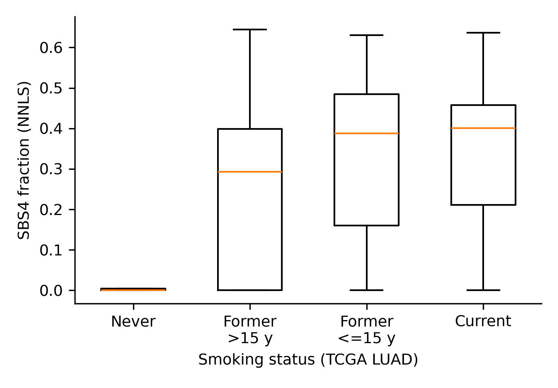
Figure 2. Smoke-signature validation (LUAD). SBS4 fraction by smoking status; never-smokers show near-zero SBS4, confirming the exposure scale before outcome analysis.

3.2 Primary analysis: SCLC among smokers
Across 143 SCLC tumours the adjusted share of mutations in disordered regions did not track SBS4 strength: O/E = 1.008 per SD (95% CI 0.985-1.033, NB2-t). Per the pre-specified rules this is an informative null: effects of 1.2 per SD and larger are excluded, and the interval constrains effects to roughly -1.5% to +3.3% per SD on the measured scale. Both negative controls passed (SBS1: 0.994, 0.973-1.016; silent outcome: 1.032, 0.983-1.084).

3.3 Dose across the full smoking range: LUAD
In LUAD the smoking range extends to zero. The dose-response slope of the adjusted disordered-region share on SBS4 was again null: O/E = 0.9998 per SD (95% CI 0.975-1.025). Independent smoking measures agreed: pack-years 0.9991 (0.978-1.021, n = 158), and the never-vs-current contrast 1.017 (0.966-1.071). Adding the mapping-discard fraction as covariate left the estimate unchanged (0.9991). Controls passed (SBS1: 0.979, 0.942-1.017; silent: 1.012, 0.963-1.065). Figure 3 summarises all estimates.
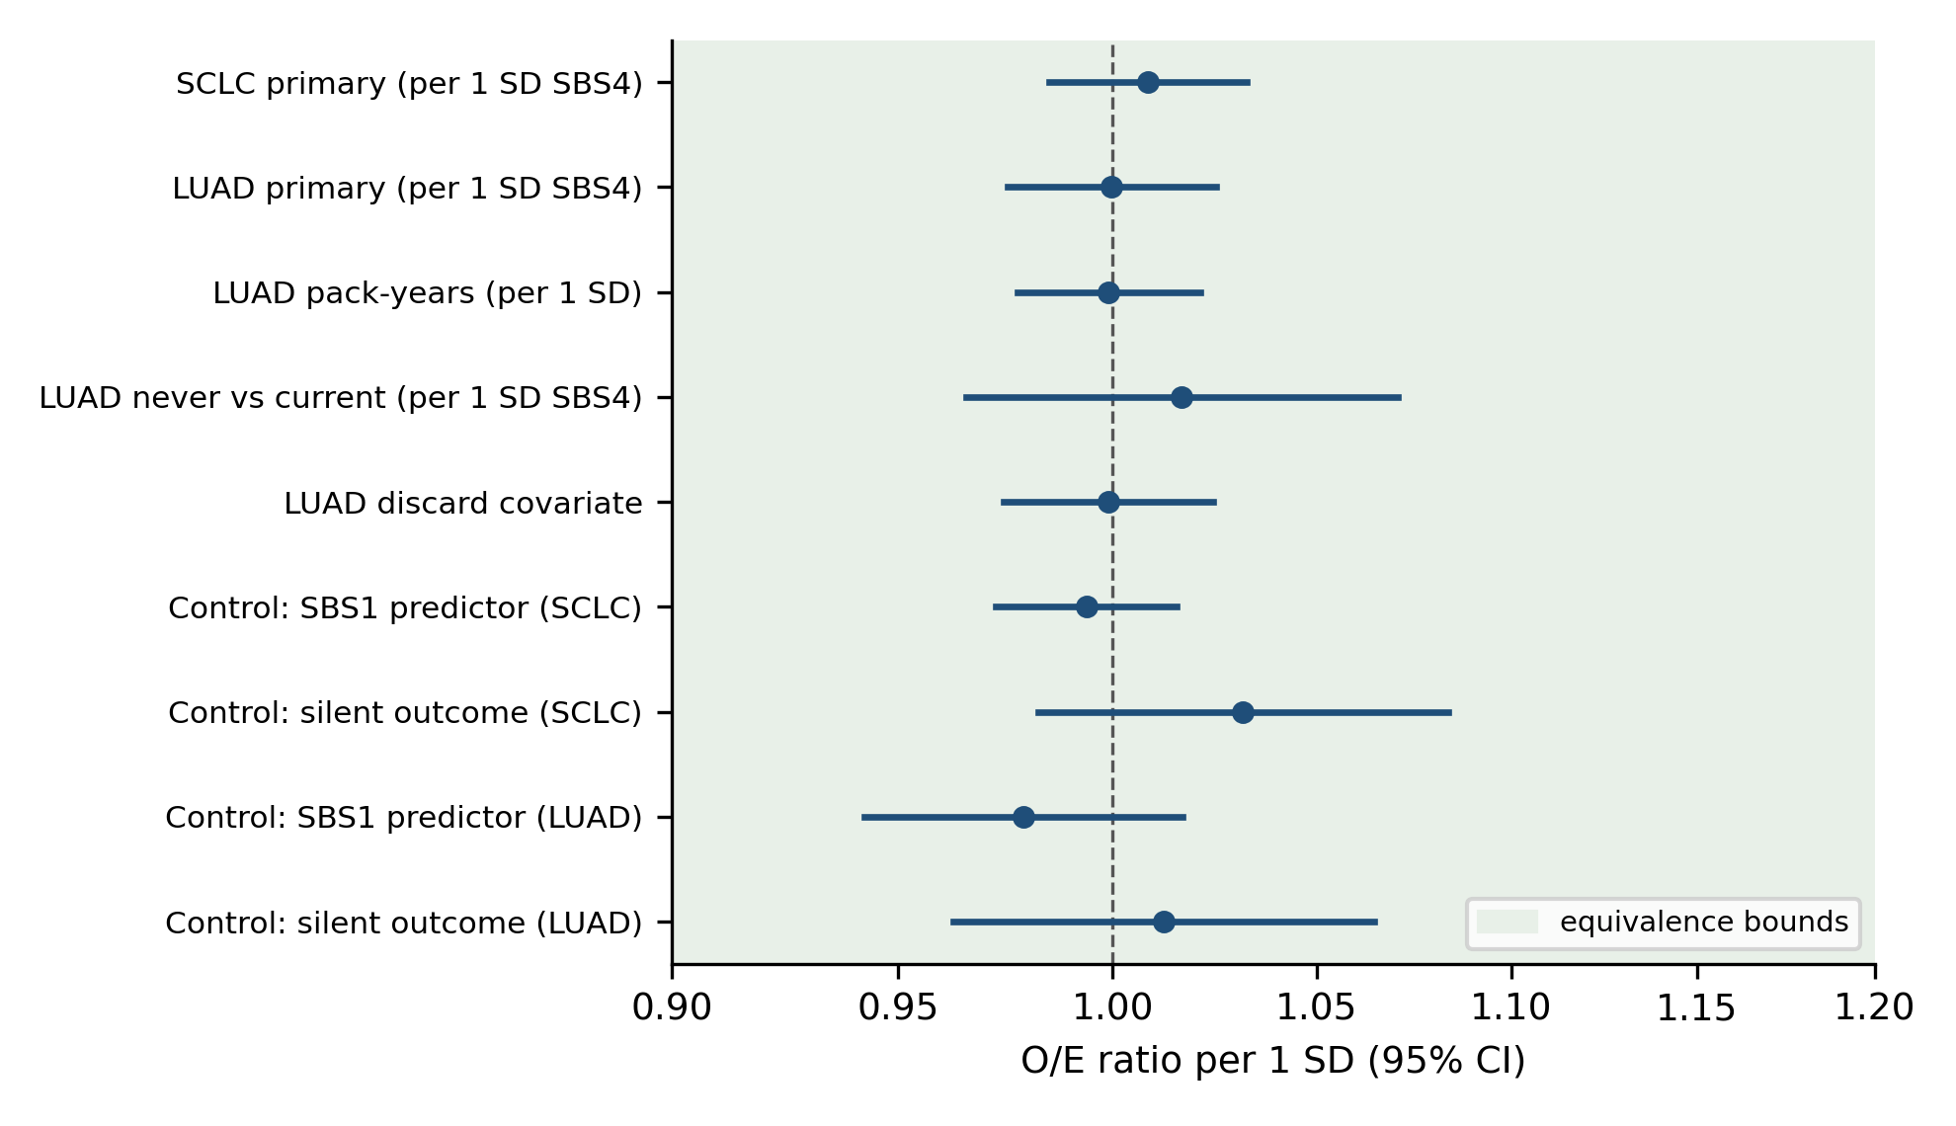
Figure 3. All model estimates (O/E ratio per 1 SD, 95% CI, log scale) with the pre-specified equivalence bounds (0.833, 1.2).

3.4 Raw (unadjusted) associations
Without the context adjustment the raw correlation of the disordered mutation share with SBS4 was also null: Pearson r = -0.12 (p = 0.16) and Spearman rho = -0.03 (p = 0.75) in SCLC; Pearson r = +0.08 (p = 0.25) and Spearman rho = +0.09 (p = 0.20) in LUAD (Figure 4). These are descriptive statistics without adjustment for cohort or mutation burden; the Pearson/Spearman divergence in SCLC suggests outlier influence.
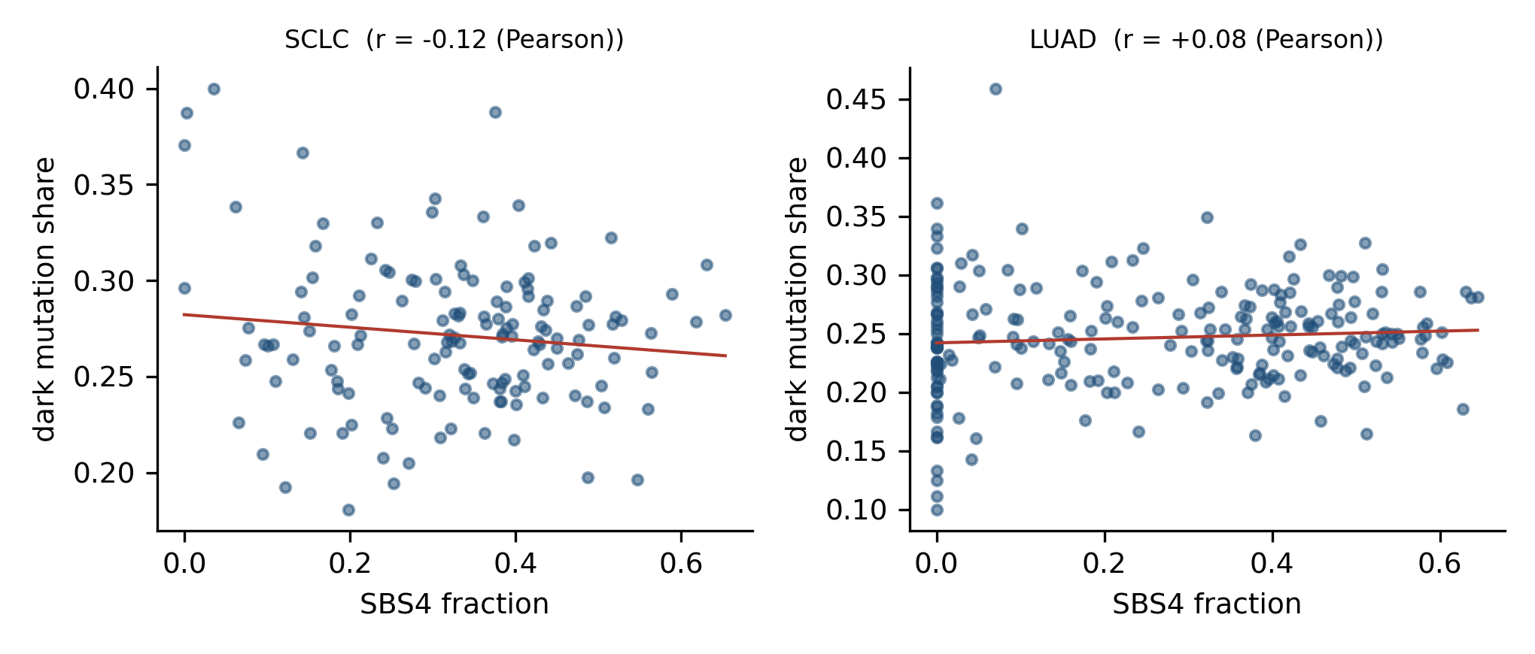
Figure 4. Raw disordered-region mutation share versus SBS4 fraction (each point: one tumour).

3.5 Global level of O/E
Globally, fewer mutations landed in disordered regions than expected (SCLC O/E = 0.94, LUAD 0.89). A formal significance level is not reported for this global level: the background-resampling test treats mutations as independent, whereas real mutations cluster within genes and hotspots, which inflates significance; the deviation is therefore reported descriptively. Its cause is not established; technical factors (capture coverage, expression, replication timing, selection, annotation filtering) are possible, and this observation is not interpreted biologically.
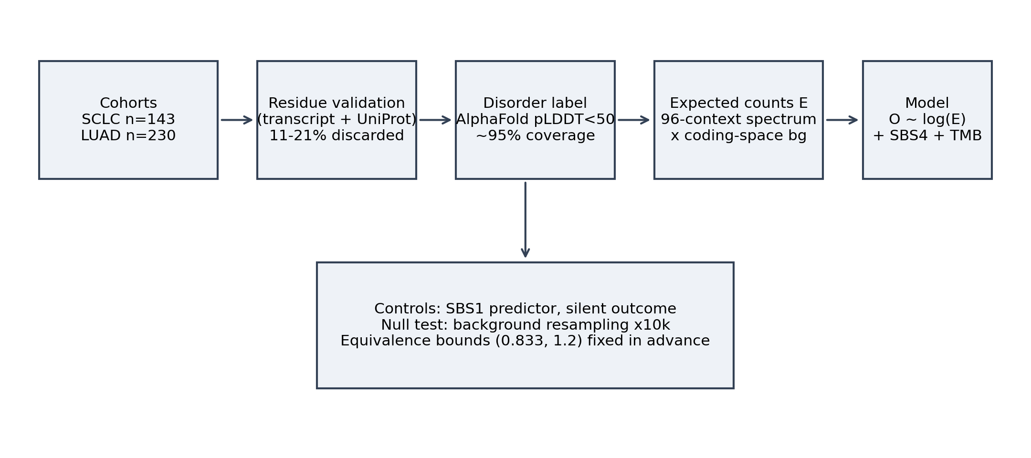
Figure 1. Study design.

4. Discussion
In both cohorts - among smokers with varying signature strength and across the full range from never-smokers to heavy smokers - the placement of mutations in predicted disordered regions did not track the tobacco mutational signature. Effects of 1.2 per SD and larger are excluded by the pre-specified equivalence bounds, and the confidence intervals narrow plausible effects to a few percent per SD on the measured scale. The result matches prior expectations: there is no mechanism linking a DNA damage signature to a property of the translated protein, and the study now quantifies how large such a link could be if present.
Limitations. (i) The SBS4 estimate is noisy (NNLS on a few hundred coding mutations), which attenuates observed effects toward zero; pack-years, an independent measure, agreed with the primary result. (ii) Signature and outcome are computed from the same mutations (not applicable to pack-years). (iii) Disordered positions are defined by AlphaFold pLDDT < 50, a proxy rather than experimental disorder maps. (iv) Absolute O/E levels are shifted by an unestablished background bias (global 0.94/0.89); two candidate artefacts were checked and do not explain it: recomputing the background on genes whose representative transcript translates identically to UniProt (72% of genes) moved global O/E only to 0.95/0.89, and restricting both mutations and background to those genes left the depletion unchanged (0.94/0.90); requiring a three-residue validation window instead of a single residue retained 98.5-99.5% of validated mutations. Conclusions therefore rest on within-cohort associations. (v) Exact exome capture territories are unknown; the background uses the protein-coding space. (vi) All SCLC tumours are from smokers; the smoking-vs-no-smoking contrast lives in LUAD. Larger cohorts, experimental disorder maps and independent signature estimates would tighten the bound further. Comparisons with the reported enrichment of mutations in disordered regions in pan-cancer settings (2) should be made cautiously: the setups differ.
Conclusions. Across 373 lung tumours and the full range of tobacco exposure, the strength of the smoke mutational signature does not change where mutations land relative to predicted disordered protein regions. Effects of biological interest (>= 1.2 per SD) are excluded; smaller effects, if any, lie below a few percent per SD on the measured scale.

Data and code availability
All source data are public: cBioPortal datahub (SCLC studies sclc_ucologne_2015, sclc_jhu, sclc_clcgp), TCGA/GDC (LUAD), AlphaFold Protein Structure Database, GENCODE v19, UniProt/Swiss-Prot, COSMIC v3.3.1. Analysis code, tests, run outputs with input checksums and the analysis plan: https://github.com/ArsikProgrammer/Darkcancer

References
1. Wright PE, Dyson HJ. Intrinsically disordered proteins in cellular signalling and regulation. Nat Rev Mol Cell Biol. 2015;16:18-29.
2. Zou H, Pan Y, Chen C, et al. Pan-cancer assessment of mutational landscape in intrinsically disordered hotspots reveals potential driver genes. Nucleic Acids Res. 2022;50(9):e49.
3. Meszaros B, Gadi I, Dosztanyi Z, et al. The impact of structural disorder on protein function and disease. Biomolecules. 2021;11(3):381. doi:10.3390/biom11030381
4. Alexandrov LB, Ju YS, Haase K, et al. Mutational signatures associated with tobacco smoking in human cancer. Science. 2016;354(6312):618-622.
5. Alexandrov LB, Nik-Zainal S, Wedge DC, et al. Signatures of mutational processes in human cancer. Nature. 2013;500:415-421.
6. George J, Lim JS, Jang SJ, et al. Comprehensive genomic profiles of small cell lung cancer. Nature. 2015;524:47-53. doi:10.1038/nature15338
7. Rudin CM, Durinck S, Stawiski EW, et al. Integrative genome analyses identify key somatic driver mutations in small cell lung cancer. Nat Genet. 2012;44(10):1111-1116. PMID:22941188. (Peifer M, et al. Nat Genet. 2012;44(10):1104-1110. PMID:22941189.)
8. The Cancer Genome Atlas Research Network. Comprehensive molecular profiling of lung adenocarcinoma. Nature. 2014;511:543-550. doi:10.1038/nature13385
9. Jumper J, Evans R, Pritzel A, et al. Highly accurate protein structure prediction with AlphaFold. Nature. 2021;596:583-589. doi:10.1038/s41586-021-03819-2
10. Varadi M, Anyango S, Deshpande M, et al. AlphaFold Protein Structure Database. Nucleic Acids Res. 2022;50:D439-D444. doi:10.1093/nar/gkab1061
11. Harrow J, Frankish A, Gonzalez JM, et al. GENCODE: the reference human genome annotation. Genome Res. 2012;22:1760-1774. doi:10.1101/gr.135350.111
12. UniProt Consortium. UniProt: the Universal Protein Knowledgebase in 2023. Nucleic Acids Res. 2023;51:D523-D531. doi:10.1093/nar/gkac1000
13. Tate JG, Bamford S, Jubb HC, et al. COSMIC: the Catalogue Of Somatic Mutations In Cancer. Nucleic Acids Res. 2019;47:D941-D947.
14. Gao J, Aksoy BA, Dogrusoz U, et al. Integrative analysis of complex cancer genomics and clinical profiles using the cBioPortal. Sci Signal. 2013;6(269):pl1.
15. Harris CR, Millman KJ, van der Walt SJ, et al. Array programming with NumPy. Nature. 2020;585:357-362. doi:10.1038/s41586-020-2649-2
16. Virtanen P, Gommers R, Oliphant TE, et al. SciPy 1.0: fundamental algorithms for scientific computing in Python. Nat Methods. 2020;17:261-272. doi:10.1038/s41592-019-0686-2
17. Seabold S, Perktold J. statsmodels: Econometric and statistical modeling with Python. Proc 9th Python in Science Conf. 2010.
18. McKinney W. Data structures for statistical computing in Python. Proc 9th Python in Science Conf. 2010:56-61.

Tables
Cohort | Samples | Coding SNVs | Validated (%) | pLDDT coverage (%)
SCLC: George (WGS) | 107 | 34,582 | 29,936 (86.6) | 92.6
SCLC: JHU (WES) | 30 | 5,190 | 4,403 (84.9) | 96.0
SCLC: CLCGP (WES) | 6 | 8,078 | 6,680 (82.7) | 94.3
LUAD: TCGA (WES) | 230 (32 never) | 66,770 | 52,914 (79.3) | 95.1
Table 1. Cohorts and quality control.
Analysis | O/E per 1 SD | 95% CI | Interpretation
SCLC primary (SBS4) | 1.008 | 0.985-1.033 | informative null
LUAD primary (SBS4) | 0.9998 | 0.975-1.025 | informative null
LUAD pack-years | 0.9991 | 0.978-1.021 | informative null
LUAD never vs current | 1.017 | 0.966-1.071 | informative null
LUAD discard covariate | 0.9991 | 0.974-1.024 | informative null
Control SBS1 (SCLC / LUAD) | 0.994 / 0.979 | 0.973-1.016 / 0.942-1.017 | passed
Control silent (SCLC / LUAD) | 1.032 / 1.012 | 0.983-1.084 / 0.963-1.065 | passed
Table 2. Model estimates. Equivalence bounds (0.833, 1.2) were fixed before the runs; rules for informative null / inconclusive / effect are given in the analysis plan.

