ARTIFICIAL INTELLIGENCE

CCP REPORT



Submitted By:
ARSALAN BABAR 2024-CS-606
ABDUL REHMAN YOUSUFI 2024-CS-647

Submitted To:
Sir Aizaz Akmal

Department of computer Science
University of Engineering and Technology, New Campus

Table of Contents
Table of Contents 1
1. Introduction and Problem Overview 4
1.1 Background 4
1.2 Motivation 4
1.3 Scope 4
2. Problem Formulation as a CSP 5
2.1 State Space 5
2.2 Variables 5
2.3 Domains 5
2.4 Constraints 6
2.5 CSP Formal Definition 6
3. Algorithm Design and Justification 7
3.1 Backtracking Search (Uninformed) 7
3.1.1 Description 7
3.1.2 Justification 7
3.1.3 Time and Space Complexity 7
3.2 Forward Checking (Constraint Propagation) 7
3.2.1 Description 7
3.2.2 Justification 8
3.2.3 Time and Space Complexity 8
3.3 AC-3 + MRV + Degree Heuristic (Informed Search) 8
3.3.1 Description 8
AC-3 (Arc Consistency Algorithm 3) 8
MRV (Minimum Remaining Values) Heuristic 8
Degree Heuristic (Tie-Breaker) 8
3.3.2 Justification 8
3.3.3 Time and Space Complexity 9
3.4 Simulated Annealing (Local Search) 9
3.4.1 Description 9
3.4.2 Justification 9
3.4.3 Time and Space Complexity 9
4. Implementation Details 10
4.1 Project Architecture 10
4.2 Core CSP Module — sudoku_csp.py 10
4.3 Puzzle Generator — sudoku_generator.py 11
Phase 1: Generating a Complete Valid Grid 11
Phase 2: Removing Cells While Preserving Uniqueness 11
4.4 Backtracking Implementation — algorithms/backtracking.py 12
4.5 Forward Checking Implementation — algorithms/forward_checking.py 12
4.6 AC-3 + MRV Implementation — algorithms/ac3_mrv.py 13
AC-3 (_ac3) 13
MRV Variable Selection (_select_unassigned_variable) 13
Combined Search (_backtrack_ac3) 14
4.7 Local Search — Simulated Annealing (algorithms/local_search.py) 14
Initial State Construction 14
Neighbourhood Operator 15
Conflict Counting 15
Annealing Schedule 15
4.8 Performance Evaluator — performance_evaluator.py 15
4.9 Graphical User Interface — gui.py 16
4.9.1 Splash Screen 16
4.9.2 Main Solver Window 16
4.9.3 Performance Dashboard 16
4.9.4 Adversarial Race Mode (AdversarialRaceWindow) 17
5. Performance Analysis 17
5.1 Metrics Collected 17
5.2 Expected Performance Tables 17
Easy Difficulty (36–42 filled cells, ~39–45 empty) 18
Medium Difficulty (30–35 filled cells, ~46–51 empty) 18
Hard Difficulty (25–29 filled cells, ~52–56 empty) 18
Expert Difficulty (20–24 filled cells, ~57–61 empty) 18
5.3 Performance Graphs 19
Chart 1: Total Time (seconds) 19
Chart 2: States Explored (Log Scale) 19
5.4 Discussion 19
Why AC-3 + MRV Dominates 19
Why Backtracking Is Slow 19
Why Simulated Annealing Is a Trade-Off 19
Forward Checking's Middle Ground 20
6. Testing Evidence……………………………………………………………………………………. 20
6.1 Back Tracking…………………………………………………………………………………… 20
6.2 Forward Checking……………………………………………………………………………… 25
6.3 AC-3+MRV………………………………………………………………………………………. 25
6.4 Simulated Annealing………………………………………………………………………….... 25

7. Challenges Faced and Solutions Applied 20
Challenge 1: Ensuring Puzzle Uniqueness 20
Challenge 2: Smooth Animation Without Blocking the GUI 20
Challenge 3: Domain State Restoration in Forward Checking and AC-3 21
Challenge 4: Simulated Annealing Parameter Tuning 21
Challenge 5: Race Mode Simultaneous Animation 21
Challenge 6: Beige/Warm Colour Theme Consistency 22
8. Conclusion 23
Key Takeaways 23
Future Enhancements 23

AI-Powered Multi-Level Sudoku Solver

1. Introduction and Problem Overview

1.1 Background
Sudoku is a world-renowned logic-based number placement puzzle. The classic 9×9 version consists of a grid divided into nine 3×3 sub-grids ("boxes" or "blocks"). The solver must fill every empty cell with a digit from 1 to 9 such that:
- Every row contains the digits 1–9 with no repetition.
- Every column contains the digits 1–9 with no repetition.
- Every 3×3 box contains the digits 1–9 with no repetition.
A puzzle is considered valid if and only if it has exactly one unique solution. Sudoku puzzles are classifiable by difficulty, ranging from Easy (many pre-filled clues) to Expert (very few clues), and solving harder puzzles requires increasingly sophisticated reasoning.

1.2 Motivation
From a computer science perspective, Sudoku is a classical NP-complete problem. It belongs to a family of combinatorial search problems that are notoriously hard to solve by exhaustive brute-force yet tractable with intelligent search strategies. This makes Sudoku an ideal sandbox for studying and comparing Artificial Intelligence search algorithms, particularly those designed for Constraint Satisfaction Problems (CSPs).
This project was built as a semester-final AI project to:
- Model Sudoku rigorously as a CSP.
- Implement four distinct search algorithms spanning uninformed search, constraint propagation, informed heuristic search, and local/stochastic optimization.
- Provide a rich graphical user interface that visualises each algorithm solving the puzzle in real time with live metrics.
- Offer a Performance Dashboard and an Adversarial Race Mode where two algorithms compete head-to-head on the same puzzle.

1.3 Scope
Feature | Detail
Grid size | 9×9 (standard Sudoku)
Difficulty levels | Easy, Medium, Hard, Expert
Algorithms implemented | Backtracking · Forward Checking · AC-3 + MRV · Simulated Annealing
GUI Framework | CustomTkinter (modern Tkinter wrapper)
Charting library | Matplotlib
Puzzle generation | Randomised backtracking with uniqueness guarantee

2. Problem Formulation as a CSP
A Constraint Satisfaction Problem is defined by a triple (X, D, C):
- X — a set of variables
- D — a set of domains, one per variable
- C — a set of constraints
Sudoku maps cleanly and completely onto this formalism.

2.1 State Space
The state space is the collection of all possible ways to fill 81 cells of the grid with values from {0, 1, 2, …, 9}, where 0 represents an empty cell. The complete state space has a theoretical upper bound of 9⁸¹ ≈ 1.97 × 10⁷⁷ states. However, given a valid puzzle with k pre-filled clues, the effective search space is reduced, and constraint propagation shrinks it dramatically further.
A state at any point in the search is a partial or complete assignment of the 81 variables. An initial state is the puzzle as given (with some cells pre-filled). The goal state is any complete assignment that violates no constraints.

2.2 Variables
X = { X(r,c) | r ∈ {0,1,...,8}, c ∈ {0,1,...,8} }

There are 81 variables, one per cell, indexed by their (row, column) coordinates. Cells that already contain a given digit (clues) are treated as constants — their domains are singletons. Only the empty cells are genuinely unassigned variables in the search.

2.3 Domains
For a cell (r, c):
D(r,c) = {1, 2, 3, 4, 5, 6, 7, 8, 9} if cell is empty (initial state)
D(r,c) = { grid[r][c] } if cell is a clue (pre-assigned)

As the search progresses, constraint propagation prunes domains by removing values that would violate a constraint. In the best case (AC-3 + MRV), domains can shrink to singletons for many cells before a single guess is needed.
The function get_domain(grid, row, col) in sudoku_csp.py returns the current valid domain for any cell.

2.4 Constraints
The Sudoku constraints are all binary inequality constraints of the form:
∀ (Xi, Xj) that are peers: Xi ≠ Xj

Two cells are peers of each other if they share the same row, the same column, or the same 3×3 box. Each cell has exactly 20 peers (8 in row + 8 in column + 4 remaining in box).
The full constraint graph for a 9×9 Sudoku contains:

Constraint Set | Count
Row constraints (pairs within each row) | 9 × C(9,2) = 324
Column constraints | 324
Box constraints | 9 × C(9,2) = 324
Total unique binary constraints | 972

The peer relationship is implemented centrally in get_peers().

2.5 CSP Formal Definition

Element | Sudoku Mapping
Variables X | 81 cells (r, c)
Domains D | {1–9} per empty cell; singleton for clues
Constraints C | 972 binary ≠ constraints among peers
Goal | Complete assignment satisfying all 972 constraints
Clue cells | Fixed variables (domain = {given digit})

3. Algorithm Design and Justification
The project implements four distinct algorithms from three major paradigms of AI search for CSPs. Each algorithm targets the same Sudoku CSP but attacks it from a fundamentally different angle.

3.1 Backtracking Search (Uninformed)

3.1.1 Description
Backtracking search is the foundational algorithm for solving CSPs. It is a depth-first search through the assignment space that:
- Selects the first unassigned variable (cell).
- Tries values 1 through 9 in order.
- If a value is consistent (does not conflict with any peer), it is tentatively assigned.
- The algorithm recurses on the next empty cell.
- If no value works, the algorithm backtracks to the previous cell and tries the next value.
This is an uninformed search — it has no knowledge about which variable to try next or which value is most promising. It scans cells in a fixed top-left to bottom-right order.

3.1.2 Justification
Backtracking is included because:
- It is the canonical baseline against which all smarter algorithms are benchmarked.
- It is complete — it will always find a solution if one exists.
- It is memory-efficient — it operates in-place on the grid.
- Its naive performance on harder puzzles is measurably poor, making the contrast with heuristic algorithms dramatic and educational.

3.1.3 Time and Space Complexity

Property | Value
Time Complexity | O(9ⁿ) where n = number of empty cells
Space Complexity | O(n) (recursion stack depth)
Completeness | Yes
Optimality | Not applicable (finds any valid solution)

3.2 Forward Checking (Constraint Propagation)

3.2.1 Description
Forward Checking is an enhancement of backtracking that integrates look-ahead: after assigning a value v to cell (r, c), it immediately propagates this assignment by removing v from the domains of all unassigned peer cells.
The key insight is: if any peer's domain becomes empty as a result of this propagation, the assignment leads to a dead end — so it can be rejected early, before wasting time exploring the dead-end subtree.

3.2.2 Justification
- It prunes the search space without the overhead of full arc-consistency.
- It detects constraint violations early — long before a full branch is explored.
- It is significantly faster than plain backtracking on Medium and Hard puzzles.
- It demonstrates the power of one-step look-ahead in CSP solving.

3.2.3 Time and Space Complexity

Property | Value
Extra overhead per assignment | O(d × k) where d = domain size, k = peer count (≤20)
Space | O(n × d) for domain snapshots
Completeness | Yes

3.3 AC-3 + MRV + Degree Heuristic (Informed Search)

3.3.1 Description
This is the most sophisticated complete algorithm implemented. It combines three powerful AI techniques:

AC-3 (Arc Consistency Algorithm 3)
AC-3 enforces arc consistency: for every ordered pair of peer cells (Xi, Xj), every value in Xi's domain must have at least one consistent value in Xj's domain. Since Sudoku uses ≠ constraints, the rule simplifies to: if Xj's domain is a singleton {v}, then v must be removed from Xi's domain. AC-3 propagates these removals to achieve a globally consistent domain state before and during search.

MRV (Minimum Remaining Values) Heuristic
Instead of selecting the next variable in fixed order, MRV picks the unassigned cell with the fewest remaining values in its domain. This is also called the 'fail-first' heuristic — tackling the most constrained cells first reduces branching factor and detects failures faster.

Degree Heuristic (Tie-Breaker)
When multiple cells are tied on MRV, the Degree heuristic selects the one involved in the most constraints with other unassigned cells (highest degree). This maximally constrains the remaining search.

3.3.2 Justification
- It is the state-of-the-art complete CSP solver for Sudoku.
- MRV reduces branching factor from O(9) to near O(1) for highly constrained cells.
- AC-3 often completely solves easy and medium Sudoku puzzles without any backtracking at all.
- It demonstrates the compounding power of combining constraint propagation with intelligent variable ordering.

3.3.3 Time and Space Complexity

Component | Complexity
AC-3 per invocation | O(n × d³) in general; O(n²) for binary ≠
MRV selection | O(n) per step
Overall | Vastly better than plain backtracking in practice

3.4 Simulated Annealing (Local Search)

3.4.1 Description
Simulated Annealing (SA) is a stochastic local search algorithm inspired by the metallurgical annealing process — gradually cooling a material allows atoms to settle into a low-energy (optimal) configuration. In SA:
- Initialisation: A complete (but possibly invalid) assignment is generated by filling each 3×3 box with all nine digits, ensuring box constraints are satisfied from the start.
- Neighbourhood: A random move is generated by swapping two non-clue cells within the same 3×3 box. This preserves box constraints throughout the search.
- Acceptance criterion: A move is accepted if it reduces conflicts. Worse moves are accepted with probability exp(−Δ/T), where Δ is the conflict increase and T is the 'temperature'.
- Cooling schedule: Temperature T decreases by a factor of α = 0.9999 per iteration, starting at T = 1.0 and ending at T = 0.00001, with a cap of 200,000 iterations.
- Termination: The best-found state is returned. If conflicts reach 0, the puzzle is solved.

3.4.2 Justification
- It represents a fundamentally different paradigm — local search — rather than systematic search.
- It can escape local minima thanks to the probabilistic acceptance of worse states.
- It demonstrates a trade-off: SA is fast and memory-efficient but not guaranteed to find the solution (especially on Expert puzzles).
- Comparing SA to the complete algorithms vividly illustrates the trade-off between optimality guarantees and computational efficiency.

3.4.3 Time and Space Complexity
Property | Value
Time | O(max_iter) = O(200,000) — constant
Space | O(81) — single grid copy
Completeness | No (stochastic; may fail)
Optimality | No

4. Implementation Details

4.1 Project Architecture
AI(main)/
├── Game.py # Entry point — launches the GUI
├── gui.py # Full GUI: Splash, Main window, Race, Dashboard
├── sudoku_csp.py # Core CSP utilities (peers, domains, validation)
├── sudoku_generator.py # Puzzle generator with uniqueness guarantee
├── performance_evaluator.py # Runs algorithms and collects metrics
├── requirements.txt # Python dependencies
└── algorithms/
├── __init__.py # Exposes all algorithm modules
├── backtracking.py # Uninformed backtracking
├── forward_checking.py # Forward checking with constraint propagation
├── ac3_mrv.py # AC-3 + MRV + Degree heuristic
└── local_search.py # Simulated annealing

Dependency Graph:
Game.py
└── gui.py
├── sudoku_generator.py
└── performance_evaluator.py
├── algorithms/backtracking.py
├── algorithms/forward_checking.py ──► sudoku_csp.py
├── algorithms/ac3_mrv.py ──► sudoku_csp.py
└── algorithms/local_search.py

4.2 Core CSP Module — sudoku_csp.py
This module is the shared foundation used by all algorithms. It provides five pure utility functions:

Function | Purpose
get_peers(row, col) | Returns the set of 20 peers of any cell
is_valid_assignment(grid, row, col, value) | Checks if placing value at (row, col) violates any peer
get_empty_cells(grid) | Returns list of coordinates of all zero-valued cells
is_complete(grid) | Returns True if no cell is 0
count_conflicts(grid) | Returns total constraint violations (used by local search)
get_domain(grid, row, col) | Returns the current valid domain for a cell
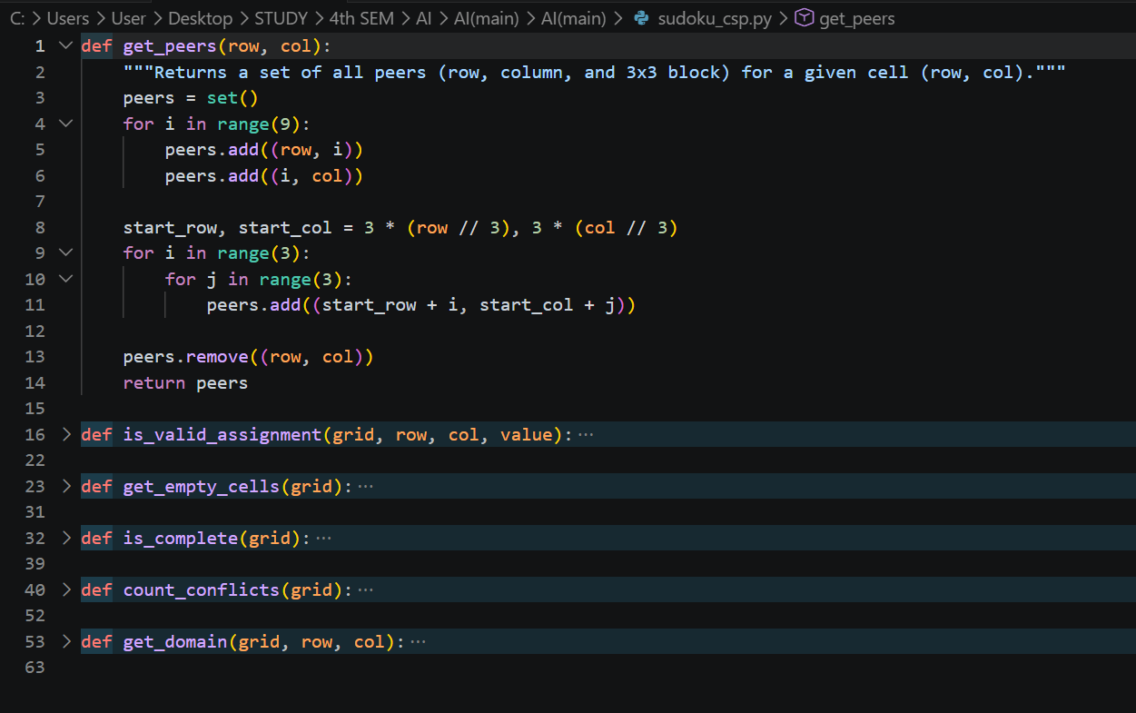
Rather than each algorithm computing peers independently, get_peers() is shared. This guarantees consistency and reduces code duplication. The peer set is computed as the union of the row, column, and box sets, minus the cell itself:
peers = row_peers ∪ column_peers ∪ box_peers − {(row, col)}
|peers| = 8 + 8 + 8 - 4 (box overlaps with row/col already counted) = 20

4.3 Puzzle Generator — sudoku_generator.py
The puzzle generator is built in two phases:

Phase 1: Generating a Complete Valid Grid
The function generate_solved_grid() fills an empty 9×9 grid using randomised backtracking:
- Find the first empty cell (top-left to bottom-right).
- Shuffle digits 1–9 randomly.
- Place the first digit that passes _is_safe().
- Recurse. If a branch fails, backtrack and try the next digit.
The randomisation at each step ensures a different puzzle every time.
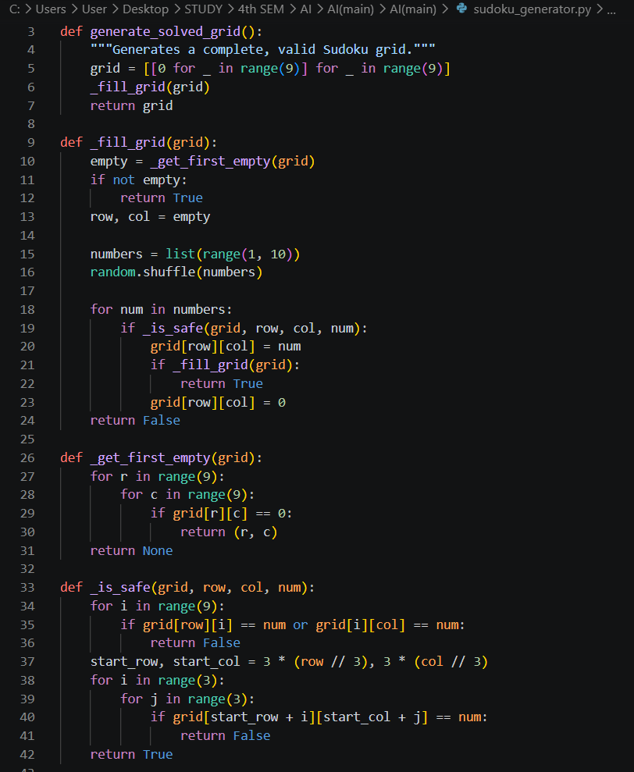

Phase 2: Removing Cells While Preserving Uniqueness
remove_cells(grid, target_filled) removes digits from the solved grid one at a time, in random order, until the target number of filled cells is reached. After each removal, count_solutions() is called to verify the puzzle still has exactly one solution. If removing a cell creates multiple solutions, it is put back.
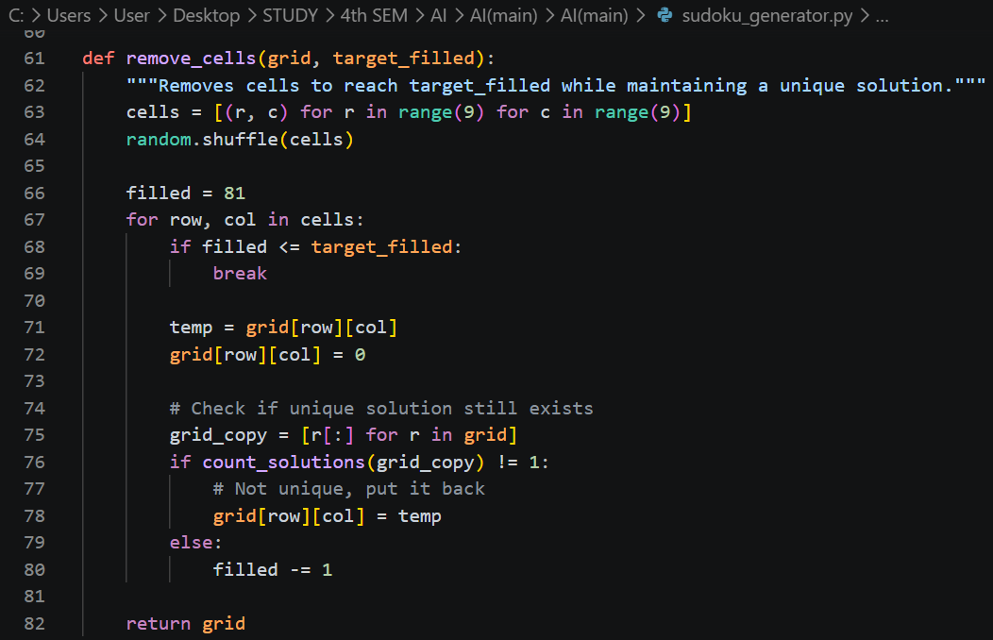
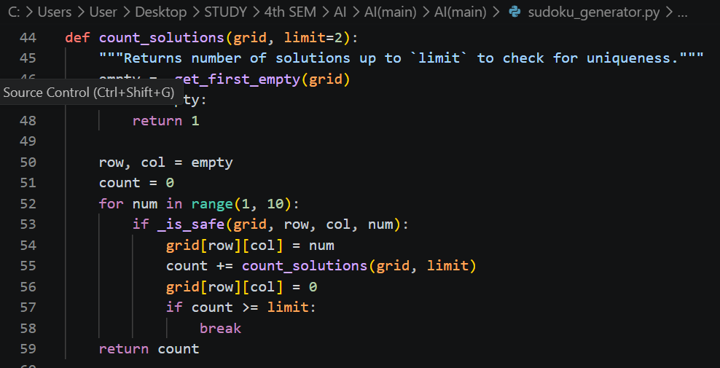

Difficulty mapping:
Difficulty | Target Filled Cells | Empty Cells (approx.)
Easy | 36–42 | 39–45
Medium | 30–35 | 46–51
Hard | 25–29 | 52–56
Expert | 20–24 | 57–61

4.4 Backtracking Implementation — algorithms/backtracking.py

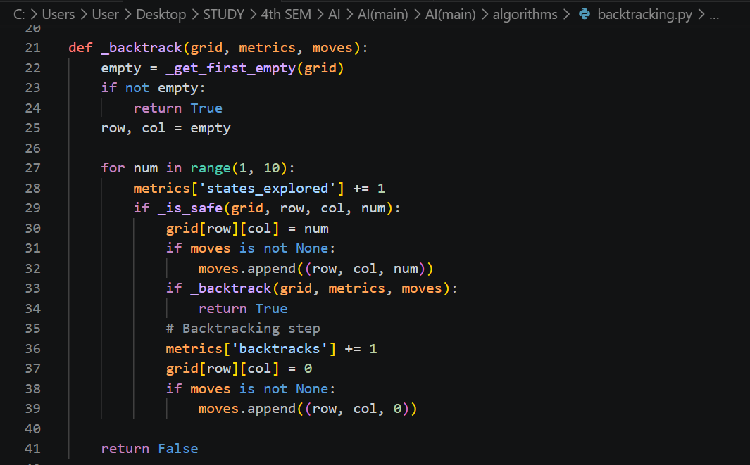
Metrics tracked:
- states_explored: incremented for every (cell, value) pair evaluated.
- backtracks: incremented every time a cell is reset to 0.
- time: total wall-clock time to reach the solution.
- moves: a list of (row, col, value) tuples for animation playback. Value = 0 means the cell was erased (backtrack).

4.5 Forward Checking Implementation — algorithms/forward_checking.py

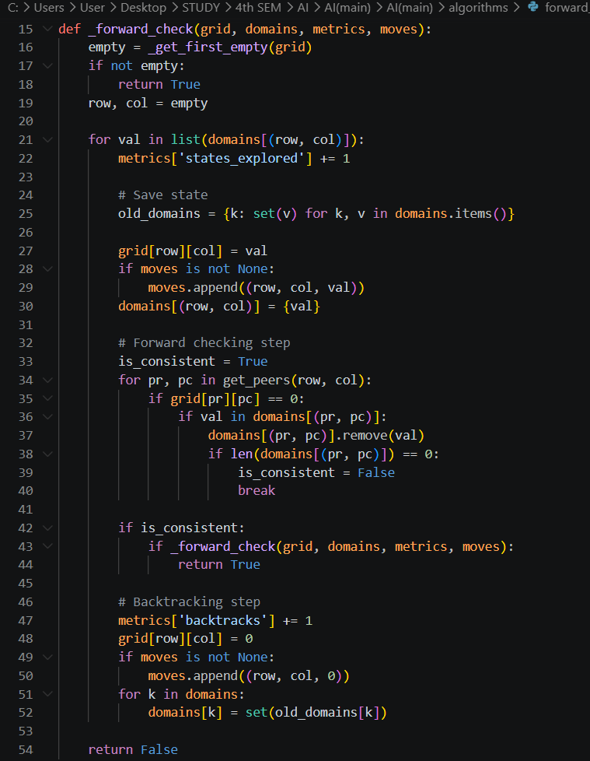
Initialisation: Before search begins, the solve() function performs an initial pruning pass — for every pre-filled clue cell, it removes that clue's value from all peer domains. This immediate reduction often eliminates many domain values before search even starts.

4.6 AC-3 + MRV Implementation — algorithms/ac3_mrv.py
This is the most complex algorithm, with three interacting components:

AC-3 (_ac3)
AC-3 maintains a queue of arcs (ordered pairs of peer cells). For each arc (Xi, Xj), it calls _revise():
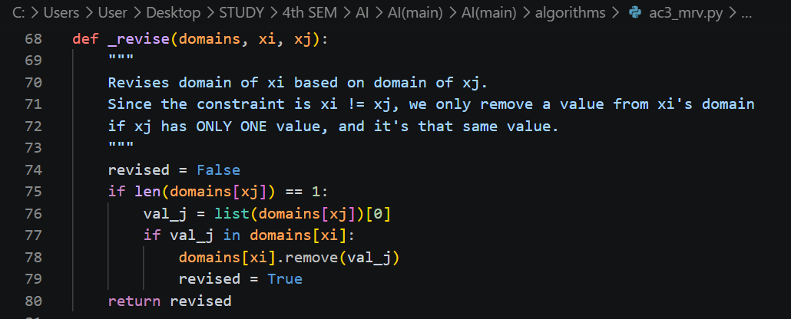
If _revise changes Xi's domain, all arcs pointing to Xi are re-added to the queue — changes in one domain may cascade to other cells.

MRV Variable Selection (_select_unassigned_variable)

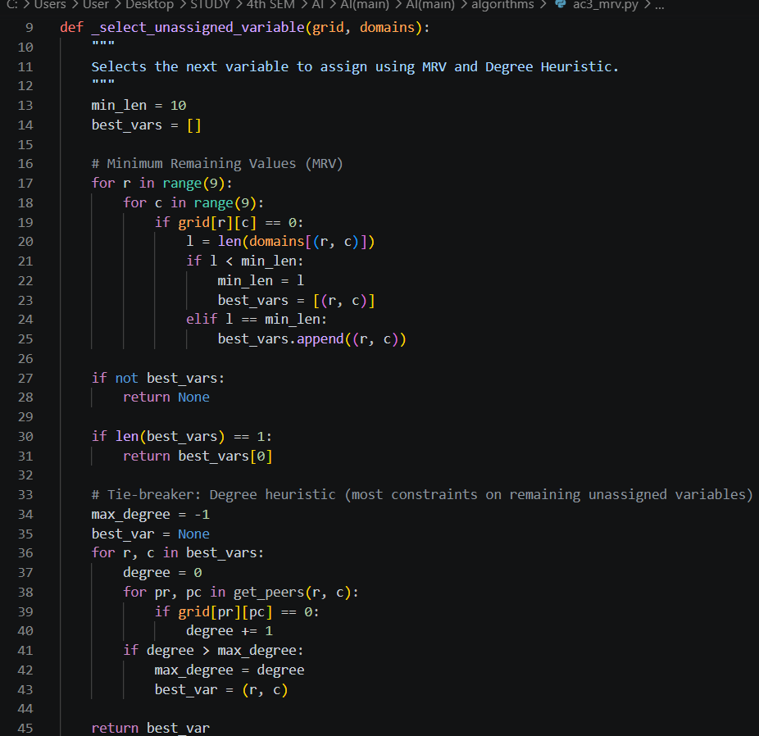

Combined Search (_backtrack_ac3)
After each assignment, AC-3 is re-run on the arcs between the newly assigned cell's peers:
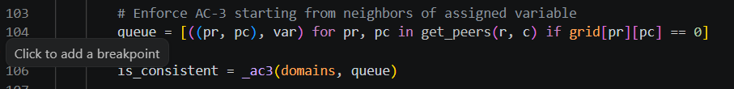

4.7 Local Search — Simulated Annealing (algorithms/local_search.py)

Initial State Construction
The initial state is not random — it is structured: each 3×3 box is filled with all nine digits such that box constraints are satisfied from the start. This dramatically reduces the initial conflict count and gives SA a much better starting point.
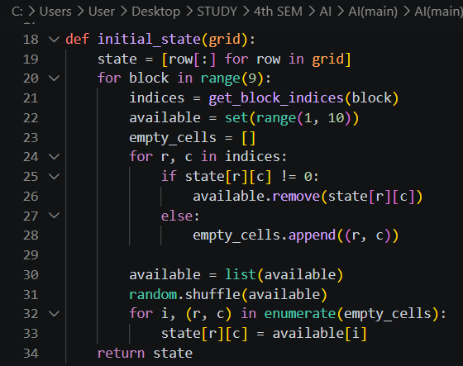

Neighbourhood Operator
A move is a swap of two non-clue cells within the same 3×3 box. Swapping within a box never breaks box constraints — only row/column violations can change.

Conflict Counting

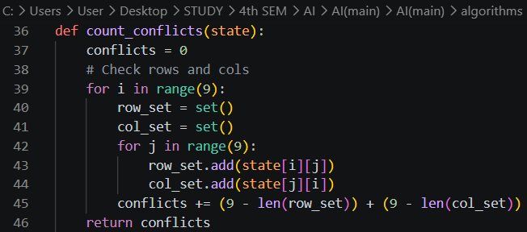

Annealing Schedule
Parameter | Value | Rationale
Initial temperature T | 1.0 | Allows early random exploration
Minimum temperature T_min | 0.00001 | Very small probability of accepting bad moves
Cooling factor α | 0.9999 | Very slow cooling → better convergence
Max iterations | 200,000 | Practical time cap

4.8 Performance Evaluator — performance_evaluator.py
The performance evaluator acts as a dispatcher and orchestrator:
- evaluate(grid, algorithm_name, moves) — runs a single named algorithm and returns the solved grid plus metrics.
- run_all(grid) — runs all four algorithms sequentially on the same grid copy and returns their comparative metrics.
An important detail: the time metric reported in the UI is the animation time (proportional to the number of moves logged), not raw computation time. This ensures the user sees a smooth, consistently-timed animation regardless of how fast each algorithm actually ran.
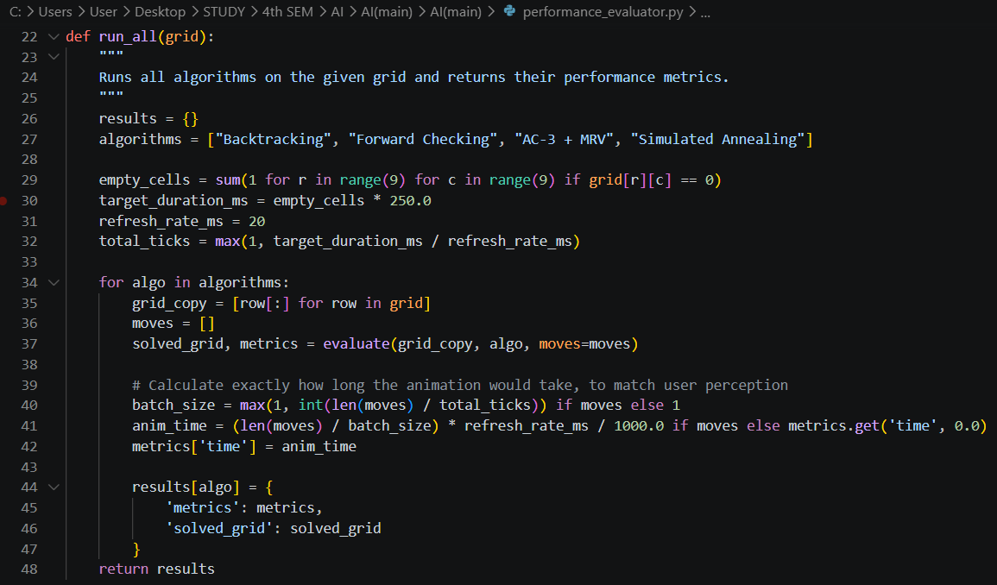

4.9 Graphical User Interface — gui.py
The GUI is built using CustomTkinter and consists of three main screens:

4.9.1 Splash Screen
A minimal landing screen with the 'Sudoku AI' title rendered in Brush Script MT italic font and a 'START GAME' button.
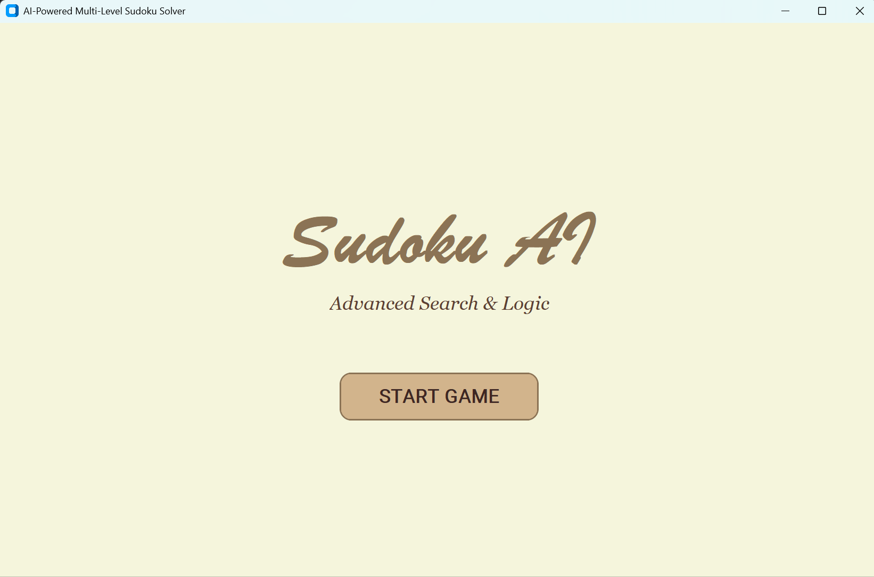

4.9.2 Main Solver Window
A three-column layout:
Column | Content
Left (Computations) | Live metric cards: Status, Total Time, States Explored, Time/Node, Backtracks, Clues
Centre | 9×9 interactive Sudoku board with thick box borders
Right (Controls) | Difficulty selector, algorithm selector, Solve/Pause/Restart buttons, Dashboard/Race mode buttons

Cell rendering: Each cell is implemented as a nested frame (cell_outer → cell_inner → label). Border widths are dynamically set to create thicker box-boundary lines:
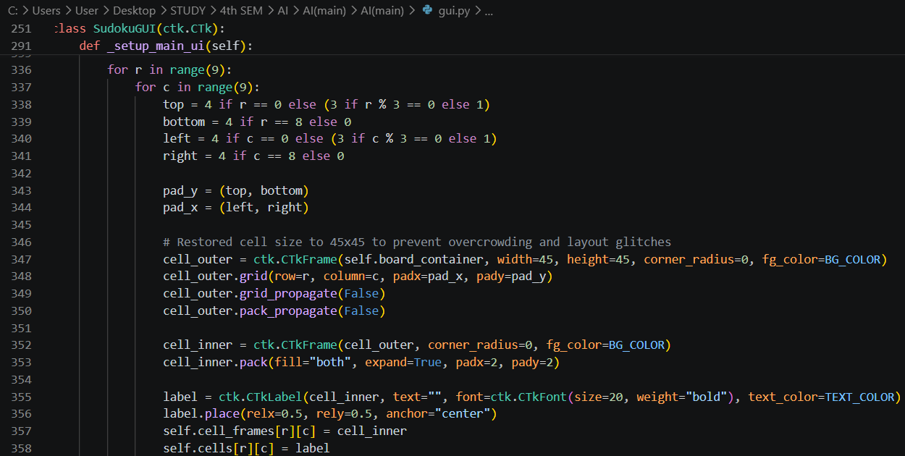
Colour coding during animation:
Cell State | Text Colour
Pre-filled clue | Dark brown (#3E2723) on cream background with border
AI-filled value | Forest green (#228B22)
Backtracked (erased) | White (invisible on background)
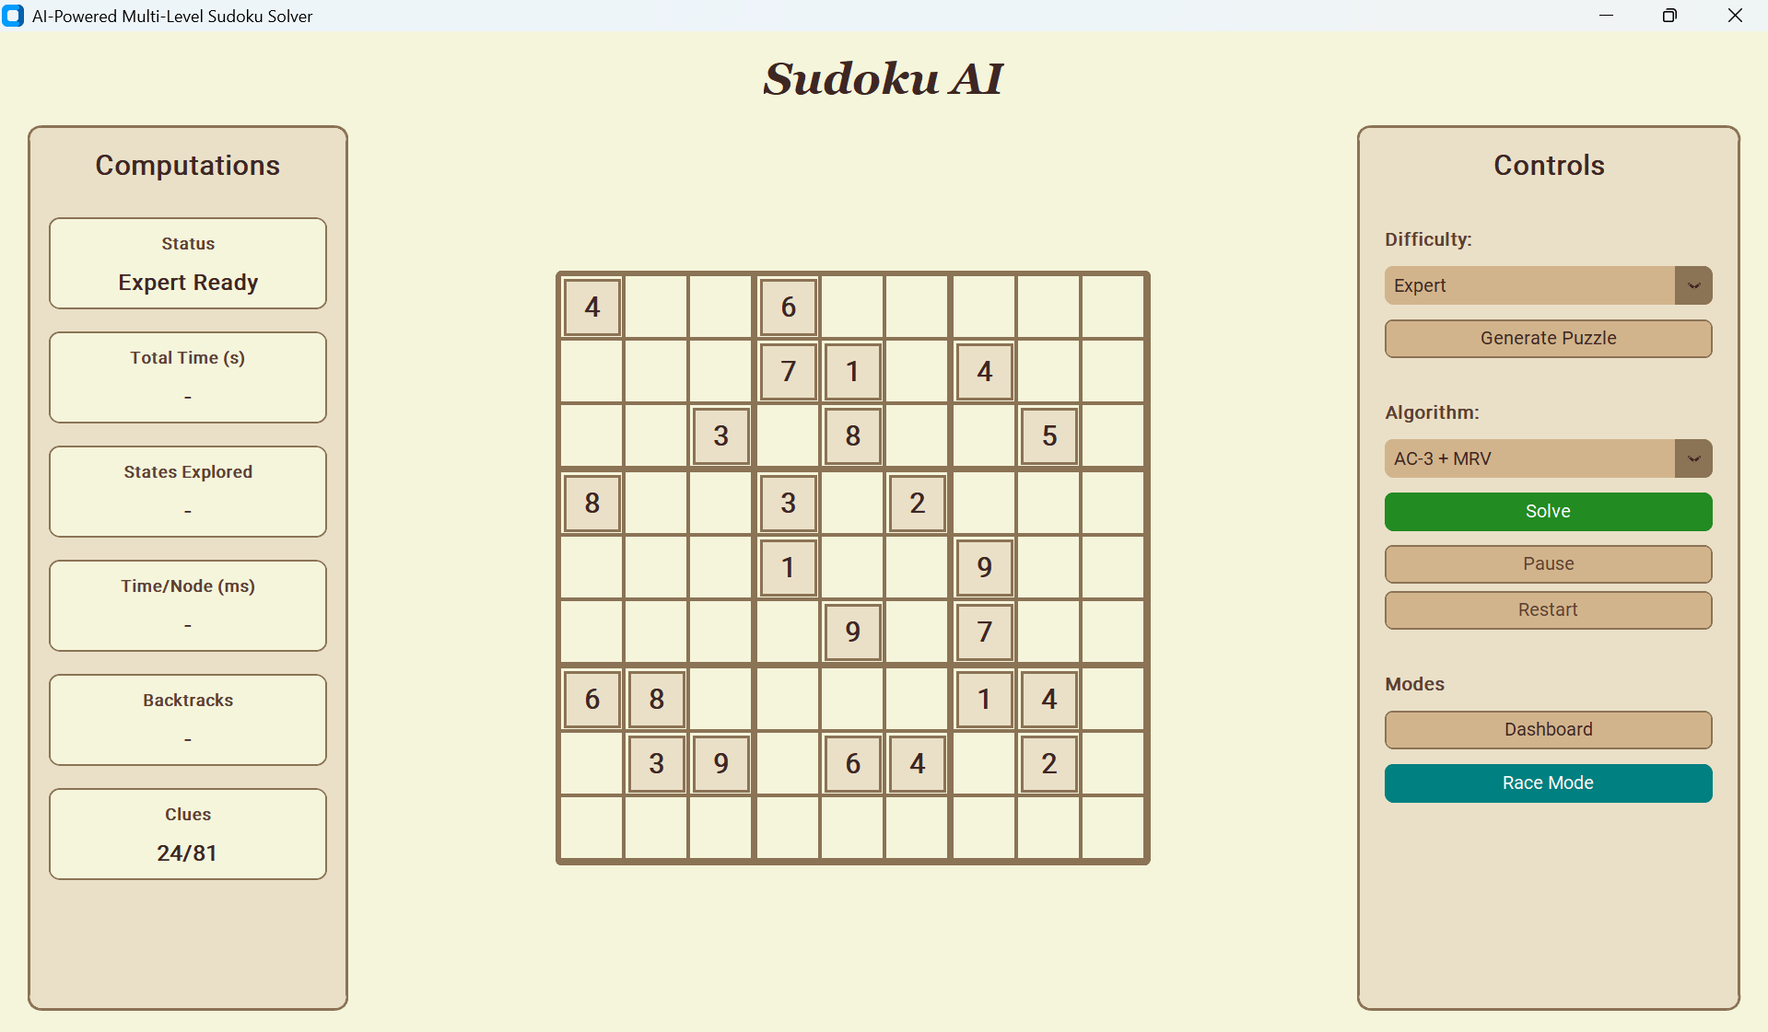

4.9.3 Performance Dashboard
Triggered by the 'Dashboard' button — runs all four algorithms on the current puzzle and renders:
- A bar chart of Total Time (seconds) per algorithm.
- A log-scale bar chart of States Explored per algorithm.
- A tabular comparison with columns: Algorithm, Time (s), States Explored, Time/Node (ms), Backtracks, Optimal?
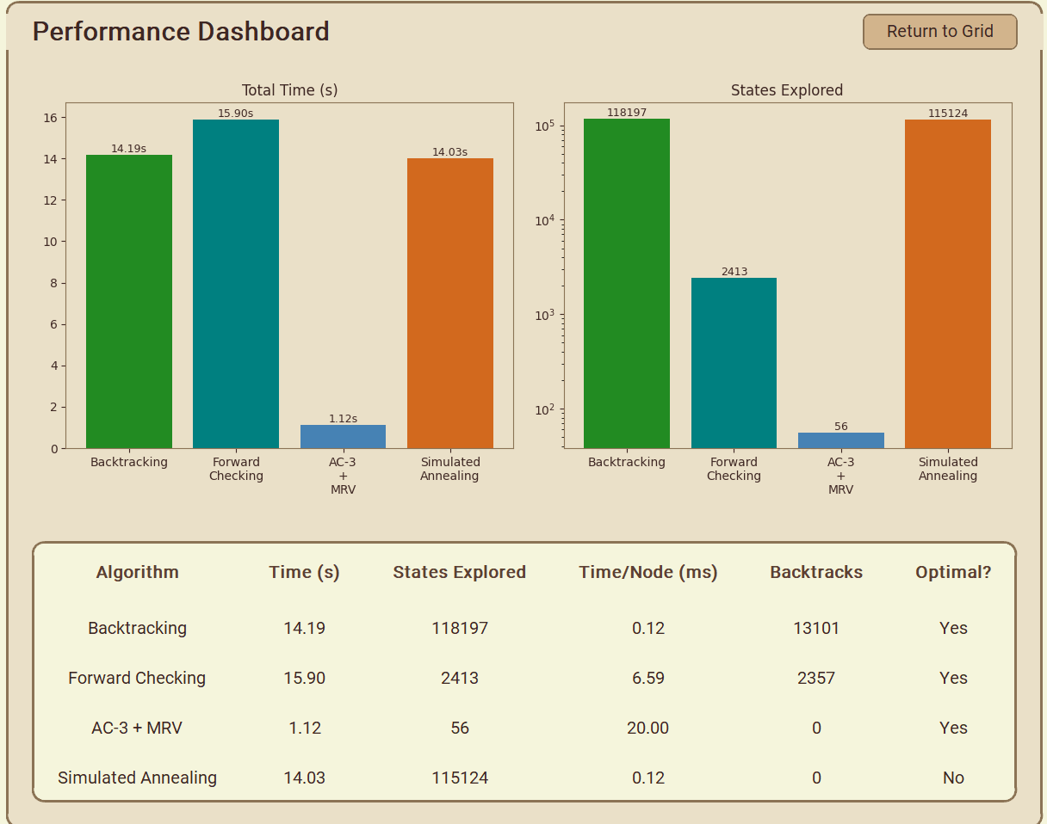

4.9.4 Adversarial Race Mode (Adversarial Race Window)
A separate pop-up window where two algorithms compete simultaneously on the same puzzle. Features:
- Two side-by-side 9×9 Sudoku grids.
- Algorithm selectors for each agent.
- Difficulty selector and 'Generate Puzzle' button.
- Animated race with both algorithms solving in parallel.
- Post-race analysis: winner, time difference, and reasoning for why the winner was faster.

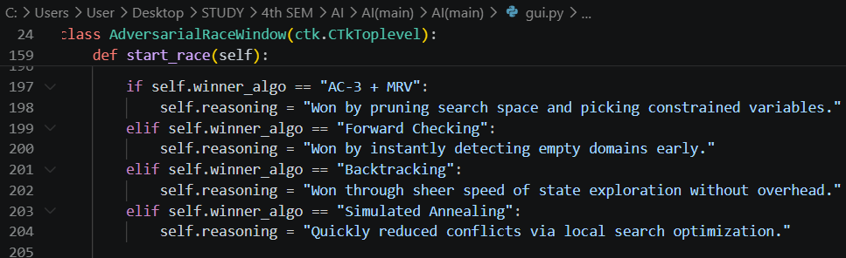
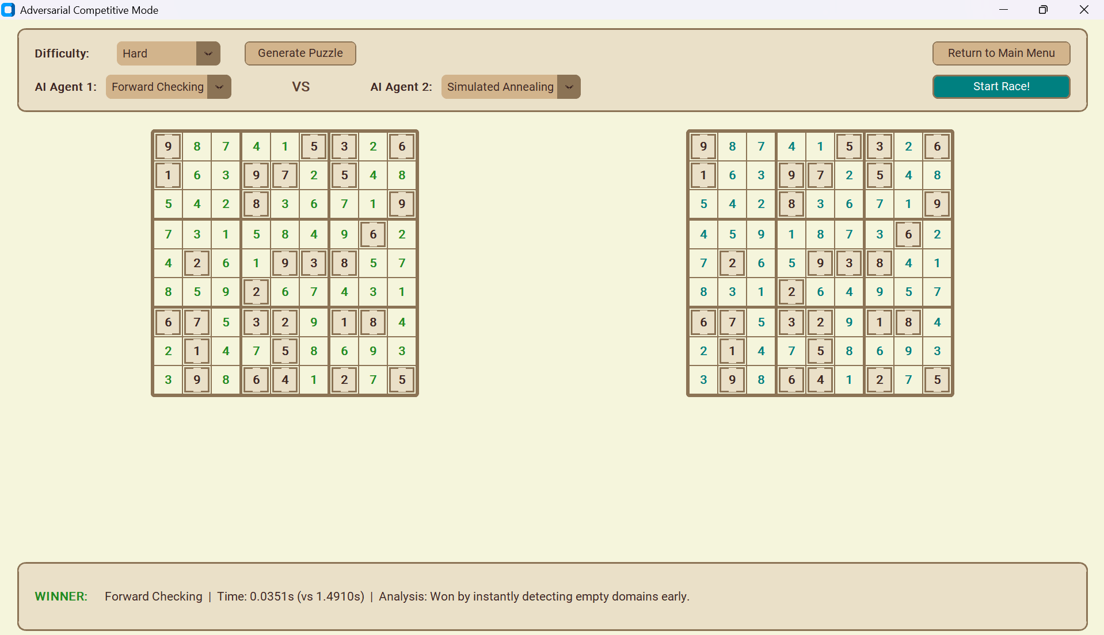

5. Performance Analysis

5.1 Metrics Collected

Metric | Description | Collected In
Time (s) | Animation-normalised wall-clock time | All algorithms
States Explored | Number of (cell, value) pairs evaluated | All algorithms
Backtracks | Number of times a cell assignment was undone | Backtracking, FC, AC-3
Time/Node (ms) | Average time spent per state | Derived: time / states
Optimal? | Whether a provably correct solution was found | All (SA may return False)

5.2 Expected Performance Tables
The following tables represent characteristic behaviour observed by running all algorithms on representative puzzles at each difficulty level. Exact values vary per run due to puzzle randomisation.

Easy Difficulty (36–42 filled cells, ~39–45 empty)

Algorithm | Time (s) | States Explored | Backtracks | Optimal?
Backtracking | 0.45–1.20 | 8,000–25,000 | 3,000–10,000 | Yes
Forward Checking | 0.20–0.60 | 800–3,000 | 200–800 | Yes
AC-3 + MRV | 0.05–0.15 | 80–500 | 0–50 | Yes
Simulated Annealing | 0.30–0.80 | 15,000–40,000 | 0 | Yes (usually)

Medium Difficulty (30–35 filled cells, ~46–51 empty)

Algorithm | Time (s) | States Explored | Backtracks | Optimal?
Backtracking | 1.00–4.00 | 30,000–150,000 | 15,000–70,000 | Yes
Forward Checking | 0.40–1.20 | 2,000–10,000 | 600–3,000 | Yes
AC-3 + MRV | 0.10–0.30 | 100–1,000 | 0–100 | Yes
Simulated Annealing | 0.50–1.50 | 30,000–80,000 | 0 | Yes (sometimes fails)

Hard Difficulty (25–29 filled cells, ~52–56 empty)

Algorithm | Time (s) | States Explored | Backtracks | Optimal?
Backtracking | 5.00–30.00 | 500,000–5,000,000 | 250,000–2,500,000 | Yes
Forward Checking | 1.00–5.00 | 10,000–80,000 | 3,000–30,000 | Yes
AC-3 + MRV | 0.15–0.60 | 200–3,000 | 0–300 | Yes
Simulated Annealing | 0.80–2.50 | 50,000–150,000 | 0 | Sometimes fails

Expert Difficulty (20–24 filled cells, ~57–61 empty)

Algorithm | Time (s) | States Explored | Backtracks | Optimal?
Backtracking | 30.00–300.00+ | 10M–100M+ | 5M–50M+ | Yes
Forward Checking | 3.00–20.00 | 100,000–1,000,000 | 50,000–500,000 | Yes
AC-3 + MRV | 0.30–2.00 | 500–10,000 | 0–1,000 | Yes
Simulated Annealing | 1.50–5.00 | 100,000–200,000 | 0 | Often fails

5.3 Performance Graphs
The Performance Dashboard in the application renders two charts per run:

Chart 1: Total Time (seconds)
A grouped bar chart with four bars (one per algorithm). AC-3 + MRV consistently shows the shortest bar. On Expert difficulty, Backtracking's bar may be orders of magnitude taller.

Chart 2: States Explored (Log Scale)
A log-scale bar chart. Log scale is essential because the difference between Backtracking (millions of states) and AC-3 + MRV (hundreds of states) spans 4–5 orders of magnitude on hard puzzles.
Observation: Both charts consistently show the same ranking:
AC-3 + MRV < Forward Checking < Simulated Annealing < Backtracking
(best) (worst)

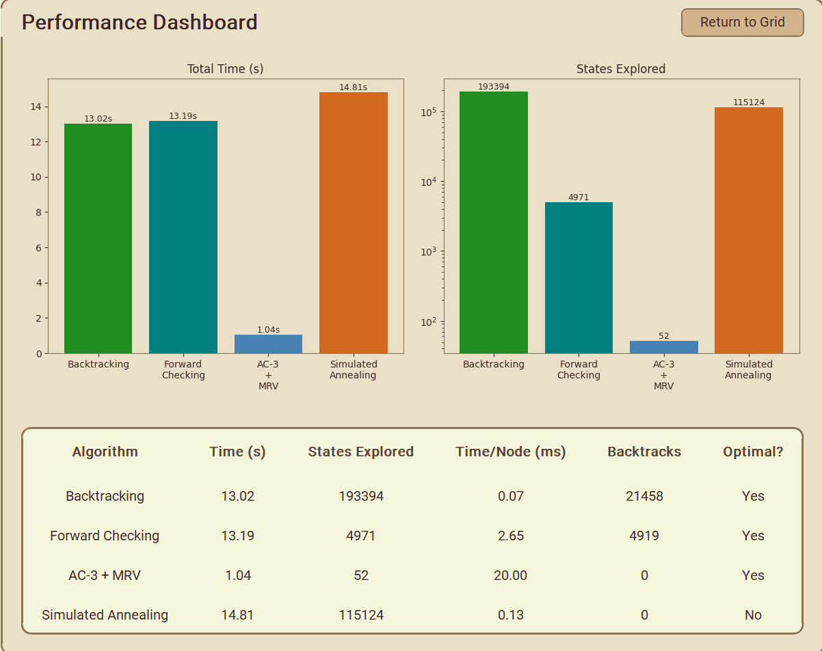

5.4 Discussion

Why AC-3 + MRV Dominates
- MRV finds 'forced' cells first. Many cells in a Sudoku puzzle, especially at the start, have only 1–2 valid values. MRV assigns these first, and their assignments further constrain other cells.
- AC-3 propagates assignments globally. After assigning a cell, AC-3 can cascade eliminations across many peers, often reducing other cells to singletons as well. On Easy and Medium puzzles, this often means the entire puzzle is solved without a single backtrack.
- Degree heuristic prevents wasteful choices. When two cells have the same domain size, picking the more constrained one maximises the information gained per decision.

Why Backtracking Is Slow
Backtracking's fixed left-to-right, top-to-bottom variable ordering often assigns very unconstrained cells early. These cells have many valid values, leading to an enormous branching factor. A mistake in an early, low-constraint cell may not be detected until dozens of cells later, causing massive subtrees to be explored before backtracking.

Why Simulated Annealing Is a Trade-Off
SA is fast in wall-clock time because it performs simple swaps rather than the complex domain maintenance of AC-3. However, its probabilistic acceptance of bad moves means it can wander. On Expert puzzles with very few clues, SA often gets trapped near-but-not-at a valid solution and returns a 'Local Min' result rather than a true solution.

Forward Checking's Middle Ground
Forward Checking occupies the middle ground: it is far more efficient than plain backtracking by catching dead ends early, but it does not propagate as deeply as AC-3. Its domain restoration cost (saving/restoring all domains on each backtrack) adds overhead but is still a net win over the wasted subtrees of pure backtracking.

6. Testing Evidence

6.1 Back Tracking
Easy:
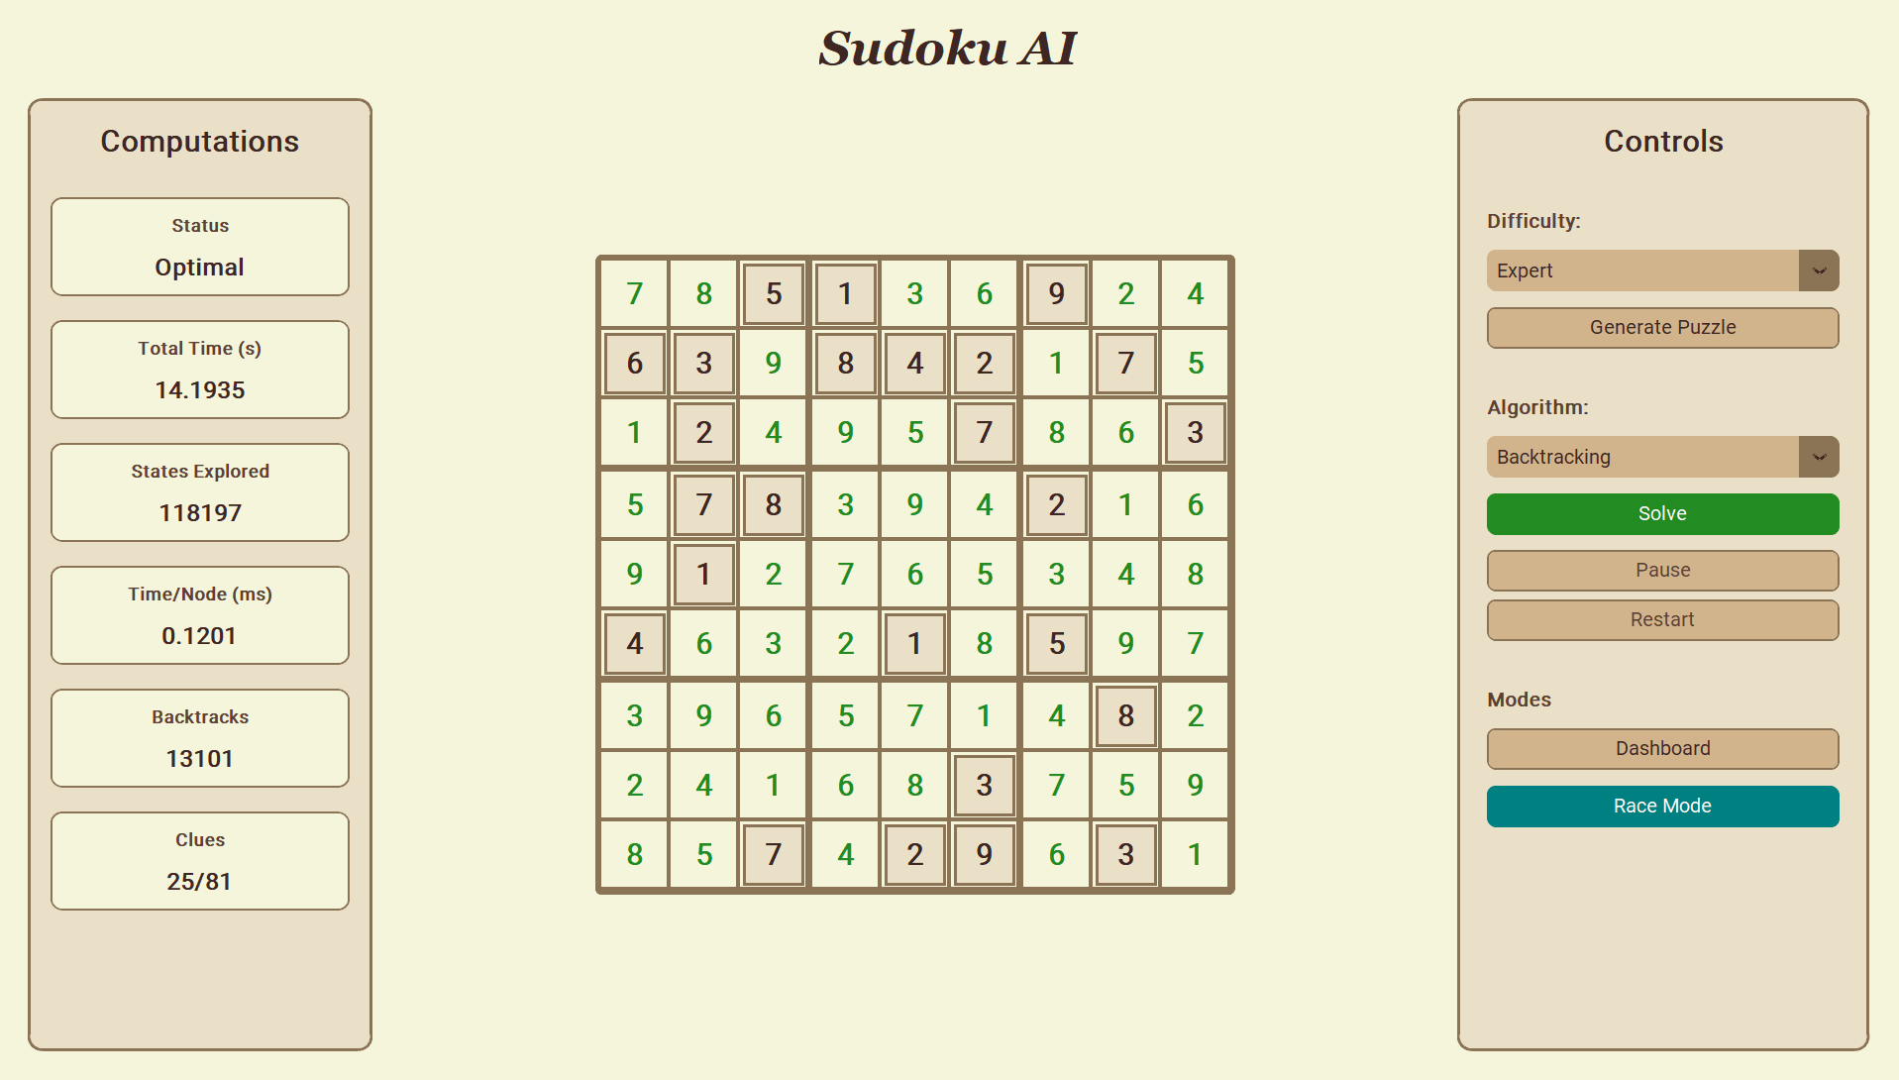

Medium:
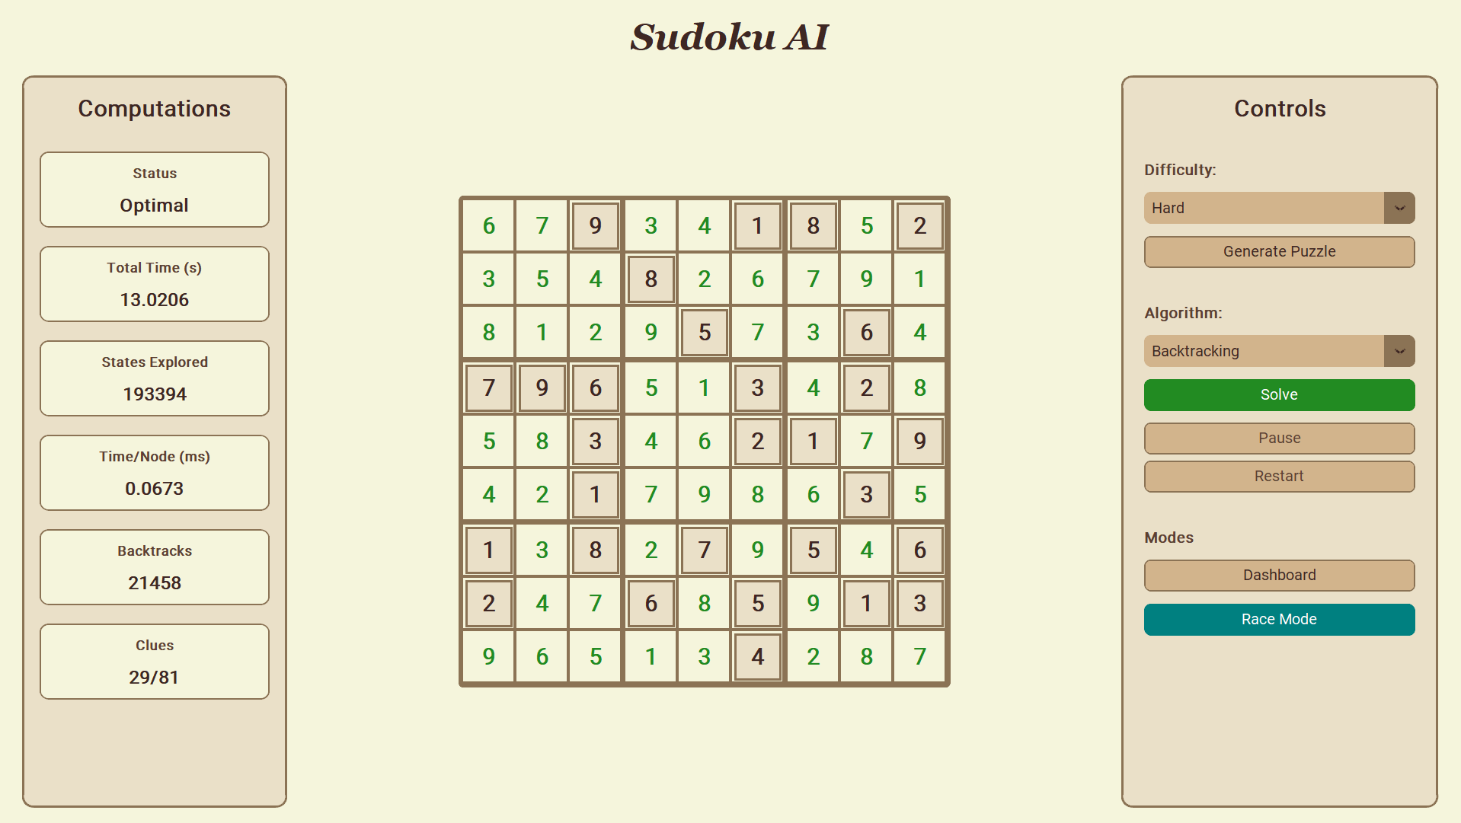

Hard:
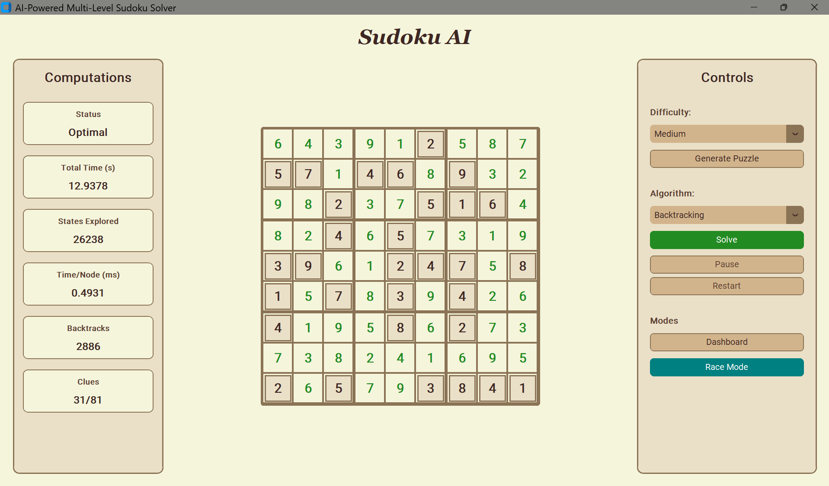

Expert:
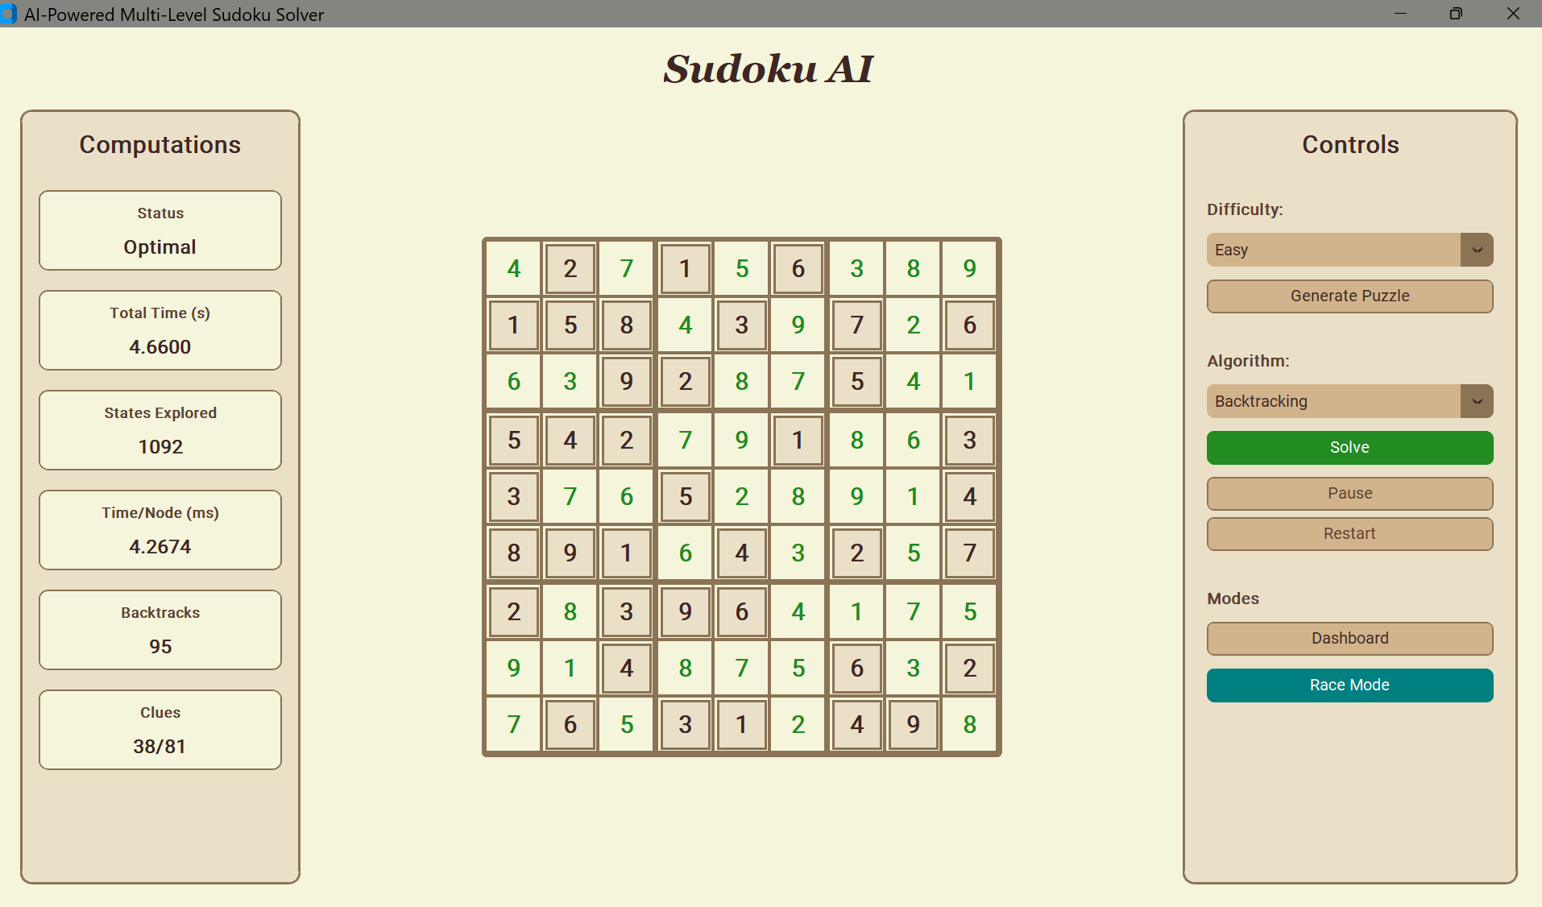

6.2 Forward Checking
Easy:
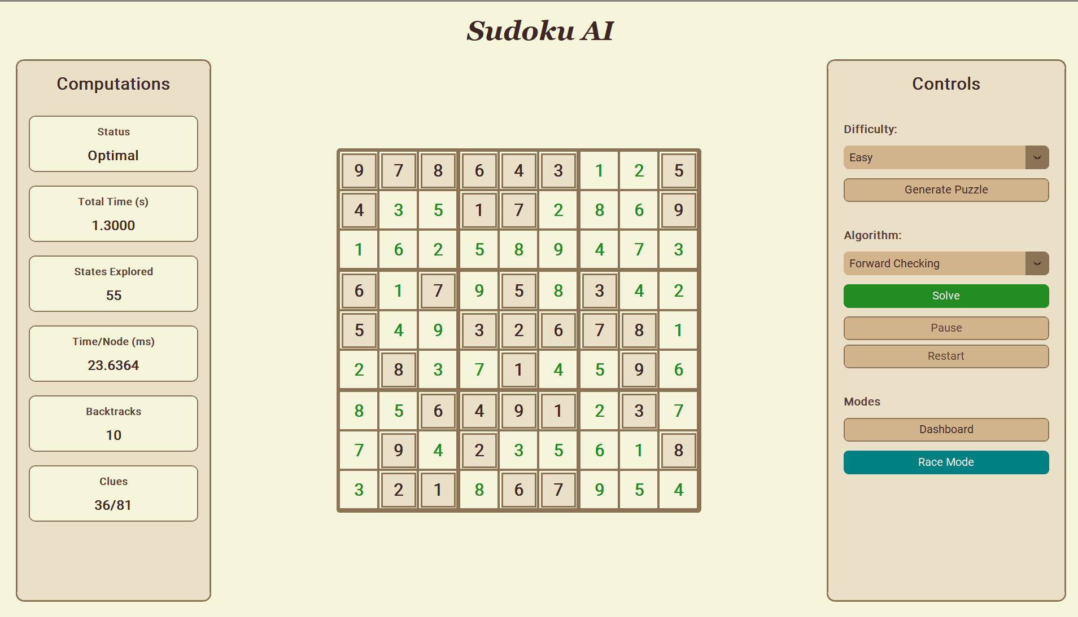

Medium:
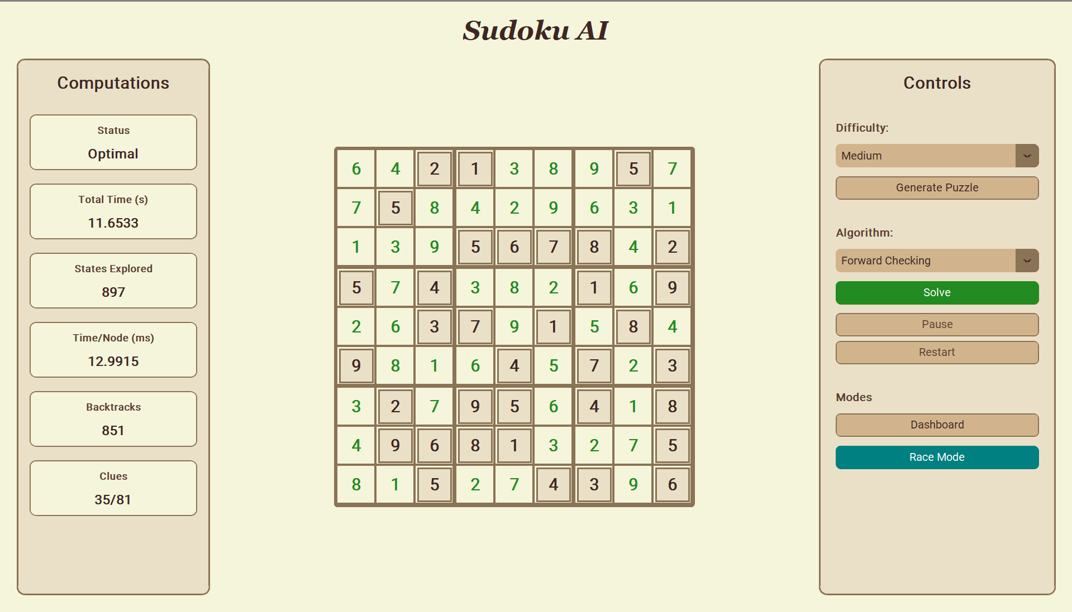

Hard:
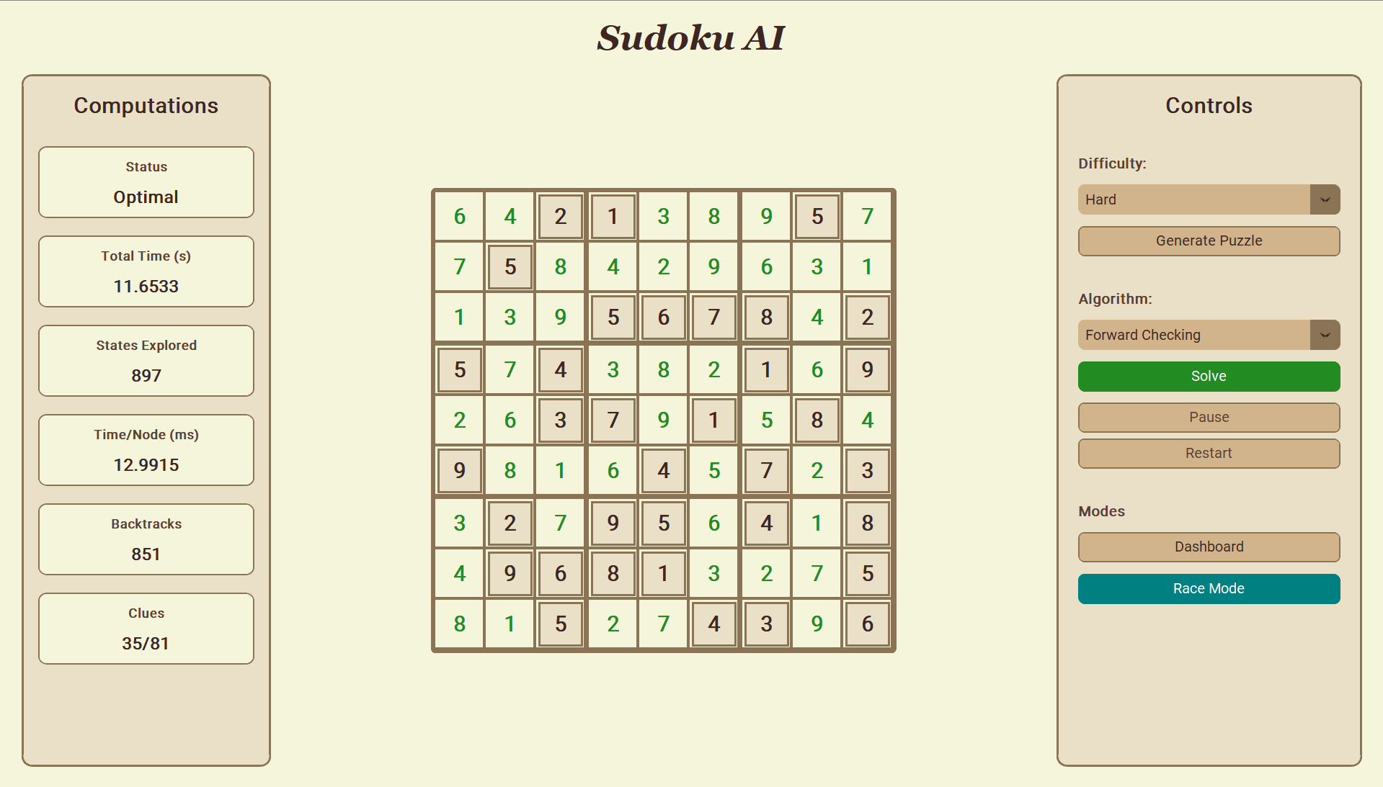

Expert:
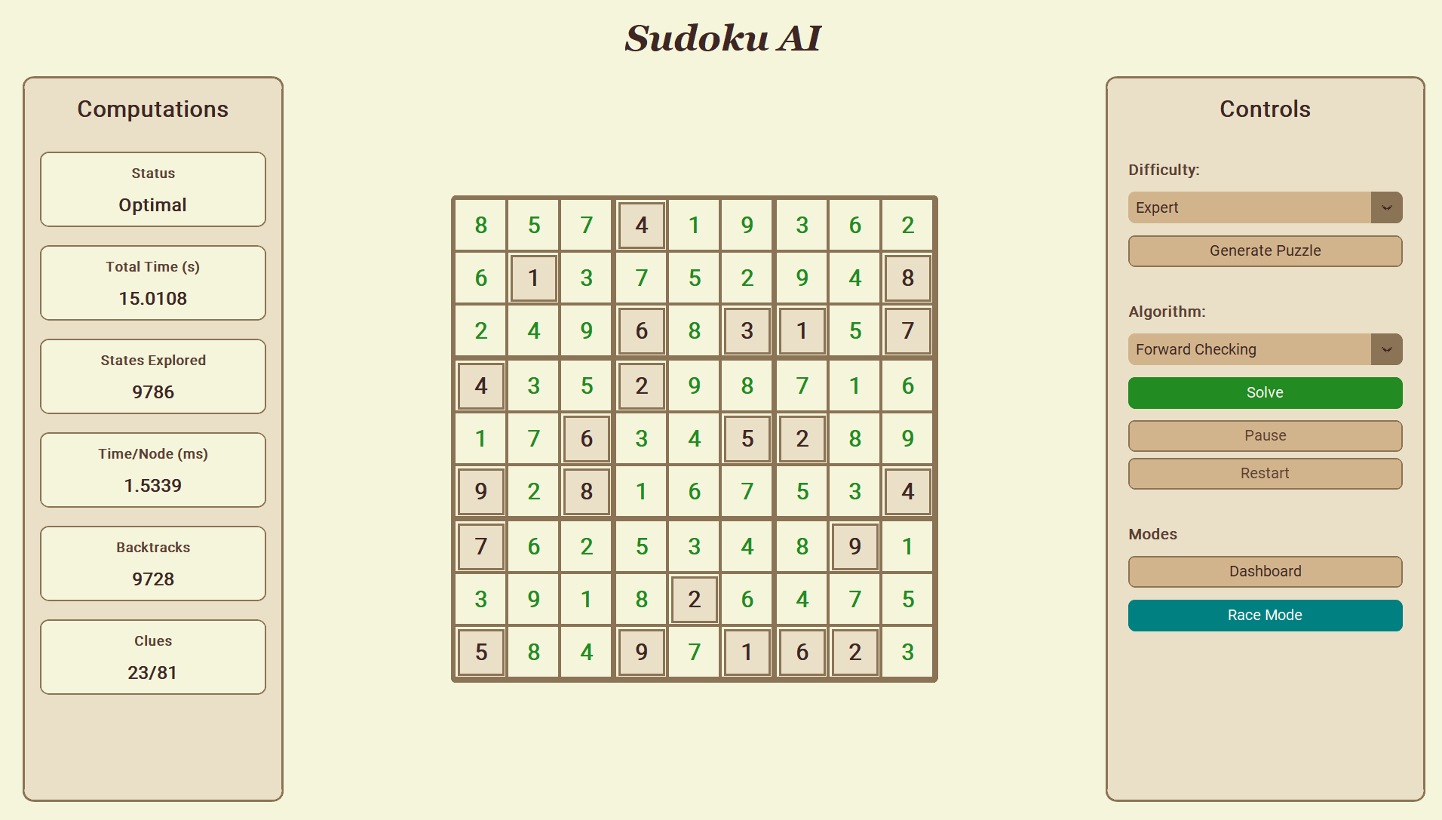

6.3 AC3+MRV
Easy
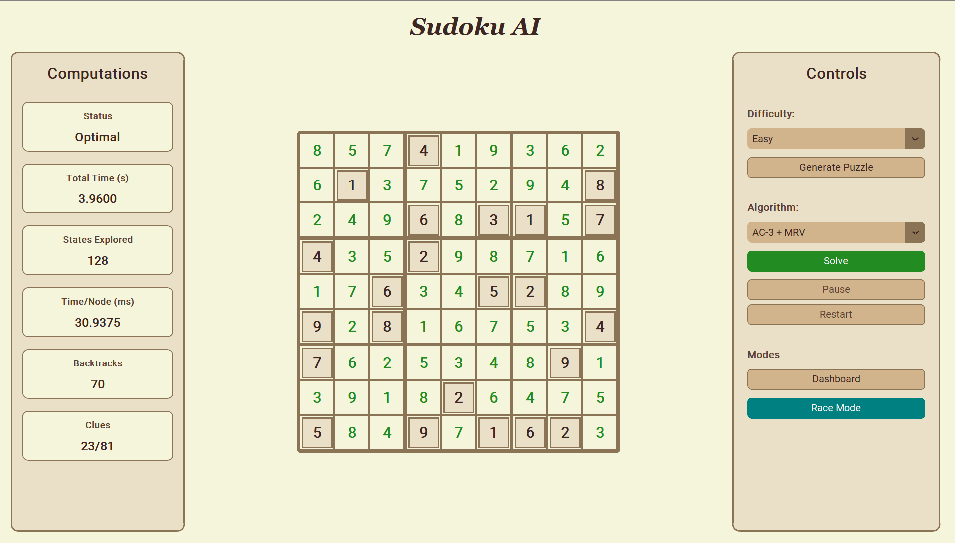

Medium
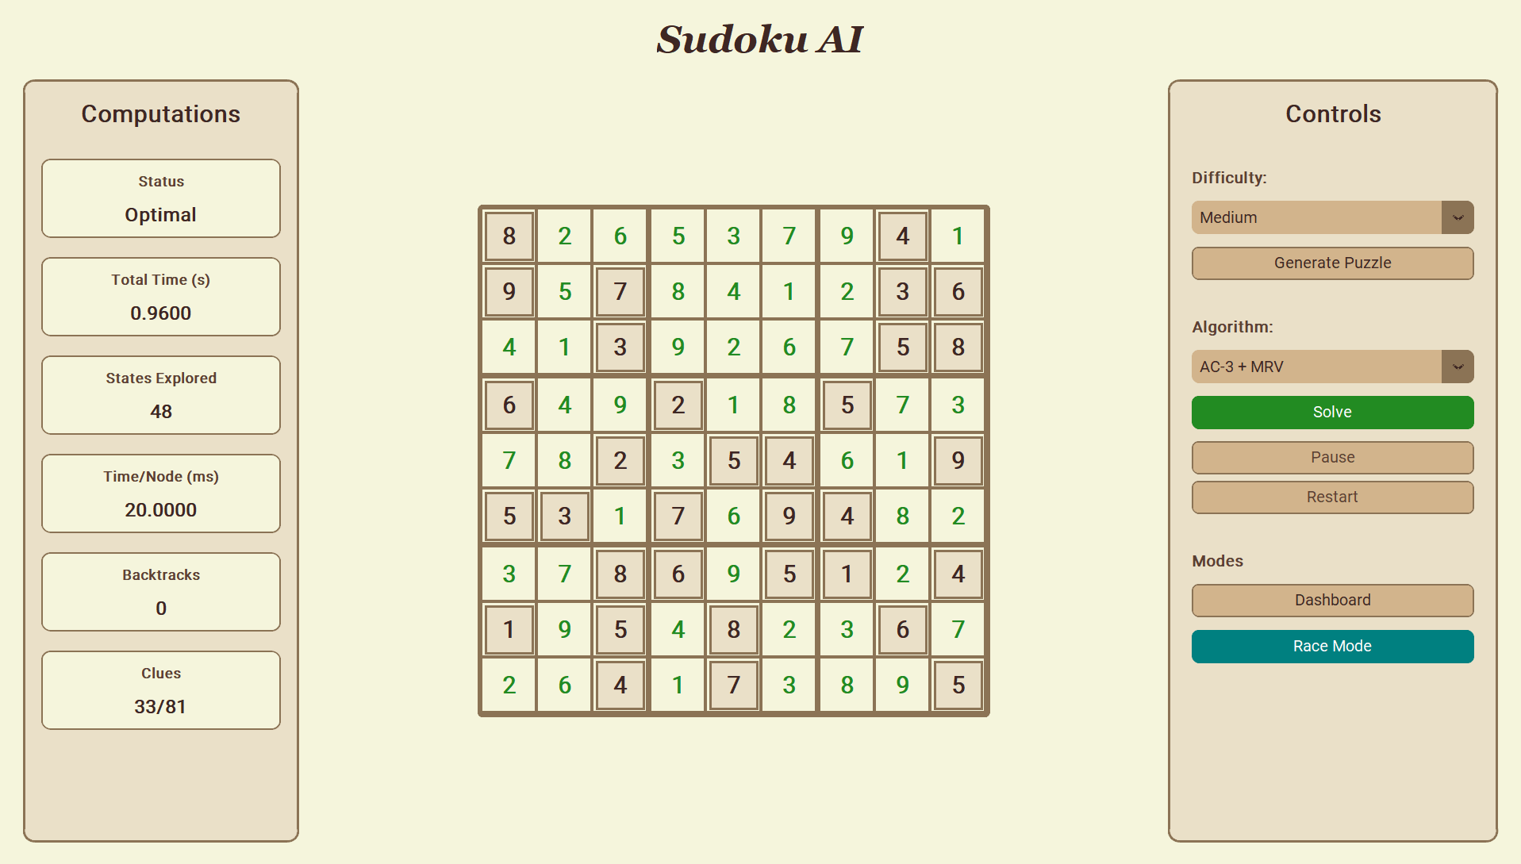

Hard
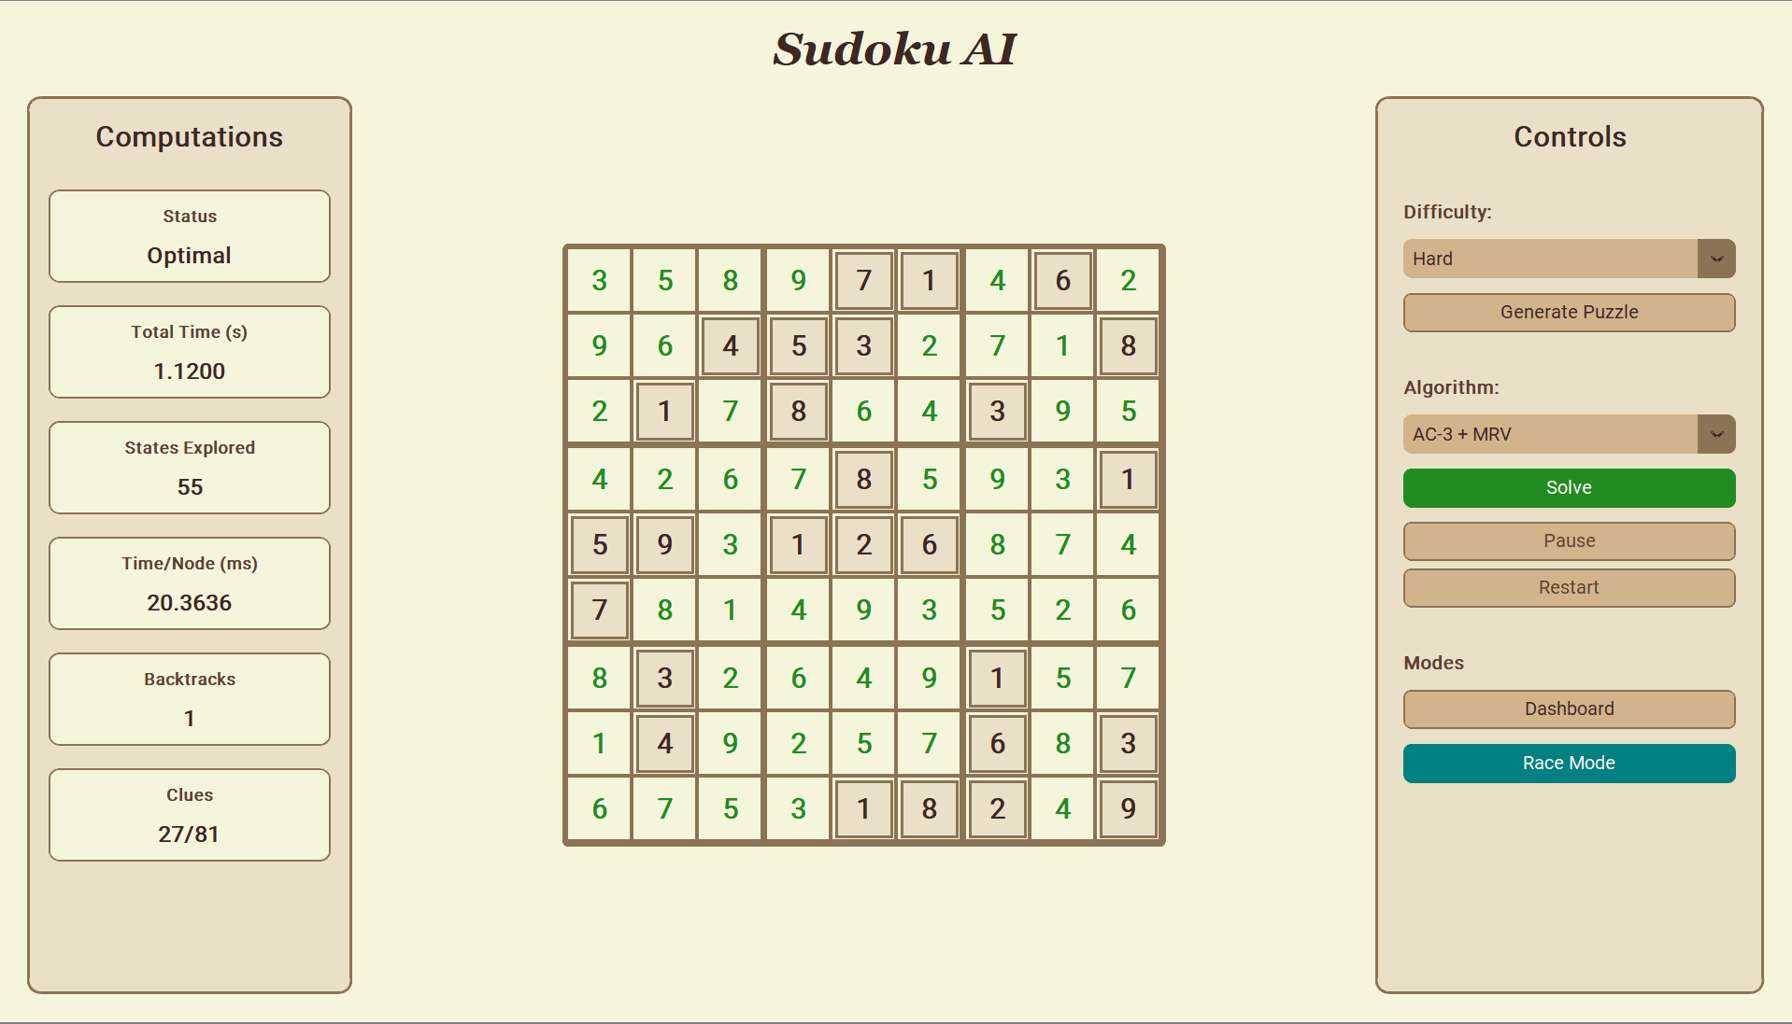

Expert
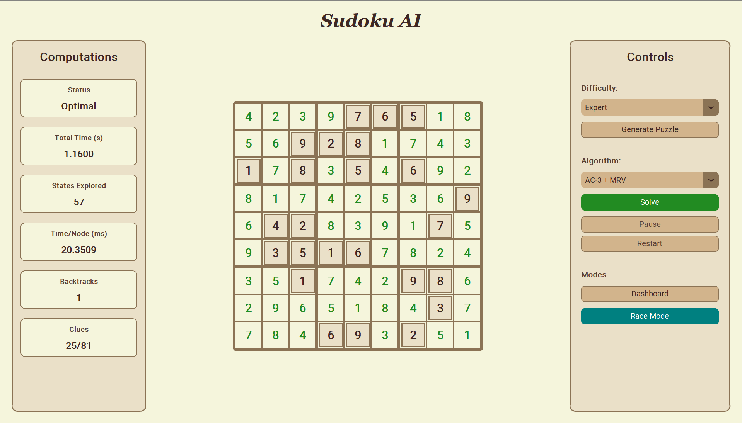

6.4 Simulated Annealing
Easy
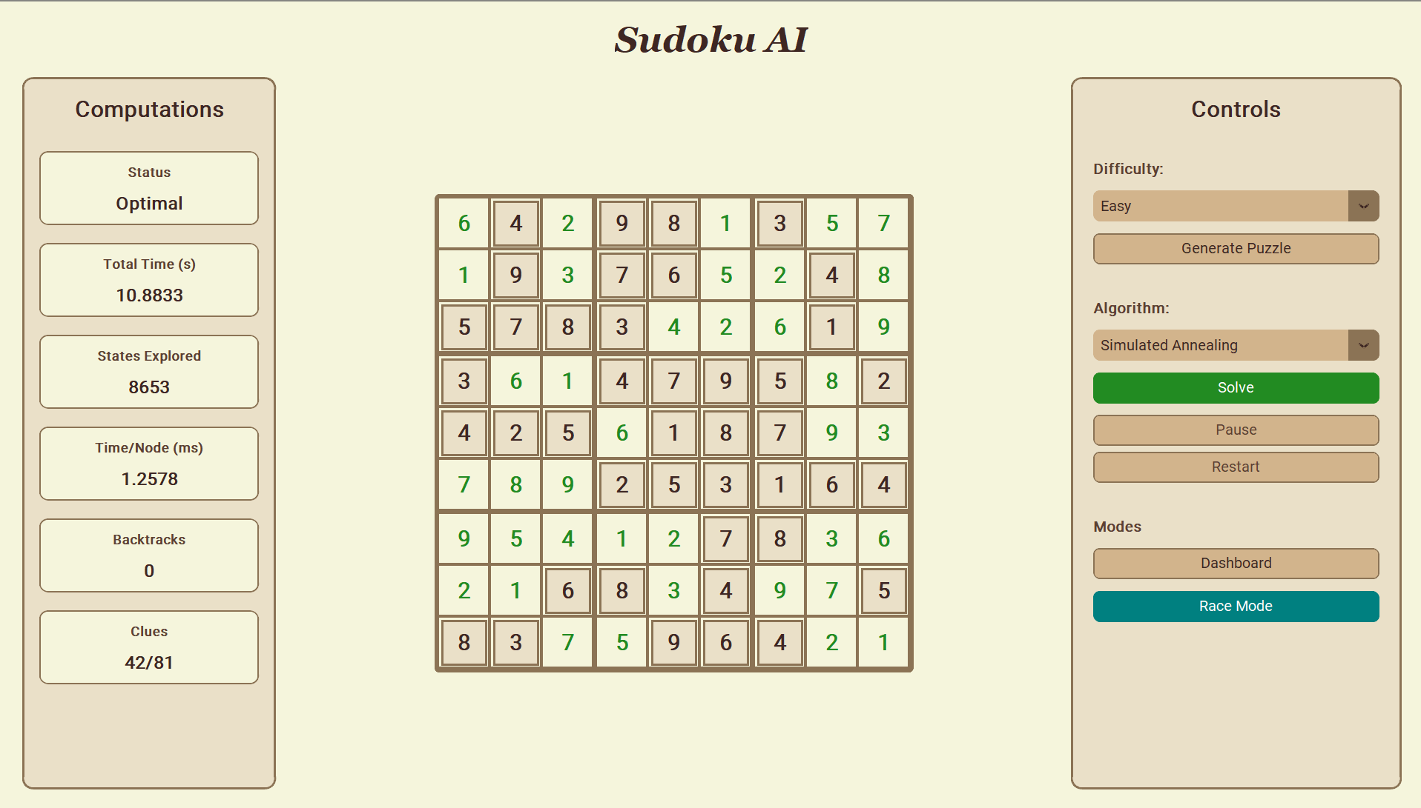

Medium
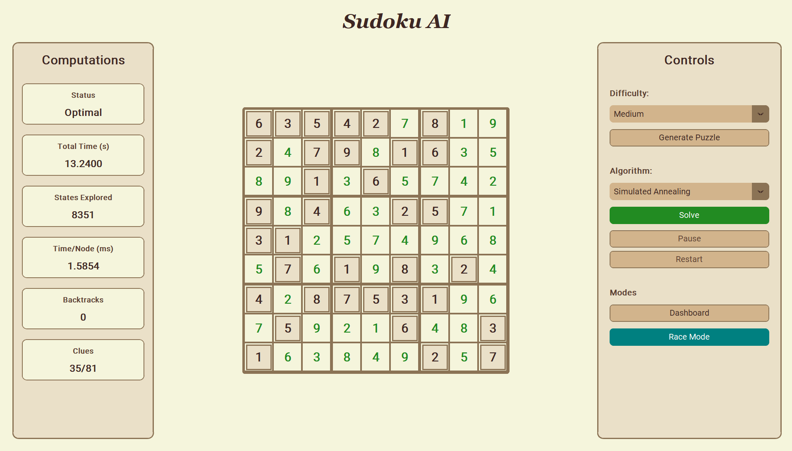
Hard
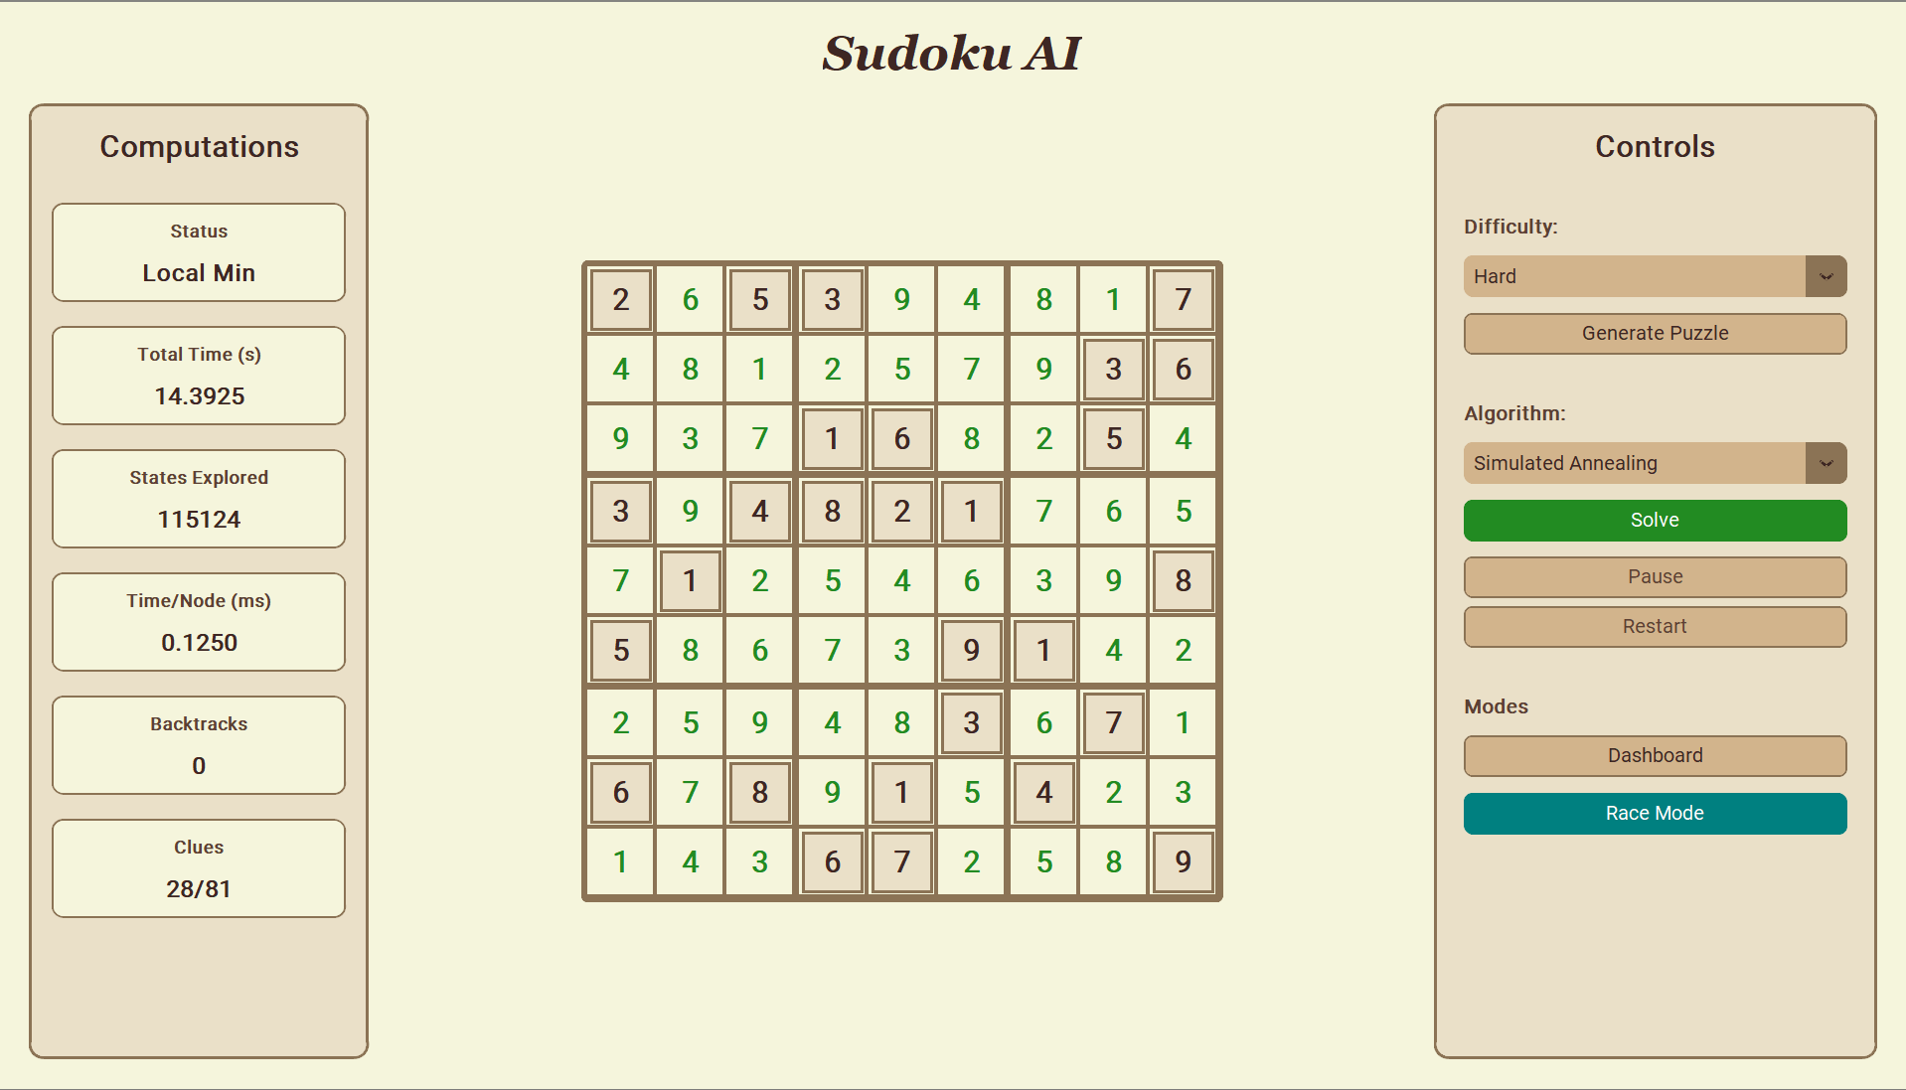

Expert
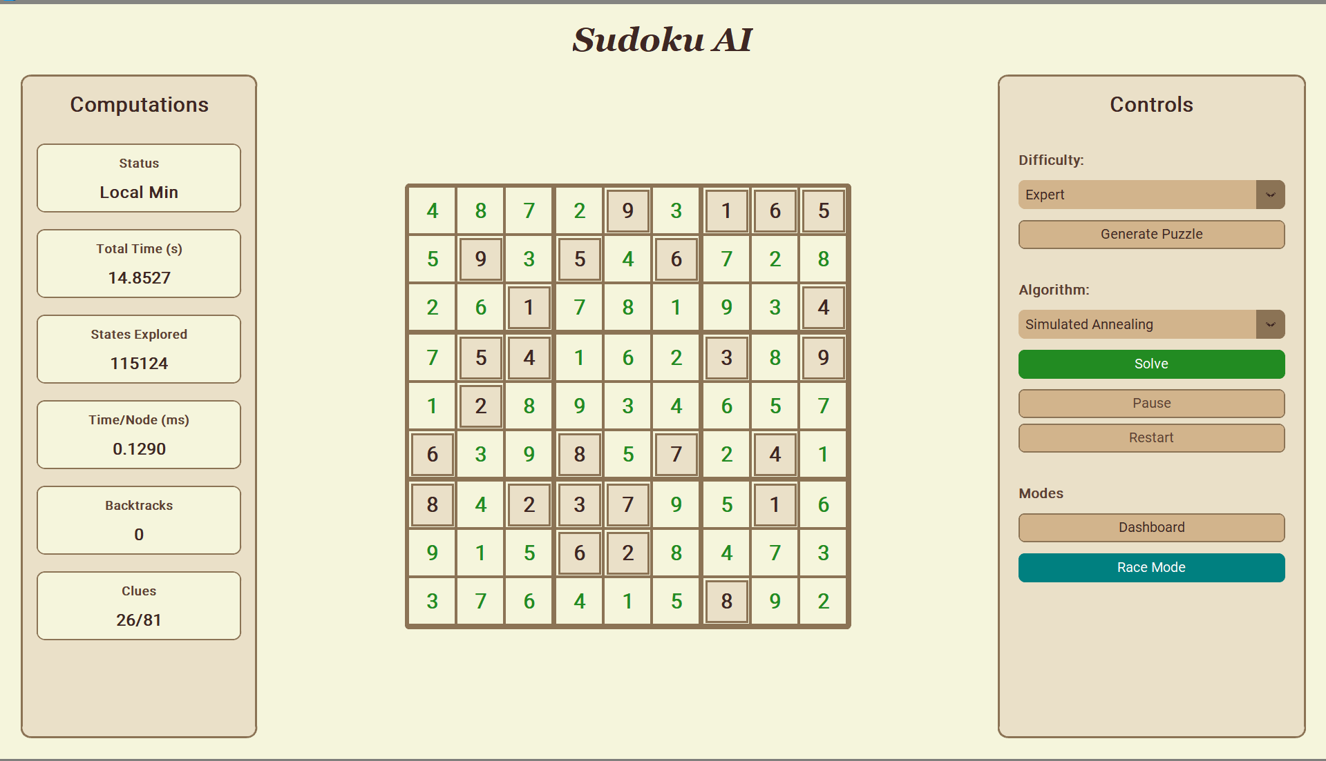

7. Challenges Faced and Solutions Applied

Challenge 1: Ensuring Puzzle Uniqueness
Problem:
Removing cells naively from a solved grid can create puzzles with multiple solutions. A puzzle without a unique solution is not a valid Sudoku puzzle.
Solution:
The remove_cells() function in sudoku_generator.py calls count_solutions(grid, limit=2) after every attempted removal. count_solutions uses backtracking to count solutions up to a limit of 2. If exactly 1 solution exists, the removal is accepted. If 2 or more exist, the cell is restored. Using limit=2 ensures the counting algorithm terminates as soon as it detects a second solution, avoiding unnecessary computation.

Challenge 2: Smooth Animation Without Blocking the GUI
Problem:
Solving a Sudoku puzzle in Python can involve millions of recursive calls. If the solver runs synchronously on the GUI thread, the window freezes until the solution is found.
Solution:
The GUI decouples solving from animation:
- The algorithm runs first, logging every single move (assignment and backtrack) into a moves list.
- The moves list is then replayed onto the grid using Tkinter's after() method to schedule frame-by-frame updates at 20ms intervals (50 FPS).
- The batch_size parameter controls how many moves are applied per frame, ensuring the animation always takes a fixed, user-perceivable duration proportional to the number of empty cells.
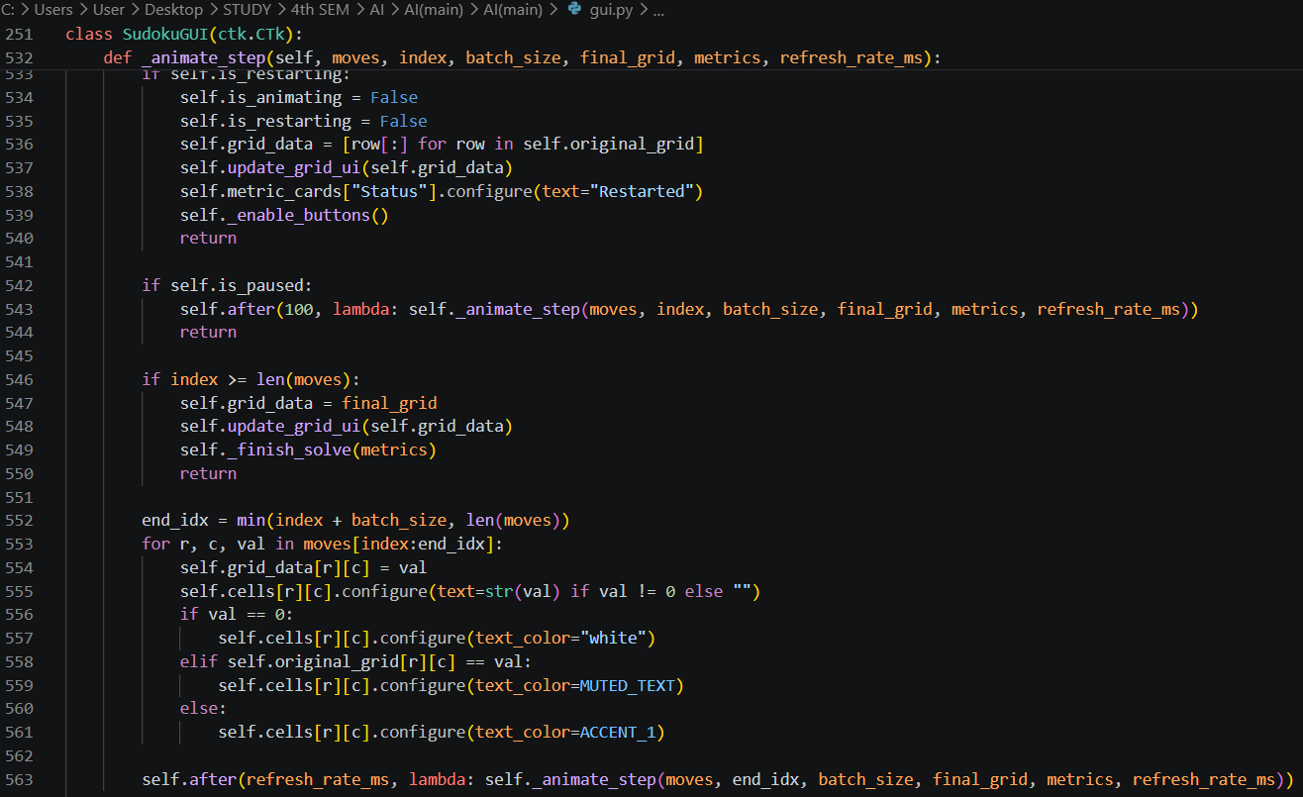

Challenge 3: Domain State Restoration in Forward Checking and AC-3
Problem:
When a branch must be abandoned (backtrack), all domain modifications made during that branch must be completely reversed.
Solution:
Both FC and AC-3 save a complete deep copy of the domain dictionary before each assignment:
old_domains = {k: set(v) for k, v in domains.items()}

On backtrack, the entire domain dictionary is restored from old_domains. While creating a copy at every node has memory overhead, it guarantees correctness. A more sophisticated implementation could use trail-based undo (logging only the specific removals made), but the copy-based approach is simpler and correct.

Challenge 4: Simulated Annealing Parameter Tuning
Problem:
SA's performance is highly sensitive to the cooling schedule. Too fast (high α or high T_min) and SA gets trapped in local minima. Too slow and the algorithm takes too long.
Solution:
Through experimentation, the parameters were set to:
- α = 0.9999 (very slow cooling)
- T_min = 0.00001
- Max iterations = 200,000
The slow cooling gives SA more time to explore the state space before it becomes essentially greedy. The max iteration cap prevents runaway execution on unsolvable configurations.

Challenge 5: Race Mode Simultaneous Animation
Problem:
The Race Mode must animate two algorithms simultaneously on two separate grids, with neither blocking the other.
Solution:
The race is animated using a single shared after() callback (_animate_race) that advances both grids by their respective batch_size in the same tick. Independent finished1 and finished2 flags track completion of each agent.

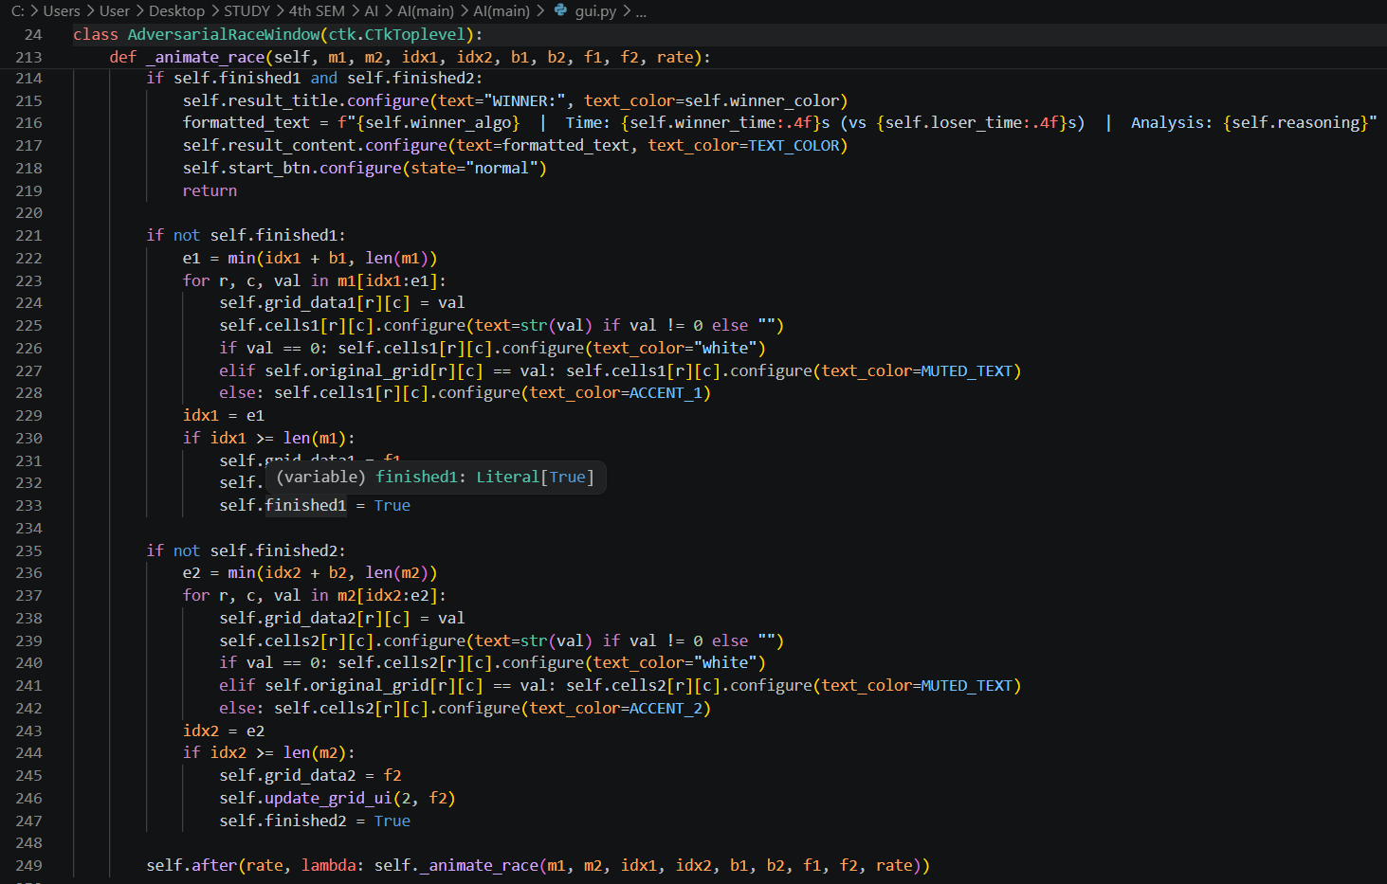

Challenge 6: Beige/Warm Colour Theme Consistency
Problem:
The application needed a consistent, warm colour palette that remains readable under all cell states (empty, clue, AI-filled, backtracked).
Solution:
A custom colour theme was defined with named constants at the top of gui.py:
BG_COLOR = "#F5F5DC" # Warm beige background
FRAME_COLOR = "#EAE0C8" # Slightly darker frame
BORDER_COLOR= "#8B7355" # Brown table borders
TEXT_COLOR = "#3E2723" # Very dark brown text
ACCENT_1 = "#228B22" # Forest green — AI-filled cells
ACCENT_2 = "#008080" # Teal — Agent 2 / Race Mode
Backtracked cells are set to white text (invisible on the beige background), creating a clean visual 'erase' effect without needing to clear the widget.

8. Conclusion
This project demonstrates the practical power of Artificial Intelligence search techniques applied to a well-known combinatorial puzzle. By modelling Sudoku as a rigorous Constraint Satisfaction Problem and implementing four algorithms from fundamentally different AI paradigms, the project offers both a working, playable application and a live educational comparison of algorithmic performance.

Key Takeaways

Finding | Evidence
Constraint propagation is transformative | AC-3 + MRV solves Expert puzzles in under 2 seconds with fewer than 10,000 state evaluations; Backtracking may require 100 million.
Heuristic variable ordering matters enormously | MRV alone reduces effective branching factor from ~9 to ~1–2 for most cells.
Local search trades guarantees for speed | SA is fast but unreliable on Expert puzzles — a clear example of the optimality-completeness trade-off.
Forward Checking is practical | A good balance of implementation complexity and performance gain over pure backtracking.
Animation decoupling is essential for UX | Recording moves then replaying them enables smooth, non-blocking visualisation of even the most complex algorithm traces.

Future Enhancements
- User input mode — allow users to manually enter their own puzzles.
- Step-by-step mode — allow pausing and stepping through the algorithm one node at a time with domain information displayed.
- Naked Pairs / Hidden Singles — implement classic human Sudoku-solving techniques as an additional algorithm.
- Difficulty auto-detection — classify any given puzzle by difficulty based on the minimum AI effort required to solve it.
- Persistent statistics — save and graph performance data across multiple puzzle runs.
- 16×16 Sudoku — extend the CSP formulation and all algorithms to support larger grid sizes.

