# **NuXL**

# Protein-RNA and Protein-DNA cross-linking Nodes

# for Proteome Discoverer 2.5

# Official beta program – Do not distribute without permission.

# User Manual

## Installation

Installing the NuXL plugin for Proteome Discoverer is easy: just run the binary installer   
*NuXL-PD2.5.exe* and it should automatically detect your PD folder and install the nodes in the correct location.

|  |  |
| --- | --- |
| ! | Proteome Discoverer should be closed before running the installer. |

After successful installation, you should find the NuXL processing and consensus nodes in your Proteome Discoverer workflow editor.

|  |  |
| --- | --- |
| ? | In rare cases, the installer does not work, because the Proteome Discoverer registry key cannot be found. Should this be the case, please contact us for instruction how to perform a manual installation. |

### Usage

### Setting up the study

1. Start Proteome Discoverer 2.5 and load *NuXL.pdStudy* to set up the study.
2. 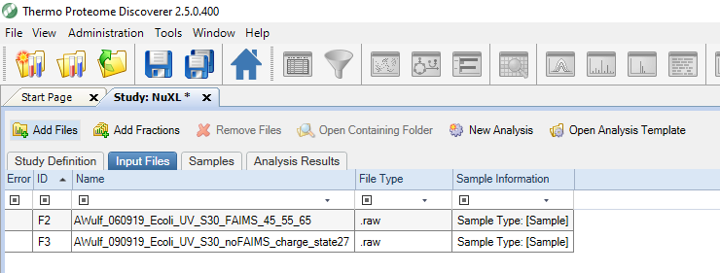Add the Thermo raw files you want to analyze

### Setting up the workflows from a preconfigured analysis template

The easiest way of getting started is to use the preconfigured processing and consensus workflows from the analysis templates:

1. Make sure to open the correct analysis template for the input files.
2. Add the input files by dragging them on the Processing Step in the **Analysis** tab.
3. Check the **By File** checkbox.

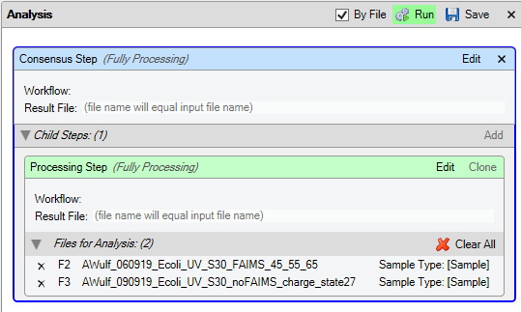

|  |  |
| --- | --- |
| ! | Checking the By File checkbox is crucial for proper processing in this beta version. |

|  |  |
| --- | --- |
| ! | Choosing the correct analysis template is crucial for valid search results. E.g., searching for chemical cross-links in UV data will not yield meaningful results. |

Your project is now set up and you can click on **Run** to execute the analysis

### Advanced: setting up a custom analysis workflow

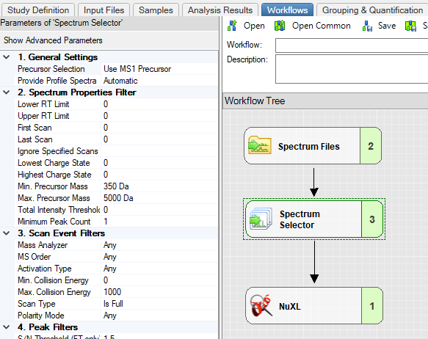If you prefer to set up the workflows yourself, we recommend building the processing workflow so that it looks like the figure to the right.

|  |  |
| --- | --- |
| ! | Make sure to set “MS Order” to “Any” in the Spectrum Selector node (otherwise, MS1 spectra are discarded and the workflow makes use of them). Adapt the parameters of the NuXL processing node as needed. |

The consensus workflow is even simpler:

1. Connect an MSF Files node to an NuXL Consensus node.

|  |  |
| --- | --- |
| ! | Make sure to set “Spectra to Store” to “All” in the MSF Files node. |

1. Drag&drop the input files by dragging them on the Processing Step in the **Analysis** tab.
2. Check the **By File** checkbox.
3. Run the workflow

# Results

Once your jobs have completed you can open the results from the **Administration** tab by double-clicking (or selecting “**Open Results**”) on a row that shows Type “Consensus”.

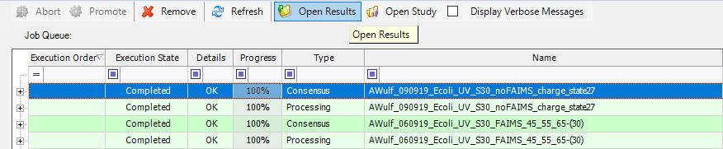

The “Proteins” and “PSMs” tables are empty in this beta version. The results will be contained in the “XLs” table (see Figure below).

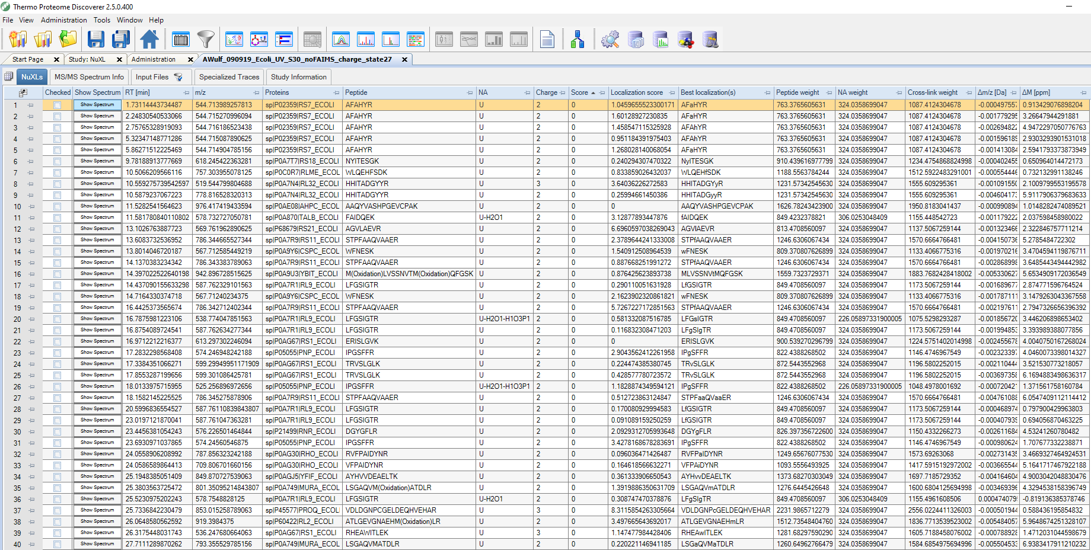

Figure 1 Example output of cross-link search.

See the table below for a description of table content:

|  |  |
| --- | --- |
| Column | Description |
| Show Spectrum | Click button to visualize annotated spectrum |
| RT [min] | Retention time of the MS/MS spectrum |
| m/z | Precursor m/z |
| Proteins | Protein accessions |
| Peptide | Peptide sequence |
| NA | Cross-linked precursor adduct |
| Charge | Precursor charge |
| Score | Cross-link PSM-level q-value (lower is better) |
| Localization score | Score of the best localization site (higher is better) |
| Best localizations | The cross-linked position(s) (marked in lower-case) |
| Peptide weight | for z=0 |
| NA weight | for z=0 |
| XL weight | for z=0 |
| ∆m/d [Da] | Absolute precursor mass error |
| ∆M [ppm] | Relative precursor mass error |

Table Result columns

You can visualize cross-link PSMs by clicking on the “Show Spectrum” button.

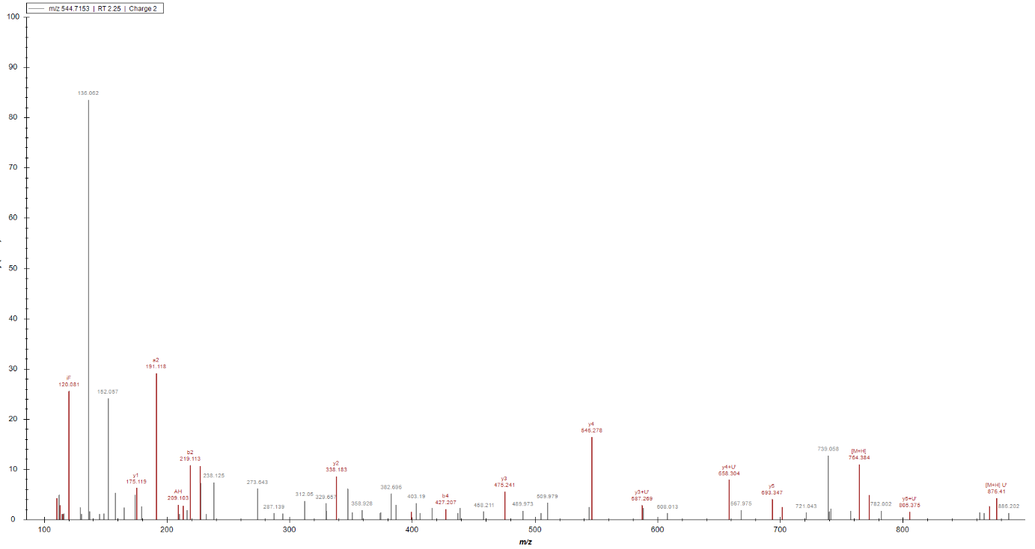

Figure 2 Spectrum visualization

# Supplementary

### Preset RNA-UV

#### Precursor adducts:

U:

U:-H2O

U:-H2O-HPO3

U:-HPO3

C:

C:-NH3

C:-H2O

C:-NH3-HPO3

C:-H2O-HPO3

C:-HPO3

G:

G:-H2O

G:-NH3

G:-H2O-HPO3

G:-NH3-HPO3

G:-HPO3

A:

A:-NH3

A:-NH3-HPO3

A:-HPO3

#### Fragment adducts:

U:C9H10N2O5;U-H3PO4

U:C4H4N2O2;U'

U:C4H2N2O1;U'-H2O

U:C3O;C3O

U:C9H13N2O9P1;U

U:C9H11N2O8P1;U-H2O

U:C9H12N2O6;U-HPO3

U:C5H9O7P;ribose

U:C5H7O6P;ribose-H2O

U:C5H6O3;ribose-H2O-HPO3

C:C9H14N3O8P;C

C:C9H11N2O8P;C-NH3

C:C9H12N3O7P;C-H2O

C:C9H13N3O5;C-HPO3

C:C9H11N3O4;C-H3PO4

C:C4H5N3O;C'

C:C4H3N3;C'-H2O

C:C4H2N2O;C'-NH3

G:C10H14N5O8P;G

G:C10H12N5O7P;G-H2O

G:C10H11N4O8P;G-NH3

G:C10H13N5O5;G-HPO3

C:C9H10N2O5;C-NH3-HPO3

G:C10H10N4O5;G-NH3-HPO3

G:C10H11N5O4;G-H3PO4

G:C5H5N5O;G'

G:C5H3N5;G'-H2O

G:C5H2N4O;G'-NH3

A:C10H14N5O7P;A

A:C10H12N5O6P;A-H2O

A:C10H11N4O7P;A-NH3

A:C10H13N5O4;A-HPO3

A:C10H11N5O3;A-H3PO4

A:C10H10N5O4;A-NH3-HPO3

A:C5H5N5;A'

A:C5H2N4;A'-NH3

C:C5H9O7P;ribose

G:C5H9O7P;ribose

A:C5H9O7P;ribose

G:C5H7O6P;rib-H2O

C:C5H7O6P;rib-H2O

A:C5H7O6P;rib-H2O

G:C5H6O3;ribose-H2O-HPO3

C:C5H6O3;ribose-H2O-HPO3

A:C5H6O3;ribose-H2O-HPO3

### Preset RNA-UV (4SU)

#### Precursor adducts:

S:

S:-H2O

S:-H2O-HPO3

S:-HPO3

S:-H2S+HPO3

S:-H2S

#### Fragment adducts:

*all of RNA-UV (U)*

S:C4H2N2O1;tU-H2S

### Preset DNA-UV

#### Precursor adducts:

T:

T:-H2O

T:-H2O-HPO3

T:-HPO3

A:

A:-H2O

A:-H2O-HPO3

A:-HPO3

G:

G:-H2O

G:-NH3

A:-NH3

G:-HPO3

G:-H2O-HPO3

G:-NH3-HPO3

C:

C:-H2O

C:-NH3

C:-H2O-HPO3

C:-NH3

C:-NH3-HPO3

T:+C5H7O5P // + dribose-H2O

A:+C5H7O5P

G:+C5H7O5P

C:+C5H7O5P

C:-C4H5N3O // loss of base -> only dribose remains

T:-C5H6N2O2

G:-C5H5N5O

A:-C5H5N5

T:+HPO3

C:+HPO3

A:+HPO3

G:+HPO3

T:+HPO3-H2O

C:+HPO3-H2O

A:+HPO3-H2O

G:+HPO3-H2O

#### Fragment adducts:

T:C10H15N2O8P;T

T:C10H13N2O7P;T-H2O

T:C10H14N2O5;T-HPO3

T:C10H12N2O4;T-H3PO4

T:C5H6N2O2;T'

T:C5H4N2O;T'-H2O

C:C9H14N3O7P;C

C:C9H11N2O7P;C-NH3

C:C9H12N3O6P;C-H2O

C:C9H13N3O4;C-HPO3

C:C9H11N3O3;C-H3PO4

C:C9H10N2O4;C-NH3-HPO3

C:C4H5N3O;C'

C:C4H3N3;C'-H2O

C:C4H2N2O;C'-NH3

G:C10H14N5O7P;G

G:C10H12N5O6P;G-H2O

G:C10H11N4O7P;G-NH3

G:C10H13N5O4;G-HPO3

G:C10H10N4O4;G-NH3-HPO3

G:C10H11N5O3;G-H3PO4

G:C5H5N5O;G'

G:C5H3N5;G'-H2O

G:C5H2N4O;G'-NH3

A:C10H14N5O6P;A

A:C10H12N5O5P;A-H2O

A:C10H11N4O6P;A-NH3

A:C10H13N5O3;A-HPO3

A:C10H11N5O2;A-H3PO4

A:C10H10N5O3;A-NH3-HPO3

A:C5H5N5;A'

A:C5H2N4;A'-NH3

A:C5H9O6P;dribose

G:C5H9O6P;dribose

C:C5H9O6P;dribose

T:C5H9O6P;dribose

A:C5H7O5P;dribose-H2O

G:C5H7O5P;dribose-H2O

C:C5H7O5P;dribose-H2O

T:C5H7O5P;dribose-H2O

A:C5H8O3;dribose-HPO3

G:C5H8O3;dribose-HPO3

C:C5H8O3;dribose-HPO3

T:C5H8O3;dribose-HPO3

### Preset RNA-DEB

#### Precursor adducts:

U:+C4H6O2

U:+C4H6O2-H2O

U:+C4H6O2-HPO3

U:+C4H6O2-H3PO4

U:+C4H6O2-H2O-H2O

U:+C4H6O2-H3PO4-H2O

G:+C4H6O2

G:+C4H6O2-H2O

G:+C4H6O2-HPO3

G:+C4H6O2-H3PO4

G:+C4H6O2-H2O-H2O

G:+C4H6O2-H3PO4-H2O

G:+C4H6O2-NH3

C:+C4H6O2

C:+C4H6O2-H2O

C:+C4H6O2-HPO3

C:+C4H6O2-H3PO4

C:+C4H6O2-H2O-H2O

C:+C4H6O2-H3PO4-H2O

C:+C4H6O2-H2O

C:+C4H6O2-NH3

A:+C4H6O2

A:+C4H6O2-H2O

A:+C4H6O2-HPO3

A:+C4H6O2-H3PO4

A:+C4H6O2-H2O-H2O

A:+C4H6O2-H3PO4-H2O

A:+C4H6O2-H2O

A:+C4H6O2-NH3

#### Fragment adducts:

U:C4H6O2;DEB

U:C4H4O;DEB-H2O

U:C13H16N2O7;DEB+U-H3PO4

U:C8H10N2O4;DEB+U'

U:C8H8N2O3;DEB+U'-H2O

U:C7H6O3;DEB+C3O

U:C13H19N2O11P1;DEB+U

U:C13H17N2O10P1;DEB+U-H2O

U:C13H16N2O7;DEB+U-H3PO4

G:C4H6O2;DEB

G:C4H4O;DEB-H2O

G:C14H17N5O6;DEB+G-H3PO4

G:C9H11N5O3;DEB+G'

G:C8H9N5O3;DEB+G'-H2O

G:C14H20N5O10P1;DEB+G

G:C14H18N5O9P1;DEB+G-H2O

G:C14H17N5O6;DEB+G-H3PO4

C:C4H6O2;DEB

C:C4H4O;DEB-H2O

C:C13H17N3O6;DEB+C-H3PO4

C:C8H11N3O3;DEB+C'

C:C8H9N3O2;DEB+C'-H2O

C:C13H20N3O10P1;DEB+C

C:C13H18N3O9P1;DEB+C-H2O

C:C13H17N3O6;DEB+C-H3PO4

A:C4H6O2;DEB

A:C4H4O;DEB-H2O

A:C14H17N5O5;DEB+A-H3PO4

A:C9H11N5O2;DEB+A'

A:C8H9N5O2;DEB+A'-H2O

A:C14H20N5O9P1;DEB+A

A:C14H18N5O8P1;DEB+A-H2O

A:C14H17N5O5;DEB+A-H3PO4

A:C19H12N5O6P;A-H2O

A:C9H17N4O;DEB+A'-NH3

A:C14H17N4O9;DEB+A-NH3

### Preset DNA-DEB

#### Precursor adducts:

T:+C4H6O2

T:+C4H6O2-H2O

G:+C4H6O2

G:+C4H6O2-C5H9O6P

G:+C4H6O2-H2O-C5H9O6P

G:+C4H6O2-H2O

C:+C4H6O2

C:+C4H6O2-H2O

A:+C4H6O2

A:+C4H6O2-H2O

#### Fragment adducts:

T:C4H6O2;DEB

T:C4H4O;DEB-H2O

T:C5H6N2O2;T' // needed for marker ion

T:C9H12N2O4;DEB+T'

T:C9H10N2O3;DEB+T'-H2O

T:C14H21N2O10P1;DEB+T // C4H6O2 + C10H15N2O8P

T:C14H19N2O9P1;DEB+T-H2O

T:C14H20N2O7;DEB+T-HPO3 // C4H6O2 + C10H15N2O8P - HPO3

T:C14H18N2O6;DEB+T-H3PO4 // C4H6O2 + C10H15N2O8P - H3PO4

C:C4H6O2;DEB

C:C4H4O;DEB-H2O

C:C4H5N3O;C' // needed for marker ion

C:C8H11N3O3;DEB+C'

C:C8H8N2O3;DEB+C'-NH3

C:C8H9N3O2;DEB+C'-H2O

C:C13H20N3O9P1;DEB+C

C:C13H17N2O9P1;DEB+C-NH3

C:C13H18N3O8P1;DEB+C-H2O

// "C:C13H19N3O6;DEB+C-HPO3

// "C:C13H17N3O5;DEB+C-H3PO4

G:C4H6O2;DEB

G:C4H4O;DEB-H2O

G:C9H11N5O3;DEB+G'

G:C9H9N5O2;DEB+G'-H2O

G:C14H20N5O9P1;DEB+G

G:C5H5N5O;G' // needed for marker ion

G:C10H9N5O2;G-H3PO4-H2O // exclusive to Fanni

G:C14H18N5O8P1;DEB+G-H2O // not in Fanni's list

// "G:C14H19N5O6;DEB+G-HPO3

// "G:C14H17N5O5;DEB+G-H3PO4

A:C4H6O2;DEB

A:C4H4O;DEB-H2O

A:C5H5N5;A' // needed for marker ion

A:C9H11N5O2;DEB+A' // C4H6O2 + C5H5N5

A:C9H9N5O1;DEB+A'-H2O // not in Fanni's list

A:C9H8N4O2;DEB+A'-NH3 // C4H6O2 + C5H5N5 - NH3

A:C14H20N5O8P1;DEB+A // C4H6O2 + C10H14N5O6P

A:C14H17N4O8P1;DEB+A-NH3 // C4H6O2 + C10H14N5O6P - NH3

A:C14H18N5O7P1;DEB+A-H2O // not in Fanni's list

A:C10H9N5O;A-H3PO4-H2O" // Fanni

// "A:C14H19N5O5;DEB+A-HPO3 // C4H6O2 + C10H14N5O6P - HPO3

// "A:C14H17N5O4;DEB+A-H3PO4" // C4H6O2 + C10H14N5O6P - H3PO4

### Preset RNA-NM

#### Precursor adducts:

U:+C5H9N1

U:+C5H9N1-HPO3

U:+C5H9N1-H3PO4

U:+C5H9N1-H2O-H2O

U:+C5H9N1-H3PO4-H2O

U:+C5H9N1-H2O

G:+C5H9N1

G:+C5H9N1-HPO3

G:+C5H9N1-H3PO4

G:+C5H9N1-H2O-H2O

G:+C5H9N1-H3PO4-H2O

G:+C5H9N1-H2O

G:+C5H9N1-NH3

C:+C5H9N1

C:+C5H9N1-HPO3

C:+C5H9N1-H2O

C:+C5H9N1-H3PO4

C:+C5H9N1-H2O-H2O

C:+C5H9N1-H3PO4-H2O

C:+C5H9N1-NH3

A:+C5H9N1

A:+C5H9N1-HPO3

A:+C5H9N1-H2O

A:+C5H9N1-H3PO4

A:+C5H9N1-H2O-H2O

A:+C5H9N1-H3PO4-H2O

A:+C5H9N1-NH3

#### Fragment adducts:

U:C5H9N1;NM

U:C14H21N3O6;NM+U-HPO3

U:C9H13N3O2;NM+U'

U:C9H11N3O1;NM+U'-H2O

U:C8H9N1O1;NM+C3O

U:C14H22N3O9P1;NM+U

U:C14H20N3O8P1;NM+U-H2O

U:C14H19N3O5;NM+U-H3PO4

C:C5H9N1;NM

C:C14H20N4O4;NM+C-H3PO4

C:C9H14N4O1;NM+C'

C:C9H12N4;NM+C'-H2O

C:C14H23N4O8P1;NM+C

C:C14H21N4O7P1;NM+C-H2O

G:C5H9N1;NM

G:C15H22N6O5;NM+G-HPO3

G:C10H14N6O1;NM+G'

G:C10H12N6;NM+G'-H2O

G:C15H23N6O8P1;NM+G

G:C15H21N6O7P1;NM+G-H2O

G:C15H20N6O4;NM+G-H3PO4

A:C5H9N1;NM

A:C10H14N6;NM+A'

A:C10H11N5;NM+A'-NH3

A:C15H23N6O7P1;NM+A

A:C15H20N6O3;NM+A-H3PO4

A:C15H21N6O6P1;NM+A-H2O

C:C14H22N4O5;NM+C-HPO3

C:C14H20N3O8P1;NM+C-NH3

C:C9H11N3O1;NM+C'-NH3

G:C10H14N6O1;NM+G'-NH3

A:C15H22N6O4;NM+A-HPO3

### Preset DNA-NM

#### Precursor adducts:

T:+C5H9N1

T:+C5H9N1-HPO3

T:+C5H9N1-H3PO4

T:+C5H9N1-H2O-H2O

T:+C5H9N1-H3PO4-H2O

T:+C5H9N1-H2O

T:+C5H9N1-NH3-HPO3

G:+C5H9N1

G:+C5H9N1-HPO3

G:+C5H9N1-H3PO4

G:+C5H9N1-H2O-H2O

G:+C5H9N1-H3PO4-H2O

G:+C5H9N1-H2O

G:+C5H9N1-NH3

G:+C5H9N1-NH3-HPO3

C:+C5H9N1

C:+C5H9N1-H2O

C:+C5H9N1-HPO3

C:+C5H9N1-H3PO4

C:+C5H9N1-H2O-H2O

C:+C5H9N1-H3PO4-H2O

C:+C5H9N1-NH3

C:+C5H9N1-NH3-HPO3

A:+C5H9N1

A:+C5H9N1-H2O

A:+C5H9N1-H3PO4-H2O

A:+C5H9N1-H2O-H2O

A:+C5H9N1-H3PO4

A:+C5H9N1-HPO3

A:+C5H9N1-NH3

A:+C5H9N1-NH3-HPO3

#### Fragment adducts:

T:C5H9N1;NM

T:C14H19N3O5;NM+T-H3PO4

T:C10H15N3O2;NM+T'

T:C10H13N3O1;NM+T'-H2O

T:C15H24N3O8P1;NM+T

T:C15H22N3O7P1;NM+T-H2O

T:C15H19N3O4;NM+T-H3PO4

T:C10H12N2O2;NM+T'

T:C15H20N2O8P1;NM+T-NH3

T:C15H19N2O5;NM+T-NH3-HPO3

C:C5H9N;NM

C:C9H14N4O1;NM+C'

C:C9H12N4;NM+C'-H2O

C:C14H23N4O7P1;NM+C

C:C14H21N4O6P1;NM+C-H2O

C:C14H20N4O3;NM+C-H3PO4

C:C14H22N4O4;NM+C-HPO3

G:C5H9N1;NM

G:C10H14N6O1;NM+G'

G:C10H12N6;NM+G'-H2O

G:C10H11N5O1;NM+G'-NH3

G:C15H23N6O7P1;NM+G

G:C15H21N6O6P1;NM+G-H2O

G:C15H22N6O4;NM+G-HPO3

G:C15H20N6O3;NM+G-H3PO4

G:C15H20N5O7P1;NM+G-NH3

G:C15H19N5O4;NM+G-NH3-HPO3

A:C5H9N1;NM

A:C10H14N6;NM+A'

A:C10H11N5;NM+A'-NH3

A:C15H23N6O6P1;NM+A

A:C15H20N6O2;NM+A-H3PO4

A:C15H21N6O5P1;NM+A-H2O

A:C15H22N6O3;NM+A-HPO3

A:C15H20N5O6P1;NM+A-NH3

A:C15H19N5O3;NM+A-NH3-HPO3