OpenMS Nodes for Proteome Discoverer 2.x



Manual Installation Instructions

## Step 0/4: Prerequisites

In order to use the OpenMS nodes for Proteome Discoverer, you need to have Proteome Discoverer 2.x installed. Proteome Discoverer needs to be closed before installing the nodes.

**Note**: the manual installation procedure described in this document is only necessary if the binary installers on www.openms.de/pd do not work for you (the reason for this is usually that the Proteome Discoverer registry key is not found and hence our installer does not know where to install).

## Step 1/4: Unblock zip file

After downloading the zip file containing the manual installation package, be sure to unblock it first. Depending on your Windows version and security settings, Windows might try to protect you from the executable files and libraries within the zip file because it has been downloaded from the internet. In order to avoid having to unblock every single extracted executable and library, please unblock the entire zip file once before extracting. Usually, this works via right-clicking the zip file, selecting Properties from the context menu, and clicking Unblock in the window that appears.

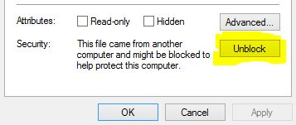

## Step 2/4: Copy dlls

Copy the dll files (PD.OpenMS.AdapterNodes.dll and ZedGraph_OpenMS.dll) to the System\Release folder of your Proteome Discoverer installation, e.g., to

C:\Program Files\Thermo\Proteome Discoverer 2.1\System\Release

## Step 3/4: Copy OpenMS folder

Copy the OpenMS-2.0 folder from the zip file to the Tools folder of your Proteome Discoverer Installation, e.g., to

C:\Program Files\Thermo\Proteome Discoverer 2.1\Tools

## Step 4/4: Run Magellan server install command

In this last step, you need to run the install command so the Magellan server of your Proteome Discoverer installation registers the new nodes. In order to do this, please start a command prompt (cmd.exe), navigate to the System\Release folder of your PD installation, and run the following command:

.\Thermo.Magellan.Server.exe -install

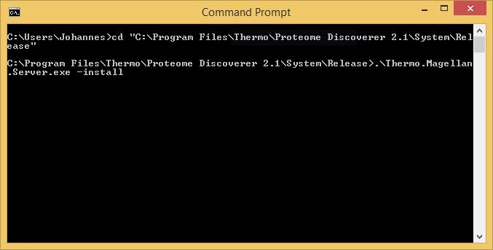

Please note that the “.\” in the beginning of this command can be important if you have several PD installations on the system. When omitted, it can happen that the Thermo.Magellan.Server.exe of the wrong PD installation is run instead.

The result should look something like this:

