Topics in Software Engineering I

Assignment # 03Style Guidelines for Final Year Project Reports

A 4th Year StudentSubmitted to: DR. Fatima Sabir

A project submitted in partial fulfilment of the

COMSATS University Degree of

BSc. (Hons.)BS in Computer Science / Software Engineering (CUI)



Department of Computer Science

COMSATS University Islamabad, Lahore Campus

**09 January 2023**

**Project Registration**

|  |  |  |  |  |  |  |  |
| --- | --- | --- | --- | --- | --- | --- | --- |
| Project ID (for office use) | | |  | | | | |
| Type (Nature of project) | | | [ ] **D**evelopment [ ] **R**esearch [ **•** ] **R**&**D** | | | | |
| Area of specialization | | |  | | | | |
| **Project Group Members** | | | | | | | |
| Sr.# | Reg. # | Student Name | | CGPA | Email ID | Phone # | Signature |
| (i) | **SP20-BSE-061** | **M Mateen Saleem** | | **3.0** | **SP20-BSE-061@cuilahore.edu.pk** |  |  |
| (ii) | **SP20-BSE-108** | **Syed Arslan Ali Shah** | | **3.0** | **SP20-BSE-108@cuilahore.edu.pk** |  |  |
| (iii) | **SP20-BSE-037** | **Shameer Khalid** | | **3.0** | **SP20-BSE-0037@cuilahore.edu.pk** |  |  |
| Name & Signature of Batch Advisor  (If students are eligible for FYP) | | | |  | | | |

**(B) Assign tasks to team mates on jira**

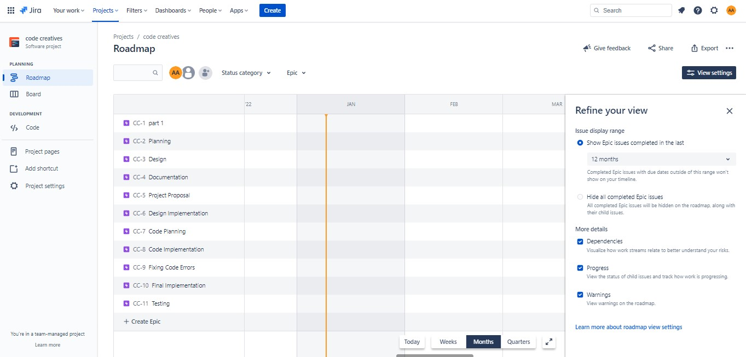

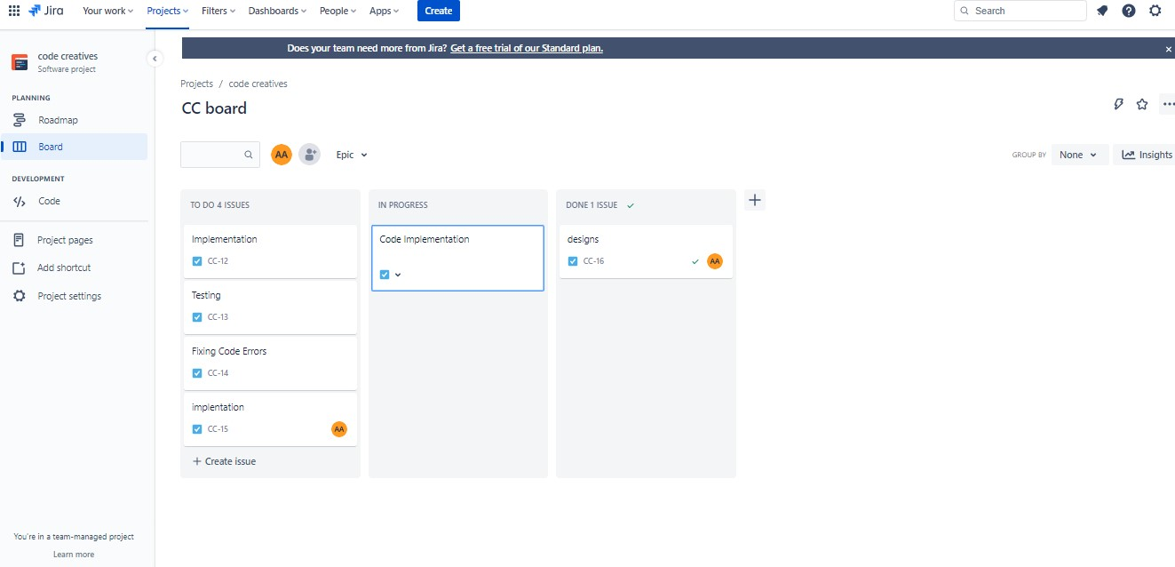

we have assigned different tasks to different members. Design, Code Implementation is handled by Syed Arslan, Testing, Implementation is handled by Muhammad Mateen, Project Planning and proposal phase is handled by Shameer

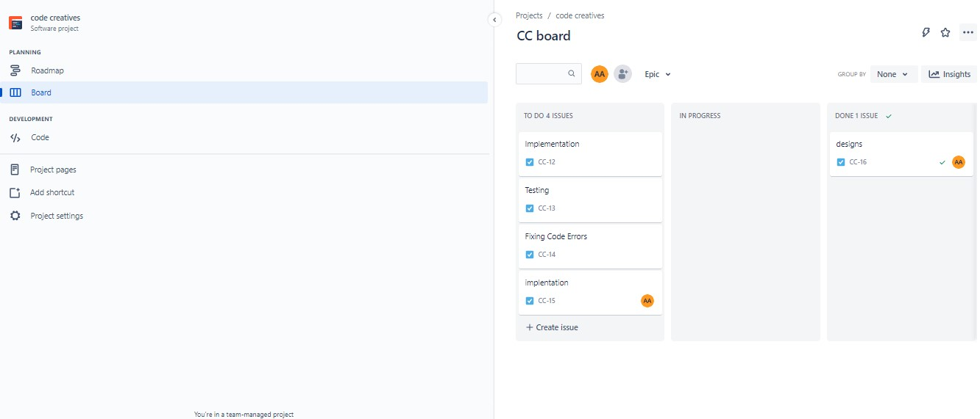

**(C) Coding:**

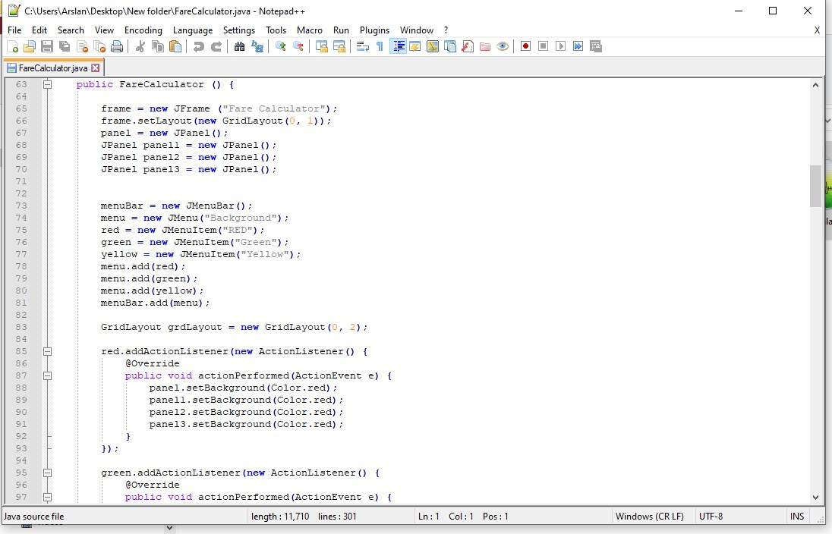

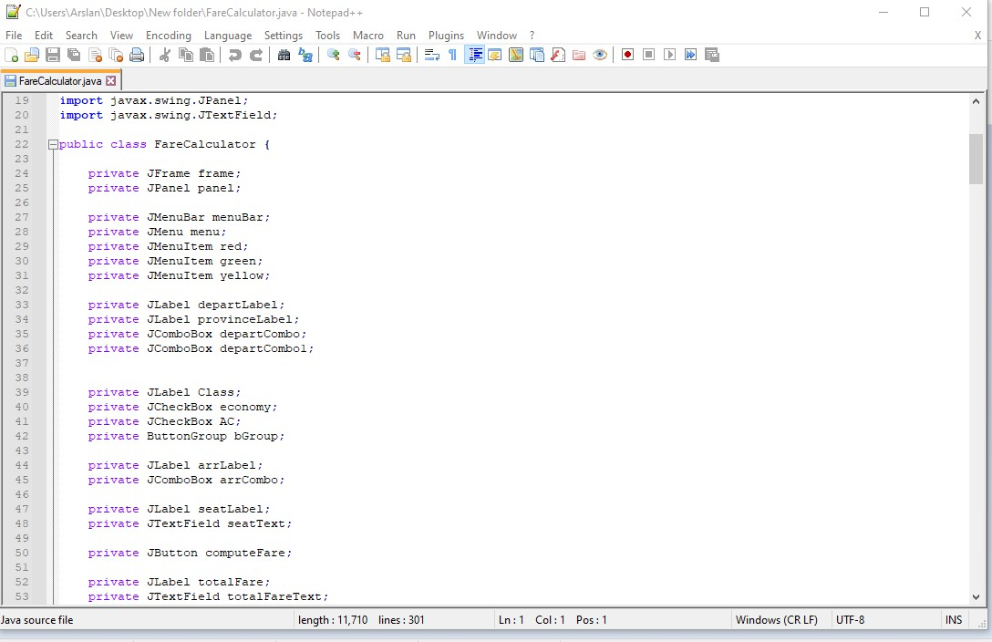

**Coding:**

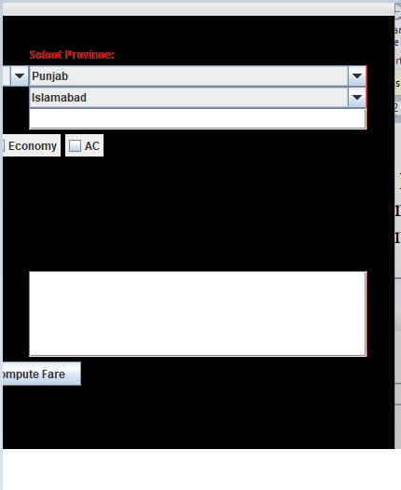

1. **Class Diagram or AST:**

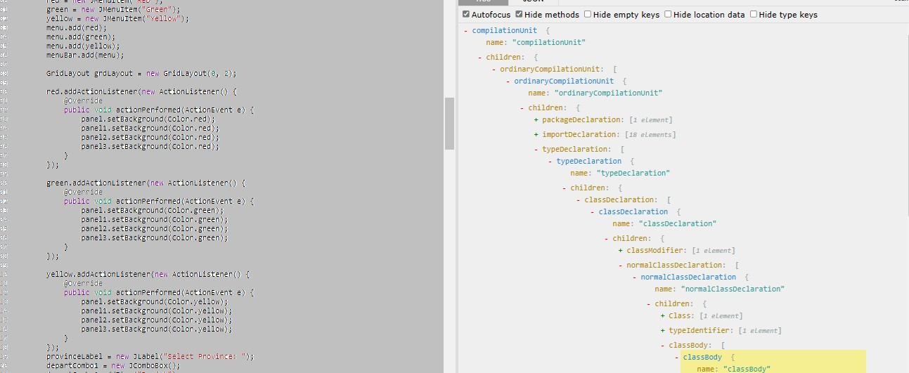

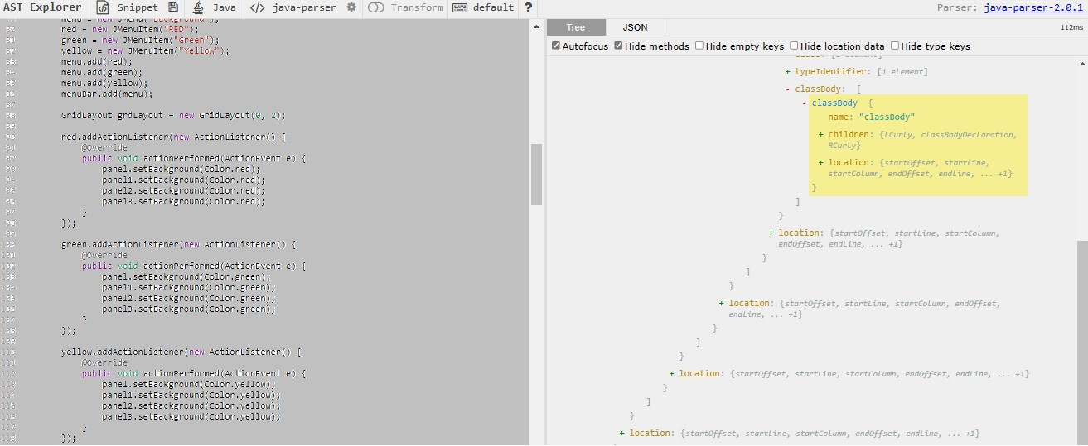

This is created and Generated by **AST Explorer**

**GitHub:**

**This is our repository screenshots. Our repository name is Code Creative and Fare Calculator java is uploaded in Repository and Pics are attached below.**



