MODEL EVALUATION · DOCUMENT AI
Invoice Field Extraction — Model Benchmark
August 6, 2026 · 10 model configurations · 23,343 documents scored · 15 fields per invoice · $89.78 total API spend

Key results
Each model reads invoice PDFs as page images and returns 15 structured fields (vendor, customer, totals, dates, references). The headline metric is end-to-end score: the share of all fields present in a document that the model extracted correctly.
 | Result | Detail
Top score | 88.9% | Gemini 3.6 Flash · $10.04 / 1k docs
Best value | 87.3% | Qwen 3.6 27B · $2.20 / 1k docs, open-weight
Fastest response | 6.9 s | GPT-5.6 Terra · 86.5% E2E · $8.27 / 1k docs
Premium ceiling | 92.2% | Claude Opus 5 accuracy — at $44.19 / 1k docs

Bottom line: Gemini 3.6 Flash remains the best accuracy-for-price choice for production, and Qwen 3.6 27B is the strongest open-weight alternative at roughly a fifth of the cost with only 1.6 points less accuracy. GPT-5.6 Terra lands mid-pack: it does not beat Gemini on accuracy or Qwen on price, but it is the fastest model tested — relevant if we ever need real-time extraction in the product UI. Claude Opus 5 gives the most accurate individual answers and wins the like-for-like subset, but at 4–20× the unit cost it only makes sense for high-value documents.

Leaderboard — end-to-end extraction score
Bars show each model on its full run. Because models processed different document counts, diamonds re-score every model on the identical 215 documents all ten completed — the ranking holds, so the full-run numbers are trustworthy.
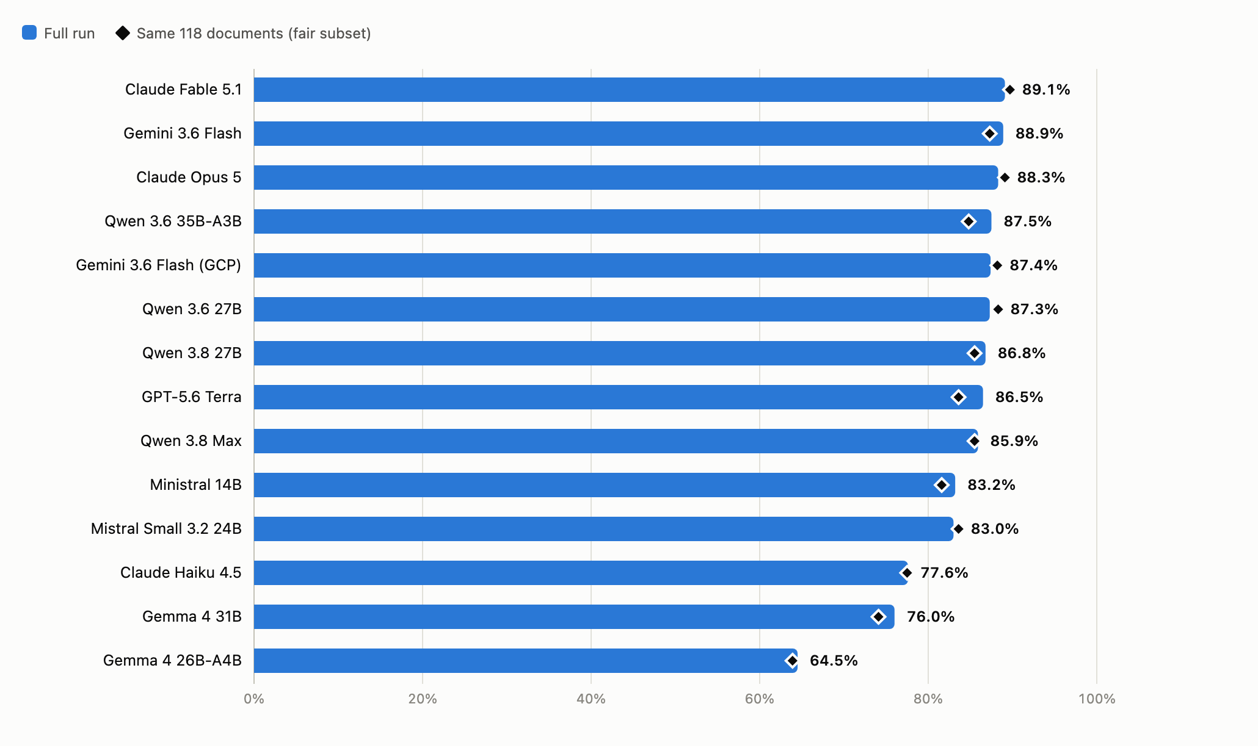

Cost vs. quality
What one thousand documents cost against what you get back. Up and to the left is better; the cost axis is logarithmic. Gemini 3.6 Flash (GCP deployment) is omitted — it is billed through the GCP contract, so no per-call cost is reported.
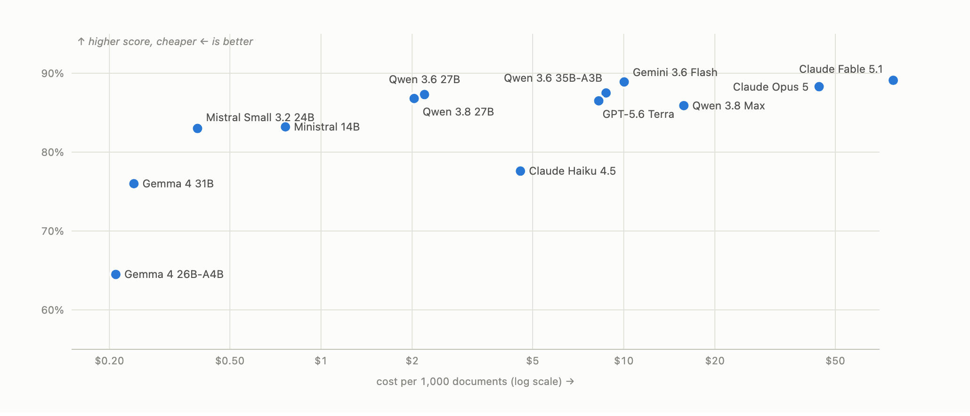

Where extraction breaks down, field by field
End-to-end score per field, darkest for the highest score. Header fields (invoice ID, dates, totals) are largely solved; the losses concentrate in PO number, delivery note and payment terms — mostly fields the models fail to return at all — and in vendor-name formatting mismatches.
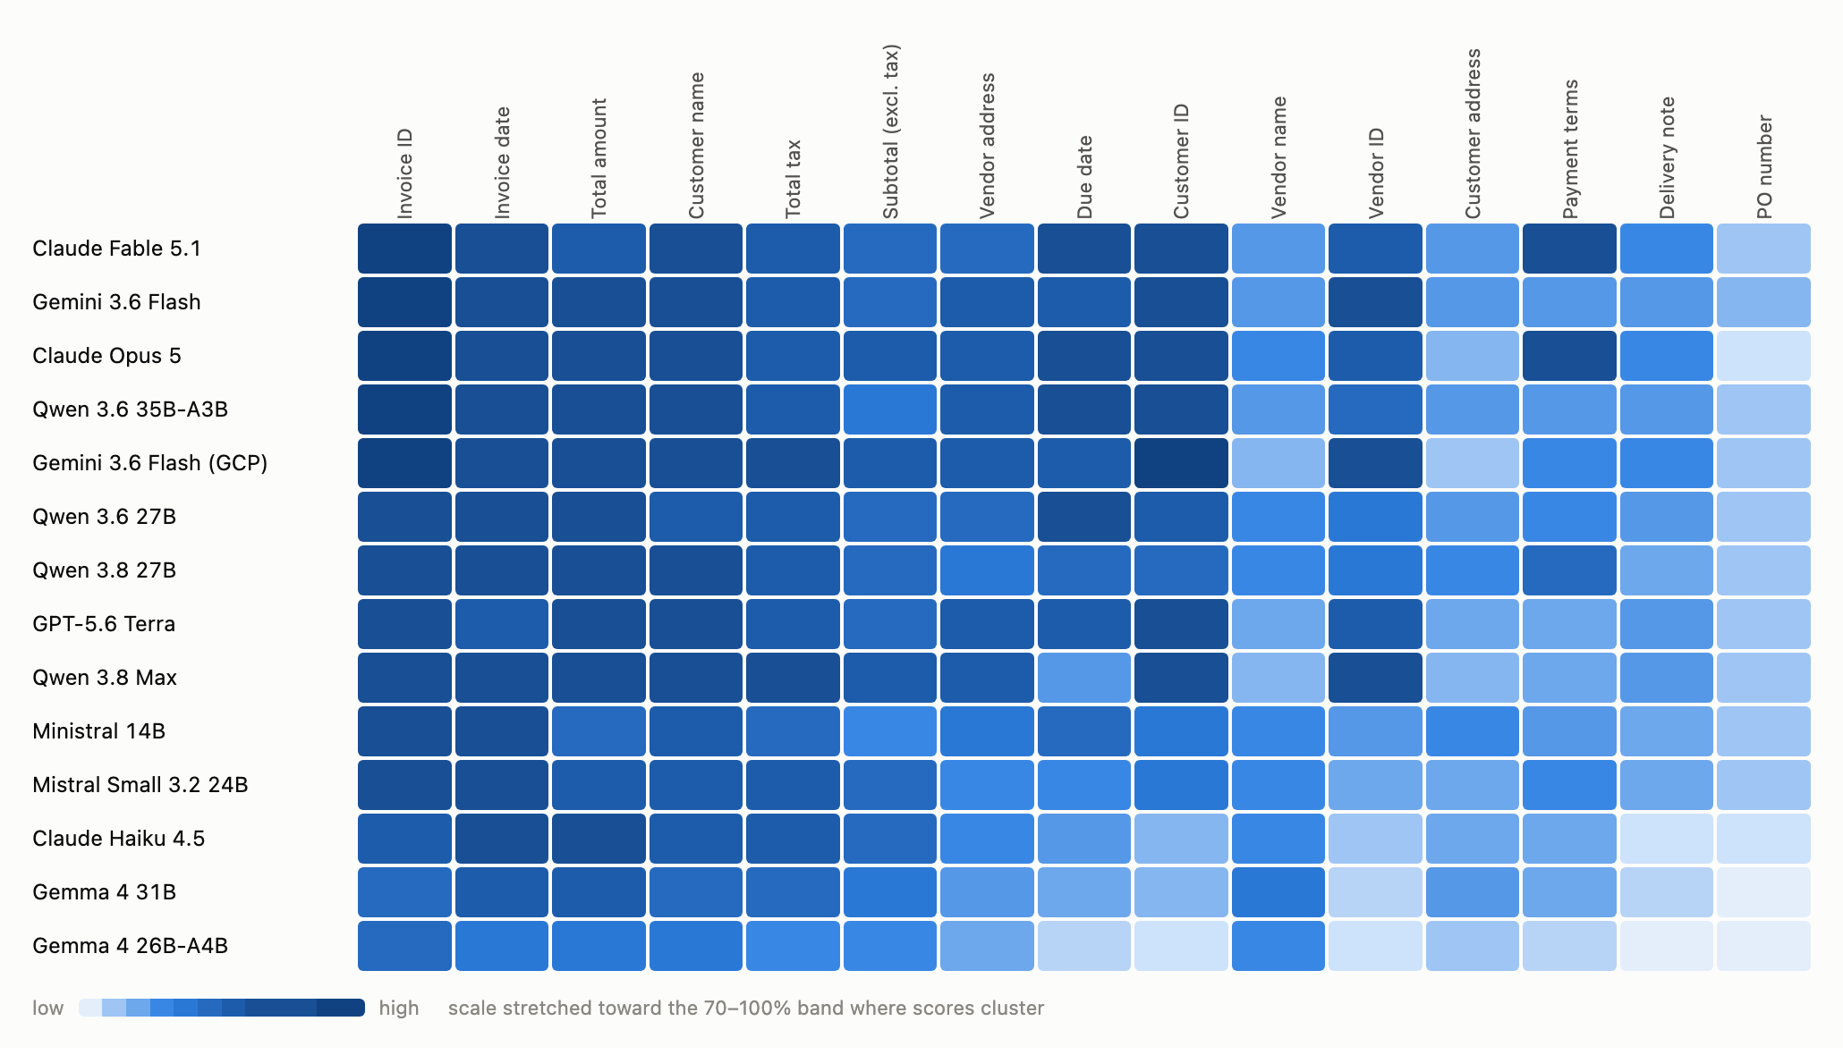

What kind of failure is it?
Every ground-truth field across all model runs combined — about 315,000 comparisons — split by outcome. The totals are almost never string-identical (ground truth stores raw numbers, models copy the printed format) but overwhelmingly correct after normalisation. Vendor name and the addresses are mostly a normalisation problem; PO number, delivery note and payment terms are a coverage problem — the model returns nothing at all.
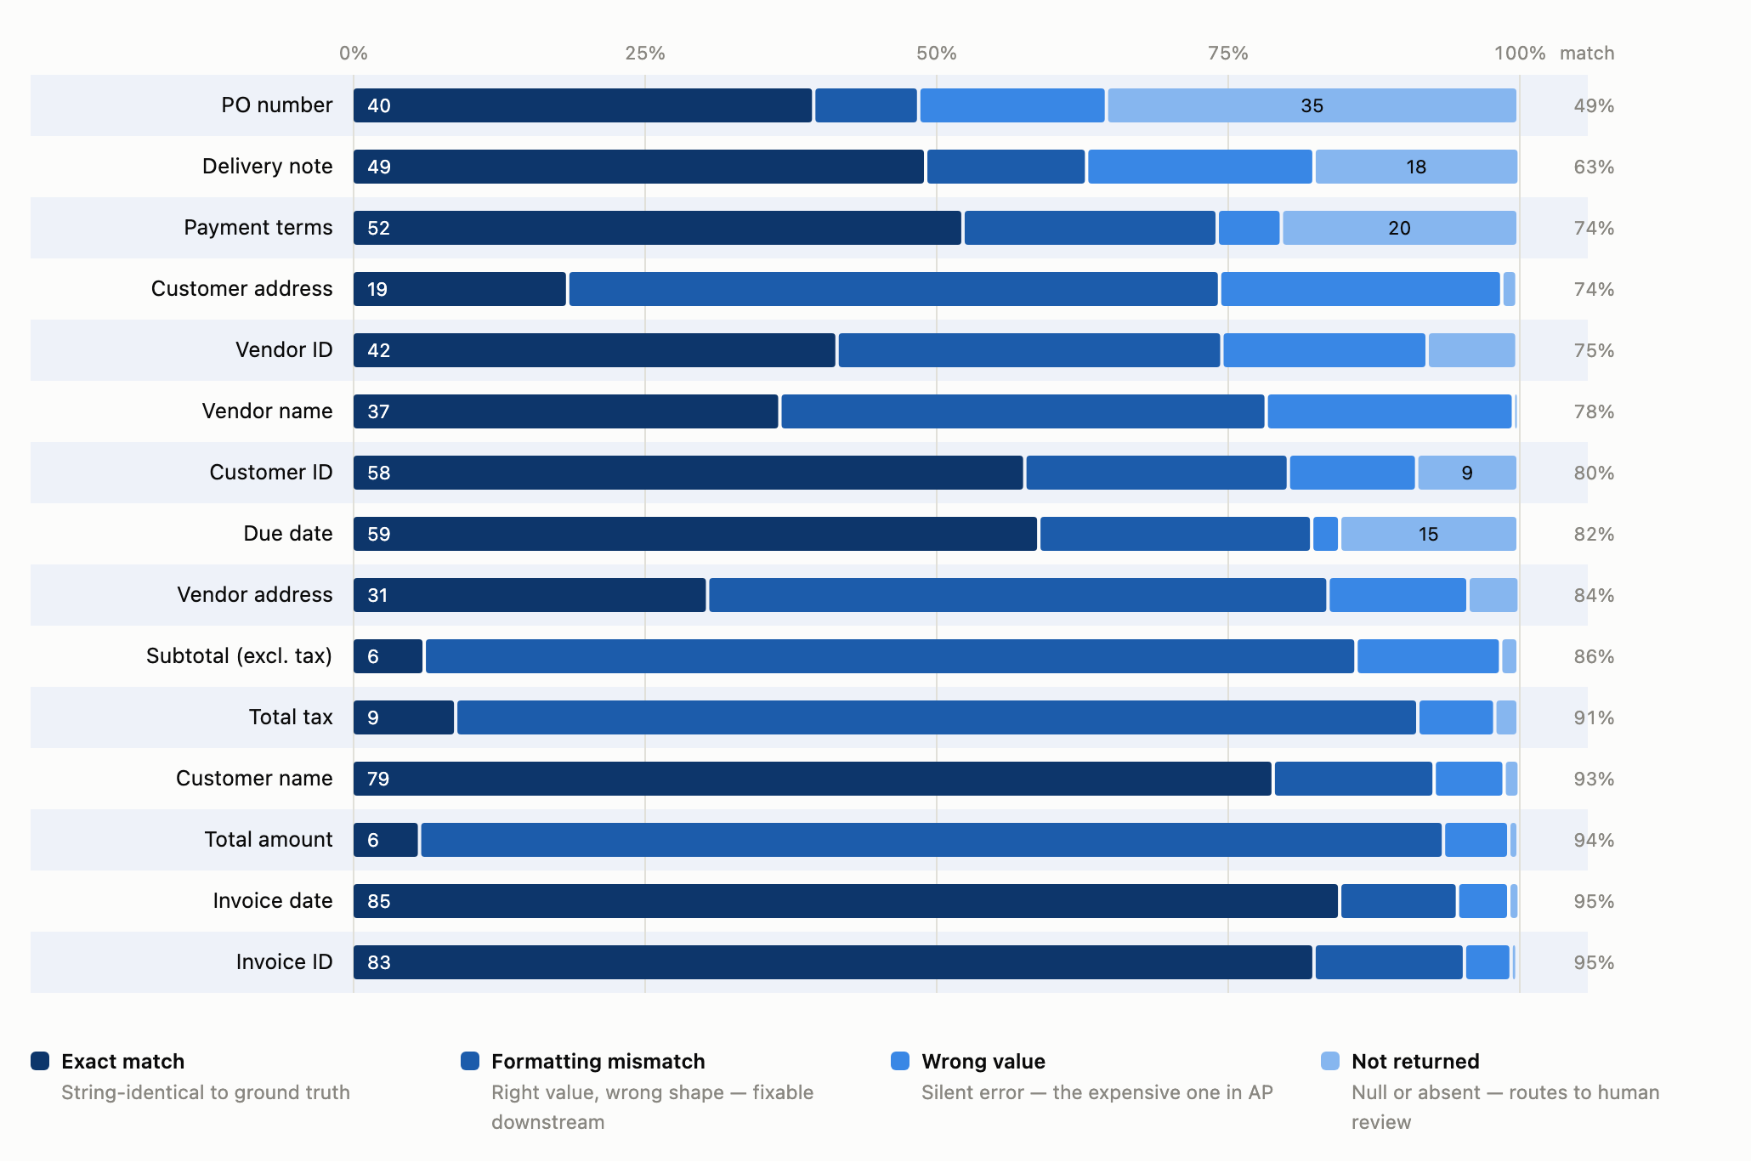

Full comparison
Model | End-to-end | E2E (215 docs) | Coverage | Accuracy | Cost / 1k docs | Tokens / doc | Latency | Docs run
Claude Fable 5.1 | 89.1% | 89.7% | 97.0% | 91.9% | $77.67 | 6,417 | 11.1 s | 207
Gemini 3.6 Flash | 88.9% | 87.3% | 97.0% | 91.7% | $10.04 | 3,164 | 11.0 s | 2,323
Claude Opus 5 | 88.3% | 89.1% | 95.7% | 92.2% | $44.19 | 7,473 | 16.7 s | 234
Qwen 3.6 35B-A3B | 87.5% | 84.8% | 96.8% | 90.3% | $8.74 | 11,241 | 82.9 s | 2,361
Gemini 3.6 Flash (GCP) | 87.4% | 88.2% | 96.9% | 90.2% | n/a | 5,113 | 12.3 s | 488
Qwen 3.6 27B | 87.3% | 88.3% | 96.8% | 90.2% | $2.20 | 4,574 | 42.5 s | 2,380
Qwen 3.8 27B | 86.8% | 85.5% | 96.3% | 90.1% | $2.03 | 4,204 | 26.7 s | 3,508
GPT-5.6 Terra | 86.5% | 83.6% | 96.0% | 90.0% | $8.27 | 5,543 | 6.9 s | 1,815
Qwen 3.8 Max | 85.9% | 85.5% | 95.0% | 90.4% | $15.79 | 5,866 | 22.9 s | 950
Ministral 14B | 83.2% | 81.6% | 95.2% | 87.3% | $0.76 | 4,127 | 13.2 s | 4,973
Mistral Small 3.2 24B | 83.0% | 83.6% | 94.0% | 88.3% | $0.39 | 4,723 | 11.4 s | 1,300
Claude Haiku 4.5 | 77.6% | 77.5% | 90.0% | 86.3% | $4.56 | 3,415 | 509 s* | 2,182
Gemma 4 31B | 76.0% | 74.1% | 90.7% | 83.8% | $0.24 | 1,067 | 18.3 s | 4,158
Gemma 4 26B-A4B | 64.5% | 63.9% | 78.7% | 82.0% | $0.21 | 1,078 | 37.3 s | 2,429
Coverage = share of fields present in the document that the model returned. Accuracy = share of returned values that match ground truth. End-to-end = correct ÷ present. * Claude Haiku 4.5 latency is inflated by rate-limit retries during its run and is not comparable.

Outcome split by field
The numbers behind “What kind of failure is it?”, pooled across all ten model runs.
Field | Exact | Formatting | Wrong value | Not returned | Correct total | Comparisons
Invoice ID | 82.5% | 12.9% | 4.0% | 0.5% | 95.4% | 28,900
Invoice date | 84.7% | 10.1% | 4.4% | 0.9% | 94.8% | 29,144
Total amount | 5.8% | 87.8% | 5.6% | 0.8% | 93.6% | 28,914
Customer name | 79.0% | 13.8% | 6.0% | 1.3% | 92.8% | 28,994
Total tax | 8.9% | 82.5% | 6.6% | 2.0% | 91.4% | 28,505
Subtotal (excl. tax) | 6.2% | 79.9% | 12.4% | 1.5% | 86.1% | 28,655
Vendor address | 30.5% | 53.2% | 12.0% | 4.4% | 83.7% | 29,049
Due date | 58.9% | 23.4% | 2.4% | 15.3% | 82.3% | 22,199
Customer ID | 57.7% | 22.6% | 11.0% | 8.7% | 80.3% | 28,724
Vendor name | 36.7% | 41.7% | 21.2% | 0.4% | 78.4% | 29,194
Vendor ID | 41.6% | 33.0% | 17.6% | 7.7% | 74.6% | 29,096
Customer address | 18.5% | 55.9% | 24.2% | 1.3% | 74.4% | 27,223
Payment terms | 52.4% | 21.8% | 5.5% | 20.3% | 74.2% | 17,069
Delivery note | 49.2% | 13.8% | 19.5% | 17.6% | 63.0% | 17,533
PO number | 39.6% | 9.0% | 16.1% | 35.3% | 48.6% | 21,863

Method & caveats
- Setup. Invoice PDFs rendered locally to page images (up to 4 pages per document, 150 dpi) and sent to each model with the same extraction prompt and JSON schema, temperature 0, via OpenRouter — plus one Gemini 3.6 Flash deployment on GCP Vertex for comparison. Reasoning modes were capped at minimum effort so models are compared on extraction, not thinking-token budgets.
- Ground truth. Model output is compared field-by-field against a reviewed ground-truth set, with tolerant matching for dates and number formats.
- Document category is excluded from all scores. Every model scored about 0% on it because the ground truth uses internal labels (e.g. “Expense”) while models return the document’s printed type — a taxonomy mismatch to fix in the ground truth, not a model failure.
- Unequal run sizes. Runs range from 234 documents (Claude Opus 5) to 4,973 (Ministral 14B) because of per-model cost caps. The fair-subset re-score on the 215 shared documents confirms the ordering, with one change: Opus 5 moves to first place there.
- Vendor name scores understate the models. A large share of vendor-name misses are formatting variants of the correct name; tightening ground-truth normalisation would lift every model roughly equally.
- Failure types. Exact = string-identical to ground truth; formatting mismatch = same value after normalisation (date formats, thousand separators, accents, punctuation) — these count as correct in all scores; wrong value = returned but doesn’t match; not returned = null or absent.
- Costs are actual billed OpenRouter charges at list prices, not estimates.

