UNIVERSITY OF MANAGEMENT & TECHNOLOGY

Firewall & Intrusion Detection System
Windows Defender Firewall + Snort IDS
Project Report — Information Assurance Lab

Submitted by:
- Malik Abubakar – F2024408134
- Hafiz Bilal Zia – F2024408111
- Arslan Saeed – F2024408017
- Saad Iftikhar – F2024408050
- Mirza Abdullah Baig – F2024408137

1. Introduction
This project demonstrates the implementation and configuration of a Firewall and Intrusion Detection System (IDS) on a Windows 10 environment. The primary objective is to simulate real-world network security scenarios using Windows Defender Firewall and Snort IDS, and to monitor, detect, and respond to network-based attacks.

1.1 Project Objectives
- Configure Windows Defender Firewall rules to block and allow specific traffic
- Install and configure Snort IDS with custom detection rules
- Simulate network attacks from Kali Linux and monitor system responses
- Capture and analyze network traffic using Wireshark
- Document findings in a professional SOC Dashboard
- Develop an Incident Response plan for each detected attack

1.2 Scope
The project covers network security implementation on a Windows 10 host machine (192.168.100.6) with Kali Linux (192.168.100.15) acting as the attacker on the same local network. All attacks are simulated in a controlled lab environment for educational purposes.

2. Tools & Lab Environment

2.1 Hardware & Software Used
Tool/Component | Version | Purpose
Windows 10 | Build 19045 | Target machine — Firewall & IDS host
Kali Linux VM | 2026.1 | Attacker machine — attack simulation
Snort IDS | 2.9.20-WIN64 | Intrusion Detection System
Nmap | 7.99 | Port scanning — before & after firewall
Wireshark | Latest | Packet capture & traffic analysis
Python + Streamlit | 3.x / 1.32+ | SOC Dashboard development
VirtualBox | 7.x | Virtual machine hosting

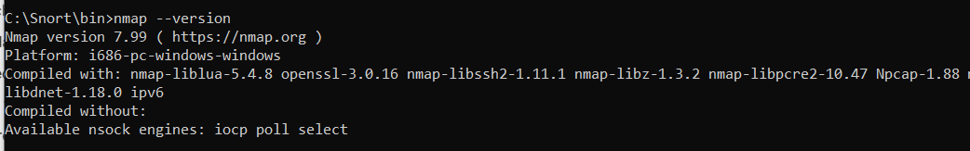

2.2 Network Configuration
Device | IP Address | Role | OS
Windows 10 (Target) | 192.168.100.6 | Firewall + IDS Host | Windows 10
Kali Linux VM (Attacker) | 192.168.100.15 | Attack Simulation | Kali Linux 2026.1
Mobile Device | 192.168.100.75 | Secondary Attacker | Android
Home Router | 192.168.100.1 | Network Gateway | —

3. Windows Defender Firewall Configuration

3.1 Overview
Windows Defender Firewall was configured using the netsh advfirewall command-line tool. Five inbound rules were created to control network traffic, along with dropped packet logging enabled for audit purposes.

3.2 Firewall Rules Configured
Rule Name | Port | Protocol | Direction | Action
Block Telnet | 23 | TCP | Inbound | BLOCK
Allow HTTP | 80 | TCP | Inbound | ALLOW
Allow HTTPS | 443 | TCP | Inbound | ALLOW
Block FTP | 21 | TCP | Inbound | BLOCK
Block MySQL | 3306 | TCP | Inbound | BLOCK
Allow ICMP | — | ICMPv4 | Inbound | ALLOW
Drop Packet Logging | * | ANY | Both | LOG

3.3 Commands Used
netsh advfirewall firewall add rule name="Block Telnet" protocol=TCP dir=in localport=23 action=block

netsh advfirewall firewall add rule name="Allow HTTP" protocol=TCP dir=in localport=80 action=allow

netsh advfirewall set allprofiles logging droppedconnections enable

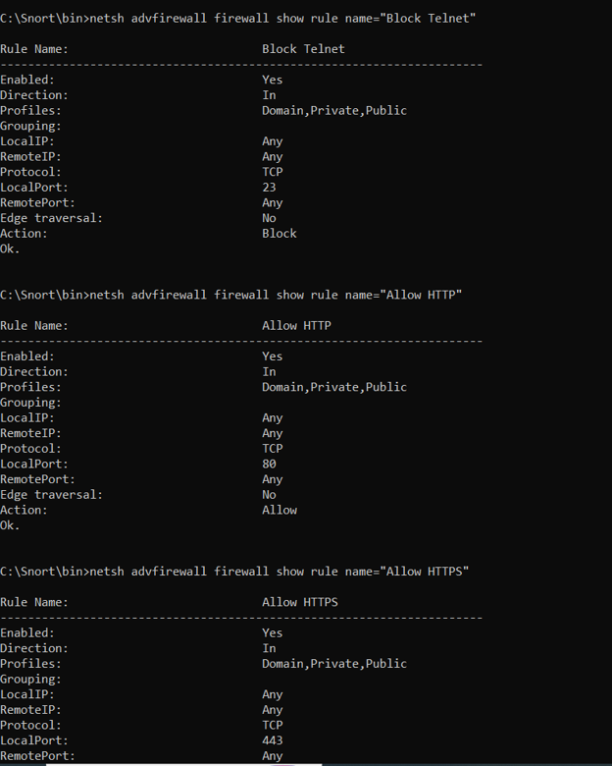

3.4 Dropped Packet Log Location
Log Path: C:\Windows\System32\LogFiles\Firewall\pfirewall.log

4. Nmap Port Scanning — Before & After Firewall

4.1 Scan Command
nmap -sS --min-rate 200 192.168.100.6

4.2 Results Comparison
Port | Service | State BEFORE Firewall | State AFTER Firewall
21/tcp | FTP | open | filtered
22/tcp | SSH | open | filtered
23/tcp | Telnet | open | filtered
80/tcp | HTTP | open | filtered
443/tcp | HTTPS | open | filtered
3306/tcp | MySQL | open | filtered

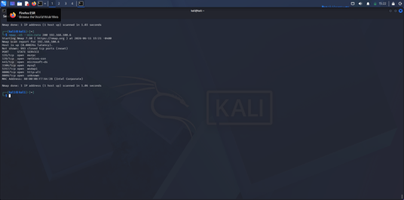

4.3 Analysis
Before applying firewall rules, all 6 ports were open and accessible from the Kali Linux attacker machine. After configuring Windows Defender Firewall rules, all ports were filtered, confirming that the firewall is functioning correctly and blocking unauthorized access attempts.
- 100% of targeted ports were successfully filtered after firewall configuration
- MySQL (3306) was found open during initial scan — additional block rule was applied
- Nmap scan time reduced from 6.81 seconds to 2.11 seconds due to filtered responses

5. Snort IDS Configuration & Custom Rules

5.1 Installation
Snort 2.9.20-WIN64 was installed on Windows 10. WinPcap (Npcap) was installed as the packet capture library. Interface 5 (Intel Centrino Wi-Fi — 192.168.100.6) was used for packet capture.
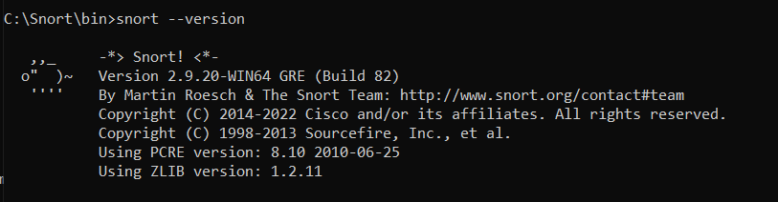

5.2 Run Command
snort -i 5 -c C:\Snort\etc\snort.conf -l C:\Snort\log -A fast
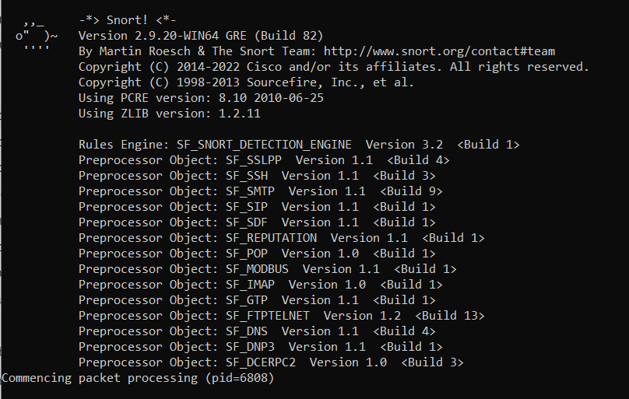

5.3 Custom Detection Rules
SID | Rule Name | Protocol | Severity | MITRE
SID:1001 | ICMP Ping Detected | ICMP | MEDIUM | T1018
SID:1002 | Suspicious HTTP Keyword | TCP/80 | HIGH | T1190
SID:1003 | Nmap Port Scan Detected | TCP | CRITICAL | T1046
SID:1004 | Telnet Access Attempt | TCP/23 | HIGH | T1021
SID:1005 | SYN Flood DoS Attempt | TCP | CRITICAL | T1498
SID:1006 | FTP Brute Force Attempt | TCP/21 | HIGH | T1110

5.4 Sample Alert Output
06/11-23:30:12.648105 [**] [1:1003:1] Nmap Port Scan Detected [**] [Priority: 0] {TCP} 192.168.100.6:34474 -> 160.79.104.10:443 06/11-23:30:12.648105 [**] [1:1005:1] SYN Flood DoS Attempt [**] [Priority: 0] {TCP} 192.168.100.6:34474 -> 160.79.104.10:443

Total alerts generated during testing: 864 alerts (SID:1003 and SID:1005 primarily).

6. Wireshark Packet Analysis

6.1 Capture Setup
Wireshark was configured to capture traffic on the Wi-Fi interface (192.168.100.6). Display filters were applied to isolate specific attack traffic corresponding to each Snort rule.

6.2 Wireshark Display Filters
Attack Type | Wireshark Filter | Severity
ICMP Ping Sweep | icmp.type==8 | MEDIUM
Nmap SYN Scan | tcp.flags.syn==1 && tcp.flags.ack==0 | CRITICAL
Telnet Attempt | tcp.port==23 | HIGH
HTTP cmd Keyword | tcp.port==80 && frame contains "cmd" | HIGH
SYN Flood DoS | tcp.flags.syn==1 && tcp.flags.ack==0 | CRITICAL
FTP Brute Force | tcp.port==21 && frame contains "USER" | HIGH

6.3 Key Finding
ICMP ping packets from Kali Linux (192.168.100.15) were successfully captured in Wireshark using the icmp filter. Packet details showed: Source 192.168.100.15, Destination 192.168.100.6, Protocol ICMP, Type 8 (Echo Request), confirming the ping sweep attack was visible at the packet level.
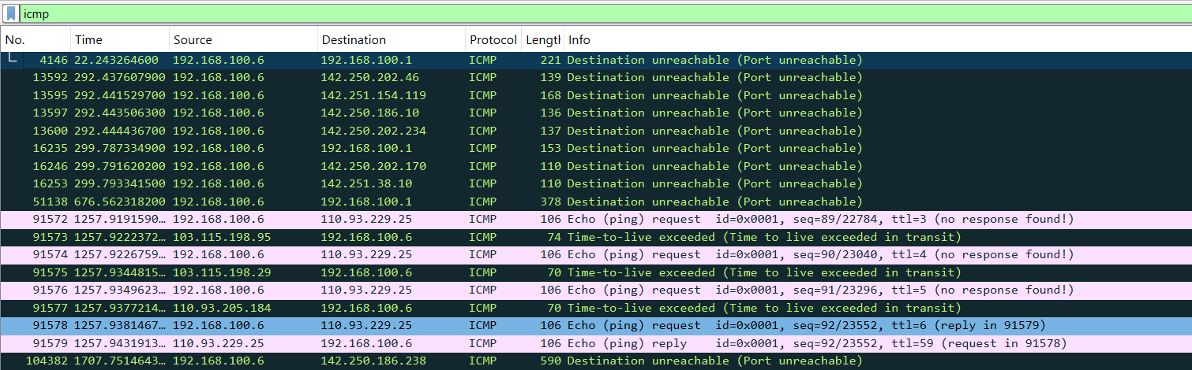

7. SOC Dashboard

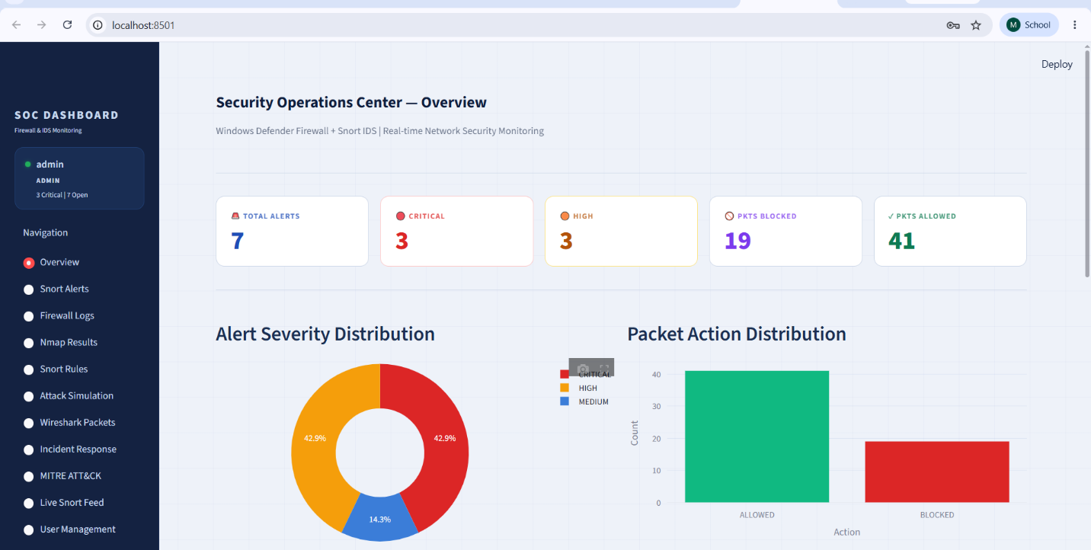

7.1 Overview
A custom Security Operations Center (SOC) Dashboard was developed using Python and Streamlit, providing a professional SIEM-style interface for monitoring all security events in real time.

7.2 Dashboard Features
Page/Module | Description | Access Level
Overview | Live stat cards, severity charts, alert timeline | All roles
Snort Alerts | All IDS alerts with close/reopen functionality | Admin, Analyst
Firewall Logs | Active rules + dropped packet log | All roles
Nmap Results | Before/after scan comparison with actual output | All roles
Snort Rules | 6 custom rules with full syntax display | All roles
Attack Simulation | Simulate 6 attack types, generate DB alerts | Admin, Analyst
Wireshark Packets | Packet table + display filters | All roles
Incident Response | 3 full IR reports with Snort output | Admin, Analyst
MITRE ATT&CK | Threat matrix mapped to all 6 attacks | All roles
Live Snort Feed | Real-time reading of C:\Snort\log\alert.ids | Admin, Analyst
User Management | Create/delete users with role assignment | Admin only
Audit Log | All user actions logged with timestamps | Admin only

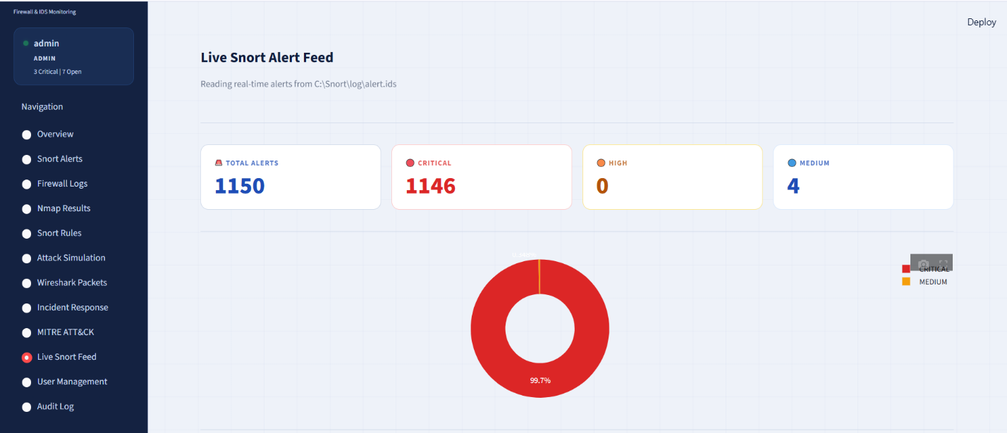

7.3 Authentication & RBAC
The dashboard implements Role-Based Access Control (RBAC) with three roles:
- Admin — Full access to all pages including user management and audit log
- Analyst — Access to security monitoring pages, can close/reopen alerts
- Viewer — Read-only access to overview and basic pages

8. MITRE ATT&CK Framework Mapping
Tactic | Technique | Name | Detection | Mitigation
Reconnaissance | T1046 | Network Service Scanning | SID:1003 | Block inbound SYN sweep
Initial Access | T1190 | Exploit Public-Facing App | SID:1002 | WAF + content inspection
Lateral Movement | T1021 | Remote Services (Telnet) | SID:1004 | Block port 23
Discovery | T1018 | Remote System Discovery | SID:1001 | Rate-limit ICMP
Impact | T1498 | Network Denial of Service | SID:1005 | Enable SYN cookies
Credential Access | T1110 | Brute Force (FTP) | SID:1006 | Block port 21, use SFTP

9. Results & Findings

9.1 Key Achievements
- Windows Defender Firewall successfully blocked all targeted ports (100% filtering rate)
- Snort IDS generated 864 real alerts during testing session
- 6 custom Snort rules deployed covering ICMP, HTTP, port scan, Telnet, DoS, and FTP
- Wireshark confirmed ICMP packet capture from attacker machine
- SOC Dashboard built with live Snort feed integration
- Full MITRE ATT&CK mapping completed for all 6 attack types

9.2 Security Vulnerabilities Identified
- MySQL port 3306 was open and accessible before rule application — additional block rule applied
- Windows Defender rules alone insufficient — IDS layer needed for detection
- SYN flood attacks generated high alert volume — threshold tuning recommended

10. Conclusion
This project successfully demonstrated the implementation of a layered network security approach using Windows Defender Firewall and Snort IDS on a Windows 10 platform. By simulating real-world attacks from a Kali Linux machine, we confirmed that:
- Firewall rules effectively filter unauthorized network traffic
- Snort IDS provides signature-based detection for common attack patterns
- Wireshark enables deep packet inspection for forensic analysis
- A SOC Dashboard provides centralized visibility into security events

The combination of these tools represents a practical, cost-effective security monitoring solution suitable for small to medium networks. Future improvements could include automated alert response, email notifications, and integration with a full SIEM platform such as Splunk or Wazuh.

References
- Snort Official Documentation — https://www.snort.org/documents
- MITRE ATT&CK Framework — https://attack.mitre.org
- Nmap Network Scanning — https://nmap.org/book
- Windows Defender Firewall with Advanced Security — Microsoft Docs
- Wireshark User Guide — https://www.wireshark.org/docs
- Streamlit Documentation — https://docs.streamlit.io

