NAME:

DATE: 12-08-2020

revision number of report: 01

CSCE 155N Final Project

2020

# Question # 01

%power input = P_in

P_in=[0:5:125];

%power lose = P_lose

P_lose=0.6+0.02*P_in+0.0015*(P_in).^2;

P_out=P_in-P_lose;

%effeciency

E=P_out./P_in;

%plot effeciency vs power input

plot(P_in,E);

xlabel('power input')

ylabel('effeciency')

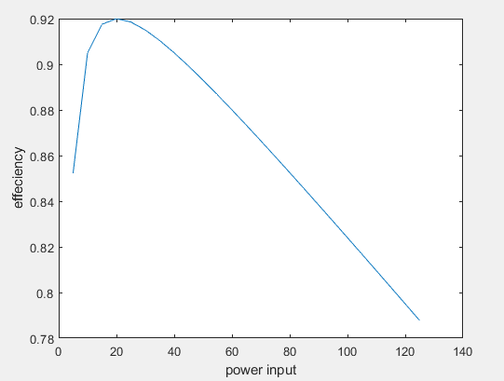

# Question # 02

T_e=0.25;

E_g=8.8;

P=298;

%fuel flow

R_f=P/(E_g*T_e);

%input parameter

C_f=[25:1:100];

% endurance equation is

X=C_f./R_f;

plot(C_f,X)

xlabel('fuel capacity')

ylabel('Endurance')

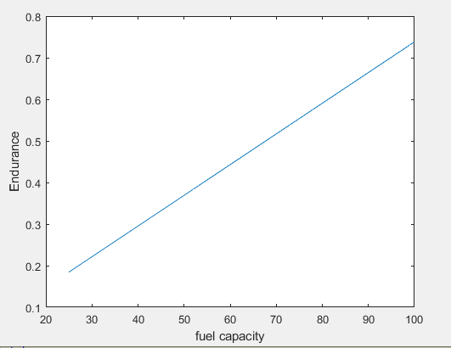

# Question # 03

## Question 01

From the plot of question one we can see that the efficiency of the vehicle increases 1st with the increase of the input power from 0 to 20 KW. The maximum value of the efficiency of the vehicle is 92% or 0.92 but after the increase from 20-125-kW efficiency decreases to value of 79%. The general shape for the decreasing of the efficiency is an exponential function. Thus, while designing the vehicle the input power of engine must be specified in region of increasing efficiency from 0-20kW. After this interval we have to compromise on the efficiency to increase the input and output power.

## Question # 02

From the graph of 2nd question, we can see it’s a line graph with positive slop. This straight line shows that with increase of fuel capacity the endurance of engine also increases. Thus, while designing the vehicle we admire to have maximum endurance thus we can select the highest fuel capacity of vehicle for that endurance.

# Question # 04

The time taken for the completion of the project for the programming in MATLAB was 4 hours for each question for the plotting of graphs. While the report was typed in 3 hours. Thus, the overall time taken for the completion of this project was approximately 1 day including proof reading time.

# Question # 05

The problems that I faced while programming on MATLAB was with question 1 for the calculation of efficiency array. First, I didn’t use the dot operator and this leads to a single value of the efficiency after a number of iterations to correct my answer I was unable to locate the problem. Afterward I used dot operator in the array division that leads to successful plotting of results.

In question two I did not face any difficulty regarding the plotting since it was a simple line plot and also in the formula of the endurance denominator was just a scalar number it was not an array thus it was simpler then question 1.