

**ASSIGNMENT # 01**

**Submitted by : ARSLAN SAJID**

**Roll No : S P _ 2 2 _ b c s _ 1 3 0**

**Submitted to : Ma’am Yasmeen**

**Subject :** DSA-LAB

**Program 01:**

#include <iostream>

int main () {

int num = 42; int* ptr = &num;

std::cout << "Value of num: " << *ptr << std::endl; return 0;

**}**

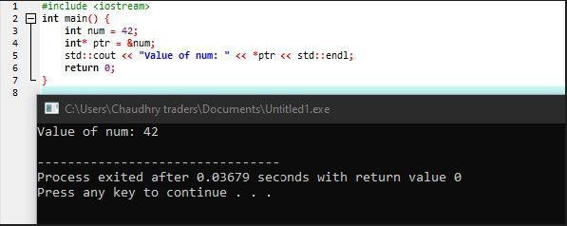

**Program 02:**

#include <iostream>

int main () {

int arr[] = {1, 2, 3, 4, 5};

int* ptr = arr;

std::cout << "First element: " << *ptr << std:: endl; std::cout << "Second element: " << *(ptr + 1) <<

std::endl ;

return 0;

**}**

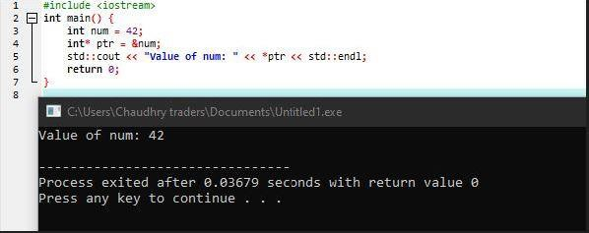

**Program 03:**

#include <iostream>

int main () {

int num = 42;

int* ptr1 = &num; int** ptr2 = &ptr1;

std::cout << "Value of num: " << **ptr2 << std::endl; return 0;

**}**

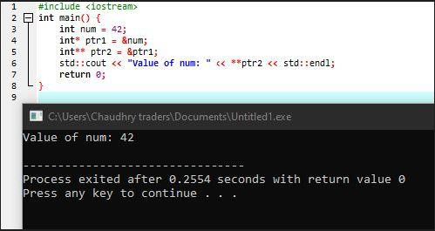

**Program 04:**

#include <iostream>

void increment (int* num) { (*num)++;

**}**

int main() { int x = 5;

increment(&x);

std::cout << "Incremented value: " << x << std::endl; return 0;

**}**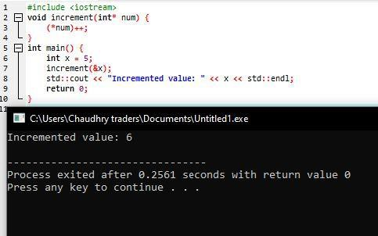

**Program 05:**

#include <iostream>

int main () {

int* num = new int;

*num = 42;

std::cout << "Value of num: " << *num << std::endl; delete num;

return 0;

**}**

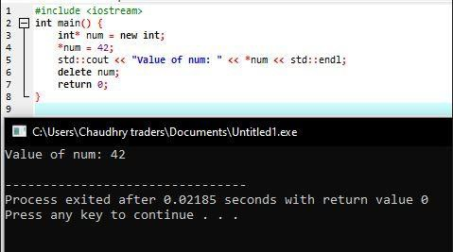

**Program 06:**

#include <iostream>

int main () {

int arr[] = {1, 2, 3}; int* ptr[3];

for (int i = 0; i < 3; i++) { ptr[i] = &arr[i];

std::cout << "Value at index " << i << ": " << *ptr[i]

<< std::endl;

**}**

return 0;

**}**

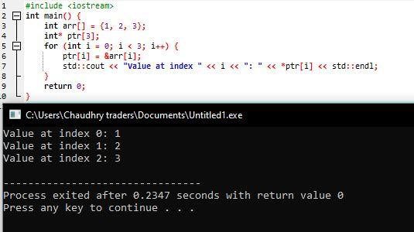

**Program 07:**

#include <iostream>

int main () {

const int num = 42; const int* ptr = &num;

std::cout << "Value of num: " << *ptr << std::endl; return 0;

**}**

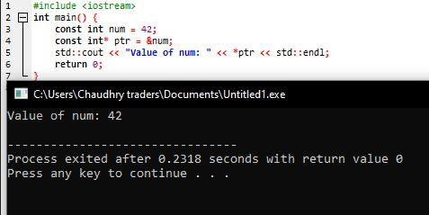

**Program 08:**

#include <iostream>

int main () {

int num = 42;

int* const ptr = &num;

*ptr = 50; // Valid

std::cout << "Value of num: " << *ptr << std::endl; return 0;

**}**

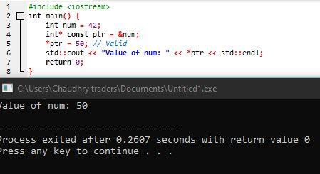

**Program 09:**

#include <iostream>

int main () {

const int num = 42;

const int* const ptr = &num;

std::cout << "Value of num: " << *ptr << std::endl; return 0;

**}**

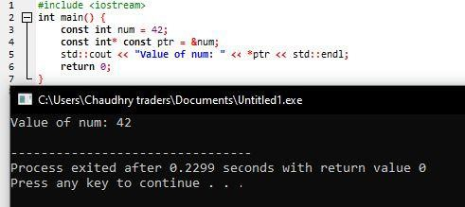

**Program 10:**

#include <iostream>

int add (int a, int b) { return a + b;

**}**

int main() {

int (*ptr)(int, int) = add;

std::cout << "Result: " << ptr(5, 7) << std::endl; return 0;

**}**

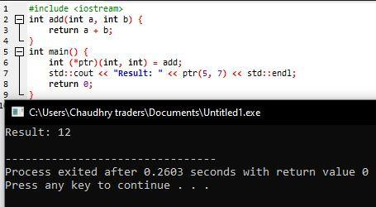

Program: 11

#include<iostream>

int main () {

int arr[] = {1, 2, 3}; int (*ptr)[3] = &arr;

std::cout << "Value at index 0: " << (*ptr)[0] << std::endl;

return 0;

**}**

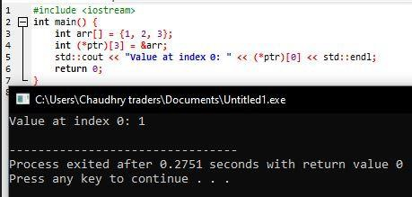

Programe = 12

#include<iostream

class MyClass { public:

int x;

**};**

int main() { MyClass obj;

int MyClass::*ptr = &MyClass::x; obj.*ptr = 42;

std::cout << "Value of x: " << obj.*ptr << std::endl; return 0; }

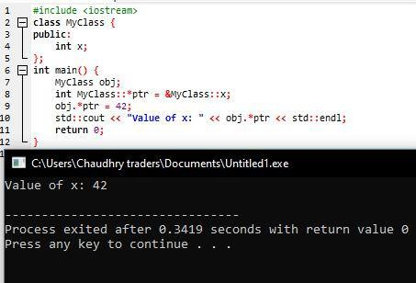

**Program 14:**

#include <iostream>

class MyClass { public:

int add(int a, int b) { return a + b; }

**};**

int main() {

int (MyClass::*ptr)(int, int) = &MyClass::add; MyClass obj;

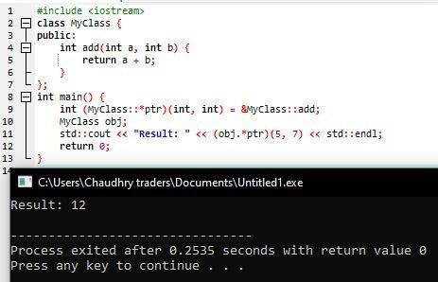std::cout << "Result: " << (obj.*ptr)(5, 7) << std::endl;

return 0; }

int main () {

int arr[] = {1, 2, 3, 4, 5};

int* ptr = arr;

for (int i = 0; i < 5; i++) {

std::cout << "Value at index " << i << ": " << *(ptr + i) << std::endl;

**}**

return 0;

**}**

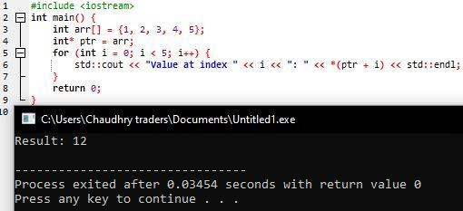

int add (int a, int b) { return a + b;

**}**

int main() {

int (*const ptr)(int, int) = add;

std::cout << "Result: " << ptr(5, 7) << std::endl; return 0;

**}**

