James Karwacki

December 9, 2016

Web Design

Dr. Danielle Yemma

Graphic Citation

Graphic Citation

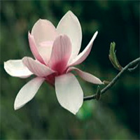

[Magnolia]. (2013, March 24). Retrieved November 21, 2016, from https://www.theguardian.com/lifeandstyle/2013/mar/24/guide-to-growing-magnolias

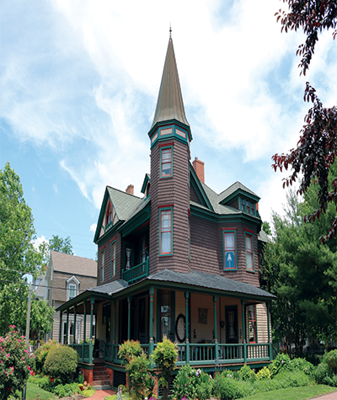

Karwacki, James(Photographer).(2016) *The John S. McDaniel House Bed and Breakfast*[photograph]. Easton, Maryland.



Karwacki, James (Designer). (2016) *Logo to the John S. McDaniel House Bed and Breakfast*. Easton, Maryland.

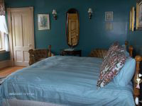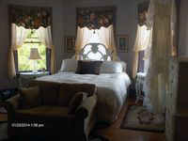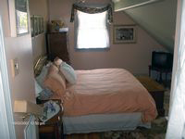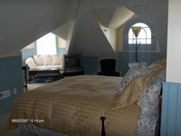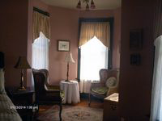

Karwacki, James(Photographer).(2016) The John S. McDaniel House Bed and Breakfast Rooms[photographs]. Easton, Maryland.

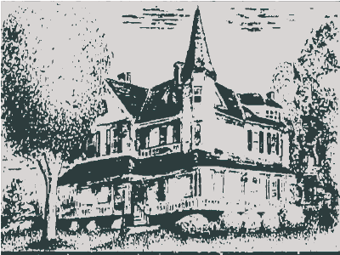

Karwacki, James (designer).(2016) The John S. McDaniel House Bed and Breakfast Watermark [digital image]. Easton, Maryland.