AI Startup Opportunity Scanner
Project Report | Data, ML, NLP, GenAI, and Streamlit Dashboard
Generated from the attached AI startup datasets and the implemented project pipeline.

1. Project Overview
The AI Startup Opportunity Scanner combines startup funding records, Product Hunt launches, and startup outcome data to identify market whitespace. It calculates a weighted Opportunity Score, provides an XGBoost success predictor, supports BERTopic trend analysis, and exposes a LangChain/Chroma RAG advisor for failure-aware business plans.

2. Technology Stack
Python 3.10+, Pandas, NumPy, scikit-learn, XGBoost, SHAP, BERTopic, SentenceTransformers, LangChain, Gemini 3.6 Flash, ChromaDB, Streamlit, Plotly, and Matplotlib.

3. Data Pipeline
Raw CSV datasets are loaded by scripts/run_cleaning.py and passed through DataCleaner. Processed data is stored in data/processed/. The dashboard derives category-level features and sends them to OpportunityScorer. SuccessPredictor consumes startup outcome records, while GenAIAdvisor retrieves historical failure records from ChromaDB before prompting GPT-4o.

4. Dataset Results
Dataset | Rows
AI funding | 38
Indian funding | 300
Product Hunt | 5,624
Startup outcomes | 100,000
Observed startup outcomes: 55,610 Failure, 42,335 Acquisition, and 2,055 IPO records.

5. User Interface

Home
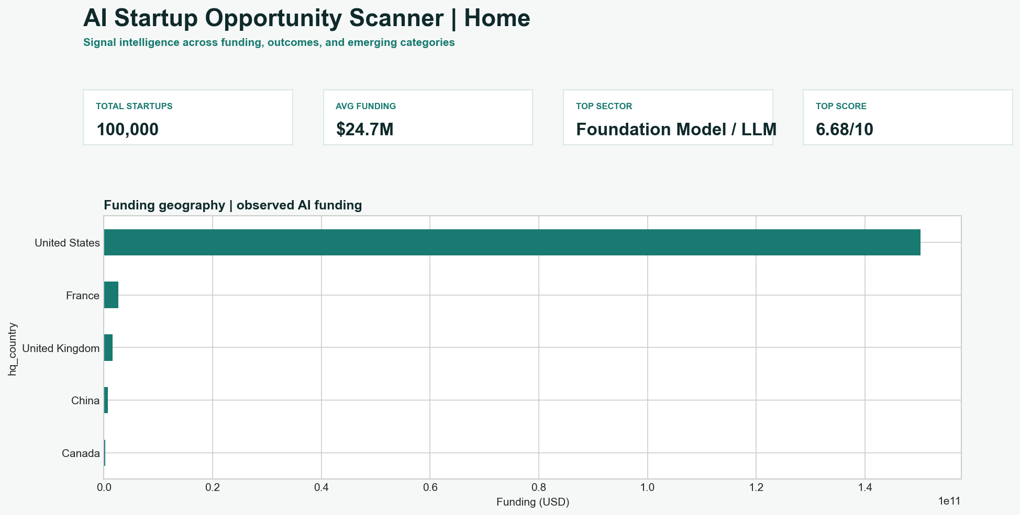
Dashboard metrics and funding geography.

Funding Analytics
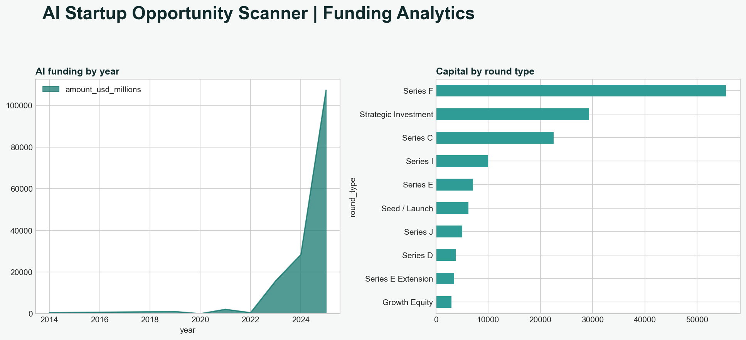
Funding trend and round-type analytics.

Opportunity Scanner
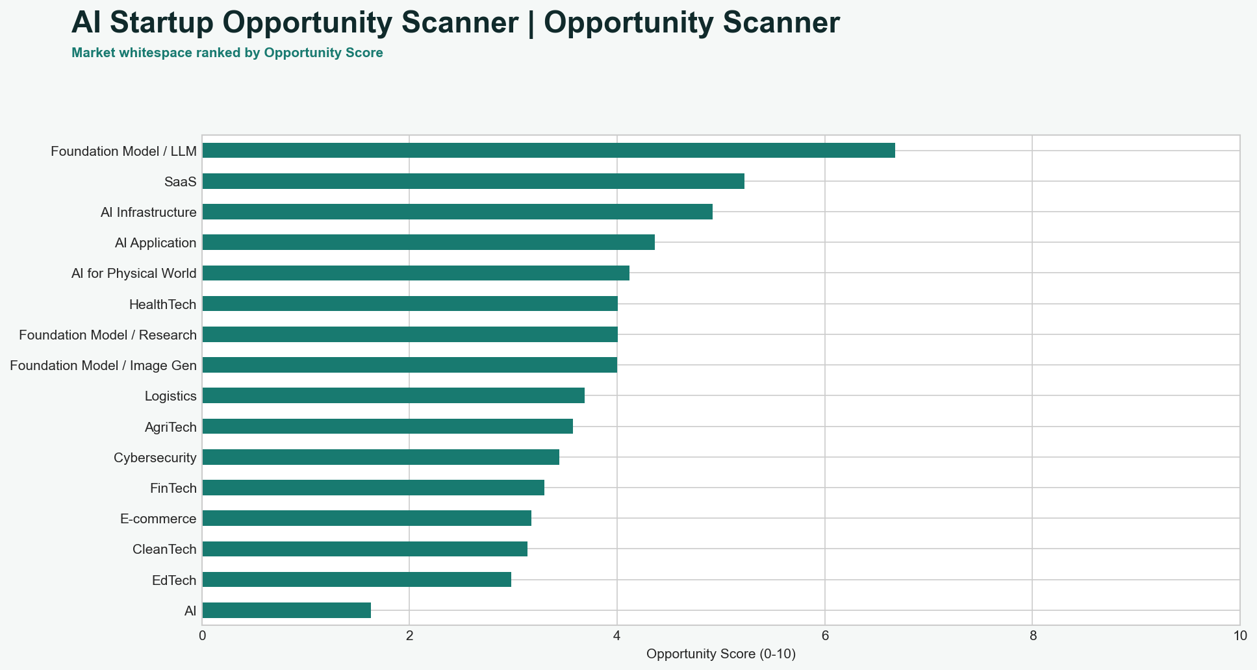
Opportunity scores by sector.

6. Run Instructions
Install dependencies with: py -3 -m pip install -r requirements.txt
Clean data with: py -3 scripts/run_cleaning.py
Launch the UI with: py -3 -m streamlit run dashboard/app.py
The AI Advisor requires GOOGLE_API_KEY in the process environment. API keys must never be committed to the repository or shared in chat.

7. Validation
The project was compiled across all Python files. The cleaning pipeline completed successfully. The dashboard served HTTP 200 on localhost:8501. The opportunity table produced 16 sectors with scores constrained to 0-10. The persisted XGBoost model reloaded and returned valid probabilities.

