**ATmega2560**

|  |  |
| --- | --- |
| **Vector name** | **Description** |
| ADC_vect | ADC Conversion Complete |
| ANALOG_COMP_vect | Analog Comparator |
| EE_READY_vect | EEPROM Ready |
| INT0_vect | External Interrupt 0 |
| INT1_vect | External Interrupt Request 1 |
| INT2_vect | External Interrupt Request 2 |
| INT3_vect | External Interrupt Request 3 |
| INT4_vect | External Interrupt Request 4 |
| INT5_vect | External Interrupt Request 5 |
| INT6_vect | External Interrupt Request 6 |
| INT7_vect | External Interrupt Request 7 |
| PCINT0_vect | Pin Change Interrupt Request 0 |
| PCINT1_vect | Pin Change Interrupt Request 1 |
| PCINT2_vect | Pin Change Interrupt Request 2 |
| SPI_STC_vect | Serial Transfer Complete |
| SPM_READY_vect | Store Program Memory Read |
| TIMER0_COMPA_vect | TimerCounter0 Compare Match A |
| TIMER0_COMPB_vect | Timer Counter 0 Compare Match B |
| TIMER0_OVF_vect | Timer/Counter0 Overflow |
| TIMER1_CAPT_vect | Timer/Counter Capture Event |
| TIMER1_COMPA_vect | Timer/Counter1 Compare Match A |
| TIMER1_COMPB_vect | Timer/Counter1 Compare MatchB |
| TIMER1_COMPC_vect | Timer/Counter1 Compare Match C |
| TIMER1_OVF_vect | Timer/Counter1 Overflow |
| TIMER2_COMPA_vect | Timer/Counter2 Compare Match A |
| TIMER2_COMPB_vect | Timer/Counter2 Compare Match A |
| TIMER2_OVF_vect | Timer/Counter2 Overflow |
| TIMER3_CAPT_vect | Timer/Counter3 Capture Event |
| TIMER3_COMPA_vect | Timer/Counter3 Compare Match A |
| TIMER3_COMPB_vect | Timer/Counter3 Compare Match B |
| TIMER3_COMPC_vect | Timer/Counter3 Compare Match C |
| TIMER3_OVF_vect | Timer/Counter3 Overflow |
| TIMER4_CAPT_vect | Timer/Counter4 Capture Event |
| TIMER4_COMPA_vect | Timer/Counter4 Compare Match A |
| TIMER4_COMPB_vect | Timer/Counter4 Compare Match B |
| TIMER4_COMPC_vect | Timer/Counter4 Compare Match C |
| TIMER4_OVF_vect | Timer/Counter4 Overflow |
| TIMER5_CAPT_vect | Timer/Counter5 Capture Event |
| TIMER5_COMPA_vect | Timer/Counter5 Compare Match A |
| TIMER5_COMPB_vect | Timer/Counter5 Compare Match B |
| TIMER5_COMPC_vect | Timer/Counter5 Compare Match C |
| TIMER5_OVF_vect | Timer/Counter5 Overflow |
| TWI_vect | 2-wire Serial Interface |
| USART0_RX_vect | USART0, Rx Complete |
| USART0_TX_vect | USART0, Tx Complete |
| USART0_UDRE_vect | USART0 Data Register Empty |
| USART1_RX_vect | USART1, Rx Complete |
| USART1_TX_vect | USART1, Tx Complete |
| USART1_UDRE_vect | USART1, Data Register Empty |
| USART2_RX_vect | USART2, Rx Complete |
| USART2_TX_vect | USART2, Tx Complete |
| USART2_UDRE_vect | USART2 Data register Empty |
| USART3_RX_vect | USART3, Rx Complete |
| USART3_TX_vect | USART3, Tx Complete |
| USART3_UDRE_vect | USART3 Data register Empty |
| WDT_vect | Watchdog Timeout Interrupt |
|  |  |

**TIMER0**

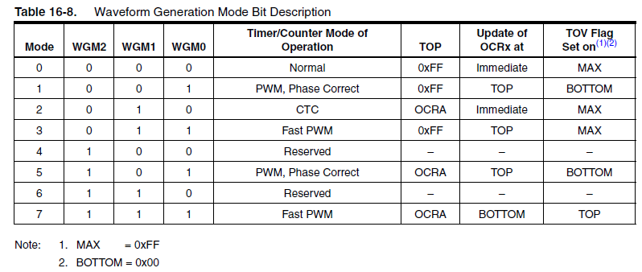

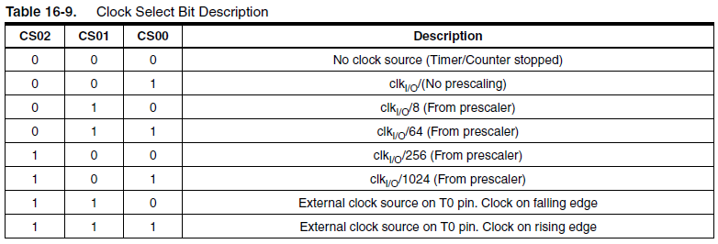

**TIMER0**

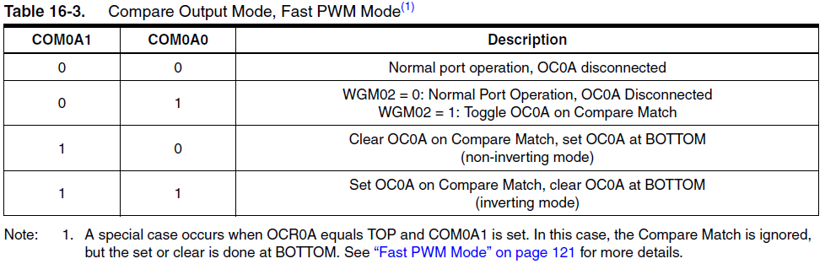

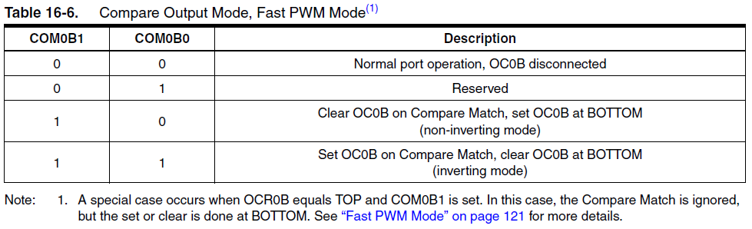

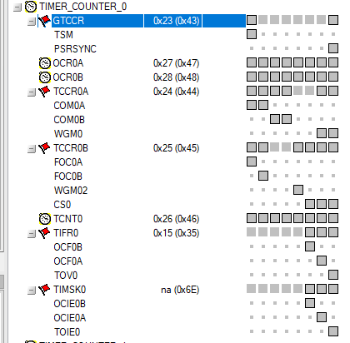

**TIMER1, 3, 4, and 5**

