CMPE 332 Project Part 1

Xinbo Chen 20004426

Zhen Meng 20002644

Jianan Lin 10180364

## Assumption

Assume all IDs are within 10 characters in length - Committee ID, Attendee ID, Job ID, Speech Session ID

Assume all room number are within 5 characters in length

Assume all first/last name are within 100 characters in length

Only one speaker for each conference session

Staff will not allow more than 3 people inside one hotel room

Student of all genders can sleep in the same hotel room

Parallel sessions cannot be hold at the same location

One member can only be chair for one committee, but can be a member of other committees

Assume all the functions for dealing parallel condition (eg: same name with different ID for attendee, same time with different location for conference schedule) works with future study in course.

## ER Schema

The ER Schema can be found as figure 1 shown.

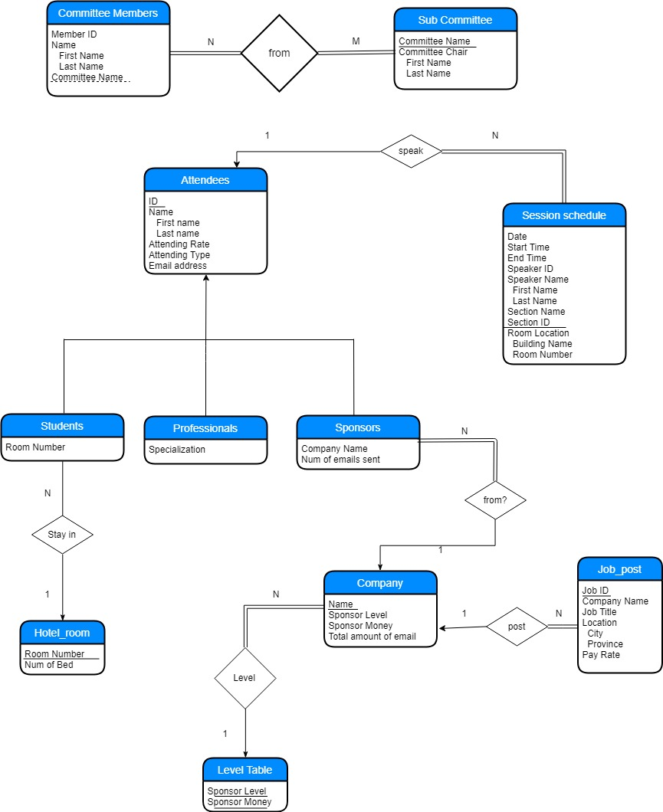

Figure : ER Schema

