Section 4.8.2: The **kwargs list examples

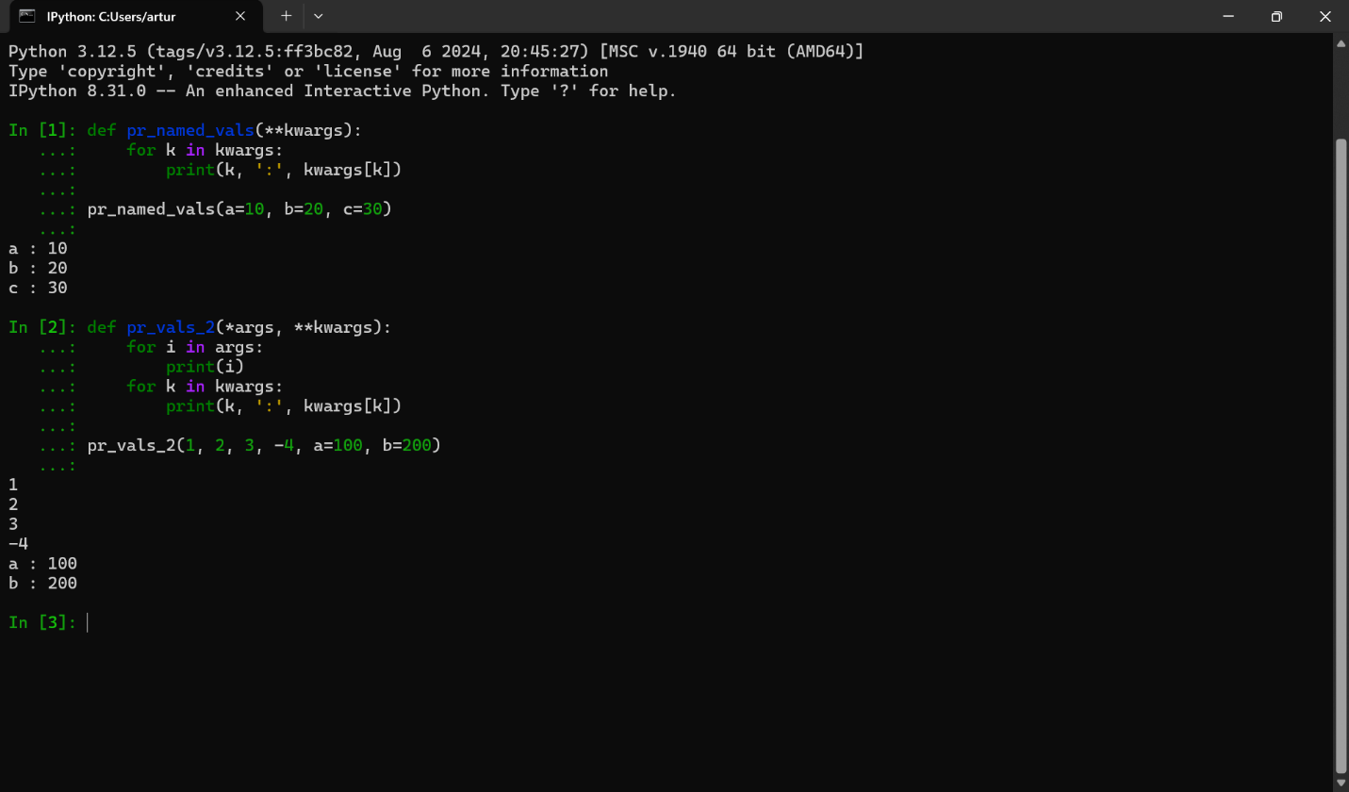

The advantage of using a **kwargs list is that it has a great amount of flexibility when it comes to function arguments. For instance, you don’t have to define a varying number of named arguments because the functions are allowed to accept them. Furthermore, the code is much more readable because named arguments provide context which makes function calls easier to understand. Lastly, the code is easier to maintain because it’s easier to update functions without editing the function signature.

The disadvantage of using a **kwargs list is that they don’t have auto completion which makes it annoying to use because there aren’t autocomplete suggestions and it doesn’t detect type errors for **kwargs. Furthermore, when you use **kwargs way too much it makes it hard for a function to know what arguments to expect. Lastly, **kwargs are just hard to debug with, because they gather multitudes of keyword arguments which can lead to errors.

**Numerated answers:**

Advantages

1. Very flexible
2. Good Readability
3. Easy to Maintain

Disadvantages

1. No auto completion
2. Hard to read if used too much
3. Hard to constantly debug with