# Modeling, estimating, and simulating: formalizing attitudes towards inequality as a complex network

## Abstract

## 1. Introduction

## 2. Theory

## 2.1 Attitudes towards inequality in the U.S.

### Definition

### Literature in the us

### But what is missing is a network approach + study of dynamics

## 2.2 A network approach to the study of attitudes towards inequality

### Few words on the latent variable model

### A network approach to attitudes

### CAN

### Better belief system

## 3. Method

## 3.1 Data and variables

Studying attitudes towards inequality with a holistic approach requires a wide variety of indicators. The ISSP 2019 – Social Inequality V module (ISSP Research Group, 2022) offers this possibility, as it includes questions concerning perceptions, beliefs, and judgments about inequality, taxation, and redistribution. This paper uses U.S. data, which are collected with a multistage probabilistic design and Computer Assisted Web Interface methodology. The sample is representative of the population aged 18 years or older. The original dataset includes 1852 individuals. After listwise deletion, we work with a subsample of 1,188 individuals for the network estimations and simulation. Additional analyses reveal missing cases do not impact meaningfully on the final sample. Figure 7 of the Supplement shows that variables generated between 2% (e.g.: *ineq_p*) and 11% (*ineq_j*) of missing cases. Thus, nonresponses were fairly distributed between the selected variables. Moreover, Table 3 of the Supplement shows that the means of the variables do not significantly differ between the original sample and the reduced one.

Following the operationalization proposed by (Janmaat, 2013), we account for the multidimensionality of attitudes towards inequality by measuring it through perceptions, beliefs, and judgments. Considering the close relationship between inequality, taxation, and redistribution, we use evaluative reactions in all three domains. Table 1 shows the selected variables and their corresponding ISSP question. We uniform the polarity of each variable to have high values indicating larger perceptions, egalitarian beliefs, and judgments of unfairness about existing levels of inequality. All variables are measured on a 1 to 5 scale, with the exceptions of ineq_j (1-4) and anger towards inequality (0-10).

### Describe perceptions

To cumulate with past research adopting a network approach to the study of attitudes towards inequality, the article includes twelve perceptions, seven beliefs, and three judgments about inequality in the U.S. (Franetovic & Bertero, 2023). Respondents were asked to report their perceptions of high-income inequality (*ineq_p*) and of tax regressivity (*reg_p*). The analyses include ten inequality beliefs (Mijs, 2018), which are items asking respondents to indicate how important they perceive a set of structural and individual factors to be for getting ahead in life (*family-sex*).

### Beliefs

Belief items ask respondents to express normative judgments on how they would desire society to be organized. The questionnaire included the belief in progressive taxation (*prog_b*), and in public and private redistribution (*redis_p, redis_m*). Moreover, one survey battery tapped into beliefs on just pay criteria, asking respondents to indicate whether they would agree on wages to be regulated based on the responsibility associated with the job (*resp*), or on workers’ training levels, needs, and merits (*train, merit, need*).

### Judgments

Finally, respondents judged the fairness of the existing income distribution in the U.S. (*ineq_j*), the political willingness to address inequality (*redis_d*), and the level with which governmental actions fought the issue (*redis_f*).

Table 1: labels and survey questions

|  |  |  |
| --- | --- | --- |
| **Label** | **Question** | **Type** |
| ineq_p | To what extent do you agree or disagree with the following statement: Differences in income in the U.S. are too large. * | Perception |
| reg_p | Generally, how would you describe taxes in the U.S. today for those with high incomes? | Perception |
| family | [How important is] coming from a wealthy family [for getting ahead in life?] * | Perception |
| edupar | […] having well-educated parents […] * | Perception |
| edu | […] having a good education yourself […] * | Perception |
| work | […] hard work […] * | Perception |
| people | […] knowing the right people […] * | Perception |
| connec | […] having political connections […] * | Perception |
| bribes | […] giving bribes […] * | Perception |
| race | […] a person’s race […] * | Perception |
| relig | […] a person’s religion […] * | Perception |
| sex | […] being born a man or a woman […] * | Perception |
| prog_b | Do you think people with high incomes should pay a larger share of their income in taxes than those with low incomes, the same share, or a smaller share? * | Belief |
| redis_p | It is the responsibility of the government to reduce the differences in income between people with high incomes and those with low incomes. * | Belief |
| redis_m | It is the responsibility of private companies to reduce the differences in pay between their employees with high pay and those with low pay. * | Belief |
| resp | [How important do you think that ought to be in deciding pay?] How much responsibility goes with the job * | Belief |
| train | […] The number of years spent in education and training. * | Belief |
| need | […] Whether the person has children to support. * | Belief |
| merit | […] How well he or she does the job. * | Belief |
| ineq_j | […] How fair or unfair do you think the income distribution is in the U.S.? | Judgment |
| redis_d | […] Most politicians in the U.S. do not care about reducing the differences in income between people with high incomes and people with low incomes. * | Judgment |
| redis_f | How successful do you think the government in the U.S. is nowadays in reducing the differences in income between people with high incomes and people with low incomes? | Judgment |

*Caption:* Squared brackets indicate common prompts between different items. The polarity of asterisked variables was inverted to have maximum values aligned with meritocratic beliefs, high perception, and critical judgments of existing inequality.

## 3.2 Network estimation

### The general process of estimation (from data to robustness)

Network estimation of multivariate data follows a multistage process (Borsboom et al., 2021). First, variables are selected on the grounds of a literature review. This ensures resulting models validly render the construct under scrutiny. Second, network estimation techniques are fitted to survey data. This step depends on the data type. This article applies Graphical Models, which encode the joint probability distribution of the selected variables in a weighted adjacency matrix. The matrix is then represented as a network that encodes conditional dependences with the presence of network edges, and conditional independences through their absence (Lauritzen, 1996). With cross-sectional data, network estimation results in an undirected network, which represents the aggregated correlational structure of attitudes towards inequality in the U.S. Third, the toolbox of network analysis is applied to the network, to describe its structural or local properties. As a final step, the stability of the model’s parameters is assessed with bootstrapping techniques (Efron, 1979). As Graphical Models differ in how they estimate model parameters, the remainder of this section details the estimation procedures adopted in this article, and details how hypotheses are tested.

### mgm estimation (here also small world and centrality)

To address H1 and H2, a Mixed Graphical Model (mgm) is estimated (Haslbeck & Waldorp, 2020). This model can accommodate variables measured on different scales and estimates the model’s parameters through a loop of node-wise regularized linear regressions. At the beginning of the analysis, variables are mean-centered and re-scaled to have one unit of standard deviation. Then, each variable is iteratively regressed on each other, while controlling for every other node of the model. To avoid multicollinearity issues and to increase the specificity of the model, mgm uses regularized regressions.

The regularization technique of choice is the l1-penalized regression (LASSO) (Tibshirani, 1996). Unlike linear regression, the goal of regularized regression is not to find the coefficients that minimize the sum of squared differences between the predicted values and the actual values of the target variable. In LASSO regularization, an additional penalty term is introduced. The tuning parameter lambda (λ) controls the amount of regularization applied. When λ is set to zero, LASSO regularization has no effect, and the model is mathematically equivalent to a linear regression. As λ increases, the penalty term becomes more significant, and it shrinks the coefficient estimates toward zero. Therefore, LASSO regularization induces sparsity in the coefficient estimates and thus, in the resulting network matrix. As λ increases, the LASSO penalty starts to force some coefficients to become exactly zero, effectively performing variable selection. This means that LASSO can identify and exclude irrelevant covariates from the regressions composing the model. The appropriate value of the tuning parameter is searched with a model selection approach and is found by minimizing the Extended Bayesian Information Criterion, an extension of the BIC (Schwarz, 1978) that penalizes with additional intensity nonzero parameters (Chen & Chen, 2008). This strategy was extensively validated in dedicated studies (Epskamp & Fried, 2018; Foygel & Drton, 2010; Haslbeck & Waldorp, 2020). This procedure allows to compute *node predictability*, which is the portion of its variance that is explained by the connections it has with other variables. Since all variables are modeled as continuous, R2 values are reported. Moreover, modeling the selected variables as continuous allows for the interpretation of edges as partial correlation coefficients (Burger et al., 2022).

After the mgm network estimation, H1 and H2 are tested. The small-worldness of the network is assessed through the statistical test proposed by Telesford and collegues (2011), which compares the clustering coefficient and the connectivity of the target network with those of a lattice network of the same size. The clustering coefficient of a network measures the extent to which its nodes form cliques, which are fully connected graphs (Watts & Strogatz, 1998). Connectivity is measured by the Average Shortest Path Length [ASPL], which is equal to the mean value of all minimum path lengths connecting each pair of network nodes. To cumulate with past research adopting this index, the clustering coefficient and the ASPL are calculated from the absolute and unweighted adjacency matrix. A network possesses small-world characteristics if its connectivity is greater than or equal to that of the simulated random network, and if the clustering coefficient of the former is greater than that of the latter. Formally, a network is said to be a small-world network if the test produces a value between −0.5 and 0.5. The centrality of network nodes is calculated with the strength metric (Opsahl et al., 2010). The strength score of a given node is obtained by summing all absolute values of the edge weight of the relationships in which it is involved. Although many metrics could have been computed, research suggests avoiding the application of other conventional centrality conceptualizations to Graphical Models of this kind. Indeed, the calculation of measures such as betweenness or closeness relies on assumptions that are often violated in a network where nodes do not have agency (Bringmann et al., 2019).

### Moderated ggm

The third research hypothesis investigates whether the network structure estimated on the full sample hides structural heterogeneities that are produced by different levels of anger towards inequality. A common approach for testing research questions involving group differences is to split the sample into low and high levels of self-reported anger, estimate two network models, and compare them with a Network Comparison Test (Borkulo et al., 2022). Alternatively, researchers have implemented the fused graphical lasso, which jointly estimates two network structures to investigate group differences in edge weights (Danaher et al., 2013). Both these procedures are impeded by two shortcomings. First, data-split approaches reduce sample size, and thus statistical leverage; second, these strategies can only model a step moderation process, where the relationship between a pair of variables is supposed to be constant within a group, and different between them. One way to resolve both obstacles is the adoption of a Moderated Network Model (MNM) (Haslbeck et al., 2021). This model estimates edge parameters with the same strategy outlined above, relying on a set of regularized linear regressions whose tuning parameter is obtained by minimizing the EBIC. However, in each of these regressions, the MNM models a moderation effect of a selected continuous variable. Thus, MNM outputs two sets of parameters, one corresponding to each pairwise interaction between network nodes, and one to each retrieved three-way interaction between node pairs and the moderator variable. To address H3, this article fits an MNM in which anger towards inequality is specified as a moderator. H3 is confirmed if anger meaningfully moderates network edges.

### Ising

To test H4, this article implements a network simulation, which requires a data reduction process where variables are dichotomized[1]. Network estimation of this data type follows the same procedure detailed in the above paragraphs, fitting a mgm where nodes are modeled as binary variables. However, linear regressions are replaced by logistic ones. Hence, the mgm reduces to an Ising model (Ising, 1925), whose edges are interpretable as logistic regression coefficients (Borkulo et al., 2015). The Ising model estimates two additional classes of parameters that are discussed in Section 3.3.

### bootstrap

Network analysis of multivariate data results in a parameter matrix. However, these values are only point estimates of the conditional associations of a dataset. To evaluate their robustness, it is necessary to perform bootstrapping techniques (Epskamp et al., 2018). Non-parametric bootstrap allows building bootstrapped confidence intervals around edge parameters. For each estimated network, 10000 samples are built by sampling individuals with replacement from the original one. Edges parameters are re-estimated in each sample, and their aggregation leads to bootstrapped confidence intervals, encapsulating the central 95% of the bootstrapped distribution. Results of this procedure are made available in Figures 2 and 4 of the Supplement. The same procedure is applied to check the robustness of the moderation effects of anger (Table 2 of the Supplement).

To inspect the stability of strength centrality metrics case-dropping bootstrap is implemented. Observations are gradually dropped from the sample and at each step centrality scores are calculated. This allows building the Correlation Stability [CS] coefficient. This metric represents the maximum percentage of cases that can be dropped from the original sample to preserve -with 95% probability- a correlation of 0.7 between the original centrality scores and those obtained in the smaller samples. Centrality estimates are stable if the CS coefficient is greater than 0.25 or, preferably, higher than 0.50. Finally, to directly compare two given edges or strength scores, bootstrapped difference tests are computed. Non-overlapping bootstrapped CIs are evidence of significant differences between point estimates (ibid.).

## 3.3 Network simulation

### More on the model

Given the paucity of temporal data on attitudes toward inequality, H4 is tested through a simulation of network dynamics. Following the CAN model (Dalege et al., 2016), the temporal development of the network of attitudes towards inequality is supposed to conform to the Ising model (Ising, 1925). Nodes can assume two states (-1; +1). Originally, these states represented the positive or negative spin of a magnet. In the attitude domain, they represent endorsement or rejection of each survey item. Three classes of parameters regulate the overall configuration of an attitude network. The *temperature* parameter governs the entropy of the system. This variable is held constant across all simulations, as it was observed to correlate with attitude strength (Dalege et al., 2018). Two other parameters are described by the Hamiltonian function, which estimates the amount of energy expenditure of a given network configuration:

Each network node (Xᵢ to Xⱼ) is associated with a *threshold* ( 𝛕ᵢ to 𝛕ⱼ) indicating its predisposition to be endorsed or not. Thresholds continuously range between -1 and +1. Positive values indicate that an item is likely to be endorsed (hence assuming the state +1), and vice versa (-1). Moreover, the *ω parameter* models the strength of the interaction between each pair of network nodes. Positive values indicate positive interactions and vice versa. Therefore, network configurations in which nodes characterized by positive [negative] thresholds are tied by positive [negative] edges reduce the level of energy expenditure. The Hamiltonian function encodes the central axiom of CAN by modeling the fact that attitude networks strive for low energy expenditure configurations, according to the need for cognitive consistency.

### Simulation

The simulation mocks a series of successful persuasion attempts targeting one network node at a time, and has been already applied to diverse socio-political attitudes (Dalege et al., 2017; Schlicht-Schmälzle et al., 2018). Manipulations are operationalized as an increase of nodes’ thresholds (𝛕). The dependent variable of this simulation is the sum score of all evaluative reactions[2], measured before and after each manipulation. H4 is confirmed if changes in central -rather than peripheral- nodes produce downstream effects. A downstream effect occurs when the state change of a given node reverberates into a state change of at least one other.

The simulation starts by creating 23 samples of 3000 individuals answering the 22 survey items in Table 1. Differences in the values of their responses are generated by differences set in the values of node thresholds. In the baseline condition, all nodes have a moderately negative threshold (-0.1). The other 22 samples are built by setting the threshold of one node at a time to a high value (+1), while all others maintain their moderately negative threshold (-0.1). For each of these subsamples, an attitude network is estimated, and the sum score is calculated. Finally, sum scores are compared to understand whether manipulation attempts of the same strength are associated with changes of different magnitudes in the global network structure.

## 4. Results

## 4.1 Modelling attitudes toward inequality as a network

### Brief description of the levels of these attitudes

Table 1 of the Supplement reports the descriptives of the 22 attitudes. Overall, U.S. citizens perceive high disparities in economic resources, state to believe in a more egalitarian distribution and judge existing inequalities as unfair. Indeed, respondents perceive income inequality as very high, perceive that the taxation system is too regressive (x̄*ineq_p =* 4.098[3];x̄*reg_p* =3.642), and that the main factors for getting ahead in life are under individuals’ control (the items *work* and *edu* scores the highest means among the inequality beliefs). The sample firmly believes in progressive taxation (x̄*prog_b =* 4.035), and thinks both private corporations and public actors should enact policies to reduce differences in income. Regarding pay allocation principles, respondents believe merit should be the most important factor determining the entity of wages (x̄*merit =* 4.327). Coherently, the Northern American public expresses critical judgments of existing inequalities and considers political actors disinterested (x̄*redis_d =* 3.997), and not capable of impacting them adequately (x̄*redis_f =* 3.982).

### Description of GGM

Figure 1: mgm network of attitudes towards inequality

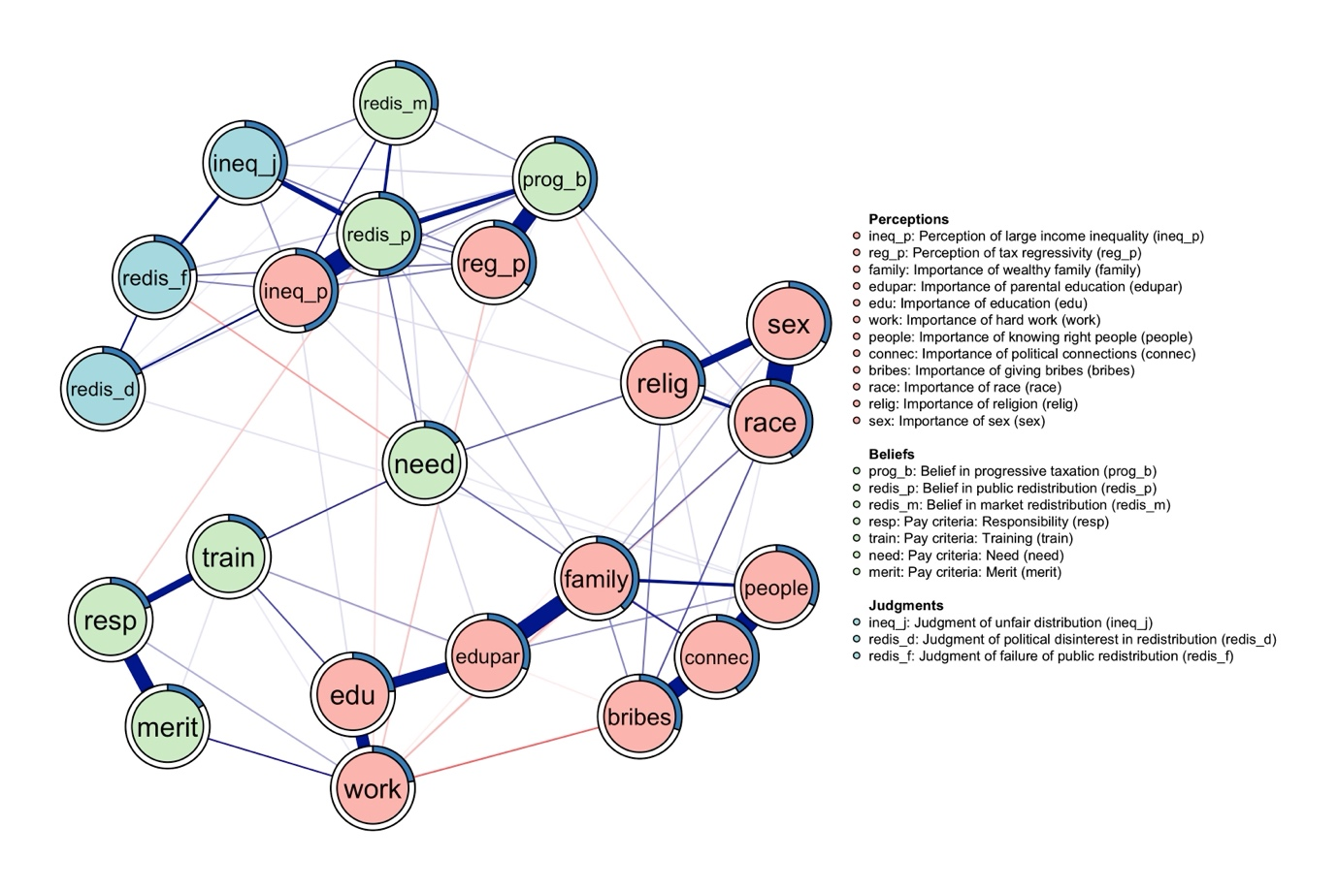

*Caption:* the network of attitudes towards inequality. Variables are represented as nodes, which are connected by weighted and signed edges. Nodes are colored according to their theoretical classification in perceptions, beliefs, and judgments about inequality. The circular shape around each node plots the partition of its variance that was explained by the model. Ties are indicative of the unique variance shared between each item pair. Their width is proportional to the strength of the corresponding associations. Blue edges represent positive linear influences, red negative ones.

Figure 1 shows the network of attitudes towards inequality in the U.S., as estimated by the mgm. Nodes represent the 22 perceptions, beliefs, and judgments, and are colored according to membership to these categories. Edges are indicative of the unique variance shared between each item pair and are interpretable as partial correlation coefficients. The network is visualized with a force-directed layout (Fruchterman & Reingold, 1991), with blue (red) weighted edges indicating positive (negative) associations, and circular shapes around each attitude displaying the portion of its explained variance. The network estimation shows that attitudes towards inequality are integrated into a single belief system in the U.S., as the network of attitudes is composed of a single component. This means U.S. citizens can organize their beliefs about income, taxation, and redistribution in a single mental structure. The strongest associations in the model are those between *race* and *sex*, *people* and *connec*, and *ineq_p* and *redis_p*. The strongest negative associations in the network are those between *work* and *bribes*, *redis_p* and *resp*, and between *family* and *work*. Indeed, there are strong and positive partial correlations between perceiving individuals’ race and sex (bootstrapped[4] x̄*race-sex* = 0.359; bootstrapped CI 0.302 – 0.423), and knowing the right people and having political connections (x̄*people-connec* = 0.331; CI: 0.287 - 0.387]) as important factors for determining personal success. In the same vein, those who hold critical perceptions of income inequality are more likely to believe in public redistribution (x̄*ineq_p-redis_p* = 0.331; CI: 0.287 – 0.387). Importantly, respondents seem at least partially able to differentiate between individualistic and structuralist explanations of inequality, as -on the one hand- they perceive either hard work or bribes (x̄*work-bribes* = -0.115; CI: -0.182; -0.058), or -on the other hand- hard work and coming from a wealthy family to be important sources of social and economic inequalities (x̄*work-family* = -0.047; CI: -0.092; -0.001). Moreover, believing in public redistribution increases the likelihood of rejecting a job’s responsibility as an acceptable pay criterion (x̄*redis_p-resp* = -0.051; CI: -0.094; -0.012). The description of these edges highlights two patterns that are found in the network of attitudes towards inequality.

First, most of the retrieved associations are positive in sign. Considering that U.S. citizens express on average critical levels of attitudes towards inequality, this first pattern entails that their negative perceptions, egalitarian beliefs, and severe judgments are also coherently organized structure-wise.

A second pattern lies in network nodes that are most likely to be strongly connected. Indeed, Figure 1 shows strong partial correlations are most likely to be found between variables tapping the same conceptual domain. This is evident when observing the strong and positive partial correlations between *resp* and *merit,* and between *resp* and *train* (e.g.: the pay criteria), and when considering the associations linking the ten inequality beliefs (variables from *family* to *sex* of Table 1, bottom right corner nodes in Figure 1).

However, some important exceptions are found concerning this second pattern. First, not all inequality beliefs correlate with the same intensity, underlining the fact that individuals do not hold them indiscriminately. On top of the negative associations discussed above (between *work* and *bribes*, and between *work* and *family*), is important to observe the segregation of the three strongest structural explanations of inequality (*relig, race,* and *sex*), which are much more likely to interact with themselves rather than with the other perceptions, beliefs, and judgments in the model. This entails that individuals endorsing one of these three perceptions are more likely to consider the other two factors as important sources of inequality, rather than believing in the relevance of individual characteristics such as hard work or personal education. Moreover, strong associations can also emerge across conceptual domains. This is the case of the aforementioned association between the perception of high-income inequality and the belief in public redistribution (*ineq_j-redis_p*), and also occurs for the positive association between the perception of tax regressivity and the belief in progressive taxation (x̄*reg_p-prog_b* = 0.281; CI: 0.224; 0.334). Finally, not all nodes whose survey questions are semantically similar, or belong to the same dimension of attitudes towards inequality vehemently correlate. For example, believing in a person’s need as a just pay criterion is largely unrelated to endorsing the meritocratic principle (x̄*need-merit* = -0.002; CI: -0.016; 0.016), or the responsibility one (x̄*need-resp* = -0.002; CI: -0.013; 0.013). Yet, Figure 1 shows that cross-dimension associations can be considerably strong, as for the case of the belief in public redistribution, which is strongly associated with both judgments (e.g.: *ineq_j*) and perceptions (e.g.: *ineq_p*).

Node predictability gives information on the extent to which the variance of a given variable is captured by the network model. The R2 scores vary greatly across nodes. Pay criteria show the lowest predictability (R2*need* = 0.159, R2*merit* = 0.164, R2*train* = 0.170, R2*resp* = 0.200). These variables are the least embedded in the network structure, and this means their levels are likely to be influenced by additional variables excluded from the model. Conversely, *ineq_p* and *redis_p* display the highest R2 (0.463 and 0.500 respectively). This result was anticipated by discussing the strong connections these nodes have with the others. Their high scores speak in favor of the validity of the variable selection procedure, as variables that are central to the literature on attitudes towards inequality are also well-described in the network model.

At a structural level, the network of attitudes towards inequality shows low density, as only 30.6% of possible network edges are retrieved by the network estimation procedure. When modeled as an unweighted network, ASPL scores 1.801, and the clustering coefficient is equal to 0.447. The estimated network has a higher ASPL and lower clustering coefficient than a simulated random network of the same size. As testified by the result of the small world test, H1 is confirmed, as the network is associated with a small world score of 0.228.

Figure 2: Node centrality

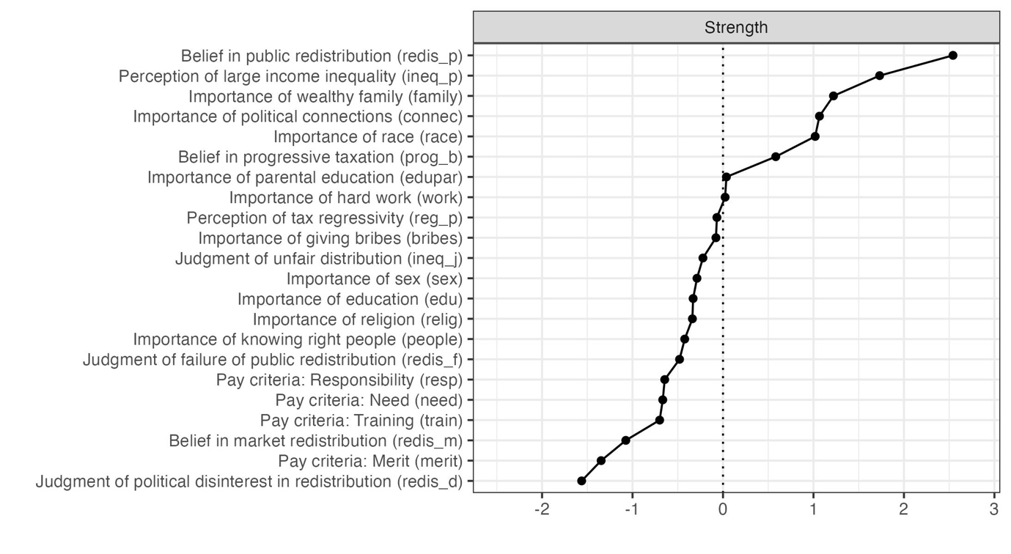

*Caption:* Strength centrality of GGM’s nodes. Each row shows one node and its centrality, measured in z-scores.

### Description of centrality

Centrality gives insight into nodes’ importance in the network. Figure 2 shows standardized strength centrality scores. Z-scores help compare this metric across the full-scale and Ising networks. Strength is a direct function of the magnitude of nodes’ connections. Thus, variables that are strongly and/or frequently connected to other nodes are associated with the highest scores. Raw values range between 0.506 and 1. 271 (for the nodes *redis_d* and *redis_p* respectively). The belief in public redistribution and the perception of large income inequality are the most central nodes in the estimated network (raw scores of 1.271 and 1.141 respectively) and across all bootstrapped samples (bootstrapped mean centrality scores of 1.146 and 1.278). Bootstrapped difference tests reveal their scores are not significantly different (CI*redis_p-ineq_p* = -0.06; 0.328), although *redis_p* is significantly more central than all other nodes (CIredis_p-family = -0.437;-0.123), and *ineq_p* is significantly more important than all nodes below *prog_b* in Figure 2 (CI*ineq_p-prog_b* = -0.407;-0.049). Moreover, centrality estimates are remarkably stable, as the CS coefficient scores 0.75. This means dropping as much as 75% of cases from the original sample would preserve a correlation of 0.7 between the original centrality scores and those obtained in the reduced sample. Given the results of the point estimates of strength centrality, and considering their excellent stability, H2 is confirmed. Moreover, Figure 2 negatively highlights the four pay criteria and the belief in market redistribution. This is consistent with what was discussed above, as the nodes *resp*, *need*, *train*, and *merit* have weak connections in the network, and their R2 are very low. However, the case of the node *redis_m* is interesting. The levels of attitudes towards market redistribution (x̄*redis_m* = 3.641) are higher than those of public redistribution (x̄*redis_p* = 3.272). However, the former is peripheral to the network -being loosely connected to other nodes and weakly captured by the model- whereas the latter is the most central node, and strongly interacts with the other perceptions, beliefs, and judgments about inequality.

## 4.2 Estimating structural differences in the network of attitudes towards inequality

Figure 3: Moderated Network Model of the network of attitudes towards inequality

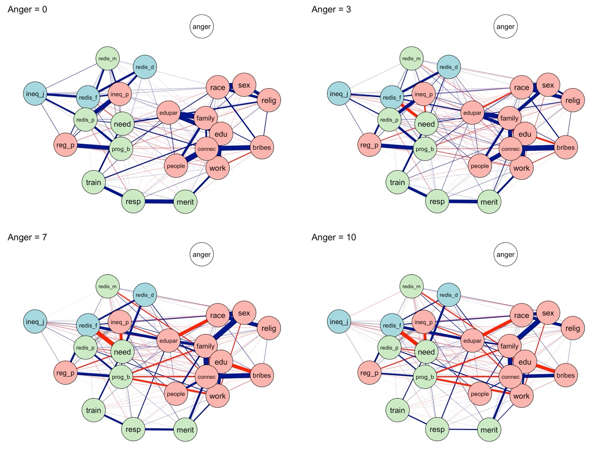

*Caption:* each panel shows the result of a GGM estimation at a fixed level of the moderating variable, anger. Nodes are colored according to their classification in perceptions, beliefs, and judgments. Anger is plotted in white for clarity. Weighted and signed edges indicate conditional associations. Moderation effects are detectable by observing variations in edge color and/or width.

Figure 1 assumes attitudes towards inequality are organized in the same way in all population strata. However, cognitive variables such as anger towards inequality might produce different attitudinal configurations. To test H3, a MNM is fitter to ISSP data, and anger is specified to intervene on all network edges. Results are visualized in Figure 3. The figure is organized in four panels, each of these representing the result of a network estimation performed at a fixed level of anger towards inequality. Networks’ layouts are determined by averaging the force-directed layouts of each panel. Anger is represented as a disconnected and white node to highlight it is part of the model, as the MNM checks whether it moderates all network edges. The magnitude of moderation effects is reported in Table 2 of the Supplement, which also shows the proportion of time a given effect is found across the bootstrapped samples. Overall, H3 is confirmed, as more than 25 network edges are strongly moderated by anger towards inequality. Results are robust to bootstrapping techniques, as these effects are retrieved in more than 0.83 of the derived samples.

The strongest moderation effect is equal to 0.064 and involves the pairwise relationship between *redis_f* and *redis_p.* This triadic relationship can be interpreted as in standard regression analysis, with the exception that dependent and independent variables can be inverted. When anger equals zero, an increase of a unit of *redis_p* produces an increase of 0.025 unit of *redis_f*, and vice versa. As the moderation effect is positive, the higher is anger towards inequality, the stronger the relationship between *redis_p* and *redis_f*. When anger scores 3 (top right panel of Figure 2) the relationship grows to 0.217. In the other two panels of the figure, the edge *redis_p* *- redis_f* increases in magnitude (ω = 0.473 and 0.665). This moderation means that anger towards inequality makes the association between the belief in public redistribution and the judgment on its failure stronger. Note that this association was null in the model (ω = 0). The exploration of three ways interactions shows this relationship is instead very strong, but only for individuals who are angry towards inequality.

Other strong moderation effects regard the relationships between the inequality beliefs *family* and *sex*, *family* and *connec, edupar* and *race,* and *edu* and *bribes*, (M = 0.06, 0.06, -0.5, and -0.05 respectively). Two patterns emerge. On the one hand, increasing levels of anger are associated with reduced boundaries between the endorsement of individualistic and structuralistic explanations of inequality. When anger equals zero, perceiving a wealthy family as an important factor for getting ahead in life increases the likelihood of considering personal sex as important, and vice versa (ω*family-sex* = 0.065). When anger equals ten, an increase of one unit in the belief of the importance of a rich family increases the belief in the importance of personal sex of 0.475 units. In the same fashion -when anger is zero- perceiving the importance of a wealthy family is weakly related to believing in the importance of having good connections (ω*family-connec* = 0.145). However, for those who report the maximum levels of anger, this relationship became stronger (ω*family-connec* = 0.465).

On the other hand, the relationships between other inequality beliefs are negatively moderated by anger, meaning that the endorsement of structuralist explanations reduces the likelihood of believing in individualistic ones, and vice versa. In the mgm of Figure 1, the perceptions of the importance of good parental education and personal race are not associated (ω*edupar-race* = 0). However, when anger equals ten, an increase of one unit on the item *edupar* is associated with a decrease of 0.300 of the variable *race*, and vice versa. Similarly, the perceptions of the importance of personal education and giving bribes are weakly and negatively associated when anger is low (ω*edu-bribes* = -0.018) and became strongly opposed when anger scores its maximum (ω*edu-bribes* -0.418).

Another strong moderation effect regards *edu* and *redis_m*. When anger is zero, believing in the importance of personal education is weakly predictive of the belief in market redistribution (ω = 0.009). This relationship is much stronger when anger equals ten (ω*edu-redis_m* = 0.269). Note that this moderation entails that nodes’ importance in the network can change dramatically when considering the role of the cognitive variable. For individuals who do not experience anger towards inequality, the belief is market redistribution is a peripheral variable (see Figure 2), whose variance is only marginally captured by the model (Figure 1). However, when individuals feel angry, the belief in market distribution interacts more firmly with the other nodes, becoming more central in the network of perceptions, beliefs, and judgments about inequality.

Finally, some moderation effects also involve pay criteria. For example, an increase of one point in the perception of high-income inequality increases the belief in merit as a just allocation principle of only 0.010 units, when anger is equal to zero. A variation of the same entity of *ineq_p* would produce an increase in *merit*’s levels of 0.043, 0.087, and 0.120 units when anger scores 3, 7, and 10.

**Something on density and signes**

The description of these moderation effects introduces two important findings relative to the structure of the network of attitudes towards inequality. When anger is low, the estimated networks show lower mean edge absolute values and a low number of negative associations. For example, when anger towards inequality scores 0 and 3, the networks of attitudes have mean absolute edge weights of 0.061 and 0.068, and only 46 and 59 associations are negative in sign. When anger scores 7 and 10, the mean absolute edge weight is 0.101 and 0.127, and the number of negative edges grows to 62 and 63. Thus, an increased level of anger produces tighter associations in the belief system and prompts individuals to organize their perceptions, beliefs, and judgments in a potentially conflictual way.

## 4.3 Simulating change in the network of attitudes towards inequality

Since attitudes have different importance in the network, it is important to verify if attitude change follows the pattern stated by H4. To do so, full-scale variables are dichotomized, and an Ising simulation is performed on ISSP data. Table 1 of the Supplement shows descriptives of the dummy variables. Figure 4 plots the resulting network (top panel) and the strength centrality of each node (bottom one).

Figure 4: Ising network and centrality table

*Caption:* The top panel shows the results of the Ising estimation. The bottom panel shows z-scores of Strength centrality.

Contrary to Figure 1 and Figure 2, the edges of Figure 4 represent regularized logistic regression coefficients obtained by regressing each item onto each other node, while controlling for all other variables in the model. The layout of the network replicates that of Figure 1, to improve the comparability between the full and reduced-scale network estimation. The Ising network has a similar density to the full-scale one (density = 0.32). Moreover, the strongest edges of Figure 1 remain the most important in the Ising model. Indeed, the strongest associations in the networks are those between *race* and *sex*, *reg_p* and *prog_b*, *connec* and *bribes*, and *ineq_p* and *redis_p*. As a consequence strength centrality estimates are consistent between the two types of network estimation. The bottom panel of Figure 4 shows *ineq_p*, *race*, and *redis_p* are the most central nodes, whereas pay criteria and *redis_m* are the most peripheral ones. Figure 1 in the Supplement compares the standardized centrality scores that each node totalizes in the two models. The plot confirms the ranking is subject to marginal variations only, with the position of the node redis_p being the most important exception (the most important node in the full-scale network, the third in the Ising one). As for the mgm network, the point estimates of the strength scores of the most important nodes of the Ising network do not statistically differ. Indeed, the nodes *ineq_p*, *race*, *redis_p,* and *family* have raw centrality scores of 5.819, 5.131,

4.473, and 4.076 respectively, and bootstrapped tests reveal overlapping CIs for many of these differences[5]. Yet, *ineq_p* and *redis_p* are clearly more central than the majority of other nodes. The score of the former significantly differs from all nodes below *family* in the centrality table of Figure 4[6]; the score of the latter is statistically different from those of nodes below *connec*[7]. The CS coefficient is remarkably high also for these estimates (0.75). Finally, the small world test is applied to the Ising network to ensure the robustness of the result discussed above. The test outputs a small world score of 0.223, in line with the score of the full-scale network. Overall, these results confirm *ineq_p* and *redis_b* as two of the most important nodes in the network, which display small-world characteristics, irrespective of modeling strategies.

Figure 5: results of simulated manipulation attempts

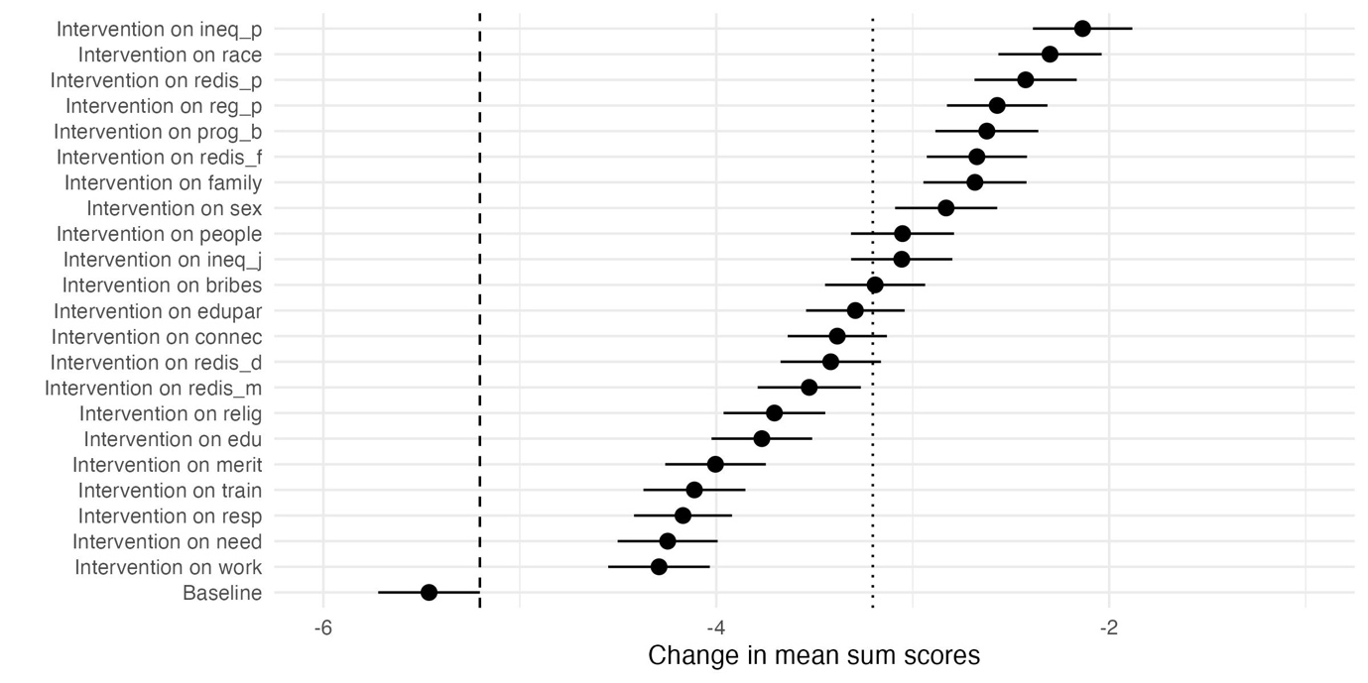

*Caption:* each row is associated with a simulated manipulation attempt targetting one network node. Dots and confidence intervals show the mean sum score of the network after each intervention. The dashed line on the left separates successful versus unsuccessful manipulations. The dotted line on the right represents the threshold for downstream effects.

To test H4, simulated manipulation attempts are implemented. Manipulation attempts are modeled as an increased value of the threshold of the targeted node (from 𝛕 = -0.1 to 𝛕 = +1), while keeping the others fixed at a moderately negative value (𝛕 = -0.1). Note that according to the Hamiltionian function, reported in the method section, the change in the threshold value of a given node is not automatically reflected in the change of its state. Indeed, nodes are embedded in the network of attitudes, and their state is also dependent on the ω parameter. This means that changing 𝛕 from -0.1 to 𝛕 = +1 only increases the probability that a given node will assume the state +1. However, this is a probabilistic prediction rather than a mechanical one. For example, a node with 𝛕 = +1 could become negatively linked with other nodes, and this can in turn exercise pressure on it to remain in the negative state.

Results are shown in the forest plot of Figure 5. When all thresholds are set to a moderately negative value (𝛕 = -0.1), the network sumscore is -5.462 (CI: -5.721; -5.203). This synthetic index represents a moderately negative configuration of attitudes towards inequality, as the dependent variable of the simulation ranges between -22 (all items are rejected) to 22 (all items are endorsed). The reference line on the left of Figure 4 discerns between successful and unsuccessful manipulation attempts. All dots have confidence intervals on the right of the dashed reference line, meaning each simulated manipulation induced a significant change of the network sumscore. The dotted reference line of Figure 4 helps detect downstream effects, as it is positioned 2 units on the right of the former. Nodes whose confidence interval is on the right of the line produced downstream effects, as their manipulation produced their state change, and also induced wider readaptation processes in the network of attitudes towards inequality. The manipulation of eight nodes produced sumscores’ changes that are bigger than two units. These nodes are *ineq_p* (x̄ = -2.135; CI: -2.388; -1.882), *race* (x̄ = -2.301; CI: -2.564; -2.038), *redis_p* (x̄ = -2.425; CI: -2.685; -2.165), *reg_p* (x̄ = -2.570; CI: -2.826; -2.314), *prog_b* (x̄ = -2.623; CI: -2.884; -2.360), and *redis_f* (x̄ = -2.673; CI: -2.928; -2.418). These nodes include *ineq_p* and *redis_p*, confirming H4. A comparison between Figure 5 and the centrality table of Figure 4 reveals that strength centrality and entity of sumscore’ change are highly correlated. Indeed, nodes whose manipulation produces downstream effects cover the highest position in the centrality table. The only exception to this pattern is the node *redis_f*, which has medium strength centrality, but still produces huge variations in the network when targeted. Importantly, the simulation shows that regardless of how important and embedded a node is in the network of attitudes, its state change is not strong enough to produce drastic variation in network sumscores. Indeed, across all manipulations, the synthetic index representing the overall levels of attitudes towards inequality remains negative in sign.

## 5. Discussion

## 6. Conclusions

## 7. References

Borkulo, C. D. van, Bork, R. van, Boschloo, L., Kossakowski, J. J., Tio, P., Schoevers, R. A., Borsboom, D., & Waldorp, L. J. (2022). Comparing network structures on three aspects: A permutation test. *Psychological Methods*. https://doi.org/10.1037/met0000476

Borkulo, C. D. van, Borsboom, D., Epskamp, S., Blanken, T. F., Boschloo, L., Schoevers, R. A., & Waldorp, L. J. (2015). A new method for constructing networks from binary data. *Scientific Reports*, *4*(1), 5918. https://doi.org/10.1038/srep05918

Borsboom, D., Deserno, M. K., Rhemtulla, M., Epskamp, S., Fried, E. I., McNally, R. J., Robinaugh, D. J., Perugini, M., Dalege, J., Costantini, G., Isvoranu, A.-M., Wysocki, A. C., Borkulo, C. D. van, Bork, R. van, & Waldorp, L. J. (2021). Network analysis of multivariate data in psychological science. *Nature Reviews Methods Primers*, *1*(1), 58. https://doi.org/10.1038/s43586-021-00055-w

Bringmann, L. F., Elmer, T., Epskamp, S., Krause, R. W., Schoch, D., Wichers, M., Wigman, J. T. W., & Snippe, E. (2019). What do centrality measures measure in psychological networks? *Journal of Abnormal Psychology*, *128*(8), 892–903. https://doi.org/10.1037/abn0000446

Burger, J., Isvoranu, A.-M., Lunansky, G., Haslbeck, J. M. B., Epskamp, S., Hoekstra, R. H. A., Fried, E. I., Borsboom, D., & Blanken, T. F. (2022). Reporting Standards for Psychological Network Analyses in Cross-Sectional Data. *Psychological Methods*. https://doi.org/10.1037/met0000471

Chen, J., & Chen, Z. (2008). Extended Bayesian information criteria for model selection with large model spaces. *Biometrika*, *95*(3), 759–771. https://doi.org/10.1093/biomet/asn034

Dalege, J., Borsboom, D., Harreveld, F. van, Berg, H. van den, Conner, M., & Maas, H. L. J. van der. (2016). Toward a formalized account of attitudes: The Causal Attitude Network (CAN) model. *Psychological Review*, *123*(1), 2–22. https://doi.org/10.1037/a0039802

Dalege, J., Borsboom, D., Harreveld, F. van, & Maas, H. L. J. van der. (2017). Network Analysis on Attitudes: A Brief Tutorial. *Social Psychological and Personality Science*, *8*(5), 528–537. https://doi.org/10.1177/1948550617709827

Dalege, J., Borsboom, D., van Harreveld, F., & van der Maas, H. L. J. (2018). The Attitudinal Entropy (AE) Framework as a General Theory of Individual Attitudes. *Psychological Inquiry*, *29*(4), 175–193. https://doi.org/10.1080/1047840X.2018.1537246

Danaher, P., Wang, P., & Witten, D. M. (2013). The Joint Graphical Lasso for Inverse Covariance Estimation Across Multiple Classes. *Journal of the Royal Statistical Society Series B: Statistical Methodology*, *76*(2), 373–397. https://doi.org/10.1111/rssb.12033

Efron, B. (1979). Bootstrap Methods: Another Look at the Jackknife. *The Annals of Statistics*, *7*(1). https://doi.org/10.1214/aos/1176344552

Epskamp, S., Borsboom, D., & Fried, E. I. (2018). Estimating psychological networks and their accuracy: A tutorial paper. *Behavior Research Methods*, *50*(1), 195–212. https://doi.org/10.3758/s13428-017-0862-1

Epskamp, S., & Fried, E. I. (2018). A Tutorial on Regularized Partial Correlation Networks. *Psychological Methods*, *23*(4), 617–634. https://doi.org/10.1037/met0000167

Foygel, R., & Drton, M. (2010). Extended Bayesian Information Criteria for Gaussian Graphical Models. In J. Lafferty, C. Williams, J. Shawe-Taylor, R. Zemel, & A. Culotta (Eds.), *Advances in Neural Information Processing Systems* (Vol. 23). Curran Associates, Inc. https://proceedings.neurips.cc/paper_files/paper/2010/file/072b030ba126b2f4b2374f342be9ed44-Paper.pdf

Franetovic, G., & Bertero, A. (2023). How do people understand inequality in Chile? A study through attitude network analysis. *AWARI*, *4*. https://doi.org/10.47909/awari.42

Fruchterman, T. M. J., & Reingold, E. M. (1991). Graph drawing by force‐directed placement. *Software: Practice and Experience*, *21*(11), 1129–1164. https://doi.org/10.1002/spe.4380211102

Haslbeck, J. M. B., Borsboom, D., & Waldorp, L. J. (2021). Moderated Network Models. *Multivariate Behavioral Research*, *56*(2), 256–287. https://doi.org/10.1080/00273171.2019.1677207

Haslbeck, J. M. B., & Waldorp, L. J. (2020). mgm: Estimating Time-Varying Mixed Graphical Models in High-Dimensional Data. *Journal of Statistical Software*, *93*(8). https://doi.org/10.18637/jss.v093.i08

Ising, E. (1925). Beitrag zur Theorie des Ferromagnetismus. *Zeitschrift für Physik*, *31*(1), 253–258. https://doi.org/10.1007/BF02980577

ISSP Research Group. (2022). *International Social Survey Programme: Social Inequality V - ISSP 2019*. https://doi.org/10.4232/1.14009

Janmaat, J. G. (2013). Subjective Inequality: A Review of International Comparative Studies on People’s Views about Inequality. *European Journal of Sociology*, *54*(3), 357–389. https://doi.org/10.1017/s0003975613000209

Lauritzen, S. L. (1996). *Graphical models* (Vol. 17). Clarendon Press.

Mijs, J. J. B. (2018). Inequality Is a Problem of Inference: How People Solve the Social Puzzle of Unequal Outcomes. *Societies*, *8*(3), 64. https://doi.org/10.3390/soc8030064

Opsahl, T., Agneessens, F., & Skvoretz, J. (2010). Node centrality in weighted networks: Generalizing degree and shortest paths. *Social Networks*, *32*(3), 245–251. https://doi.org/10.1016/j.socnet.2010.03.006

Schlicht-Schmälzle, R., Chykina, V., & Schmälzle, R. (2018). An attitude network analysis of post-national citizenship identities. *PLoS ONE*, *13*(12), e0208241. https://doi.org/10.1371/journal.pone.0208241

Schwarz, G. (1978). Estimating the Dimension of a Model. *The Annals of Statistics*, *6*(2), 461–464. https://doi.org/10.1214/aos/1176344136

Telesford, Q. K., Joyce, K. E., Hayasaka, S., Burdette, J. H., & Laurienti, P. J. (2011). The Ubiquity of Small-World Networks. *Brain Connectivity*, *1*(5), 367–375. https://doi.org/10.1089/brain.2011.0038

Tibshirani, R. (1996). Regression Shrinkage and Selection Via the Lasso. *Journal of the Royal Statistical Society: Series B (Methodological)*, *58*(1), 267–288. https://doi.org/10.1111/j.2517-6161.1996.tb02080.x

Watts, D. J., & Strogatz, S. H. (1998). Collective dynamics of ‘small-world’ networks. *Nature*, *393*(6684), 440–442. https://doi.org/10.1038/30918

1. Variables were truncated considering their mean values. Descriptives are made available in Table 2 of the Supplement. Additional analyses confirmed dichotomization of all nodes following different criterias (truncation at two, or at three out of five points) does not impact on the estimated network.
2. That is, the sum of the values of the state of all nodes (either -1 or +1). Hence, the sum scores range between -22 (all evaluative reactions are not endorsed) and +22 (every item is endorsed).
3. In the remainder of the article, network nodes are mentioned in italics.
4. Since network estimation is followed by bootstrap analyses, the magnitude of network edges can be described by the mean value of the parameters scored across all bootstrapped samples. Reference to the point estimates of the parameters are indicated with ω*.* 
5. CI*ineq_p-race* = -1.835; 1.121. CIineq_p-redis_p = -2.102; 1.072. CIredis_p-race = -1.142; 1.552; CIredis_p-family = -2.157; 0.32.
6. CIineq_p-family = -2.938; -0.055.
7. CIredis_p -connec = -2.583; -0.146.