**Figure 1.** BUF Rapid Dissemination Model System Design

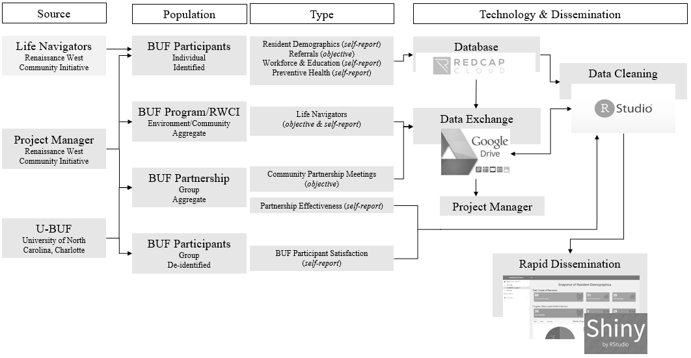

**Figure 2.** BUF Trends System Design

