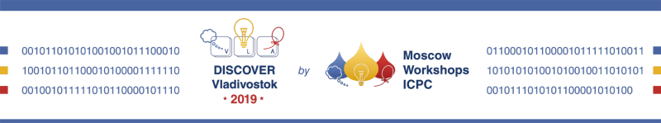

MIPT Vice-Rector,
Moscow Workshops ICPC founder
Alexey Maleev
May 21, 2019

Prof. Dr. habil. biol.
Indriķis Muižnieks

Rectorate
Raiņa bulvāris 19,
room 274,
Riga, LV–1586
Tel.: (+371) 67034300
Email: indrikis.muiznieks@lu.lv

Dear Dr. Muižnieks,
We would like to invite your university team composed of ffsfdfdfdfd gfgfg qwerty, gfgfgfg fgf last_name_2, first_name_3 gfgfg fgfgfg, coach coach_firstname gfgfgf fgf to participate in programming workshop Discover Vladivostok 2019 by Moscow Workshops ICPC. The Workshops is organized by Moscow Workshops ICPC (LTD “Russian Code School”) and the Far East Federal University.
Dates: July 6-13, 2019
Location: the City of Vladivostok, Russia
Website: https://discover.it-edu.com/vladivostok/en
The registration fee varies from 520 to 790 USD per person
depending on the date of payment
Discover Vladivostok 2019 Workshop is a 7-days training program designed for the best students in the field of computer science to prove they are the best of the kind or/and to improve their skills. 11 of 12 team-medalists and 51 universities out of 135 that participated in ICPC World Finals 2019 in Porto had attended educational and training programs organized by Moscow Workshops ICPC.
The International Collegiate Programming Contest (ICPC) is the biggest annual multi-tiered programming competition among the universities of the World. It covers 6 continents, 115 countries, 3 233 universities and is known to be the Olympic Games of competitive programming. The International Collegiate Programming Contest is the leading global platform for academic and industrial partners and a universal professional community. It attracts attention to IT industry opportunities and shows possibilities for coming IT Professionals generation which is aimed at perfection.
The official language of the workshop is English. The workshop’s program consists of daily contests, problem analysis, lectures and upsolving. Sport and cultural activities will be organized in the evenings and on the leisure day. The participants will learn from the best coaches which are the former medalists and medalists' coaches from the previous ICPC seasons.
For additional information please contact the Moscow Workshops ICPC team (call +7(929)978-75-55, email to workshops@it-edu.com).

Moscow Workshops ICPC founder, ICPC World Finals 2020 Director | Aleksey Maleev

