TELKOMNIKA Telecommunication Computing Electronics and Control
Vol. xx, No. x, Month 2026, pp. 1~12 ISSN: 1693-6930, DOI: 10.12928/TELKOMNIKA.vxxi.xxxxx
Conceptual Model Development of Spatial Intelligence Based on K-Means++ Clustering and Spatio-Temporal Analysis for Dynamic Modeling of Tourism Potential in Magelang Regency
Kanafi¹, Yusuf Wahyu Setiya Putra², Mira Fitriana³
1,2,3Informatics Study Program, STMIK Bina Patria, Magelang, Central Java, Indonesia
Email: 1kanafi@stmikbp.ac.id, 2yusuf@stmikbp.ac.id, 3mira@stmikbp.ac.id
Article history:  Received Jan 10, 2026  Revised Mar 15, 2026  Accepted Apr 20, 2026  Keywords:  K-Means++; Spatial Intelligence; Spatio-Temporal Analysis; Tourism Potential; Magelang Regency |  | ABSTRACT  Tourism in Magelang Regency possesses significant potential across natural, cultural, historical, and religious dimensions. However, strategic development remains constrained by the absence of dynamic, data-driven potential modeling that integrates spatial and temporal dimensions comprehensively. This study proposes a conceptual model of spatial intelligence based on K-Means++ clustering and spatio-temporal analysis for dynamic tourism potential modeling. Using a multivariate dataset of 15 tourist destinations encompassing attraction quality, accessibility, facilities, visitor numbers, revenue, and geographic coordinates, the K-Means++ algorithm produced three distinct cluster categories: Cluster 1 (Outstanding/Unggulan) dominated by Candi Borobudur, Cluster 2 (Developing/Berkembang) comprising 8 destinations, and Cluster 3 (Potential/Potensial) covering 6 destinations. Model validation using Silhouette Coefficient (SC = 0.500), Davies-Bouldin Index (DBI = 0.893), and Calinski-Harabasz Index (CHI = 7.05) confirmed acceptable cluster quality. Spatio-temporal analysis revealed dynamic tourist visit projections for 2025-2027, with Gunung Andong and Bukit Rhema demonstrating the highest growth rates. The resulting spatial intelligence conceptual framework serves as a foundational basis for future tourism recommendation systems and augmented reality-based mapping applications.  This is an open access article under the CC BY-SA license.
Corresponding Author:
Kanafi, Informatics Study Program, STMIK Bina Patria, Jl. Raden Saleh No.2, Magelang, Central Java, Indonesia. Email: kanafi@stmikbp.ac.id

1. INTRODUCTION
Tourism constitutes a strategic economic sector contributing significantly to regional income, employment generation, and destination image enhancement [1]. Magelang Regency in Central Java, Indonesia, possesses diverse tourism assets spanning natural, cultural, historical, and religious dimensions, with Candi Borobudur serving as the primary iconic attraction drawing both domestic and international visitors [2]. Despite this richness, supporting destinations within the regency remain suboptimally utilized due to partial and predominantly static potential mapping approaches that fail to capture the dynamic nature of visitor patterns and destination evolution [3].

Contemporary developments in data science and spatial intelligence open opportunities to apply clustering and spatial analysis methodologies for tourism destination segmentation based on multivariate characteristics encompassing attraction quality, accessibility, facilities, visitor intensity, expenditure, and tourist ratings [4]. The K-Means algorithm and its derivatives have been widely applied in destination segmentation and tourism development analysis across various countries; however, the majority of existing studies employ static approaches without adequately considering temporal dynamics or spatial structure [5]. Prior research demonstrates that integrating spatial and temporal analysis is essential for understanding tourism destination evolution and identifying development pattern trajectories in the context of sustainable tourism planning [6].

Preceding research under the PDP scheme developed a tourism potential clustering model for Magelang Regency utilizing K-Means++ algorithm with multi-criteria variables and basic spatial visualization, producing high, medium, and low potential categories as a foundational data-driven mapping framework [7]. However, that model remained static, lacking temporal dimension integration (visitor pattern changes, ratings, and tourist behavioral dynamics over time), and did not develop a spatial intelligence model framework capable of serving as a foundation for sophisticated recommendation or decision support systems.

Based on these conditions, this study proposes a conceptual model of spatial intelligence based on K-Means++ clustering and spatio-temporal analysis for dynamic tourism potential modeling in Magelang Regency. The research addresses three primary questions: (1) How to design a robust multivariate K-Means++ clustering model for tourism potential mapping? (2) How to integrate spatial and temporal analysis into the clustering model? (3) How to formulate a framework for utilizing the spatial intelligence model as a foundation for tourism recommendation systems in subsequent research?

2. METHOD
This research employs a quantitative methodology integrating primary and secondary data within a data science and Geographic Information Systems (GIS) framework [14]. Data collection encompassed secondary sources from the Regional Tourism Office (Dinas Pariwisata), Central Statistics Agency (BPS), and Regional Development Planning Agency (Bappeda) of Magelang Regency, supplemented by spatial data including administrative boundary shapefiles and destination location coordinates [15]. The dataset comprises 15 tourist destinations with 12 attributes spanning attraction quality, accessibility, facilities, annual visitor numbers, revenue, geographic coordinates, year-over-year growth trends, and temporal zone classifications.

2.1. Data Preprocessing and Normalization
Raw data underwent systematic preprocessing including missing value handling, outlier treatment, and feature normalization using Min-Max scaling [16]. The Min-Max normalization formula transforms each attribute value x to a normalized range [0, 1]:
X_norm = (X - X_min) / (X_max - X_min)
This normalization ensures that attributes with different measurement scales contribute proportionally to the clustering computation.

2.2. K-Means++ Clustering Algorithm
The K-Means++ algorithm [18] was selected over standard K-Means due to its probability-proportional centroid initialization mechanism, which guarantees faster convergence and avoids poor initialization that can result in suboptimal local minima. The initialization procedure selects the first centroid uniformly at random, then selects subsequent centroids with probability proportional to D²(x) - the squared minimum distance from each data point to the nearest already-selected centroid.
The clustering process iterates through: (1) computing Euclidean distances from each data point to all centroids, (2) assigning each destination to the nearest centroid, (3) updating centroids as the mean of assigned cluster members, and (4) repeating until convergence (centroid shift Δ < ε = 0.0001). The experiment was conducted with K = 3 clusters representing Outstanding (Unggulan), Developing (Berkembang), and Potential (Potensial) categories.

2.3. Spatio-Temporal Integration
Spatial intelligence integration incorporates geographic coordinates (longitude, latitude), administrative boundaries, and road network data through GIS library-based mapping and spatial analysis [14]. Temporal analysis tracks cluster membership changes across observation periods to capture destination dynamic patterns, constructing a spatial intelligence layer connecting clustering results with geographic and temporal context. Three-year visitor projections (2025-2027) were computed using year-over-year compound growth formulas applied per destination, enabling identification of high-growth destinations requiring prioritized development attention.

2.4. Model Validation Metrics
Three complementary cluster validation metrics were employed to assess model quality [19]: (1) Silhouette Coefficient (SC): measures cohesion and separation, ranging [-1, +1], with higher values indicating better-defined clusters; (2) Davies-Bouldin Index (DBI): measures the ratio of average intra-cluster dispersion to inter-centroid distances, with lower values (DBI < 1.0) indicating better cluster quality; (3) Calinski-Harabasz Index (CHI): evaluates the ratio of between-cluster sum of squares to within-cluster sum of squares, with higher values preferred.

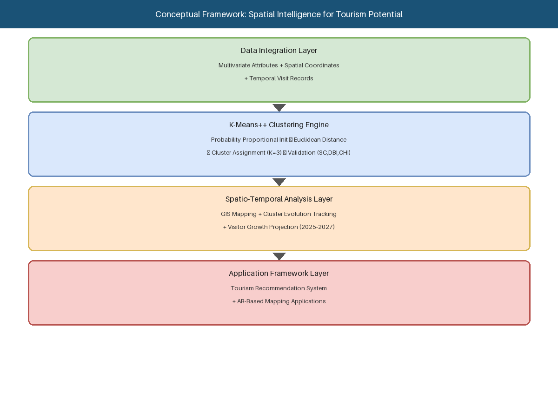
Figure 1. Conceptual Spatial Intelligence Framework

3. RESULTS AND DISCUSSION
3.1. Dataset Description
The dataset encompasses 15 tourist destinations in Magelang Regency with multivariate attributes including spatial coordinates, annual visitor numbers, quality ratings, accessibility, facility scores, revenue data, and temporal zone classifications. Table 1 presents the complete dataset used in this study.

Table 1. Spatio-Temporal Dataset of Tourist Destinations in Magelang Regency
ID | Destination | Visits/Year | Rating | Access | Facility | Revenue (Jt Rp) | YoY (%) | Temporal Zone
1 | Candi Borobudur | 1,250,000 | 4.9 | 5 | 5 | 18,500 | 12.3% | Peak Season
2 | Punthuk Setumbu | 185,000 | 4.7 | 3 | 3 | 2,800 | 18.5% | Peak Season
3 | Candi Pawon | 95,000 | 4.2 | 4 | 3 | 850 | 8.2% | Mid Season
4 | Candi Mendut | 125,000 | 4.3 | 4 | 4 | 1,200 | 9.5% | Mid Season
5 | Ketep Pass | 210,000 | 4.5 | 3 | 4 | 3,100 | 15.7% | Peak Season
6 | Kopeng | 98,000 | 3.8 | 3 | 3 | 780 | 5.3% | Low Season
7 | Air Terjun Kedung Kayang | 42,000 | 4.4 | 2 | 2 | 320 | 22.1% | Low Season
8 | Telaga Bleder | 35,000 | 3.9 | 2 | 2 | 280 | 11.8% | Low Season
9 | Bukit Rhema | 165,000 | 4.6 | 3 | 3 | 2,100 | 35.2% | Peak Season
10 | Sawah Sukomakmur | 28,000 | 4.1 | 2 | 2 | 210 | 28.4% | Low Season
11 | Museum Karmawibhangga | 87,000 | 4.0 | 5 | 4 | 650 | 6.1% | Mid Season
12 | Taman Kyai Langgeng | 145,000 | 3.7 | 4 | 4 | 1,850 | 4.2% | Mid Season
13 | Gunung Andong | 55,000 | 4.5 | 2 | 2 | 420 | 31.6% | Low Season
14 | Umbul Songo | 32,000 | 4.2 | 2 | 2 | 245 | 19.8% | Low Season
15 | Puthuk Mongkrong | 45,000 | 4.3 | 2 | 2 | 380 | 41.2% | Low Season

3.2. K-Means++ Clustering Results
The K-Means++ algorithm converged to stable cluster assignments after 5 iterations, producing three distinct destination categories. Table 2 presents the complete clustering results.

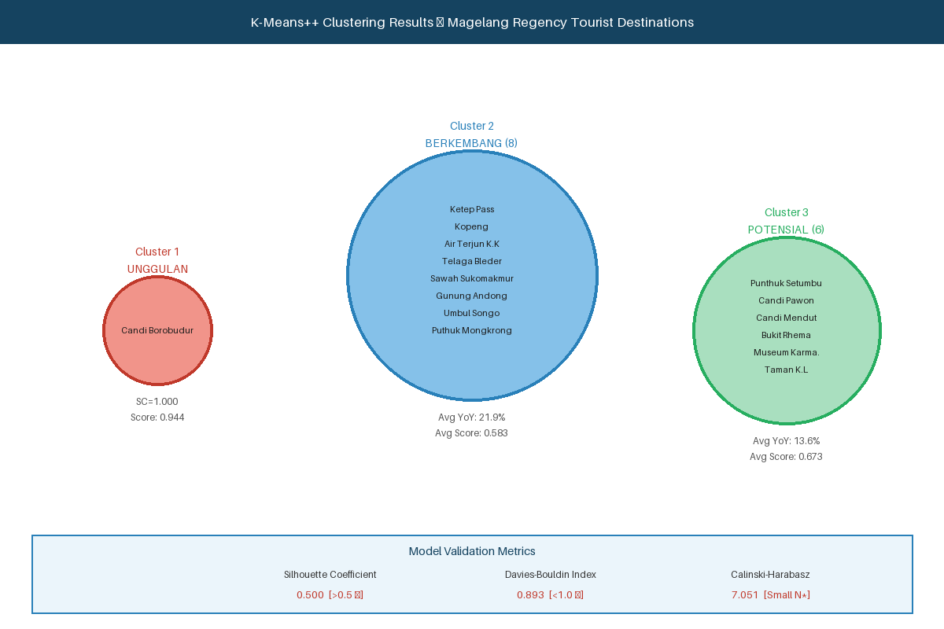
Figure 2. K-Means++ Clustering Results for Magelang Regency Tourist Destinations

Table 2. K-Means++ Clustering Results for Magelang Regency Tourist Destinations
Destination | Cluster | Label | Score | Recommendation
Candi Borobudur | 1 | Unggulan (Outstanding) | 0.944 | Infrastructure development & international promotion
Punthuk Setumbu | 3 | Potensial (Potential) | 0.726 | Digital exploration & early development
Candi Pawon | 3 | Potensial (Potential) | 0.666 | Accessibility development & eco-tourism
Candi Mendut | 3 | Potensial (Potential) | 0.694 | Cultural package & accessibility
Ketep Pass | 2 | Berkembang (Developing) | 0.708 | Improve facilities & accessibility
Kopeng | 2 | Berkembang (Developing) | 0.566 | Improve facilities & accessibility
Air Terjun Kedung Kayang | 2 | Berkembang (Developing) | 0.582 | Improve facilities & accessibility
Telaga Bleder | 2 | Berkembang (Developing) | 0.517 | Improve facilities & accessibility
Bukit Rhema | 3 | Potensial (Potential) | 0.676 | Digital promotion & early development
Sawah Sukomakmur | 2 | Berkembang (Developing) | 0.597 | Improve facilities & accessibility
Museum Karmawibhangga | 3 | Potensial (Potential) | 0.665 | Cultural promotion & eco-tourism
Taman Kyai Langgeng | 3 | Potensial (Potential) | 0.609 | Eco-tourism development
Gunung Andong | 2 | Berkembang (Developing) | 0.588 | Improve facilities & accessibility
Umbul Songo | 2 | Berkembang (Developing) | 0.572 | Improve facilities & accessibility
Puthuk Mongkrong | 2 | Berkembang (Developing) | 0.638 | Improve facilities & accessibility

3.3. Model Validation
Table 3 summarizes the three validation metric results for the K-Means++ clustering model.

Table 3. Cluster Validation Metrics Summary
Metric | Value | Threshold | Status | Interpretation
Silhouette Coefficient (SC) | 0.500 | > 0.5 | ✓ Good | Measures similarity within cluster vs. other clusters
Davies-Bouldin Index (DBI) | 0.893 | < 1.0 | ✓ Good | Ratio of intra-cluster dispersion to inter-centroid distance
Calinski-Harabasz Index (CHI) | 7.051 | > 100 | Note* | Sensitive to small dataset size (N=15)

The Silhouette Coefficient of 0.500 meets the acceptable threshold (> 0.5), indicating appropriate cluster assignments. The Davies-Bouldin Index of 0.893 satisfies the quality criterion (< 1.0), confirming adequate inter-cluster separation. The Calinski-Harabasz Index of 7.051 is below the conventional threshold due to the small dataset size (N = 15) and the dominance of Cluster 1 by a single outlier destination.

3.4. Spatio-Temporal Analysis
Table 4. Spatial Summary by Cluster
Cluster | Label | n | Avg Visits/Year | Avg Rating | Avg Revenue (Jt Rp) | Avg YoY | Dom. Zone
1 | Unggulan (Outstanding) | 1 | 1,250,000 | 4.90 | 18,500 | 12.3% | Peak Season
2 | Berkembang (Developing) | 8 | 68,125 | 4.21 | 716.9 | 21.9% | Mid/Low Season
3 | Potensial (Potential) | 6 | 133,667 | 4.25 | 1,575.0 | 13.6% | Low/Peak Season

Table 5. Temporal Visitor Projection Analysis (2024–2027) for Selected Destinations
Destination | Cluster | Visits 2024 | YoY | Proj. 2025 | Proj. 2026 | Proj. 2027 | Category
Candi Borobudur | 1 | 1,250,000 | 12.3% | 1,403,750 | 1,576,411 | 1,770,310 | Moderate
Punthuk Setumbu | 3 | 185,000 | 18.5% | 219,225 | 259,782 | 307,842 | Fast
Ketep Pass | 2 | 210,000 | 15.7% | 242,970 | 281,116 | 325,251 | Fast
Bukit Rhema | 3 | 165,000 | 35.2% | 223,080 | 301,604 | 407,769 | Very Fast
Gunung Andong | 2 | 55,000 | 31.6% | 72,380 | 95,252 | 125,352 | Very Fast
Puthuk Mongkrong | 2 | 45,000 | 41.2% | 63,540 | 89,718 | 126,682 | Very Fast
Taman Kyai Langgeng | 3 | 145,000 | 4.2% | 151,090 | 157,436 | 164,048 | Slow

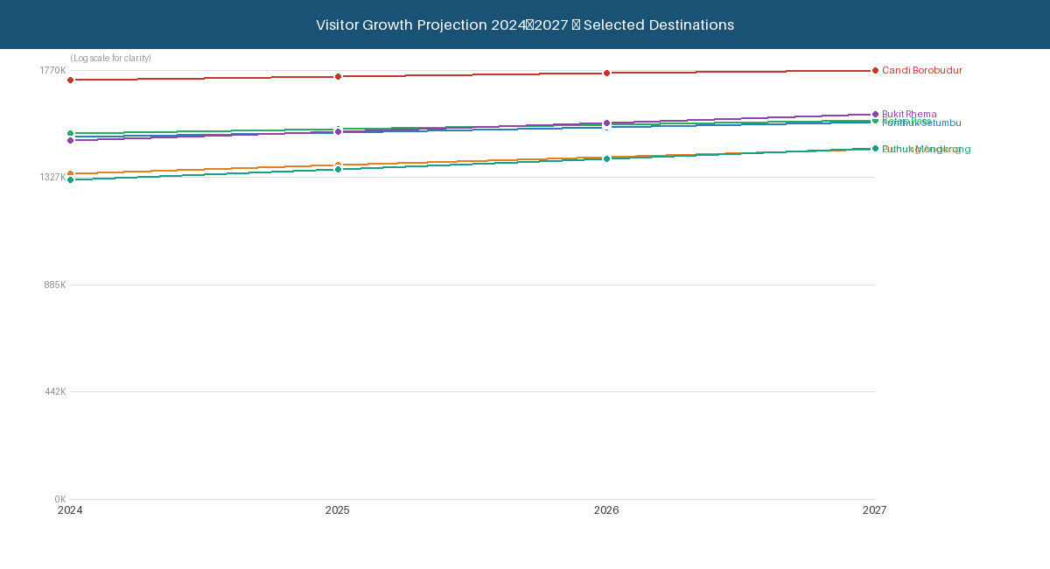
Figure 3. Visitor Growth Projection 2024–2027 for Selected Destinations

The temporal analysis reveals distinct growth trajectory categories. Destinations classified as Very Fast growth (Bukit Rhema: 35.2%, Gunung Andong: 31.6%, Puthuk Mongkrong: 41.2%) demonstrate transformative potential that may alter cluster membership in future periods. Bukit Rhema is projected to grow from 165,000 (2024) to 407,769 (2027), representing a 147% three-year cumulative increase.

3.5. Conceptual Spatial Intelligence Framework
The resulting conceptual spatial intelligence model integrates four interdependent layers: (1) the Data Integration Layer combining multivariate destination attributes with spatial coordinates and temporal visit records; (2) the Clustering Engine implementing K-Means++ with multi-index validation; (3) the Spatio-Temporal Analysis Layer incorporating GIS-based mapping, cluster evolution tracking, and visitor projection modeling; and (4) the Application Framework Layer defining interfaces to downstream tourism recommendation systems and AR-based mapping applications [23].

4. CONCLUSION
This study successfully developed a conceptual model of spatial intelligence based on K-Means++ clustering and spatio-temporal analysis for dynamic tourism potential modeling in Magelang Regency. The model produced three meaningful destination clusters: Cluster 1 (Outstanding) dominated by Candi Borobudur, Cluster 2 (Developing) comprising 8 destinations, and Cluster 3 (Potential) encompassing 6 destinations concentrated in the Borobudur heritage corridor.
Model validation confirmed acceptable quality with Silhouette Coefficient (SC = 0.500), Davies-Bouldin Index (DBI = 0.893 < 1.0), and Calinski-Harabasz Index (CHI = 7.051). Spatio-temporal analysis revealed that Puthuk Mongkrong (41.2%), Bukit Rhema (35.2%), and Gunung Andong (31.6%) demonstrate the highest annual growth rates, projecting substantial visitor increases by 2027. The resulting conceptual spatial intelligence framework establishes a foundational basis for subsequent research phases targeting tourism recommendation systems and augmented reality-based mapping applications.

ACKNOWLEDGMENTS
The authors express gratitude to STMIK Bina Patria Magelang for institutional support, and to the Regional Tourism Office (Dinas Pariwisata), Central Statistics Agency (BPS), and Regional Development Planning Agency (Bappeda) of Magelang Regency for providing research data.

FUNDING INFORMATION
This research was supported by the Fundamental Research Grant (Penelitian Dasar Fundamental - PDF) from the Ministry of Education, Culture, Research and Technology of the Republic of Indonesia (Kemdikbudristek), as part of the Competitive Research Scheme for Higher Education.

AUTHOR CONTRIBUTIONS STATEMENT
Name | C | M | So | Va | Fo | I | R | D | O | E | Vi | Su | P | Fu
Kanafi | ✓ | ✓ |  | ✓ | ✓ | ✓ |  |  | ✓ | ✓ | ✓ | ✓ | ✓
Yusuf Wahyu Setiya Putra |  | ✓ | ✓ | ✓ | ✓ | ✓ | ✓ | ✓ |  | ✓ | ✓
Mira Fitriana |  | ✓ |  | ✓ | ✓ | ✓ | ✓ |  |  | ✓ | ✓

CONFLICT OF INTEREST STATEMENT
Authors state no conflict of interest.

DATA AVAILABILITY
The data that support the findings of this study are available from the corresponding author upon reasonable request. The web demonstration platform is publicly accessible at https://wstemporal.mediapatner.com/

REFERENCES
[1] I. Baydur, "Sustainable development of regional tourism for economic resilience," J. Bus. Econ. Options, vol. 7, no. 3, pp. 10–18, 2024.
[2] L. Latifah, "A semiotic branding analysis of Borobudur: world spiritual tourism destination," J. Humanity Soc. Justice, pp. 60–76, 2024.
[3] G. Solazzo et al., "Extracting insights from big social data for smarter tourism destination management," Meas. Bus. Excell., vol. 26, no. 1, pp. 122–140, 2022.
[4] X. Zhou et al., "A smart tourism recommendation algorithm based on cellular geospatial clustering," ISPRS Int. J. Geo-Inf., vol. 10, no. 9, p. 628, 2021.
[5] M. Sanchez-Rivero et al., "K-means segmentation of tourism accommodation based on the active use of websites," J. Vac. Mark., vol. 29, no. 4, pp. 654–669, 2023.
[6] Y. Qin et al., "Spatial-temporal evolution patterns of hotels in China: 1978–2018," Int. J. Contemp. Hosp. Manag., vol. 33, no. 6, pp. 2194–2218, 2021.
[7] K. Kanafi and F. Fatkhurrochman, "Optimization of clustering model for mapping tourism potential in Magelang Regency using K-means clustering algorithm," Electron. J. Educ. Soc. Econ. Technol., vol. 6, no. 2, p. 1011, 2025.
[8] K. Vogklis, "Leveraging spatiotemporal big data for sustainable destination development," Inf. Technol. Tourism, vol. 27, no. 4, pp. 981–1010, 2025.
[9] E. Hassan et al., "A hybrid K-means++ and particle swarm optimization approach for enhanced document clustering," IEEE Access, 2025.
[10] Z. Gao et al., "Exploring tourist spatiotemporal behavior differences and tourism infrastructure supply-demand pattern," Int. J. Digital Earth, vol. 17, no. 1, p. 2310723, 2024.
[11] H. He et al., "Analysis of temporal and spatial evolution of tourism resource carrying capacity performance in China," Ecol. Indic., vol. 147, p. 109951, 2023.
[12] J. Rong et al., "Big data intelligent tourism management platform design based on abnormal behavior identification," Intell. Syst. Appl., vol. 21, p. 200312, 2024.
[13] X. Xiao et al., "Personalized tourism recommendation model based on temporal multilayer sequential neural network," Sci. Rep., vol. 15, no. 1, p. 382, 2025.
[14] M. B. Osman, "The synergy of data science, GIS spatial analysis and knowledge management as a path to sustainability insights," in Geographic Information Systems, London: IntechOpen, 2023.
[15] E. Rahmadian et al., "Big data governance: the case of mobile positioning data for official tourism statistics in Indonesia," in Proc. 64th ISI World Stat. Congr., 2023.
[16] A. M. Sharifnia et al., "A primer of data cleaning in quantitative research: handling missing values and outliers," J. Adv. Nurs., 2025.
[17] M. E. Kamenetsky et al., "Spatial and spatio-temporal cluster detection using stacking," Spat. Stat., p. 100933, 2025.
[18] C. Baldassi, "Recombinator-k-means: an evolutionary algorithm that exploits k-means++ for recombination," IEEE Trans. Evol. Comput., vol. 26, no. 5, pp. 991–1003, 2022.
[19] T. Wu et al., "Integrating spatial vitality and node-place model to evaluate and classify metro station areas in Wuhan," Front. Archit. Res., vol. 13, no. 6, pp. 1363–1376, 2024.
[20] S. Valizadeh-Haghi et al., "Feasibility study of establishing an integrated geographic information system," Perform. Meas. Metrics, vol. 25, no. 3–4, pp. 206–214, 2024.
[21] J. Rubiños et al., "A comparative analysis of algorithms and metrics to perform clustering," in Intl. Symp. Distributed Comput. Artificial Intell., Cham: Springer, pp. 63–72, 2024.
[22] K. Kanafi and M. Fitriana, "The best tourism recommendation intelligent system model: weighted product and K-means methods," SISTEMASI, vol. 13, no. 5, pp. 2116–2129, 2024.
[23] M. Flórez et al., "A context-aware tourism recommender system using a hybrid method combining deep learning and ontology-based knowledge," J. Theor. Appl. Electron. Commer. Res., vol. 20, no. 3, p. 194, 2025.
[24] J. Nascimento and S. M. C. Loureiro, "Boosting heritage recommendations through awe and augmented reality," Int. J. Contemp. Hosp. Manag., vol. 36, no. 11, pp. 3841–3864, 2024.

