1.启动grafana路径/home/ccit/monitor/grafana/bin
nohup ./grafana server --config ./config.ini &
2.启动prometheus和data-export-docker和node-exporter

1）路径/home/ccit/monitor/prometheus
nohup ./prometheus --config.file=prometheus.yml &
2）docker run -d name node-exporter -p 9010:9100 --restart=always -h "Master1 服务器" -v "/proc:c:/host/proc:ro" -v "/sys:/host/sys:ro"
-v "/:/rootfs:ro" prom/node-exporter

3）
data_export启动：
拷贝证书
cp -r /home/ccit/webase-deploy/nodes/cert/* ./config/
配置连接数据库
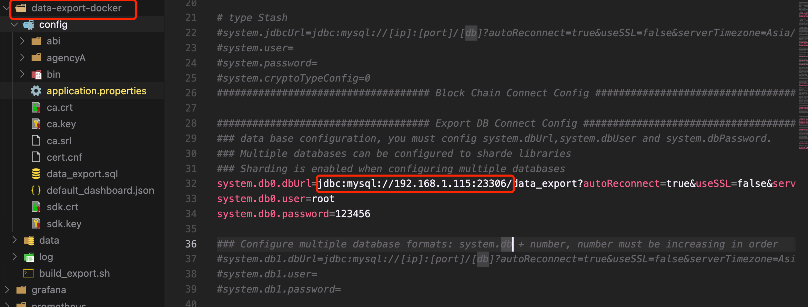

启动 bash build_export.sh

- 配置数据源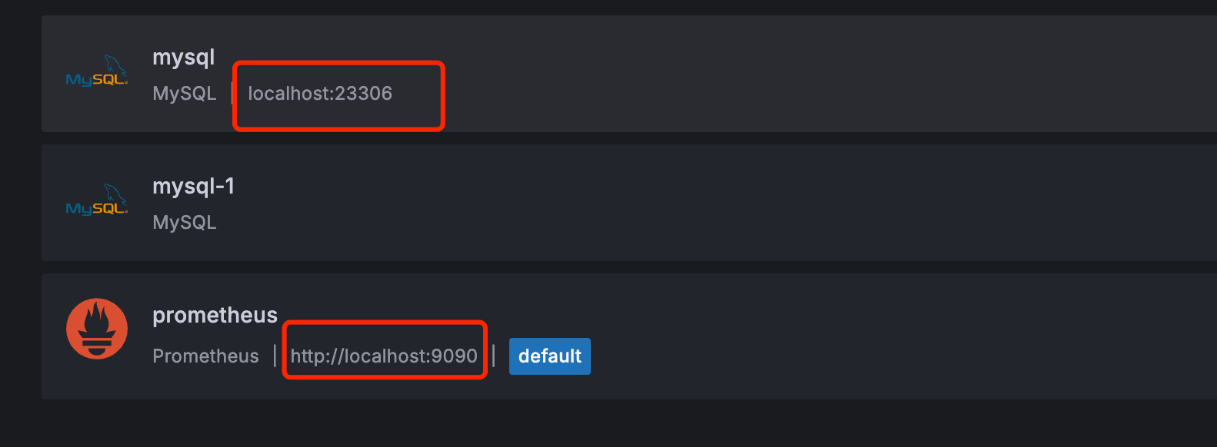

- 倒入json
