**Title:**  Deoxycholic acid, a gut microbiota product, produces a hypertensive and tachycardiac response in rats.

**INTRAVENOUS ADMINISTRATION**

**Figure S1**

Changes in hemodynamic parameters in Sprague-Dawley rats after the intravenous administration (IV) of either a vehicle (0.9% NaCl) or sodium deoxycholate (DOC) at doses of 4, 12, and 36 mmol/kg   
**a)** mean arterial blood pressure (ΔMABP, mmHg); **\***p<0.05 vs. baseline, **%** p<0.05: 4 mmol/kg DOC series vs. the vehicle, **$**p<0.05: 12 mmol/kg DOC series vs. the vehicle, &p<0.05: 12 mmol/kg vs. 4 mmol/kg DOC series, #p<0.05: 36 mmol/kg DOC series vs. 4, 12 DOC series and the vehicle.   
**b)** heart rate (ΔHR, beats/min); **\***p<0.05 vs. baseline, **%** p<0.05: 4 mmol/kg vs. 12 and 36 mmol/kg DOC series and the vehicle, &p<0.05: 12 mmol/kg vs. 4 mmol/kg DOC series and the vehicle, **$**p<0.05: 36 mmol/kg DOC series vs. the vehicle #p<0.05: 36 mmol/kg DOC series vs. 4, 12 mmol/kg DOC series and the vehicle **c) and d)** ΔMABP and ΔMHR after the intravenous infusions of sodium deoxycholate (DOC) at a dose of 36 mmol/kg (DOC), or DY 268 (DY), or glycyrrhetic acid (GA) or the vehicle (CTRL), or DOC after pretreatment with either DY 268 or glycyrrhetic acid (DOC+DY, DOC+GA). **\***p<0.05 vs. baseline. Means ± SE are presented

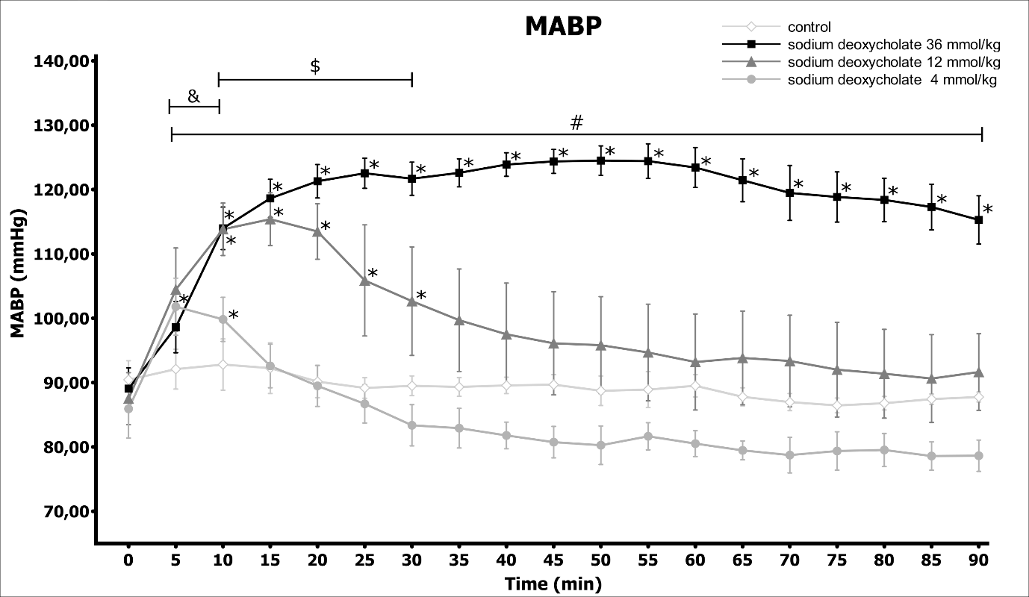

**Figure S2**

Mean arterial blood pressure (MABP) in Sprague-Dawley rats after the intravenous administration (IV) of either a vehicle (0.9% NaCl) or sodium deoxycholate (DOC) at doses of 4, 12, and 36 mmol/kg; **\***p<0.05 vs. baseline, **%** p<0.05: 4 mmol/kg DOC series vs. the vehicle, **$**p<0.05: 12 mmol/kg DOC series vs. the vehicle, &p<0.05: 4 mmol/kg DOC series vs. vehicle. Means ± SE are presented

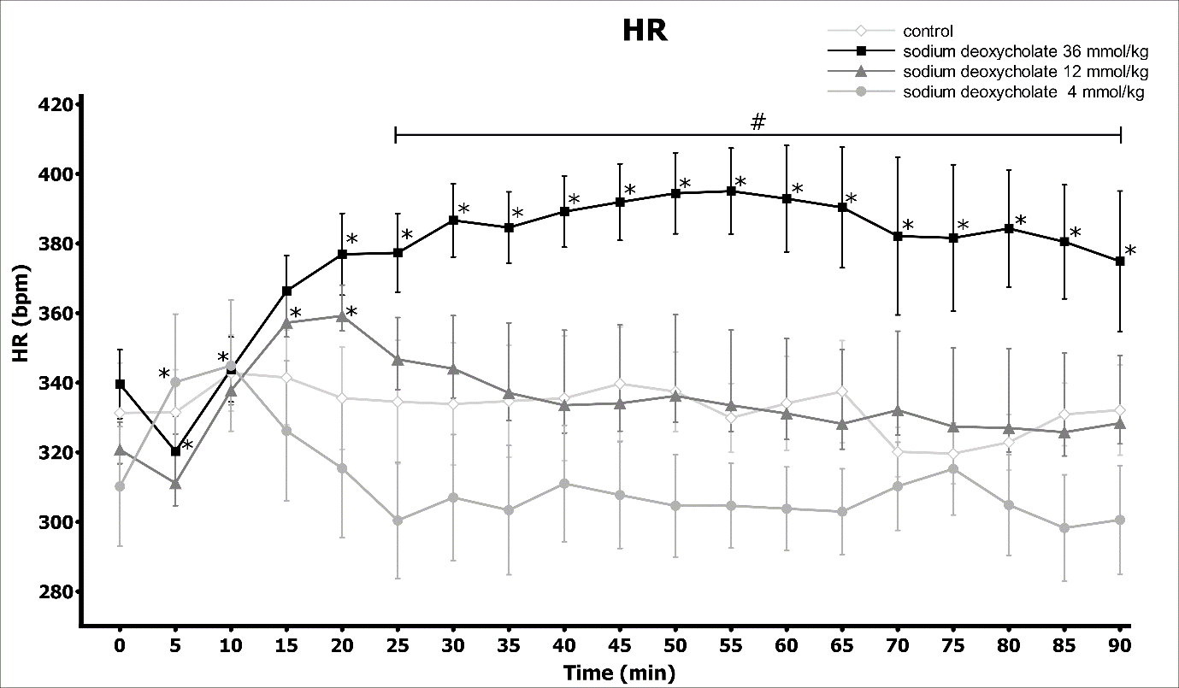

**Figure S3**

Mean heart rate (HR) in Sprague-Dawley rats after the intravenous administration (IV) of either a vehicle (0.9% NaCl) or sodium deoxycholate (DOC) at doses of 4, 12, and 36 mmol/kg; **\***p<0.05 vs. baseline, #p<0.05: 36 mmol/kg DOC vs. the vehicle. Means ± SE are presented

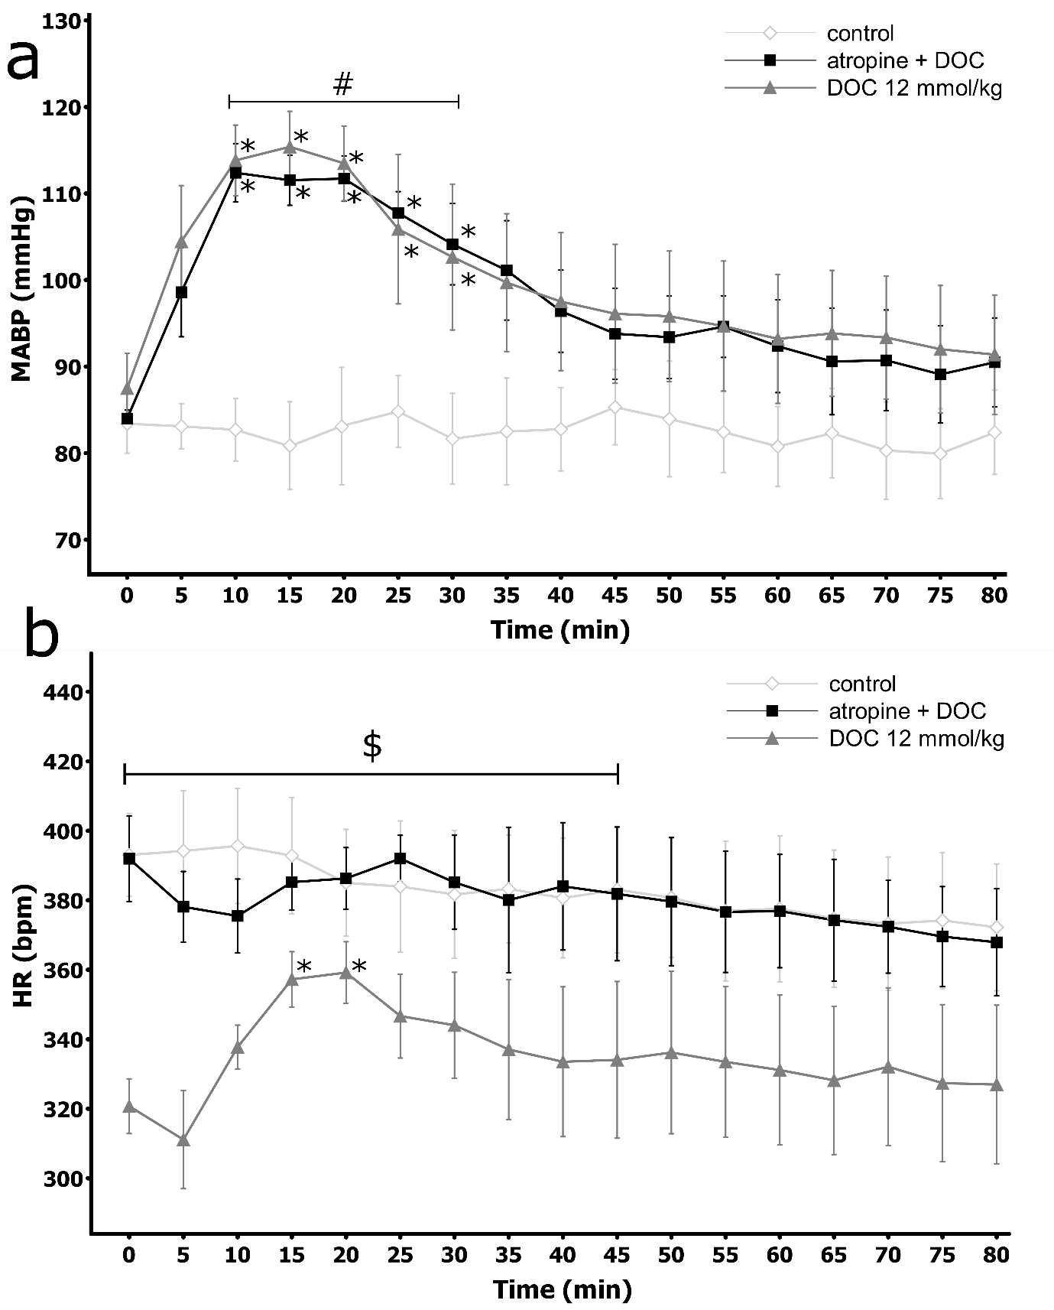

**Figure S4**

Hemodynamic parameters in Sprague-Dawley rats after the intravenous administration (IV) of sodium deoxycholate (DOC) at a dose of 12mmol/kg without pretreatment or after pretreatment with atropine: DOC at a dose 12 mmol/kg (atropine+DOC) or the vehicle (control): **a.** Mean arterial blood pressure (MABP, mmHg); **b.** Heart rate (HR, bpm); **\***p<0.05 vs. baseline, **#** p<0.05: atropine + DOC vs. control, **$** p<0.05: atropine + DOC vs. DOC. Means ± SE are presented

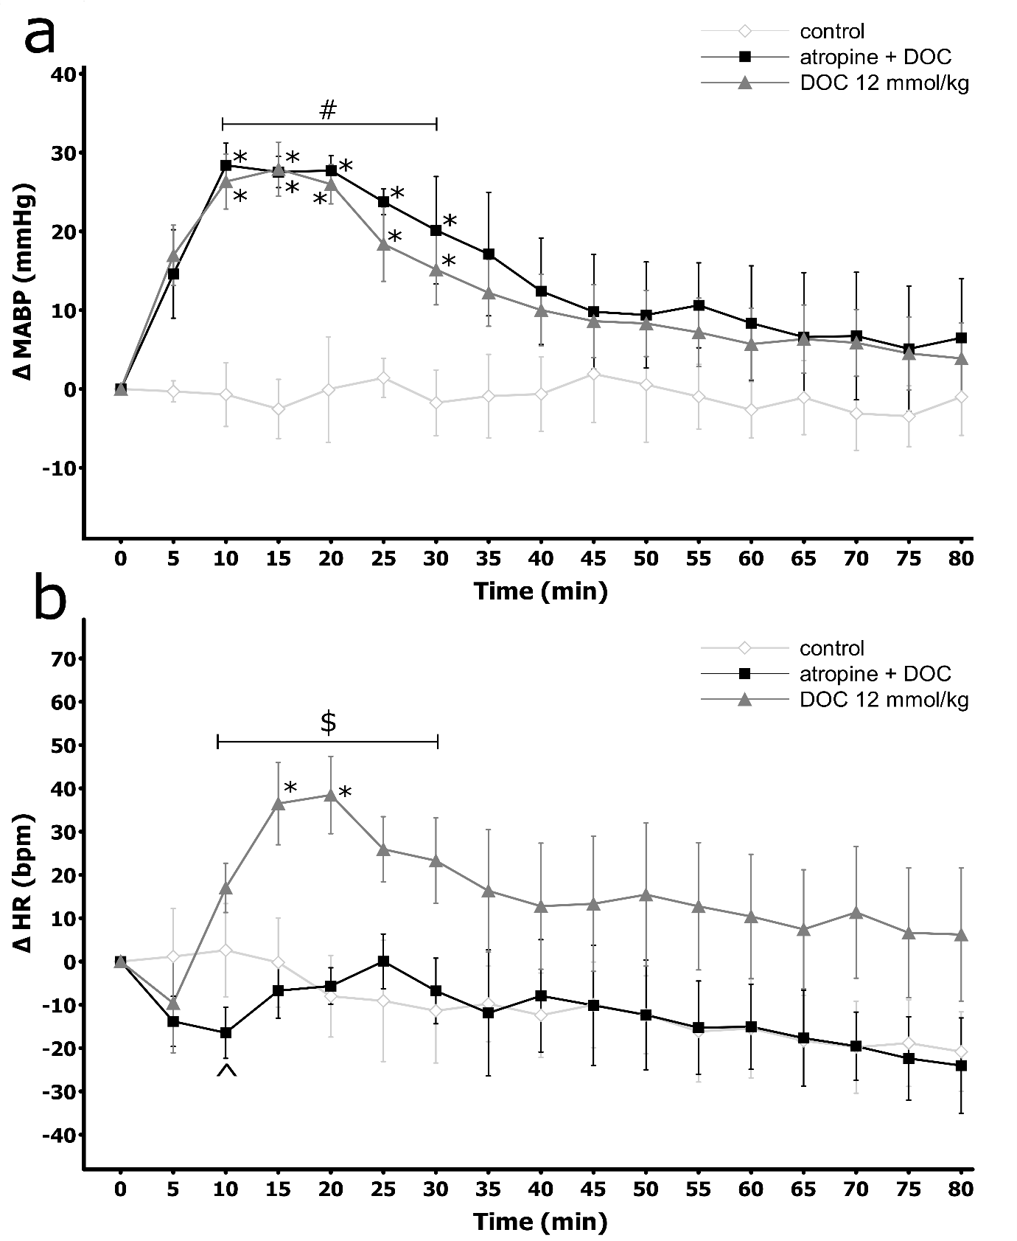

**Figure S5**

Changes in hemodynamic parameters in Sprague-Dawley rats after the intravenous administration (IV) of sodium deoxycholate (DOC) at a dose of 12mmol/kg without pretreatment or after pretreatment with atropine: DOC at a dose of 12 mmol/kg (atropine+DOC) or the vehicle (control): **a.** ΔMABP (mmHg), **b.** ΔHR (bpm); **\***p<0.05 vs. baseline, **#** p<0.05: atropine + DOC vs. control, **$**p<0.05: atropine + DOC vs. DOC, **^** p<0.05: atropine + DOC vs. atropine. Means ± SE are presented

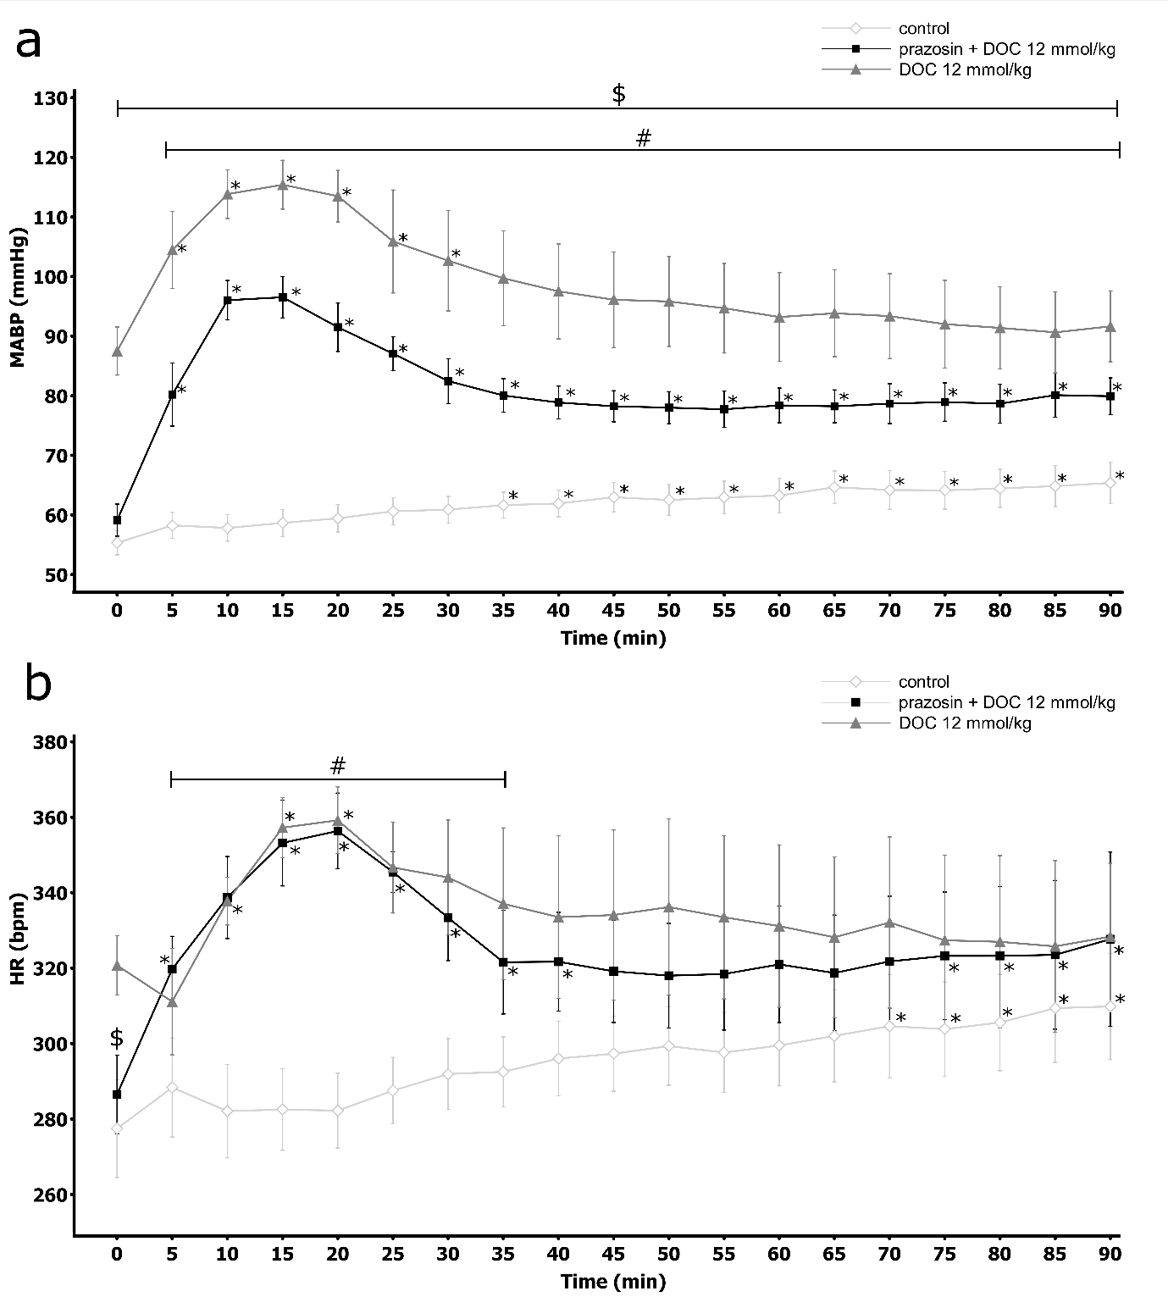

**Figure S6**

Hemodynamic parameters in Sprague-Dawley rats after the intravenous administration (IV) of sodium deoxycholate (DOC) at a dose of 12mmol/kg without pretreatment or after pretreatment with prazosin: DOC at a dose of 12 mmol/kg (prazosin+DOC) or the vehicle (control); **a.** Mean arterial blood pressure (MABP, mmHg), **b.** Heart rate (HR, bpm); **\***p<0.05 vs baseline, **#** p<0.05: prazosin + DOC vs. control **$** p<0.05: prazosin + DOC vs. DOC. Means ± SE are presented

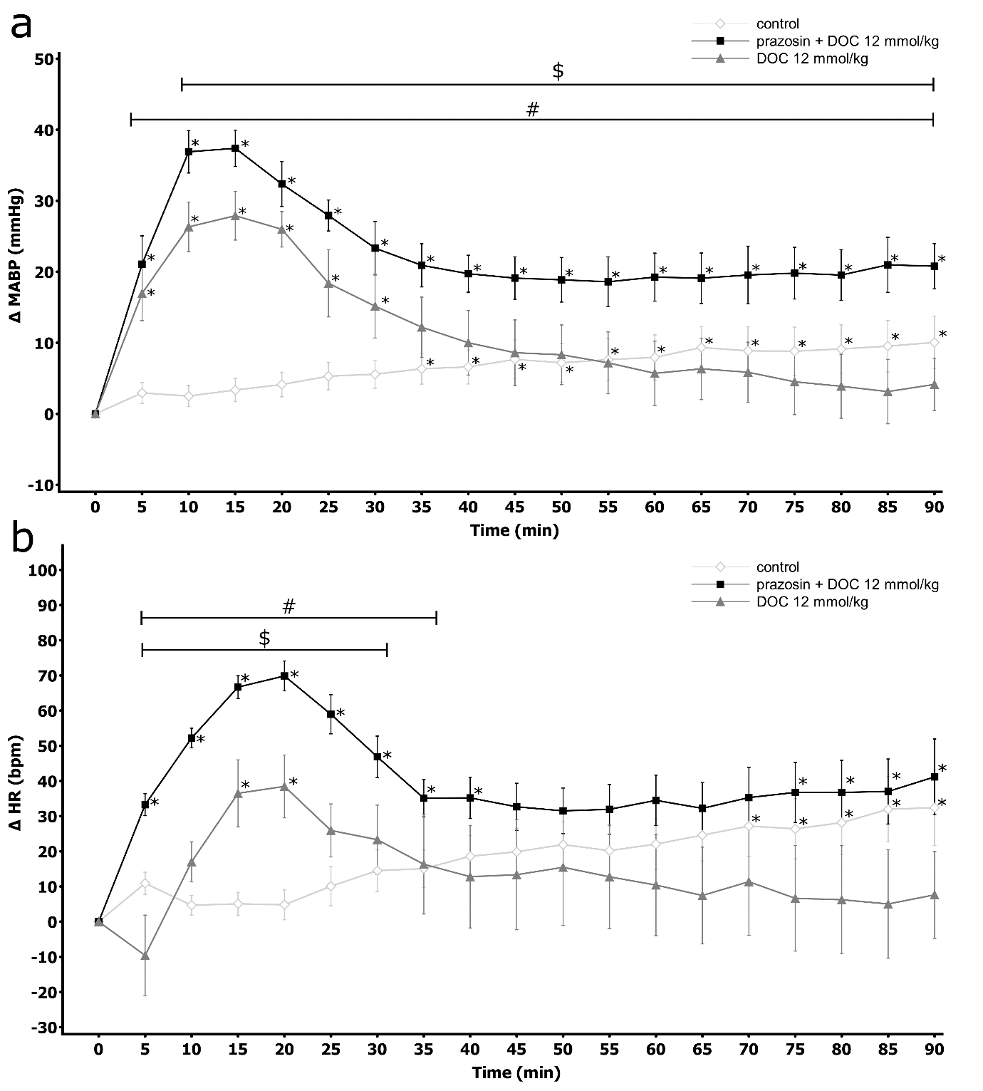

**Figure S7**

Changes in hemodynamic parameters in Sprague-Dawley rats after the intravenous administration (IV) of sodium deoxycholate (DOC) at a dose of 12mmol/kg without pretreatment or after pretreatment with prazosin: DOC at a dose of 12 mmol/kg (prazosin+DOC) or the vehicle (control): **a.** ΔMABP (mmHg), **b.** ΔHR (bpm); **\***p<0.05 vs. baseline, **#** p<0.05: prazosin + DOC vs. control **$** p<0.05: prazosin + DOC vs. DOC. Means ± SE are presented

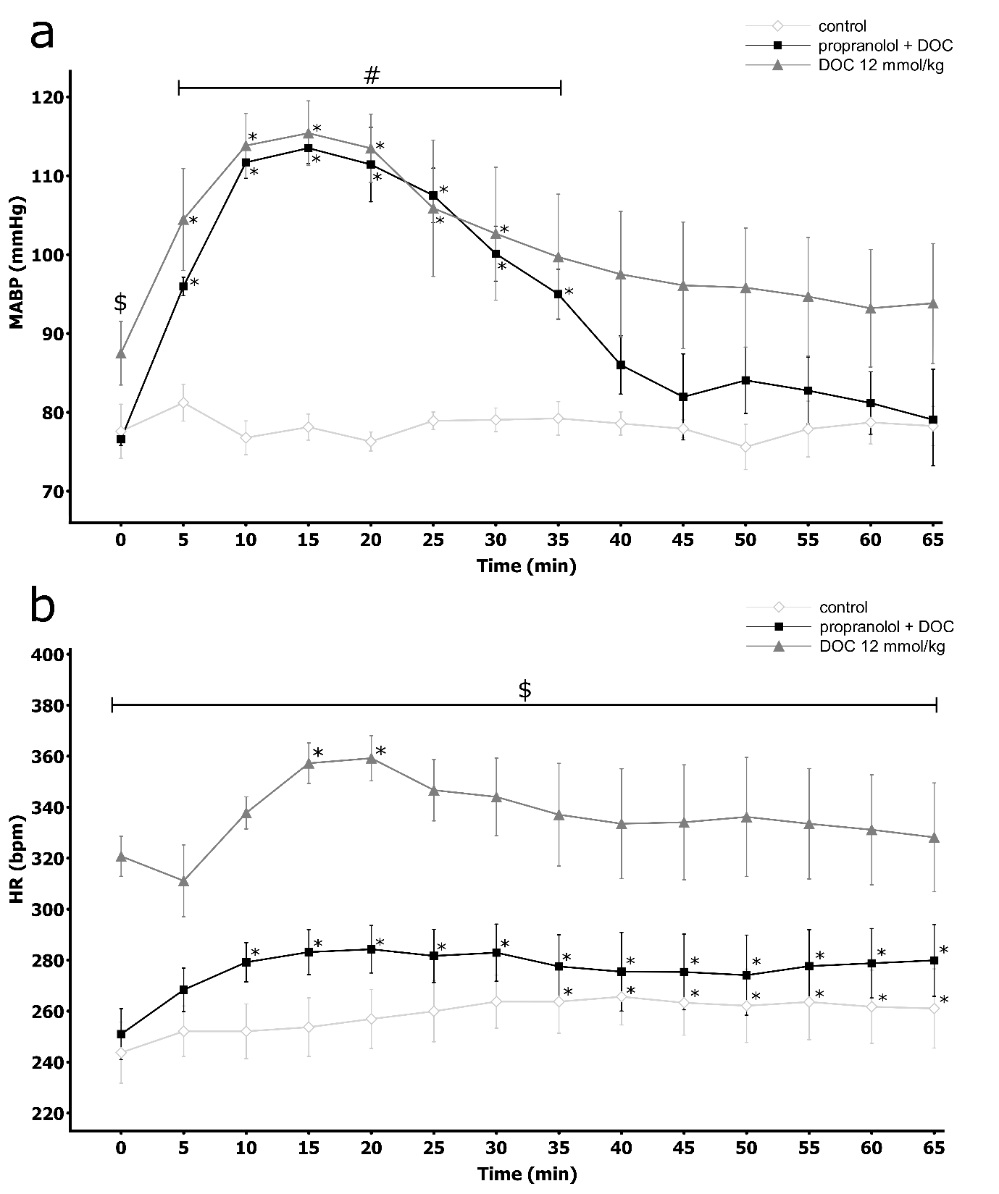

**Figure S8**

Hemodynamic parameters in Sprague-Dawley rats after the intravenous administration (IV) of sodium deoxycholate (DOC) at a dose of 12mmol/kg without pretreatment or after pretreatment with propranolol: DOC at a dose of 12 mmol/kg (propranolol+DOC) or the vehicle (control): **a.** Mean arterial blood pressure (MABP, mmHg), **b.** Heart rate (HR, bpm); **\***p<0.05 vs. baseline, **#** p<0.05: propranolol + DOC vs. control, **$** p<0.05: propranolol + DOC vs. DOC. Means ± SE are presented

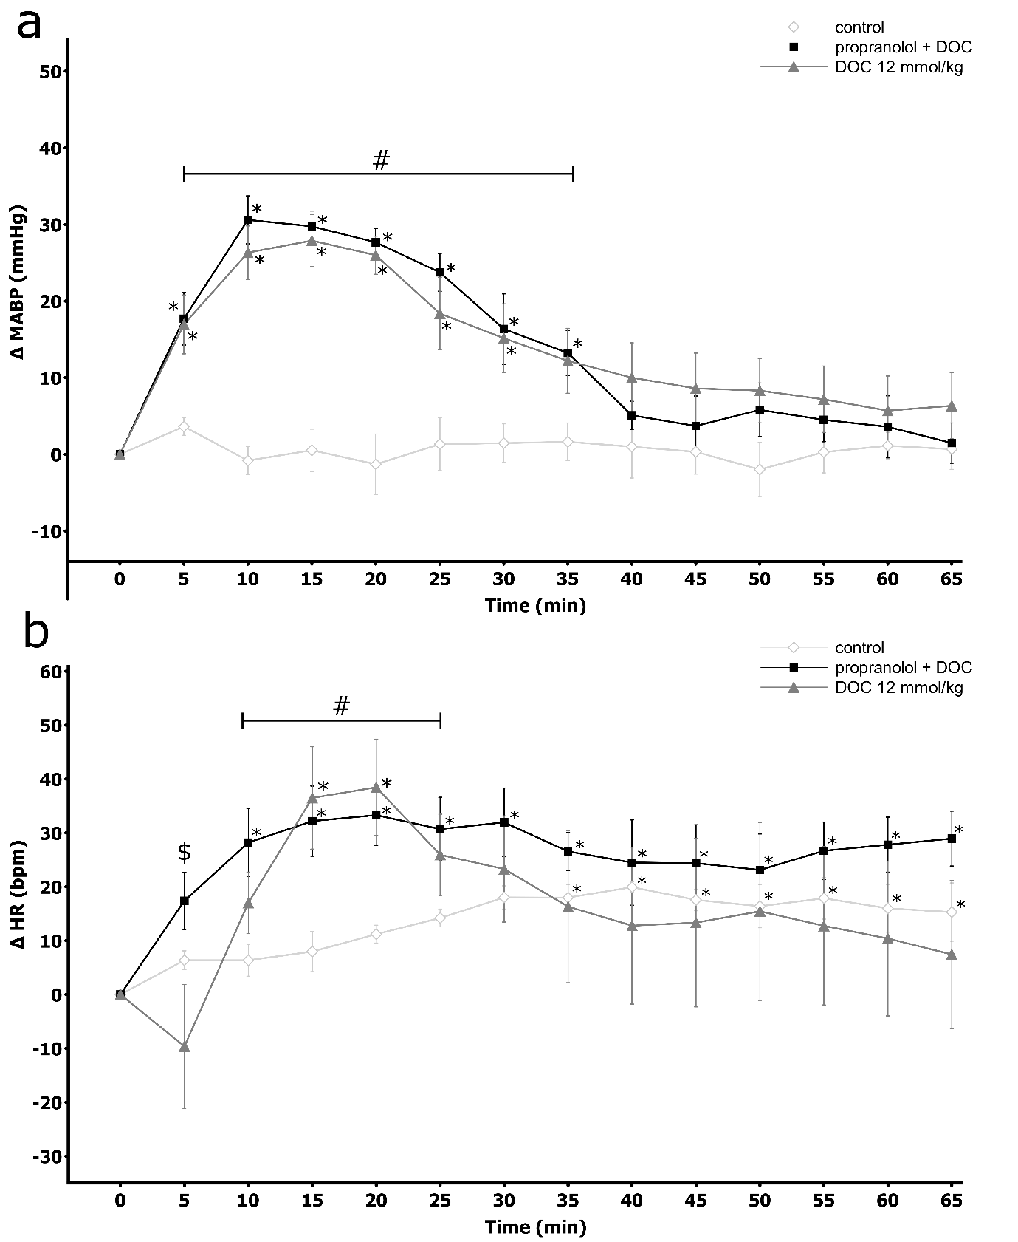

**Figure S9**

Changes in hemodynamic parameters in Sprague-Dawley rats after the intravenous administration (IV) of sodium deoxycholate (DOC) at a dose of 12mmol/kg without pretreatment or after pretreatment with propranolol: DOC at a dose of 12 mmol/kg (propranolol+DOC) or the vehicle (control): **a.** ΔMABP (mmHg), **b.** ΔHR (bpm); **\***p<0.05 vs. baseline, **#** p<0.05: propranolol + DOC vs. control, **$** p<0.05: propranolol + DOC vs. DOC. Means ± SE are presented

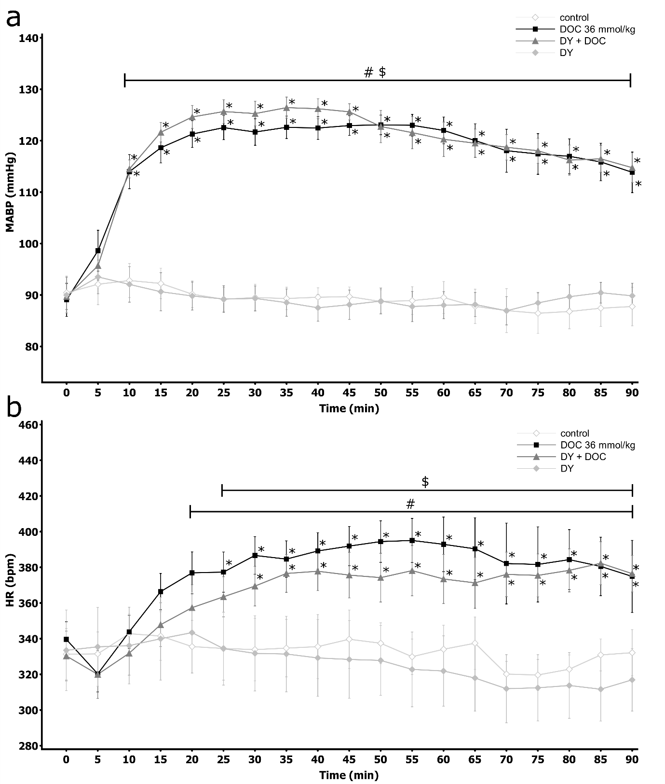

**Figure S10**

Hemodynamic parameters in Sprague-Dawley rats after the intravenous administration (IV) of sodium deoxycholate (DOC) at a dose of 36 mmol/kg or the vehicle (control) without pretreatment or after pretreatment with DY 268: DOC at a dose of 36 mmol/kg (DY+DOC) or the vehicle (DY group): **a)** Mean arterial blood pressure (MABP, mmHg); **b)** Heart rate (HR, bpm); **\***p<0.05 vs. baseline, **$** p<0.05: DY+DOC vs. DY, **#** p<0.05: DOC vs. control. Means ± SE are presented

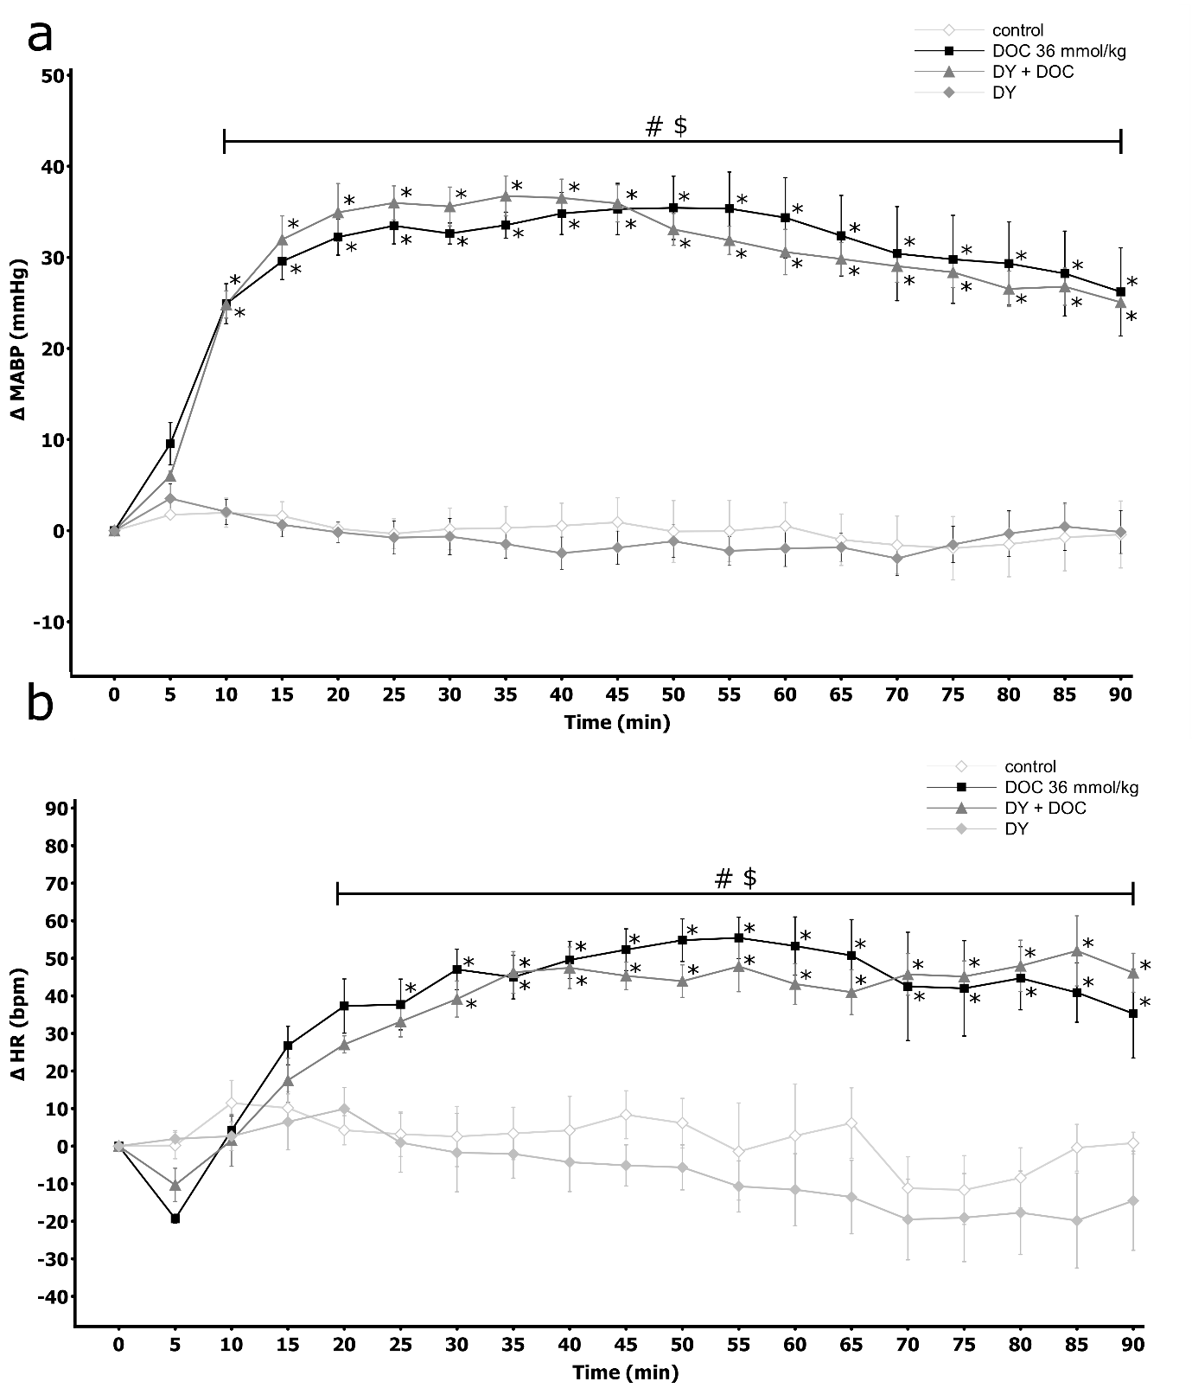

**Figure S11**

Changes in hemodynamic parameters in Sprague-Dawley rats after the intravenous administration (IV) of sodium deoxycholate (DOC) at a dose of 36 mmol/kg or the vehicle (control) without pretreatment or after pretreatment with DY 268: DOC at a dose of 36 mmol/kg (DY+DOC) or the vehicle (DY group): **a)** ΔMABP (mmHg), **b)** ΔHR (bpm); **\***p<0.05 vs. baseline, **$** p<0.05: DY+DOC vs. DY, **#** p<0.05: DOC vs. control. Means ± SE are presented

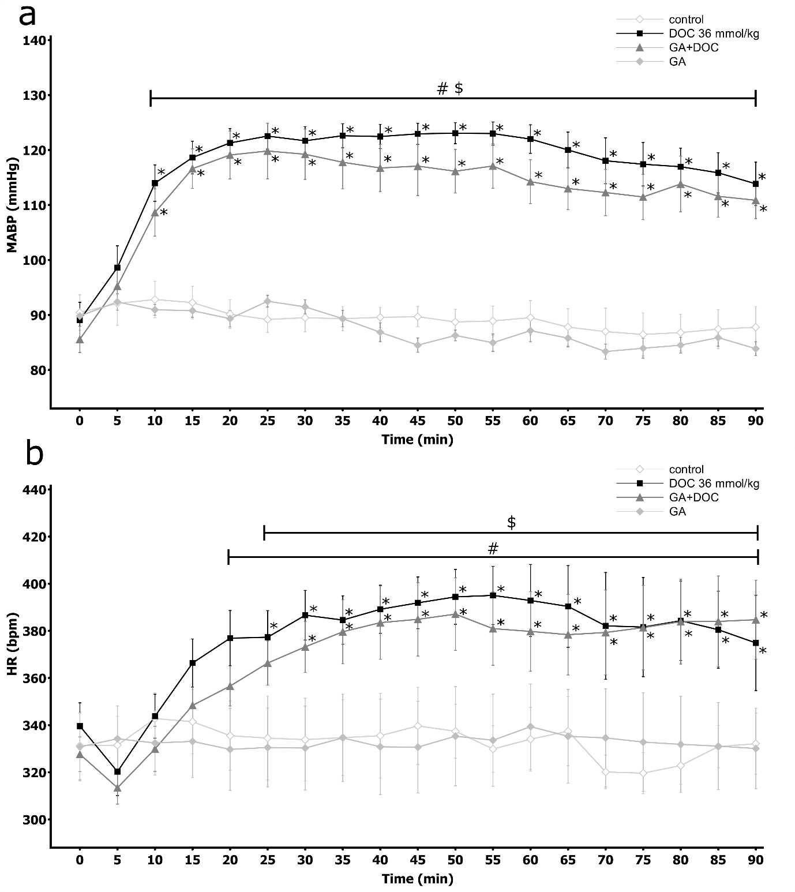

**Figure S12**

Hemodynamic parameters in Sprague-Dawley rats after the intravenous administration (IV) of sodium deoxycholate (DOC) at a dose of 36 mmol/kg or the vehicle (control) without pretreatment or after pretreatment withglycyrrhetinic acid: DOC at a dose of 36 mmol/kg (GA+DOC) or the vehicle (GA group): **a)** Mean arterial blood pressure (MABP, mmHg), **b)** Heart rate (HR, bpm); **\***p<0.05 vs. baseline, **$** p<0.05: GA+DOC vs. GA, **#** p<0.05: DOC vs. control. Means ± SE are presented

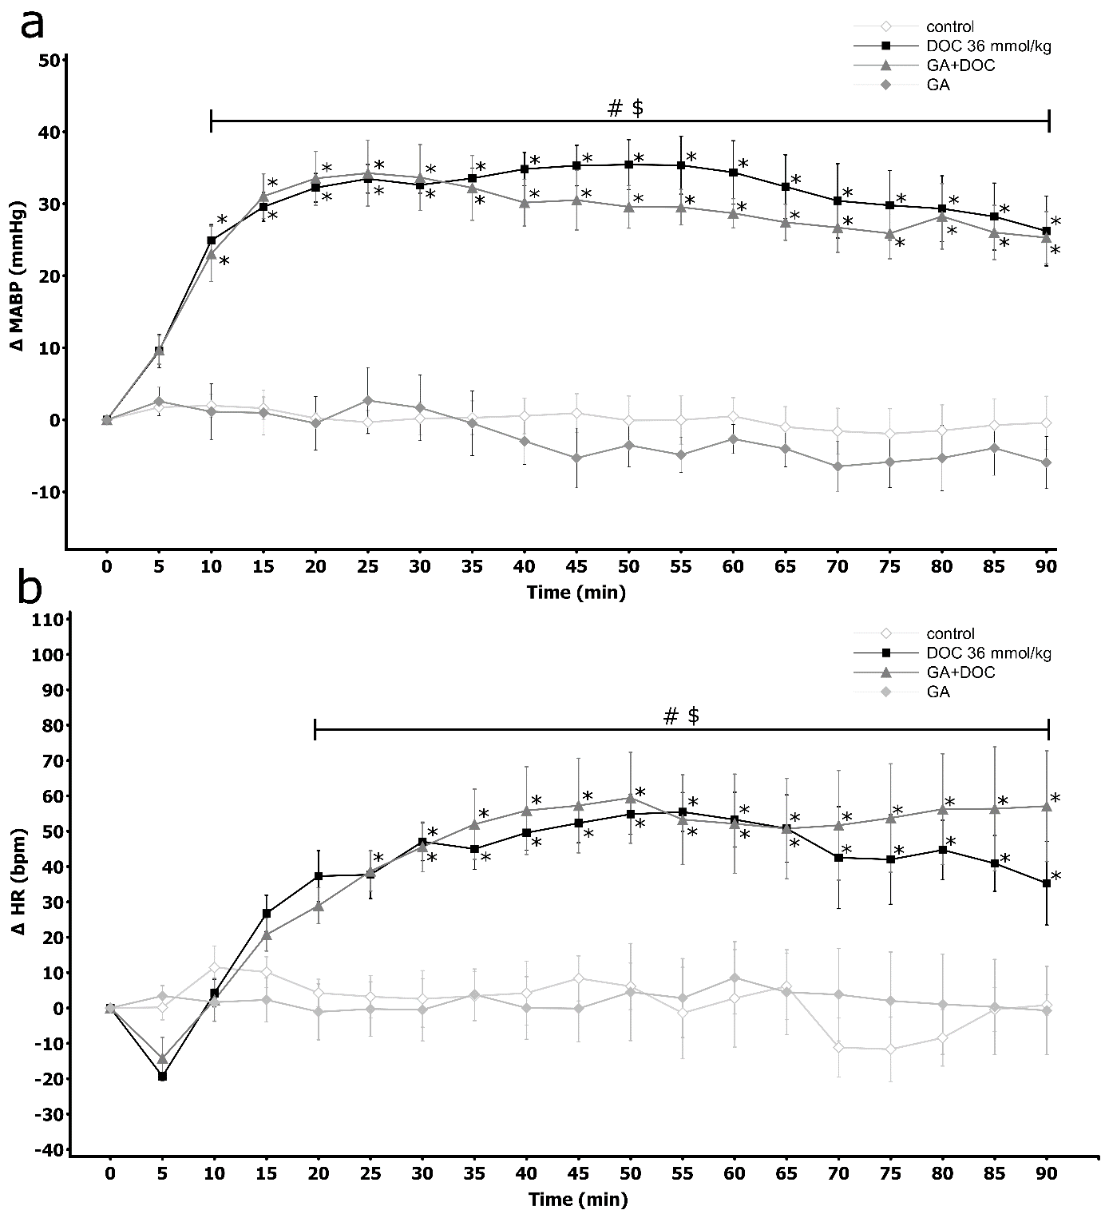

**Figure S13**

Changes in hemodynamic parameters in Sprague-Dawley rats after the intravenous administration (IV) of sodium deoxycholate (DOC) at a dose of 36 mmol/kg or the vehicle (control) without pretreatment or after pretreatment withglycyrrhetinic acid: DOC at a dose of 36 mmol/kg (GA+DOC) or the vehicle (GA group): **a)** ΔMABP (mmHg), **b)** ΔHR (bpm); **\***p<0.05 vs. baseline, **$** p<0.05: GA+DOC vs. GA, **#** p<0.05: DOC vs. control. Means ± SE are presented

**INTRACEREBROVENTRICULAR ADMINISTRATION**

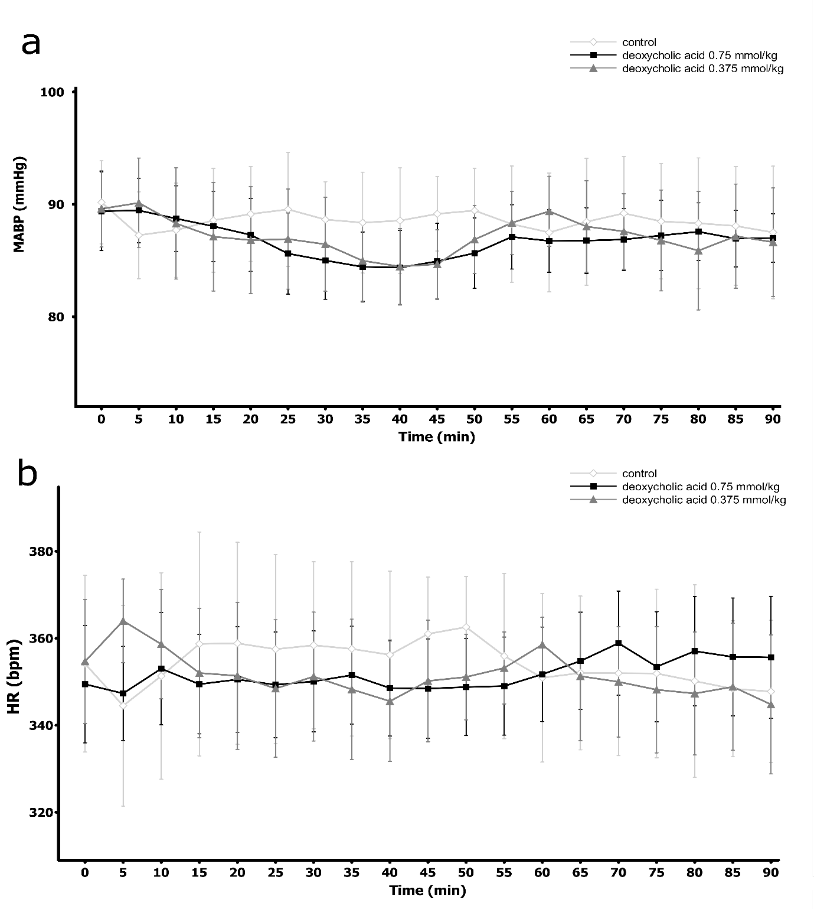 **Figure S14**

Hemodynamic parameters in Sprague-Dawley rats after the intracerebroventricular (ICV) administration of either the vehicle or deoxycholic acid (DCA) at a dose of 0.375 or 0.75 mmol/kg:   
**a)** Mean arterial blood pressure (MABP, mmHg), **b)** Heart rate (HR, bpm). No significant differences vs. baseline and between the groups. Means ± SE are presented

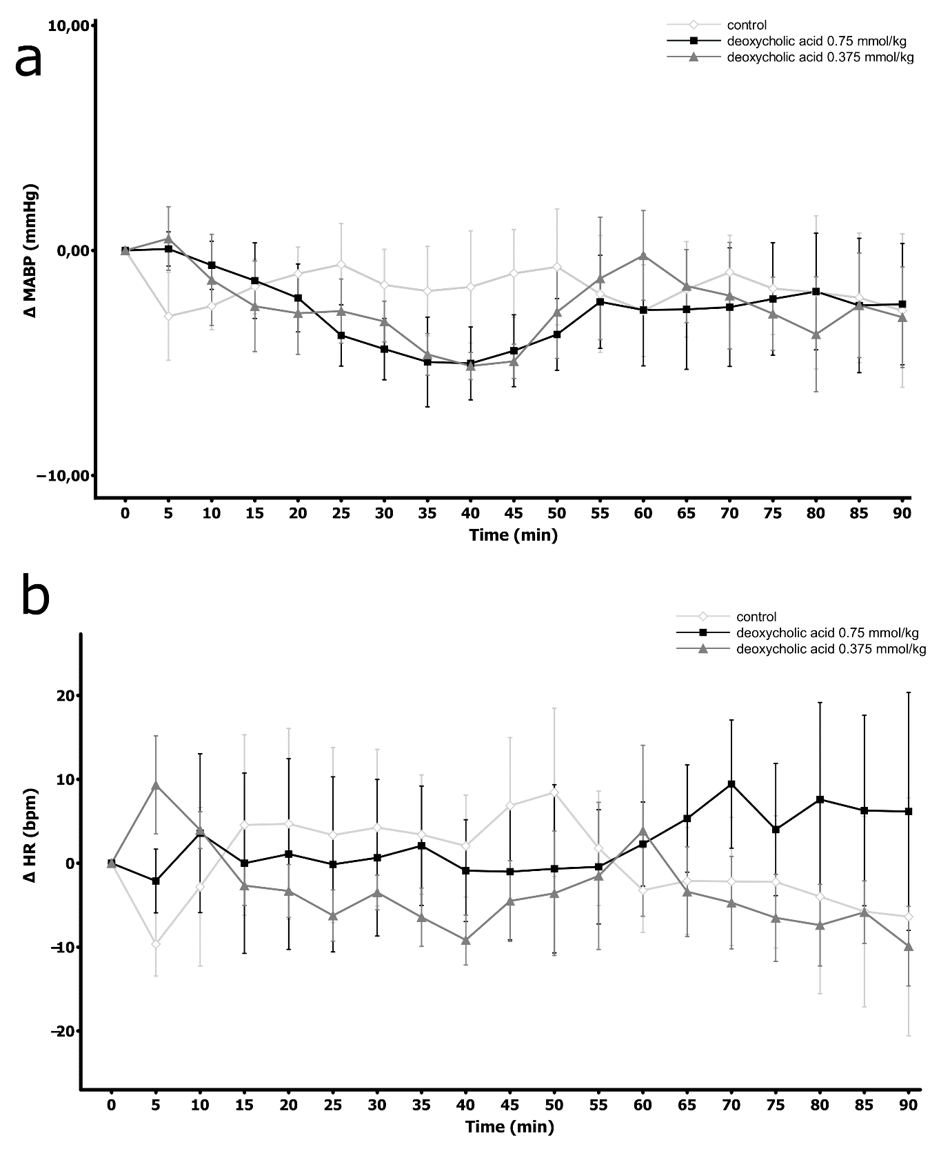

**Figure S15**

Changes in hemodynamic parameters in Sprague-Dawley rats after the intracerebroventricular (ICV) administration of either the vehicle or deoxycholic acid (DCA) at a dose of 0.375 or 0.75 mmol/kg:  
 **a)** ΔMABP (mmHg), **b)** ΔHR (bpm). No significant differences vs. baseline and between the groups. Means ± SE are presented

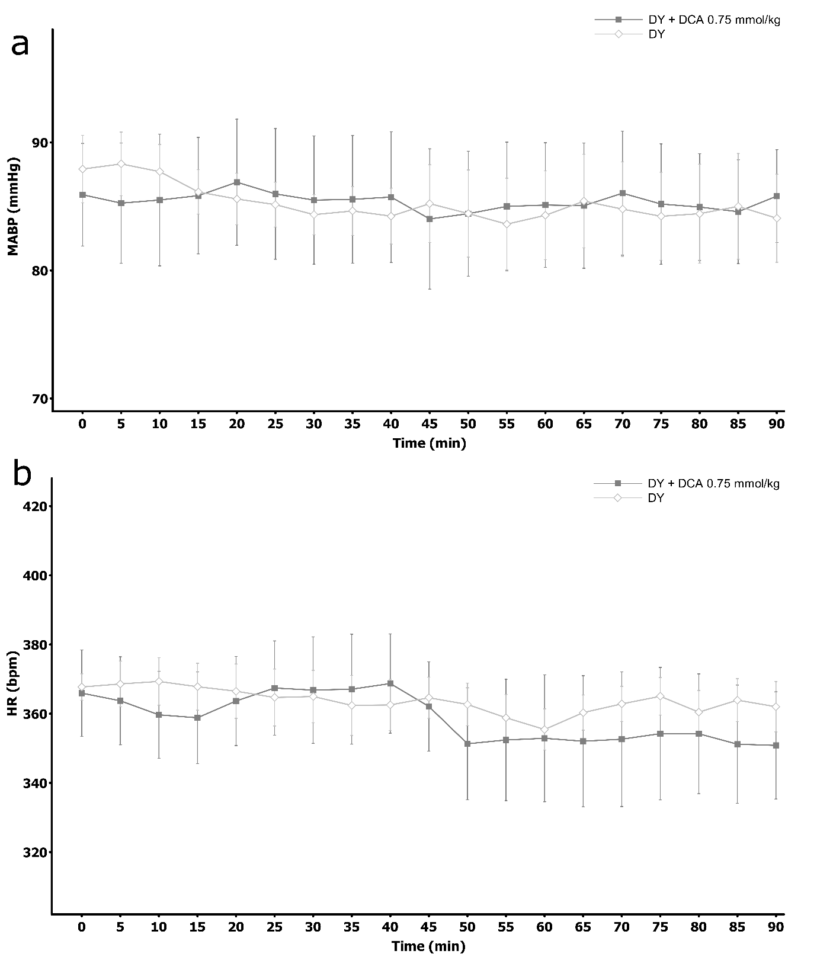

**Figure S16**

Hemodynamic parameters in Sprague-Dawley rats after the intracerebroventricular (ICV) administration of either the vehicle or deoxycholic acid (DCA) at a dose of 0.75 mmol/kg after pretreatment with DY 268: **a)** Mean arterial blood pressure (MABP, mmHg), **b)** Heart rate (HR, bpm). No significant differences vs. baseline and between the groups. Means ± SE are presented

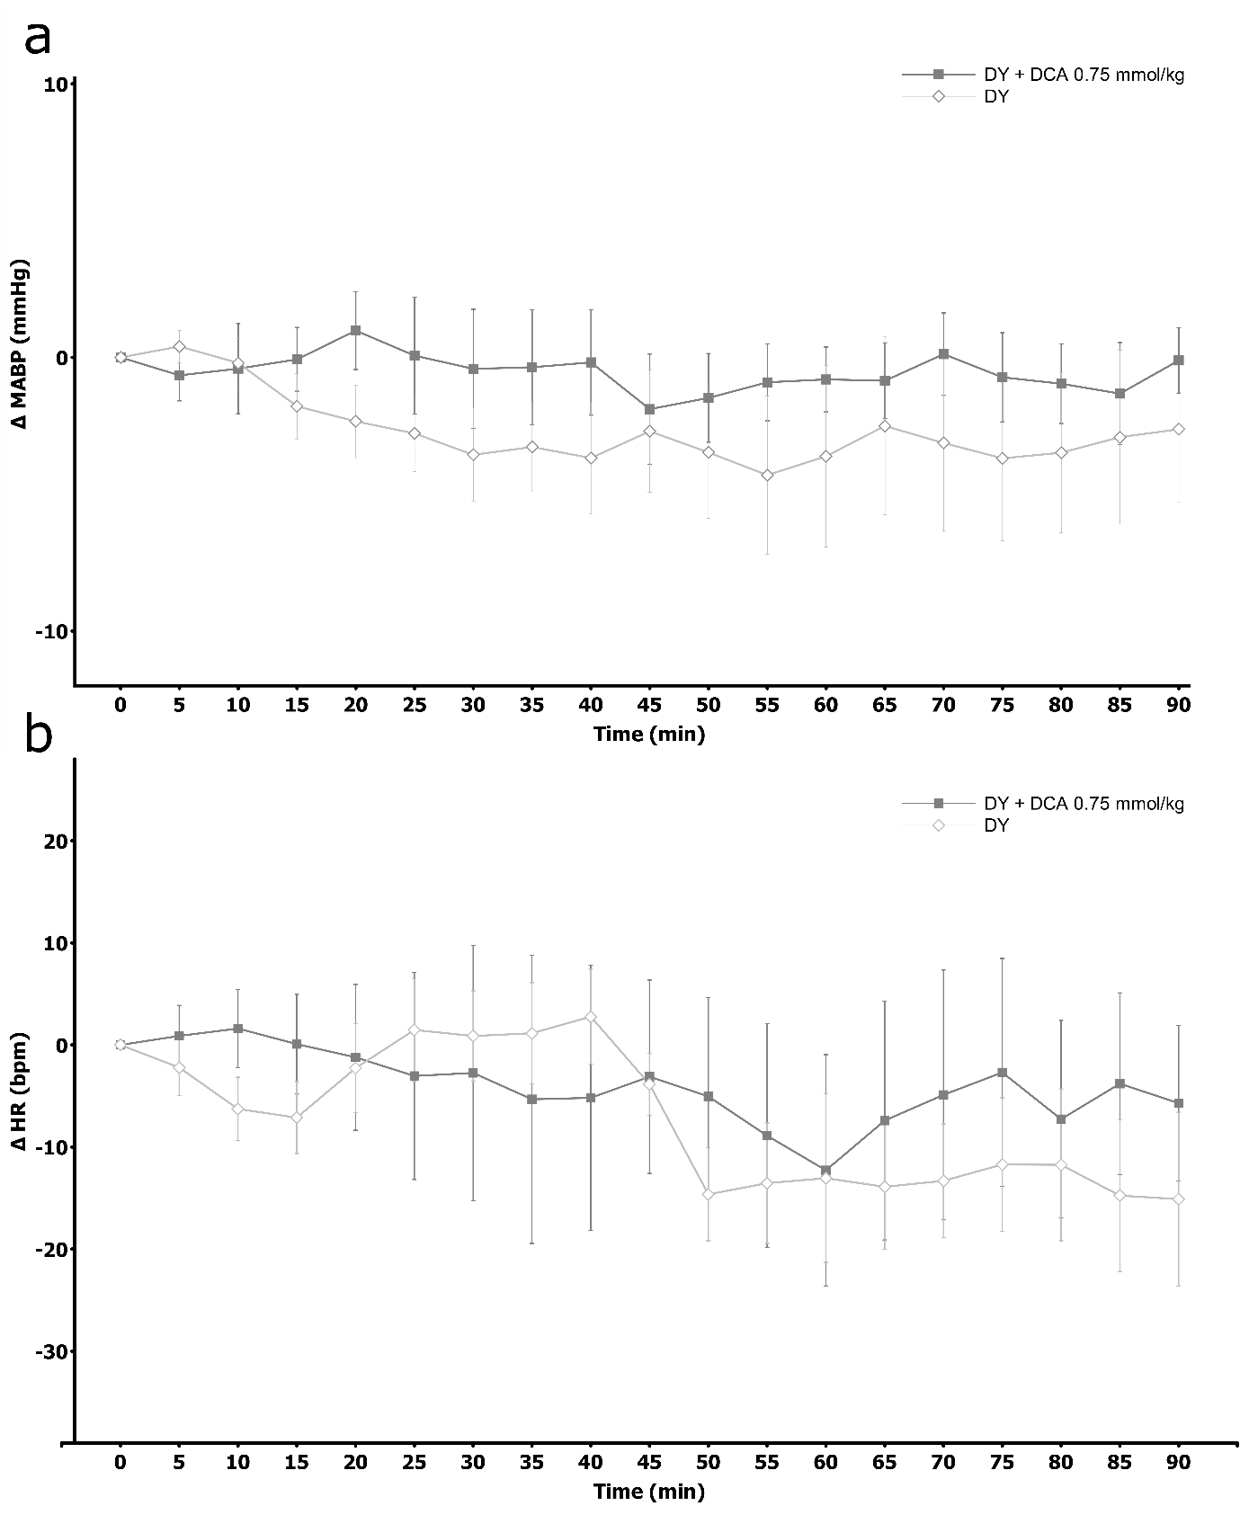

**Figure S17**

Changes in hemodynamic parameters in Sprague-Dawley rats after the intracerebroventricular (ICV) administration of either the vehicle or deoxycholic acid (DCA) at a dose of 0.75 mmol/kg after pretreatment with DY 268: **a)** ΔMABP (mmHg), **b)** ΔHR (bpm). No significant differences vs. baseline and between the groups. Means ± SE are presented

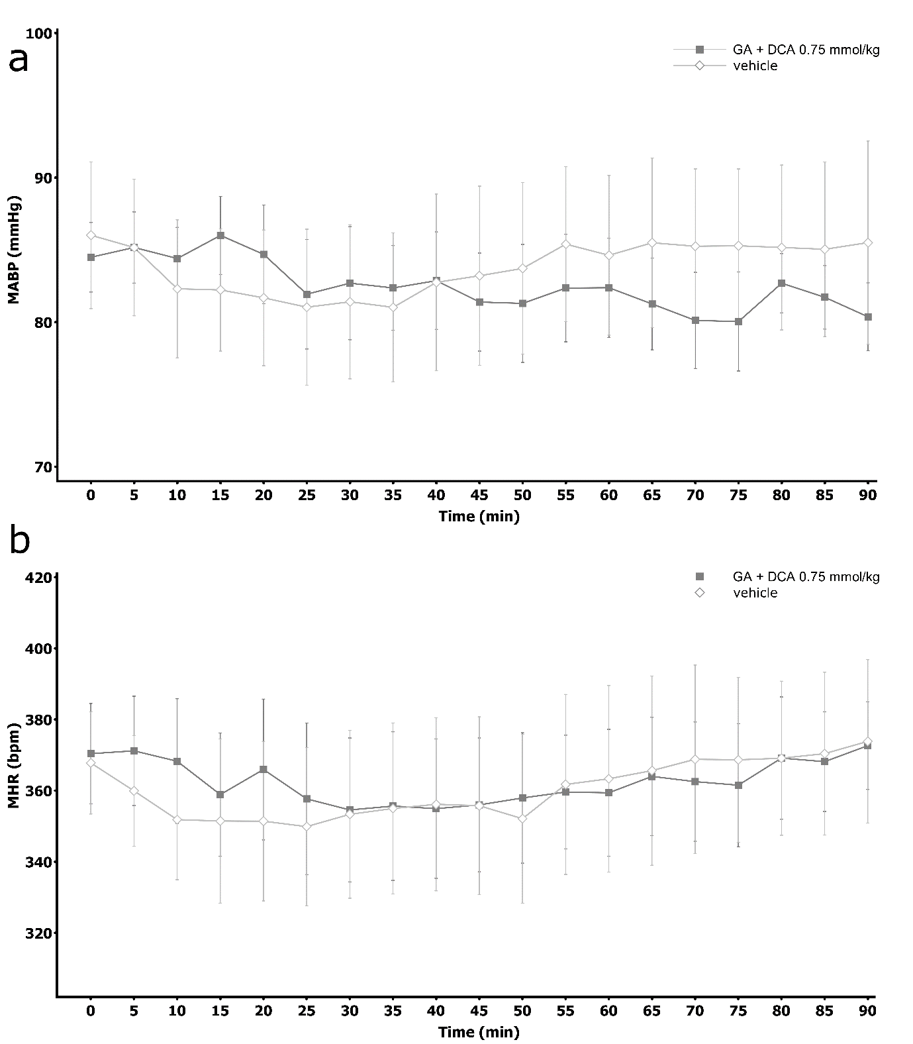  
**Figure S18**

Hemodynamic parameters in Sprague-Dawley rats after the intracerebroventricular (ICV) administration of either the vehicle or deoxycholic acid (DCA) at a dose of 0.75 mmol/kg after pretreatment with glycyrrhetinic acid: **a)** Mean arterial blood pressure (MABP, mmHg), **b)** Heart rate (HR, bpm). No significant differences vs. baseline and between the groups. Means ± SE are presented

.

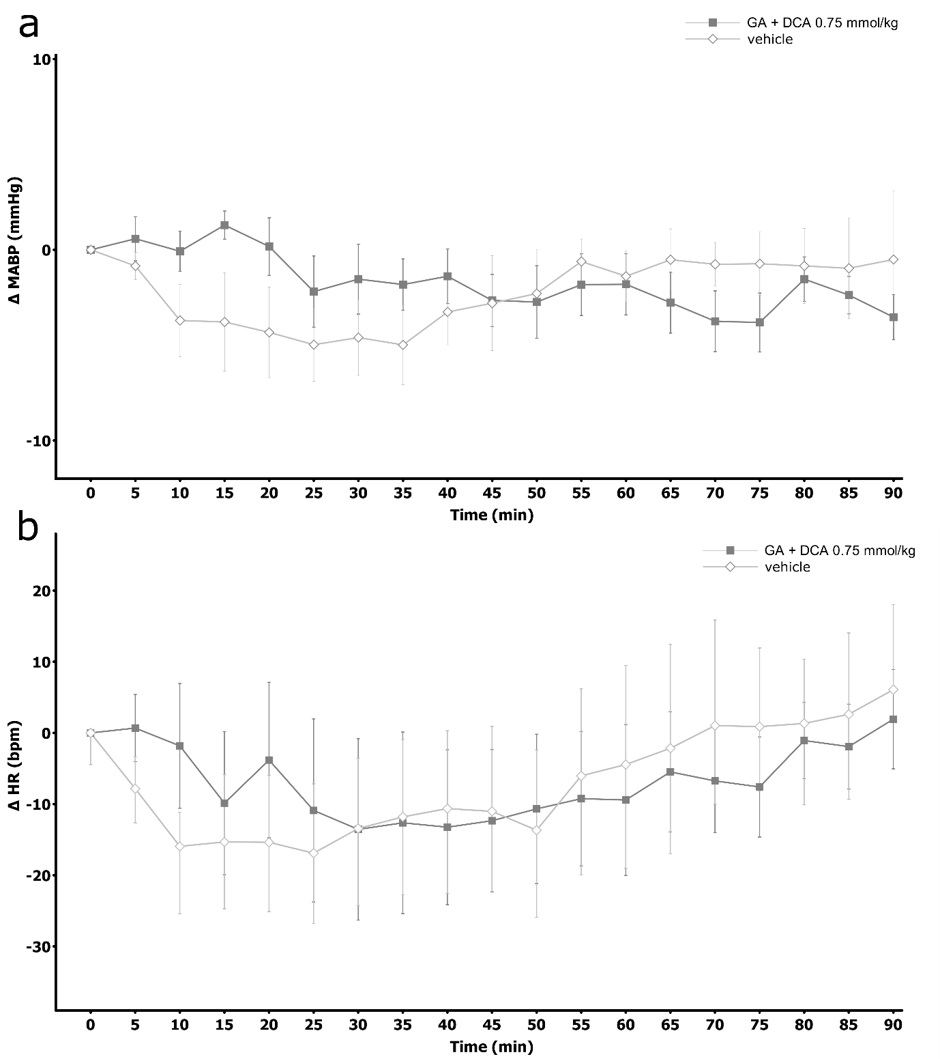

**Figure S19**

Changes in hemodynamic parameters in Sprague-Dawley rats after the intracerebroventricular (ICV) administration of either the vehicle or deoxycholic acid (DCA) at a dose of 0.75 mmol/kg after pretreatment with glycyrrhetinic acid: **a)** ΔMABP (mmHg), **b)** ΔHR (bpm). No significant differences vs. baseline and between the groups. Means ± SE are presented

**SPECTROMETRY – DETAILED METHODS**

Cholic and deoxycholic acid were determined using liquid chromatography coupled with tandem mass spectrometry (LC-MS/MS). Separation was achieved on a Kinetex C-18 column (100 mm × 4.6 mm, particle size 2.6 µm) supplied by Phenomenex (Torrance, CA, US) using Agilent 1260 Infinity (Agilent Technologies, Santa Clara, CA, USA) chromatograph connected to a hybrid triple quadrupole/linear ion trap mass spectrometer (QTRAP 4000; AB SCIEX, Framingham, MA, USA). Fifty µl of plasma was mixed with 10 µl of the internal standards solution (CA-D5 and DCA-D5, 10 µg mL-1) and 200 µl of ice-cold acetonitrile. Next, the samples were vortexed for 5 min and centrifuged at 9,300 *× g* at 4°C for 5 min. The supernatant was transferred to a vial and analyzed. The curtain gas, ion source gas 1, ion source gas 2 and collision gas (all high purity nitrogen) were set at 241 kPa, 414 kPa, 275 kPa and “high” instrument units, respectively. The ion spray voltage and source temperature were set at -4500 V and 600°C, respectively. The chromatographic column was maintained at 40°C at a flow rate of 0.5 mL min−1. The mobile phases consisted of a water solution of 0.2% formic acid as eluent A and acetonitrile with 0.2% formic acid as eluent B. The gradient (%B) was as follows: 0 min 80%; 0.5 min 80%; 4 min 5%; 9.5 min 5%. The volume of injection was 10 µL. The target compounds were analyzed in multiple reaction monitoring mode. The transitions used for quantitation were *m/z* 407>343 and *m/z* 391>345 and *m/z* 412>348 and *m/z* 396>350 for CA, DCA and CA-D5 and DCA-D5, respectively. The compound parameters, viz. declustering potential (DP), collision energy (CE), entrance potential (EP) and collision cell exit potential (CXP) were -150 V, -44 V, -10 V, -9 V for CA, -155 V, -46 V, -10 V, -17 V for DCA, -145 V, -44 V, -10 V, -15 V for CA-D5 and -130 V, -48 V, -10 V, -9 V for DCA-D5.