BattleShips is a very popular tactical game where the main task is to find and destroy a certain number of ships. The winner is the one who can sink all the opponent's ships first. The game continues until one of the players wins (destroys all enemy ships).

Speaking more about the process, in the game, there are 2 options – you can play against AI (ext.) and against real player. Each of the players has 5 (ext.) ships whose coordinates are checked for correctness (ext.). After setting up battle fields, each player tries to kill opponent’s ships one after another ( player 1 always starts ). After every try, there is a text which says if the shot was successful or not.

Talking about code, various mistakes that the user can commit (ext) are being checked, so there is no chance of inputing invalid data. The code itself was written as a number of classes which are connected with each other, so the OOP method was used.

**Code explanation:**

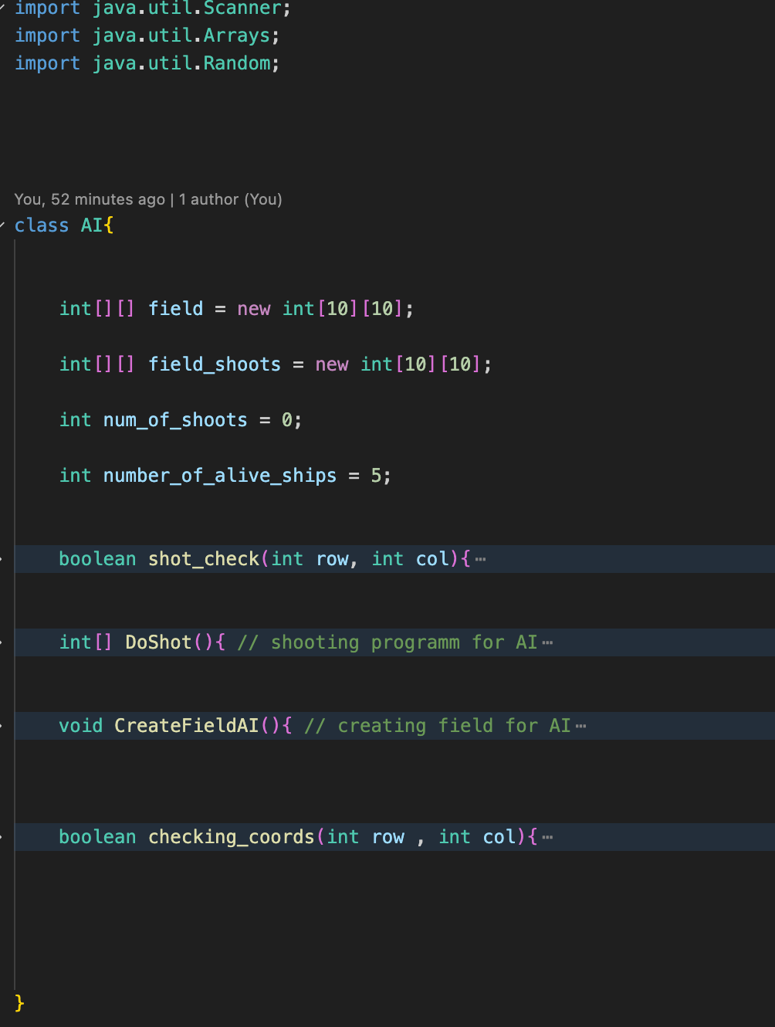

Firstly, we import all the necessary libraries.

**CLASS AI:**

class AI – is a class which consists of all the stuff which will be used if player decides to play against AI

Values:

* field is a 2d array which represents ships
* field_shoots is a 2d array which represents point of shots
* num_of_shoots counts number of shots
* number_of_alive_ships is a number of ships which are still in game

Functions:

* Shot_check checks that AI didn’t choose a point which was chosen in other tries
* DoShot generates values which will be used as a coordinates of shot
* CreateFieldAI creates field with ships ( ships’ coordinates are being chosen by random library )
* Checking_coords just checks if coordinates of ships are valid

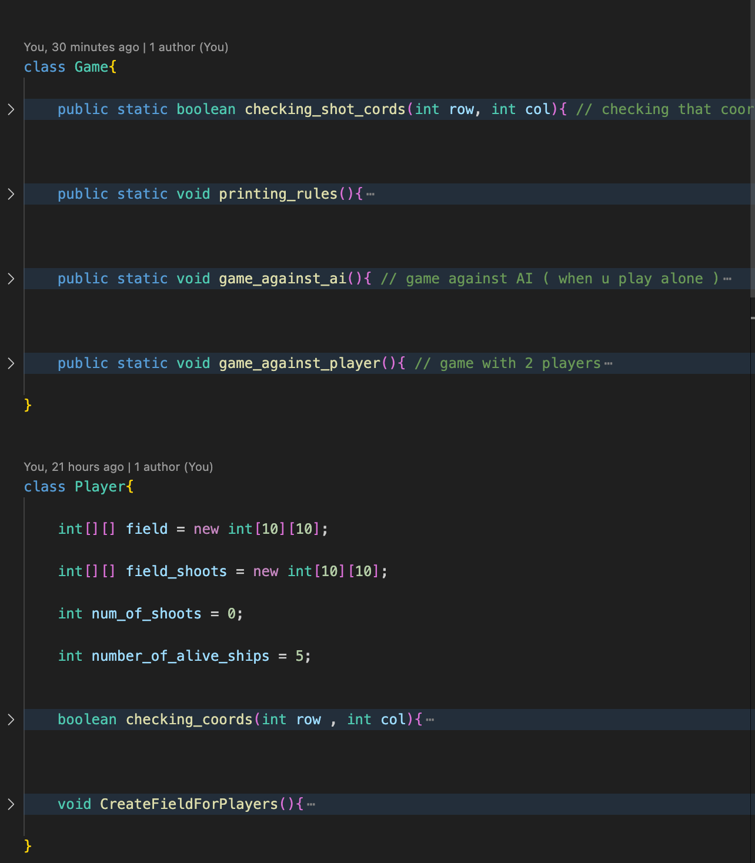

**CLASS GAME:**

Class game – is a class which manage all the game processes

Functions:

* Printing_rules prints out rules of the game in the start
* Game_against_ai conducts the game against AI ( when player plays alone )
* Game_against_player conducts the game against other player
* Checking_shot_cors is just a function that helps checking shot coordinates of a player

**CLASS PLAYER:**

Class player - is a class which consists of different functions which will help to conduct Player’s game

Values:

* field is a 2d array which represents ships
* field_shoots is a 2d array which represents point of shots
* num_of_shoots counts number of shots
* number_of_alive_ships is a number of ships which are still in game

Functions:

* CreateFieldForPlayers creates field with ships ( ships’ coordinates are being chosen by user’s input )
* Checking_coords just checks if coordinates of ships are valid

**PUBLIC CLASS NEW_CODE:**

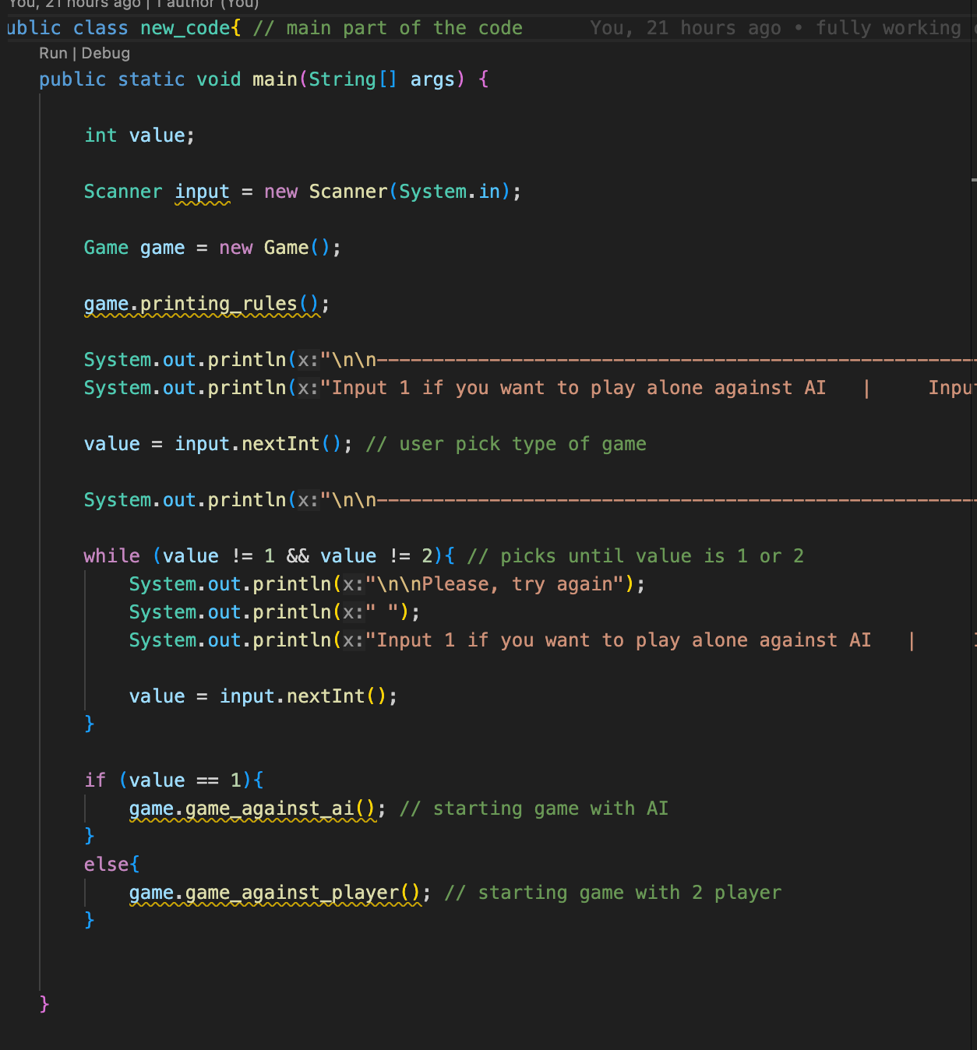

It starts all the code.

Firstly, it prints game’s rules. Then it asks user to choose the mode of game - when program asks for the input, this input will be declared into the integer named value. If value equals 1, game mode is player against AI and the specific function which starts game against AI is being run . If value equals 2, then game mode is player against player and the specific function which starts game is being run.