DIGITAL CONTENT

Level : CEFR A2
Meeting : 2 (Greetings & Introduction)
Unit Topic : People
Vocabulary : Greetings expressions
Grammar : -
Functional Skills : Introducing yourself and other people

Set 1: Vocabulary acquisition
- Multiple choice
Instructions: Read the expression and choose the correct image.
Q1: Hello



Option:

Answer: √

Q2: Good morning



Option:

Answer: √

Q3: Good evening


Option:

Answer: √

Q4: I’m fine, thank you.
Option:

Answer: √

Q5: Good afternoon
Option:

Answer: √

- Listening Comprehension – Multiple choice
Instructions: Listen to the audio and choose the correct image.
Audio:
Q1: Good morning
Option:

Answer: √

Q2: Good evening
Option:

Answer: √

Q3: I’m fine, thank you.

Option:

Answer: √

Q4: Good afternoon
Option:

Answer: √

Q5: Hello
Option:

Answer: √

Set 2: Structure recognition
- True/ False: audio vs text
Instructions: Listen to the audio, read the text and choose true or false
Audio, text & True/ False
Q1: Audio: Good morning
Text: Good morning
Options: True | False
Answer: True

Q2: Audio: Hi
Text: Hello
Options: True | False
Answer: False

Q3: Audio: How are you?
Text: How are you?
Options: True | False
Answer: True

Q4: Audio: I’m fine, thank you
Text: I’m good, thank you
Options: True | False
Answer: False

Q5: Audio: Good afternoon
Text: Good afternoon
Options: True | False
Answer: True

- Reordering
Instructions: Put the words into the correct order
Dragging
Q1: evening / Good
Answer: Good evening.

Q2: you?/ How/ are
Answer: How are you?

Q3: bad / Not
Answer: Not bad

Q4: thank / fine / you / I’m
Answer: I’m fine, thank you.

Q5: life? / how’s
Answer: How’s life?

Set 3: Fluency & accuracy (integrated skills)
- Reading & multiple matching – Role play
Instructions: Read the text and choose the correct answer (dragging)
Role play dialogue and options provided
Jen : Hello, good morning.
Jack : ….., ……
Jen : I’m Jen. How are you?
Jack : I’m Jack. ……..

Options: Hello | I’m fine, thank you | good morning
Answers: Hi, good morning, I’m fine, thank you

Tom : Hello, Rose, good evening.
Rose : …. Tom. ………
Tom : How’s life?
Rose : …….

Options: Good evening | Not bad | Hi
Answers: Hi, good evening, not bad

- Fill in the blanks (Reading & Writing) – Role play
Instructions: Read the text and write the correct answer
Role play dialogue (fill in the blanks)
John : Hello, good afternoon
Jill : ……, ……………..
John : ………………….?
Jill : I’m good. How's life?
Person A: …….. I'm fine, thank you.

Answers: Hi, good afternoon, How are you?, Not bad

Set 4: CES
B1 Preliminary Reading Part 1
Instructions: Read the greetings and write the responses
Questions
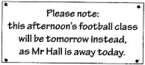
Q1: Image:

Options: A.There is no football class today.
B. Mr Hall can’t come to the football class tomorrow.
C. You can choose to go to the football class today or tomorrow.
Answer: A
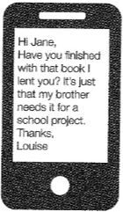
Q2: Image:

Options: A. Louise is offering to lend Jane a book.
B. Louise wants her book back from Jane.
C. Louise’s brother has borrowed a book from Jane.
Answer: B
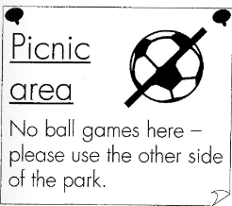
Q3: Image:

Options: A. You can buy food somewhere else in the park.
B. Please don’t eat while you are playing sport there.
C. This is a place for eating and you can’t play football here.
Answer: C

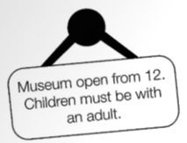
Q4: Image:

Options: A. Adults can take children to the museum in the morning.
B. Adults with children over 12 will enjoy the museum.
C. Children can visit the museum if they are with adult.
Answer: C
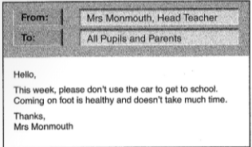
Q5: Image:

Question: Why has Mrs Monmouth written the message?
Options: A. to ask pupils to walk to school.
B. to tell pupils to get to school on time.
C. to explain about a health problem at school.
Answer: A
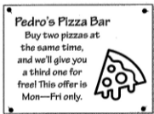
Q6: Image:

Options: A. Pedro’s Pizza Bar isn’t open at weekends.
B. The third time you visit, you get a free pizza.
C. Three pizzas cost the same as two.
Answer: C

