DIGITAL CONTENT

Level : CEFR A2
Meeting : 3 (+ to be (are, am, is))
Unit Topic : People
Vocabulary : countries & nationalities
Grammar : -
Functional Skills : Introducing yourself and other people

Set 1: Vocabulary acquisition
- Matching country’s flags and names
Instructions: Choose the correct answer for each image.

picture :
Q1:
Option: Indonesia/ Japan/ China
Answer: Indonesia

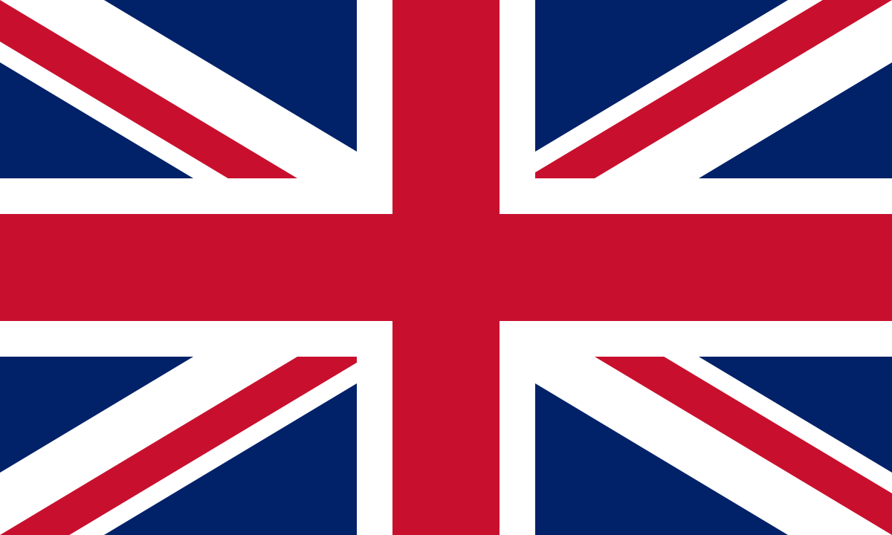
Q2:
Option: The UK/ The USA/ China
Answer: The United Kingdom

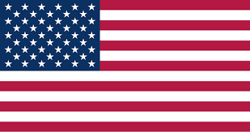
Q3:
Option: The UK/ The USA/ China
Answer: The USA

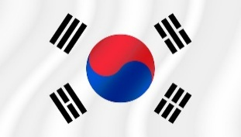
Q4:
Option: Japan/ The USA/ Korea
Answer: South Korea

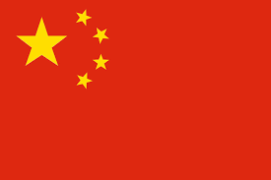
Q5:
Option: Indonesia/ Japan/ China
Answer: China

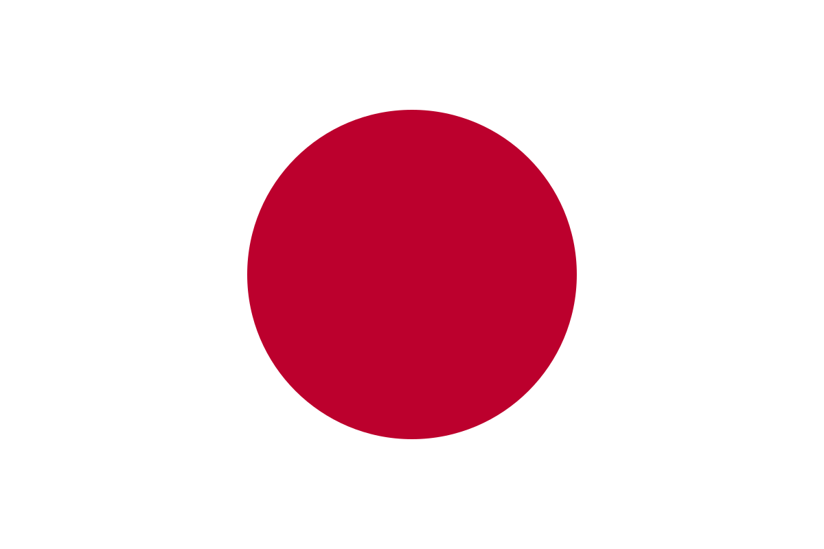
Q6:
Option: Indonesia/ Japan/ The USA
Answer: Japan

Match the flags to the nationalities
Instructions: Choose the correct answer for each image.
picture :
Q1:
Option: Indonesian/ Korean / Chinese

Answer: Indonesian

Q2:
Option: British / Chinese / American

Answer: British
Q3:
Option: American/ British / Korean

Answer: American

Q4:
Option: Indonesian / Korean / Chinese

Answer: Korean

Q5:
Option: Japanese / Korean / Chinese

Answer: Chinese

Q6:
Option: : Indonesian/ Japanese / Chinese

Answer: Japanese

Set 2: Structure recognition
- Guessing the country (What country am I?)
Instructions: guess the country from the riddle
Sentences & options:
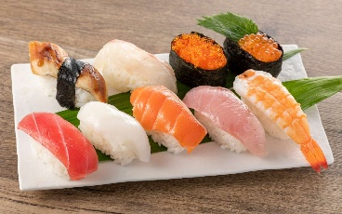
Q1:

- I’m famous for sushi and cherry blossoms.
- People here are very polite.
What country am I?
Answer: Japan

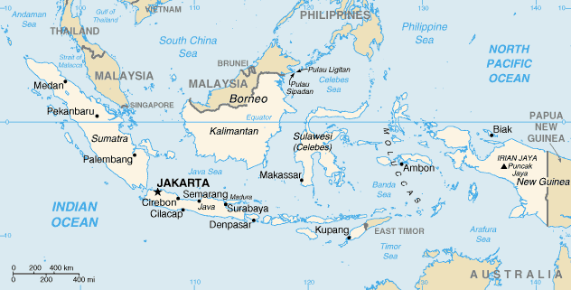
Q2:

- I’m made up of thousands of islands.
- My capital is Jakarta.
- What country am I?
Answer: Indonesia
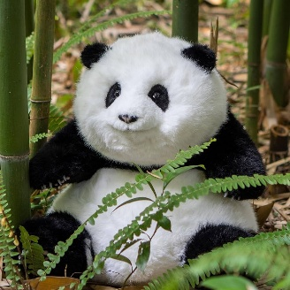

Q3:

- I have the Great Wall.
- It is where pandas live.
- What country am I?
Answer: China

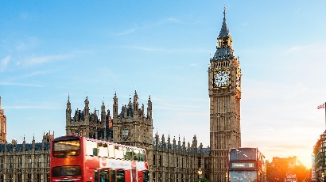
Q4:

- It is where people speak English.
- My place has Big Ben.
- What country am I?
Answer: The UK


Q5:

- My people love K-pop and kimchi.
- My place has Seoul as the capital city.
- What country am I?
Answer: South Korea

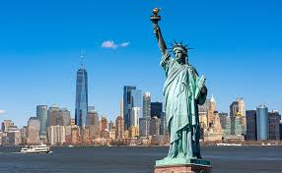
Q6:

- My flag has stars and stripes.
- My place has the Statue of Liberty.
- What country am I?
Answer: The USA

- Fill in the blanks with the correct form of “to be”
Instructions: Read and choose the correct answer.
Questions & options:

Q1: I ___ from Indonesia.
Options: am | is | are
Answer: am

Q2: He ___ from China.
Options: am | is | are
Answer: is

Q3: You ___ from the UK.
Options: am | is | are
Answer: are

Q4: Indonesia ___ a big country.
Options: am | is | are
Answer: is

Q5: My brother and I ___ Korean.
Options: am | is | are
Answer: are

Q6: Japan ____ in Asia
Options: am | is | are
Answer: is

Set 3: Fluency & accuracy (integrated skills)
- Speaking – pronunciation
Instructions: listen and repeat the words
Audio with avatar talking,
Q1:I’m a student, I’m from Mexico

Q2: I’m a singer. I’m from Vietnam.

Q3: I’m a dancer. I’m from South Korea.

Q4: I’m an actor. I’m from Australia

Q5: I’m the president of Portugal. I’m Portuguese.

Q6: They are teachers from China. They’re Chinese.

- Listening & Speaking – speech recognition
Instructions: Read and say the word
a name of a country shown, speech recognition
Q1: Spain
Answer: Spain

Q2: The United States of America
Answer: The United States of America

Q3: Japan
Answer: Japan

Q4: China
Answer: China

Q5: The United Kingdom
Answer: The United Kingdom

Q6: South Korea
Answer: South Korea

Set 4: Writing
- Writing
Instructions: Write a paragraph about your idol
Questions
Prompt:
My idol is Lalisa Manoban. She is a member of Blackpink. She is from Thailand. She is Thai. She is 28 years old. She is very beautiful and cute.

