DIGITAL CONTENT

Level : CEFR A2
Meeting : 3 (+ to be (are, am, is))
Unit Topic : People
Vocabulary : countries & nationalities
Grammar : -
Functional Skills : Introducing yourself and other people

Set 1: Vocabulary acquisition
- Matching – country & nationality
Instructions: Choose the correct nationality for each country.
picture :

Q1:

Japan
Option: American, Japanese, Chinese, Korean, Indonesian, British
Answer: Japanese

Q2:

China
Option: American, Japanese, Chinese, Korean, Indonesian, British
Answer: Chinese

Q3:

South Korea
Option: American, Japanese, Chinese, Korean, Indonesian, British
Answer: Korean


Q4:

The United Kingdom
Option: American, Japanese, Chinese, Korean, Indonesian, British
Answer: British


Q5:

The USA
Option: American, Japanese, Chinese, Korean, Indonesian, British
Answer: American

Q6:

Indonesia
Option: American, Japanese, Chinese, Korean, Indonesian, British
Answer: Indonesian

- Categorising/ grouping (suffixes for nationalities)
Instructions: Choose the nationalities with the same suffix.
Q1: -(i)an: _________
Option : American, Japanese, Chinese, Korean, Indonesian, British
Answer: Indonesian, Korean, American

Q2: -ese: _________
Option : American, Japanese, Chinese, Korean, Indonesian, British
Answer: Indonesian, Korean, American

Q3: : -ish: _________

Option : American, Japanese, Chinese, Korean, Indonesian, British
Answer: British

Set 2: Structure recognition
- Word order
Instructions: Drag the words to make a correct sentence.
Sentences :
Q1: American / am / I
Answer: I am American.

Q2: British / friend / my / is
Answer: My friend is Vietnamese.

Q3: Indonesian / is / singer / an / she
Answer: She is an Indonesian singer.

Q4: teacher / my / Chinese / is
Answer: My teacher is Chinese.

Q5: Korean / a / is / he / actor
Answer: He is a Korean actor

Q6: I / am / student / a / Japanese
Answer: I am a Japanese student

- Multiple choice
Instructions: Read and choose the correct answer
Questions & options:

Q1: My idol is BTS. They are from South Korea. They are …..
Option: Chinese/ Korean/ Indonesian
Answer: Korean

Q2: My favorite singer is Taylor Swift. She is from the USA. She is ….
Options: American / Japanese / British
Answer: American

Q3: My president is Prabowo. He is from Indonesian. He is from…
Options: Indonesia / Japan / China
Answer: Indonesia

Q4: My favorite actor is Jackie Chan. He is from China. He is ….
Options: Chinese / Korean / Japanese
Answer: Chinese

Q5: My favorite actor is Daniel Radcliffe. He is British. He is from….
Options: The USA / Japan / The UK
Answer: The UK

Set 3: Fluency & accuracy (integrated skills)
- True or false
Instructions: match the sentence with the picture. Choose if it’s true or false
Sentence shown
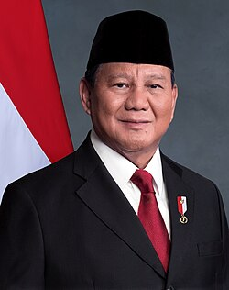

Q1: I’m the president of Indonesia.
Answer: True

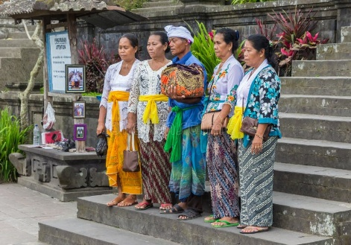

Q2: I’m from South Korea. I’m Korean.
Answer: False



Q3: My teacher is Chinese
Answer: True



Q4: We are football players from the UK.
Answer: True



Q5: I’m a student, I live in the USA.
Answer: False

- Listen and type
Instructions: listen and type the answer
Audio played, students type after audio played
Q1: She is Indonesian. She is from …..
Answer: Indonesia

Q2: They are from The USA, they are …...
Answer: American

Q3: Her mom is Chinese. She is from …..
Answer: China

Q4: Their teacher is British. She is from……
Answer: The UK

Q5: My friend Ken is from Japan. He is ……
Answer: Japanese

Q6: my favourite idol is from South Korea. They are….
Answer: Korean

Set 4: multiple choice

- 3 option multiple choice
Instructions: for each questions choose the correct answer
multiple choice

