DIGITAL CONTENT

Level : CEFR A2
Meeting : 5 (family member & be negative)
Unit Topic : People
Vocabulary : family members
Grammar : -
Functional Skills :

Set 1: Vocabulary acquisition
- Listening comprehension
Instructions: Choose the word you hear.
Audio with avatar talking, the spelling is shown in a bubble.
Q1: “mother”
option: mother / father/ brother
Answer: mother

Q2: : “father”
option: sister / father/ brother
Answer: father

Q3: : “brother”
option: sister / father/ brother
Answer: brother

Q4: : “cousin”
option: sister / uncle / cousin
Answer: cousin

Q5: : “grandmother”
option: sister / grandmother / cousin
Answer: grandmother

Q6: : “uncle”
option: uncle / sister / cousin
Answer: uncle

- Match the picture with the family member
Instructions: Choose the correct family member from the picture.
picture & option:

Q1:

Option: sister/ mother / brother

Answer: sister



Q2:
Option: grandmother/ father / mother

Answer: father


Q3:
Option: grandmother/ uncle / father

Answer: grandmother


Q4:
Option: uncle / mother / grandmother

Answer: mother


Q5:
Option: sister / grandmother / uncle

Answer: uncle

Set 2: Structure recognition
- True or false
Instructions: Read and look at the picture, then choose whether it’s true or false.
Picture and description:

Q1:

This is me, my mother and my father.
Option: true / false
Answer: True

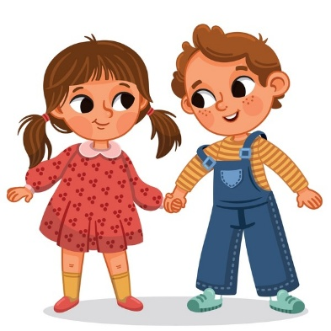
Q2:

This is me and my father.
Option: true / false
Answer: False
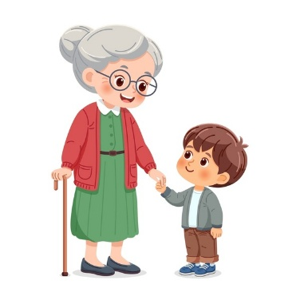

Q3:

My grandma is not in the picture
Option: true / false
Answer: False


Q4:

This is my family, there are 6 of us
Option: true / false
Answer: True
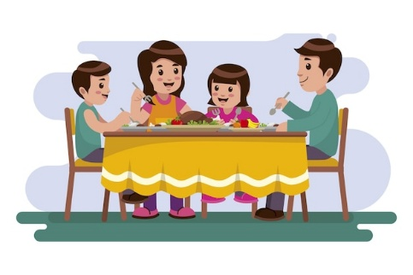
Q5:

My family is having dinner together
Option: true / false
Answer: True

- Fill-in the blanks with correct to be
Instructions: Look at the picture and fill in the blank with the correct form of “to be” (is / are).
Questions and pictures:
Q1:

She _____ my sister
Answer: is

Q2:

He _____ not my grandfather
Answer: is

Q3:

they _____ my mother and father
Answer: are

Q4:

She _____ not my grandmother
Answer: is

Q5:

You _____ not my father
Answer: are

Set 3: Fluency & accuracy (integrated skills)
- True or false
Instructions: listen and choose if it’s true or false
Audio:
Q1: Your sister is your parents’ daughter.
Option: true / false
Answer: true

Q2: Your grandmother is your father’s mother
Option: true / false
Answer: true

Q3: Your uncle is not your mother’s or father’s brother.
Option: true / false
Answer: false

Q4: Your cousin is your brother’s child.
Option: true / false
Answer: false

Q5: Your mother is the woman who takes care of you and loves you.
Option: true / false
Answer: true

- Pronunciation
Instructions: repeat the sentence
Audio played and speech recognition
Q1: I love my family
Answer: I love my family

Q2: my uncle is not from China
Answer: my uncle is not from China

Q3: I have 2 sisters
Answer: I have 2 sisters

Q4: She’s not my mother
Answer: she is not my mother

Q5: my grandmother is not young
Answer: my grandmother is not young

Q6: they’re not my cousins
Answer: they’re not my cousins

Set 4: Writing
Instructions: Insert a picture and describe your family.
Student can add picture of their family
Prompt:
This is my family. I have a father, a mother, and one sister. We are Indonesian.
My father is a teacher, and my mother is a nurse.

