1. MongoDB Usage
Local connectivity test using mongo 127.0.0.1:27017was successful.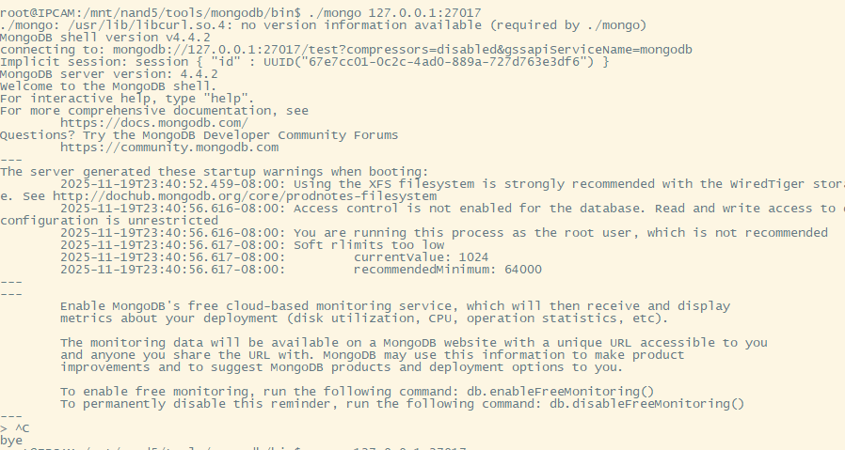

2. RabbitMQ Usage, actual port tested is 15672
Check that the cookie on the server and the CLI tool are consistent, and permissions must be 400.
find / -name .erlang.cookie 2>/dev/null
cp /.erlang.cookie /root/.erlang.cookie
chmod 400 /root/.erlang.cookie
rabbitmqctl status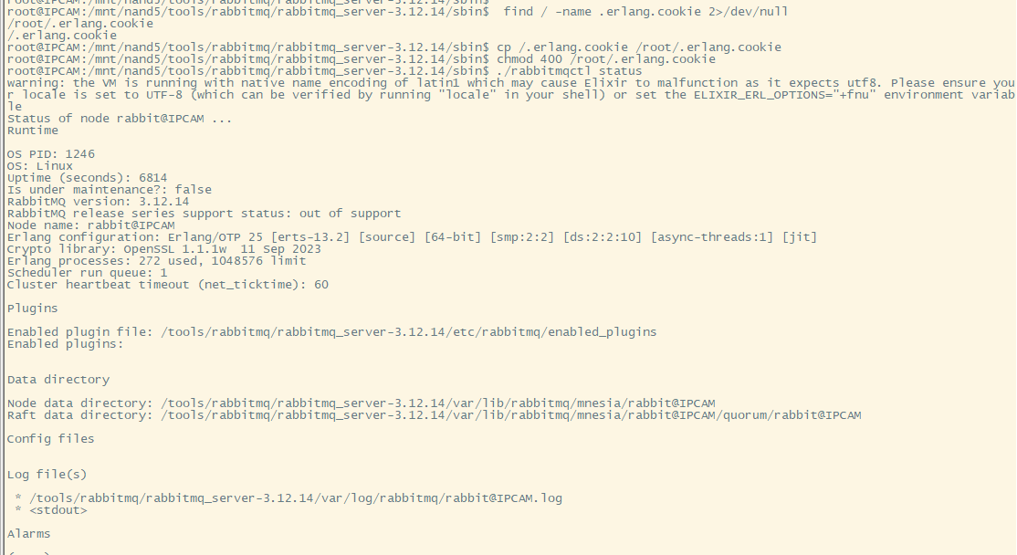
rabbitmq-plugins enable rabbitmq_management
Username: guest
Password: guest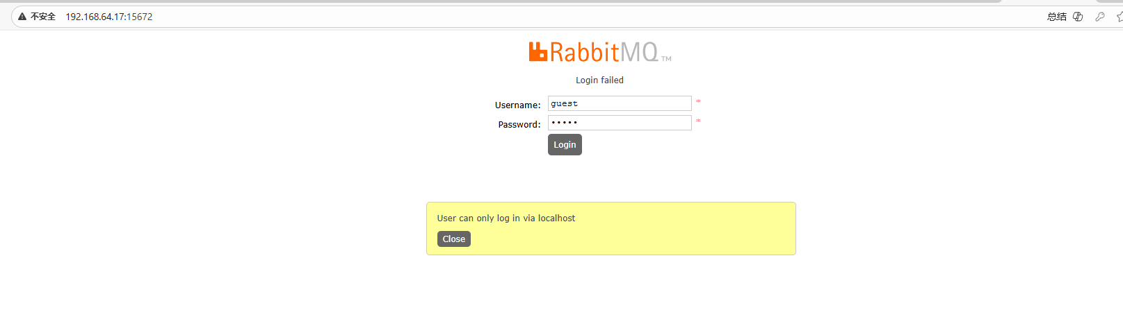
Add a test account (Create your own user and password based on actual usage):
rabbitmqctl add_user myuser mypassword
rabbitmqctl set_user_tags myuser administrator
rabbitmqctl set_permissions -p / myuser ".*" ".*" ".*"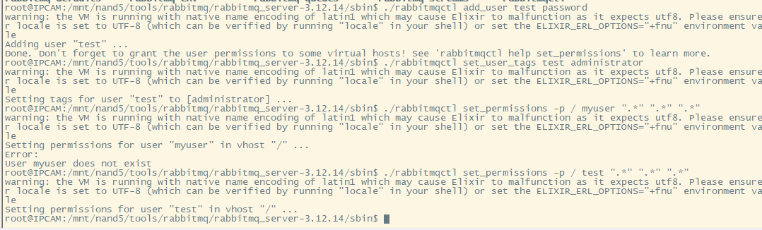
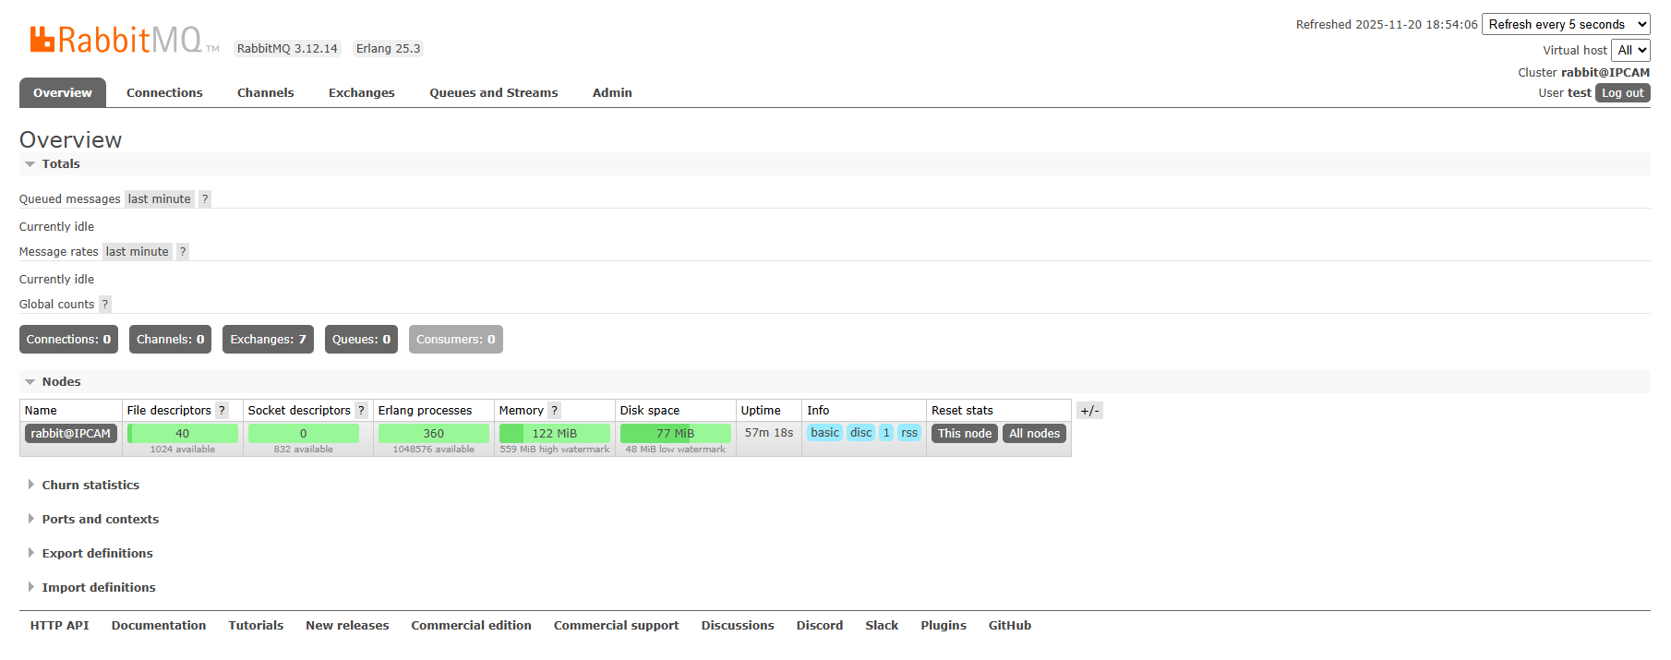

3. haproxy Usage
Navigate to the /mnt/nand5/tools/haproxydirectory (the haproxy.cfgconfiguration can be added or modified based on usage)../haproxy -f haproxy.cfg -db
Browser can connect normally.

4. Nginx Usage
nginx -c /tools/nginx/conf/nginx.conf -p /tools/nginx(The nginx.confconfiguration can be created or changed based on actual use; the default template was used for testing).
Browser can connect normally.

5. The storage partition is /mnt/mmc. Memory size can be allocated according to quota needs, then use this partition.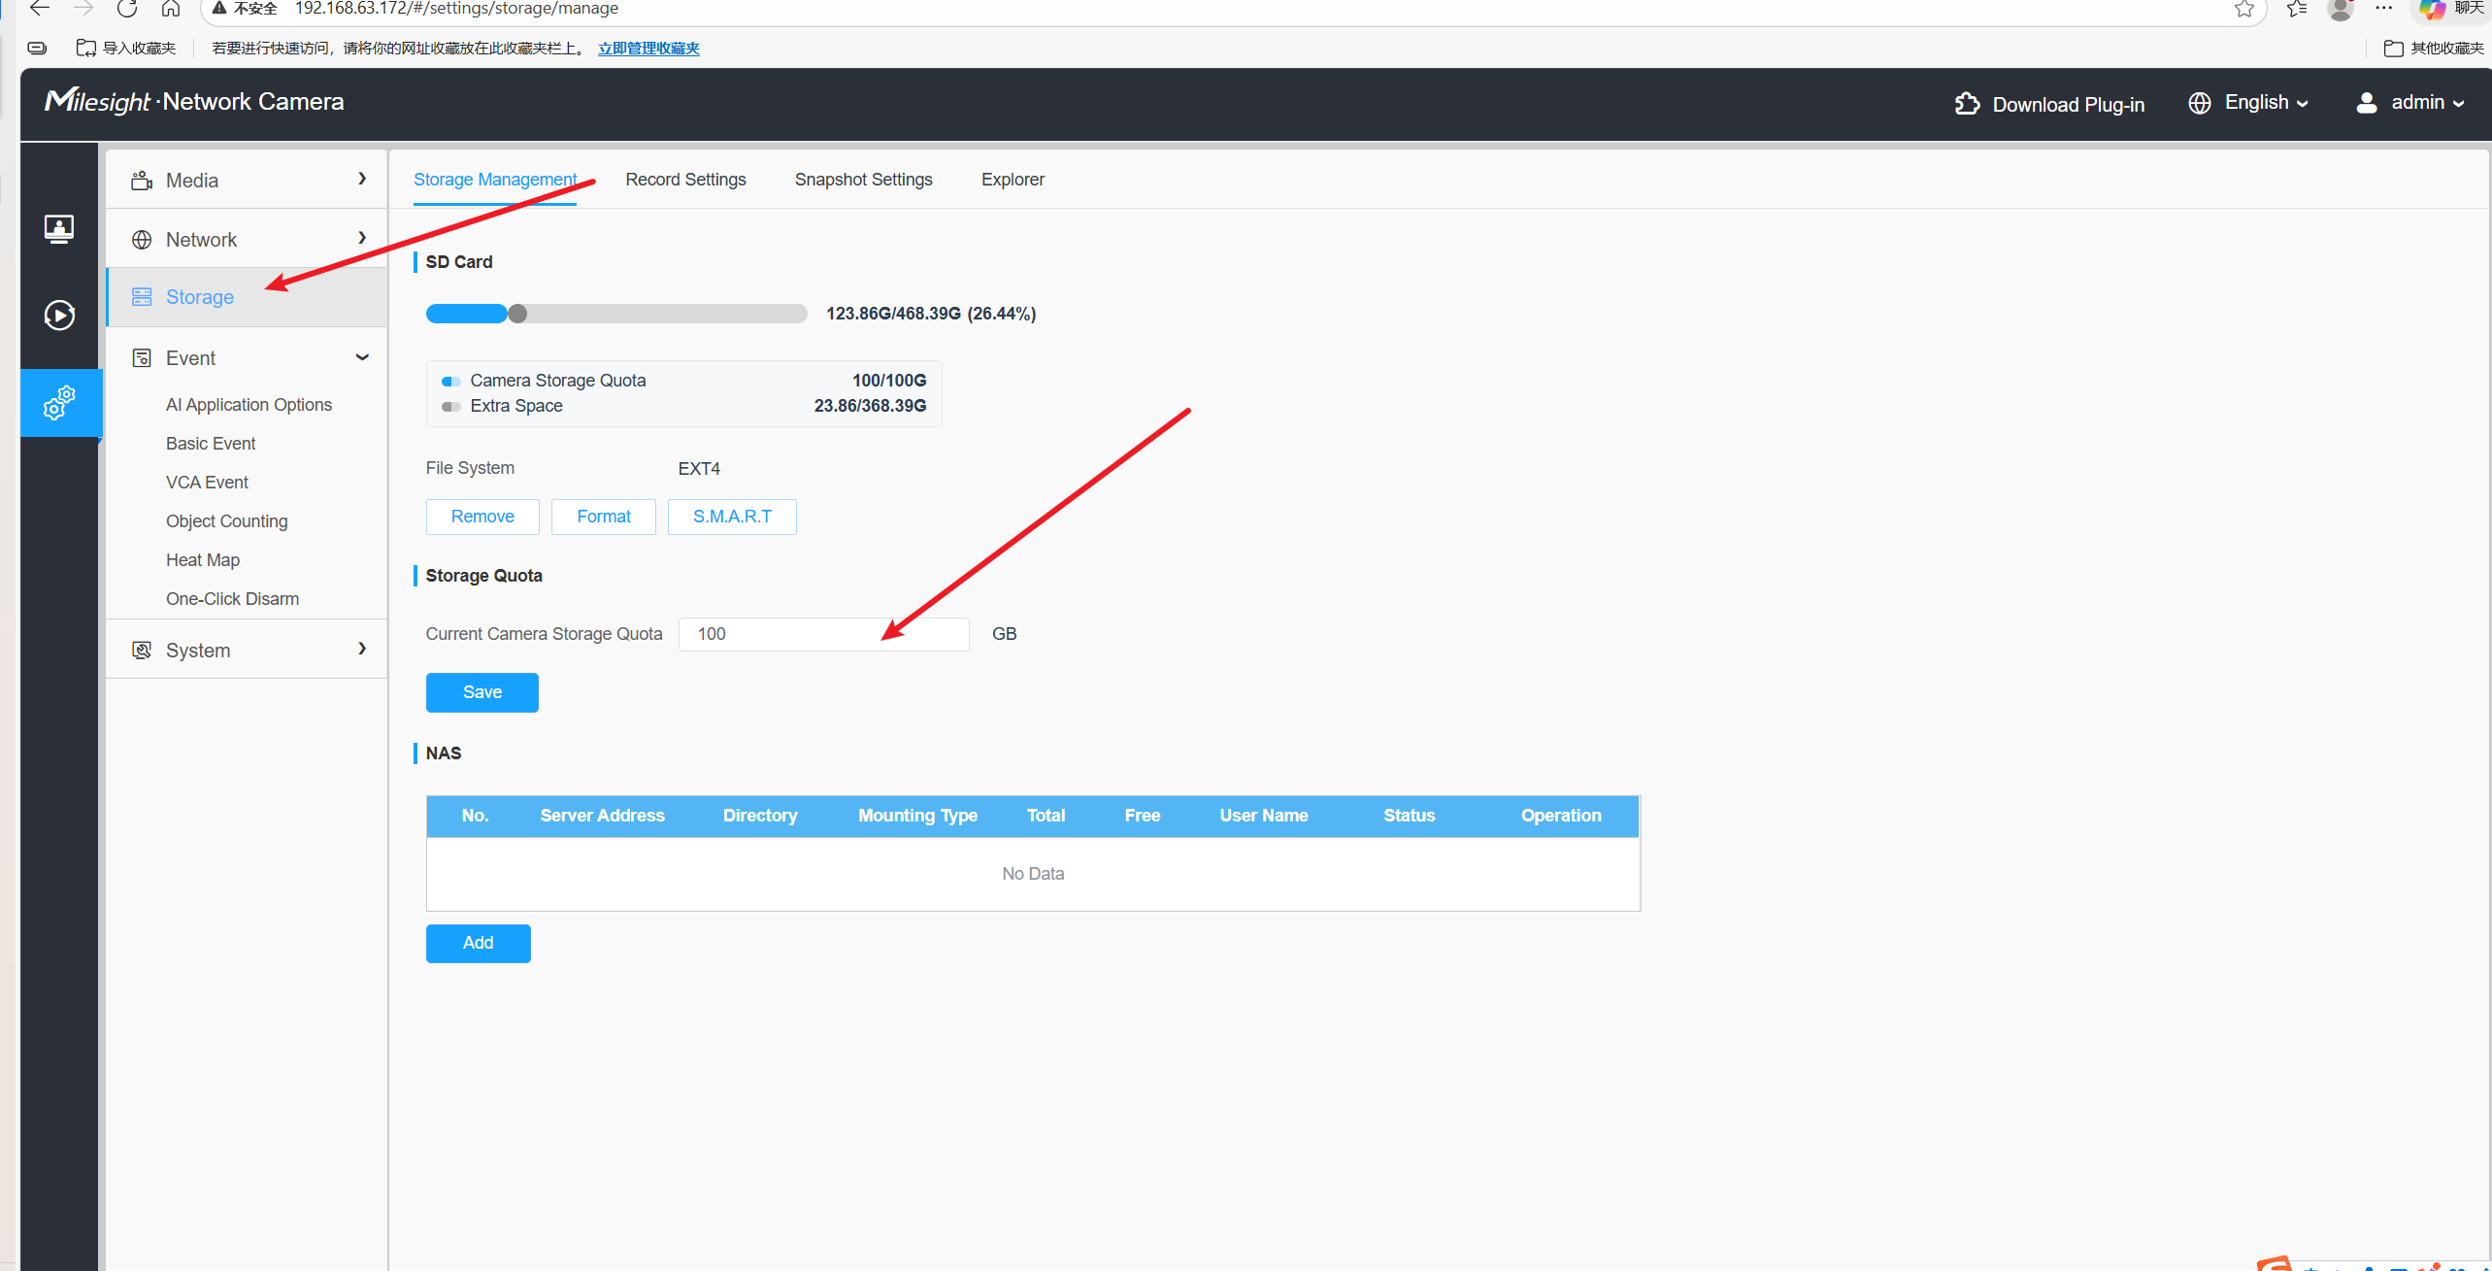

6. SSH Login
Username: root
Password: test1234

