DriverPass System Design Document
CS 255 Project Two | UML diagrams and technical requirements for the DriverPass platform
Prepared for review and client presentation planning

This document presents the proposed system design for DriverPass, an online platform that combines DMV based practice testing, lesson scheduling, progress tracking, and administrative support. The design uses a blended modeling approach that shows how users interact with the system, how major workflows operate, and what technical components are required to support the solution.

UML Diagrams

UML Use Case Diagram
The use case diagram identifies the major people and connected systems that interact with DriverPass. It shows that the platform must support student account access, practice testing, lesson scheduling, progress viewing, content maintenance, and business administration.
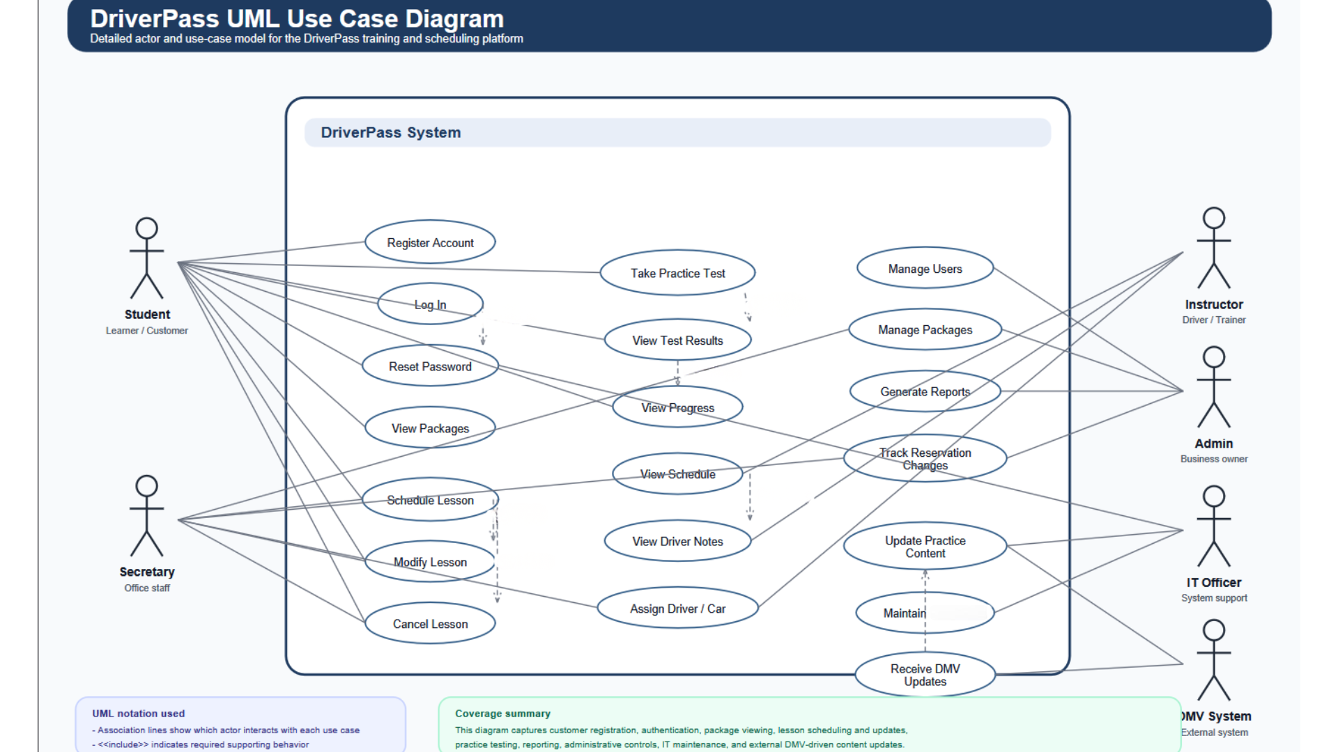
Figure 1. DriverPass use case diagram
The diagram reflects the needs of students, office staff, instructors, administrators, IT support, and the external DMV update source. Together, these interactions establish the core scope of the system.

UML Activity Diagrams

Activity Diagram 1: Schedule Lesson
This activity diagram breaks down the lesson scheduling process. It begins when a student signs in and reviews available time slots, then checks whether the student has an active package and whether the requested time is open. If a valid selection is made, the system creates the request, assigns resources, and sends a confirmation.
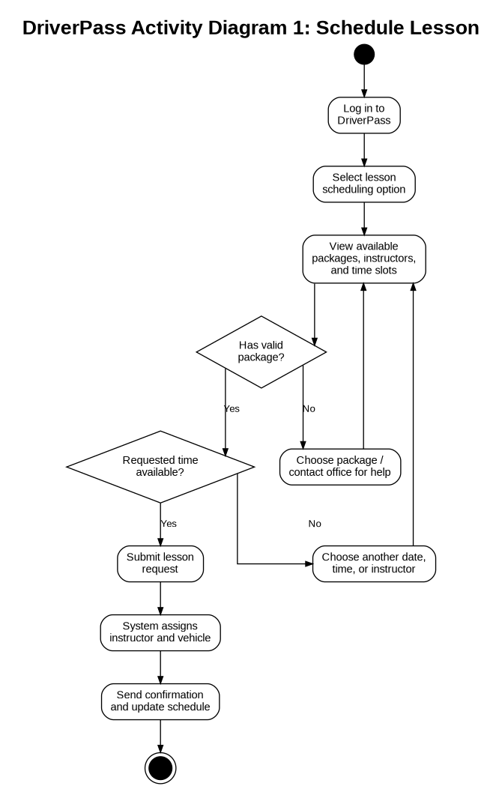
Figure 2. Activity diagram for scheduling a lesson

Activity Diagram 2: Take Practice Test
This activity diagram shows how a student completes an online practice test. The system loads current DMV based questions, presents them one at a time, and records the answers until the test is submitted. After submission, the system scores the test and updates the student’s results and progress information.
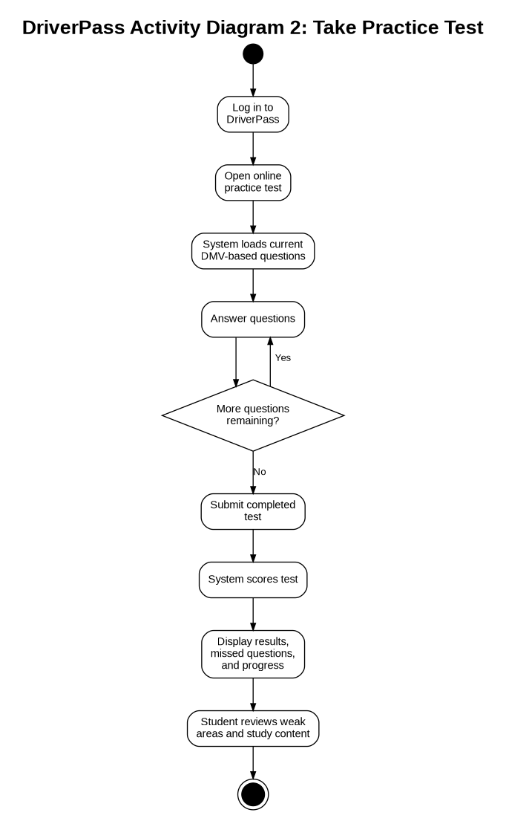
Figure 3. Activity diagram for taking a practice test

UML Sequence Diagram
The sequence diagram focuses on the schedule lesson use case because it involves several coordinated system interactions. It shows how the student request moves through the DriverPass portal, scheduling service, package validation, vehicle assignment, and confirmation process.
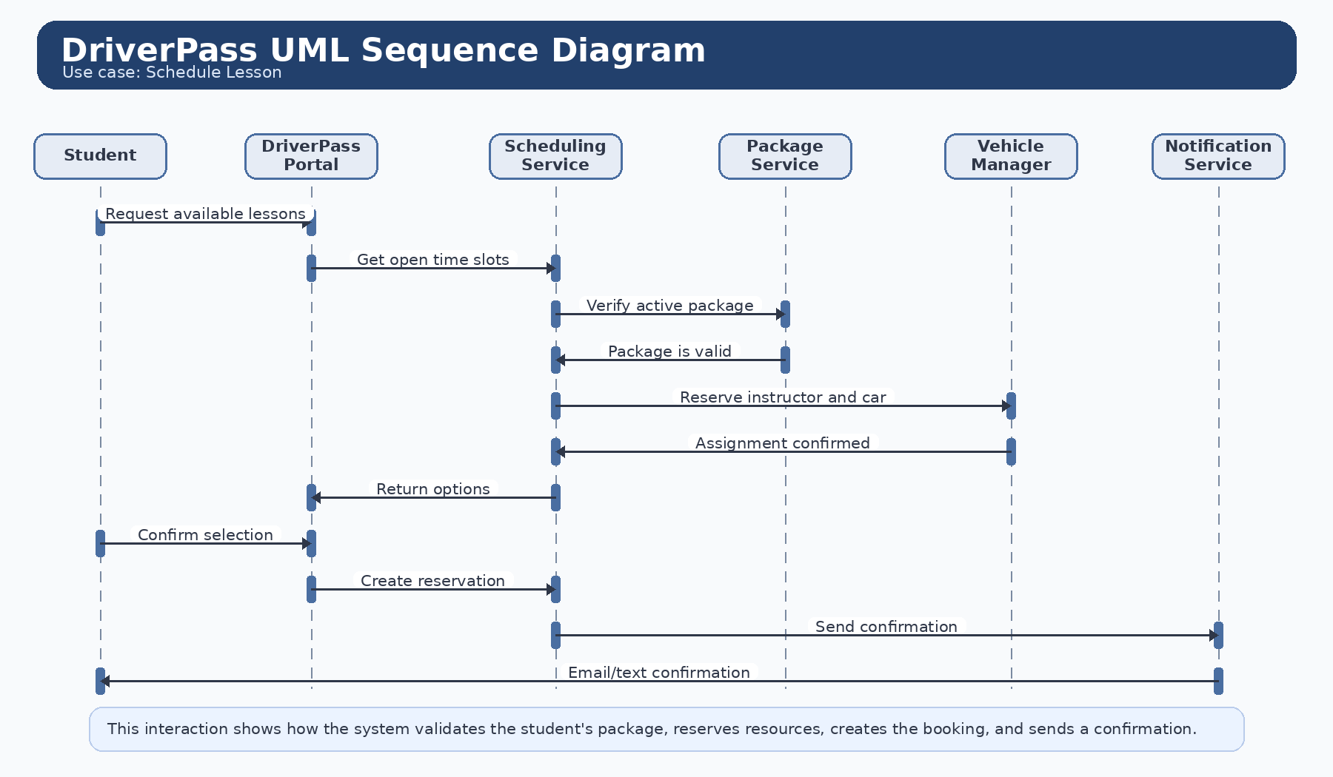
Figure 4. Sequence diagram for scheduling a lesson

UML Class Diagram
The class diagram identifies the main classes needed to support the design and the relationships between them. The model centers on a shared user record, specialized user roles, lessons, reservations, practice tests, and progress tracking.
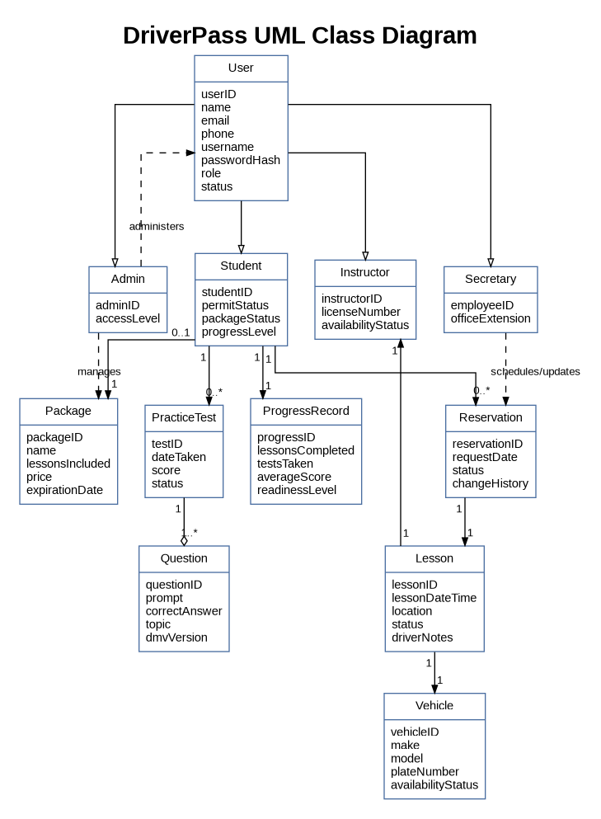
Figure 5. DriverPass class diagram

Technical Requirements
The following technical requirements are based on the behavior shown in the UML diagrams. These requirements describe the hardware, software, tools, and infrastructure needed to support a secure and reliable DriverPass implementation.

Hardware
- Cloud hosted application and database servers capable of supporting concurrent student and staff access.
- Staff workstations for secretaries, administrators, instructors, and IT support to manage schedules, reports, and updates.
- Student compatible end user devices such as laptops, tablets, or smartphones with internet access.
- Reliable storage capacity for user accounts, lesson schedules, progress data, and practice test history.

Software
- A web based application that supports account registration, login, lesson scheduling, online practice testing, and progress tracking.
- A relational database management system to store users, packages, reservations, lesson records, and assessment results.
- Secure browser support with HTTPS, session management, and role-based access control.
- Administrative tools to update practice content when DMV rules or test questions change.

Tools
- UML and design tools such as Lucidchart for diagram creation and design communication.
- Source control and deployment tools to manage application updates and reduce release risk.
- Monitoring, backup, and logging tools to support troubleshooting, uptime visibility, and recovery.
- Testing tools for validating login, scheduling, reporting, and security related behavior before release.

Infrastructure
- A secure hosted environment with network availability, SSL/TLS encryption, and routine backup procedures.
- Role based permissions so each user type only sees the features and records needed for that job.
- Integration support for receiving updated DMV content and refreshing practice materials.
- Notification services such as email or text messaging to confirm reservations and communicate schedule changes.

Summary
Overall, the proposed DriverPass system requires a secure web platform, reliable scheduling and data storage services, current practice test content, and administrative controls that support both staff operations and student learning. These technical requirements align with the diagrams and support DriverPass’s goal of helping students prepare for the DMV exam while also simplifying lesson management.

