|  |  |  |
| --- | --- | --- |
|  | | |
| Федеральное государственное бюджетное  образовательное учреждение высшего образования «Новосибирский государственный технический университет» | | |
|  | | |
| Кафедра теоретической и прикладной информатики | | |
| Лабораторная работа № 4 | | |
| по дисциплине «Операционные системы и компьютерные сети» | | |
| **Анализ структуры кадра/фрейма технологии Ethernet** | | |
|  | | |
|  | Бригада 4 | Лойченко ДАНИЛА |
| ПМ-12 | Ушатов сергей |
|  |
|  |
|  |
|  |
| Преподаватели | Кобылянский валерий григорьевич |
|  | Сивак Мария алексеевна |
| Новосибирск, 2024 | | |

1. **Цель работы**

Спроектировать и реализовать программу, выполняющую анализ структуры кадра/фрейма технологии Ethernet.

1. **Ход выполнения**

Разработать и отладить программу, выполняющую анализ потока кадров. Потокикадров представлены в виде файлов двоичного формата, место нахождения которых уточняется у преподавателя. В кадрах отсутствует преамбула и контрольная сумма, для исходящего кадра длина может быть меньше минимальной. Каждая бригада выполняет обработку одного файла с именем ethersXX.bin, где ХХ – номер бригады.

При выполнении работы в дистанционном режиме в обязательном порядке выполнить анализ файлов ethers06.bin и ethers07.bin.

#include <iostream>

#include <vector>

#include <fstream>

#include <windows.h>

#include <map>

#include <iomanip>

using namespace std;

int main()

{

SetConsoleCP(1251);

SetConsoleOutputCP(1251);

map<string, UCHAR> frameNumber = { {"IPv4: ", 0}, {"DIX: ", 0}, {"RAW: ", 0}, {"SNAP: ", 0}, {"LLC: ", 0}, {"ARP: ", 0} };

ifstream in;

ofstream out("frames_info.txt");

string filename;

cout << "Input filename: ";

cin >> filename;

in.open(filename, ios::binary); //ios::binary гарантирует, что данные считываются или записываются без перевода символов новой строки

in.seekg(0, ios_base::end); // Определение размера файла. Функция считывания с начала до конца файла

int fileSize = in.tellg(); // Функция-член tellg возвращает текущую позицию в файле для чтения (мы в конце файла)

in.seekg(0); // Вернуться в начало

// Считывание текста

vector<UCHAR> data(istreambuf_iterator<char>(in), {}); // Запись всего файла в вектор

in.close();

out << "File size of " << filename << " is " << fileSize << " byte" << endl;

out << endl;

int byte = 0; // Номер текущего байта

int frameCount = 0; // Количество фреймов

while (byte < data.size())

{

frameCount++;

out << "Frame №: " << frameCount << endl; // Вывод номера фрейма

out << hex << uppercase;

for (bool check = true; check;) // Проверка МАС-адреса на пустоту

{

for (int ptr = byte; ptr < (byte + 6) && check; ptr++) //Ищем MAC-адрес в первых 6 байтах

if (data[ptr] != 0)

check = false;

if (check)

byte += 6;

}

out << "MAC address of the recipient: "; // Выводим MAC-адрес назначения

for (UCHAR i = 0; i < 5; i++)

out << setw(2) << setfill('0') << (int)data[byte + i] << ':'; // Вывод по два символа с заполнением пробелов нулями

out << setw(2) << setfill('0') << (int)data[byte + 5] << endl;

out << "MAC address of the sender: "; // Выводим MAC-адрес источника

for (UCHAR i = 6; i < 11; i++)

out << setw(2) << setfill('0') << (int)data[byte + i] << ':';

out << setw(2) << setfill('0') << (int)data[byte + 11] << endl;

out << dec;

USHORT BN = (data[byte + 12] << 8) + data[byte + 13]; // Определение типа фрейма

if (BN > 0x05DC)

{

out << "Type of frame: DIX (Ethernet II)" << endl;

frameNumber["DIX"]++;

USHORT frameSize = 0;

if (BN == 0x0800)

{

out << "Protocol: IPv4" << endl;

frameNumber["IPv4"]++;

out << "IP address of the sender: ";

out << (int)data[byte + 26] << '.';

out << (int)data[byte + 27] << '.';

out << (int)data[byte + 28] << '.';

out << (int)data[byte + 29] << endl;

out << "IP address of the recipient: ";

out << (int)data[byte + 30] << '.';

out << (int)data[byte + 31] << '.';

out << (int)data[byte + 32] << '.';

out << (int)data[byte + 33] << endl;

BN = (data[byte + 16] << 8) + data[byte + 17] + 14;

out << "Package Size: " << BN << " byte" << endl;

byte += BN;

}

else if (BN == 0x0806)

{

out << "Protocol: ARP" << endl;

frameNumber["ARP"]++;

out << hex << uppercase;

out << "MAC address of the sender: ";

for (UCHAR i = 0; i < 5; i++)

out << setw(2) << setfill('0') << (int)data[byte + 22 + i] << ':';

out << setw(2) << setfill('0') << (int)data[byte + 27] << endl;

out << dec;

out << "IP address of the sender: ";

for (int i = 0; i < 3; i++)

out << (int)data[byte + 28 + i] << '.';

out << (int)data[byte + 31] << endl;

out << hex << uppercase;

out << "MAC address of the recipient: ";

for (UCHAR i = 0; i < 5; i++)

out << setw(2) << setfill('0') << (int)data[byte + 32 + i] << ':';

out << setw(2) << setfill('0') << (int)data[byte + 37] << endl;

out << dec;

out << "IP address of the recipient: ";

for (int i = 0; i < 3; i++)

out << (int)data[byte + 38 + i] << '.';

out << (int)data[byte + 41] << endl;

out << dec;

byte += 42;

}

else

byte += BN + 14;

}

else

{

USHORT LLC = (data[byte + 14] << 8) + data[byte + 15];

if (LLC == 0xFFFF)

{

frameNumber["RAW"]++;

out << "Type of frame: Ethernet Raw 802.3" << endl;

}

else if (LLC == 0xAAAA)

{

frameNumber["SNAP"]++;

out << "Type of frame: Ethernet SNAP" << endl;

}

else

{

frameNumber["LLC"]++;

out << "Type of frame: Ethernet 802.2/LLC" << endl;

}

byte += BN + 14;

}

out << endl;

}

out << "Total frames: " << frameCount << endl << endl;

out << "Type of frames:" << endl;

out << "DIX (Ethernet II): " << (int)frameNumber["DIX"] << endl;

out << "Ethernet Raw 802.3 (Novell 802.3): " << (int)frameNumber["RAW"] << endl;

out << "Ethernet SNAP: " << (int)frameNumber["SNAP"] << endl;

out << "Ethernet 802.2 / LLC: " << (int)frameNumber["LLC"] << endl;

out << "IPv4: " << (int)frameNumber["IPv4"] << endl;

out << "ARP: " << (int)frameNumber["ARP"] << endl;

out.close();

cout << "The program has finished working!";

return 0;

}

**Результат работы программы**

|  |  |  |
| --- | --- | --- |
| ethers04.bin | ethers06.bin | ethers07.bin |
| File size of ethers04.bin is 1891 byte  Frame №: 1  MAC address of the recipient: 00:02:16:09:FA:40  MAC address of the sender: 00:90:27:A1:36:D0  Type of frame: DIX (Ethernet II)  Protocol: IPv4  IP address of the sender: 195.62.2.11  IP address of the recipient: 83.222.15.90  Package Size: 54 byte  Frame №: 2  MAC address of the recipient: 00:02:16:09:FA:40  MAC address of the sender: 00:90:27:A1:36:D0  Type of frame: DIX (Ethernet II)  Protocol: IPv4  IP address of the sender: 195.62.2.11  IP address of the recipient: 83.222.15.90  Package Size: 54 byte  Frame №: 3  MAC address of the recipient: 00:02:16:09:FA:40  MAC address of the sender: 00:90:27:A1:36:D0  Type of frame: DIX (Ethernet II)  Protocol: IPv4  IP address of the sender: 195.62.2.11  IP address of the recipient: 83.222.15.90  Package Size: 54 byte  Frame №: 4  MAC address of the recipient: 00:16:17:A8:C2:4C  MAC address of the sender: 00:02:16:09:FA:40  Type of frame: DIX (Ethernet II)  Protocol: IPv4  IP address of the sender: 217.22.165.203  IP address of the recipient: 195.62.2.49  Package Size: 54 byte  Frame №: 5  MAC address of the recipient: 00:16:B6:B8:2B:1A  MAC address of the sender: 00:02:16:09:FA:40  Type of frame: DIX (Ethernet II)  Protocol: IPv4  IP address of the sender: 217.22.165.203  IP address of the recipient: 195.62.2.6  Package Size: 54 byte  Frame №: 6  MAC address of the recipient: 00:90:27:A1:36:D0  MAC address of the sender: 00:02:16:09:FA:40  Type of frame: DIX (Ethernet II)  Protocol: IPv4  IP address of the sender: 81.181.78.206  IP address of the recipient: 195.62.2.11  Package Size: 82 byte  Frame №: 7  MAC address of the recipient: 00:90:27:A1:36:D0  MAC address of the sender: 00:16:17:A8:C2:4C  Type of frame: DIX (Ethernet II)  Protocol: IPv4  IP address of the sender: 195.62.2.49  IP address of the recipient: 195.62.2.11  Package Size: 54 byte  Frame №: 8  MAC address of the recipient: 00:90:27:A1:36:D0  MAC address of the sender: 00:16:17:A8:C2:4C  Type of frame: DIX (Ethernet II)  Protocol: IPv4  IP address of the sender: 195.62.2.49  IP address of the recipient: 195.62.2.11  Package Size: 54 byte  Frame №: 9  MAC address of the recipient: 00:90:27:A1:36:D0  MAC address of the sender: 00:16:17:A8:C2:4C  Type of frame: DIX (Ethernet II)  Protocol: IPv4  IP address of the sender: 195.62.2.49  IP address of the recipient: 195.62.2.11  Package Size: 54 byte  Frame №: 10  MAC address of the recipient: 00:90:27:A1:36:D0  MAC address of the sender: 00:16:17:A8:C2:4C  Type of frame: DIX (Ethernet II)  Protocol: IPv4  IP address of the sender: 195.62.2.49  IP address of the recipient: 195.62.2.11  Package Size: 54 byte  Frame №: 11  MAC address of the recipient: 00:90:27:A1:36:D0  MAC address of the sender: 00:16:17:A8:C2:4C  Type of frame: DIX (Ethernet II)  Protocol: IPv4  IP address of the sender: 195.62.2.49  IP address of the recipient: 195.62.2.11  Package Size: 54 byte  Frame №: 12  MAC address of the recipient: 00:02:16:09:FA:40  MAC address of the sender: 00:90:27:A1:36:D0  Type of frame: DIX (Ethernet II)  Protocol: IPv4  IP address of the sender: 195.62.2.11  IP address of the recipient: 81.181.78.206  Package Size: 66 byte  Frame №: 13  MAC address of the recipient: 00:90:27:A1:36:D0  MAC address of the sender: 00:02:16:09:FA:40  Type of frame: DIX (Ethernet II)  Protocol: IPv4  IP address of the sender: 83.222.15.90  IP address of the recipient: 195.62.2.11  Package Size: 92 byte  Frame №: 14  MAC address of the recipient: 00:16:17:A8:C2:4C  MAC address of the sender: 00:90:27:A1:36:D0  Type of frame: DIX (Ethernet II)  Protocol: IPv4  IP address of the sender: 195.62.2.11  IP address of the recipient: 195.62.2.49  Package Size: 92 byte  Frame №: 15  MAC address of the recipient: 00:90:27:A1:36:D0  MAC address of the sender: 00:16:17:A8:C2:4C  Type of frame: DIX (Ethernet II)  Protocol: IPv4  IP address of the sender: 195.62.2.49  IP address of the recipient: 195.62.2.11  Package Size: 1019 byte  Total frames: 15  Type of frames:  DIX (Ethernet II): 15  Ethernet Raw 802.3 (Novell 802.3): 0  Ethernet SNAP: 0  Ethernet 802.2 / LLC: 0  IPv4: 15  ARP: 0 | File size of ethers06.bin is 1118 byte  Frame №: 1  MAC address of the recipient: 00:90:27:A1:36:D0  MAC address of the sender: 00:02:16:09:FA:40  Type of frame: DIX (Ethernet II)  Protocol: IPv4  IP address of the sender: 81.181.78.206  IP address of the recipient: 195.62.2.11  Package Size: 218 byte  Frame №: 2  MAC address of the recipient: 00:02:16:09:FA:40  MAC address of the sender: 00:90:27:A1:36:D0  Type of frame: DIX (Ethernet II)  Protocol: IPv4  IP address of the sender: 195.62.2.11  IP address of the recipient: 81.181.78.206  Package Size: 66 byte  Frame №: 3  MAC address of the recipient: 01:80:C2:00:00:00  MAC address of the sender: 00:04:4D:8A:B0:D5  Type of frame: Ethernet 802.2/LLC  Frame №: 4  MAC address of the recipient: 00:90:27:A1:36:D0  MAC address of the sender: 00:02:16:09:FA:40  Type of frame: DIX (Ethernet II)  Protocol: IPv4  IP address of the sender: 81.181.78.206  IP address of the recipient: 195.62.2.11  Package Size: 210 byte  Frame №: 5  MAC address of the recipient: 01:80:C2:00:00:00  MAC address of the sender: 00:04:4D:8A:B0:C3  Type of frame: Ethernet 802.2/LLC  Frame №: 6  MAC address of the recipient: 01:80:C2:00:00:00  MAC address of the sender: 00:04:4D:8A:B0:C4  Type of frame: Ethernet 802.2/LLC  Frame №: 7  MAC address of the recipient: 01:80:C2:00:00:00  MAC address of the sender: 00:04:4D:8A:B0:C5  Type of frame: Ethernet 802.2/LLC  Frame №: 8  MAC address of the recipient: 01:80:C2:00:00:00  MAC address of the sender: 00:04:4D:8A:B0:C8  Type of frame: Ethernet 802.2/LLC  Frame №: 9  MAC address of the recipient: 01:80:C2:00:00:00  MAC address of the sender: 00:04:4D:8A:B0:C9  Type of frame: Ethernet 802.2/LLC  Frame №: 10  MAC address of the recipient: 01:80:C2:00:00:00  MAC address of the sender: 00:04:4D:8A:B0:CA  Type of frame: Ethernet 802.2/LLC  Frame №: 11  MAC address of the recipient: 01:80:C2:00:00:00  MAC address of the sender: 00:04:4D:8A:B0:CB  Type of frame: Ethernet 802.2/LLC  Frame №: 12  MAC address of the recipient: 01:80:C2:00:00:00  MAC address of the sender: 00:04:4D:8A:B0:CC  Type of frame: Ethernet 802.2/LLC  Frame №: 13  MAC address of the recipient: 01:80:C2:00:00:00  MAC address of the sender: 00:04:4D:8A:B0:CE  Type of frame: Ethernet 802.2/LLC  Frame №: 14  MAC address of the recipient: 01:80:C2:00:00:00  MAC address of the sender: 00:04:4D:8A:B0:CF  Type of frame: Ethernet 802.2/LLC  Frame №: 15  MAC address of the recipient: 01:80:C2:00:00:00  MAC address of the sender: 00:04:4D:8A:B0:D0  Type of frame: Ethernet 802.2/LLC  Total frames: 15  Type of frames:  DIX (Ethernet II): 3  Ethernet Raw 802.3 (Novell 802.3): 0  Ethernet SNAP: 0  Ethernet 802.2 / LLC: 12  IPv4: 3  ARP: 0 | File size of ethers07.bin is 2763 byte  Frame №: 1  MAC address of the recipient: 00:02:16:09:FA:40  MAC address of the sender: 00:90:27:A1:36:D0  Type of frame: DIX (Ethernet II)  Protocol: IPv4  IP address of the sender: 195.62.2.11  IP address of the recipient: 62.167.64.216  Package Size: 153 byte  Frame №: 2  MAC address of the recipient: 00:90:27:A1:36:D0  MAC address of the sender: 00:02:16:09:FA:40  Type of frame: DIX (Ethernet II)  Protocol: IPv4  IP address of the sender: 81.181.78.206  IP address of the recipient: 195.62.2.11  Package Size: 66 byte  Frame №: 3  MAC address of the recipient: 00:90:27:A1:36:D0  MAC address of the sender: 00:02:16:09:FA:40  Type of frame: DIX (Ethernet II)  Protocol: IPv4  IP address of the sender: 81.181.78.206  IP address of the recipient: 195.62.2.11  Package Size: 86 byte  Frame №: 4  MAC address of the recipient: 00:02:16:09:FA:40  MAC address of the sender: 00:90:27:A1:36:D0  Type of frame: DIX (Ethernet II)  Protocol: IPv4  IP address of the sender: 195.62.2.11  IP address of the recipient: 81.181.78.206  Package Size: 66 byte  Frame №: 5  MAC address of the recipient: 00:02:16:09:FA:40  MAC address of the sender: 00:90:27:A1:36:D0  Type of frame: DIX (Ethernet II)  Protocol: IPv4  IP address of the sender: 195.62.2.11  IP address of the recipient: 81.181.78.206  Package Size: 810 byte  Frame №: 6  MAC address of the recipient: 00:08:02:8F:DA:6E  MAC address of the sender: 00:02:16:09:FA:40  Type of frame: DIX (Ethernet II)  Protocol: IPv4  IP address of the sender: 205.188.9.82  IP address of the recipient: 195.62.2.42  Package Size: 252 byte  Frame №: 7  MAC address of the recipient: 00:90:27:A1:36:D0  MAC address of the sender: 00:02:16:09:FA:40  Type of frame: DIX (Ethernet II)  Protocol: IPv4  IP address of the sender: 81.181.78.206  IP address of the recipient: 195.62.2.11  Package Size: 218 byte  Frame №: 8  MAC address of the recipient: 00:02:16:09:FA:40  MAC address of the sender: 00:90:27:A1:36:D0  Type of frame: DIX (Ethernet II)  Protocol: IPv4  IP address of the sender: 195.62.2.11  IP address of the recipient: 81.181.78.206  Package Size: 66 byte  Frame №: 9  MAC address of the recipient: FF:FF:FF:FF:FF:FF  MAC address of the sender: 00:08:02:8F:DA:6E  Type of frame: DIX (Ethernet II)  Type of frame: ARP  MAC address of the sender: 00:08:02:8F:DA:6E  IP address of the sender: 195.62.2.42  MAC address of the recipient: 00:00:00:00:00:00  IP address of the recipient: 195.62.2.1  Frame №: 10  MAC address of the recipient: 00:08:02:8F:DA:6E  MAC address of the sender: 00:02:16:09:FA:40  Type of frame: DIX (Ethernet II)  Type of frame: ARP  MAC address of the sender: 00:02:16:09:FA:40  IP address of the sender: 195.62.2.1  MAC address of the recipient: 00:08:02:8F:DA:6E  IP address of the recipient: 195.62.2.42  Frame №: 11  MAC address of the recipient: 00:02:16:09:FA:40  MAC address of the sender: 00:08:02:8F:DA:6E  Type of frame: DIX (Ethernet II)  Protocol: IPv4  IP address of the sender: 195.62.2.42  IP address of the recipient: 205.188.9.82  Package Size: 54 byte  Frame №: 12  MAC address of the recipient: 00:90:27:A1:36:D0  MAC address of the sender: 00:02:16:09:FA:40  Type of frame: DIX (Ethernet II)  Protocol: IPv4  IP address of the sender: 62.167.64.216  IP address of the recipient: 195.62.2.11  Package Size: 54 byte  Frame №: 13  MAC address of the recipient: FF:FF:FF:FF:FF:FF  MAC address of the sender: 00:50:8B:95:40:A8  Type of frame: DIX (Ethernet II)  Protocol: IPv4  IP address of the sender: 195.62.2.14  IP address of the recipient: 195.62.2.63  Package Size: 92 byte  Frame №: 14  MAC address of the recipient: FF:FF:FF:FF:FF:FF  MAC address of the sender: 00:50:8B:95:40:A8  Type of frame: DIX (Ethernet II)  Protocol: IPv4  IP address of the sender: 195.62.2.14  IP address of the recipient: 195.62.2.63  Package Size: 92 byte  Frame №: 15  MAC address of the recipient: 00:90:27:A1:36:D0  MAC address of the sender: 00:02:16:09:FA:40  Type of frame: DIX (Ethernet II)  Protocol: IPv4  IP address of the sender: 168.95.1.14  IP address of the recipient: 195.62.2.11  Package Size: 216 byte  Frame №: 16  MAC address of the recipient: 00:02:16:09:FA:40  MAC address of the sender: 00:90:27:A1:36:D0  Type of frame: DIX (Ethernet II)  Protocol: IPv4  IP address of the sender: 195.62.2.11  IP address of the recipient: 168.95.192.14  Package Size: 102 byte  Frame №: 17  MAC address of the recipient: 01:80:C2:00:00:00  MAC address of the sender: 00:04:4D:8A:B0:D5  Type of frame: Ethernet 802.2/LLC  Frame №: 18  MAC address of the recipient: 00:90:27:A1:36:D0  MAC address of the sender: 00:02:16:09:FA:40  Type of frame: DIX (Ethernet II)  Protocol: IPv4  IP address of the sender: 81.181.78.206  IP address of the recipient: 195.62.2.11  Package Size: 210 byte  Frame №: 19  MAC address of the recipient: 00:02:16:09:FA:40  MAC address of the sender: 00:90:27:A1:36:D0  Type of frame: DIX (Ethernet II)  Protocol: IPv4  IP address of the sender: 195.62.2.11  IP address of the recipient: 217.71.128.77  Package Size: 90 byte  Total frames: 19  Type of frames:  DIX (Ethernet II): 18  Ethernet Raw 802.3 (Novell 802.3): 0  Ethernet SNAP: 0  Ethernet 802.2 / LLC: 1  IPv4: 16  ARP: 2 |

Анализ 4 фрейма из файла ethers04.bin

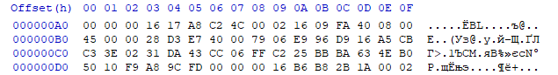

4 фрейм начинается с адреса 000000A2:

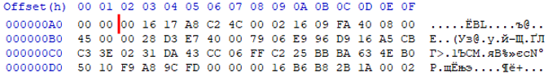

Данные 6 байт занимает MAC адрес получателя: 00:16:17:A8:C2:4C:

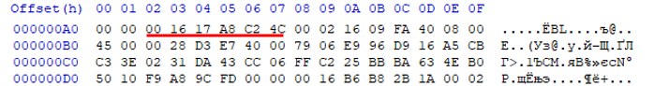

Данные 6 байт занимает MAC адрес отправителя: 00:02:16:09:FA:40:

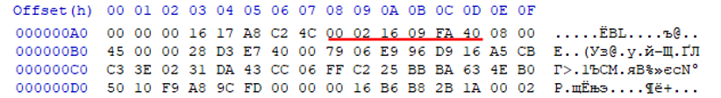

Данные 2 байты указывают на протокол IPv4:

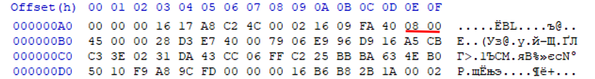

Данныйбайт показывает длину заголовка Internet Header Length (IHL) в 32-битных словах:

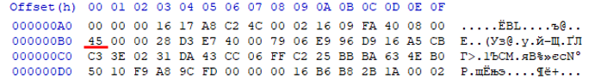

Данный байт показывает на DSCP (6 бит)+ ECN (2 бита) :

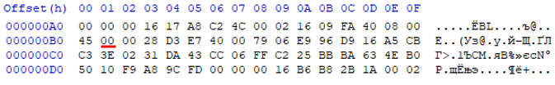

Данные байты определяют суммарный размер IP-пакета, включая, заголовок, параметры и данные:

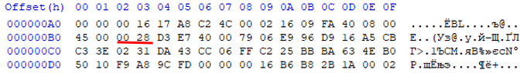

Данные байты показывают идентификатор (нужен для определения конкретной последовательности IP-пакета при его сборке) :

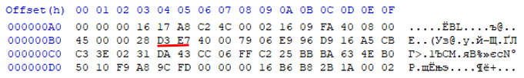

Данные байты показывают флаги (3 бита) и на смещение фрагмента (13 бит) :

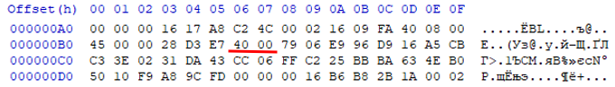

Данный байт показывает на Time to Live (TTL):

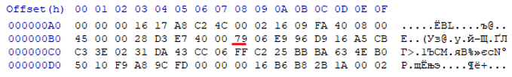

Данный байт указывает на протокол TCP:

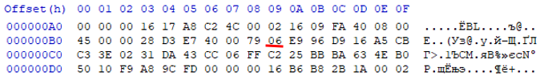

Данные байты показывают контрольную сумму заголовка:

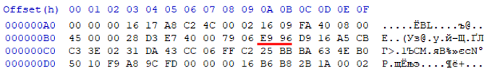

Данные байты указывают на IP адрес отправителя 217.22.165.203:

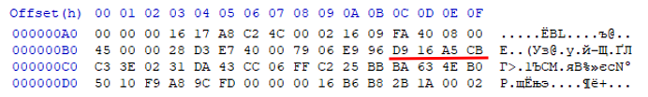

Данные байты указывают на IP адрес получателя 195.62.2.49:

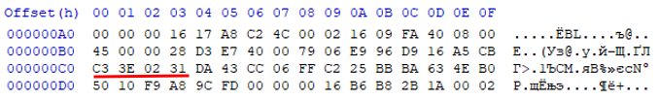

Данные байты указывают на передаваемые данные

