1. ER-модель схемы базы данных системы кредитного скоринга.

Логическая схема:

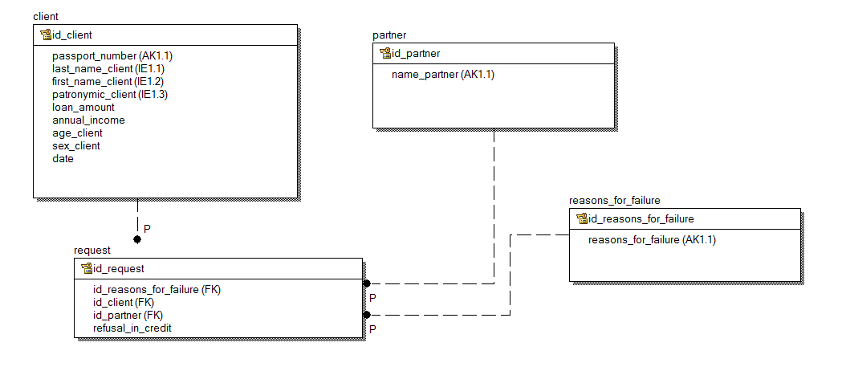Физическая схема:

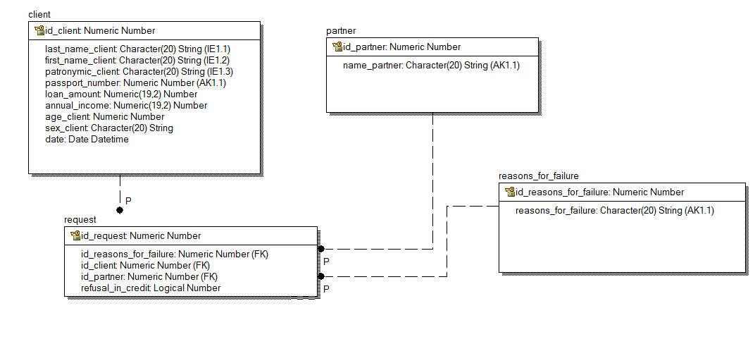

2. Запросы SQL.

1. Отображает статистику по партнерам: партнер, общее количество заявок, количество одобренных заявок, количество отказов, количество выданных денег.

WITH allowed AS

( SELECT COUNT(Request.id_request)

FROM client

INNER JOIN data1!request

ON Client.id_client = Request.id_client

INNER JOIN data1!partner

ON Partner.id_partner = Request.id_partner

WHERE NOT (Request.refusal_in_credit )

GROUP BY Partner.name_partner ),

AmountSUM AS

(

SELECT SUM(Client.loan_amount)

FROM

data1!client

INNER JOIN data1!request

ON Client.id_client = Request.id_client

INNER JOIN data1!partner

ON Partner.id_partner = Request.id_partner

WHERE NOT (Request.refusal_in_credit )

GROUP BY Partner.name_partner )

),

Refusal AS

( SELECT COUNT(Request.id_request)

FROM

data1!client

INNER JOIN data1!request

ON Client.id_client = Request.id_client

INNER JOIN data1!partner

ON Partner.id_partner = Request.id_partner

WHERE Request.refusal_in_credit

GROUP BY Partner.name_partner

)

SELECT Partner.name_partner, allowed, AmountSUM,Refusal

FROM

data1!partner

INNER JOIN data1!request

ON Partner.id_partner = Request.id_partner

INNER JOIN data1!client

ON Client.id_client = Request.id_client

1. Отображает все заявки по конкретному партнеру с указанием параметров заявки и ее текущего статуса, причину отказа в кредите.

SELECT Client.*, Request.refusal_in_credit,

Reasons_for_failure.reasons_for_failure

FROM

data1!client

INNER JOIN data1!request

ON Client.id_client = Request.id_client

INNER JOIN data1!partner

ON Partner.id_partner = Request.id_partner

INNER JOIN data1!reasons_for_failure

ON Reasons_for_failure.id_reasons_for_failure = Request.id_reasons_forfailure

WHERE Partner.name_partner LIKE '<указывается имя партнера>'

3. Возвращает массив клиентов в разрезе причин отказа в выдаче кредита (Map<Enum, Client[]>) за заданный интервал дат.

С#

using MySql.Data.MySqlClient;

static void Main(string[] args)

{

string connStr = "<параметры> ";

MySqlConnection conn = new MySqlConnection(connStr);

conn.Open();

string sql = " SELECT Client.*, Reasons_for_failure.reasons_for_failure;

FROM reasons_for_failure INNER JOIN request ON Reasons_for_failure.id_reasons_for_failure = Request.id_reasons_forfailure

INNER JOIN client ON Client.id_client = Request.id_client

WHERE Request.refusal_in_credit

AND YEAR(Client.date) BETWEEN 2015 AND 2017";

MySqlCommand command = new MySqlCommand(sql, conn);

MySqlDataReader reader = command.ExecuteReader();

while (reader.Read())

{

Console.WriteLine(reader[0].ToString() + " " + reader[1].ToString()+ " " + reader[2].ToString()+ " " + reader[3].ToString()+ " " + reader[4].ToString()+ " " + reader[5].ToString()+ " " + reader[6].ToString()+ " " + reader[7].ToString()+ " " + reader[8].ToString()+ " " + reader[9].ToString()+ " " + reader[10].ToString());

}

reader.Close();

conn.Clone();

}

RPG

**FREE

Dcl-DS CLIENT_TEMP Qualified Template;

CLIEN_ID Uns(10);

CLIEN_PAS Uns(10);

CLIEN_LAST_NAME Char(25);

CLIEN_FIST_NAME Char(25);

CLIEN_PATR Char(25)

CLIEN_LOAN_AMOUN Packed(11:2);

CLIEN_ANNUAL_INCOM Packed(11:2);

CLIEN_AGE Uns(3);

CLIEN_SEX Char(4);

CLIEN_DATA;

End_Ds;

Dcl-DS REQUEST_TEMP Qualified Template;

REQUEST_ID Uns(10);

REQUEST_CLIEN Uns(10);

REQUEST_PARTNER Uns(10);

REQUES_REASON_FOR_FAILURE Uns(10);

REQUEST_REFUSAL_IN_CREDIT LOG();

End_Ds;

Dcl-DS PARTNER _TEMP Qualified Template;

PARTNER _ID Uns(10);

PARTNER _NAME Char(25);

End_Ds;

Dcl-DS REASON_FOR_FAILURE _TEMP Qualified Template;

REASON_FOR_FAILURE _ID Uns(10);

REASON_FOR_FAILURE_NAME Char(25);

End_Ds;

Dcl-DS CLIENT LikeDS(CLIENT_TEMP);

Dcl-DS REQUEST LikeDS(REQUEST_TEMP);

Dcl-DS PARTNER LikeDS(PARTNER _TEMP);

Dcl-DS REASON_FOR_FAILURE LikeDS(REASON_FOR_FAILURE _TEMP);

Exec SQL SELECT CLIEN_ID,

CLIEN_PAS,

CLIEN_LAST_NAME,

CLIEN_FIST_NAME,

CLIEN_PATR,

CLIEN_LOAN_AMOUN,

CLIEN_ANNUAL_INCOM,

CLIEN_AGE,

CLIEN_SEX,

CLIEN_DATA,

REASON_FOR_FAILURE_NAME

INTO :CLIENT.CLIEN_ID,

:CLIENT.CLIEN_PAS,

:CLIENT.CLIEN_LAST_NAME,

:CLIENT.CLIEN_FIST_NAME,

:CLIENT.CLIEN_PATR,

:CLIENT.CLIEN_LOAN_AMOUN,

:CLIENT.CLIEN_ANNUAL_INCOM,

:CLIENT.CLIEN_AGE,

:CLIENT.CLIEN_SEX,

:CLIENT.CLIEN_DATA,

:REASON_FOR_FAILURE.REASON_FOR_FAILURE

FROM CLIENT,

REQUEST,

REASON_FOR_FAILURE

WHERE REQUEST_REFUSAL_IN_CREDIT IS TRUE AND

CLIEN_DATA BETWEEN <параметр> AND <параметр>;

*InLR = *on;

Return;