Easy Collider Editor

May, 2019

# Recent Changes

### Version 4

Features an improved, more accurate, and easier to use version of rotated box collider creation.

Additional field in preferences for layer of created collider holders and rotated box colliders.

Improvements in initial creation, and finding the path on load, of the preferences asset.

## Overview

By using primitive colliders instead of mesh colliders, rigidbodies can be added to gameobjects to allow for physics interactions. No more painfully adding primitive colliders and positioning and resizing them to fit each mesh. Using Easy Collider Editor you can very quickly, easily, and precisely add multiple primitive colliders to gameobjects.

## Installation

It is best to use Unity's built-in import package (Located in Assets > Import package > Custom package) to quickly and easily install Easy Collider Editor. Or import the package from the asset store by searching and clicking import.

If you are using an older version of Unity, moving the Editor folder located in Assets/EasyColliderEditor to the root Assets folder may be required.

# Collider Creation

## Box Colliders

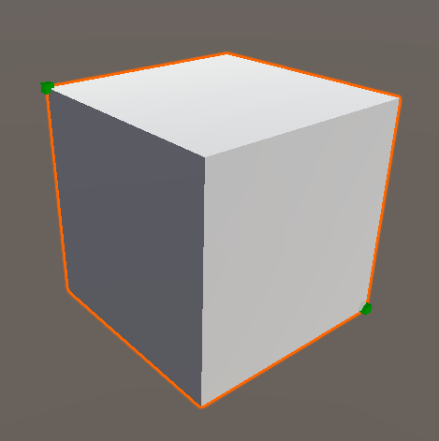

Box colliders are created by selecting the vertices of the box you wish to be encapsulated. This can be accomplished using only 2 vertex points on opposite corners. Additional vertices can be selected to ensure their inclusion in the generated box collider.

## 

## 

## Sphere Colliders

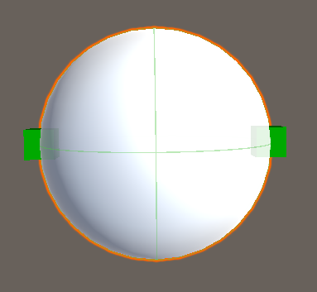

Sphere colliders are created by selecting the two vertices on opposite sides of the spherical object. This can be accomplished using any two opposing points on the sphere, however it is most easily accomplished using the end-caps of a spherical object. Many vertices can also be selected around a spherical object, and the script will attempt to create a sphere collider that should best fit those points.

## Capsule Colliders

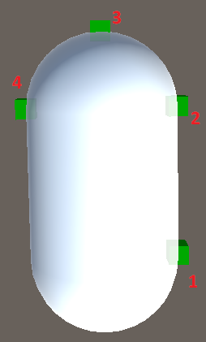

Capsule colliders are using the selection of 4 vertex points. The first two points are selected in a horizontal or vertical line along the length of the capsule shape. The third vertex point is a point anywhere on the spherical part of the capsule object. The final vertex point is selected directly across from one of the first vertex points, on the side closest to the vertex point located on the spherical part.

The old method of creating capsule colliders has been left in for anyone used to that workflow. It is highly recommended to use the new method instead.

## Rotated Box Colliders

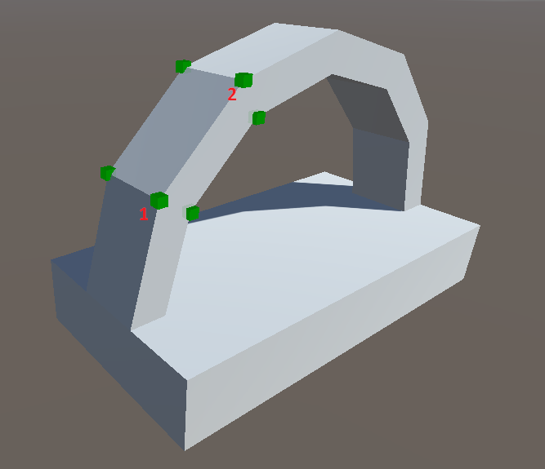

The new method of creating rotated box colliders only requires the selection of 2 points. These 2 points should lay along one of the edges of the resulting box collider, or along the same rotation as an edge of the resulting box collider. As many other points as you wish can be selected after these initial 2 points. All vertices that are selected will be within the resulting rotated box collider.

The old version of this method has been kept in the project for anyone used to that workflow. It is highly recommended to use the new version of rotated box collider.

# Main Editor Window

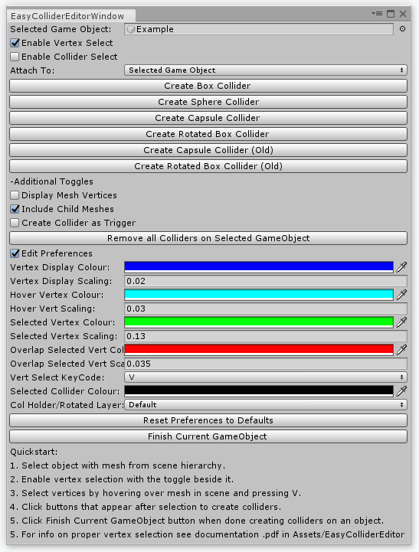

**Selected Game Object:** The currently selected game object you are creating colliders for.

**Enable Vertex Select:** Checking this box allows you to select vertices on the selected gameobject.

**Enable Collider Select:** Allows you to select added colliders so that they can be removed using the button that appears once a collider has been selected.

**Attach Colliders to:** These options decide if the created colliders will be attached to the selected gameobject, or use colliderholder gameobjects. Rotated colliders cannot be attached to the selected gameobject and create their own rotated gameobject to hold the box collider.

**Create collider buttons:** These are the buttons used to create Box, Sphere, Capsule and Rotated Box Colliders. These buttons appear once vertices have been selected. Warnings will display that will tell you if an appropriate number of vertices have been selected to properly create the selected collider. For more information on how to select vertices for each collider, see the appropriate information below.

## Additional Toggles & Buttons

**Display Mesh Vertices:** Displays the vertices of the mesh vertices currently able to be selected.

**Include Child Meshes:** Enabling this option allows meshs on child gameobjects to be include in the selectable vertices.

**Create Collider as Trigger:** Enabling this option marks the isTrigger option on created colliders to true.

**Remove all Colliders on Selected GameObject:** Clicking this button removes all colliders that exist on the selected gameobject, and it’s children if include child meshes has been enabled.

**Finish Current GameObject:** Tries to clean up components added/disabled on the gameobject, and empties the selected gameobject field.

## Preferences

**Edit Preferences**:allows you to edit various options used during creation.

**Vertex Display Colour:** The colour of the boxes when Display Mesh Vertices is enabled.

**Vertex Display Scaling:** The scale of the boxes when Display Mesh Vertices is enabled.

**Hover Vertex Colour:** The colour of the box when hovering over selectable vertices.

**Hover Vertex Scaling:** The scale of the box when hovering over selectable vertices.

**Selected Vertex Colour:** The colour of the box of selected vertices.

**Selected Vertex Scaling:** The scale of the box of selected vertices.

**Overlap Selected Vertex Colour:** The colour of the box of vertices that have been selected that are are currently being hovered over.

**Overlap Selected Vertex Scaling:** The scale of the box vertices that have been selected that are are currently being hovered over.

**Vert Select KeyCode:** The key that is used to select/deselect vertices for collider creation.

**Selected Collider Colour:** The colour of the lines drawn when a collider is selected using Enable Collider Select.

**ColHolder/Rotated Layer:** The layer to set on the gameobjects when rotated colliders, or attach To: Collider Holders is used.

# Frequently Asked Questions

**I am unable to select vertices on my object.**

**Solution:** This can occur if non-kinematic rigidbodies are present with non-convex mesh colliders. These do not respond properly to the raycasts used during vertex selection. Although this version should properly handle this problem, it can still occur if a non-kinematic rigidbody is on a parent of the selected gameobject.

**Alternate Solution:** This can also occur if the gameobject is not actually selected correctly. You can see the selectable vertices of the gameobject you have selected by checking the box beside display mesh vertices in the window. Additionally, if the mesh is a child of a gameobject, make sure that include child meshes is checked before selecting the gameobject.

**The collider did not generate correctly.**

**Solution:** Please refer to the documentation above for proper selection of vertices for collider generation.

**There are additional primitive colliders from other assets that I have access to, are these supported?**

**Solution:** Unfortunately, generation of any primitive colliders that aren’t officially included in Unity by default are not supported.

**I have a great idea for additional features that could be added, will you add these?**

**Solution:** I would be happy to look into adding any additional features for my customers, please feel free to contact me at pmurph.software@gmail.com. However, please understand that not all requested features are guaranteed to be added. I will try to get back to any received e-mail as quickly as I can.

**I encountered a bug not listed here.**

**Solution: I** would love to further improve this asset! If any bugs are encountered, please let me know so I can fix them for everybody. Please send me an e-mail at pmurph.software@gmail.com. It would be helpful to find and fix the bug if as much information as possible about what was occurring is included. (ie. Any manual removal of components, what button was clicked that generated the unexpected problem or error, version of unity, etc.)

**I have other questions.**

**Solution:** Please contact me at pmurph.software@gmail.com