Technical Design Document: ArtemBrattsev_ProgrammingExercise_6
Name: Artem Brattsev
Date: June 23, 2026
Program Description: This program uses regular expressions to validate phone numbers, social security numbers, and zip codes entered by the user.
Class: Validator
Description: Contains methods that validate user input using regular expressions.

Method: validate_phone
Parameters: phone (str)
Variables: pattern (str)
Return: Match object or None

Method: validate_ssn
Parameters: ssn (str)
Variables: pattern (str)
Return: Match object or None

Method: validate_zip
Parameters: zip_code (str)
Variables: pattern (str)
Return: Match object or None

Function: main
Parameters: None
Variables: validator, phone, ssn, zip_code
Return: None

Repository Link
https://github.com/ArtemBrattsev/exercise-6
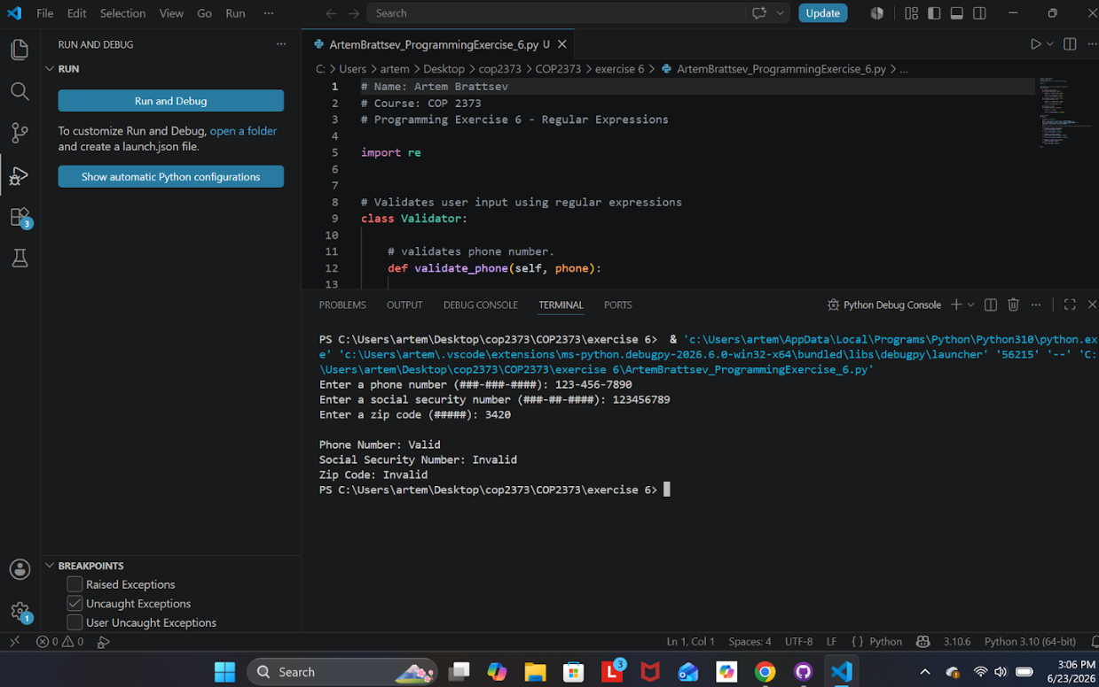
Testing Examples
Valid Phone: 941-555-1234
Invalid Phone: 9415551234
Valid SSN: 123-45-6789
Invalid SSN: 123456789
Valid Zip: 34208
Invalid Zip: 3420

