Abstract

Intro

Data and EDA
Data Annotation
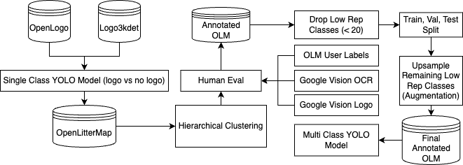
The biggest challenge of the project was creating labels for the data as OLM does provide annotations. Hand labelling 27k images was not an option and we used a combination of object detection, clustering, pre-trained models, and human evaluation to generate a training dataset.
As a first step, we used OpenLogo and Logo3kdet, two labelled datasets of logo images to train a single-class YOLO model that can detect logos in the images (logo detector). This model did not distinguish between various brands, rather provided a bounding box for what appeared to be a logo. We then applied this model to the OpenLitterMap dataset to produce a dataset of approximately 20k of bounding boxes.
In the second step, we performed hierarchical clustering on the results to group similar images. The idea was that images of the logo fo a particular brand will look alike and will cluster together. To avoid making assumption about the number of clusters we opted for hierarchical clustering in this step. The resultig clusters were far from perfect, and we manually corrected mistakes and added missing annotations.
In the third step we addressed significant class imbalance. To that end we sought out additional training examples in the OLM dataset. Out logo detector missed a significant number of potential training examples and we used Google Vision’s logo and optical character recognition models to flag additional images. We specifically focused on the underrepresented classes and did not seek additional examples of the top 5 classes. This helped to address our class imbalance for many classes but some remained severely underrepresented and we decided to cut classes with less than 20 annotations.
We then split the dataset into training, validation, and test sets and up-sampled the remaining low-representation classes using augmentation techniques such as flips, random adjustments of brightness and random noise addition.
Final model: YOLOv8
YOLOv8 was trained on this dataset to recognize

AWS-base infrastructure

User interface: Browser extension

