This document specify basic UI on Car project. Start tab (Picture 1. Start-tab) will appear first where user can select item which he/she want to measure. Scroll-area gives choices which user can select. Auto start and Manual start buttons start measurement and then measure-tab (Picture 2) activates.

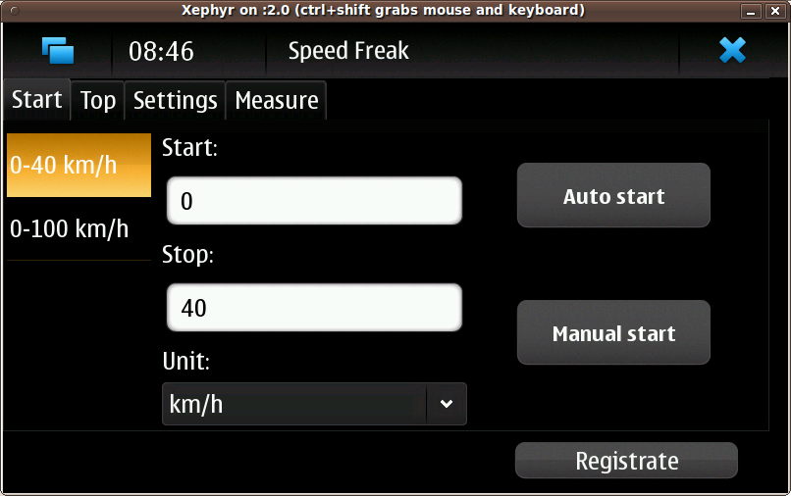
Picture 1. Start-tab

Measure-tab activates and it shows basic measures in labels. Abort button stops measuring and then Start-tab will appear again. When target speed (e.g. 40 km/h) has been reached result appears after Time label. Send result button is disabled until the target speed has reached. Send result button sends user's result to the server.
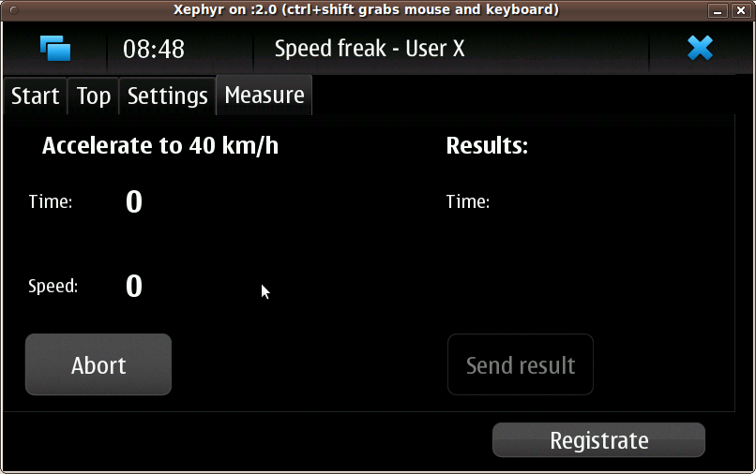
Picture 2. Measure-tab

Setting-tab (Picture 3. Setting-tab) gives chance to set username and password when Change user button is clicked. Then Setting username dialog (Picture 4. Setting username dialog) opens.
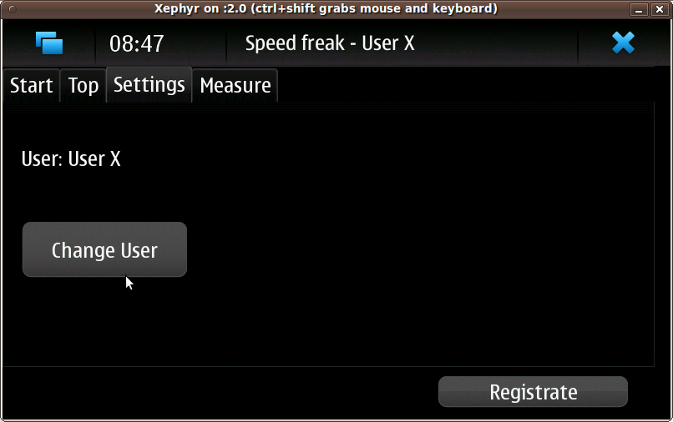
Picture 3. Settings-tab

User can set username and password in Setting username dialog. When username is set name appears above after program name.
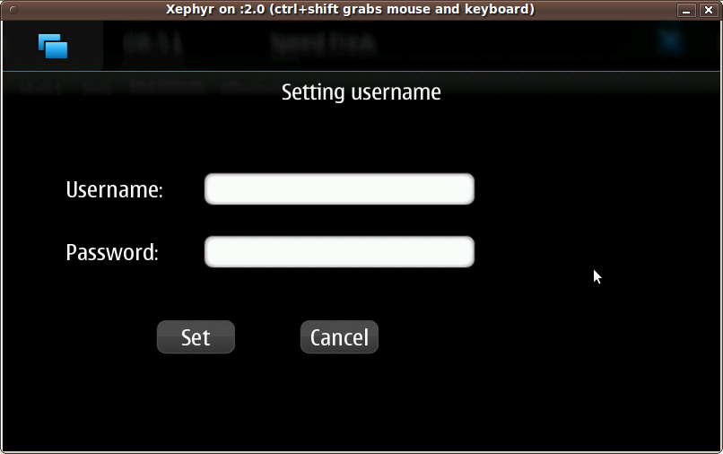
Picture 4. Setting username dialog

Top-tab (Picture 5. Top-tab) shows top lists which has got from server.
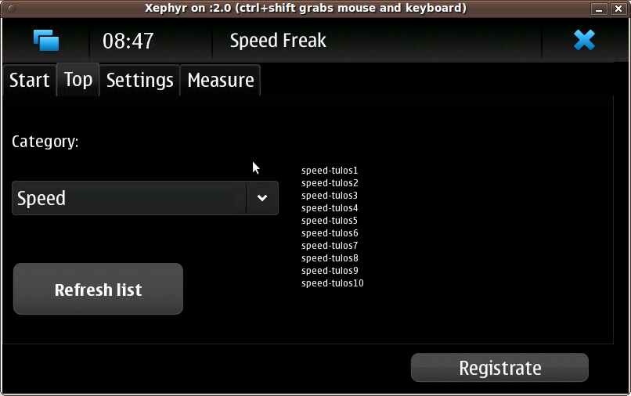
Picture 5. Top-tab

Registrate-button opens Registration dialog (Picture 6. Registration dialog) where user can give registration information to the server.

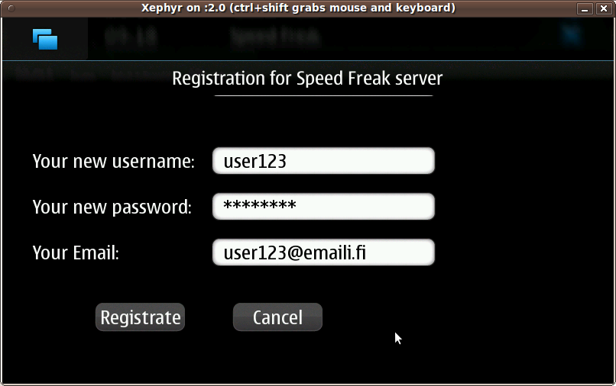
Picture 6. Registration dialog

