[ARTEM DUDKO] - [HW #10] - [4/22/2020]
[PROBLEM #4] 1
[PROBLEM #10] 2
[PROBLEM #11] 2
[PROBLEM #21] 3

[PROBLEM #4]
format compact, clear, clc, close all
x = [-4:0.01:4];
y = [-3:0.0075:3];
z = (x.^2)/4 + 2.*(sin(0.7.*y).^2);
plot3(x,y,z);
grid on;
xlabel('x'); ylabel('y'); zlabel('z');
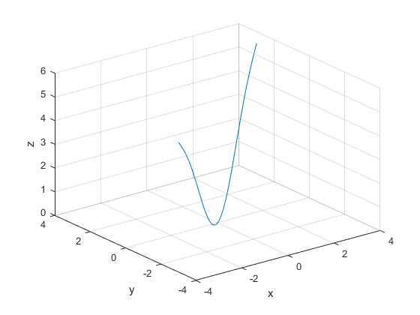

[PROBLEM #10]
format compact, clear, clc, close all
aOverLambda = [-20:0.08:20];
theta = [2:0.016:10];
[X,Y] = meshgrid(aOverLambda,theta);
IoverImax = (sin(pi.*X.*sin(Y))./pi.*X.*sin(Y)).^2;
mesh(X,Y,IoverImax);
grid on;
xlabel('aOverLambda'); ylabel('theta'); zlabel('IoverImax');
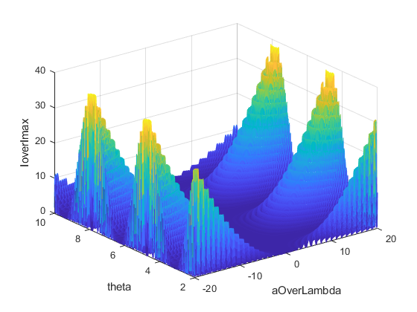

[PROBLEM #11]
format compact, clear, clc, close all
v = [0:1:1000];
t = [70:1:320];
R = 8.31;
M = 0.032;
[V,T] = meshgrid(v,t);
Pv = 4.*pi.*(M./(2.*pi.*R.*T)).^(1.5).*(V.^2).*exp(-M.*(V.^2)./(2.*R.*T));
mesh(V,T,Pv);
grid on;
xlabel('Speed'); ylabel('Temp'); zlabel('Prob. Distribution');
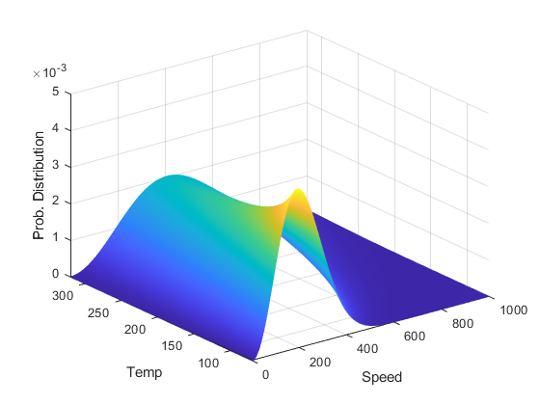

[PROBLEM #21]
format compact, clear, clc, close all
K = 300;
t = [0:0.1:90];
r = [0.02:0.01:0.2];
[T,R] = meshgrid(t,r);
xx = (-K ./ sqrt(2.*pi.*R)).*sin((T./2).*(2+cos(T./2).*cos(1.5.*T)));
yy = (K ./ sqrt(2.*pi.*R)).*sin((T./2).*(cos(T./2).*cos(1.5.*T)));
xy = (K ./ sqrt(2.*pi.*R)).*cos((T./2).*(1-sin(T./2).*sin(1.5.*T)));
mesh(T,R,xx);
grid on;
xlabel('T'); ylabel('R'); zlabel('Stress Fields XX');
mesh(T,R,yy);
grid on;
xlabel('T'); ylabel('R'); zlabel('Stress Fields YY');
mesh(T,R,xy);
grid on;
xlabel('T'); ylabel('R'); zlabel('Stress Fields XY');

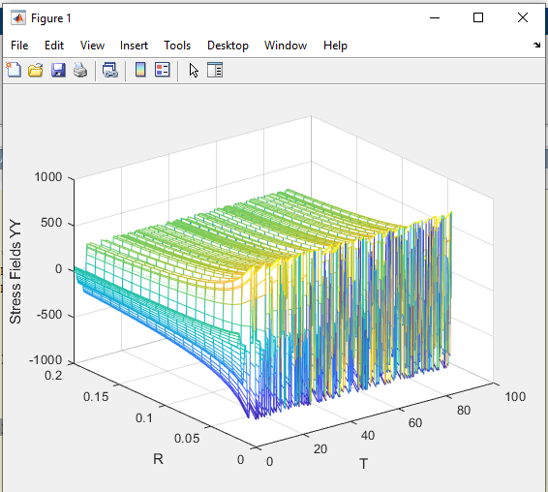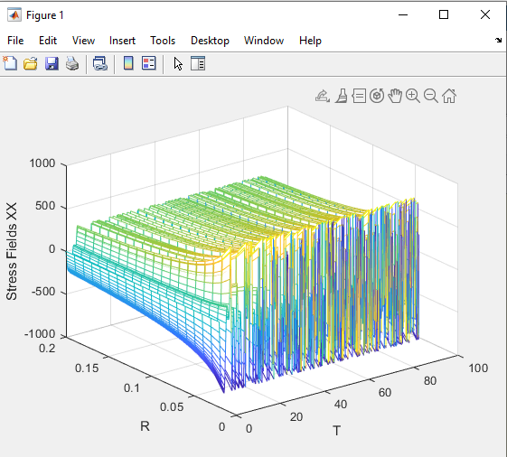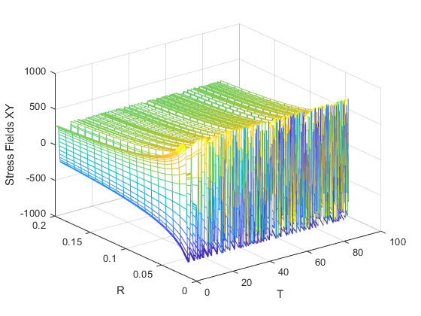
Published with MATLAB® R2020a

